Experiment 20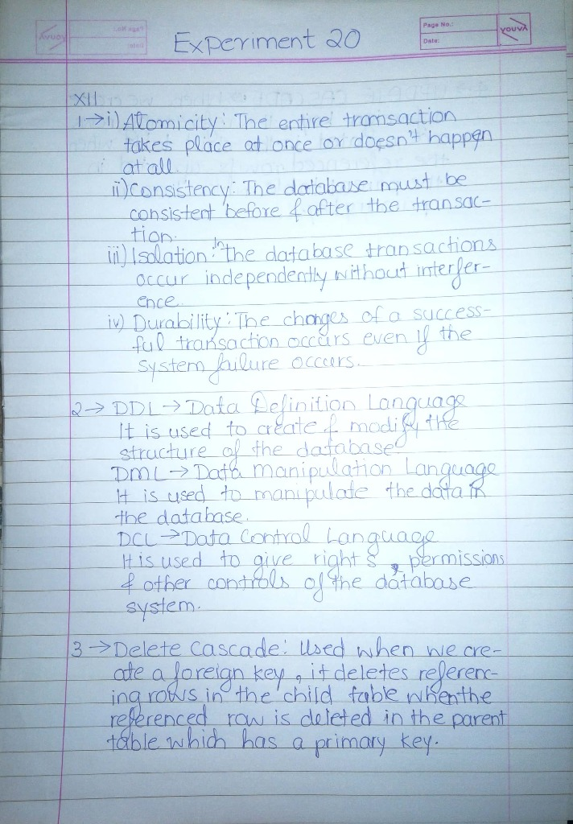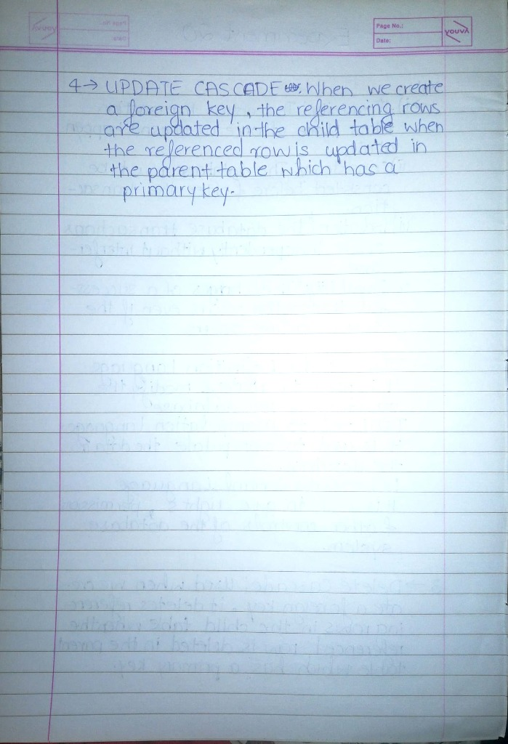

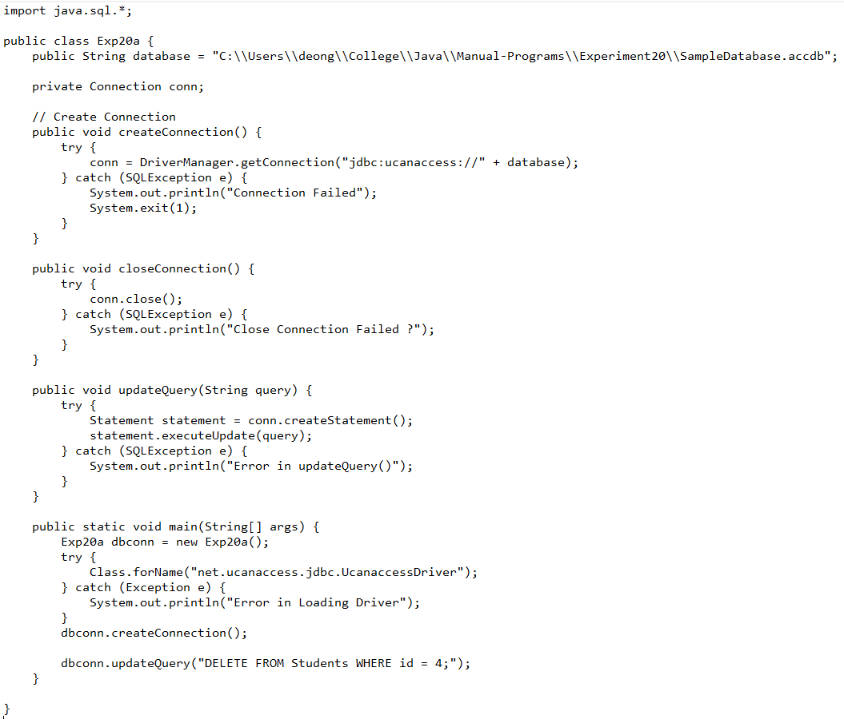

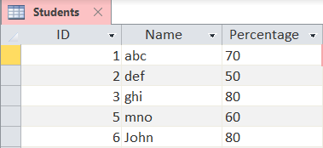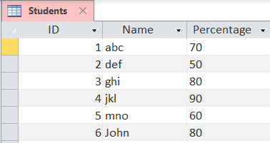

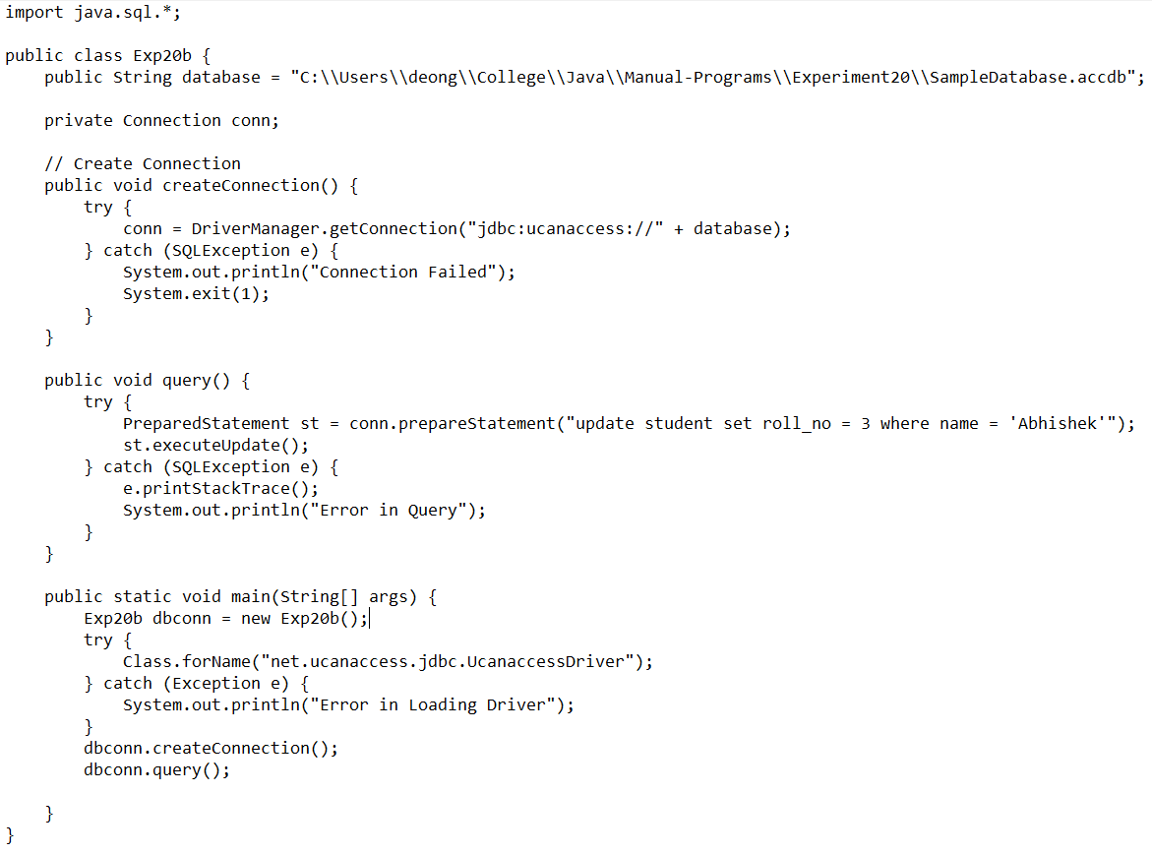

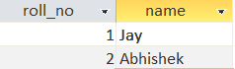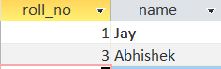

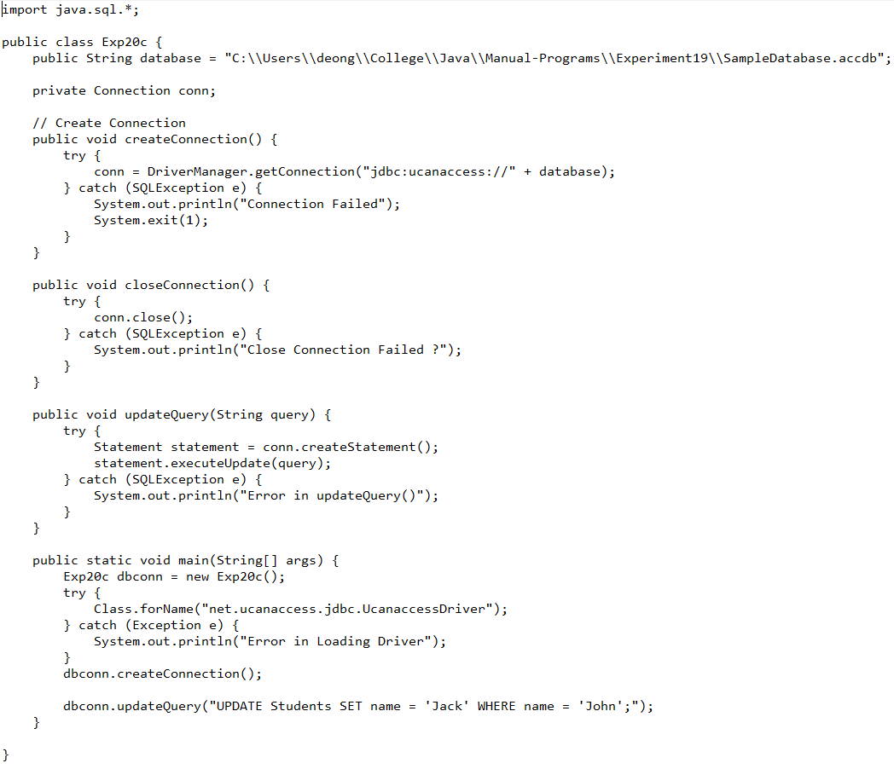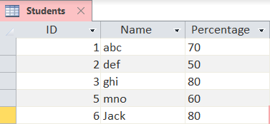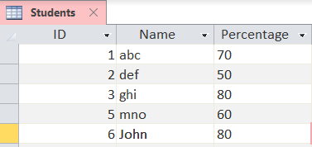

import java.sql.Connection;

import java.sql.DriverManager;

import java.sql.Statement;

import java.sql.PreparedStatement;

import java.sql.ResultSet;

import java.sql.SQLException;

public class Exp20d {

public String database = "C:\\Users\\deong\\College\\Java\\Manual-Programs\\Experiment20\\SampleDatabase.accdb";

private Connection conn;

// Create Connection

public void createConnection() {

try {

conn = DriverManager.getConnection("jdbc:ucanaccess://" + database);

} catch (SQLException e) {

System.out.println("Connection Failed");

System.exit(1);

}

}

public void updateQuery(String query) {

try {

Statement statement = conn.createStatement();

statement.executeUpdate(query);

} catch (SQLException e) {

System.out.println("Error in updateQuery()");

}

}

public void insertQuery(String id, String name, float price) {

try {

PreparedStatement statement = conn.prepareStatement("INSERT INTO Product (ID, Name, Price) VALUES(?,?,?);");

statement.setString(1, id);

statement.setString(2, name);

statement.setFloat(3, price);

statement.executeUpdate();

} catch (SQLException e) {

System.out.println("Error in insertQuery()");

}

}

public void selectQuery(String query) {

try {

Statement statement = conn.createStatement();

ResultSet resultSet = statement.executeQuery(query);

while (resultSet.next()) {

String product = "Product " + resultSet.getString("ID") + ":" + "\n\tName : "

+ resultSet.getString("name") + "\n\tPrice : " + resultSet.getFloat("price");

System.out.println(product);

}

} catch (SQLException e) {

System.out.println("Error in Printing With WHERE Condition");

}

}

public static void main(String[] args) {

Exp20d dbconn = new Exp20d();

try {

Class.forName("net.ucanaccess.jdbc.UcanaccessDriver");

} catch (Exception e) {

System.out.println("Error in Loading Driver");

}

dbconn.createConnection();

dbconn.updateQuery("DROP TABLE Product;");

dbconn.updateQuery("CREATE TABLE Product (ID VARCHAR(10), name VARCHAR(50), price FLOAT);");

dbconn.insertQuery("P1234", "abc", 300);

dbconn.insertQuery("P1234", "abc", 900);

dbconn.insertQuery("P1234", "abc", 700);

dbconn.selectQuery("SELECT ID , name , price FROM Product WHERE price > 500 AND ID = 'P1234';");

}

}

