Experiment 24

# Theory

Write the methods of Cookie.

* public void setMaxAge(int expiry) : Sets the maximum age of the cookie in seconds.
* public String getName() : Returns the name of the cookie. The name cannot be changed after creation.
* public String getValue() : Returns the value of the cookie.
* public void setName(String name) : changes the name of the cookie.
* public void setValue(String value) : changes the value of the cookie.

Write the advantages of Cookie over URL rewriting

* Sessions tracking using Cookies are more secure and fast. Session tracking using Cookies can also be used with other mechanism of Session Tracking like url rewriting.
* Cookies are stored at client side so some clients may disable cookies so we may not sure that the cookies may work or not.
* In url rewriting requites large data transfer from and to the server.
* So, it leads to network traffic and access may be become slow.

Write the steps to disable Cookie

* Go to the Browsers Settings.
* Click Show Advanced Settings or Advanced
* Click on Site Settings or Content Settings in the Privacy and Security section.
* Click on Cookies and site data.
* Click the toggle switch next to “Allow sites to save and read cookie data”.
* Click the toggle switch next to “Block Third Party Cookies”.

# Programs

# 1

Java

import java.io.*;

import javax.servlet.*;

import javax.servlet.annotation.WebServlet;

@WebServlet("/Cookies")

public class Cookies extends HttpServlet {

private static final long serialVersionUID = 1L;

public Cookies() {

super();

// TODO Auto-generated constructor stub

}

protected void doGet(HttpServletRequest request, HttpServletResponse response)

throws ServletException, IOException {

response.setContentType("text/html");

String name = request.getParameter("name");

String orderedCookie = request.getParameter("orderedCookie");

String quantity = request.getParameter("quantity");

response.addCookie(new Cookie("name", name));

response.addCookie(new Cookie("orderedCookie", orderedCookie));

response.addCookie(new Cookie("quantity", quantity));

PrintWriter pw = response.getWriter();

pw.println(

"<link rel='stylesheet' href='https://cdn.jsdelivr.net/npm/bootstrap@4.5.3/dist/css/bootstrap.min.css' integrity='sha384-TX8t27EcRE3e/ihU7zmQxVncDAy5uIKz4rEkgIXeMed4M0jlfIDPvg6uqKI2xXr2' crossorigin='anonymous' /> <script defer src='https://code.jquery.com/jquery-3.5.1.slim.min.js' integrity='sha384-DfXdz2htPH0lsSSs5nCTpuj/zy4C+OGpamoFVy38MVBnE+IbbVYUew+OrCXaRkfj' crossorigin='anonymous' ></script> <script defer src='https://cdn.jsdelivr.net/npm/bootstrap@4.5.3/dist/js/bootstrap.bundle.min.js' integrity='sha384-ho+j7jyWK8fNQe+A12Hb8AhRq26LrZ/JpcUGGOn+Y7RsweNrtN/tE3MoK7ZeZDyx' crossorigin='anonymous' ></script><div class='container'><h1 style='text-align:center'>Ordered Cookie</h1><table class='table table-bordered'><thead class='thead-dark'><tr><th scope='col'>Name</th><th scope='col'>Value</th></tr></thead><tbody>");

Cookie[] cookies = request.getCookies();

for (Cookie cookie : cookies) {

String cookieName = cookie.getName();

String cookieValue = cookie.getValue();

pw.println("<tr><td scope='row'>" + cookieName + "</td><td>" + cookieValue + "</td></tr>");

}

pw.println("</tbody></div></div>");

for (Cookie cookie : cookies) {

cookie.setValue("");

cookie.setMaxAge(0);

response.addCookie(cookie);

}

}

protected void doPost(HttpServletRequest request, HttpServletResponse response)

throws ServletException, IOException {

doGet(request, response);

}

}

HTML

<!DOCTYPE html>

<html>

<head>

<meta charset="ISO-8859-1" />

<title>Cookies</title>

<link

rel="stylesheet"

href="https://cdn.jsdelivr.net/npm/bootstrap@4.5.3/dist/css/bootstrap.min.css"

integrity="sha384-TX8t27EcRE3e/ihU7zmQxVncDAy5uIKz4rEkgIXeMed4M0jlfIDPvg6uqKI2xXr2"

crossorigin="anonymous"

/>

<script defer

src="https://code.jquery.com/jquery-3.5.1.slim.min.js"

integrity="sha384-DfXdz2htPH0lsSSs5nCTpuj/zy4C+OGpamoFVy38MVBnE+IbbVYUew+OrCXaRkfj"

crossorigin="anonymous"

></script>

<script defer

src="https://cdn.jsdelivr.net/npm/bootstrap@4.5.3/dist/js/bootstrap.bundle.min.js"

integrity="sha384-ho+j7jyWK8fNQe+A12Hb8AhRq26LrZ/JpcUGGOn+Y7RsweNrtN/tE3MoK7ZeZDyx"

crossorigin="anonymous"

></script>

</head>

<style>

#main {

width: 100vw;

height: 100vh;

display: flex;

justify-content: center;

align-items: center;

}

.card {

box-shadow: 4px 4px 10px 3px rgba(0, 0, 0, 0.2);

width: 500px;

}

</style>

<body>

<div class="container" id="main">

<form

action="Cookies"

method="get"

class="card"

>

<h5 class="card-header">Order a Cookie</h5>

<div class="card-body">

<div class="form-group">

<label for="name">Your Name</label>

<input type="text" name="name" class="form-control" />

</div>

<div class="form-group">

<label for="orderedCookie">Type of Cookie</label>

<select class="form-control" id="orderedCookie" name="orderedCookie">

<option

value="ChocolateChipCookies"

>

Chocolate Chip Cookies

</option>

<option value="Snickerdoodles">Snickerdoodles</option>

<option value="Gingersnaps">Gingersnaps</option>

<option value="PeanutButterCookies">

Peanut Butter Cookies

</option>

<option value="Biscotti">Biscotti</option>

<option value="ButterCookies">Butter Cookies</option>

</select>

</div>

<div class="form-group">

<label for="quantity">Quantity</label>

<input

type="text"

name="quantity"

id="quantity"

class="form-control"

/>

</div>

<div class="form-group">

<button id="submit-btn" type="submit" class="btn btn-primary">

Order

</button>

</div>

</div>

</form>

</div>

</body>

</html>

Outputs

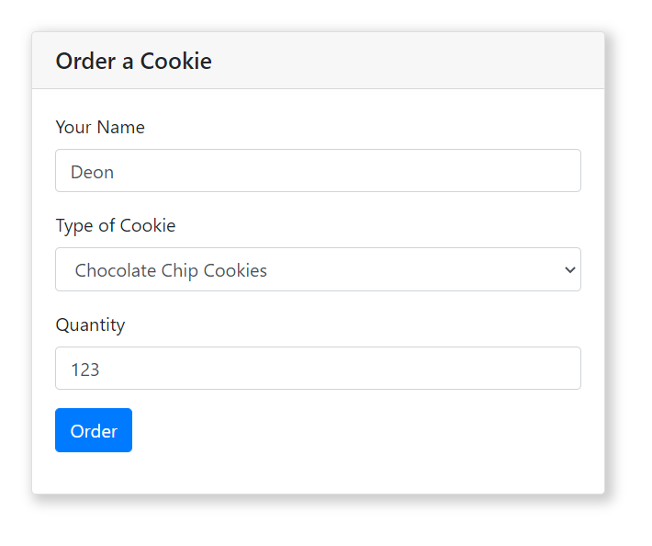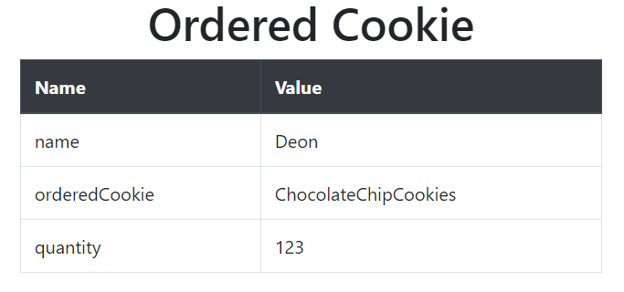

# 2

Java

FirstServlet.java

import java.io.IOException;

import java.io.PrintWriter;

import javax.servlet.ServletException;

import javax.servlet.annotation.WebServlet;

import javax.servlet.http.Cookie;

import javax.servlet.http.HttpServlet;

import javax.servlet.http.HttpServletRequest;

import javax.servlet.http.HttpServletResponse;

@WebServlet("/FirstServlet")

public class FirstServlet extends HttpServlet {

protected void doPost(HttpServletRequest request, HttpServletResponse response)

throws ServletException, IOException {

try {

response.setContentType("text/html");

PrintWriter out = response.getWriter();

String n = request.getParameter("userName");

out.print("Welcome " + n);

Cookie ck = new Cookie("uname", n);

response.addCookie(ck);

out.print("<form action='SecondServlet'>");

out.print("<input type='submit' value='go'/>");

out.print("</form>");

out.close();

} catch (Exception e) {

System.out.println(e);

}

}

}

SecondServlet.java

import java.io.IOException;

import java.io.PrintWriter;

import javax.servlet.ServletException;

import javax.servlet.annotation.WebServlet;

import javax.servlet.http.Cookie;

import javax.servlet.http.HttpServlet;

import javax.servlet.http.HttpServletRequest;

import javax.servlet.http.HttpServletResponse;

@WebServlet("/SecondServlet")

public class SecondServlet extends HttpServlet {

protected void doGet(HttpServletRequest request, HttpServletResponse response)

throws ServletException, IOException {

response.setContentType("text/html");

try {

response.setContentType("text/html");

PrintWriter out = response.getWriter();

Cookie ck[] = request.getCookies();

out.print("Hello " + ck[0].getValue());

out.close();

} catch (Exception e) {

System.out.println(e);

}

}

}

Html

<form action="FirstServlet" method="post">

Name:<input type="text" name="userName" /><br/>

<input type="submit" value="go">

</form>

Outputs

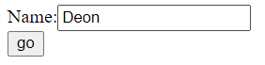





# 3

Java

import java.io.IOException;

import java.io.PrintWriter;

import javax.servlet.ServletException;

import javax.servlet.annotation.WebServlet;

import javax.servlet.http.Cookie;

import javax.servlet.http.HttpServlet;

import javax.servlet.http.HttpServletRequest;

import javax.servlet.http.HttpServletResponse;

@WebServlet("/Cookies")

public class Cookies extends HttpServlet {

private static final long serialVersionUID = 1L;

public Cookies() {

super();

// TODO Auto-generated constructor stub

}

protected void doGet(HttpServletRequest request, HttpServletResponse response)

throws ServletException, IOException {

response.setContentType("text/html");

String name = request.getParameter("name");

String orderedCookie = request.getParameter("orderedCookie");

String quantity = request.getParameter("quantity");

response.addCookie(new Cookie("name", name));

response.addCookie(new Cookie("orderedCookie", orderedCookie));

response.addCookie(new Cookie("quantity", quantity));

PrintWriter pw = response.getWriter();

pw.println(

"<link rel='stylesheet' href='https://cdn.jsdelivr.net/npm/bootstrap@4.5.3/dist/css/bootstrap.min.css' integrity='sha384-TX8t27EcRE3e/ihU7zmQxVncDAy5uIKz4rEkgIXeMed4M0jlfIDPvg6uqKI2xXr2' crossorigin='anonymous' /> <script defer src='https://code.jquery.com/jquery-3.5.1.slim.min.js' integrity='sha384-DfXdz2htPH0lsSSs5nCTpuj/zy4C+OGpamoFVy38MVBnE+IbbVYUew+OrCXaRkfj' crossorigin='anonymous' ></script> <script defer src='https://cdn.jsdelivr.net/npm/bootstrap@4.5.3/dist/js/bootstrap.bundle.min.js' integrity='sha384-ho+j7jyWK8fNQe+A12Hb8AhRq26LrZ/JpcUGGOn+Y7RsweNrtN/tE3MoK7ZeZDyx' crossorigin='anonymous' ></script><div class='container'><h1 style='text-align:center'>Ordered Cookie</h1><table class='table table-bordered'><thead class='thead-dark'><tr><th scope='col'>Name</th><th scope='col'>Value</th></tr></thead><tbody>");

Cookie[] cookies = request.getCookies();

for (Cookie cookie : cookies) {

String cookieName = cookie.getName();

String cookieValue = cookie.getValue();

pw.println("<tr><td scope='row'>" + cookieName + "</td><td>" + cookieValue + "</td></tr>");

}

pw.println("</tbody></div></div>");

for (Cookie cookie : cookies) {

cookie.setValue("");

cookie.setMaxAge(0);

response.addCookie(cookie);

}

}

protected void doPost(HttpServletRequest request, HttpServletResponse response)

throws ServletException, IOException {

doGet(request, response);

}

}

Html

<!DOCTYPE html>

<html>

<head>

<meta charset="ISO-8859-1" />

<title>Cookies</title>

<link

rel="stylesheet"

href="https://cdn.jsdelivr.net/npm/bootstrap@4.5.3/dist/css/bootstrap.min.css"

integrity="sha384-TX8t27EcRE3e/ihU7zmQxVncDAy5uIKz4rEkgIXeMed4M0jlfIDPvg6uqKI2xXr2"

crossorigin="anonymous"

/>

<script defer

src="https://code.jquery.com/jquery-3.5.1.slim.min.js"

integrity="sha384-DfXdz2htPH0lsSSs5nCTpuj/zy4C+OGpamoFVy38MVBnE+IbbVYUew+OrCXaRkfj"

crossorigin="anonymous"

></script>

<script defer

src="https://cdn.jsdelivr.net/npm/bootstrap@4.5.3/dist/js/bootstrap.bundle.min.js"

integrity="sha384-ho+j7jyWK8fNQe+A12Hb8AhRq26LrZ/JpcUGGOn+Y7RsweNrtN/tE3MoK7ZeZDyx"

crossorigin="anonymous"

></script>

</head>

<style>

#main {

width: 100vw;

height: 100vh;

display: flex;

justify-content: center;

align-items: center;

}

.card {

box-shadow: 4px 4px 10px 3px rgba(0, 0, 0, 0.2);

width: 500px;

}

</style>

<body>

<div class="container" id="main">

<form

action="Cookies"

method="get"

class="card"

>

<h5 class="card-header">Order a Cookie</h5>

<div class="card-body">

<div class="form-group">

<label for="name">Your Name</label>

<input type="text" name="name" class="form-control" />

</div>

<div class="form-group">

<label for="orderedCookie">Type of Cookie</label>

<select class="form-control" id="orderedCookie" name="orderedCookie">

<option

value="ChocolateChipCookies"

>

Chocolate Chip Cookies

</option>

<option value="Snickerdoodles">Snickerdoodles</option>

<option value="Gingersnaps">Gingersnaps</option>

<option value="PeanutButterCookies">

Peanut Butter Cookies

</option>

<option value="Biscotti">Biscotti</option>

<option value="ButterCookies">Butter Cookies</option>

</select>

</div>

<div class="form-group">

<label for="quantity">Quantity</label>

<input

type="text"

name="quantity"

id="quantity"

class="form-control"

/>

</div>

<div class="form-group">

<button id="submit-btn" type="submit" class="btn btn-primary">

Order

</button>

</div>

</div>

</form>

</div>

</body>

</html>

Outputs



# 4

Java

import java.io.IOException;

import java.io.PrintWriter;

import javax.servlet.ServletException;

import javax.servlet.annotation.WebServlet;

import javax.servlet.http.HttpServlet;

import javax.servlet.http.HttpServletRequest;

import javax.servlet.http.HttpServletResponse;

@WebServlet("/ClientInfo")

public class ClientInfo extends HttpServlet {

private static final long serialVersionUID = 1L;

public ClientInfo() {

super();

}

protected void doGet(HttpServletRequest request, HttpServletResponse response)

throws ServletException, IOException {

response.setContentType("text/html");

PrintWriter pw = response.getWriter();

pw.println(

"<link rel='stylesheet' href='https://cdn.jsdelivr.net/npm/bootstrap@4.5.3/dist/css/bootstrap.min.css' integrity='sha384-TX8t27EcRE3e/ihU7zmQxVncDAy5uIKz4rEkgIXeMed4M0jlfIDPvg6uqKI2xXr2' crossorigin='anonymous' /> <script defer src='https://code.jquery.com/jquery-3.5.1.slim.min.js' integrity='sha384-DfXdz2htPH0lsSSs5nCTpuj/zy4C+OGpamoFVy38MVBnE+IbbVYUew+OrCXaRkfj' crossorigin='anonymous' ></script> <script defer src='https://cdn.jsdelivr.net/npm/bootstrap@4.5.3/dist/js/bootstrap.bundle.min.js' integrity='sha384-ho+j7jyWK8fNQe+A12Hb8AhRq26LrZ/JpcUGGOn+Y7RsweNrtN/tE3MoK7ZeZDyx' crossorigin='anonymous' ></script><style>.container{display:flex;align-item:center;justify-content:center;height:100vh;flex-direction:column}</style><div class='container'><h1 style='text-align:center'>Browser Info</h1><br/><table class='table table-bordered'><thead class='thead-dark'><tr><th scope='col'>Name</th><th scope='col'>Value</th></tr></thead><tbody>");

String[][] browserInfo = { { "User Agent", request.getHeader("User-Agent") },

{ "Client IP Address", request.getRemoteAddr() },

{ "Requested URL", new String(request.getRequestURL()) }, { "Client OS", getClientOS(request) } };

for (String[] info : browserInfo) {

pw.println("<tr><td scope='row'>" + info[0] + "</td><td>" + info[1] + "</td></tr>");

}

pw.println("</tbody></div>");

}

public String getClientOS(HttpServletRequest request) {

final String browserDetails = request.getHeader("User-Agent");

final String lowerCaseBrowser = browserDetails.toLowerCase();

if (lowerCaseBrowser.contains("windows")) {

return "Windows";

} else if (lowerCaseBrowser.contains("mac")) {

return "Mac";

} else if (lowerCaseBrowser.contains("x11")) {

return "Unix";

} else if (lowerCaseBrowser.contains("android")) {

return "Android";

} else if (lowerCaseBrowser.contains("iphone")) {

return "IPhone";

} else {

return "UnKnown, More-Info: " + browserDetails;

}

}

protected void doPost(HttpServletRequest request, HttpServletResponse response)

throws ServletException, IOException {

doGet(request, response);

}

}

Html

<!DOCTYPE html>

<html>

<head>

<meta charset="ISO-8859-1" />

<title>Cookies</title>

<link

rel="stylesheet"

href="https://cdn.jsdelivr.net/npm/bootstrap@4.5.3/dist/css/bootstrap.min.css"

integrity="sha384-TX8t27EcRE3e/ihU7zmQxVncDAy5uIKz4rEkgIXeMed4M0jlfIDPvg6uqKI2xXr2"

crossorigin="anonymous"

/>

<script defer

src="https://code.jquery.com/jquery-3.5.1.slim.min.js"

integrity="sha384-DfXdz2htPH0lsSSs5nCTpuj/zy4C+OGpamoFVy38MVBnE+IbbVYUew+OrCXaRkfj"

crossorigin="anonymous"

></script>

<script defer

src="https://cdn.jsdelivr.net/npm/bootstrap@4.5.3/dist/js/bootstrap.bundle.min.js"

integrity="sha384-ho+j7jyWK8fNQe+A12Hb8AhRq26LrZ/JpcUGGOn+Y7RsweNrtN/tE3MoK7ZeZDyx"

crossorigin="anonymous"

></script>

</head>

<style>

#main {

width: 100vw;

height: 100vh;

display: flex;

padding:15px;

justify-content: center;

align-items: center;

}

.btn{

width:100%;

height:100%

}

</style>

<body>

<form

action="ClientInfo"

method="get"

id="main"

>

<button id="submit-btn" type="submit" class="btn btn-danger btn-block">

<h5>Get Browser Information</h5>

</button>

</form>

</body>

</html>

Outputs



