Ansible

* We know that ansible is built on the top of python language so we can install ansible on any os only iff that system has already python 3 installed .

Cmd to check which version of python is installed in our os : Python -V

Python3 should be there in your os on which you want to install ansible.

* We can install it by the python package manager pip3.

Cmd : pip3 install ansible

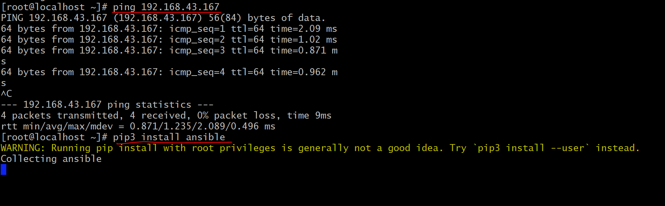

Note : its always good practice to check network connectivity to internet first adter that try to download and install any packages from internet.

We can check network connectivity by using cmd : ping google.com

The above cmd took 4-5 minute to install ansible on your system it depends on the internet speed of your network.

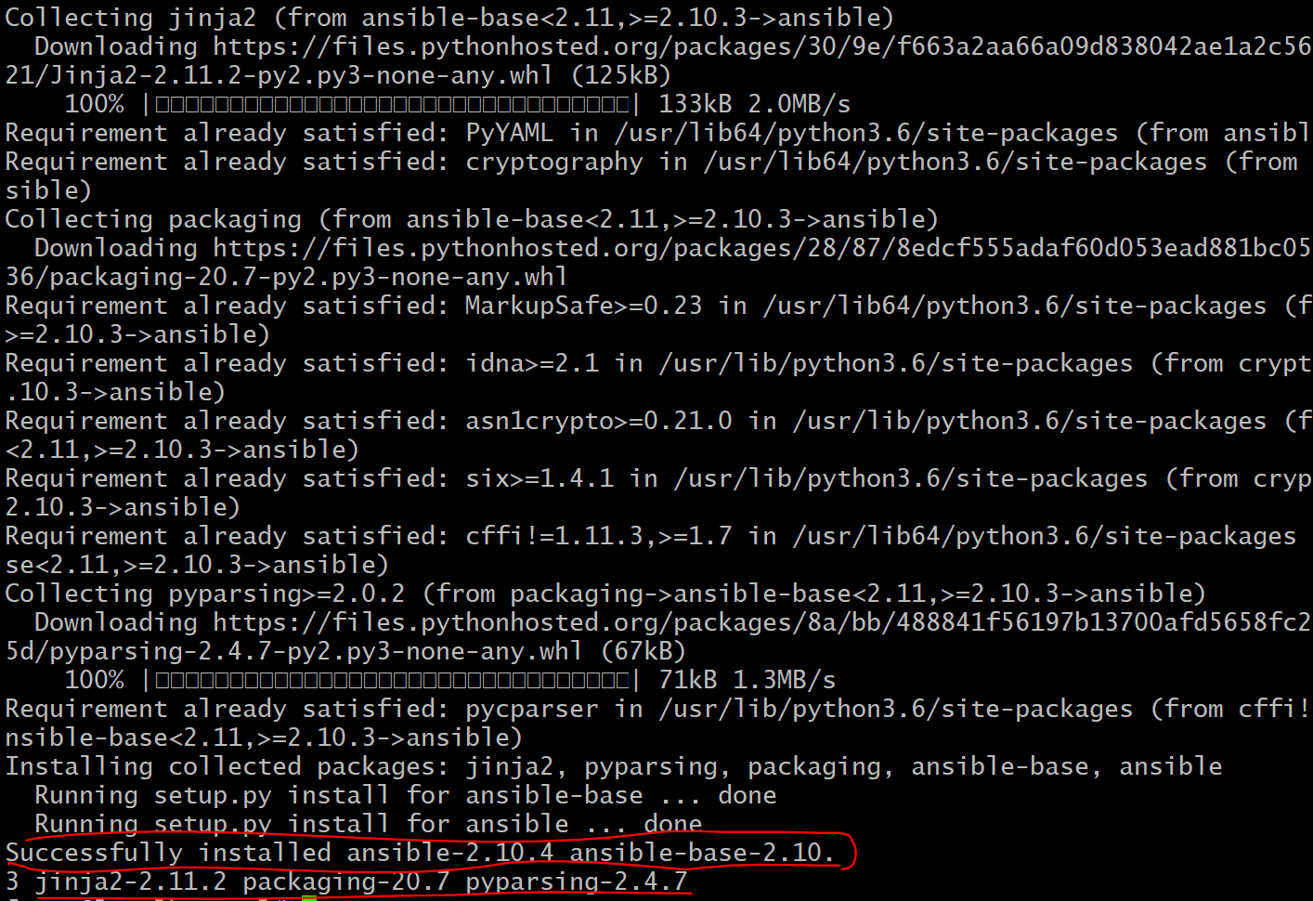

From above picture you can see the ansible software is finally installed in my os. You can check ansible is installed in your system or not by using cmd : ansible –version

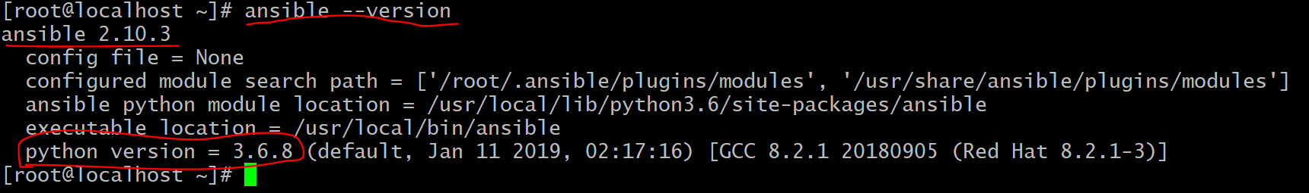

To check how many list host is there in your inventory : ansible all –list-host

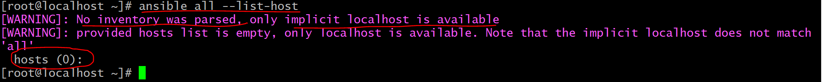

Initaially its shows the that total hosts is zero right now bcz I have not created any inventory file .

So lets first assign inventory file to ansible.

1. First create ‘ansible’ directory inside /etc/.
2. After that create ‘ansible.cfg’ file inside /etc/ansible

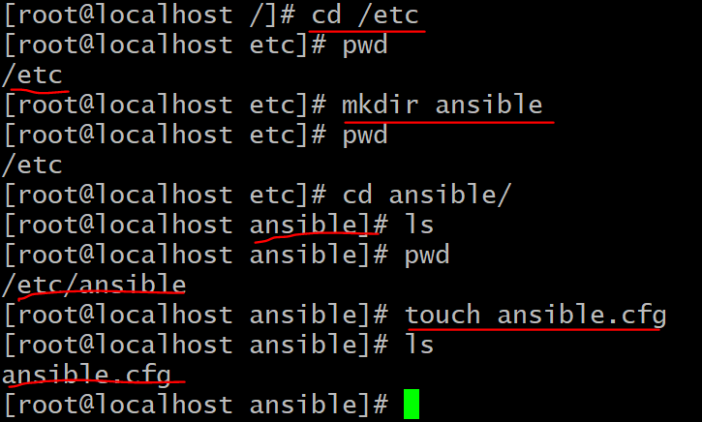

1. Create one inventory file anywhere in your os. Like as, : touch /etc/ansible/ip.txt

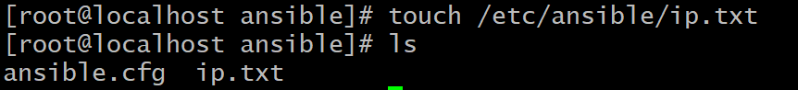

1. Now tell your ansible.cfg file that where is your inventory file ( i.e ip.txt ) is located in your os.

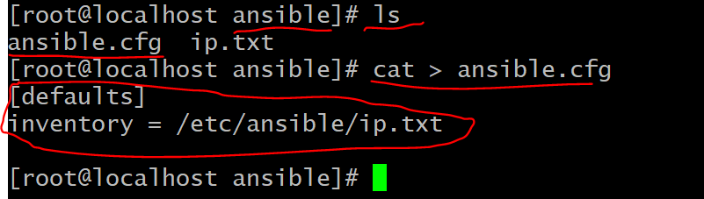

1. Now add hosts to your inventory file ( i.e ip.txt ) as,

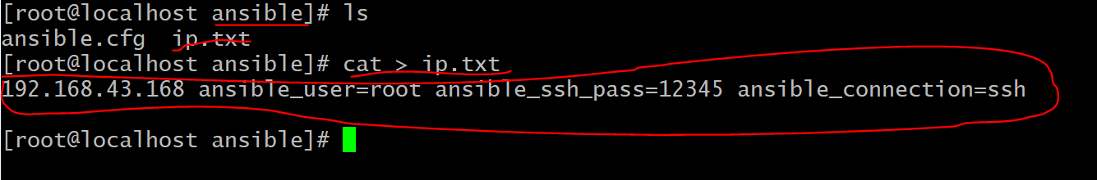

Now finelly your inventory has successfully been created. Now you can check total no. of hosts. It will show 1 rightnow bcz I have added only 1 ip to my inventory file.

Cmd : ansible all –list-host

