Planning for project

Week 2:
I start by creating a md checklist of what I need to do for the week
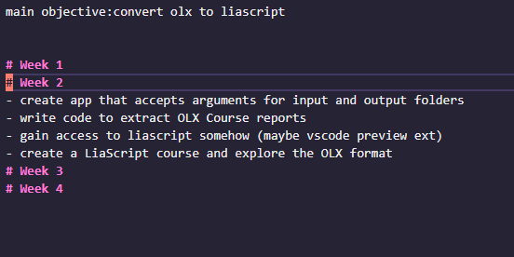
- My first objective is conquering my demons (parsing files) so Im going to learn a bit about the fast-xml-parser library and create a function to parse the xml files
- Then ill learn about the tar library and write code to extract from the folders
- look through all the files in a directory and generate an object (tree structure) of all the files

inclide package.json

Week 3/4
1. I plan on generating a tree structure for all directories, sub directories and the files within them,
and included in the branch level of this tree ill have the actual xml content parsed in the json format so the tree should look like this:

Week 5
at this point its time to think about how im going to build a liascript file with my tree structure
ideas:
- recursively walk through structure
- climb to a leaf node, until we reach the xml for a course (top level of olx structure)
  - make edits to a string/file as we traverse
  - traverse using a search algorithm and the url_name attributes of each level

OLX OBSERVATIONS:
