Add Equipment

Screen Shot:

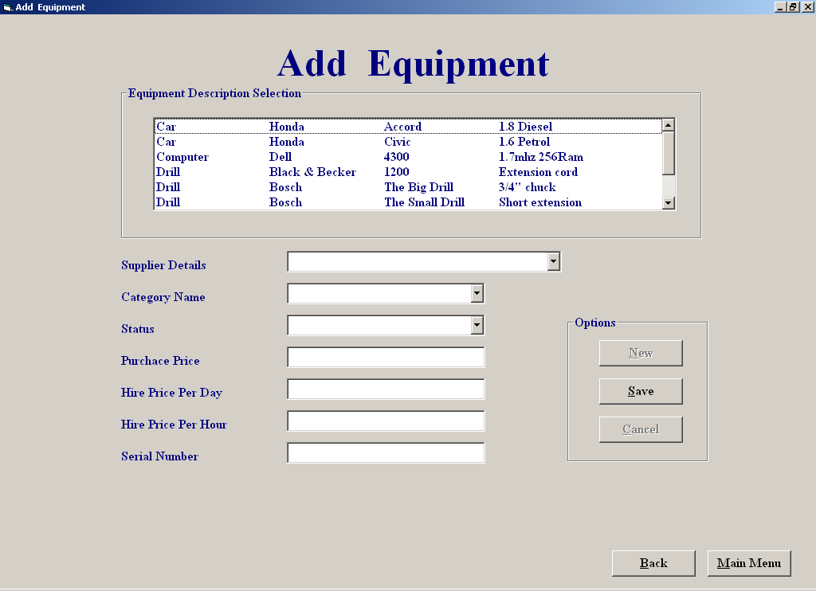

Code:

'Purpose of screen:

'the purpose of this screen is to allow the user to add in new equipment
'to the database,the user can enter in the new equipment details by selecting
'on some of the listed details such as equipment type description
'supplier of the equipment and category of the equipment, the rest of the
'details are then manually entered in, when all the details are entered
'the user has two options exit without saving the new equipment
'details to the database or he/she can save the details to the database
'and he/she can then cancel/delete the record just entered from
'the database
,the user can then add another new record to the database
'by clicking the add new button

'Author: Derek Stafford com2026
'15/03/2002

'variables used purpose
'strMake string; holds make fields from the equipment type table
'strModel, string; holds model fields from the equipment type table
'strDetails string; holds details fields from the equipment type table
'strSQL string; holds SQL query result
'strDescription string; holds description fields form the equipment type table
'curHirePDay currency; stores a tempary currency value from the hire per day textbox
'strStatus, currency; stores a tempary currency value from the status textbox
'strDescription currency; stores a tempary currency value from the descrption textbox
'intindex integer; used as a counter variable in loops etc
'intTempEquipTypeID integer; holds equipment type ID value
'intEmpSupplierID integer; holds supplier ID
'intcategoryID integer; holds category id
'intResult integer; holds result of answer from message box
'
'objects used
'
'datEquipmentType datacontrol; holds data from the equipment type table
'datEquipment datacontrol; holds data from the equipment table
'datSupplier datacontrol; holds data from the supplier table
'datCategory datacontrol; holds data from the category table

'Author: Derek Stafford com2026
'15/03/2002

Option Explicit

Dim intEquipTypeID, intCategoryID, intSupplierID As Integer

Private Sub cmbCategory_Click()
intCategoryID = cmbCategory.ItemData(cmbCategory.ListIndex)
datCategory.Recordset.FindFirst "Category_ID = " & intCategoryID & ""
End Sub
=============================================================
Private Sub cmdAddNew_Click()
cmbEquipType.Text = ""
cmbCategory.Text = ""
cmbSupplier.Text = ""
txtSerialNumber = ""
txtStatus = ""
txtPurchasePrice = ""
txtHireDay = ""
txtHireHour = ""
End Sub
============================================================
Private Sub cmdCancel_Click()

Dim intResult As Integer
intResult = MsgBox("Are you sure you want to cancel,if you click yes you will delete the new record from the database", vbYesNo, "Cancel")
If intResult = vbYes Then
With datEquipment
.Recordset.MoveLast
.Recordset.Delete
End With

End If
Cmdcancel.Enabled = False
cmdNew.Enabled = True
End Sub
=============================================================
Private Sub cmdNew_Click()

cmdSave.Enabled = True
Cmdcancel.Enabled = False
cmbSupplier = ""
cmbCategory = ""
cmbStatus = ""
txtPurchasePrice = ""
txtHireDay = ""
txtHireHour = ""
txtSerialNumber = ""
lstEquipmentType.SetFocus
End Sub
=============================================================
Private Sub cmdSave_Click()

Dim intindex As Integer
If intEquipTypeID = "" Then
Call MsgBox("An equipment description has not been selected", vbCritical, "Empty Field")
cmdSave.Enabled = True
cmbSupplier.SetFocus
Else
If cmbCategory.ListIndex = -1 Or cmbSupplier.ListIndex = -1 Or txtPurchasePrice = "" Or cmbStatus.ListIndex = -1 Or txtHireDay = "" Or txtHireHour = "" Then
Call MsgBox("All/Some Of The Equipment Details Have Not Been Filled In ", vbCritical, "Details InComplete")
cmdSave.Enabled = True
Else
datEquipment.Recordset.MoveLast
intindex = datEquipment.Recordset("Equipment_ID") + 1
With datEquipment
.Recordset.AddNew
.Recordset("Equipment_ID") = intindex
.Recordset("Type_ID") = intEquipTypeID
.Recordset("Supplier_ID") = intSupplierID
.Recordset("S/N") = Val(txtSerialNumber.Text)
.Recordset("Status") = cmbStatus.Text
.Recordset("[Purchase Price]") = CCur(Val(txtPurchasePrice.Text))
.Recordset("[Hire Price Per Day]") = CCur(Val(txtHireDay.Text))
.Recordset("[Hire Price Per Hour]") = CCur(Val(txtHireHour))
.Recordset.Update

End With
cmdSave.Enabled = False
Cmdcancel.Enabled = True
cmdNew.Enabled = True

End If
End If
End Sub
=============================================================
Private Sub cmbStatus_DropDown()
cmbStatus.Clear
cmbStatus.AddItem ("Available")
cmbStatus.AddItem ("Broke")
cmbStatus.AddItem ("Out")
End Sub
=============================================================
Private Sub cmbcategory_DropDown()
'Fills the supplier combo box
While Not datCategory.Recordset.EOF
cmbCategory.AddItem (datCategory.Recordset("Category Name"))
cmbCategory.ItemData(cmbCategory.NewIndex) = datCategory.Recordset("Category_ID")
datCategory.Recordset.MoveNext
Wend
End Sub
=============================================================
Private Sub cmbSupplier_DropDown()
cmbSupplier.Clear
datSupplier.Recordset.MoveFirst
While Not datSupplier.Recordset.EOF
cmbSupplier.AddItem datSupplier.Recordset("Supplier Name") + ", " + datSupplier.Recordset("Address 1") + ", " + datSupplier.Recordset("Address 2")
cmbSupplier.ItemData(cmbSupplier.NewIndex) = datSupplier.Recordset("Supplier_ID")
datSupplier.Recordset.MoveNext
Wend
End Sub
=============================================================

'Stores the selected supplier id number
Private Sub cmbSupplier_Click()
intSupplierID = cmbSupplier.ItemData(cmbSupplier.ListIndex)
End Sub
=============================================================
Private Sub cmdMainMenu_Click()
frmMainMenu.Show
Unload Me
End Sub
=============================================================
'Loads Equipmentfileprocessing screen and unloads the amend/view equipment screen

Private Sub cmdBack_Click()
frmEquipmentFileProcessing.Show
Unload Me
End Sub
=============================================================
'Fills the two listboxes and sets up screen layout

Private Sub Form_Activate()
Dim srtDescription, strMake, strModel, strDetails As String, intindex As Integer
cmdNew.Enabled = False
lstEquipmentType.SetFocus
cmdSave.Enabled = True

datEquipmentType.Recordset.MoveFirst
While Not datEquipmentType.Recordset.EOF
With datEquipmentType
srtDescription = .Recordset("Description")
strMake = .Recordset("Make")
strModel = .Recordset("Model")
strDetails = .Recordset("Details")
For intindex = Len(.Recordset("Description")) To 20
srtDescription = srtDescription + " "
Next intindex
For intindex = Len(.Recordset("Make")) To 20
strMake = strMake + " "
Next intindex
For intindex = Len(.Recordset("Model")) To 20
strModel = strModel + " "
Next intindex
For intindex = Len(.Recordset("Details")) To 20
strDetails = strDetails + " "
Next intindex

lstEquipmentType.AddItem (srtDescription + vbTab + strMake + vbTab + strModel + vbTab + strDetails)
lstEquipmentType.ItemData(lstEquipmentType.NewIndex) = .Recordset("Type_ID")
.Recordset.MoveNext
End With
Wend
End Sub
=============================================================
Private Sub Form_Load()
Cmdcancel.Enabled = False
cmdAMend.Enabled = False

cmdSave.Enabled = False
datEquipmentType.DatabaseName = "c:/EHS.mdb"
datEquipmentType.RecordSource = "Equipment Type"
datEquipment.DatabaseName = "c:/EHS.mdb"
datEquipment.RecordSource = "Equipment"
datCategory.DatabaseName = "c:/EHS.mdb"
datCategory.RecordSource = "Category"
datSupplier.DatabaseName = "c:/EHS.mdb"
datSupplier.RecordSource = "Supplier"

End Sub
=============================================================
Private Sub lstEquipmentType_Click()
Dim strmySQl As String

intEquipTypeID = lstEquipmentType.ItemData(lstEquipmentType.ListIndex)
End Sub
=============================================================
'Checks that serial number entered is valid
Private Sub txtSerialNumber_Validate(Cancel As Boolean)
If IsNumeric(txtSerialNumber.Text) Then
Cancel = False
Else
Call MsgBox("Sorry invalid data", vbOKOnly, "Warning")
txtSerialNumber.SetFocus
Cancel = True
End If
End Sub
=============================================================
Private Sub txtPurchasePrice_Validate(Cancel As Boolean)
If IsNumeric(txtPurchasePrice.Text) Then
Cancel = False
Else
Call MsgBox("Sorry invalid data", vbOKOnly, "Warning")
txtHireDay.SetFocus
Cancel = True
End If
End Sub
=============================================================
'Checks that hire day number entered is valid
Private Sub txtHireDay_Validate(Cancel As Boolean)

If IsNumeric(txtHireDay.Text) Then
Cancel = False
Else
Call MsgBox("Sorry invalid data", vbOKOnly, "Warning")
txtHireDay.SetFocus
Cancel = True
End If
End Sub
=============================================================
'Checks that hire hour number entered is valid
Private Sub txtHireHour_Validate(Cancel As Boolean)
If IsNumeric(txtHireHour.Text) Then
Cancel = False
Else
Call MsgBox("Sorry invalid data", vbOKOnly, "Warning")
txtHireHour.SetFocus
Cancel = True
End If
End Sub
=============================================================

Amend/View Equipment

Screen Shot:

Code:

'Purpose of screen:

'the purpose of this screen is to allow the user to to select an item of
'equipment either by entering the equipment id number or by browsing threw
'equipment details until the item is found ,when the item is found the user
'can 'make changes to the equipment details by clicking on the amend button
'to which allows the user to to select the listed details any manually enter
'the rest,when the changes have been made the user has two options,either
'save or cancel the changes made to the equipment details,if the details
'are saved the relevant tables are updated ie the equipment type table and
'the equipment.
'
'
'Author: Derek Stafford com2026
'15/03/2002

'Variables Used Purpose of string

'strSerialNumb string stores a tempary string value from the serial number textbox
'strStatus, string stores a tempary string value from the status textbox
'strDescription string stores a tempary string value from the descrption textbox
'strmySQL string stores the SQL queries
'curHirePDay currency stores a tempary currency value from the hire per day textbox
'strStatus, currency stores a tempary currency value from the status textbox
'strDescription currency stores a tempary currency value from the descrption textbox
'intindex integer used as a counter variable in loops etc
'intTempEquipTypeID integer stores a tempary equipment type ID value
'intEmpSupplierID integer stores supplier ID

'objects used

'datEquipmentType datacontrol Retrieves info from equipmentType table
'datEquipment datacontrol retrieves info from equipment table
'datSupplier datacontrol retrieves info from supplier table
'datSupplier datacontrol retrieves info from category table
'datCategory

Option Explicit

Dim strSerialNumb, strStatus, strDescription As String
Dim curHirePDay, curHirePHour, curPurchPrice As Currency
Dim intTempEquipTypeID, intTempSupplierID, intTempEquipmentID As Integer
Dim intEquipTypeID, intEquipTypeID2, intSupplierID, intEquipmentID As Integer

'Empties textboxes on the screen

Private Sub Cleartextboxes()
cmbSupplier = ""
txtSerialNumber = ""
cmbStatus = ""
txtPurchasePrice = ""
txtHireDay = ""
txtHireHour = ""
txtDescription = ""
End Sub
=============================================================
'Fills combo box with serial numbers of the equipment type

Private Sub cmbSerialNumb_click()
Dim strmySQl As String
lstEquipmentType2.Enabled = False
cmdAMend.Enabled = True
cmbSerialNumb.Enabled = False
strSerialNumb = cmbSerialNumb.ItemData(cmbSerialNumb.ListIndex)
If intEquipTypeID = "" Then
Call MsgBox("you have not selected an item", vbCritical, "Equipment Not Selected")

Else
cmdAMend.Enabled = True
strmySQl = "SELECT Equipment.* From Equipment WHERE (((Equipment.Type_ID)=" & intEquipTypeID & ") AND ((Equipment.[S/N])='" & strSerialNumb & "'));"
datEquipment.RecordSource = strmySQl
datEquipment.Refresh
intEquipmentID = datEquipment.Recordset("Equipment_ID")
display
End If
End Sub
=============================================================
'Puts data into combobox

Private Sub cmbStatus_DropDown()
cmbStatus.Clear
cmbStatus.AddItem ("Available")
cmbStatus.AddItem ("Broke")
cmbStatus.AddItem ("Out")
End Sub
=============================================================
'Fills the supplier combo box
Private Sub cmbSupplier_DropDown()
cmbSupplier.Clear
datSupplier.Recordset.MoveFirst
While Not datSupplier.Recordset.EOF
cmbSupplier.AddItem (datSupplier.Recordset("Supplier Name")) + ", " + (datSupplier.Recordset("Address 1")) + ", " + (datSupplier.Recordset("Address 2"))
cmbSupplier.ItemData(cmbSupplier.NewIndex) = datSupplier.Recordset("Supplier_ID")
datSupplier.Recordset.MoveNext
Wend
End Sub
=============================================================
'Stores the selected supplier id number

Private Sub cmbSupplier_Click()
intSupplierID = cmbSupplier.ItemData(cmbSupplier.ListIndex)
End Sub

'Stores the textbox data into variables for retieval if changes are cancelled
'and also resets screen layout

Private Sub cmdAMend_Click()
cmdAMend.Enabled = False
lstEquipmentType.Enabled = False
lstEquipmentType.Visible = False
lstEquipmentType.Visible = False
lstEquipmentType2.Visible = True
lstEquipmentType2.Enabled = False
lstEquipmentType2.Enabled = True
cmbSupplier.Enabled = True
cmbSupplier.SetFocus
txtSerialNumber.Enabled = True
txtSerialNumber.SetFocus
cmbStatus.Enabled = True
txtPurchasePrice.Enabled = True
txtHireDay.Enabled = True
txtHireHour.Enabled = True
cmdSave.Enabled = True
Cmdcancel.Enabled = True

intTempEquipmentID = datEquipment.Recordset("Equipment_ID")
If intEquipTypeID2 = "" Then
intTempEquipTypeID = intEquipmentID
Else
intTempEquipTypeID = intEquipTypeID2
End If
intTempEquipTypeID = datEquipment.Recordset("Type_ID")
intTempSupplierID = intSupplierID
strSerialNumb = txtSerialNumber
strStatus = cmbStatus.Text
curPurchPrice = txtPurchasePrice
curHirePDay = txtHireDay
curHirePHour = txtHireHour
strDescription = txtDescription
End Sub
=============================================================
'Puts back the orignal data back into textboxes before changes were made

Private Sub cmdCancel_Click()
cmdAMend.Enabled = True
intSupplierID = datEquipment.Recordset("Supplier_ID")
datSupplier.Recordset.FindFirst "Supplier_ID =" & intTempSupplierID & ""
cmbSupplier.Text = datSupplier.Recordset("Supplier Name")

txtSerialNumber = strSerialNumb
cmbStatus = strStatus
txtPurchasePrice = curPurchPrice
txtHireDay = curHirePDay
txtHireHour = curHirePHour
lstEquipmentType.Visible = True
lstEquipmentType.Enabled = True
txtDescription = strDescription
Disabletextboxes
End Sub
=============================================================
'Check for valid number

Function IsValid(StrEQID As Variant) As Boolean
Dim intindex As Integer, temp As Variant, blnValid As Boolean
blnValid = False
For intindex = 1 To Len(StrEQID)
temp = Mid(StrEQID, intindex, 1)
If (temp > 0 And temp < 9) Then
blnValid = True
Else
intindex = Len(StrEQID)
blnValid = False

End If
Next
IsValid = blnValid
End Function
=============================================================
'Check if equipment id entered is valid and if so it finds the info to be diplayed
'if not a an error message is displayed

Private Sub cmdDisplay_Click()
If IsValid(txtEquipmentID.Text) = False Then
Call MsgBox("You have entered invalid data or no data ,you must enter a number", vbCritical, "Invalid Data Entry")
txtEquipmentID = ""
txtEquipmentID.SetFocus
Else
If txtEquipmentID > 9999 Then
Call MsgBox("The highest entry is 9999", vbCritical, "Entry Exceeds Limit")
txtEquipmentID.Text = ""
txtEquipmentID.SetFocus
Else
intEquipmentID = txtEquipmentID
cmdAMend.Enabled = True
datEquipment.RecordSource = "Equipment"
datEquipment.Refresh
datEquipment.Recordset.FindFirst "Equipment_ID=" & intEquipmentID & ""
If datEquipment.Recordset.NoMatch Then
Call MsgBox("This ID is not listed ", vbInformation, "Not Listed")
txtEquipmentID.Text = ""
txtEquipmentID.SetFocus
Else
intEquipTypeID = datEquipment.Recordset("Type_ID")
cmdAMend.Enabled = True
lstEquipmentType.Visible = False
lstEquipmentType2.Visible = True
lstEquipmentType.Enabled = False
lstEquipmentType2.Enabled = False
display
End If
End If
End If
End Sub
=============================================================
'Checks if valid info was entered and if so searches for the the correct
'record in the equipment table record to save the amended info to

Private Sub cmdSave_Click()
cmdAMend.Enabled = True
Dim intindex As Integer, blnInvalid As Boolean

If IsValid(txtSerialNumber) = False Then
Call MsgBox("You have entered invalid serial number ,you must enter a number", vbCritical, "Invalid Data Entry")
txtSerialNumber = ""
txtSerialNumber.SetFocus
Else
Disabletextboxes
datEquipmentType.RecordSource = "Equipment Type"
datEquipmentType.Refresh
blnInvalid = False
If ((cmbStatus.Text = "Broke") Or (cmbStatus.Text = "Out") Or (cmbStatus.Text = "Available")) = False Then
blnInvalid = True
Else
blnInvalid = False
End If
If txtSerialNumber = "" Or txtPurchasePrice = "" Or txtHireDay = "" Or txtHireHour = "" Or (blnInvalid = True) Then
Call MsgBox("All The Equipment Details Have Not Been Filled In Or The Status Entry Has Been Written in Not Selected", vbCritical, "Details InComplete")
cmdAMend.Enabled = True
Else
datEquipment.Recordset.MoveFirst
datEquipment.Recordset.FindFirst "Equipment_ID=" & intEquipmentID & ""
intTempEquipmentID = intEquipmentID
With datEquipment
.Recordset.Edit
If intEquipTypeID2 = "" Then
.Recordset("Type_ID") = intEquipTypeID
datEquipmentType.Recordset.FindFirst "Type_ID = " & intEquipTypeID & ""
txtDescription = datEquipmentType.Recordset("Make") + " " + datEquipmentType.Recordset("Model") & _
" " + datEquipmentType.Recordset("Description") + " " + datEquipmentType.Recordset("Details")
Else
.Recordset("Type_ID") = intEquipTypeID2
datEquipmentType.Recordset.FindFirst "Type_ID = " & intEquipTypeID2 & ""
txtDescription = datEquipmentType.Recordset("Make") + " " + datEquipmentType.Recordset("Model") & _
" " + datEquipmentType.Recordset("Description") + " " + datEquipmentType.Recordset("Details")
End If

.Recordset("Supplier_ID") = intSupplierID
.Recordset("S/N") = Val(txtSerialNumber.Text)
.Recordset("Status") = cmbStatus
.Recordset("[Purchase Price]") = CCur(Val(txtPurchasePrice.Text))
.Recordset("[Hire Price Per Day]") = CCur(Val(txtHireDay.Text))
.Recordset("[Hire Price Per Hour]") = CCur(Val(txtHireHour))
.Recordset.Update

End With
optEquipmentType.Value = False
optEquipmentID.Value = False
lstEquipmentType.Enabled = False
lstEquipmentType2.Enabled = False
End If
End If
End Sub
=============================================================
'Disables textboxes and combo boxes on the screen

Private Sub Disabletextboxes()
txtSerialNumber.Enabled = False
cmbSupplier.Enabled = False
cmbStatus.Enabled = False
txtPurchasePrice.Enabled = False
txtHireDay.Enabled = False
txtHireHour.Enabled = False
cmdSave.Enabled = False
Cmdcancel.Enabled = False
End Sub

'Loads main menu screen and unloads the amend/view equipment screen

Private Sub cmdMainMenu_Click()
frmMainMenu.Show
Unload Me
End Sub
=============================================================
'Loads Equipmentfileprocessing screen and unloads the amend/view equipment screen

Private Sub cmdBack_Click()
frmEquipmentFileProcessing.Show
Unload Me
End Sub

'Fills the two listboxes and sets up screen layout

Private Sub Form_Activate()
Dim srtDescription, strMake, strModel, strDetails As String, intindex As Integer
txtEquipmentID.Visible = True
cmdDisplay.Visible = False
cmbSerialNumb.Visible = False
optEquipmentType.SetFocus
lblSerialNo.Visible = False
lblEqID.Visible = False

cmbSerialNumb.Visible = False
lstEquipmentType.Visible = True
lstEquipmentType2.Visible = False
lstEquipmentType.Enabled = False
txtEquipmentID.Enabled = False
Disabletextboxes
cmdDisplay.Enabled = False
lblSerialNo.Visible = False
lstEquipmentType.Clear
lstEquipmentType2.Clear
datEquipmentType.Recordset.MoveFirst

‘Sets layout and fills two list boxes

While Not datEquipmentType.Recordset.EOF
With datEquipmentType
srtDescription = .Recordset("Description")
strMake = .Recordset("Make")
strModel = .Recordset("Model")
strDetails = .Recordset("Details")
For intindex = Len(.Recordset("Description")) To 20
srtDescription = srtDescription + " "
Next intindex
For intindex = Len(.Recordset("Make")) To 20
strMake = strMake + " "
Next intindex
For intindex = Len(.Recordset("Model")) To 20
strModel = strModel + " "
Next intindex
For intindex = Len(.Recordset("Details")) To 20
strDetails = strDetails + " "
Next intindex

lstEquipmentType.AddItem (srtDescription + vbTab + strMake + vbTab + strModel + vbTab + strDetails)
lstEquipmentType.ItemData(lstEquipmentType.NewIndex) = .Recordset("Type_ID")
lstEquipmentType2.AddItem (srtDescription + vbTab + strMake + vbTab + strModel + vbTab + strDetails)
lstEquipmentType2.ItemData(lstEquipmentType2.NewIndex) = .Recordset("Type_ID")
.Recordset.MoveNext
End With
Wend
End Sub
=============================================================
'Displays the selected item details to the screen

Private Sub display()
intSupplierID = datEquipment.Recordset("Supplier_ID")
datEquipmentType.RecordSource = "Equipment Type"
datEquipmentType.Refresh
datEquipmentType.Recordset.FindFirst "Type_ID = " & intEquipTypeID & ""
txtDescription = datEquipmentType.Recordset("Make") + " " + datEquipmentType.Recordset("Model") & _
" " + datEquipmentType.Recordset("Description") + " " + datEquipmentType.Recordset("Details")

txtSerialNumber = datEquipment.Recordset("S/N")
cmbStatus = datEquipment.Recordset("Status")
txtPurchasePrice = datEquipment.Recordset("Purchase Price")
txtHireDay = datEquipment.Recordset("Hire Price Per Day")
txtHireHour = datEquipment.Recordset("Hire Price Per Hour")
datEquipmentType.RecordSource = "Equipment Type"
datEquipmentType.Refresh

datSupplier.Recordset.MoveFirst
datSupplier.Recordset.FindFirst "Supplier_ID =" & intSupplierID & ""
cmbSupplier.Text = datSupplier.Recordset("Supplier Name") + ", " + datSupplier.Recordset("Address 1") + ", " + datSupplier.Recordset("Address 2")

End Sub
============================================================
'Assigns the record sources to the datacontrols,from the selected database

Private Sub Form_Load()
Cmdcancel.Enabled = False
cmdAMend.Enabled = False

cmdSave.Enabled = False
datEquipmentType.DatabaseName = "c:/EHS.mdb"
datEquipmentType.RecordSource = "Equipment Type"
datEquipment.DatabaseName = "c:/EHS.mdb"
datEquipment.RecordSource = "Equipment"
datCategory.DatabaseName = "c:/EHS.mdb"
datCategory.RecordSource = "Category"
datSupplier.DatabaseName = "c:/EHS.mdb"
datSupplier.RecordSource = "Supplier"

End Sub
=============================================================
'Takes in the selected equipment type details and gives out the and fills a combo box
'of all the serial numbers stored on that equipment type

Private Sub lstEquipmentType_Click()
Dim strmySQl As String

optEquipmentType.Value = False
cmbSerialNumb.Visible = True
cmbSerialNumb.Enabled = True
cmbSerialNumb.Visible = True
lblSerialNo.Visible = True

cmbSerialNumb.SetFocus
lblSerialNo.Visible = True
lstEquipmentType.Enabled = False
cmbSerialNumb.Enabled = True

intEquipTypeID = lstEquipmentType.ItemData(lstEquipmentType.ListIndex)
strmySQl = "SELECT Equipment.Type_ID, [Equipment Type].Type_ID, [Equipment Type].Model, Equipment.[S/N]" & _
"FROM [Equipment Type] INNER JOIN Equipment ON [Equipment Type].Type_ID = Equipment.Type_ID " & _
"WHERE ((([Equipment Type].Type_ID)=" & intEquipTypeID & "));"
datEquipmentType.RecordSource = strmySQl

datEquipmentType.Refresh
cmbSerialNumb.Clear
If datEquipmentType.Recordset.EOF Then
Call MsgBox("There is no Items matching this Description stored", vbCritical, "No Match")
lstEquipmentType.Enabled = True
Else
cmbSerialNumb.Clear
While Not datEquipmentType.Recordset.EOF
cmbSerialNumb.AddItem (datEquipmentType.Recordset("S/N"))
cmbSerialNumb.ItemData(cmbSerialNumb.NewIndex) = datEquipmentType.Recordset("S/N")
datEquipmentType.Recordset.MoveNext
Wend
End If
End Sub
=============================================================
'Holds the new equipment type id that has been selected by the user

Private Sub lstEquipmentType2_Click()
intEquipTypeID2 = lstEquipmentType.ItemData(lstEquipmentType2.ListIndex)
End Sub
=============================================================
'Sets up the screen layout for the enter equipment id option

Private Sub optEquipmentID_Click()
txtEquipmentID.Visible = True
cmdDisplay.Visible = True
cmbSerialNumb.Visible = False

Cleartextboxes
cmdAMend.Enabled = False
txtEquipmentID.Enabled = True
txtEquipmentID.Text = ""
cmdSave.Enabled = False
txtEquipmentID.Enabled = True
Cmdcancel.Enabled = False
intEquipTypeID = ""
intEquipTypeID2 = ""
Disabletextboxes
cmbSerialNumb.Visible = False
lblSerialNo.Visible = False
lblEqID.Visible = True
cmdDisplay.Enabled = True
txtEquipmentID.Enabled = True
txtEquipmentID.SetFocus
End Sub
=============================================================
'Sets up the screen layout for the enter equipment browse option

Private Sub optEquipmentType_Click()
cmdAMend.Enabled = False

txtEquipmentID.Visible = False
cmdDisplay.Visible = False

'lblSerialNo.Visible = True
txtEquipmentID.Enabled = False
txtEquipmentID.Text = ""
Cleartextboxes
intEquipTypeID = ""
intEquipTypeID2 = ""
Disabletextboxes
cmdSave.Enabled = False
Cmdcancel.Enabled = False
lblEqID.Visible = False
lstEquipmentType.Visible = True
lstEquipmentType2.Visible = False
lstEquipmentType.Enabled = True
lstEquipmentType2.Enabled = False
End Sub

'Checks that serial number is valid

Private Sub txtSerialNumber_Validate(Cancel As Boolean)
If IsNumeric(txtSerialNumber.Text) Then
Cancel = False
Else
Call MsgBox("Sorry invalid data", vbOKOnly, "Warning")
txtSerialNumber.SetFocus
Cancel = True
End If
End Sub
=============================================================

'Checks that serial number entered is valid

Private Sub txtPurchasePrice_Validate(Cancel As Boolean)
If IsNumeric(txtPurchasePrice.Text) Then
Cancel = False
Else
Call MsgBox("Sorry invalid data", vbOKOnly, "Warning")
txtHireDay.SetFocus
Cancel = True
End If
End Sub
=============================================================
'Checks that hire day number entered is valid

Private Sub txtHireDay_Validate(Cancel As Boolean)
If IsNumeric(txtHireDay.Text) Then
Cancel = False
Else
Call MsgBox("Sorry invalid data", vbOKOnly, "Warning")
txtHireDay.SetFocus
Cancel = True
End If
End Sub
=============================================================
'Checks that hire hour number entered is valid

Private Sub txtHireHour_Validate(Cancel As Boolean)
If IsNumeric(txtHireHour.Text) Then
Cancel = False
Else
Call MsgBox("Sorry invalid data", vbOKOnly, "Warning")
txtHireHour.SetFocus
Cancel = True
End If
End Sub
=============================================================

Delete Customer:

Screen Shot:

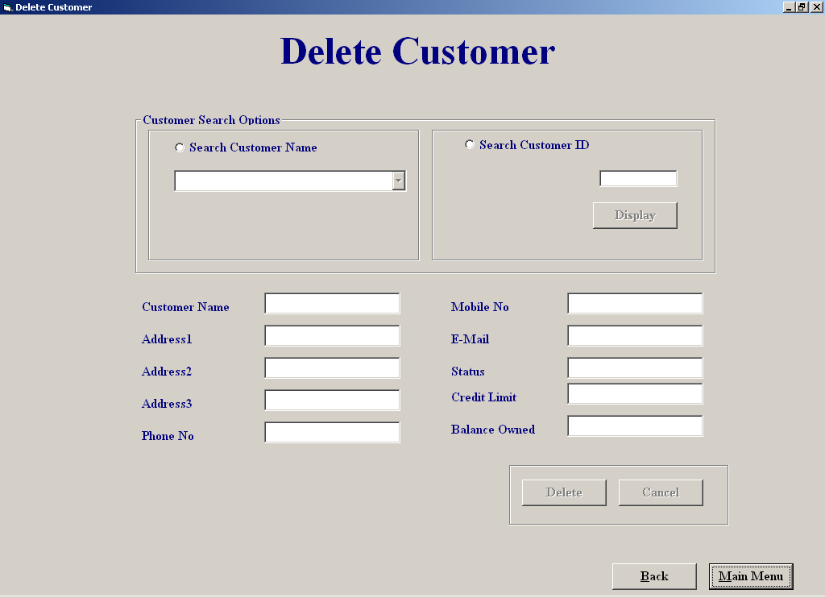

Code:

'Purpose of screen:

'This screen allows the user to delete an existing customer from the database
'the user can select the customer from a list or enter in the customer id number,
'when a customer is selected the rest of the customer details are displayed
'on the screen,the user can delete the cutomer from the screen by clicking the
'"Delete" button or they can cancel'the deletion or return to the main menu without
'deleting,if the user presses the "cancel" button all the deletios are undeleted

'Author Derek Stafford
'Date 015/03/2002

'varibales used Purpose
'intMaxoption integer; sores a count for exception deletion
'intCustID integer; store customer id number
'intCounter integer; stores counter in for loop for entrycode to exception deletion
'intResult integer; stores result of an answer
'strmySQl string; store sql string
'strTempName string; stores name of customer
'strTempAdd1 string; stores address1 of customer
'strTempAdd2 string; stores address2 of customer
'Delete boolean; stores true/false value
'Enterycode const; stores the exception entry code
'ainCustID Array of Integers hold all deleted customer ids

'Objects used

'datCustomer; Datacontrol retrieves data from customer table
'datRentalReturn; Datacontrol retrieves data from rental/return table

Option Explicit
Dim intCustID, intindex, aintCustIDs(1 To 30) As Integer
Private Sub cmdCancel_Click()
'find the last record entered into the cutomer table and deletes it
Dim intAmount, intResult, intDelCust As Integer

datCustomer.RecordSource = "Customer"
datCustomer.Refresh
intResult = MsgBox("Are you sure you want to undelete the " & intindex - 1 & " customer(s) you deleted ", vbYesNo, "System response")
If intResult = vbYes Then
For intAmount = 1 To intindex
intDelCust = aintCustIDs(intAmount)
datCustomer.Recordset.FindFirst "Cust_ID = " & intDelCust & ""
datCustomer.Recordset.Edit
datCustomer.Recordset("Deletion") = "False"
datCustomer.Recordset.Update
datCustomer.Recordset.MoveNext
Next intAmount
intindex = 1
Cmdcancel.Enabled = False
End If
End Sub
=============================================================
Private Sub cmdDisplay_Click()
'Searchs for the a customer based on the customer id entered, if found it calls display procedure 'if not found it returns an error
Dim strmySQl, Result As String

intCustID = Val(txtCustNumber)

strmySQl = "SELECT Customer.Cust_ID, Customer.Name,Customer.[Address 1], Customer.[Address 2], Customer.Deletion " & _
"From Customer " & _
"WHERE (((Customer.Deletion)=False));"
datCustomer.RecordSource = strmySQl
datCustomer.Refresh
datCustomer.Recordset.FindFirst "Cust_ID = " & intCustID & ""
If datCustomer.Recordset.NoMatch Then
Call MsgBox("This customer migth not be listed or is already deleted", vbInformation, "Not Found")
Else
display
Cmdcancel.Enabled = True
End If
End Sub
=============================================================
Private Sub cmdMainMenu_Click()
Unload Me
frmMainMenu.Show
End Sub
============================================================
Private Sub txtCustNumber_change()
cmdDisplay.Enabled = True
End Sub
=============================================================
Private Sub txtCustNumber_Validate(Cancel As Boolean)
'Checks for valid id was entered
If IsNumeric(txtCustNumber.Text) Then
Cancel = False
Else
Call MsgBox("Sorry invalid data", vbOKOnly, "Warning")
txtCustNumber.SetFocus
Cancel = True
End If
End Sub
=============================================================
Private Sub optCustName_Click()
'Resets screen layout
lblID.Visible = False
cmdDisplay.Enabled = False
txtCustNumber = ""
cmbCustomer.Enabled = True
txtCustNumber.Enabled = False
Clear
End Sub
=============================================================
Private Sub Clear()
'Empties all textboxes
txtCustomerName = ""
txtAddress1 = ""
txtAddress2 = ""
txtAddress3 = ""
txtPhoneNo = ""
txtMobileNo = ""
txtEmail = ""
txtStatus = ""
txtCreditLimit = ""
txtBalanceowned = ""
End Sub
Private Sub optCustID_Click()
'Resets screen

txtCustNumber = ""
lblID.Visible = True
cmbCustomer.Enabled = False
txtCustNumber.Enabled = True
txtCustNumber.SetFocus
cmbCustomer.Text = ""
Clear
End Sub
=============================================================
Private Sub cmbCustomer_Click()
'Stores the cutomer id selected

intCustID = cmbCustomer.ItemData(cmbCustomer.ListIndex)
datCustomer.Recordset.FindFirst "Cust_ID = " & intCustID & ""
cmdDelCust.Enabled = True
display
End Sub
=============================================================
Private Sub cmbCustomer_DropDown()
'Fills the customer combo box based on result of SQL
Dim strmySQl As String
strmySQl = "SELECT Customer.Cust_ID, Customer.Name,Customer.[Address 1], Customer.[Address 2], Customer.Deletion " & _
"From Customer " & _
"WHERE (((Customer.Deletion)=False));"
cmbCustomer.Clear
datCustomer.RecordSource = strmySQl
datCustomer.Refresh
While Not datCustomer.Recordset.EOF
cmbCustomer.AddItem (datCustomer.Recordset("Name")) + ", " + (datCustomer.Recordset("Address 1")) + ", " + (datCustomer.Recordset("Address 2"))
cmbCustomer.ItemData(cmbCustomer.NewIndex) = datCustomer.Recordset("Cust_ID")
datCustomer.Recordset.MoveNext
Wend
End Sub
=============================================================
Private Sub cmdDelCust_Click()
'Search for the selected customer record and finds out if that customer can be
'deleted or not based on having equipment still on hire or having an outstanding
'balance

Dim ccurID As Currency, intReturnValue As Integer, BalanceOwed As Currency
Dim strmySQl, strTempCustName, strTempAdd1, strTempAdd2 As String, Delete As Boolean
Delete = False

strmySQl = "SELECT Customer.Cust_ID, Customer.Name, Customer.[Address 1],Customer.[Address 2], [Rental/Return].[Date/Time returned],Customer.[Balance owed], [Rental/Return].Equipment_ID, Customer.Deletion " & _
"From Customer, [Rental/Return]" & _
"WHERE (((Customer.Cust_ID)= " & intCustID & "));"

datCustomer.RecordSource = strmySQl
datCustomer.Refresh
datCustomer.Recordset.MoveFirst
datCustomer.Recordset.FindFirst "Cust_ID = " & intCustID & ""

'Checks if customer has an outstanding balance or still has equipment on hire
If datCustomer.Recordset("Balance Owed") > 0 Or datCustomer.Recordset("Date/Time returned") = "" Then
strTempCustName = datCustomer.Recordset("Name")
strTempAdd1 = datCustomer.Recordset("Address 1")
strTempAdd2 = datCustomer.Recordset("Address 2")
If datCustomer.Recordset("Deletion") = True Then
Call MsgBox(strTempCustName & " From " & strTempAdd1 & ", " & strTempAdd2 & " Has Already Been Deleted ", vbInformation, "Information")
Else
Call MsgBox(strTempCustName & " From " & strTempAdd1 & ", " & strTempAdd2 & " Cannot Be Deleted As He/She Still Has An Equipment On Hire OR Has An OutStanding Balance ", vbInformation, "Information")
intReturnValue = MsgBox("If You Wish To Delete " & strTempCustName & " From " & strTempAdd1 & ", " & strTempAdd2 & " Anyway Press Yes ", vbYesNo, "Exception Deletion")
If intReturnValue = vbYes Then
ExceptionDeletion
Cmdcancel.Enabled = True
End If
End If
Else
While Not datCustomer.Recordset.EOF
datCustomer.Recordset.FindNext "Cust_ID = " & intCustID & ""
If datCustomer.Recordset("Date/Time returned") = "" Then
If datCustomer.Recordset("Deletion") = False Then
Delete = True
End If
End If
datCustomer.Recordset.MoveNext
Wend
If Delete Then
Call MsgBox(strTempCustName & " From " & strTempAdd1 & "," & strTempAdd2 & " Has Already Been Deleted", vbInformation, "Information")
Else
Cmdcancel.Enabled = True
Deletion
End If
End If
End Sub
=============================================================
Private Sub ExceptionDeletion()
'Allows the user to make exception deletions
Dim intCounter, intMaxoption, intResult As Integer
Const intEntrycode As Integer = 1111, intMax As Integer = 3
For intCounter = 1 To intMax
If intEntrycode = Val(InputBox("Please Enter Security Code", "Security")) Then
intCounter = intMax
Deletion
Else
Call MsgBox("Incorrect Code! You Have " & intMax - intCounter & " Changes Left", vbCritical, "System Response")
intMaxoption = intMax - intCounter
If intMaxoption > 0 Then
intResult = MsgBox("Do You Want To Try Again ", vbYesNo, "System Response")
If intResult = vbNo Then
intCounter = intMax
End If
End If
End If
Next intCounter
End Sub
=============================================================
Private Sub cmdBack_Click()
Dim intAmount, intResult, intDelCust As Integer
'Asks user to confirm deletion and shows another form
datCustomer.RecordSource = "Customer"
datCustomer.Refresh
If intindex > 1 Then
intResult = MsgBox("Are you Sure you want to save the deletions made ", vbYesNo, "System response")
If intResult = vbNo Then
For intAmount = 1 To intindex
intDelCust = aintCustIDs(intAmount)
datCustomer.Recordset.FindFirst "Cust_ID = " & intDelCust & ""
datCustomer.Recordset.Edit
datCustomer.Recordset("Deletion") = "False"
datCustomer.Recordset.Update
datCustomer.Recordset.MoveNext
Next intAmount
intindex = 1
End If
End If
frmCustomerFileProcessing.Show
Unload Me
End Sub
=============================================================
Private Sub Deletion()
'This procedure deletes the selected customer from the customer table
Dim strTempCustName, strTempAdd1, strTempAdd2 As String
Dim intReturnValue, integ As Integer

datCustomer.RecordSource = "Customer"
datCustomer.Refresh
datCustomer.Recordset.FindFirst "Cust_ID = " & intCustID & ""
strTempCustName = datCustomer.Recordset("Name")
strTempAdd1 = datCustomer.Recordset("Address 1")
strTempAdd2 = datCustomer.Recordset("Address 2")
intReturnValue = MsgBox("Are You Sure You Want To Delete" & strTempCustName & " From " & strTempAdd1 & "," & strTempAdd2 & " From The System ", vbYesNo, "Response Required")
If intReturnValue = vbYes Then
datCustomer.Recordset.Edit
datCustomer.Recordset("Deletion") = "True" 'marks the customer for deletion
datCustomer.Recordset.Update
Call MsgBox(strTempCustName & ", From " & strTempAdd1 & ", " & strTempAdd2 & " Has Sucessfully Been Deleted", vbInformation, "Sucessful Deletion")
aintCustIDs(intindex) = intCustID
intindex = intindex + 1
End If
End Sub
=============================================================
Private Sub Form_Activate()
'Sets screen when form is activated
lblID.Visible = False
cmbCustomer.Enabled = False
txtCustNumber.Enabled = False
cmdDelCust.Enabled = False
cmdDisplay.Enabled = False
Cmdcancel.Enabled = False
intindex = 1
End Sub
=============================================================
Private Sub Form_Load()
'Assigns tables to data controls

datCustomer.DatabaseName = "c:/EHS.mdb"
datCustomer.RecordSource = "Customer"
datRentalReturn.RecordSource = "EHS.mdb"
datRentalReturn.RecordSource = "Rental/Return"

End Sub
=============================================================
Private Sub display()
'Fill all the textboxes with the selected customer details
Dim AmountDue, Cost, ChargeType As Currency
datCustomer.RecordSource = "Customer"
datCustomer.Refresh
datCustomer.Recordset.FindFirst "Cust_ID = " & intCustID & ""
txtCustomerName.Text = datCustomer.Recordset("Name")
txtAddress1.Text = datCustomer.Recordset("Address 1")
txtAddress2.Text = datCustomer.Recordset("Address 2")
txtAddress3.Text = datCustomer.Recordset("Address 3")
txtPhoneNo.Text = datCustomer.Recordset("Phone No")
txtMobileNo.Text = datCustomer.Recordset("Mobile No")
txtEmail.Text = datCustomer.Recordset("E-Mail")
txtStatus.Text = datCustomer.Recordset("Status")
txtCreditLimit.Text = datCustomer.Recordset("Credit Limit")
txtBalanceowned.Text = datCustomer.Recordset("Balance owed")

End Sub
=============================================================
Private Sub txtCustomerName_Change()

cmdDelCust.Enabled = True
End Sub
=============================================================

Equipment Hired Report:

Screen Shot

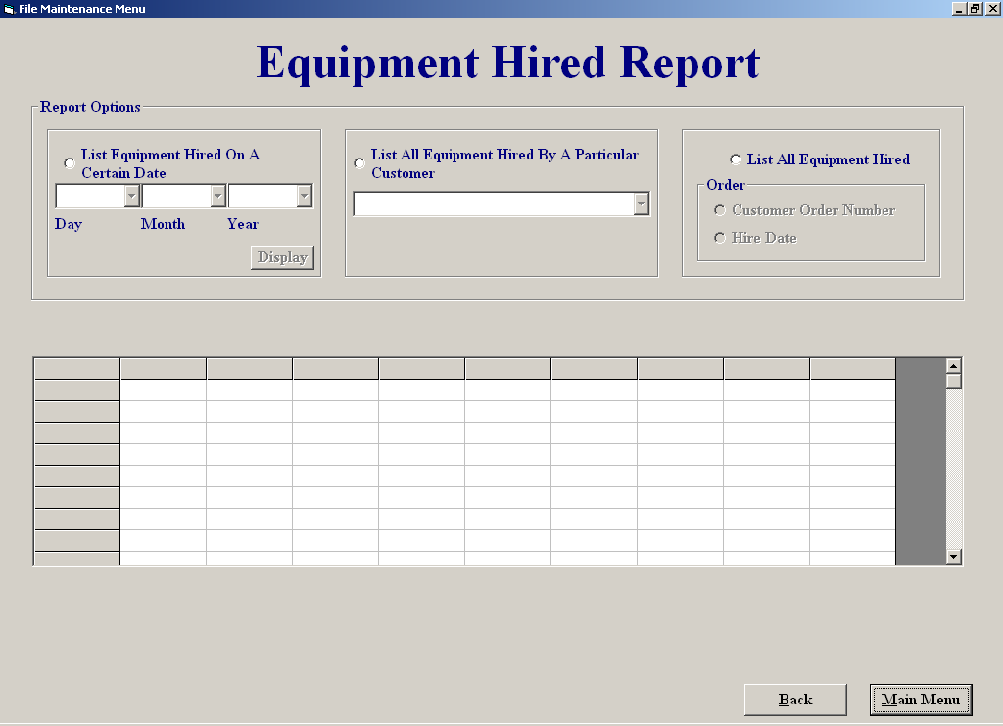

Code:

'Purpose of screen:

'The purpose of this screen is to display equipment hired in different
'formats such as:
'1listing equipment hired on a certain date
'2listing equipment hired by a particular customer
'3listing all equipment presently on hire which the user can display either
'by date ored or customer number order

'Author: Derek Stafford com2026
'15/03/2002

'variable used purpose

'Inindex integer; used to control for loops
'intCustID integer; store customer id number
'srtTime1 string; used to hold date
'srtTime2 string; used to hold date

'objects used

'datRental datacontrol; used to retrieve info from rental/return table
'datCustomer datacontrol; used to retrieve info from customer table
'thegrid flexigrid ; bound to the datRental datacontrol

Option Explicit
Dim intCustID As Integer
Private Sub CmbEqCust_click()

Dim strmySQl As String
'List equipment hired by a certain customer

intCustID = CmbEqCust.ItemData(CmbEqCust.ListIndex)

strmySQl = "SELECT [Rental/Return].[Date/Time out] as [Hire Date],Customer.Cust_ID as [Customer No], " & _
"Customer.Name,Customer.[Address 1],Customer.[Address 2], [Rental/Return].Equipment_ID as [Equipment ID], " & _
"[Rental/Return].Rental_ID as [Rental ID No],[Rental/Return].[Date/Time returned]as [Return Date] " & _
"FROM Customer INNER JOIN [Rental/Return] ON Customer.Cust_ID = [Rental/Return].Cust_ID " & _
"Where (((Customer.Cust_ID) = " & intCustID & "))" & _
"ORDER BY Customer.Cust_ID;"
datRental.RecordSource = strmySQl
datRental.Refresh
End Sub
=============================================================
Private Sub CmbEqCust_DropDown()
datCustomer.RecordSource = "Customer"

'Put customer details into combo box

CmbEqCust.Clear

datCustomer.Recordset.MoveFirst
While Not datCustomer.Recordset.EOF
CmbEqCust.AddItem (datCustomer.Recordset("Name")) + " ," + (datCustomer.Recordset("Address 1")) + ", " + (datCustomer.Recordset("Address 2"))
CmbEqCust.ItemData(CmbEqCust.NewIndex) = datCustomer.Recordset("Cust_ID")
datCustomer.Recordset.MoveNext
Wend
End Sub
=============================================================
Private Sub cmbmonth_DropDown()
'Fills combo box with month of year

Dim intindex As Integer
cmbmonth.Clear
For intindex = 1 To 12
cmbmonth.AddItem (intindex)
Next intindex
End Sub
=============================================================
Private Sub cmbDate_DropDown()
'Fills combo box with days of month

Dim intindex As Integer
CmbDate.Clear
For intindex = 1 To 31
CmbDate.AddItem (intindex)
Next intindex
End Sub
=============================================================
Private Sub cmbyear_DropDown()
'Fills combo box with yaers 2001-2009

Dim intindex As Integer

For intindex = 2001 To 2009
cmbyear.AddItem (intindex)
Next intindex
End Sub
=============================================================
Private Sub cmdBack_Click()
frmReportsMenu.Show
Unload Me
End Sub
=============================================================
Private Sub cmdDisplayDate_Click()
'Lists equipment hired on a particular date

Dim strTime1, strTime2, strmySQl As String

If CmbDate.ListIndex = -1 Or cmbyear.ListIndex = -1 Or cmbmonth.ListIndex = -1 Then
Call MsgBox("The date entry is not complete or not valid ", vbCritical, "Entry Not Complete")
Else
strTime1 = "#" & CmbDate & "/" & cmbmonth & "/" & cmbyear & "#"
strTime2 = "#" & CmbDate + 1 & "/" & cmbmonth & "/" & cmbyear & "#"

strmySQl = "SELECT [Rental/Return].[Date/Time out] as [Hire Date],Customer.Cust_ID as [Customer No], " & _
"Customer.Name,Customer.[Address 1],Customer.[Address 2], [Rental/Return].Equipment_ID as [Equipment ID], " & _
"[Rental/Return].Rental_ID as [Rental ID No],[Rental/Return].[Date/Time returned]as [Return Date] " & _
"FROM Customer INNER JOIN [Rental/Return] ON Customer.Cust_ID = [Rental/Return].Cust_ID " & _
"Where ((([Rental/Return].[Date/Time out]) >= " & strTime1 & " And ([Rental/Return].[Date/Time out]) <" & strTime2 & "))" & _
"ORDER BY Customer.Cust_ID;"

datRental.RecordSource = strmySQl
datRental.Refresh

End If
End Sub
=============================================================
Private Sub cmdMainMenu_Click()
frmMainMenu.Show
Unload Me
End Sub
=============================================================
Private Sub Form_Activate()
Optorderbydate.Enabled = False
optOrdebyrCust.Enabled = False
CmbEqCust.Enabled = False
CmbDate.Enabled = False
cmbyear.Enabled = False
cmbmonth.Enabled = False
cmdDisplayDate.Enabled = False
cmdDisplayDate.ToolTipText = "Displays the equipment hire on the choosen date"
thegrid.Clear
End Sub
=============================================================
Private Sub Form_Load()
'Assigns the tables of the data base to the controls

datRental.DatabaseName = "c:/EHS.mdb"
datRental.RecordSource = "Equipment"
datCustomer.DatabaseName = "c:/EHS.mdb"
datCustomer.RecordSource = "Customer"

End Sub
=============================================================
Private Sub optDate_Click()
'If date option is clicked
CmbDate.Text = ""
cmbmonth.Text = ""
cmbyear.Text = ""
thegrid.Clear
CmbDate.Enabled = True
cmbmonth.Enabled = True
cmbyear.Enabled = True
cmdDisplayDate.Enabled = True
CmbEqCust.Text = ""
CmbEqCust.Enabled = False
Optorderbydate.Enabled = False
optOrdebyrCust.Enabled = False
End Sub
=============================================================
Private Sub OptEqCust_Click()
cmbmonth.Clear
CmbDate.Clear
cmbyear.Clear

Optorderbydate.Enabled = False
optOrdebyrCust.Enabled = False
CmbEqCust.Enabled = True
CmbDate.Enabled = False
cmbyear.Enabled = False
cmbmonth.Enabled = False
cmdDisplayDate.Enabled = False
End Sub
=============================================================
Private Sub OptEQHired_Click()
Dim strmySQl As String
'Lists all the equipment hired
cmbmonth.Clear
CmbDate.Clear
cmbyear.Clear

CmbEqCust.Text = ""
CmbEqCust.Enabled = False
CmbDate.Enabled = False
cmbyear.Enabled = False
cmbmonth.Enabled = False
cmdDisplayDate.Enabled = False
Optorderbydate.Enabled = True
optOrdebyrCust.Enabled = True

strmySQl = "SELECT [Rental/Return].[Date/Time out] as [Hire Date],Customer.Cust_ID as [Customer No], " & _
"Customer.Name,Customer.[Address 1],Customer.[Address 2], [Rental/Return].Equipment_ID as [Equipment ID], " & _
"[Rental/Return].Rental_ID as [Rental ID No],[Rental/Return].[Date/Time returned]as [Return Date] " & _
"FROM [Rental/Return] INNER JOIN Customer ON [Rental/Return].Cust_ID = Customer.Cust_ID " & _
"Where ((([Rental/Return].[Date/Time returned]) Is Null)) " & _
"ORDER BY [Rental/Return].[Date/Time out];"

Optorderbydate.Value = True
datRental.RecordSource = strmySQl
datRental.Refresh
End Sub
=============================================================
Private Sub Optorderbydate_Click()
'Order all equipment hired by date

Dim strmySQl As String, intEquipID, intEquipType As Integer

strmySQl = "SELECT [Rental/Return].[Date/Time out] as [Hire Date],Customer.Cust_ID as [Customer No], " & _
"Customer.Name,Customer.[Address 1],Customer.[Address 2],[Rental/Return].Equipment_ID as [Equipment ID], " & _
"[Rental/Return].Rental_ID as [Rental ID No],[Rental/Return].[Date/Time returned]as [Return Date] " & _
"FROM [Rental/Return] INNER JOIN Customer ON [Rental/Return].Cust_ID = Customer.Cust_ID " & _
"Where ((([Rental/Return].[Date/Time returned]) Is Null)) " & _
"ORDER BY [Rental/Return].[Date/Time out];"

datRental.RecordSource = strmySQl
datRental.Refresh

End Sub
=============================================================
Private Sub optOrdebyrCust_Click()
'Order all equipment hired by customer id

Dim strmySQl As String

strmySQl = "SELECT [Rental/Return].[Date/Time out] as [Hire Date],Customer.Cust_ID as [Customer No], " & _
"Customer.Name,Customer.[Address 1],Customer.[Address 2], [Rental/Return].Equipment_ID as [Equipment ID], " & _
"[Rental/Return].Rental_ID as [Rental ID No],[Rental/Return].[Date/Time returned]as [Return Date] " & _
"FROM Customer INNER JOIN [Rental/Return] ON Customer.Cust_ID = [Rental/Return].Cust_ID " & _
"Where ((([Rental/Return].[Date/Time returned]) Is Null))" & _
"ORDER BY [Rental/Return].Rental_ID;"

datRental.RecordSource = strmySQl
datRental.Refresh

End Sub
=============================================================

File Maintenance Menu:

Screen Shot:

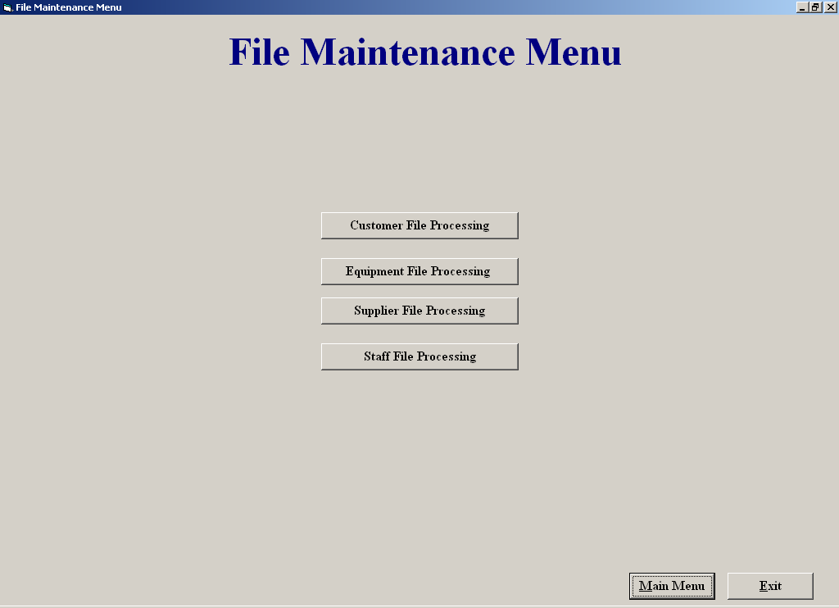

Code:

'Purpose of Screen

'The file maintenance menu is used to allow the user access to the :

'1 Customer Maintenance Menu screen
'2 Equipment Maintenance Menu screen
'3 Staff Maintenance Menu screen
'4 Supplier Maintenance Menu screen

'Author Derek Stafford com2026

Private Sub cmdCustomerFP_Click()
frmCustomerFileProcessing.Show
Unload Me
End Sub

Private Sub cmdEquipmentFP_Click()
frmEquipmentFileProcessing.Show
Unload Me
End Sub
=============================================================
Private Sub cmdExit_Click()
End
End Sub
=============================================================
Private Sub cmdMainMenu_Click()
frmMainMenu.Show
Unload Me
End Sub
=============================================================
Private Sub cmdStaffFP_Click()
frmStaffMenu.Show
Unload Me
End Sub
=============================================================
Private Sub cmdSupplierFP_Click()
frmSupplierMaintenanceMenu.Show
Unload Me
End Sub
=============================================================

Return Equipment

Screen Shot

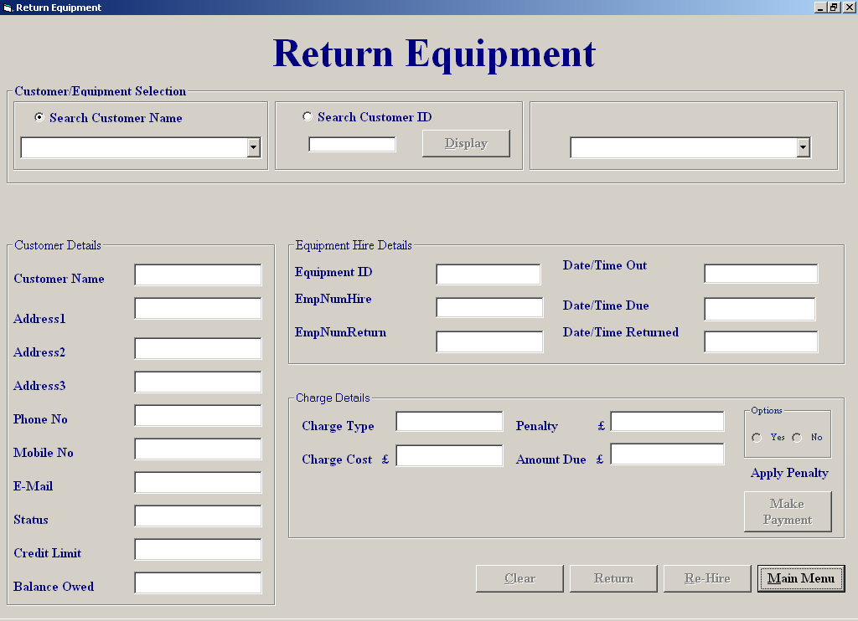

Code:

'Purpose of screen:

'The purose of this scren is to allow the user to add back returned equipment
'to the sytem in order for it to be rehired again.
'when the equipment is returned by the customer the user can select
'the the customer from a list of customer ofr by simmply entering the customers
'id number and clicking display,once the customer is selected the user can
'see all the equipment on hire by that particular customer,the user can than select the
'on the equipment being returned by that customer,when selected all the relevant
'details on that piece of equipment are displayed,the user also has the option
'of appling penanties for late returns which the system has calculated,in this
'screen it is also possible for the user to rehire the equipment back out to the
'customer, also the user can deal with payments from this by press the make payment
'button.

'Author: Derek Stafford com2026
'15/03/2002

'vaiables used Purpose

'strSQL string; holds SQL query result
'dtTime String; Holds the time part of a date split
'dtDate String; holds the date part of a date split
'strReturnTime string; temperarty holds date
'Isvalid Boolean; used to see if entry number is valid
'HourDiff integer; holds the different in hours for penalty calulations
'WeekDiff integer; holds the different in weeks for penalty calulations
'DayDiff integer; holds the different in days for penalty calulations
'intindex integer; used as a counter variable in loops etc
'intResult integer; holds result of answer from message box
'intEmpReturn integer; holds employee id number returning equipment
'intEmpHire integer; holds employee id number who rented out the item
'IntCustID integer; holds the selected customer id
'intRentalID integer; holds the selected rental id
'
'objects used
'
'datEquipmentType datacontrol retrieves data from the equipment type table
'datEquipment datacontrol retrieves data from the equipment table
'datEquip2 datacontrol retrieves data from the equipment table
'datcustomer datacontrol retrieves data from customer table
'datEmpNumReturn datacontrol retrieves data from find employees table
'datEquipment datacontrol retrieves data fom equipment table
'datReturn datacontrol retrieves locate rented table

Option Explicit

Dim counter, intRentalID, intCustID, index, intEquipID, intEmpReturn, intEmpHire As Integer, HourlyRate, DailyRate As Currency
Private Sub CheckRental()

Dim strmySQl As String 'query which checks current rentals

datCustomer.Recordset.FindFirst "Cust_ID = " & intCustID & ""
strmySQl = "SELECT Customer.Cust_ID, [Rental/Return].Equipment_ID, [Rental/Return].[Date/Time returned], [Rental/Return].Rental_ID " & _
"FROM Customer INNER JOIN [Rental/Return] ON Customer.Cust_ID = [Rental/Return].Cust_ID " & _
"WHERE (((Customer.Cust_ID)= " & intCustID & ") AND (([Rental/Return].[Date/Time returned])is Null));"
datReturn.RecordSource = strmySQl
datReturn.Refresh

End Sub
Private Sub cmbCustomer_Click()
‘Empties unneeded data from selected textboxes and suplies new customer details details
intCustID = cmbCustomer.ItemData(cmbCustomer.ListIndex)
cmdmakePayment.Enabled = True
CheckRental
display
If datReturn.Recordset.EOF Then
Call MsgBox("The selected customer currently has no equipment on hire", vbInformation, "No Equipment On Hire")
Else
lblEqSelection.Visible = True
cmdClear.Enabled = True
CmbboxEquipment.Enabled = True
txtEmpNumHire.Text = ""
txtEmpNumReturn.Text = ""
txtEquipmentID.Text = ""
txtDateOut.Text = ""
txtDateDue.Text = ""
txtChargeType.Text = ""
txtReturnTime.Text = ""
txtPenalty.Text = ""
txtCost.Text = ""
txtAmountDue.Text = ""
End If
End Sub
=============================================================
Private Sub cmdBack_Click()
frmEquipmentFileProcessing.Show
Unload Me
End Sub

Private Sub cmdClear_Click()
Clear
cmdmakePayment.Enabled = False
End Sub

Private Sub Clear()
'Clears out all textboxes on the screen
cmbCustomer.Text = ""
OptNoPenalty.Enabled = False
OptYesPenalty.Enabled = False
cmdReHire.Enabled = False
cmdReHire.Enabled = False
cmdClear.Enabled = False
cmdReturn.Enabled = False
lblEqSelection.Visible = False
txtCustomerName = ""
txtAddress1 = ""
txtAddress2 = ""
txtAddress3 = ""
txtPhoneNo = ""
txtMobileNo = ""
txtEmail = ""
txtEmpNumHire = ""
txtEmpNumReturn = ""
txtEquipmentID = ""
txtDateOut = ""
txtDateDue = ""
txtChargeType = ""
txtCost = ""
txtAmountDue = ""
txtReturnTime = ""
txtStatus = ""
txtCreditLimit = ""
txtBalanceowned = ""
txtPenalty = ""
CmbboxEquipment.Text = ""
End Sub
=============================================================
Private Sub display()
'Procedure used to display customer info

datCustomer.Recordset.FindFirst "Cust_ID = " & intCustID & ""
txtCustomerName.Text = datCustomer.Recordset("Name")
txtAddress1.Text = datCustomer.Recordset("Address 1")
txtAddress2.Text = datCustomer.Recordset("Address 2")
txtAddress3.Text = datCustomer.Recordset("Address 3")
txtPhoneNo.Text = datCustomer.Recordset("Phone No")
txtMobileNo.Text = datCustomer.Recordset("Mobile No")
txtEmail.Text = datCustomer.Recordset("E-Mail")
txtStatus.Text = datCustomer.Recordset("Status")
txtCreditLimit.Text = datCustomer.Recordset("Credit Limit")
txtBalanceowned.Text = datCustomer.Recordset("Balance owed")

End Sub
=============================================================
Private Sub cmdDisplay_Click()
'Dim strmySQl As String ’ Displays all current customers
cmdDisplay.Enabled = False
intCustID = Val(txtCustNumber)

strmySQl = "SELECT Customer.*" & _
"From Customer " & _
"WHERE (((Customer.Deletion)=False));"
cmbCustomer.Clear
datCustomer.RecordSource = strmySQl
datCustomer.Refresh

datCustomer.Recordset.FindFirst "Cust_ID = " & intCustID & ""
If datCustomer.Recordset.NoMatch Then
Call MsgBox("No Match Found", vbOKOnly, "No Match")
txtCustNumber = ""

Else
cmdmakePayment.Enabled = True
display
CheckRental
If datReturn.Recordset.EOF Then
Call MsgBox("The selected customer currently has no equipment on hire", vbInformation, "No Equipment On Hire")
Else
CmbboxEquipment.Enabled = True
End If
End If
End Sub
=============================================================
Private Sub cmdMakePayment_Click()
frmMakeaPayment.Tag = intCustID
frmMakeaPayment.Show
End Sub
=============================================================
Private Sub cmdReHire_Click()
'Sents the relavant info to hire screen so the customer can rehire the same piece of
'equipment, it also enables and disables the needed buttons on the hire screen

Dim dtTime, dtDate, strReturnTime As String
If txtReturnTime.Text = "" Then
Call MsgBox("This Equipment Has Not Been Returned", vbInformation, "Equipment Still On Hire")
Else
strReturnTime = txtReturnTime
dtTime = Mid(strReturnTime, 11, Len(strReturnTime))
dtDate = Mid(strReturnTime, 1, 10)
frmRental.Tag = "frmReturnEquipment"
frmRental.Show
frmRental.txtCustID = intCustID
frmRental.txtEmpID = intEmpReturn
frmRental.cboName.Text = txtCustomerName.Text
frmRental.txtNameFound = txtCustomerName.Text
frmRental.txtAddress1 = txtAddress1.Text
frmRental.txtAddress2 = txtAddress1.Text
frmRental.txtAddress3 = txtAddress1.Text
frmRental.txtPhoneNo = txtPhoneNo.Text
frmRental.txtMobileNo = txtMobileNo.Text
frmRental.txtCreditLimit = txtCreditLimit.Text
frmRental.txtStatus = txtStatus.Text
frmRental.txtBalance = txtBalanceowned.Text
frmRental.txtDateOut = dtDate
frmRental.txtTimeOut = dtTime
frmRental.cboID.Text = intEquipID
frmRental.txtRentPeriod.TabIndex = 1
frmRental.cmdBack.Enabled = False
frmRental.cmdDateDue.Enabled = False
frmRental.cboID.Enabled = False
frmRental.txtRentPeriod.Enabled = True
frmRental.cboPeriod.Enabled = True
frmRental.txtEmpID.Enabled = False
frmRental.cmdSeekCustomer.Enabled = False
frmRental.cmdAddCust.Enabled = False
frmRental.optName.Enabled = False
frmRental.optNumber.Enabled = False
frmRental.cboName.Enabled = False
Unload Me
End If
End Sub
=============================================================
'Function used to check that inputted characters are valid numbers

Function IsValid(StrEQID As Variant) As Boolean
Dim intindex As Integer, temp As Variant, blnValid As Boolean
blnValid = False
For intindex = 1 To Len(StrEQID)
temp = Mid(StrEQID, intindex, 1)
If (temp > 0 And temp < 9) Then
blnValid = True
Else
intindex = Len(StrEQID)
blnValid = False

End If
Next
IsValid = blnValid
End Function
=============================================================
'Checks employee id and if its valid it allow the user to
'to return equipment back into the data base,by updating the rental tables

Private Sub cmdReturn_Click()
Dim intEmpNumReturn, intResult As Integer
Dim srtmySQL As String

datEmpNumReturn.RecordSource = "Employee"
datEmpNumReturn.Refresh
datReturn.RecordSource = "Rental/Return"
datReturn.Refresh

txtEmpNumReturn = InputBox("Enter Your Employee_ID Number Please")
If IsValid(txtEmpNumReturn.Text) = False Or (Val(txtEmpNumReturn) > 9999) Then
Call MsgBox("You have entered invalid data or no data , a number exceeeding 9999", vbCritical, "Invalid Data Entry")
CmbboxEquipment.SetFocus
Else
intEmpNumReturn = Val(txtEmpNumReturn)
'Searches the employee table for match

datEmpNumReturn.Recordset.FindFirst "Employee_ID = " & intEmpNumReturn & ""

If datEmpNumReturn.Recordset("Employee_ID") = intEmpNumReturn Then
intResult = MsgBox("Are You Sure?", vbYesNo, "Returning Equipment")

If intResult = vbYes Then
cmdmakePayment.Enabled = True

intEquipID = Val(txtEquipmentID.Text)
intEmpNumReturn = Val(txtEmpNumReturn.Text)
datEmpNumReturn.Recordset.FindFirst "Employee_ID =" & intEmpNumReturn & ""
txtReturnTime = FormatDateTime(Now, vbShortDate) + " " + FormatDateTime(Now, vbShortTime)

datEquipment.Recordset.FindFirst "Equipment_ID = " & intEquipID & ""
'Updates the relevant field in the equipment table
datEquipment.Recordset.Edit
datEquipment.Recordset("Status") = "Available"
datEquipment.Recordset.Update
'Updates the relevant field in the rental table
datReturn.Recordset.FindFirst "Equipment_ID = " & intEquipID & ""
datReturn.Recordset.Edit
datReturn.Recordset("EmpNumReturn") = txtEmpNumReturn.Text
datReturn.Recordset("Date/Time returned") = txtReturnTime
datReturn.Recordset.Update
datReturn.Refresh

txtAmountDue = datReturn.Recordset("Amount Due")
txtDateDue = datReturn.Recordset("Date/Time Due")

If txtDateDue.Text >= txtReturnTime.Text Then
datReturn.Recordset.FindFirst "Equipment_ID =" & intEquipID & ""
OptNoPenalty.Enabled = False

datReturn.Recordset.Edit
datReturn.Recordset("Penalty") = CCur(Val(txtPenalty.Text)) 'FormatDateTime(Now, vbShortDate) + " " + FormatDateTime(Now, vbShortTime)
txtPenalty = datReturn.Recordset("Penalty")
datReturn.Recordset.Update

Else

OptYesPenalty.Enabled = True
datReturn.Recordset.Edit
datReturn.Recordset("Penalty") = ccurPenality 'function
txtPenalty = datReturn.Recordset("Penalty")
datReturn.Recordset.Update
End If

Call MsgBox("Return Complete", vbInformation, "System Response")

datEmpNumReturn.Recordset.FindFirst "Employee_ID =" & txtEmpNumReturn & ""
intEmpReturn = txtEmpNumReturn
txtEmpNumReturn.Text = datEmpNumReturn.Recordset("Employee Name") ' ‘Prints out employee name to the screen

cmdReturn.Enabled = False
CheckRental
If datReturn.Recordset.EOF Then
Call MsgBox("The selected customer currently has no equipment on hire", vbInformation, "No Equipment On Hire")
End If

Else
Call MsgBox("No Return ", vbInformation, "System Response")
txtEmpNumReturn = ""
End If
Else
txtEmpNumReturn = ""
Call MsgBox("Wrong Or Incorrect ID Number Entered", vbCritical, "Wrong ID Number Entered")
End If
End If
End Sub
=============================================================
Private Sub cmdMainMenu_Click()
frmMainMenu.Show
Unload Me
End Sub
Private Sub Form_Activate()
'Sets up screen layout
cmdDisplay.Enabled = False
optCustName.SetFocus
cmdmakePayment.Enabled = False
lblEqSelection.Visible = False
txtChargeType.Enabled = False
txtCustNumber.Enabled = False
cmbCustomer.Enabled = False
cmdReHire.Enabled = False
cmdReHire.Enabled = False
cmdClear.Enabled = False
cmdReturn.Enabled = False
OptNoPenalty.Enabled = False
OptYesPenalty.Enabled = False
cmdDisplay.ToolTipText = "Displays customer details"
cmdMainMenu.ToolTipText = "Back to main menu"
cmdClear.ToolTipText = "Clears current contains from the screen"
cmdReHire.ToolTipText = "Rehire the selected equipment"
CmbboxEquipment.ToolTipText = "Selects the equipment on hire from the selected customer"
cmdReturn.ToolTipText = "Allows employee to return the selected equipment onto the system"
cmdmakePayment.ToolTipText = "Allows Customer to make a payment"
End Sub
=============================================================
Private Sub cmbCustomer_DropDown()
'Fills combo box with current customers

Dim strmySQl As String
Clear
strmySQl = "SELECT Customer.* " & _
"From Customer " & _
"WHERE (((Customer.Deletion)=False));"
cmbCustomer.Clear
datCustomer.RecordSource = strmySQl
datCustomer.Refresh
While Not datCustomer.Recordset.EOF
cmbCustomer.AddItem (datCustomer.Recordset("Name")) + ", " + (datCustomer.Recordset("Address 1")) + ", " + (datCustomer.Recordset("Address 2"))
cmbCustomer.ItemData(cmbCustomer.NewIndex) = datCustomer.Recordset("Cust_ID")
datCustomer.Recordset.MoveNext
Wend
End Sub
=============================================================
Private Sub Form_Load()
'Assigns the relevant data base tables to data controls

Dim strmySQl As String
CmbboxEquipment.Enabled = False

datCustomer.DatabaseName = "c:/EHS.mdb"
datCustomer.RecordSource = "Customer"

datEmpNumReturn.DatabaseName = "c:/EHS.mdb"
datEmpNumReturn.RecordSource = "Employee" '"select*from supplier where [deletion]= false;"

datEquipment.DatabaseName = "c:/EHS.mdb"
datEquipment.RecordSource = "Equipment"

datReturn.DatabaseName = "c:/EHS.mdb"
datReturn.RecordSource = "Rental/Return"

datEquip2.DatabaseName = "c:/EHS.mdb"
datEquip2.RecordSource = "Equipment"

datEquipmentType.DatabaseName = "c:/EHS.mdb"
datEquipmentType.RecordSource = "Equipment Type"
End Sub
=============================================================
Private Sub CmbboxEquipment_DropDown()
'Fills equipment combo box with all the equipment the selected customer has on hire

Dim strmySQl As String, intEquipType As Integer

strmySQl = "SELECT Customer.Cust_ID, [Rental/Return].Equipment_ID, [Rental/Return].[Date/Time returned], [Rental/Return].Rental_ID " & _
"FROM Customer INNER JOIN [Rental/Return] ON Customer.Cust_ID = [Rental/Return].Cust_ID " & _
"WHERE (((Customer.Cust_ID)= " & intCustID & ") AND (([Rental/Return].[Date/Time returned])Is Null));"
datReturn.RecordSource = strmySQl

datReturn.Refresh
datEquipmentType.RecordSource = "Equipment Type"
CmbboxEquipment.Clear
While Not datReturn.Recordset.EOF

intEquipID = datReturn.Recordset("Equipment_ID")

datEquip2.Recordset.FindFirst "Equipment_ID = " & intEquipID & ""
intEquipType = datEquip2.Recordset("Type_ID")

datEquipmentType.Recordset.FindFirst "Type_ID = " & intEquipType & ""

CmbboxEquipment.AddItem (datEquipmentType.Recordset("Make")) + ", " + datEquipmentType.Recordset("Model") + ", " + datEquipmentType.Recordset("Details")
datEquipmentType.Recordset.MoveFirst
datEquip2.Recordset.MoveFirst

CmbboxEquipment.ItemData(CmbboxEquipment.NewIndex) = datReturn.Recordset("Equipment_ID")
datReturn.Recordset.MoveNext
Wend
End Sub
============================================================
Private Sub CmbboxEquipment_Click()
Dim Cost, AmountDue As Currency
'Find the relevant info on the selected equipment and places it in combo boxes

intEquipID = CmbboxEquipment.ItemData(CmbboxEquipment.ListIndex)
datReturn.RecordSource = "Rental/Return"
datReturn.Refresh
datEmpNumReturn.Refresh
datReturn.Recordset.FindFirst "Equipment_ID = " & intEquipID & ""

datEmpNumReturn.Recordset.FindFirst "Employee_ID =" & intEmpHire & ""

txtEmpNumHire.Text = datEmpNumReturn.Recordset("Employee Name")

txtEquipmentID.Text = datReturn.Recordset("Equipment_ID")
txtDateOut.Text = datReturn.Recordset("Date/Time Out")
txtDateDue.Text = datReturn.Recordset("Date/Time Due")

txtChargeType.Text = datReturn.Recordset("Charge Type")
Cost = CCur(datReturn.Recordset("Charge Cost"))
txtCost.Text = Str(Cost)
txtPenalty = ccurPenality
If txtPenalty = "" Then
txtPenalty = "0"
End If
If txtPenalty = "0" Then
OptYesPenalty.Enabled = False
Else
OptYesPenalty.Enabled = True
End If
AmountDue = CCur(datReturn.Recordset("Amount Due"))
txtAmountDue.Text = Str(AmountDue)
OptNoPenalty.Enabled = False
cmdReHire.Enabled = True
cmdReHire.Enabled = True
cmdReturn.Enabled = True
End Sub
=============================================================
Private Sub optCustName_Click()
'Resets screen layout
cmdDisplay.Enabled = False
txtCustNumber.Enabled = False
cmbCustomer.Enabled = True
txtCustNumber.Text = ""
txtCustNumber.Enabled = False
Clear
End Sub
=============================================================
Private Sub OpCustID_Click()
'Reset screen layout
Clear
cmdmakePayment.Enabled = False
cmbCustomer.Text = ""
cmbCustomer.Enabled = False
txtCustNumber.Enabled = True
txtCustNumber.SetFocus
cmdDisplay.Enabled = True
txtCustNumber.Enabled = True
End Sub
=============================================================
Private Sub OptNoPenalty_Click()
'Takes added penalty away from the amount due

If OptNoPenalty.Value = True Then
OptYesPenalty.Value = False
txtAmountDue.Text = Str(CCur(txtAmountDue.Text) - CCur(Val(txtPenalty.Text)))
End If
End Sub
=============================================================
Private Sub OptYesPenalty_Click()
'Adds penalty away from the amount due

If txtPenalty.Text = "0" Then
Call MsgBox("There is No Penalty ON The Selected Equipment", vbInformation, "No Penalty")
End If
If OptYesPenalty.Value = True Then
OptNoPenalty.Value = False
OptNoPenalty.Enabled = True
End If
txtAmountDue = Str(CCur(txtAmountDue.Text) + CCur(Val(txtPenalty.Text)))
End Sub
============================================================
Public Function ccurPenality()

'Works out the penalty due if any

Dim total As Currency, HourDiff, DayDiff, WeekDiff As Integer
Const PentRate As Currency = 1.5

DayDiff = DateDiff("d", txtDateDue, Now)
HourDiff = DateDiff("h", txtDateDue, Now) 'DateDiff function
WeekDiff = DateDiff("ww", txtDateDue, Now) 'reference Peter Nortons Guide to Visual Basic 6

If DayDiff > 0 Or HourDiff > 0 Or WeekDiff > 0 Then
If txtChargeType = "Hour(s)" Then
ccurPenality = Str(HourDiff * Val(txtCost.Text) * PentRate)
Else
If txtChargeType = "Day(s)" Then
ccurPenality = Str(DayDiff * Val(txtCost.Text) * PentRate)
Else
If txtChargeType = "Week(s)" Then
ccurPenality = Str(WeekDiff * Val(txtCost.Text) * PentRate)
End If
End If
End If
End If
End Function
=============================================================
Private Sub txtCustNumber_Validate(Cancel As Boolean)
'Checks for valid input
If IsNumeric(txtCustNumber.Text) Then
Cancel = False
Else
Call MsgBox("Sorry invalid data", vbOKOnly, "Warning")
txtCustNumber.SetFocus
Cancel = True
End If
End Sub

