Amend/View Staff

Screen Shot:

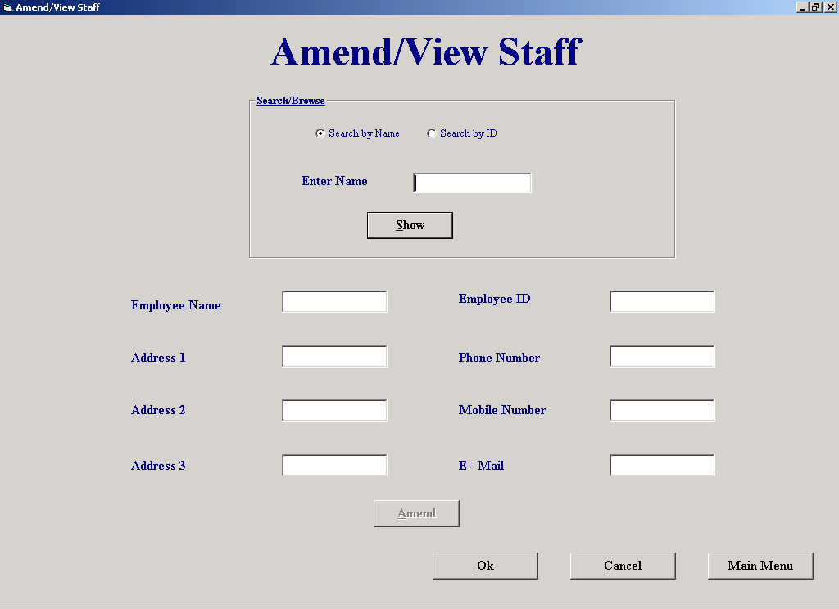

Code:
'The purpose of this screen is to make changes to an employees details

'It allows the user to search for the employee and show their details.
'It then lets the user change some of the fields.
'When user clicks "Amend" and confirms whether to Amend, the fields are updated
'using the data control "datAmendView". The original details are stored in their
'respective text boxes tag property. This method implies parallel arrays
'If the user clicks cancel at the bottom of the screen the system ignores the amendments and restores
'the staffs details to their original values that are stored in the text boxes tag.

'Author Fergal Purcell
'Date 06/03/2002

'Variables used
'strSql : String; This variable holds the SQL statement
'strID : String; Holds the Primary key of a customer
'intTab : Integer; Stores the location of the tab character
'intCounter : Integer; Control variable in for loop

'Objects used
'datAmendView : Data Control; Used to display details of the staff

Option Explicit

Private Sub cmdAmend_Click()
datAmendView.DatabaseName = strThePath
datAmendView.RecordSource = "Employee"
datAmendView.Refresh
datAmendView.Recordset.FindFirst "Employee_ID = " & txtID.Text
If MsgBox("Are you sure you wish to amend this employee's details?", vbQuestion + vbYesNo, "Confirm deletion") = vbYes Then
With datAmendView.Recordset
cmdAmend.Tag = cmdAmend.Tag & txtID.Text & Chr(9) 'Store the ID's of every employee that’s amended
txtName.Tag = txtName.Tag & .Fields("Employee Name") & Chr(9) 'Store the original details of the employee
txtAdd1.Tag = txtAdd1.Tag & .Fields("Address 1") & Chr(9)
txtAdd2.Tag = txtAdd2.Tag & .Fields("Address 2") & Chr(9)
txtAdd3.Tag = txtAdd3.Tag & .Fields("Address 3") & Chr(9)
txtPhone.Tag = txtPhone.Tag & .Fields("Phone No") & Chr(9)
txtMob.Tag = txtMob.Tag & .Fields("Mobile No") & Chr(9)
txtMail.Tag = txtMail.Tag & .Fields("E-Mail") & Chr(9)
.Edit
.Fields("Employee Name") = txtName.Text 'Amend the fields
.Fields("Address 1") = txtAdd1.Text
.Fields("Address 2") = txtAdd2.Text
.Fields("Address 3") = txtAdd3.Text
.Fields("Phone No") = txtPhone.Text
.Fields("Mobile No") = txtMob.Text
.Fields("E-Mail") = txtMail.Text
.Update
End With
Else
AssignFields 'Change the text boxes
End If
End Sub

Private Sub cmdCancel_Click()
If cmdAmend.Tag <> "" Then 'Only display this message if the user has made amendments
If MsgBox("Do you want to save changes?", vbQuestion + vbYesNo, "Save changes") = vbNo Then
CancelAmends
End If
End If
End Sub

Private Sub cmdMM_Click()
If cmdAmend.Tag <> "" Then 'Only display this message if the user has made amendments
If MsgBox("Do you wish to save amendments?", vbQuestion + vbYesNo, "Save Amendments") = vbNo Then
CancelAmends
End If
End If
frmMainMenu.Show
Unload Me
End Sub

Private Sub cmdNext_Click()
datAmendView.Recordset.MoveNext 'Move to the next match
If datAmendView.Recordset.EOF Then
datAmendView.Recordset.MoveFirst
End If
AssignFields
End Sub

Private Sub cmdOk_Click()
Unload Me
End Sub

Private Sub cmdPrevious_Click()
datAmendView.Recordset.MovePrevious 'Move to the previous match
If datAmendView.Recordset.BOF Then
datAmendView.Recordset.MoveLast
End If
AssignFields
End Sub

Private Sub cmdShow_Click()
Dim strSql As String
cmdNext.Visible = False
cmdPrevious.Visible = False
datAmendView.DatabaseName = strThePath
datAmendView.RecordSource = "Employee"
datAmendView.Refresh
If OptName = True Then 'Search for matching name
strSql = "Select Count([Employee.Employee Name]) AS CountOfEmp From Employee Where Employee.[Employee Name] Like '" & txtSearch.Text & "*'" & _
"And Employee.Deletion = False"
datAmendView.RecordSource = strSql
datAmendView.Refresh
If datAmendView.Recordset.Fields("CountOfEmp") = 0 Or txtSearch = "" Then
MsgBox "There is no match.", vbExclamation, "No Match"
txtSearch.SetFocus
txtSearch.Text = ""
ElseIf datAmendView.Recordset.Fields("CountOfEmp") = 1 Then
strSql = "Select * From Employee Where Employee.[Employee Name] Like '" & txtSearch.Text & "*'" & _
"And Employee.Deletion = False"
datAmendView.RecordSource = strSql
datAmendView.Refresh
AssignFields
Else
cmdNext.Visible = True 'Make the movenext and moveprevious buttons visible
cmdPrevious.Visible = True
strSql = "Select * From Employee Where Employee.[Employee Name] Like '" & txtSearch.Text & "*'" & _
"And Employee.Deletion = False"
datAmendView.RecordSource = strSql
datAmendView.Refresh
AssignFields
End If
Else 'Search for primary keys
If CheckNum = True Or txtSearch.Text = "" Then
MsgBox "Invalid data.", vbExclamation, "Invalid data"
txtSearch.SetFocus
txtSearch.Text = ""
Else
datAmendView.Recordset.FindFirst "Employee_ID = " & txtSearch.Text
If datAmendView.Recordset.NoMatch = True Or datAmendView.Recordset.Fields("Deletion") = True Then
MsgBox "There is no match.", vbExclamation, "No Match"
txtSearch.SetFocus
txtSearch.Text = ""
Else
AssignFields
End If
End If
End If
End Sub

Private Sub Form_activate()
txtSearch.SetFocus
End Sub

Private Sub OptID_Click()
lblSearch.Caption = "Enter ID" 'Change the labels
txtSearch.Text = ""
txtSearch.SetFocus
End Sub

Private Sub OptName_Click()
lblSearch.Caption = "Enter Name"
txtSearch.Text = ""
txtSearch.SetFocus
End Sub

Private Sub txtAdd1_Validate(Cancel As Boolean)
If Len(txtAdd1.Text) = 0 Then
MsgBox "This field cannot be empty.", vbExclamation, "Empty field"
Cancel = True
End If
End Sub

Private Sub txtAdd2_Validate(Cancel As Boolean)
If Len(txtAdd2.Text) = 0 Then
MsgBox "This field cannot be empty.", vbExclamation, "Empty field"
Cancel = True
End If
End Sub

Private Sub txtAdd3_Validate(Cancel As Boolean)
If Len(txtAdd3.Text) = 0 Then
MsgBox "This field cannot be empty.", vbExclamation, "Empty field"
Cancel = True
End If
End Sub

Private Sub txtName_Validate(Cancel As Boolean)
If Len(txtName.Text) = 0 Then
MsgBox "This field cannot be empty.", vbExclamation, "Empty field"
Cancel = True
End If
End Sub

Private Sub AssignFields()
'This procedure assigns all the text boxes there values

txtName.Text = datAmendView.Recordset.Fields("[Employee Name]")
txtID.Text = datAmendView.Recordset.Fields("Employee_ID")
txtAdd1.Text = datAmendView.Recordset.Fields("[Address 1]")
txtAdd2.Text = datAmendView.Recordset.Fields("[Address 2]")
txtAdd3.Text = datAmendView.Recordset.Fields("[Address 3]")
txtPhone.Text = datAmendView.Recordset.Fields("[Phone No]")
txtMob.Text = "" + datAmendView.Recordset.Fields("[Mobile No]")
txtMail.Text = "" + datAmendView.Recordset.Fields("E-Mail")
cmdAmend.Enabled = True
txtName.CausesValidation = True
txtAdd1.CausesValidation = True
txtAdd2.CausesValidation = True
txtAdd3.CausesValidation = True
txtPhone.CausesValidation = True
End Sub

Private Sub CancelAmends()
Dim strID As String, intTab As Integer
Do Until cmdAmend.Tag = "" 'A loop that restores the original values to the database
intTab = InStr(cmdAmend.Tag, Chr(9)) 'Find the location of the tab because it marks the end of one primary key
strID = Mid(cmdAmend.Tag, 1, intTab - 1) 'Find the primary key
With datAmendView
.DatabaseName = strThePath
.RecordSource = "Employee"
.Refresh
.Recordset.FindFirst "Employee_ID = " & strID
.Recordset.Edit
intTab = InStr(txtName.Tag, Chr(9)) 'Find the position of the first tag
.Recordset.Fields("Employee Name") = Mid(txtName.Tag, 1, intTab - 1) 'Restore fields to original settings
txtName.Tag = Mid(txtName.Tag, intTab + 1, Len(txtName.Tag) - intTab) 'Delete field from tag
intTab = InStr(txtAdd1.Tag, Chr(9))
.Recordset.Fields("Address 1") = Mid(txtAdd1.Tag, 1, intTab - 1)
txtAdd1.Tag = Mid(txtAdd1.Tag, intTab + 1, Len(txtAdd1.Tag) - intTab)

intTab = InStr(txtAdd2.Tag, Chr(9))
.Recordset.Fields("Address 2") = Mid(txtAdd2.Tag, 1, intTab - 1)
txtAdd2.Tag = Mid(txtAdd2.Tag, intTab + 1, Len(txtAdd2.Tag) - intTab)

intTab = InStr(txtAdd3.Tag, Chr(9))
.Recordset.Fields("Address 3") = Mid(txtAdd3.Tag, 1, intTab - 1)
txtAdd3.Tag = Mid(txtAdd3.Tag, intTab + 1, Len(txtAdd3.Tag) - intTab)

intTab = InStr(txtPhone.Tag, Chr(9))
.Recordset.Fields("Phone No") = Mid(txtPhone.Tag, 1, intTab - 1)
txtPhone.Tag = Mid(txtPhone.Tag, intTab + 1, Len(txtPhone.Tag) - intTab)

intTab = InStr(txtMob.Tag, Chr(9))
.Recordset.Fields("Mobile No") = Mid(txtMob.Tag, 1, intTab - 1)
txtMob.Tag = Mid(txtMob.Tag, intTab + 1, Len(txtMob.Tag) - intTab)

intTab = InStr(txtMail.Tag, Chr(9))
.Recordset.Fields("E-Mail") = Mid(txtMail.Tag, 1, intTab - 1)
txtMail.Tag = Mid(txtMail.Tag, intTab + 1, Len(txtMail.Tag) - intTab)

.Recordset.Update
End With
intTab = InStr(cmdAmend.Tag, Chr(9)) 'Remove the first primary key
cmdAmend.Tag = Mid(cmdAmend.Tag, intTab + 1, Len(cmdAmend.Tag) - intTab)
Loop
End Sub

Private Sub txtPhone_Validate(Cancel As Boolean)
If Len(txtPhone.Text) = 0 Then
MsgBox "This field cannot be empty.", vbExclamation, "Empty field"
Cancel = True
End If
End Sub

Private Function CheckNum() As Boolean
'Bug in IsNumeric says that 6d6 is numeric
Dim intCounter As Integer
For intCounter = 1 To Len(txtSearch.Text)
If Not IsNumeric(Mid(txtSearch, intCounter, 1)) Then 'Check each character
CheckNum = True
End If
Next
End Function

Property Settings

Student Name: Fergal Purcell
Form Name: frmAmendViewStaff
Form Purpose: Allow the user to make changes to staff details

Object | Property | Setting
datAmend/View | DatabaseName | strThePath
 | RecordSource | Employee

Delete Supplier

Screen Shot:

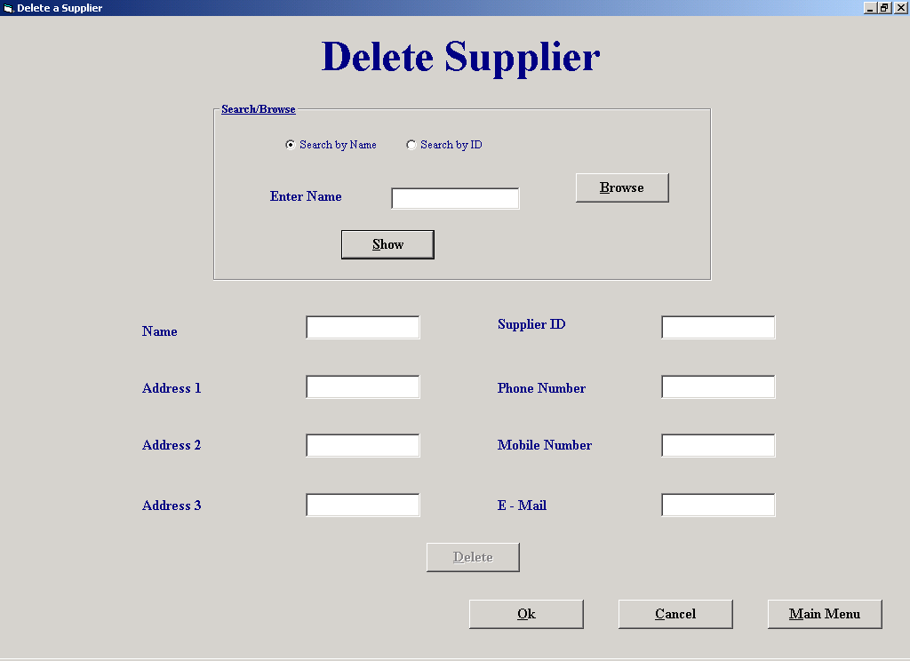

Code:
'The purpose of this screen is to allow the user to mark a supplier for deletion.

'The user enters either the suppliers name or primary key, or they can browse for the
'supplier.
'When the user clicks "Show" the system finds the matching criteria in the supplier
'table and prints the suppliers details into text boxes.
'When user then clicks on "Delete", the supplier is marked for deletion and his
'primary key is concatenated into the tag property of cmdDelete followed by a space.
'If the user clicks "Cancel" the system undeletes the supplier by getting the primary
'key from the cmdDelete tag.

'Author Fergal Purcell
'Date 06/03/2002

'Variables used
'strSql : String ; This variable stores the Sql statement.
'intSpace : Integer; Holds the position of the space as it marks the end of one primary key.
'intCounter : Integer; Control variable in for loop

'Objects used
'datSupplier : Data Control; This data control is used to query the "Supplier" table and mark it for deletion

Option Explicit

Private Function CheckNum() As Boolean
'Bug in IsNumeric says that 6d6 is numeric
Dim intCounter As Integer
For intCounter = 1 To Len(txtSearch.Text)
If Not IsNumeric(Mid(txtSearch, intCounter, 1)) Then 'Check each character
CheckNum = True
End If
Next
End Function

Private Sub cmdCancel_Click()
If cmdDelete.Tag <> "" Then 'Display this message only if the user has deleted suppliers
If MsgBox("Do you want to save deletions?", vbQuestion + vbYesNo, "Save deletions") = vbNo Then
CancelDel
End If
End If
frmSupplierMaintenanceMenu.Show
Unload Me
End Sub

Private Sub cmdDelete_Click()
Dim strSql As String
If MsgBox("Are you sure you wish to delete this supplier?", vbQuestion + vbYesNo, "Confirm deletion") = vbYes Then
datSupplier.DatabaseName = strThePath
strSql = "SELECT Count(Order.Supplier_ID) As CountOfSupp " & _
"From [Order] " & _
"WHERE (((Order.Supplier_ID)= " & txtID.Text & ") AND ((Order.Delivered)<>True)); "
datSupplier.RecordSource = strSql
datSupplier.Refresh
If datSupplier.Recordset.Fields("CountOfSupp") > 0 Then 'if CountOfSupp is greater than zero then the supplier has delivered orders
If MsgBox("This supplier has an undelivered order, are you sure you wish to delete?", vbExclamation + vbYesNo, "Undelivered order") = vbYes Then
DeleteSup
End If
Else
DeleteSup
End If
End If
cmdDelete.Enabled = False 'Disable the delete button
End Sub

Private Sub cmdMM_Click()
If cmdDelete.Tag <> "" Then 'Display this message only if the user has deleted suppliers
If MsgBox("Do you wish to save deletions?", vbQuestion + vbYesNo, "Save Deletions") = vbNo Then
CancelDel
End If
End If
Unload Me
frmMainMenu.Show
End Sub

Private Sub cmdNext_Click()
datSupplier.Recordset.MoveNext 'Move to the next match
If datSupplier.Recordset.EOF Then
datSupplier.Recordset.MoveFirst
End If
AssignFields
End Sub

Private Sub cmdOk_Click()
frmSupplierMaintenanceMenu.Show
Unload Me
End Sub

Private Sub cmdPrevious_Click()
datSupplier.Recordset.MovePrevious 'Move to the previous match
If datSupplier.Recordset.BOF Then
datSupplier.Recordset.MoveLast
End If
AssignFields
End Sub

Private Sub cmdShow_Click()
Dim strSql As String
cmdNext.Visible = False
cmdPrevious.Visible = False
datSupplier.DatabaseName = strThePath
datSupplier.RecordSource = "Supplier"
datSupplier.Refresh
If OptName = True Then 'Search for matching name
strSql = "Select Count([Supplier.Supplier Name]) AS CountOfSup From Supplier Where Supplier.[Supplier Name] Like '" & txtSearch.Text & "*'" & _
"And Supplier.Deletion = false"
datSupplier.RecordSource = strSql
datSupplier.Refresh
If datSupplier.Recordset.Fields("CountOfSup") = 0 Or txtSearch = "" Then
MsgBox "There is no match.", vbExclamation, "No match"
txtSearch.SetFocus
txtSearch.Text = ""
ElseIf datSupplier.Recordset.Fields("CountOfSup") = 1 Then
strSql = "Select * From Supplier Where Supplier.[Supplier Name] Like '" & txtSearch.Text & "*'" & _
"And Supplier.Deletion = False"
datSupplier.RecordSource = strSql
datSupplier.Refresh
AssignFields
Else
cmdNext.Visible = True 'Display these buttons if more than one match is found
cmdPrevious.Visible = True
strSql = "Select * From Supplier Where Supplier.[Supplier Name] Like '" & txtSearch.Text & "*'" & _
"And Supplier.Deletion = False"
datSupplier.RecordSource = strSql
datSupplier.Refresh
AssignFields
End If
Else 'Search for primary keys
If CheckNum = True Or txtSearch.Text = "" Then 'Function CheckNum returns True if the ID entered is not numeric
MsgBox "Invalid data.", vbExclamation, "Invalid data"
txtSearch.SetFocus
txtSearch.Text = ""
Else
datSupplier.Recordset.FindFirst "Supplier_ID = " & txtSearch.Text
If datSupplier.Recordset.NoMatch = True Or datSupplier.Recordset.Fields("Deletion") = True Then
MsgBox "There is no match.", vbExclamation, "No match"
txtSearch.SetFocus
txtSearch.Text = ""
Else
AssignFields
End If
End If
End If
End Sub

Private Sub cmdBrowse_Click()
optID.Value = True 'Set the search type to ID search since browse returns the primary key
OptName.Value = False
lblSearch.Caption = "Enter ID" 'Change the labels
frmBrowse.Tag = "Supplier"
frmBrowse.Show
End Sub

Private Sub Form_activate()
txtSearch.SetFocus
End Sub

Private Sub OptID_Click()
lblSearch.Caption = "Enter ID" 'Change the labels
txtSearch.SetFocus
txtSearch.Text = ""
End Sub

Private Sub OptName_Click()
lblSearch.Caption = "Enter Name"
txtSearch.Text = ""
txtSearch.SetFocus
End Sub

Private Sub AssignFields()
'Assign all the text fields
txtName.Text = datSupplier.Recordset.Fields("[Supplier Name]")
txtID.Text = datSupplier.Recordset.Fields("Supplier_ID")
txtAdd1.Text = datSupplier.Recordset.Fields("[Address 1]")
txtAdd2.Text = datSupplier.Recordset.Fields("[Address 2]")
txtAdd3.Text = datSupplier.Recordset.Fields("[Address 3]")
txtPhone.Text = datSupplier.Recordset.Fields("[Phone No]")
txtMob.Text = "" + datSupplier.Recordset.Fields("[Mobile No]")
txtMail.Text = "" + datSupplier.Recordset.Fields("E-Mail")
cmdDelete.Enabled = True
End Sub

Private Sub AssignBlank()
'Assign all the text fields blank
txtSearch.Text = ""
txtName.Text = ""
txtID.Text = ""
txtAdd1.Text = ""
txtAdd2.Text = ""
txtAdd3.Text = ""
txtPhone.Text = ""
txtMob.Text = ""
txtMail.Text = ""
End Sub

Private Sub CancelDel()
'This procedure returns the suppliers deletions fields to false
Dim intSpace As Integer
intSpace = 1
Do Until cmdDelete.Tag = "" 'Do until all suppliers ID's have been processed
intSpace = InStr(cmdDelete.Tag, " ") 'Find the location of the space because it marks the end of one primary key
txtID.Text = Mid(cmdDelete.Tag, 1, intSpace - 1) 'Find the primary key
datSupplier.DatabaseName = strThePath
datSupplier.RecordSource = "Supplier"
datSupplier.Refresh
datSupplier.Recordset.FindFirst "Supplier_ID = " & txtID.Text 'Find matching key field
datSupplier.Recordset.Edit
datSupplier.Recordset.Fields("Deletion") = False 'Don’t delete supplier
datSupplier.Recordset.Update
If Len(cmdDelete.Tag) <= 2 Then 'No more supplier numbers
cmdDelete.Tag = ""
Else
cmdDelete.Tag = Mid(cmdDelete.Tag, intSpace + 1, (Len(cmdDelete.Tag) - (intSpace - 1))) 'Delete the first supplier number every time
End If
Loop
End Sub

Private Sub DeleteSup()
'This procedure marks a supplier for deletion
cmdDelete.Tag = cmdDelete.Tag + txtID.Text + " " 'Add the ID of the supplier to be deleted to the tag of OK
datSupplier.RecordSource = "Supplier"
datSupplier.Refresh
datSupplier.Recordset.FindFirst "Supplier_ID = " & txtID.Text
datSupplier.Recordset.Edit
datSupplier.Recordset.Fields("Deletion") = True 'Mark the supplier for deletion
datSupplier.Recordset.Update
AssignBlank
End Sub

Property Settings

Student Name: Fergal Purcell
Form Name: frmDeleteaSupplier
Form Purpose: Allow the user to make mark a supplier for deletion

Object | Property | Setting
datSupplier | DatabaseName | strThePath
 | RecordSource | Supplier

Browse

Screen Shot:

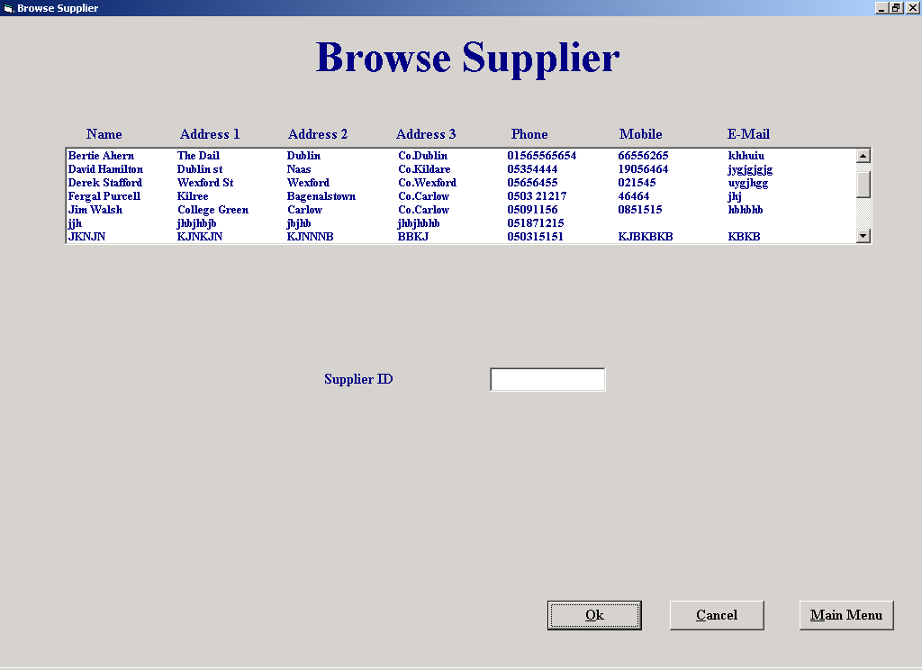

Code:
'The purpose of this screen is to allow the user to browse for a supplier or a customer.

'It allows the user to browse for the supplier or customer by placing all the persons
'details in a list box. The persons primary key is stored in the ItemData property
'of the list box.
'The user then clicks "Ok" and the primary key is passed back to the previous screen.

'Author Fergal Purcell
'Date 06/03/2002

'Variables used
'strTable : String ; This variable stores the name of the table to be browsed,
'e.g., "Customer" or "Supplier"

'Objects used
'datTable : Data Control; This data control fills the list of customers or suppliers
Option Explicit

'Use a DLL to place tab stops in a list box.
'This piece of code is taken from "Programming in Visual Basic 6.0, by Julia Case Bradley"

Private Declare Function SendMessage Lib "user32" Alias "SendMessageA" _
(ByVal hwnd As Long, ByVal wMsg As Long, ByVal wParam As Long, _
lParam As Any) As Long
Const LB_SETTABSTOPS = &H192

Private Sub cmdCancel_Click()
If frmBrowse.Tag = "Supplier" Then 'Tag property set to "Supplier" if coming from DeleteaSupplier screen
frmDeleteaSupplier.Show
ElseIf frmBrowse.Tag = "Customer" Then 'Tag property set to "Customer" if coming from DeleteaSupplier screen
frmMakeaPayment.Show
Else
frmOrdersReport.Show
End If
lstTable.Clear
Unload Me
End Sub

Private Sub cmdOk_Click()
If frmBrowse.Tag = "Supplier" Then 'Tag property set to "Supplier" if coming from DeleteaSupplier screen
frmDeleteaSupplier.txtSearch.Text = txtID.Text
frmDeleteaSupplier.Show
ElseIf frmBrowse.Tag = "Customer" Then 'Tag property set to "Customer" if coming from DeleteaSupplier screen
frmMakeaPayment.txtSearch.Text = txtID.Text
frmMakeaPayment.Show
Else
frmOrdersReport.txtList.Text = txtID.Text
frmOrdersReport.Show
End If
frmBrowse.Tag = ""
Unload Me
End Sub

Private Sub Form_activate()
Dim strTable As String
SetTabs lstTable 'Set the tabs in the list box
If frmBrowse.Tag = "Report" Then
strTable = "Supplier"
Else
strTable = frmBrowse.Tag 'Set which table is to be searched
End If
datTable.DatabaseName = strThePath
datTable.RecordSource = strTable
datTable.Refresh
If strTable = "Supplier" Then
Label1.Caption = "Browse Supplier" 'Search the Supplier table
While Not datTable.Recordset.EOF
If datTable.Recordset.Fields("Deletion") = False Then
lstTable.AddItem (datTable.Recordset("Supplier Name") & Chr(9) & datTable.Recordset("Address 1") & Chr(9) & datTable.Recordset("Address 2") & Chr(9) & datTable.Recordset("Address 3") & Chr(9) & datTable.Recordset("Phone No") & Chr(9) & datTable.Recordset("Mobile No") & Chr(9) & datTable.Recordset("E-Mail"))
lstTable.ItemData(lstTable.NewIndex) = (datTable.Recordset("Supplier_ID")) 'Store the suppliers ID
End If
datTable.Recordset.MoveNext
Wend
Else
Label1.Caption = "Browse Customer" 'Search the Customer table
Label2.Caption = "Customer ID"
While Not datTable.Recordset.EOF
If datTable.Recordset.Fields("Deletion") = False Then
lstTable.AddItem (datTable.Recordset("Name") & Chr(9) & datTable.Recordset("Address 1") & Chr(9) & datTable.Recordset("Address 2") & Chr(9) & datTable.Recordset("Address 3") & Chr(9) & datTable.Recordset("Phone No") & Chr(9) & datTable.Recordset("Mobile No") & Chr(9) & datTable.Recordset("E-Mail"))
lstTable.ItemData(lstTable.NewIndex) = (datTable.Recordset("Cust_ID")) 'Store the Customers ID
End If
datTable.Recordset.MoveNext
Wend
End If
End Sub
Private Sub lstTable_Click()
Dim strTheString As String
txtID.Text = lstTable.ItemData(lstTable.ListIndex) 'Get the Id if the person the user selected
End Sub
Private Sub SetTabs(lst As ListBox)
'Set the tab stops in a listbox
ReDim lngTabs(0 To 7) As Long 'Eight tab stops needed
Dim lngRtn As Long 'DLL function returns a long variable
lngTabs(0) = 70 'Twips measurement for 1st tab stop
lngTabs(1) = 140
lngTabs(2) = 210
lngTabs(3) = 280
lngTabs(4) = 350
lngTabs(5) = 420
lngTabs(6) = 490
lngRtn = SendMessage(lst.hwnd, LB_SETTABSTOPS, 7, lngTabs(0)) 'Set the stops
End Sub
Property Settings

Student Name: Fergal Purcell
Form Name: frmBrowse
Form Purpose: Allow the user to browse for a supplier or customer

Object | Property | Setting
datTable | DatabaseName | strThePath
 | RecordSource | Supplier
 |  | Customer

Make a Payment

Screen Shot:

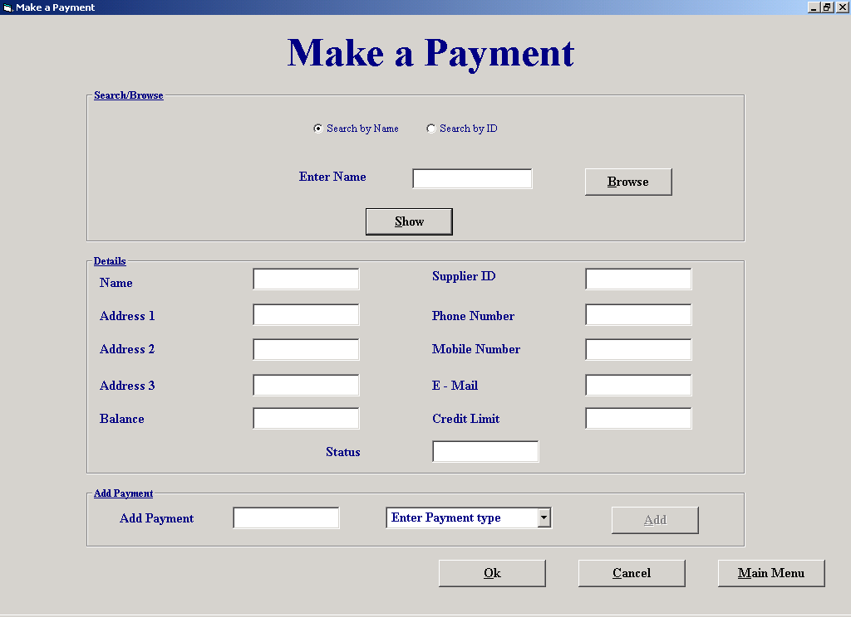

Code:
'The purpose of this screen is to allow the user to make a payment.

'The user enters either the customers name or primary key, or they can browse for the
'customer.
'When the user clicks "Show" the system finds the matching criteria in the customer
'table using the data control "datCustomer" and prints the customers details into text boxes.
'The user then enters the payment amount and selects the payment method from a combo box.
'When the user clicks "Add" the customers balance is updated and the payment details
'are stored in tags.
'If the user clicks "Cancel" the customers balance is stored to its original value.
'If the user clicks "Ok" the payment table is updated

'Author Fergal Purcell
'Date 06/03/2002

'Variables used
'strSql : String ; This variable stores the Sql statement.
'intSpace : Integer; Holds the position of the space as it marks the end of one primary key.
'intCounter : Integer; This variable is used as a control variable in a For Loop
'intPayID : Integer; Stores the system generated payment ID

'Objects used
'datCustomer : Data Control; This data control retrieves information from the "Customer" table and updates their balance owed

Option Explicit

Private Function CheckNum(ByVal strBox) As Boolean
'Bug in IsNumeric says that 6d6 is numeric
Dim intCounter As Integer
For intCounter = 1 To Len(strBox)
If Not IsNumeric(Mid(strBox, intCounter, 1)) Then 'Check each character
CheckNum = True
End If
Next
End Function

Private Sub cmdAdd_Click()
'This procedure updates the customers balance if he/she makes a payment, but it doesnt update the "Payment" table
Dim strSql As String
If txtPay.Text = "" Then
MsgBox "Please enter a payment amount", vbExclamation, "Enter amount"
ElseIf CheckNum(txtPay.Text) = True Then
MsgBox "Please enter a valid payment amount", vbExclamation, "Invalid data"
ElseIf cboType.ListIndex = -1 Then
MsgBox "Please select a payment type", vbExclamation, "Enter type"
Else
datCustomer.DatabaseName = strThePath
datCustomer.RecordSource = "Customer"
datCustomer.Refresh
datCustomer.Recordset.FindFirst "Cust_ID = " & txtID.Text
txtPay.Tag = txtPay.Tag & txtPay.Text & Chr(9) 'Store payments in case the user makes a mistake
cmdAdd.Tag = cmdAdd.Tag & txtID.Text & Chr(9) 'Store the customers ID
cboType.Tag = cboType.Tag & cboType.Text & Chr(9) 'Store the type of payment
txtStatus.Tag = txtStatus.Tag & txtStatus.Text & Chr(9)
datCustomer.Recordset.Edit
datCustomer.Recordset.Fields("Balance Owed") = datCustomer.Recordset.Fields("Balance owed") - txtPay.Text 'Update the Customers balance owed
If datCustomer.Recordset.Fields("Balance owed") <= datCustomer.Recordset.Fields("Credit Limit") Then
datCustomer.Recordset.Fields("Status") = "Normal" 'Change the customers status
txtStatus.Text = "Normal"
End If
datCustomer.Recordset.Update
txtBal.Text = datCustomer.Recordset.Fields("Balance owed")
End If
End Sub

Private Sub cmdCancel_Click()
If cmdAdd.Tag <> "" Then 'Display this message only if the user has added payments
If MsgBox("Do you wish to save payments?", vbQuestion + vbYesNo, "Save payments") = vbNo Then
CancelPay 'Call procedure that cancels the payments that a customer has made
Else
OkPay 'Call procedure that adds payments
End If
End If
If frmMakeaPayment.Tag = "" Then
frmMainMenu.Show
End If
Unload Me
End Sub

Private Sub cmdMM_Click()
If cmdAdd.Tag <> "" Then 'Display this message only if the user has added payments
If MsgBox("Do you wish to save payments?", vbQuestion + vbYesNo, "Save Payments") = vbNo Then
CancelPay
Else
OkPay
End If
End If
frmMainMenu.Show
Unload Me
End Sub

Private Sub cmdNext_Click()
datCustomer.Recordset.MoveNext
If datCustomer.Recordset.EOF Then
datCustomer.Recordset.MoveFirst
End If
AssignFields
End Sub

Private Sub cmdOk_Click()
OkPay
End Sub

Private Sub cmdPrevious_Click()
datCustomer.Recordset.MovePrevious 'Move to the previous match
If datCustomer.Recordset.BOF Then
datCustomer.Recordset.MoveLast
End If
AssignFields
End Sub

Private Sub cmdShow_Click()
ShowDetails
End Sub

Private Sub cmdBrowse_Click()
cmdNext.Visible = False
cmdPrevious.Visible = False
optID.Value = True 'Set the search type to ID search since browse returns the primary key
lblSearch.Caption = "Enter ID" 'Change the labels
frmBrowse.Show 'Display the browse screen
frmBrowse.Tag = "Customer"
End Sub

Private Sub Form_activate()
If frmMakeaPayment.Tag <> "" Then 'Check to see if the form has been activated from "Hiring of Equipment" or "Return of Equipment"
optID.Value = True
cmdMM.Enabled = False
txtSearch.Text = frmMakeaPayment.Tag 'frmMakeaPayment.Tag holds the customers ID
ShowDetails
End If
txtSearch.SetFocus
cboType.Clear
cboType.AddItem ("Cash") 'Add payment methods to the combo box
cboType.AddItem ("Cheque")
cboType.AddItem ("Credit Card")
cboType.Text = "Enter Payment type"
End Sub

Private Sub OptID_Click()
lblSearch.Caption = "Enter ID" 'Change the labels
txtSearch.SetFocus
txtSearch.Text = ""
End SubPrivate Sub OptName_Click()
lblSearch.Caption = "Enter Name"
txtSearch.Text = ""
txtSearch.SetFocus
End Sub

Private Sub AssignFields()
'This procedure assigns the text boxes
txtName.Text = datCustomer.Recordset.Fields("Name")
txtID.Text = datCustomer.Recordset.Fields("Cust_ID")
txtAdd1.Text = datCustomer.Recordset.Fields("[Address 1]")
txtAdd2.Text = datCustomer.Recordset.Fields("[Address 2]")
txtAdd3.Text = datCustomer.Recordset.Fields("[Address 3]")
txtPhone.Text = datCustomer.Recordset.Fields("[Phone No]")
txtMob.Text = "" + datCustomer.Recordset.Fields("[Mobile No]")
txtMail.Text = "" + datCustomer.Recordset.Fields("E-Mail")
txtBal.Text = datCustomer.Recordset.Fields("Balance owed")
txtCredit.Text = datCustomer.Recordset.Fields("Credit limit")
txtStatus.Text = datCustomer.Recordset.Fields("Status")
cmdAdd.Enabled = True
End Sub

Private Sub ShowDetails()
'This procedure searches for the customer and displays there details if found
cmdNext.Visible = False
cmdPrevious.Visible = False
datCustomer.DatabaseName = strThePath
datCustomer.RecordSource = "Customer"
datCustomer.Refresh
If OptName = True Then 'Search for matching name
Dim strSql As String
strSql = "Select Count(Customer.Name) AS CountOfSup From Customer Where Customer.[Name] Like '" & txtSearch.Text & "*'" & _
"And Customer.Deletion = false"
datCustomer.RecordSource = strSql
datCustomer.Refresh
If datCustomer.Recordset.Fields("CountOfSup") = 0 Or txtSearch = "" Then
MsgBox "There is no match.", vbExclamation, "No Match"
txtSearch.SetFocus
txtSearch.Text = ""
ElseIf datCustomer.Recordset.Fields("CountOfSup") = 1 Then
strSql = "Select * From Customer Where Customer.[Name] Like '" & txtSearch.Text & "*'" & _
"And Customer.Deletion = False"
datCustomer.RecordSource = strSql
datCustomer.Refresh
AssignFields
Else
cmdNext.Visible = True 'Display these buttons if there is more than one match
cmdPrevious.Visible = True
strSql = "Select * From Customer Where Customer.[Name] Like '" & txtSearch.Text & "*'" & _
"And Customer.Deletion = False"
datCustomer.RecordSource = strSql
datCustomer.Refresh
AssignFields
End If
Else 'Search for primary keys
If CheckNum(txtSearch.Text) = True Or txtSearch.Text = "" Then
MsgBox "Invalid data.", vbExclamation, "Invalid data"
txtSearch.SetFocus
txtSearch.Text = ""
Else
datCustomer.Recordset.FindFirst "Cust_ID = " & txtSearch.Text
If datCustomer.Recordset.NoMatch = True Or datCustomer.Recordset.Fields("Deletion") = True Then
MsgBox "There is no match.", vbExclamation, "Invalid data"
txtSearch.SetFocus
txtSearch.Text = ""
Else
AssignFields
End If
End If
End If
End Sub

Private Sub CancelPay()
'This procedure cancels all the payments added to the customers balance
Dim intTab As Integer, intTab2 As Integer, intTab3 As Integer
intTab = 1
intTab2 = 1
intTab3 = 1
Do Until cmdAdd.Tag = "" 'Restore the customers balance if the user presses cancel
intTab = InStr(cmdAdd.Tag, vbTab) 'Find the location of the space because it marks the end of one primary key
txtID.Text = Mid(cmdAdd.Tag, 1, intTab - 1) 'Find the primary key
datCustomer.DatabaseName = strThePath
datCustomer.RecordSource = "Customer"
datCustomer.Refresh
datCustomer.Recordset.FindFirst "Cust_ID = " & txtID.Text 'Find matching key field
datCustomer.Recordset.Edit
intTab2 = InStr(txtPay.Tag, vbTab) 'Find the location of the tab because it marks the end of every payment
intTab3 = InStr(txtStatus.Tag, vbTab)
datCustomer.Recordset.Fields("Balance owed") = (datCustomer.Recordset.Fields("Balance owed")) + (Mid(txtPay.Tag, 1, intTab2 - 1)) 'Restore the balance to the original settings
datCustomer.Recordset.Fields("Status") = Mid(txtStatus.Tag, 1, intTab3 - 1)
datCustomer.Recordset.Update
If Len(cmdAdd.Tag) <= 2 Then
cmdAdd.Tag = ""
Else
cmdAdd.Tag = Mid(cmdAdd.Tag, intTab + 1, (Len(cmdAdd.Tag) - (intTab - 1)))
txtPay.Tag = Mid(txtPay.Tag, intTab2 + 1, (Len(txtPay.Tag) - (intTab2 - 1)))
txtStatus.Tag = Mid(txtStatus.Tag, intTab3 + 1, (Len(txtStatus.Tag) - (intTab3 - 1)))
End If
Loop
End Sub

Private Sub OkPay()
'This procedure updates the payment table with all the payments added
Dim intTab As Integer, intTab2 As Integer, intTab3 As Integer, intPayID As Integer
intTab = 1
intTab2 = 1
intTab3 = 1
Do Until cmdAdd.Tag = ""
intTab = InStr(cmdAdd.Tag, vbTab) 'Find the location of the space because it marks the end of one primary key
txtID.Text = Mid(cmdAdd.Tag, 1, intTab - 1) 'Find the primary key
datCustomer.DatabaseName = strThePath
datCustomer.RecordSource = "Payment"
datCustomer.Refresh
If datCustomer.Recordset.RecordCount <> 0 Then
datCustomer.Recordset.MoveLast
intPayID = datCustomer.Recordset.Fields("Payment_ID") + 1 'Create a new payment ID
Else
intPayID = 1
End If
datCustomer.Recordset.AddNew
intTab2 = InStr(txtPay.Tag, vbTab) 'Find the location of the space because it marks the end of one primary key
intTab3 = InStr(cboType.Tag, vbTab)
With datCustomer.Recordset
.Fields("Payment_ID") = intPayID
.Fields("Cust_ID") = txtID.Text
.Fields("Date") = Date
.Fields("Amount") = Mid(txtPay.Tag, 1, intTab2 - 1) 'txtPay.Tag holds the payment amount
.Fields("Payment Method") = Mid(cboType.Tag, 1, intTab3 - 1) 'cboType.Tag holds the payment type
datCustomer.Recordset.Update
End With
If Len(cmdAdd.Tag) <= 2 Then
cmdAdd.Tag = ""
Else
cmdAdd.Tag = Mid(cmdAdd.Tag, intTab + 1, (Len(cmdAdd.Tag) - (intTab - 1))) 'Delete first ID since it has been processed
txtPay.Tag = Mid(txtPay.Tag, intTab2 + 1, (Len(txtPay.Tag) - (intTab2 - 1))) 'Delete first payment amount since it has been processed
cboType.Tag = Mid(cboType.Tag, intTab3 + 1, (Len(cboType.Tag) - (intTab3 - 1))) 'Delete first payment type since it has been processed
End If
Loop
If frmMakeaPayment.Tag = "" Then 'Go back to main menu or else back to rental or return
frmMainMenu.Show
End If
Unload Me
End Sub

Property Settings

Student Name: Fergal Purcell
Form Name: frmMakeaPayment
Form Purpose: Allow the user to enter a payment that the customer has made

Object | Property | Setting
datCustomer | DatabaseName | strThePath
 | RecordSource | Customer

Orders Report

Screen Shot:

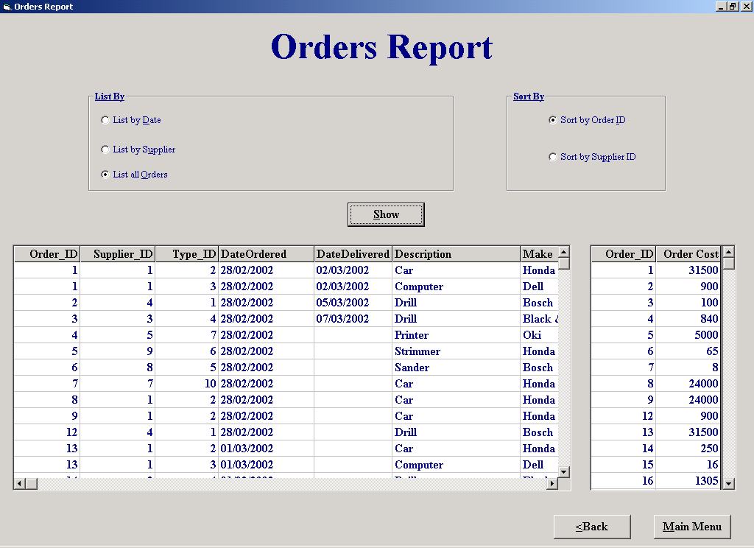

Code:
'The purpose of this screen is to show the user an order report.

'The user has the option of listing orders by date, by supplier, or all the orders.
'The user also has the option of sorting by order ID or supplier ID.
'When the user clicks show the details of every order is shown in one flex grid and each order cost is
'shown in another flex grid.

'Author Fergal Purcell
'Date 13/03/2002

'Variables used
'intCounter : Integer; This variable is used as a control variable in a For Loop
'strSql : String; This string variable is used to store an SQL
'strSort : String; Holds the field by which the user wishes to sort the report
'strSql2 : String; Stores the second SQL which finds the cost of each order

'Objects used
'datOrder : Data Control; Holds the result of the first SQL
'datTotal : Data Control; Holds the result of the second SQL

Option Explicit

Private Function CheckNum() As Boolean
'Bug in IsNumeric says that 6d6 is numeric
Dim intCounter As Integer
For intCounter = 1 To Len(txtList.Text)
If Not IsNumeric(Mid(txtList, intCounter, 1)) Then 'Check each character
CheckNum = True
End If
Next
End Function

Private Sub cmdBrowse_Click()
frmBrowse.Tag = "Report"
frmBrowse.Show
End Sub

Private Sub cmdShow_Click()
Dim strSql As String, strSort As String, strSql2 As String
datOrder.DatabaseName = strThePath
datTotal.DatabaseName = strThePath
If optSortOrder.Value = True Then
strSort = "Order.Order_ID"
Else
strSort = "Order.Supplier_ID"
End If
If optDate.Value = True Then 'List orders by date
If IsDate(txtList.Text) = True Then 'Check to see if user has entered the correct date
'strSql holds the SQL that finds all the order(s) placed since a particular date
strSql = "SELECT Order.Order_ID, Order.Supplier_ID, [Equipment Type].Type_ID, Order.DateOrdered, Order.DateDelivered, [Equipment Type].Description, [Equipment Type].Make, [Equipment Type].Model, [Equipment Type].Details, [Order/Equipment].QuantityOrdered, Equipment.[Purchase Price] " & _
"FROM ([Equipment Type] INNER JOIN ([Order] INNER JOIN [Order/Equipment] ON Order.Order_ID = [Order/Equipment].Order_ID) ON [Equipment Type].Type_ID = [Order/Equipment].Type_ID) INNER JOIN Equipment ON [Equipment Type].Type_ID = Equipment.Type_ID " & _
"GROUP BY Order.Order_ID, Order.Supplier_ID, [Equipment Type].Type_ID, Order.DateOrdered, Order.DateDelivered, [Equipment Type].Description, [Equipment Type].Make, [Equipment Type].Model, [Equipment Type].Details, [Order/Equipment].QuantityOrdered, Equipment.[Purchase Price], Equipment.Supplier_ID, Order.CancelOrder " & _
"Having (((Order.DateOrdered) >= #" & Format(txtList.Text, "MM, DD,YYYY") & "#) And ((Equipment.Supplier_ID) = [Order].[Supplier_ID]) And ((Order.CancelOrder) <> True)) " & _
"ORDER BY " & strSort & ""
'strSql2 holds the SQL that finds the cost of order(s) placed since a particular date
'"OrderReport" is a query table produced from the query that’s in strSql
strSql2 = "SELECT OrderReport.Order_ID, Sum([Purchase Price]*[QuantityOrdered]) AS [Order Cost] " & _
"From OrderReport " & _
"GROUP BY OrderReport.Order_ID, OrderReport.Supplier_ID, OrderReport.DateOrdered " & _
"Having (((OrderReport.DateOrdered) >= #" & Format(txtList.Text, "MM, DD, YYYY") & "#)) " & _
"ORDER BY " & strSort & ""
Else
MsgBox "Please enter a valid date", vbExclamation, "Invalid date"
txtList.Text = ""
End If
txtList.SetFocus
ElseIf optSupplier.Value = True Then 'List by supplier
If CheckNum = True Or txtList.Text = "" Then 'Call procedure CheckNum to see if the ID that the user has entered is numeric
MsgBox "Please enter a valid supplier number", vbExclamation, "Invalid number"
txtList.Text = ""
Else
'strSql holds the SQL that finds all the order(s) placed with a particular supplier
strSql = "SELECT Order.Order_ID, Order.Supplier_ID, [Equipment Type].Type_ID, Order.DateOrdered, Order.DateDelivered, [Equipment Type].Description, [Equipment Type].Make, [Equipment Type].Model, [Equipment Type].Details, [Order/Equipment].QuantityOrdered, Equipment.[Purchase Price] " & _
"FROM ([Equipment Type] INNER JOIN ([Order] INNER JOIN [Order/Equipment] ON Order.Order_ID = [Order/Equipment].Order_ID) ON [Equipment Type].Type_ID = [Order/Equipment].Type_ID) INNER JOIN Equipment ON [Equipment Type].Type_ID = Equipment.Type_ID " & _
"GROUP BY Order.Order_ID, Order.Supplier_ID, [Equipment Type].Type_ID, Order.DateOrdered, Order.DateDelivered, [Equipment Type].Description, [Equipment Type].Make, [Equipment Type].Model, [Equipment Type].Details, [Order/Equipment].QuantityOrdered, Equipment.[Purchase Price], Equipment.Supplier_ID, Order.CancelOrder " & _
"Having (((Order.Supplier_ID) = " & txtList.Text & ") And ((Equipment.Supplier_ID) = [Order].[Supplier_ID]) And ((Order.CancelOrder) <> True)) " & _
"ORDER BY " & strSort & ""
'strSql2 holds the SQL that finds the cost each order placed with a particular supplier
'"OrderReport" is a query table produced from the query that’s in strSql
strSql2 = "SELECT OrderReport.Order_ID, Sum([Purchase Price]*[QuantityOrdered]) AS [Order Cost]" & _
"From OrderReport " & _
"GROUP BY OrderReport.Order_ID, OrderReport.Supplier_ID " & _
"Having (((OrderReport.Supplier_ID) = " & txtList.Text & ")) " & _
"ORDER BY OrderReport.Order_ID;"
datOrder.RecordSource = strSql
datOrder.Refresh
If datOrder.Recordset.RecordCount = 0 Then
MsgBox "There is no match", vbExclamation, "No Match"
End If
End If
txtList.SetFocus
Else
'strSql holds the SQL that finds all the order(s)
strSql = "SELECT Order.Order_ID, Order.Supplier_ID, [Equipment Type].Type_ID, Order.DateOrdered, Order.DateDelivered, [Equipment Type].Description, [Equipment Type].Make, [Equipment Type].Model, [Equipment Type].Details, [Order/Equipment].QuantityOrdered, Equipment.[Purchase Price] " & _
"FROM ([Equipment Type] INNER JOIN ([Order] INNER JOIN [Order/Equipment] ON Order.Order_ID = [Order/Equipment].Order_ID) ON [Equipment Type].Type_ID = [Order/Equipment].Type_ID) INNER JOIN Equipment ON [Equipment Type].Type_ID = Equipment.Type_ID " & _
"GROUP BY Order.Order_ID, Order.Supplier_ID, [Equipment Type].Type_ID, Order.DateOrdered, Order.DateDelivered, [Equipment Type].Description, [Equipment Type].Make, [Equipment Type].Model, [Equipment Type].Details, [Order/Equipment].QuantityOrdered, Equipment.[Purchase Price], Equipment.Supplier_ID, Order.CancelOrder " & _
"Having (((Equipment.Supplier_ID) = [Order].[Supplier_ID]) And ((Order.CancelOrder) <> True)) " & _
"ORDER BY " & strSort & ""
'strSql2 holds the SQL that finds the cost each order
'"OrderReport" is a query table produced from the query that’s in strSql
strSql2 = "SELECT OrderReport.Order_ID, Sum([Purchase Price]*[QuantityOrdered]) AS [Order Cost] " & _
"From OrderReport " & _
"GROUP BY OrderReport.Order_ID " & _
"ORDER BY OrderReport.Order_ID "
End If
datOrder.RecordSource = strSql
datOrder.Refresh
datTotal.RecordSource = strSql2
datTotal.Refresh
End Sub

Private Sub cmdMM_Click()
frmMainMenu.Show
Unload Me
End Sub

Private Sub optAll_Click()
lblList.Visible = False
txtList.Visible = False
cmdBrowse.Visible = False
End Sub

Private Sub optDate_Click()
cmdBrowse.Visible = False
txtList.ToolTipText = "Enter date"
lblList.Visible = True
txtList.Visible = True
txtList.SetFocus
txtList.Text = ""
lblList.Caption = "Enter Date"
End Sub

Private Sub optSupplier_Click()
cmdBrowse.Visible = True
txtList.ToolTipText = "Enter ID"
lblList.Visible = True
txtList.Visible = True
txtList.SetFocus
txtList.Text = ""
lblList.Caption = "Enter ID"
End Sub

Property Settings

Student Name: Fergal Purcell
Form Name: frmOrdersReport
Form Purpose: Displays a report of the orders that the business has made

Object | Property | Setting
datOrder | DatabaseName | strThePath
 | RecordSource | strSQL
datTotal | DatabaseName | strThePath
 | RecordSource | strSQL2
flxOrder | DataSource | datOrder
flxTotal | DataSource | datTotal

Place an Order

Screen Shot:

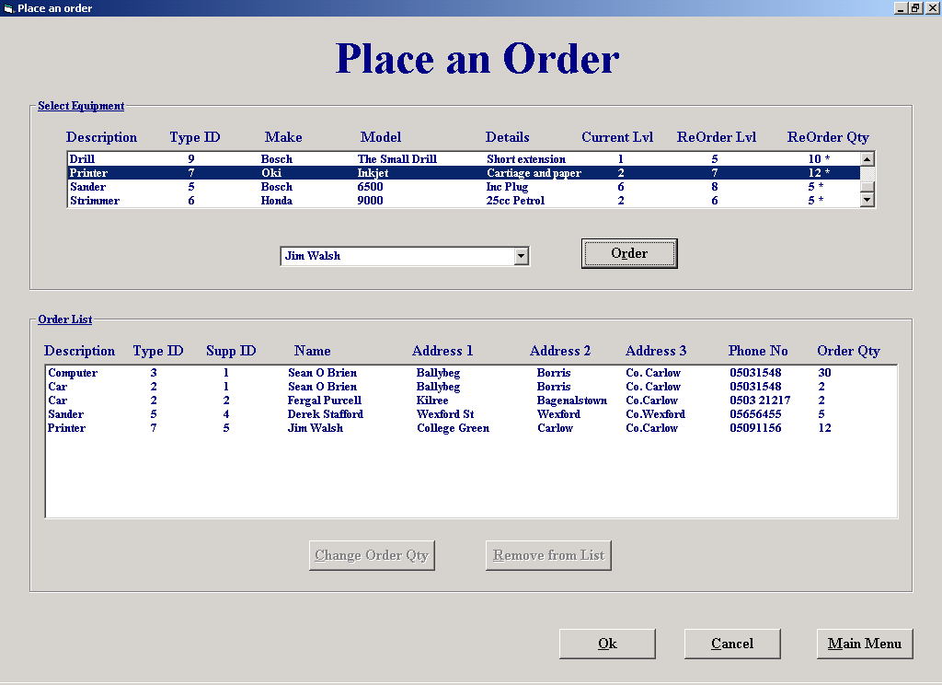

Code:
'The purpose of this screen is to allow orders to be placed with customers.

'When the form is activated the list box "lstEquip" is filled with details of every
'equipment type the business has, the equipment types ID is stored in the list boxes
'ItemData property.
'When the user selects the equipment type he wishes to order, the combo box "cboSupplier"
'is filled with names of every supplier that has supplied the equipment type and who is not
'marked for deletion.
'The user then selects the supplier he wishes to order from and clicks "Order".
'When "Order" is clicked the order is added to the list box "lstOrder".
'If the user wishes to change the order quantity he clicks "Change order Qty" and enters
'the amount required.
'If the user clicks "Remove from List" the order is removed from the list.
'When the user clicks "Ok" an order list is printed for every order and the table "Order" is
'updated with a separate order for every supplier and the table "Order/Equipment" is updated
'with every equipment type ordered.

'Author Fergal Purcell
'Date 06/03/2002

'Variables used
'strSql : String ; This variable stores the Sql statement.
'intSpace : Integer; Holds the position of the space as it marks the end of one primary key.
'intId : Integer; Stores the equipment type Id.
'intOrder_ID : Integer; Holds a concatenation of Suppier ID and Equipment Type ID.
'intIndex : Integer; Control variable.
'blnExist : Boolean; Returns true if an order already exists.
'strRecord : String; Holds the order to be changed.
'intMyPos : Integer; Stores to position of the last tab in strRecord.
'strNewAmt : Integer; The new amount required for a particular order of equipment.
'strSql : String; Holds the SQL statement
'intCounter : Integer; Holds a count an equipment that is in stock.
'intSuppID : Integer; Holds the suppliers ID.
'strSuppName : String; Holds the supplier name.
'strOrder : String; Stores details of an order for processing.
'strOrderID : String; Holds a system generated order ID.
'strSuppID : String; Holds the supplier ID.
'strTemp : Variant; Assigned a split of the order for processing as it goes through the loop.

'Objects used
'datOrder : Data Control; This data control is used to add new record to the "Order" table.
'datEquipment : Data Control; This data control is used to retrieve information from the "Equipment Type" table and the "Supplier" table.
'datSQL : Data Control; This data control is used to view the results of SQL's, its also used to retrieve information from the "Supplier" table.

Option Explicit

'Use a DLL to place tab stops in a list box.
'This piece of code is taken from "Programming in Visual Basic 6.0, by Julia Case Bradley"
Private Declare Function SendMessage Lib "user32" Alias "SendMessageA" _
(ByVal hwnd As Long, ByVal wMsg As Long, ByVal wParam As Long, _
lParam As Any) As Long
Const LB_SETTABSTOPS = &H192

Private Function CheckNum(strMyString) As Boolean
'Bug in IsNumeric says that 6d6 is numeric
Dim intCounter As Integer
For intCounter = 1 To Len(strMyString)
If Not IsNumeric(Mid(strMyString, intCounter, 1)) Then 'Check each character
CheckNum = True
End If
Next
End Function

Private Sub cboSupplier_Click()
cmdAdd.Enabled = True
End Sub

Private Sub cmdAdd_Click()
'This procedure creates an order with the selected supplier
Dim intID As Integer, intOrder_ID As Integer, intIndex As Integer, blnExist As Boolean
If cboSupplier.ListIndex = -1 Then 'Check that the user has selected a supplier
MsgBox "Please select a supplier", vbExclamation, "Select a supplier"
Else
intID = lstEquip.ItemData(lstEquip.ListIndex) 'Get the Type ID of the selected equipment type
SetTabs2 lstOrder 'Set the tabs
datEquipment.DatabaseName = strThePath
datEquipment.RecordSource = "Equipment Type"
datEquipment.Refresh
datSQL.DatabaseName = strThePath
datSQL.RecordSource = "Supplier"
datSQL.Refresh
datEquipment.Recordset.FindFirst "Type_ID = " & intID
datSQL.Recordset.FindFirst "Supplier_ID = " & cboSupplier.ItemData(cboSupplier.ListIndex) 'Find the matching suppliers record for the ID
intOrder_ID = datSQL.Recordset.Fields("Supplier_ID") & intID 'Create an order ID for every order in the list box so that only one specific order can be made
intIndex = 0
blnExist = False
For intIndex = 0 To lstOrder.ListCount - 1 'Check to see if the order already exists
If intOrder_ID = lstOrder.ItemData(intIndex) Then
blnExist = True
End If
Next intIndex
If blnExist = True Then
MsgBox "Order already exists", vbExclamation, "Order exists"
Else
With datEquipment.Recordset
lstOrder.AddItem (.Fields("Description") & Chr(9) & .Fields("Type_ID") & Chr(9) & (datSQL.Recordset.Fields("Supplier_ID")) & Chr(9) & (datSQL.Recordset.Fields("Supplier Name")) & Chr(9) & (datSQL.Recordset.Fields("Address 1")) & Chr(9) & (datSQL.Recordset.Fields("Address 2")) & Chr(9) & (datSQL.Recordset.Fields("Address 3")) & Chr(9) & (datSQL.Recordset.Fields("Phone No")) & Chr(9) & .Fields("ReOrder Quantity")) 'Add details of order
lstOrder.ItemData(lstOrder.NewIndex) = intOrder_ID 'Add order ID
End With
End If
End If
End Sub

Private Sub cmdCancel_Click()
If lstOrder.ListCount <> 0 Then 'Only display this message if there are orders in the list
If MsgBox("Do you wish to save orders?", vbQuestion + vbYesNo, "Save orders") = vbYes Then
OkOrder
End If
End If
frmMainMenu.Show
Unload Me
End Sub

Private Sub cmdCAR_Click()
'This procedure changes the amount required of a particular equipment type
Dim strRecord As String, intMyPos As Integer, strNewAmt As String
strRecord = lstOrder.List(lstOrder.ListIndex) 'Copy order details into string
intMyPos = InStrRev(strRecord, Chr(9)) 'Find the last space in the order details
strNewAmt = InputBox("Please enter the new amount required.", "ReOrder Quantity") 'Get the new amount from the user
If CheckNum(strNewAmt) = True Or strNewAmt = "" Then 'Call function CheckNum to see if inputted value is numeric
MsgBox "Invalid data", vbExclamation, "Invalid data"
ElseIf strNewAmt < 1 Then
MsgBox "Invalid data, no zero or negative amounts", vbExclamation, "Invalid data"
Else
strRecord = Mid(strRecord, 1, intMyPos)
strRecord = strRecord + strNewAmt 'Insert new amount into order details
lstOrder.List(lstOrder.ListIndex) = strRecord
End If
End Sub

Private Sub cmdMM_Click()
If lstOrder.ListCount <> 0 Then
If MsgBox("Save Orders?", vbQuestion + vbYesNo, "Save orders") = vbYes Then
OkOrder
End If
End If
frmMainMenu.Show
Unload Me
End Sub

Private Sub cmdOk_Click()
OkOrder 'Call procedure that prints order(s) and updates "Order" table
frmMainMenu.Show
Unload Me
End Sub

Private Sub cmdRemove_Click()
'This procedure removes an order from the list
If MsgBox("Are you sure you to remove this order from the list?", vbQuestion + vbYesNo, "Remove order") = vbYes Then
lstOrder.RemoveItem (lstOrder.ListIndex) 'Remove order from list
End If
cmdRemove.Enabled = False
cmdCAR.Enabled = False
End Sub

Private Sub Form_Load()
Dim strSql As String, intCounter As Integer, intID As Integer
SetTabs lstEquip 'Set the tabs in the list box
datEquipment.DatabaseName = strThePath
datEquipment.RecordSource = "Equipment Type"
datEquipment.Refresh
datSQL.DatabaseName = strThePath
While Not datEquipment.Recordset.EOF 'Display equipment types in stock
If datEquipment.Recordset.Fields("Deletion") = False Then 'Only display the equipment types that are not deleted
intID = datEquipment.Recordset.Fields("Type_ID")
strSql = "SELECT Count(Equipment.Type_ID) AS CountOfType_ID From Equipment Where Equipment.Type_ID= " & intID & "" 'Find how many equipment types are in stock
datSQL.RecordSource = strSql
datSQL.Refresh
intCounter = datSQL.Recordset.Fields("CountOfType_ID")
If datEquipment.Recordset.Fields("ReOrder Level") > intCounter Then 'Place an "*" at the end of the string to indicate that the stock level is lower than the reorder level
lstEquip.AddItem (datEquipment.Recordset("Description") & Chr(9) & datEquipment.Recordset("Type_ID") & Chr(9) & datEquipment.Recordset("Make") & Chr(9) & datEquipment.Recordset("Model") & Chr(9) & datEquipment.Recordset("Details") & Chr(9) & Str(intCounter) & Chr(9) & datEquipment.Recordset("[ReOrder Level]") & Chr(9) & datEquipment.Recordset("[ReOrder Quantity]") & " *")
Else
lstEquip.AddItem (datEquipment.Recordset("Description") & Chr(9) & datEquipment.Recordset("Type_ID") & Chr(9) & datEquipment.Recordset("Make") & Chr(9) & datEquipment.Recordset("Model") & Chr(9) & datEquipment.Recordset("Details") & Chr(9) & Str(intCounter) & Chr(9) & datEquipment.Recordset("[ReOrder Level]") & Chr(9) & datEquipment.Recordset("[ReOrder Quantity]"))
End If
lstEquip.ItemData(lstEquip.NewIndex) = (datEquipment.Recordset("Type_ID")) 'Store the type id in the ItemData property
End If
datEquipment.Recordset.MoveNext
Wend
End Sub

Private Sub SetTabs(lst As ListBox)
'Set the tab stops in a listbox
ReDim lngTabs(0 To 7) As Long 'Eight tab stops needed
Dim lngRtn As Long 'DLL function returns a long variable
lngTabs(0) = 75 'Twips measurement for 1st tab stop
lngTabs(1) = 120
lngTabs(2) = 180
lngTabs(3) = 260
lngTabs(4) = 340
lngTabs(5) = 400
lngTabs(6) = 460
lngRtn = SendMessage(lst.hwnd, LB_SETTABSTOPS, 7, lngTabs(0))
End Sub

Private Sub SetTabs2(lst As ListBox)
'Set the tab stops in a listbox
ReDim lngTabs(0 To 7) As Long 'Eight tab stops needed
Dim lngRtn As Long 'DLL function returns a long variable
lngTabs(0) = 65 'Twips measurement for 1st tab stop
lngTabs(1) = 110
lngTabs(2) = 150
lngTabs(3) = 230
lngTabs(4) = 305
lngTabs(5) = 360
lngTabs(6) = 425
lngRtn = SendMessage(lst.hwnd, LB_SETTABSTOPS, 7, lngTabs(0))
End Sub

Private Sub lstEquip_Click()
'This procedure finds all suppliers that supply the selected equipment type
Dim intID As Integer, strSql As String, intSuppID As Integer, strSuppName As String
cboSupplier.Clear
cboSupplier.Text = "Select a Supplier"
cmdAdd.Enabled = False
intID = lstEquip.ItemData(lstEquip.ListIndex) 'Get the type ID of the selected equipment type
strSql = "Select [Supplier/Type].Supplier_ID " & _
"From [Supplier/Type] INNER JOIN Supplier ON [Supplier/Type].Supplier_ID = Supplier.Supplier_ID " & _
" Where ((([Supplier/Type].Type_ID = " & intID & " AND ((Supplier.Deletion = False)))));"
datSQL.DatabaseName = strThePath
datEquipment.DatabaseName = strThePath
datEquipment.RecordSource = "Supplier"
datEquipment.Refresh
datSQL.RecordSource = strSql
datSQL.Refresh
While Not datSQL.Recordset.EOF
intSuppID = datSQL.Recordset.Fields("Supplier_ID")
datEquipment.Recordset.FindFirst "Supplier_ID = " & intSuppID 'Find the supplier
cboSupplier.AddItem (datEquipment.Recordset.Fields("[Supplier Name]"))
cboSupplier.ItemData(cboSupplier.NewIndex) = intSuppID 'Store the supplier ID
datSQL.Recordset.MoveNext
Wend
End Sub

Private Sub lstOrder_Click()
cmdCAR.Enabled = True
cmdRemove.Enabled = True
End Sub

Private Sub PrintHeader(ByVal Name As String, ByVal Add1 As String, ByVal Add2 As String, ByVal Add3 As String, ByVal ID As String, ByVal Phone As String, ByVal OrdID As String)
'This procedure prints every header for every page
With Printer 'Set the font
.FontName = "Times New Roman"
.Font.Size = 35
.FontUnderline = True
.ForeColor = &H800000
.FontBold = False
.FontItalic = True
End With
Printer.Print
Printer.Print Tab(9); "Equipment Hire System"
Printer.FontSize = 25
Printer.FontUnderline = False
Printer.Print
Printer.FontItalic = False
Printer.Print Tab(24); "Order List"
Printer.Print
Printer.FontSize = 17
Printer.Print Tab(7); Name
Printer.Print Tab(7); Add1
Printer.Print Tab(7); Add2
Printer.Print Tab(7); Add3
Printer.Print Tab(7); Phone
Printer.Print
Printer.Print Tab(7); "==============================================================="
Printer.Print Tab(7); "Supplier No. : "; ID; Tab(35); "Order No. : "; OrdID; Tab(65); "Date : "; Date
Printer.Print Tab(7); "==============================================================="
Printer.Print
Printer.FontUnderline = True
Printer.Print Tab(7); "ID"; Tab(15); "Make"; Tab(34); "Model"; Tab(50); "Details"; Tab(80); "Qty"
Printer.FontUnderline = False
Printer.Print
End Sub

Private Sub PrintDetails(ID As Integer, Make As String, Model As String, Details As String, ByVal Qty As String)
'This procedure prints the order details for every supplier
With Printer
.FontName = "Times New Roman"
.Font.Size = 15
.FontUnderline = False
.ForeColor = &H800000
End With
Printer.Print Tab(7); ID; Tab(17); Make; Tab(38); Model; Tab(56); Details; Tab(90); Qty
Printer.Print
End Sub

Private Sub OkOrder()
'This procedure prints out the order list and updates the "Order" table
Dim strOrder As String, intIndex As Integer, strOrderID As String, strSuppID As String, strTemp As Variant
Do While lstOrder.ListCount <> 0 'Do until all orders are removed from list and sent to printer
strOrder = lstOrder.List(intIndex)
strTemp = Split(strOrder, Chr(9))
strSuppID = strTemp(2) 'Get the supplier ID
datEquipment.DatabaseName = strThePath
datEquipment.RecordSource = "Equipment Type"
datEquipment.Refresh
datOrder.DatabaseName = strThePath
datOrder.RecordSource = "Order"
datOrder.Refresh
With datOrder.Recordset 'Create a new order for that supplier
If .RecordCount <> 0 Then 'Create order ID
.MoveLast
strOrderID = .Fields("Order_ID") + 1
Else
strOrderID = 1
End If
.AddNew 'Add a new order record
.Fields("Order_ID") = strOrderID
.Fields("Supplier_ID") = strSuppID
.Fields("DateOrdered") = Date
.Update
End With
PrintHeader strTemp(3), strTemp(4), strTemp(5), strTemp(6), strTemp(2), strTemp(7), strOrderID 'Print the header for the order sheet
Do While (intIndex <> lstOrder.ListCount) And (lstOrder.ListCount <> 0) 'Search the order list for matching suppliers ID
strTemp = Split(lstOrder.List(intIndex), Chr(9))
If strTemp(2) = strSuppID Then 'If true then add the current ordered euipment to the order list for that supplier
datOrder.RecordSource = "Order/Equipment"
datOrder.Refresh
With datOrder.Recordset
.AddNew 'Create a new Order/Equipment Record
.Fields("Order_ID") = strOrderID
.Fields("Type_ID") = strTemp(1)
.Fields("QuantityOrdered") = strTemp(8)
.Update
End With
datEquipment.Recordset.FindFirst "Type_ID = " & strTemp(1) 'Find equipment details
With datEquipment.Recordset
PrintDetails .Fields("Type_ID"), .Fields("Make"), .Fields("Model"), .Fields("Details"), strTemp(8) 'Print the description of the equipment that’s on order with the supplier
End With
lstOrder.RemoveItem (intIndex) 'Remove ordered equipment from list since it has been processed
Else
intIndex = intIndex + 1 'Move to next item on the order list
End If
Loop
Printer.NewPage 'Go to a new page for every supplier
intIndex = 0
Loop
Printer.EndDoc 'Start printing
End Sub
Property Settings

Student Name: Fergal Purcell
Form Name: frmPlaceanOrder
Form Purpose: Allows the user to place an order with a supplier

Object | Property | Setting
datOrder | DatabaseName | strThePath
 | RecordSource | Order
 |  | Order/Equipment
datEquipment | DatabaseName | strThePath
 | RecordSource | Equipment Type
 |  | Supplier
datSQL | DatabaseName | StrThePath
 | RecordSource | Supplier
 |  | strSQL

Supplier Maintenance Menu

Screen Shot:

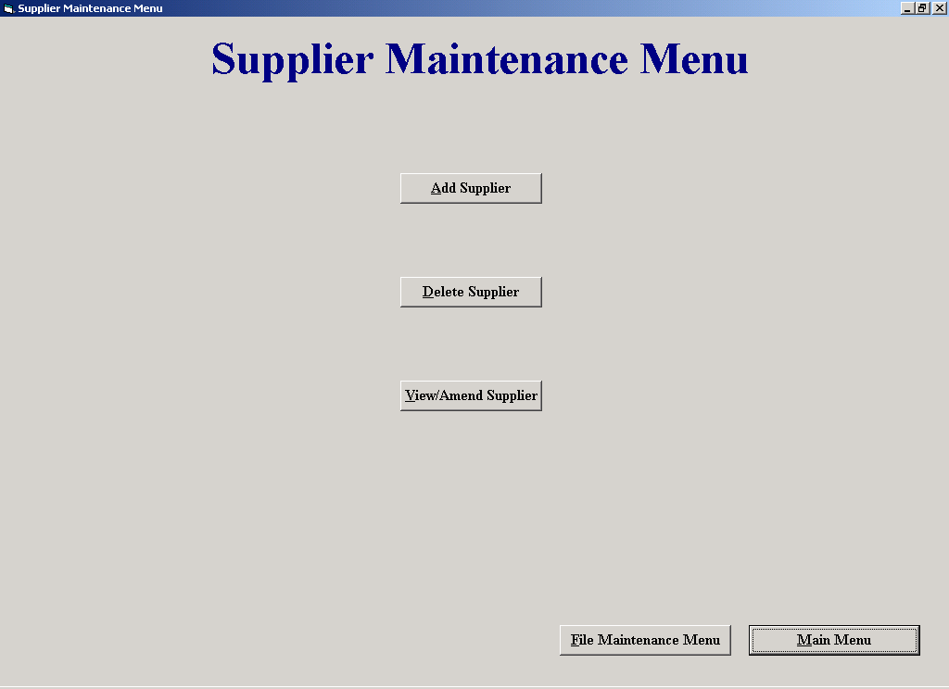

Code:
'The purpose of this screen is to allow the user to access the Add, Amend/View and Delete supplier screens.

'Author Fergal Purcell
'Date 06/03/2002

Option Explicit

Private Sub cmdAdd_Click()
frmAddaSupplier.Show
Unload Me
End Sub

Private Sub cmdDel_Click()
frmDeleteaSupplier.Show 'Display the delete a supplier screen
Unload Me
End Sub

Private Sub cmdFileMaintenance_Click()
frmFileMaintenanceMenu.Show
Unload Me
End Sub

Private Sub cmdMM_Click()
frmMainMenu.Show
Unload Me
End Sub

Private Sub cmdViewAmend_Click()
frmAmendViewaSupplier.Show
Unload Me
End Sub

Property Settings

Student Name: Fergal Purcell
Form Name: frmSupplierMaintenanceMenu
Form Purpose: Allows the user access screens that Add, Amend/View and Delete suppliers

Object | Property | Setting
None

