Add Equipment

Screen Shot:

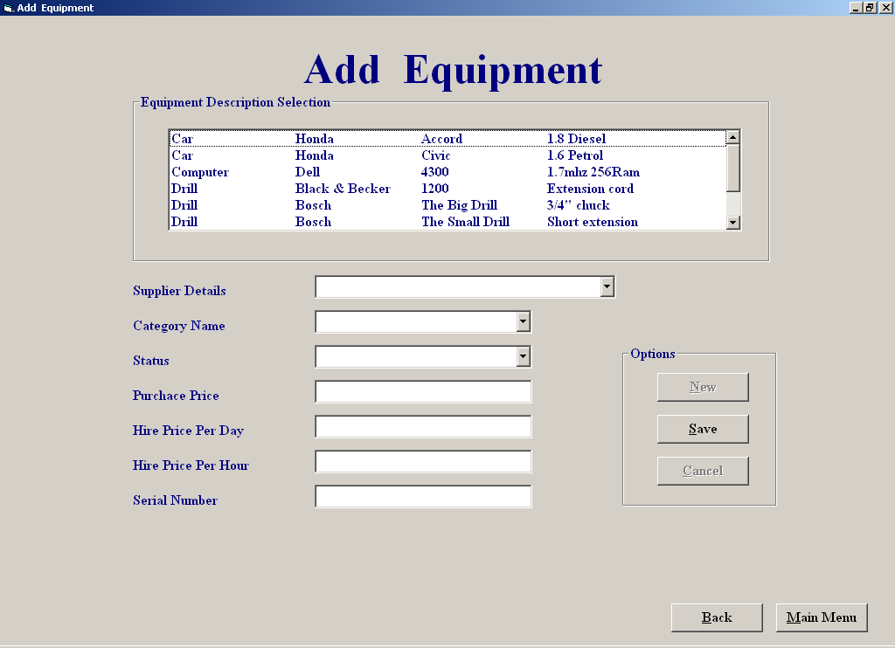

Purpose of screen:

The purpose of this screen is to allow the user to add in new in new equipment by simply selecting on some of the listed details and manually filling in the rest.

How to get to the screen:

1. Start up system;
- “Click” on “File Maintenance“ in the Main Menu screen;
- “Click” on “Equipment File Processing”;
- “Click “Add Equipment”.

How to use the screen:

- Select on one of the item description from the list ;
- Select the supplier of the equipment from the supplier drop down menu;
- Select the equipment status from the status drop down menu;
- Select the category of the equipment from the category drop down menu
- Manually fill in the rest of the details ,if you enter in any invalid data ie a letter where a number is expected you will receive the following warning message :

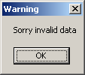

- If you try to save without filling all the details you will receive the following error message:

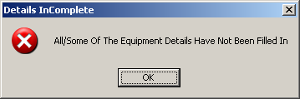

- Once all the correct details are entered you may save or cancel the newly saved record If you press cancel after saving new equipment details you will receive a confirmation message which looks like the message below:

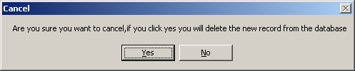

- If you want add another new equipment record to the list by pressing the “New” button

- you can repeat the process as often as you like.

- Click “Back” to return to the “Equipment File Processing” menu
Click “Main Menu” if you wish to return to the main menu.

Amend/View Equipment

Screen Shot:

Purpose of screen:

The purpose of this screen is to allow the user to amend or view existing equipment details

How to get to the screen:

1. Start up system;
a. Click on “File Maintenance“ in the Main Menu screen;
b. Click on “Equipment File Processing”;
c. Click “Amend/View Equipment”.

How to use the screen:

- Select on one of the item description from the list ;
- Select one of the search option on the screen;
- If you select the search by equipment description option ,you must select on one of the descriptions in the list in order to get any further
- Once the decription is selected a serial number drop drown menu will appear in which you will need to select one in order for a match to be found.

- If you choose the search by equipment ID a text box will appear for you to enter the equipment id number.if you enter an invalid id number you will receive the following error message:

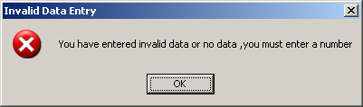

- Once you’ve selected an equipment description or have entered an equipment id number the rest of the equipment details will be displayed

- you can amend these details by clicking the “Amend button “
once the amendments are made you can either save them or cancel them as you so wish .the process can be continually repeated.

- Clicking the Back button takes you back to the equipment file processing menu

- Clicking the Main Menu button takes you back to the main menu

Delete Customer:

Screen Shot:

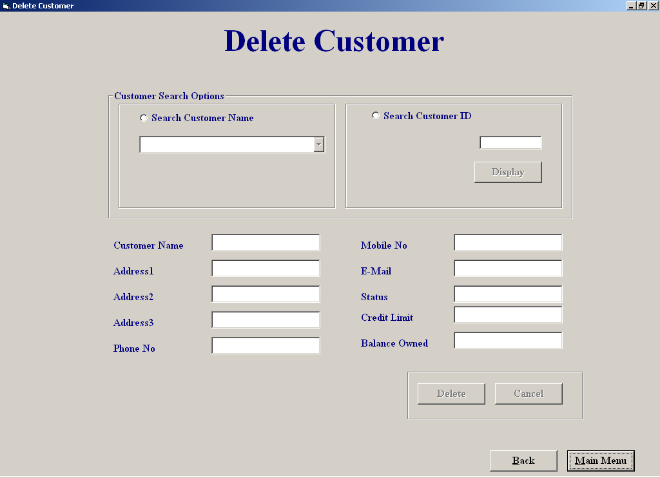

Purpose of screen:

The purpose of this screen is to allow the user to amend or view existing equipment details

How to get to the screen:

1. Start up system;
a . Click on “File Maintenance“ in the Main Menu screen;
- Click on “Customer File Processing”;
- Click “Delete Customer”.

How to use the screen:

- Choose option to search by customer name or search customer id

- If you choose the search by Customer name option you can select

- Select a customer name from the drop down menu

- If you search by customer id you must enter the customer id number and then

- Click the display button

- If you enter invalid characters in id field you will receive an invalid data message below;

- The customer cannot be deleted from the sytem if he/she has either an outstanding balance or still has equipment on hire you will recieve the following kind
if this happens

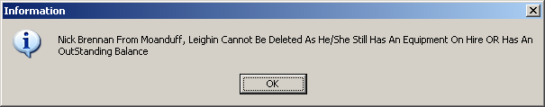

- if you wish to make an exception deletion you must enter a security code the option to do this will appear after the above message box, and will look like the message box below

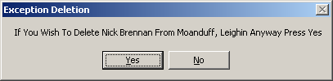

- If you click yes to the exception deletion option a message box will appear asking you to enter a security code (below)

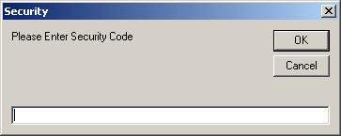

- You have 3 changes to enter the correct code if you fail a change you will get a message like below

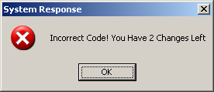

- you are then asked if you want to try enter the code again

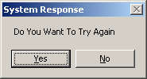

- Clicking the “Cancel” button lets you cancel all the deletion presently made
A confirmation message will appear if you do so (below)

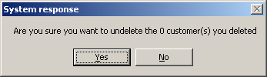

- Cicking the Back button takes you back to the customer file processing menu

- Clicking the Main Menu button takes you back to the main menu

Equipment Hired Report:

Screen Shot

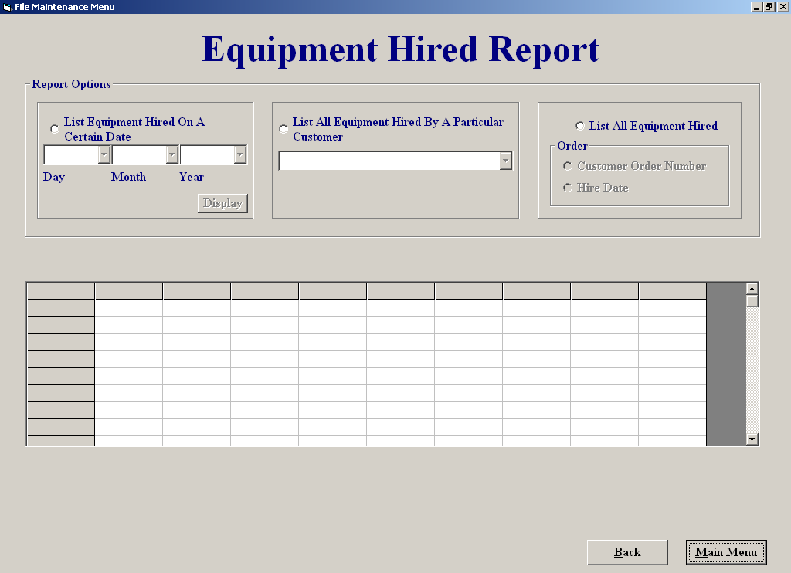

Purpose of screen:

The purpose of this screen is to allow the user to view all the equipment on hire in different formats

How to get to the screen:

1. Start up system;
a. Click on “Reports Menu“ in the Main Menu screen;
b. Click on “Equipment Hired Report ”;

How to use the screen:

- Click on the equipment hired on a certain date option allows you to select a date, which when entered ,the equipment hired on that date will appear in the grid,if you do not enter a date you will receive the following error message

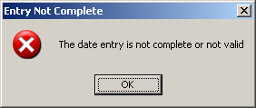

- Click on the All equipment hired by a particular customer allows you to select a customer, the equipment this customer has on hire then appears in the grid

- Click on the All equipment hired option allows you to order the equipment on hire by date or by customer Id number

- Clicking the Back button takes you back to the report menu

- Clicking the Main Menu button takes you back to the main menu

File Maintenance Menu:

Screen Shot:

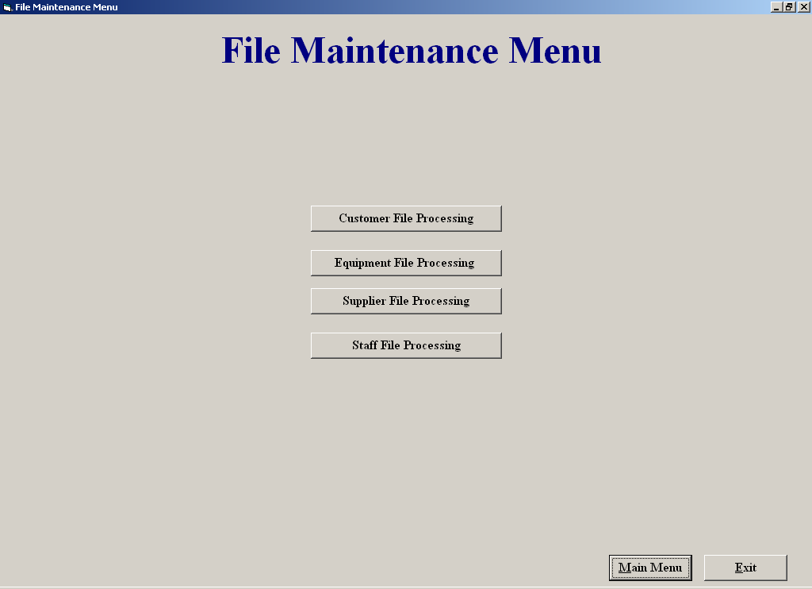

Purpose of screen:

The purpose of this screen is to allow the user easy access to all the different file processing

How to get to the screen:

1. Start up system;
a. Click on “File Maintenance“ in the Main Menu screen;

How to use the screen:

Clicking the Customer File Processing button allows you access to all the different customer maintenance options

- Clicking the Equipment File Processing button allows you access to all the different Equipment maintenance options

- Clicking the Supplier File Processing button allows you access to all the different supplier maintenance options

- Clicking the staff File Processing button allows you access to all the different staff maintenance options

Return Equipment

Screen Shot

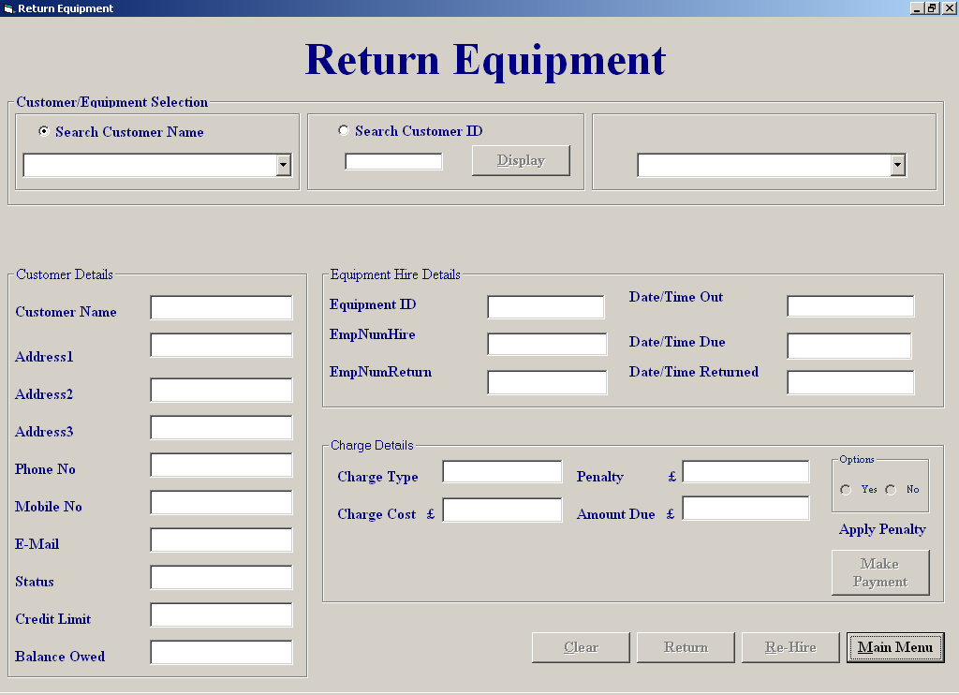

Purpose of screen:

The purpose of this screen is to allow the user to be able to accept a return of equipment when the equipment is return you can rehire it out to the same customer again by simply pressing the rehire button ,it also allows the user the option of
Accepting a payment from the customer penalties can also be applied at user discretion.

How to get to the screen:

1. Start up system;
- Click on “File Maintenance“ from the Menu screen;
- Click on “Equipment File Processing”;
- Click “Return Equipment”.

How to use the screen:

- Choose option to search by customer name or search customer id
If you choose the search by Customer name option you can select

- Select a customer name from the drop down menu
If you search by customer id you must enter the customer id number and then

- Click the “display” button

- If you enter invalid characters in id field you will receive an invalid data message Below;

- Once you have successfully selected a customer ,if this customer currently has no equipment on hire you will receive the following message

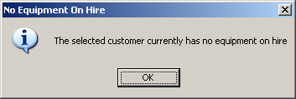

Once you have selected a customer move to the top right hand side and click on the drop down menu which holds all the equipment on hired to that particular customer

Select the equipment being returned ,when selected all that equipment details will appear on the screen.

Click return to return the equipment ,you will then be asked for an employee id number to accept the return

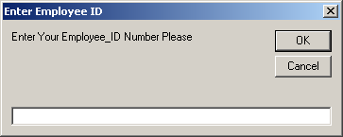

If invalid id number is entered you will receive the following error message

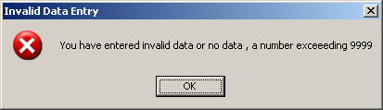

- If entry is successful you will be asked to confirm return

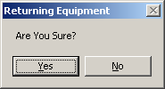

- If you say yes you will be told of confirmation of the return

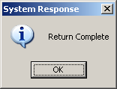

- Click “Make Payment” takes you to the make payment screen

- Click “Rehire” takes you to the hire equipment screen payment screen

- Click “Main Menu” if you wish to return to the main menu.

- Click “Back” to return to the “Equipment File Processing” menu

