Equipment Hire System

Start-Up Screen
Main Menu
Hire Equipment
Return Equipment
Payment Details
Reports
Clock-In Staff
File Maintenance
Receive an order
Customer Status
Place an Order
Equipment File Processing
Customer File Processing
Supplier File Processing
Staff File Processing
Customer Details Reports
Equipment Hired Report
Orders Reports
Payments Report
Add Equipment
Delete Equipment
Amend/View Equipment
Add Customer
Delete Customer
Amend/View Customer
Add Supplier
Delete Supplier
Amend/View Supplier
Delete Supplier
Amend/View Supplier

Student A

David Hamilton – COM2023

Reports Menu
Hire Equipment
Add Customer
Amend/View Customer
Delete Equipment
Payments Report

Hiring of equipment

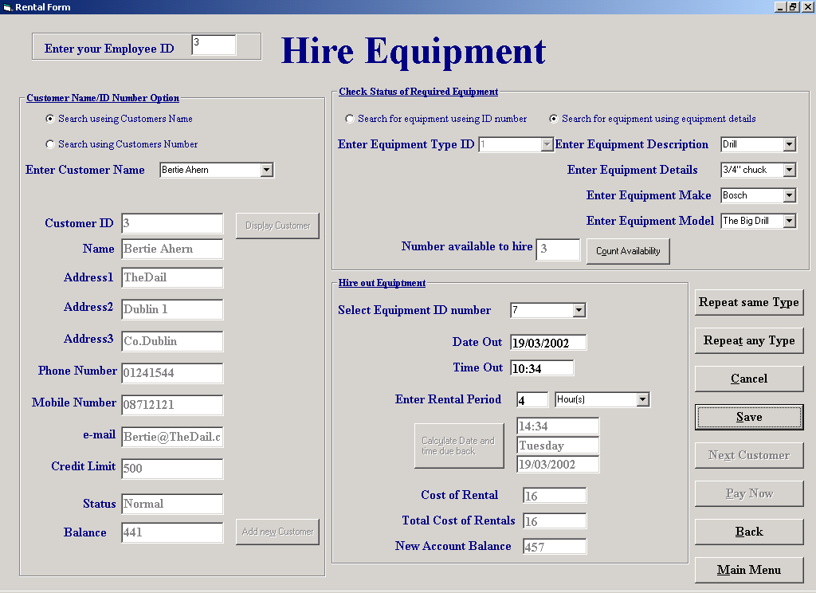

Purpose of screen
This screen allows the user of the system to hire out any available piece of equipment to a customer. The customer’s name, part of the customers name or the customers ID number can be entered. Alternatively the new customer screen can be accessed directly so a new customer can be added. The Type of equipment customer requires to rent can then be entered by Type ID number or searched for by Details, Description, Make and Model. The number available to rent is then being displayed and the equipment ID can be selected from a list.

How to get to the screen
The screen can be accessed directly from the main menu by selecting the Hire Equipment Button. Also this screen is opened from the Return of equipment screen by selecting the Rehire Button.

How to use the screen
This is quite a complicated screen and to have an understanding of the screen it may help to have an overview of what is trying to be achieved in the screen.

The following details need to be taken into form a complete record of the hiring of each piece of equipment
- The Id number of the user (employee Id)
- The Id number of the customer hiring the equipment
- The Id number of the piece of equipment being hired
- The date the hiring of the equipment starts on
- The period of time the hiring is to for (The expected return date is calculated and stored as part of the record)
- Any change in the customers account balance (stored as part of the customers record)
- Information relating to the availability of the hired equipment (i.e. This piece of equipment is not available for hire until it is returned (stored in the record of the specific piece of equipment))

For the purposes of improving ease of use of the screen the screen has been divided in to 5 distinct areas
- Entering the employee ID
- Searching for and identifying the customer
- Searching for and identifying the specific piece of equipment
- Other relevant Details
- Options after data has been entered

Entering the employee ID
- When the screen is first opened cursor will be located in the data input box marked “Enter your Employee ID”
- Enter your employee ID in the box
- If the ID enter is incorrect an error dialog box will appear prompting you to reenter the ID number

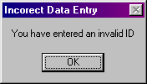

Selecting OK will allow you to reenter the ID

Searching for and identifying the customer
- A customer can be searched for by name or number
- If you wish to select to search for a customer by name (this is the default and is selected automatically when the screen opens) select the “Search using Customer’s Name “ option
- Then either
- View a list of all possible names of customers who have accounts with the company by selecting the down arrow on the right of the data input box marked “Enter Customer name”
- Then select a name by clicking on it (To allow a quick search the names are sorted alphabetically)
- When a name has been selected it will appear in the data input part of the input box
- Or
- Alternatively type any part of the name in to the data input part of the input box marked “Enter Customer name”
- If you wish to select to search for a customer by ID number select the “Search using Customer’s Number “ option
- View a list of all possible ID numbers of customers who have accounts with the company by selecting the down arrow on the right of the data input box marked “Enter Customer name”
- Then select a name by clicking on it
- When a ID number has been selected it will appear in the data input part of the input box

- Select the “Display Customer” Button
- The ‘first match’ of the customers details will be displayed in the data input boxes allowing you to confirm the details are correct either from your own knowledge of the customer or by asking the customer to confirm his address etc
- If the customer has been ‘Blacklisted’ a message box will appear on the screen to bring this to your attention. When you select OK at the end of this box the customer’s details will be deleted and you should end the transaction at this point.

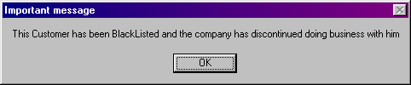

- If you have selected the “Search using Customer’s Name “ option and there is more than one match of the name entered then a box will appear with “The number of customers matching the search criteria” shown. There are two buttons on this box “Display Next” and Display Previous”. Selecting either buttons allows you to move through the customers displaying their full details. For your convince only the first customer will activate the ‘Blacklisted’ message box when he/she is displayed, so you should note the status of a customer as you confirm his details. But if you accidentally miss the ‘Blacklisted’ displayed in the ‘Status’ data input box the system will bring it to your attention when you attempt to search for equipment for the customer to hire.

- If the person seeking to hire out equipment has not used the company before and so is a new customer you can take his/her details by selecting the “Add new Customer”(alt-w) button and opening the ‘Add new Customer ‘ screen (A guide on how to use this screen is available in the Add new Customer section). When you return to this screen from the add new customer screen the name of the customer will be displayed in the “Enter Customer name” data input box. Select the “Display Customer” to view the customer’s details.

Searching for and identifying the specific piece of equipment
- To search for a piece of equipment and to confirm its availability you must search using known information about the type of equipment being searched for. This search can be carried out in one of two ways either by using the type ID or the Description, Details, Make and Model of the piece of equipment.
- To use the Type ID select the “Search for equipment using ID number” option

- Then either
- View a list of all possible ‘Equipment Type Ids’ available by selecting the down arrow on the right of the data input box marked “Enter Equipment Type ID”
- Then select a ‘Type ID Number’ by clicking on it
- When a ’Type ID Number’ has been selected it will appear in the data input part of the input box
- Or
- Enter the ‘Type ID’ of the equipment of in the “Enter Equipment Type ID” data input box

- To search by the Description, Details, Make and Model of the piece of equipment select the “ Search for Equipment using equipment details” option
- Then
- View a list of all possible ‘Equipment Descriptions’ available by selecting the down arrow on the right of the data input box marked “Enter Equipment Description”
- Then select the ’Description’ of the required piece of equipment by clicking on it
- When a ’ Description’ has been selected it will appear in the data input part of the input box
- Then
- View a list of all possible ‘Equipment Details’ available (where the ‘Description’ matches the ‘Description’ already chosen) by selecting the down arrow on the right of the data input box marked “Enter Equipment Details”
- Then select the ’ Details’ of the required piece of equipment by clicking on it
- When the ’ Details’ have been selected they will appear in the data input part of the input box
- Then
- View a list of all possible ‘Makes of the Equipment’ available (where the ‘Description’ matches the ‘Description’ already chosen and the ‘Details’ match the ‘Details’ already chosen) by selecting the down arrow on the right of the data input box marked “Enter Equipment Make”
- Then select the ’ Make’ of the required piece of equipment by clicking on it
- When the ’ Make’ has been selected it will appear in the data input part of the input box
- Then
- View a list of all possible ‘Models of the Equipment’ available (where the ‘Description’ matches the ‘Description’ already chosen and the ‘Details’ match the ‘Details’ already chosen and the ‘Make’ matches the ‘Make’ already chosen) by selecting the down arrow on the right of the data input box marked “Enter Equipment Model”
- Then select the ’ Model’ of the required piece of equipment by clicking on it
- When the ’ Model’ has been selected it will appear in the data input part of the input box
- Also at this stage the ‘Equipment Type ID’ will appear in the “Enter Equipment Type ID” data input box
- Select the “Count Availability” button to display the number of items of stock, which match the search criteria, are available to hire. The result of this check on stock is displayed in the “Number Available to hire” data input box.
- If the “Number Available to hire” data input box displays a zero there are no matches of the search criteria available to hire and a new selection process can be started.

Other relevant Details
- If the “Number Available to hire” data input box is not displaying a zero the ‘Equipment ID’ numbers of any equipment that matches the search criteria are loaded into the drop down list of the “Select Equipment ID Number” data input box

- View a list of all ‘Equipment IDs’ available by selecting the down arrow on the right of the data input box marked “Select Equipment ID Number”
- Then select the ‘Equipment ID’ of the piece of equipment retrieved from stock (Every piece of equipment should be marked/engraved/tagged with its unique ID number) by clicking on it
- When the ‘Equipment ID’ has been selected it will appear in the data input part of the input box
- The task of selecting an ‘Equipment ID’ by clicking on it will enter the present ‘Date’ and ‘Time’ in the “Date Out” and “Time Out” data input boxes. The Date and time can be change if necessary but it is expected that the present date and time will be the norm and so it set as a default. If an attempt to alter the date or time is made and the input boxes are left empty a message box will appear asking you to return to the input boxes and correct the error.

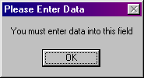

- If an attempt to alter the date in the “Date Out’ input box is made and the input is not a valid date a message box will appear asking you to return to the input box and correct the error.

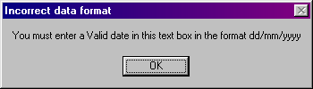

- If an attempt to alter the time in the “Time Out’ input box is made and the input is not a valid time a message box will appear asking you to return to the input box and correct the error.

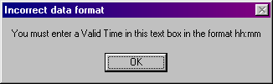

- Next you must enter the period of time that the equipment is being rented for. This is achieved by entering a number into the first part of the “Enter Rental Period” input boxes and selecting one of “Hour(s), “Day(s)” or ”Week(s)” from the drop down list of the second part of the “Enter Rental Period” input boxes. Neither of these two input boxes can be left but if one is accidentally left empty a message box will appear asking you to return to the input boxes and correct the error (See above message box headed “Please Enter Data”).
- Only a number is acceptable in the first part of the “Enter Rental Period” input boxes and if an error is made then a message box will appear asking you to return to the input box and correct the error.

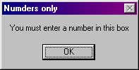

- Once the date, time have been entered you should select the “Calculate date and time due back” button which will display the date, day and time the selected equipment is due back (taking into account when the business is closed). A logical error may be encountered at this point if you have selected to enter 10 or more hours rather than a day a message box will appear asking you to return to the input box and correct the error

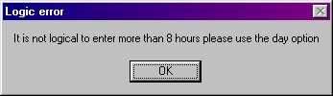

- Also Calculated by selecting the “Calculate date and time due back” button is the total cost of renting the equipment. The cost of this rental is shown in the “Cost of Rental” input box. The cost of all the rentals the customer has made so far is shown in the “Total Cost of Rental” input box. The balance of the customers account with the rentals added on is shown in the “New Account Balance” input box.

Options After Data has been entered
There are a number of options that can be selected after data has been input depending on your requirements. These options are
- Select the “Repeat Same Type”(alt-Y) button, which allows you to pick subsequent Equipment ID numbers where the ‘Equipment Type’ matches the one already selected. The details can then be filled in and the cost is added to the “Total cost of rental”
If there is no more of this type available to rent a message box will display this information

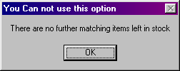

- Select the “Repeat Any Type”(alt-T) button which allows you to move back to the type selection section and select a piece of equipment that is different from the one presently being hired

- Select the “Clear”(alt-C) Button to clear all inputs that haven’t been saved

Select the “Save”(alt-S) Button to save the data input A message box will appear on screen allowing you to confirm that you wish to save. Select “OK” to save the data and “Cancel” to clear the data

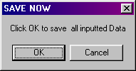

If the customer’s account is pushed over his credit limit by the rentals presently being saved then a message box appears on the screen reminding you that the customer should be informed of this situation and be in a position to make a payment immediately

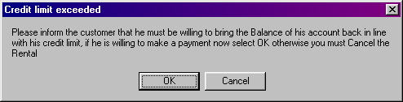

If OK is selected the rental is saved and the system will automatically open the make a payment screen
If Cancel is selected the details are not saved

- Select the “Pay Now”(alt-P) to open the “Make a Payment” screen

- Select the “Next Customer”(alt-x) to clear the details of the present customer and starting inputting the next customer (Note: this action does not clear the your employee ID and should only be used if you are dealing with the next customer)

- Select the “Main Menu”(alt-M) to return to the main menu. If there is unsaved/unlearned inputs in the screen when you select this button you will be prompted to save or clear by a message box

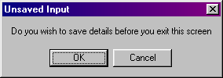

- Select the “Back”(alt-B) to return to the screen that you entered this screen from. If there is unsaved/unlearned inputs in the screen when you select this button you will be prompted to save or clear by a message box (Unsaved Input as above)

Amend\View a Customer

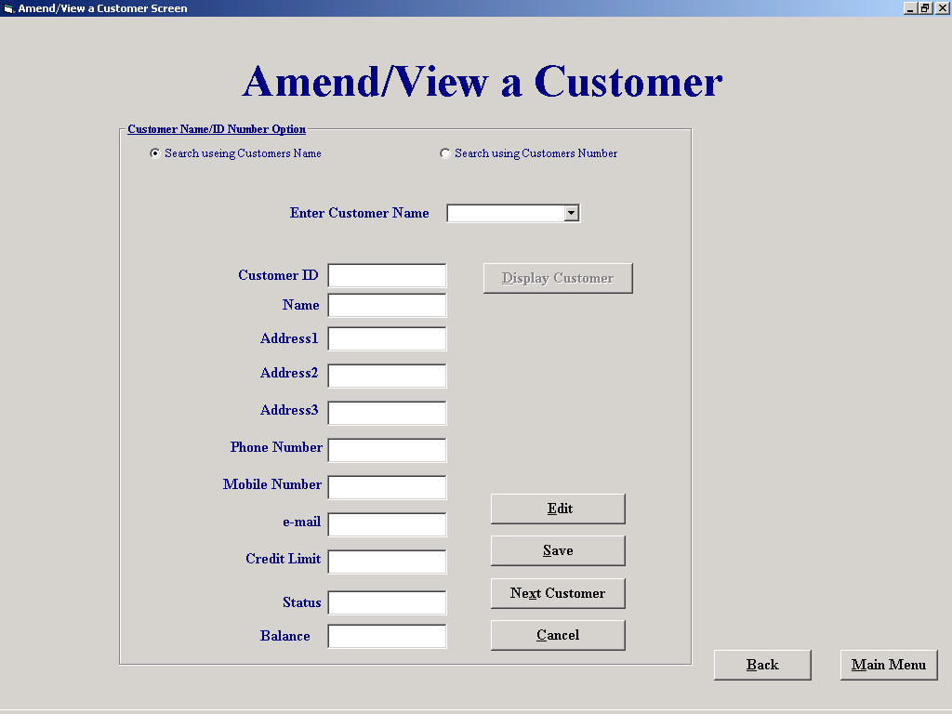

Purpose of this screen
This form allows the user to select a customer either by picking a customer ID from a drop down list, picking a customer name from a drop down list or by entering part of a name and searching through any names that match the criteria The Customers details can then be saved or amended. If a customers details are amended they will be temporarily stored in the associated tag of the relevant text box until the save command is selected. If the cancel command is selected then all amendments not saved will be deleted

How to get to the screen
Select “File Maintenance” button on the main menu, then the “Customer File processing on the File Maintenance menu followed by Amend View Customer Button

How to use the screen
- A customer can be searched for by name or number
- If you wish to select to search for a customer by name (this is the default and is selected automatically when the screen opens) select the “Search using Customer’s Name “ option
- Then either
- View a list of all possible names of customers who have accounts with the company by selecting the down arrow on the right of the data input box marked “Enter Customer name”
- Then select a name by clicking on it (To allow a quick search the names are sorted alphabetically)
- When a name has been selected it will appear in the data input part of the input box
- Or
- Alternatively type any part of the name in to the data input part of the input box marked “Enter Customer name”
- If you wish to select to search for a customer by ID number select the “Search using Customer’s Number “ option
- View a list of all possible ID numbers of customers who have accounts with the company by selecting the down arrow on the right of the data input box marked “Enter Customer name”
- Then select a name by clicking on it
- When a ID number has been selected it will appear in the data input part of the input box

- Select the “Display Customer” Button
- The ‘first match’ of the customers details will be displayed in the data input boxes allowing you to confirm the details are correct either from your own knowledge of the customer or by asking the customer to confirm his address etc
- If you have selected the “Search using Customer’s Name “ option and there is more than one match of the name entered then a box will appear with “The number of customers matching the search criteria” shown. There are two buttons on this box “Display Next” and Display Previous”. Selecting either buttons allows you to move through the customers displaying their full details.
- Selecting the “Edit”(alt-E) button allows you to make changes to the customer displayed on screen
- Selecting the “Next Customer”(alt-x) button allows to select another customer to view or amend (Note: you do not need to save the changes that you have presently displayed as these can be saved fore you exit the screen)
- Selecting the “Cancel”(alt-C) button clears all unsaved changes

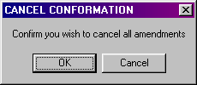

- Selecting the “Save” (alt&S) allows you to save all the customers records that you have altered

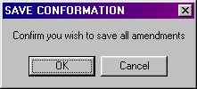

- Selecting the “Main Menu”(alt-M) brings you to the Main menu if there is unsaved data in the screen you will be prompted to save it with a message box

- Selecting the “Back”(alt-B) button brings you to the screen that you were in prior to this one

Reports Menu

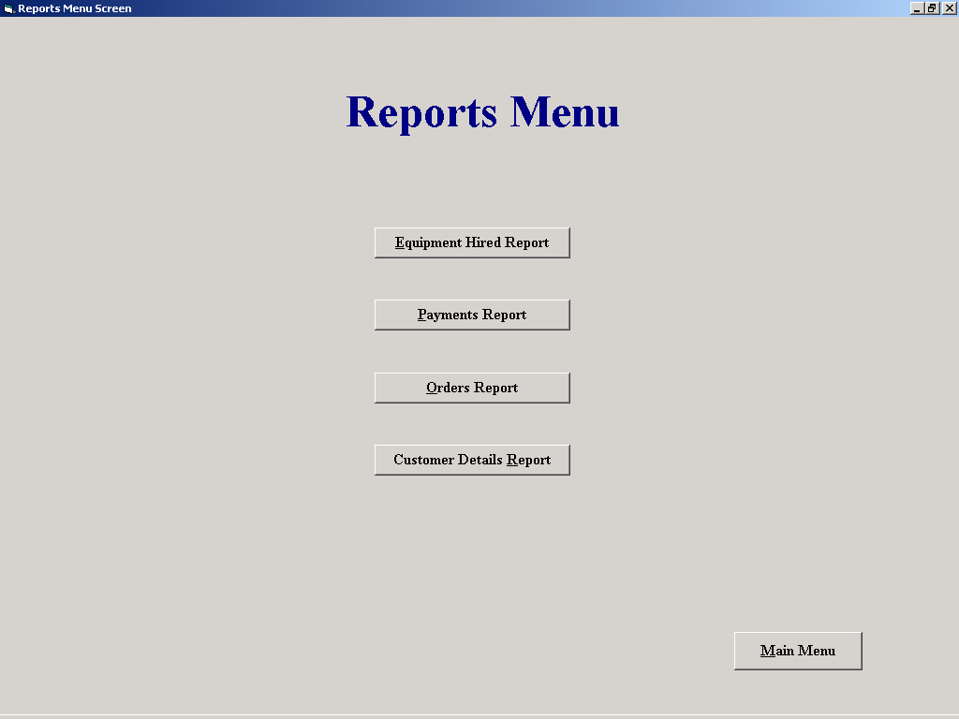

Purpose of the screen
This screen sole purpose is to form an acess point to a number of similar screens, in this case the reports screens

How to get to the screen
Select the “Reports Menu” button on the main menu

How to use the screen
Select the “Equipment Hired Report” button to open the ‘Equipment Hired Report’ screen.
Select the “Payments received Report” button to open the ‘Payments received Report’ screen.
Select the “Orders Report” button to open the ‘Orders Report’ screen.
Select the “Customer Report” button to open the ‘Customer Report’ screen.
Select the “Main Menu” Button to return to the ‘Main Menu’ screen

Payments Received report

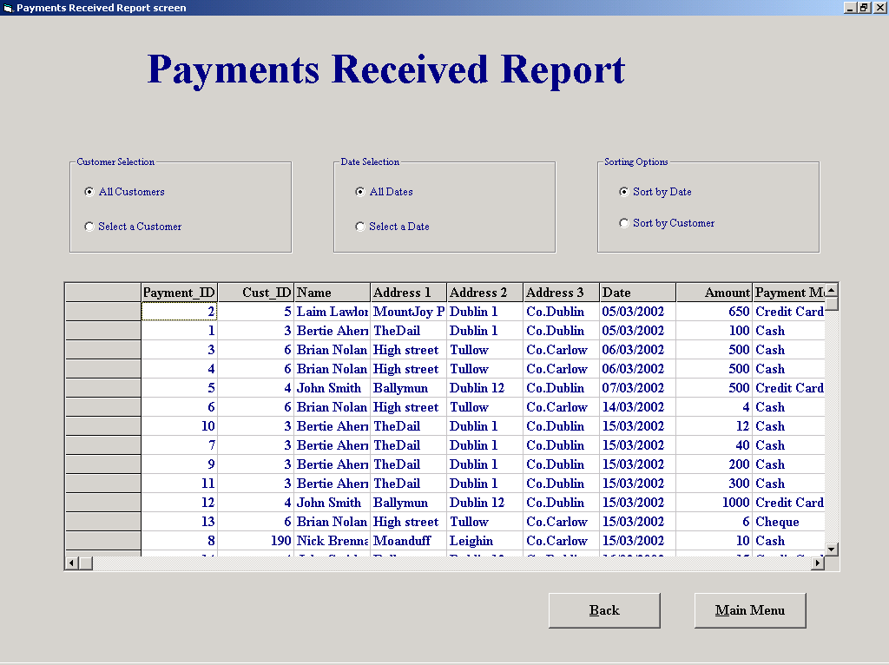

Purpose of the screen
To display a number of reports related to the monies received from customers, sorted by customer number or by date

How to get to the screen
Select the “Reports” option on the ‘Main Menu’ followed by the “Payments Report” option on the reports menu.

How to use the screen

There are six options for displaying the Payments report

List all customers
      - List all Dates
      - List a selected Customer
      - List Customers on a selected date
      - Sort by Customer ID
      - Sort by date
A combination of the options shown on the screen will display the selected selected out put, however to select a customer you need to search for that customer, and to select a specific date you need to input the date

Selecting a date
When you select the “Select a date” option a ‘Date Picker’ screen is displayed select the date and then confirm the date by selecting the “Confirm” button

Selecting a customer
- When you select the “Select a Customer “ option a small screen will appear in the center of the main screen this screen allows you to search for a customer
- A customer can be searched for by name or number
- If you wish to select to search for a customer by name (this is the default and is selected automatically when the screen opens) select the “Search using Customer’s Name “ option
- Then either
- View a list of all possible names of customers who have accounts with the company by selecting the down arrow on the right of the data input box marked “Enter Customer name”
- Then select a name by clicking on it (To allow a quick search the names are sorted alphabetically)
- When a name has been selected it will appear in the data input part of the input box
- Or
- Alternatively type any part of the name in to the data input part of the input box marked “Enter Customer name”
- If you wish to select to search for a customer by ID number select the “Search using Customer’s Number “ option
- View a list of all possible ID numbers of customers who have accounts with the company by selecting the down arrow on the right of the data input box marked “Enter Customer name”
- Then select a name by clicking on it
- When a ID number has been selected it will appear in the data input part of the input box

- Select the “Display Customer” Button and another screen will overlay the customer search screen this is the confirmation screen.
- The ‘first match’ of the customers details will be displayed in the data input boxes allowing you to confirm the details are correct either from your own knowledge of the customer or by asking the customer to confirm his address etc
- If you have selected the “Search using Customer’s Name “ option and there is more than one match of the name entered then a box will appear with “The number of customers matching the search criteria” shown in the confirmation screen. There are two buttons on this box “Display Next” and Display Previous”. Selecting either buttons allows you to move through the customers displaying their full details. Once the customer has been identified the “Confirm” button should be selected, this makes both the “Customer Search” screen and the “Confirm Screen” fade away.
- Select the “Main Menu”(alt-M) to return to the main menu.
- Select the “Back”(alt-B) to return to the screen that you entered this screen from in this case it has to be the Reports menu.

Add a Customer

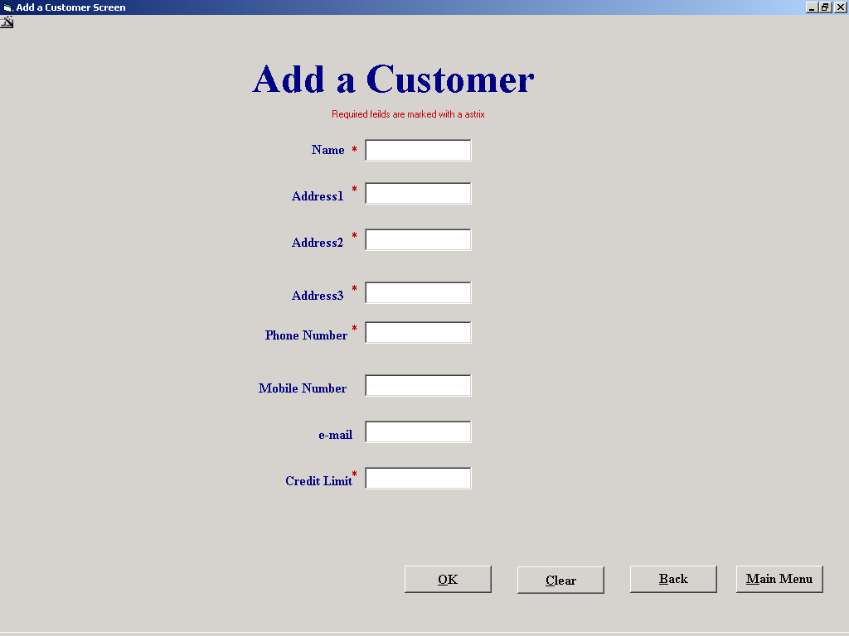

Purpose of the screen
The purpose of this screen is to allow the user to enter the details of a new customer; these will then be stored in a record with in the customer table. A unique ID number will be stored as part of the record.

How to get to this screen
This screen is opened by selecting “File Maintenance” button on the main menu, then the “Customer File processing on the File Maintenance menu followed by “Add a Customer”. Alternatively the screen can be selected from the “Hire Equipment” screen by selecting the “New Customer” button.

How to use this screen
- Enter the customers name into the “Name” input box. If this is left empty a message box will appear to prompt you to enter the information and return the cursor to the “Name” input box.

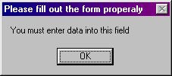

- Similarly you enter the customers address details in the data input boxes marked “Address 1”, “Address 2”, and “Address 3”. If any of these input boxes are left unfilled you will be prompted to fill them and the cursor returned.
- The customers phone number is to be entered into the “Phone number” input box and again you cannot leave this bit of information out.
- The next input box that needs to be filled is the “Credit Limit” data input box, if it is left unfilled you will again be prompted to fill in the necessary data but also if you attempt to fill this input with non numeric data you also be returned to correct your error.

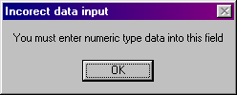

- The “email” and “Mobile phone” data input boxes need not be filled if the information is not available.
- The “Save” button takes the information entered on the screen and saves it as a new customer record. A message box prompt is given to get conformation of the save.
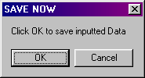

- The “Cancel” button clears the data input with out saving it. NOTE if the screen is responding to your input asking you to reenter it the cancel button can be used to clear the screen and start again.
- Selecting the “Main Menu”(alt-M) brings you to the Main menu if there is unsaved data in the screen you will be prompted to save it with a message box

- Selecting the “Back”(alt-B) button brings you to the screen that you were in prior to this one

Delete equipment

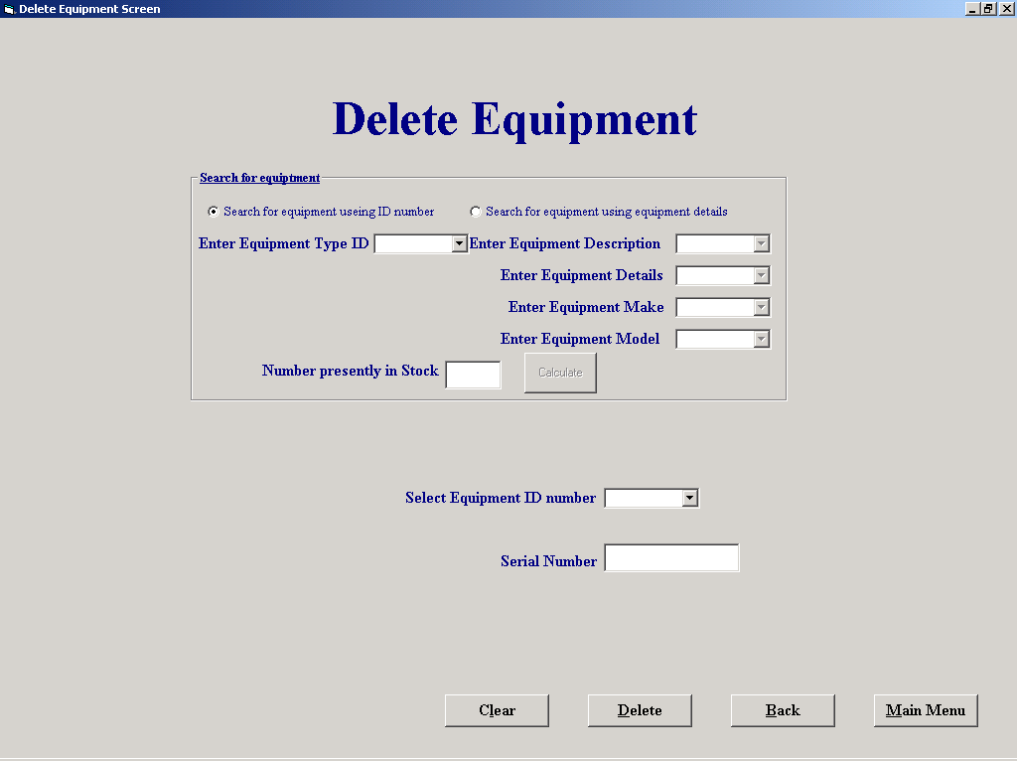

Purpose of the screen

This form allows the user to select a piece of equipment for and mark its record for deletion. If the user knows the equipments ID number he can input it in a text box and then confirm it's serial number and then delete it (If the piece of equipment is out on hire then it should not be deleted) Alternatively you can search for the ID numbers of all stock by selecting either their Type ID number or working your way down a number of selection steps to search the a unique type. Each step you take reduces the scope of your search. When you have chosen the type you require you can calculate the number in stock and add the ID numbers to drop down list of a combo box

How to get to the screen

This screen is opened by selecting the “File Maintenance” button on the main menu, then the “Equipment File processing” button on the File Maintenance menu followed by the “Delete equipment “Button.

How to use the screen
- To search for a piece of equipment and to confirm it is in stock and it can be deleted you must search using known information about the type of equipment being searched for. This search can be carried out in one of two ways either by using the type ID or the Description, Details, Make and Model of the piece of equipment.
- To use the Type ID select the “Search for equipment using ID number” option

- Then either
- View a list of all possible ‘Equipment Type Ids’ available by selecting the down arrow on the right of the data input box marked “Enter Equipment Type ID”
- Then select a ‘Type ID Number’ by clicking on it
- When a ’Type ID Number’ has been selected it will appear in the data input part of the input box
- Or
- Enter the ‘Type ID’ of the equipment of in the “Enter Equipment Type ID” data input box

- To search by the Description, Details, Make and Model of the piece of equipment select the “ Search for Equipment using equipment details” option
- Then
- View a list of all possible ‘Equipment Descriptions’ available by selecting the down arrow on the right of the data input box marked “Enter Equipment Description”
- Then select the ’Description’ of the required piece of equipment by clicking on it
- When a ’ Description’ has been selected it will appear in the data input part of the input box
- Then
- View a list of all possible ‘Equipment Details’ available (where the ‘Description’ matches the ‘Description’ already chosen) by selecting the down arrow on the right of the data input box marked “Enter Equipment Details”
- Then select the ’ Details’ of the required piece of equipment by clicking on it
- When the ’ Details’ have been selected they will appear in the data input part of the input box
- Then
- View a list of all possible ‘Makes of the Equipment’ available (where the ‘Description’ matches the ‘Description’ already chosen and the ‘Details’ match the ‘Details’ already chosen) by selecting the down arrow on the right of the data input box marked “Enter Equipment Make”
- Then select the ’ Make’ of the required piece of equipment by clicking on it
- When the ’ Make’ has been selected it will appear in the data input part of the input box
- Then
- View a list of all possible ‘Models of the Equipment’ available (where the ‘Description’ matches the ‘Description’ already chosen and the ‘Details’ match the ‘Details’ already chosen and the ‘Make’ matches the ‘Make’ already chosen) by selecting the down arrow on the right of the data input box marked “Enter Equipment Model”
- Then select the ’ Model’ of the required piece of equipment by clicking on it
- When the ’ Model’ has been selected it will appear in the data input part of the input box
- Also at this stage the ‘Equipment Type ID’ will appear in the “Enter Equipment Type ID” data input box
- Select the “Calculate” button to display the number of items of stock, which match the search criteria, are available to hire. The result of this check on stock is displayed in the “Number Presently in stock” data input box.
- If the “Number Presently in stock” data input box displays a zero there are no matches of the search criteria available to hire and a new selection process can be started.
- If the “Number Presently in stock” data input box is not displaying a zero the ‘Equipment ID’ numbers of any equipment that matches the search criteria are loaded into the drop down list of the “Select Equipment ID Number” data input box

- View a list of all ‘Equipment IDs’ available by selecting the down arrow on the right of the data input box marked “Select Equipment ID Number”
- Then select the ‘Equipment ID’ of the piece of equipment retrieved from stock (Every piece of equipment should be marked/engraved/tagged with its unique ID number) by clicking on it
- When the ‘Equipment ID’ has been selected it will appear in the data input part of the input box
- The task of selecting an ‘Equipment ID’ by clicking on it will enter this piece of equipments serial number into the “Serial Number” input box. This can then be used to confirm the equipments ID before deletion.

Alternatively

- If the piece of equipment is available you should be able to read the equipment number of the equipment (Every piece of equipment should be marked/engraved/tagged with its unique ID number). This can be entered into the “Select Equipment ID Number” input box and the serial number will be displayed in the “Serial Number” input box. This can then be used to confirm the equipments ID before deletion.
- This method is more likely to create errors as there is no check on present status so there is a couple of forms of error handling message box that will appear if an error is made
- If the status of the equipment is ‘Out’ i.e. the equipment is currently recorded as on hire then a message box will appear to inform you of this.

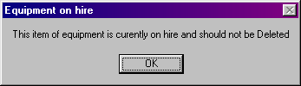

- If there is no record of the equipment then a message box will appear to inform you of this.

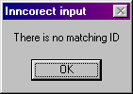

Select the “Delete”(alt-D) button to delete the displayed data a message box will appear to confirm that you require this equipment.

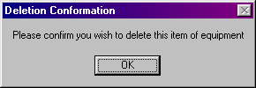

- Select the “Clear”(alt-C) button to clear the data displayed
- Selecting the “Main Menu”(alt-M) brings you to the Main menu if there is undeleted data in the screen you will be prompted to delete it now it with a message box

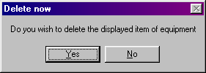

- Selecting the “Back”(alt-B) button brings you to the screen that you were in prior to this one the “Delete now” message box also appears.

Student B

Derek Stafford – COM2026

File Maintenance Menu
Return Equipment
Add Equipment
Amend/View Equipment
Delete Customer
Equipment Hired Report

Add Equipment

Screen Shot:

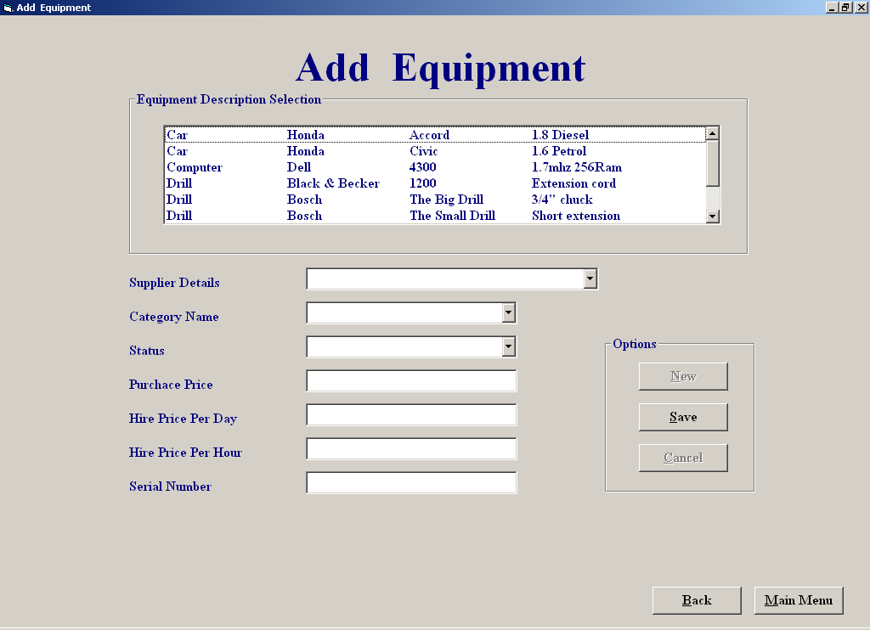

Purpose of screen:

The purpose of this screen is to allow the user to add in new in new equipment by simply selecting on some of the listed details and manually filling in the rest.

How to get to the screen:

1. Start up system;
- “Click” on “File Maintenance“ in the Main Menu screen;
- “Click” on “Equipment File Processing”;
- “Click “Add Equipment”.

How to use the screen:

- Select on one of the item description from the list ;
- Select the supplier of the equipment from the supplier drop down menu;
- Select the equipment status from the status drop down menu;
- Select the category of the equipment from the category drop down menu
- Manually fill in the rest of the details ,if you enter in any invalid data ie a letter where a number is expected you will receive the following warning message :

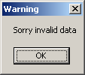

- If you try to save without filling all the details you will receive the following error message:

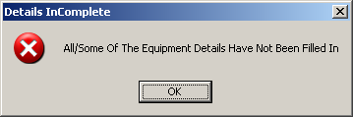

- Once all the correct details are entered you may save or cancel the newly saved record If you press cancel after saving new equipment details you will receive a confirmation message which looks like the message below:

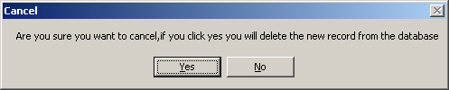

- If you want add another new equipment record to the list by pressing the “New” button

- you can repeat the process as often as you like.

- Click “Back” to return to the “Equipment File Processing” menu
Click “Main Menu” if you wish to return to the main menu.

Amend/View Equipment

Screen Shot:

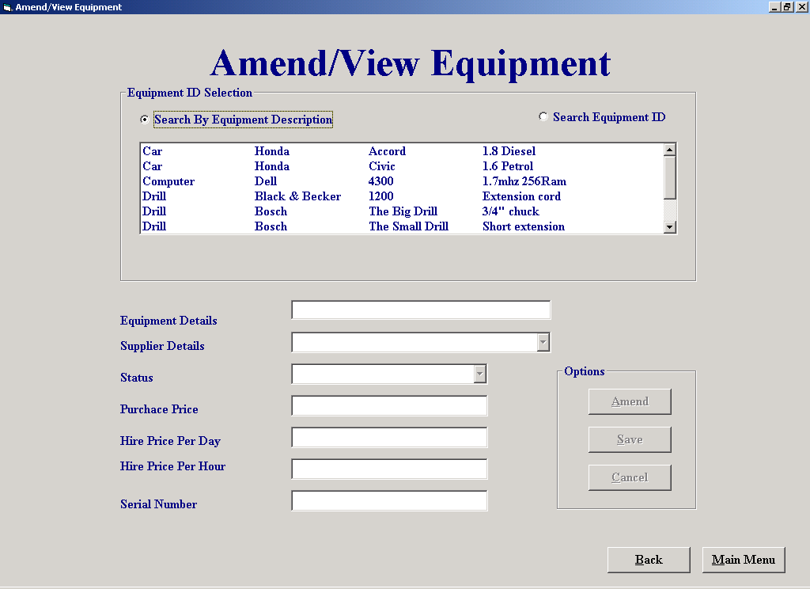

Purpose of screen:

The purpose of this screen is to allow the user to amend or view existing equipment details

How to get to the screen:

1. Start up system;
a. Click on “File Maintenance“ in the Main Menu screen;
b. Click on “Equipment File Processing”;
c. Click “Amend/View Equipment”.

How to use the screen:

- Select on one of the item description from the list ;
- Select one of the search option on the screen;
- If you select the search by equipment description option ,you must select on one of the descriptions in the list in order to get any further
- Once the decription is selected a serial number drop drown menu will appear in which you will need to select one in order for a match to be found.

- If you choose the search by equipment ID a text box will appear for you to enter the equipment id number.if you enter an invalid id number you will receive the following error message:

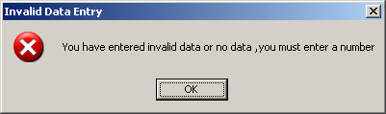

- Once you’ve selected an equipment description or have entered an equipment id number the rest of the equipment details will be displayed

- you can amend these details by clicking the “Amend button “
once the amendments are made you can either save them or cancel them as you so wish .the process can be continually repeated.

- Clicking the Back button takes you back to the equipment file processing menu

- Clicking the Main Menu button takes you back to the main menu

Delete Customer:

Screen Shot:

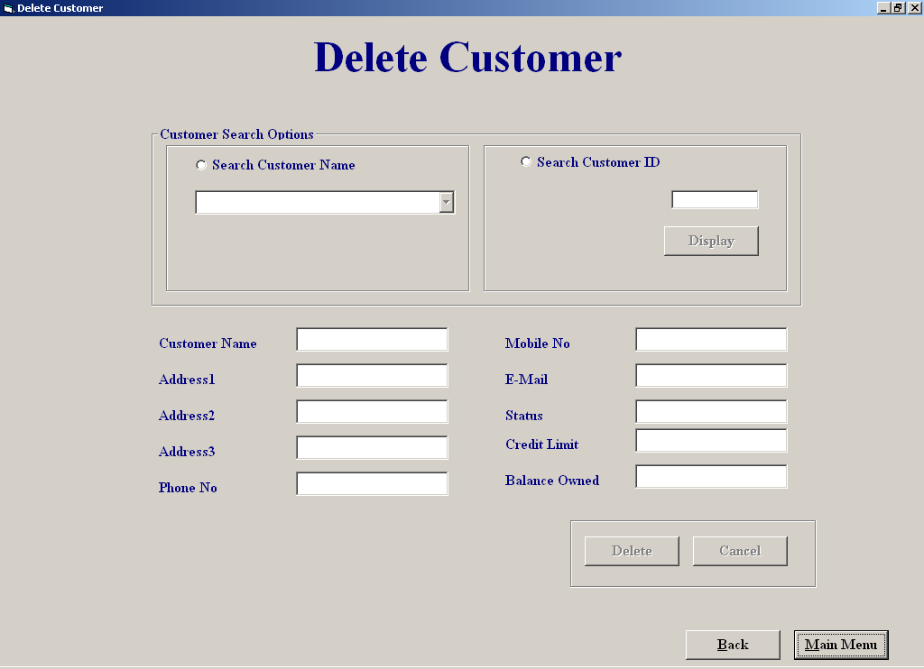

Purpose of screen:

The purpose of this screen is to allow the user to amend or view existing equipment details

How to get to the screen:

1. Start up system;
a . Click on “File Maintenance“ in the Main Menu screen;
- Click on “Customer File Processing”;
- Click “Delete Customer”.

How to use the screen:

- Choose option to search by customer name or search customer id

- If you choose the search by Customer name option you can select

- Select a customer name from the drop down menu

- If you search by customer id you must enter the customer id number and then

- Click the display button

- If you enter invalid characters in id field you will receive an invalid data message below;

- The customer cannot be deleted from the system if he/she has either an outstanding balance or still has equipment on hire you will recieves the following kind
if this happens

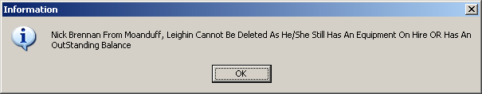

- if you wish to make an exception deletion you must enter a security code the option to do this will appear after the above message box, and will look like the message box below

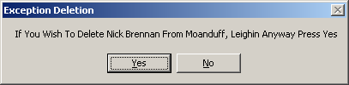

- If you click yes to the exception deletion option a message box will appear asking you to enter a security code (below)

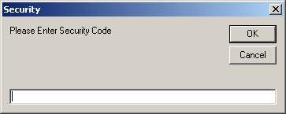

- You have 3 changes to enter the correct code if you fail a change you will get a message like below

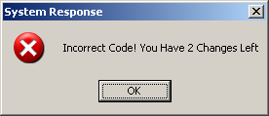

- you are then asked if you want to try enter the code again

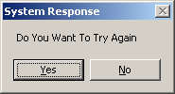

- Clicking the “Cancel” button lets you cancel all the deletion presently made
A confirmation message will appear if you do so (below)

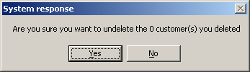

- Cicking the Back button takes you back to the customer file processing menu

- Clicking the Main Menu button takes you back to the main menu
Equipment Hired Report:

Screen Shot

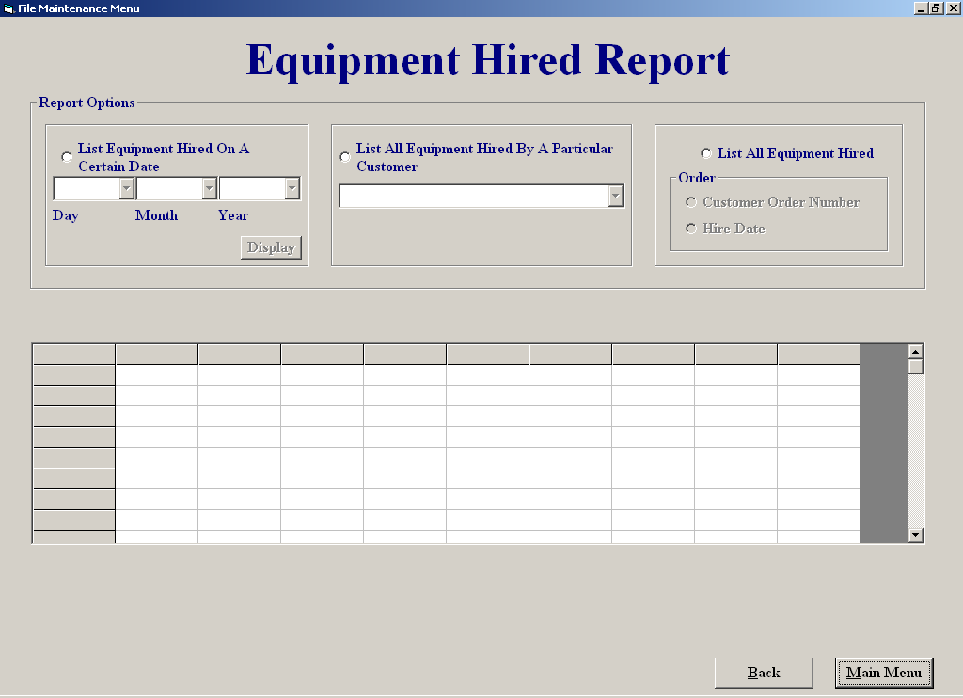

Purpose of screen:

The purpose of this screen is to allow the user to view all the equipment on hire in different formats

How to get to the screen:

1. Start up system;
a. Click on “Reports Menu“ in the Main Menu screen;
b. Click on “Equipment Hired Report ”;

How to use the screen:

- Click on the equipment hired on a certain date option allows you to select a date, which when entered ,the equipment hired on that date will appear in the grid,if you do not enter a date you will receive the following error message

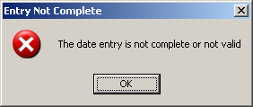

- Click on the All equipment hired by a particular customer allows you to select a customer, the equipment this customer has on hire then appears in the grid

- Click on the All equipment hired option allows you to order the equipment on hire by date or by customer Id number

- Clicking the Back button takes you back to the report menu

- Clicking the Main Menu button takes you back to the main menu

File Maintenance Menu:

Screen Shot:

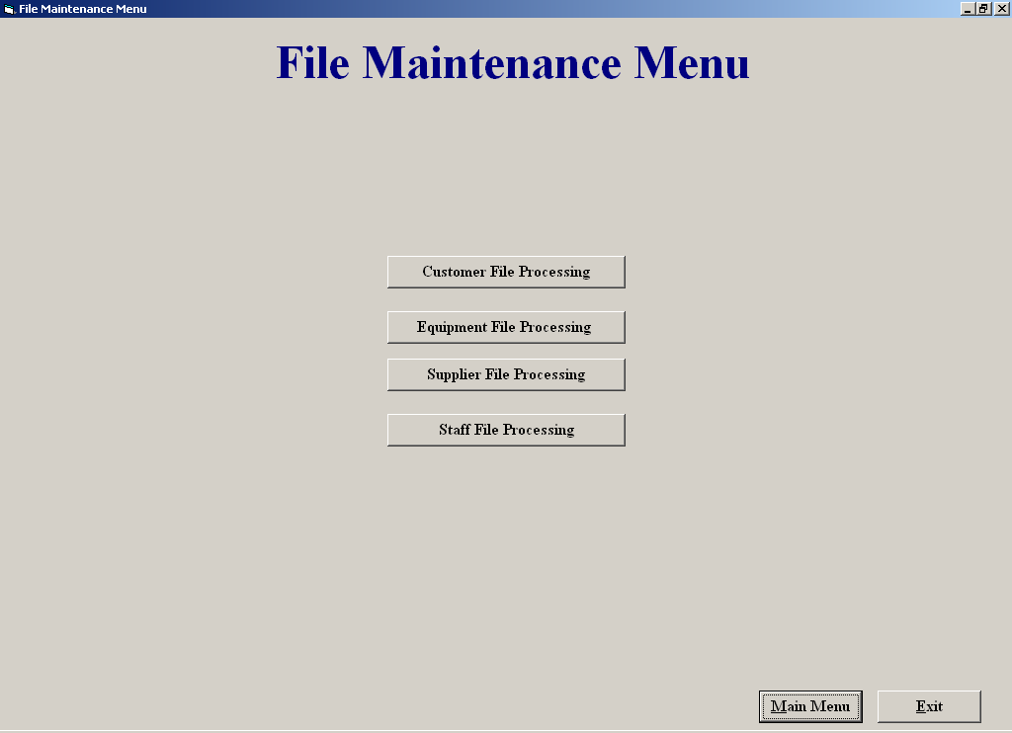

Purpose of screen:

The purpose of this screen is to allow the user easy access to all the different file processing

How to get to the screen:

1. Start up system;
a. Click on “File Maintenance“ in the Main Menu screen;

How to use the screen:

Clicking the Customer File Processing button allows you access to all the different customer maintenance options

- Clicking the Equipment File Processing button allows you access to all the different Equipment maintenance options

- Clicking the Supplier File Processing button allows you access to all the different supplier maintenance options

- Clicking the staff File Processing button allows you access to all the different staff maintenance options

Return Equipment

Screen Shot

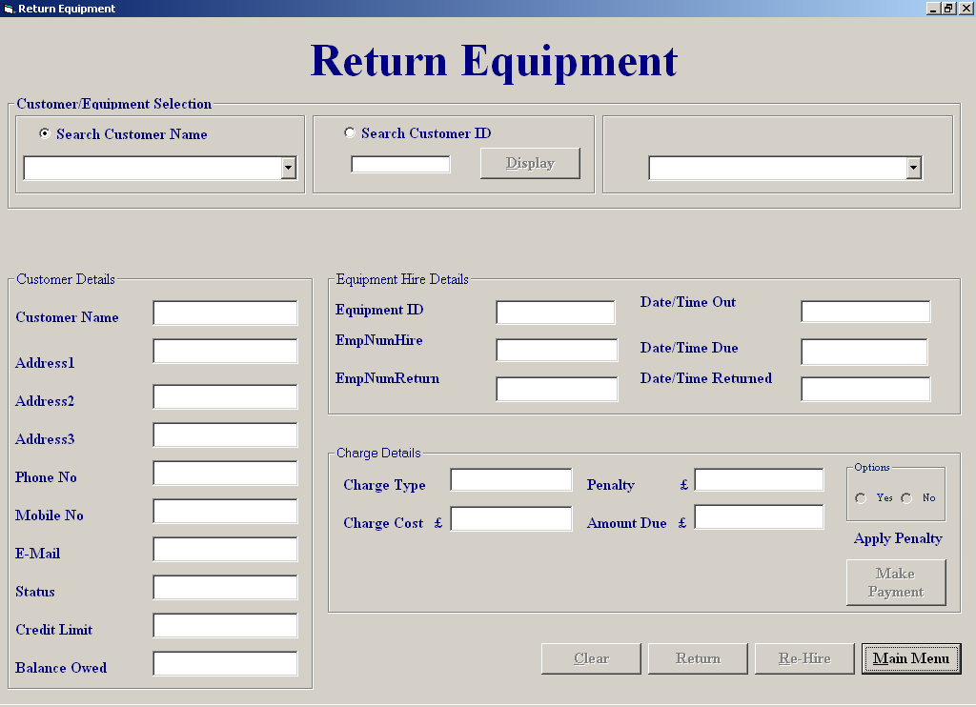

Purpose of screen:

The purpose of this screen is to allow the user to be able to accept a return of equipment when the equipment is return you can rehire it out to the same customer again by simply pressing the rehire button ,it also allows the user the option of
Accepting a payment from the customer penalties can also be applied at user discretion.

How to get to the screen:

1. Start up system;
- Click on “File Maintenance“ from the Menu screen;
- Click on “Equipment File Processing”;
- Click “Return Equipment”.

How to use the screen:

- Choose option to search by customer name or search customer id
If you choose the search by Customer name option you can select

- Select a customer name from the drop down menu
If you search by customer id you must enter the customer id number and then

- Click the “display” button

- If you enter invalid characters in id field you will receive an invalid data message Below;

- Once you have successfully selected a customer ,if this customer currently has no equipment on hire you will receive the following message

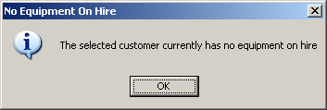

Once you have selected a customer move to the top right hand side and click on the drop down menu which holds all the equipment on hired to that particular customer

Select the equipment being returned ,when selected all that equipment details will appear on the screen.

Click return to return the equipment ,you will then be asked for an employee id number to accept the return

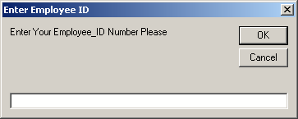

If invalid id number is entered you will receive the following error message

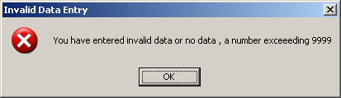

- If entry is successful you will be asked to confirm return

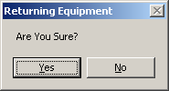

- If you say yes you will be told of confirmation of the return

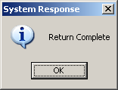

- Click “Make Payment” takes you to the make payment screen

- Click “Rehire” takes you to the hire equipment screen payment screen

- Click “Main Menu” if you wish to return to the main menu.

- Click “Back” to return to the “Equipment File Processing” menu

Student C

Fergal Purcell – COM2019

Supplier Maintenance Menu

Make a payment
Place an order
Amend/View Staff
Delete a Supplier
Orders Report

Amend/View Staff

Screen Shot:

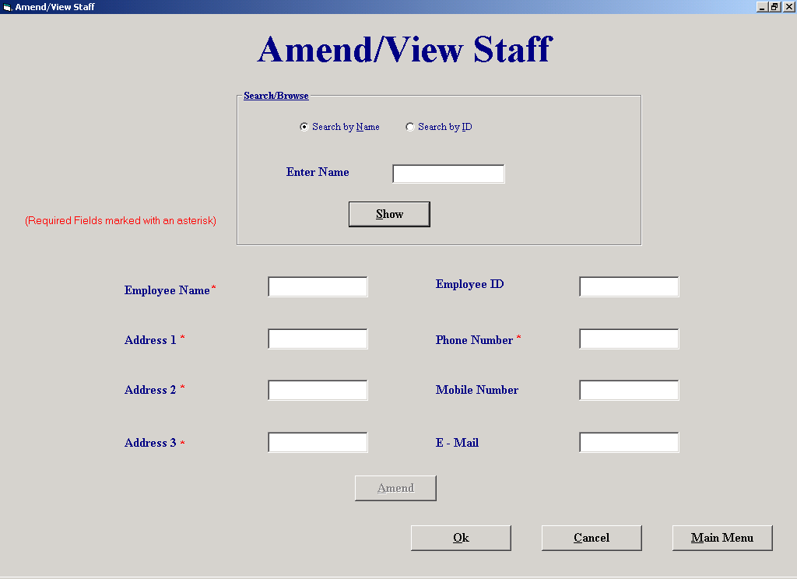

Purpose of Screen: The purpose of this screen is to allow the user to simply view staffs details or to amend staffs details.

How to get to the screen:
- Start up system;
  - Click on “File Maintenance” in the Main Menu screen;
  - Click on “Staff File Processing”;
  - Click “Amend/View Staff”.

How to use the screen:
- Choose whether to “Search by name” or “Search by ID”.
- Click “Show” when you have entered the staff’s name or number.
- If you search by ID, the ID must not contain any characters. If you do enter an ID with characters you will receive the following message:

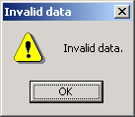

- If there is no matching name or number you will receive this message:

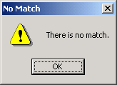

- If you have chosen “Search by Name” and there is more than one match you will see two buttons appear:

Next

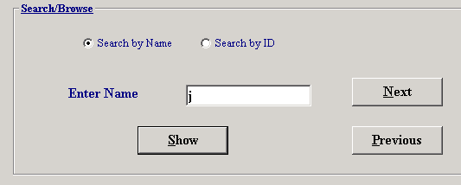

Previous

- Click “Next” to view the next match or click “Previous to view the previous match.
- If you want to amend the staff’s details, click on the field or fields you wish to change (e.g., Address 1 or E-Mail) and make the changes.
- Click “Amend” when you have made the changes.
- The process may be repeated for other staff members.
- If you decide you want to cancel all the amendments you made, click “Cancel” and you will leave the screen without making any changes.
- Click “Ok” if you want to leave the screen and keep the amendments you made.
- Click “Main Menu” if you wish to return to the main menu.

Delete Supplier

Screen Shot:

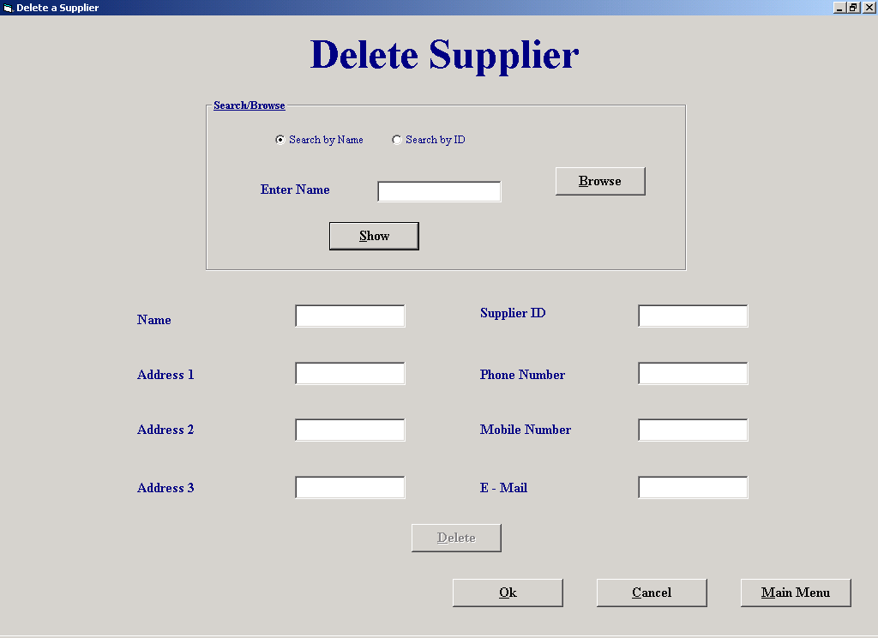

Purpose of Screen: The purpose of this screen is to allow the user to delete a supplier.

How to get to the screen:
- Start up the system;
  - Click on “File Maintenance” in the Main Menu screen;
  - Click on “Supplier File Processing”;
  - Click on “Delete Supplier”.

How to use the screen:
- Choose whether to “Search by Name” or “Search by ID” or “Browse”.
- Enter the supplier name or number if you chose to search by name or ID.
- If you clicked to browse for the supplier the following screen will appear:

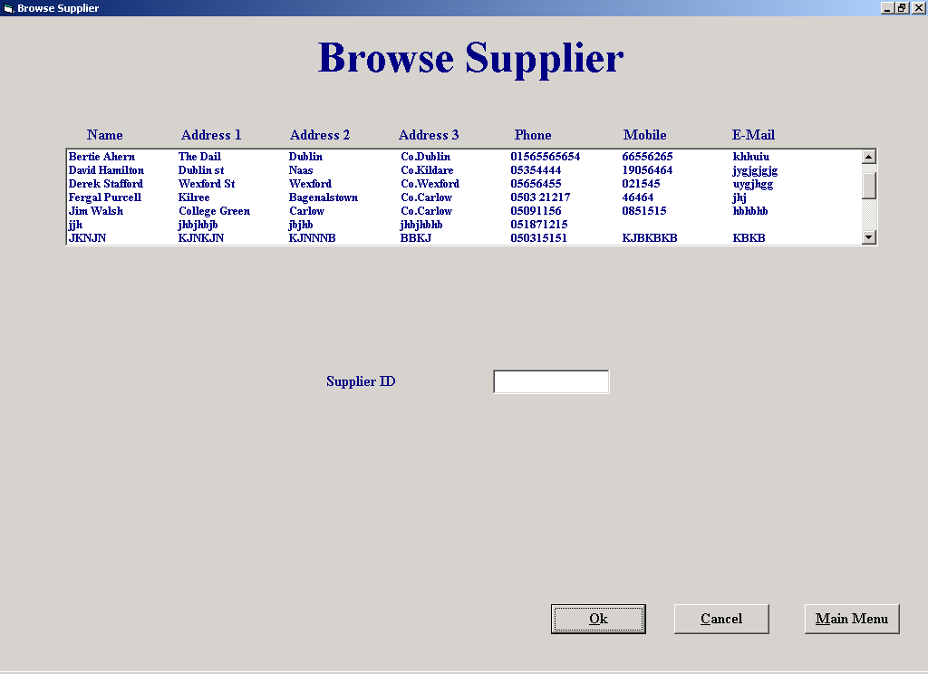

- Choose the supplier from the list that you wish to delete.
- Click “Ok”.

- Click “Show” to display the supplier’s details.
- If you search by ID, the ID must not contain any characters. If you do enter an ID with characters you will receive the following message:

- If there is no matching name or number you will receive this message:

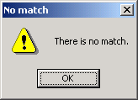

- If you have chosen “Search by Name” and there is more than one match you will see two buttons appear:

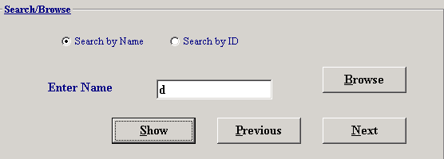

Previous Next

- Click “Next” to view the next match or click “Previous” to view the previous match.
- If you want to delete the supplier click “Delete”.
- If the supplier has an undelivered order you will receive the following message:

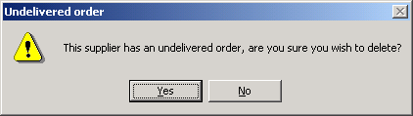

- Click “Yes” if you are sure you want to delete the supplier.
- The process may be repeated for other suppliers.
- If you decide to want to cancel all the deletions that you have just made click “Cancel” and you will leave the screen without making any deletions.
- Click “Main Menu” if you wish to return to the main menu.
- Click “Ok” if you wish to leave the screen and keep any deletions that you have just made.

Make a Payment

Screen Shot:

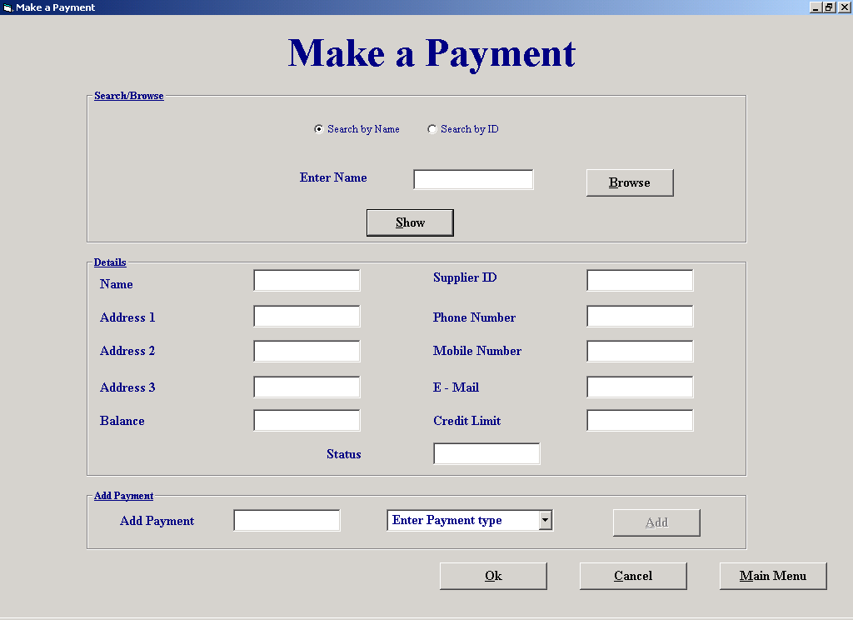

Purpose of Screen: The purpose of this screen is to allow the user to enter a payment that a customer has made.

How to get to the screen:
- Start up the system;
        - Click on “Payment Details” in the Main Menu.
- Start up system;
        - Click on “Hire Equipment” in the Main Menu;
        - Click on “Pay Now”.
- Start up system;
        - Click on “Return Equipment” in the Main Menu;
        - Click on “Make Payment”.

How to use the screen:
- Choose whether to “Search by Name” or “Search by ID” or “Browse”.
- Enter the customer name or number if you chose to search by name or ID.
- If you clicked to browse for the customer the following screen will appear:

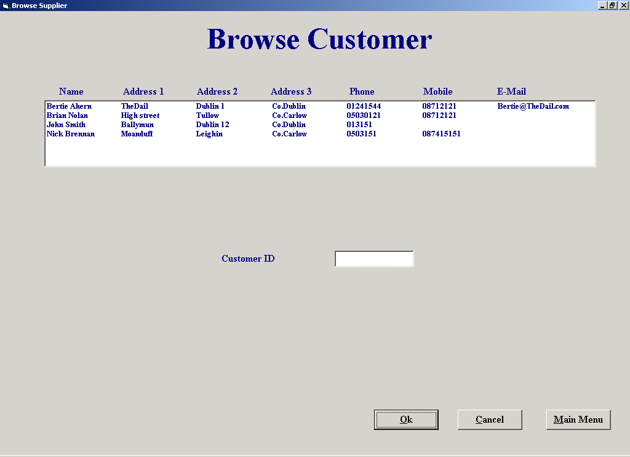

- Choose the customer from the list that you want to enter a payment for;
- Click “Ok”.

- Click “Show” to display the customer’s details.
- If you search by ID, the ID must not contain any characters. If you do enter an ID with characters you will receive the following message:

- If there is no matching name or number you will receive this message:

- If you have chosen “Search by Name” and there is more than one match you will see two buttons appear:

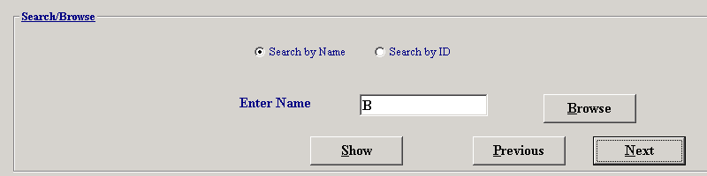

Previous Next

- Click “Next” to view the next match or click “Previous” to view the previous match.
- To add a payment, enter the payment amount in the “Enter Payment” box.
- If you enter a payment that consists of characters, you will receive the following message:

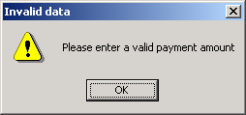

- Select a payment type from the drop down list.
- If you don’t select a payment type you will get this message:

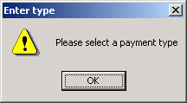

- Click “Add” to enter payment.

Enter payment box Drop down list

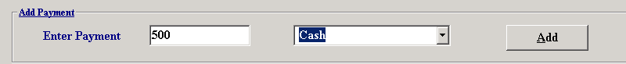

- If you decide you want to cancel all the payments that you have just entered click “Cancel” and you will leave the screen without entering any payments.
- Click “Main Menu” if you wish to return to the main menu.
- Click “Ok” if you wish to leave the screen and keep any payments that you have just entered.

Orders Report

Screen Shot:

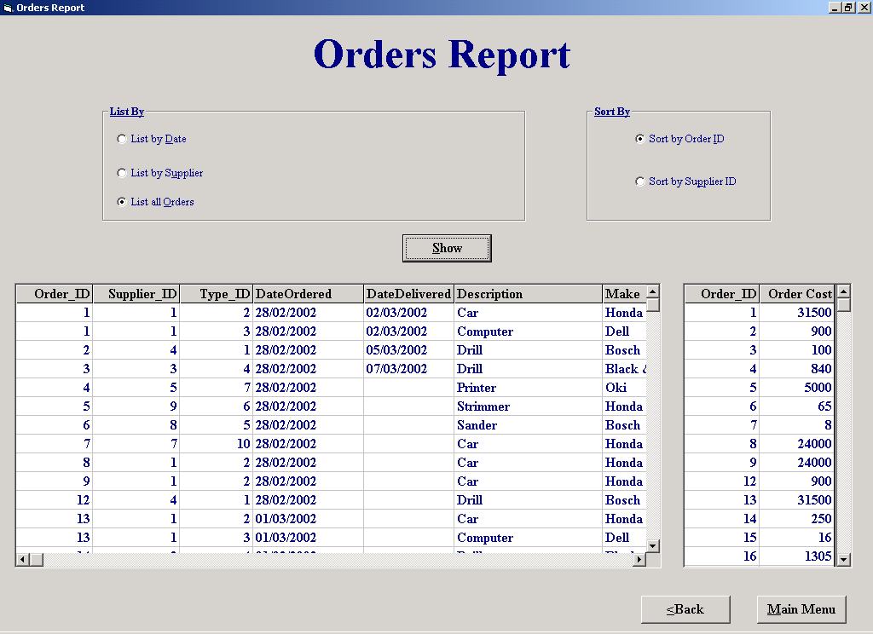

Purpose of Screen: The purpose of this screen is to give the user an orders report.

How to get to the screen:
- Start up the system;
  - Click on “Reports” in the main menu;
  - Click on “Orders Report”.

How to use the screen:
- Choose whether to “List by date” or “List by Supplier” or “List all orders”.
- If you have chosen to list by date enter the date, e.g. 01/03/2002, if you enter an invalid date you will get this message:

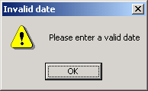

- If you have chosen to list by supplier enter the supplier ID, the supplier ID cannot contain any characters. If you enter an ID with characters you will get this message:

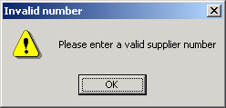

- If you do choose to list by supplier the “Browse” button will appear. Click on it to browse for the supplier that you want:

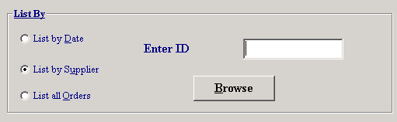

Browse

- Choose the supplier from the list that you wish to delete.
- Click “Ok”.

- If you enter the ID and there was no supplier matching the ID you entered you will get this message:

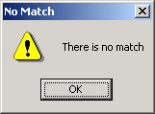

- Choose whether to “Sort by Order ID” or “Sort by Supplier ID.
- Click “Show” to view the report.
- Click “Back” to exit the screen.
- Click “Main Menu” if you wish to return to the main menu.

Place an Order

Screen Shot:

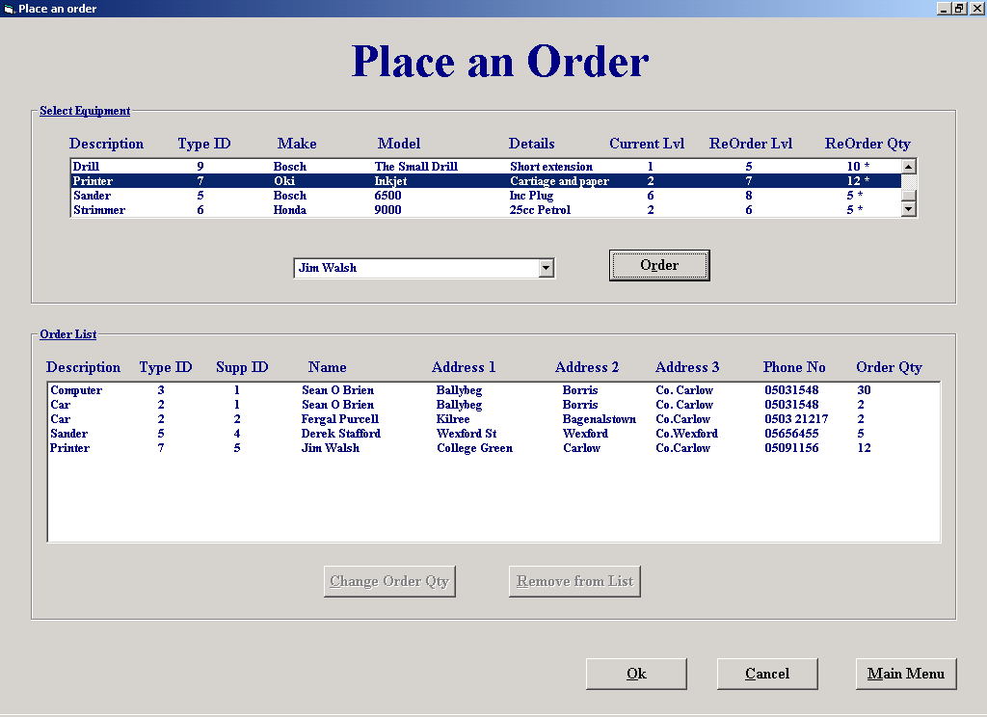

Purpose of Screen: The purpose of this screen is to allow the user to place orders for equipment from suppliers.

How to get to the screen:
- Start up system;
  - Click on “Place an Order” in the Main Menu.

How to use the screen:
- Click on the piece of equipment in the equipment list that you wish to order.
- Those that are marked with a ‘*’ are below their re-order level.
- Select a supplier from the drop down list that you wish to order from.
- Click on “Order” to add the order to the order list.

Equipment list

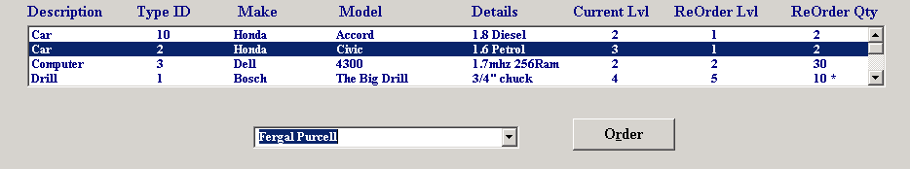

Drop down list

- If the order already exists you will receive the following message:

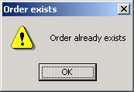

- If you clicked “Order” and didn’t select a supplier, you will receive this message:

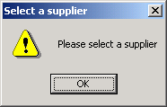

- If you wish to change the amount required for that order then click on “Change order Qty”.
- After clicking “Change order Qty” you will be prompted for a new order quantity:

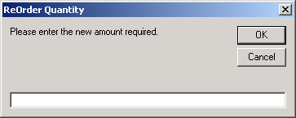

- Enter the new order quantity and click “Ok”.
- If you wish to remove the order from the list click on the order and then click “Remove from list”.
- If you decide you want to cancel the orders that you just made click “Cancel”.
- If you wish to return to the main menu then click “Main Menu”.
- Click “Ok” if you want to leave the screen and print out the order list.

Supplier Maintenance Menu

Screen Shot:

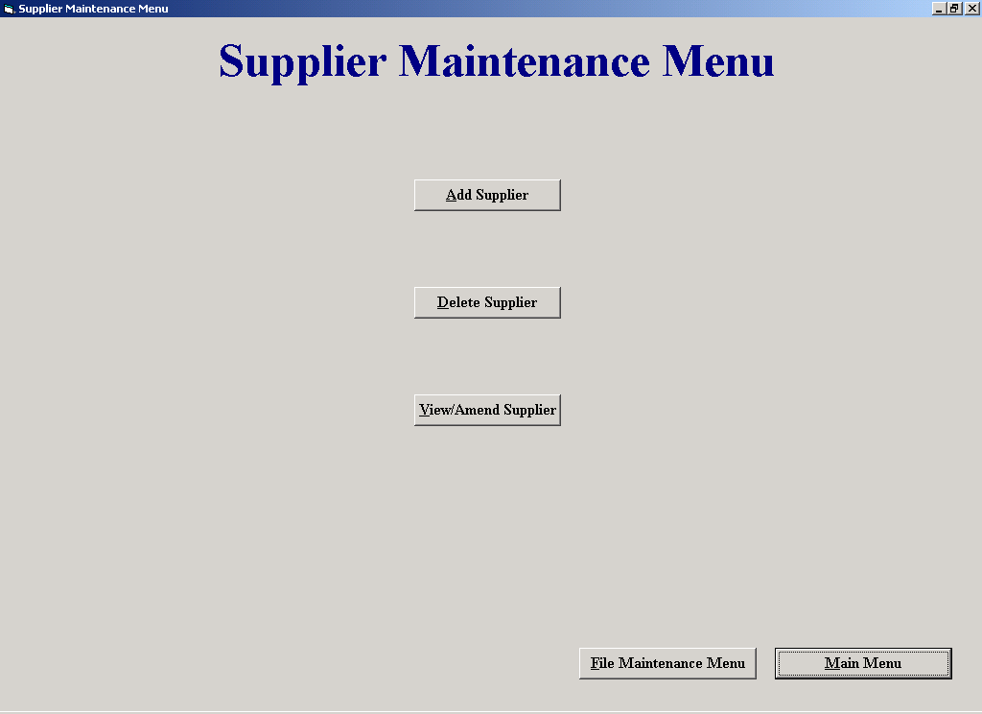

Purpose of Screen: The purpose of this screen is to allow the user to maintain the suppliers records.

How to get to the screen:
- Start up the system;
  - Click on “File Maintenance” in the main menu;
  - Click on “Supplier File Processing”.

How to use the screen:
- Click “Add Supplier” if you wish to add a new supplier.
- Click “Delete Supplier” if you wish to delete a supplier.
- Click “Amend/View supplier” if you want to amend a suppliers details or simply view their details.
- Click “File Maintenance Menu” to return to the File Maintenance Menu.
- Click “Main Menu” to return to the main menu.

Student D

Sean O Brien – COM2020

Staff Maintenance Menu
Clock In Staff
Add a Supplier
Amend/View Supplier
Delete a Staff Member
Customer Report

Staff Maintenance Menu

Screen Shot:

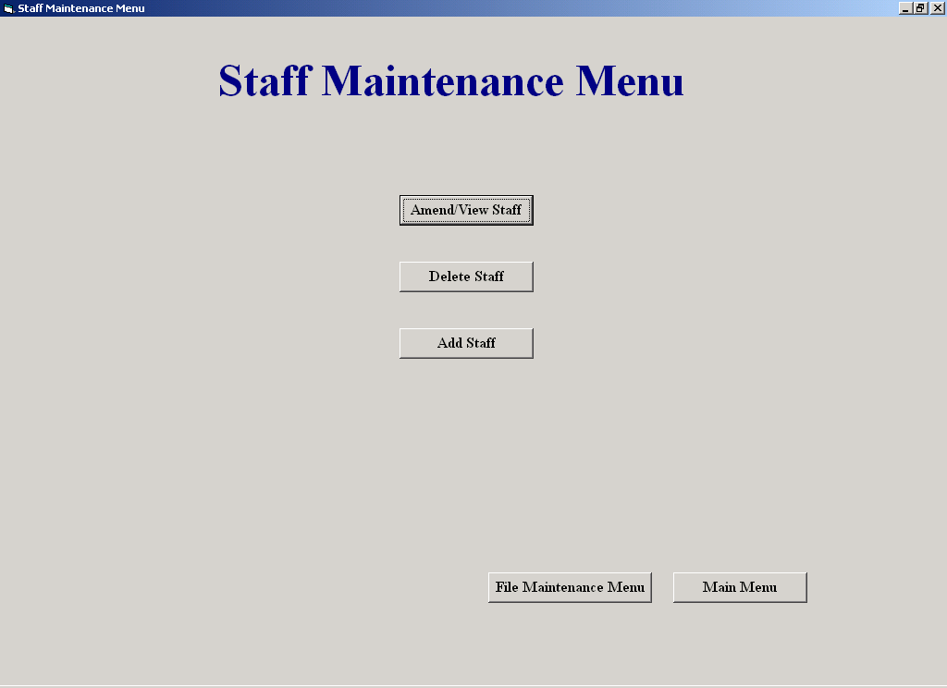

Purpose of the Screen:

Allows the user access to staff processing screens such as, Delete a Staff Member and
Amend/View Staff.

How to get to the Screen:

Click File Maintenance on the Main Menu, and then click Staff File Processing.

How to use the Screen:

- The user chooses an option and clicks on it

Clock In Staff

Screen Shot:

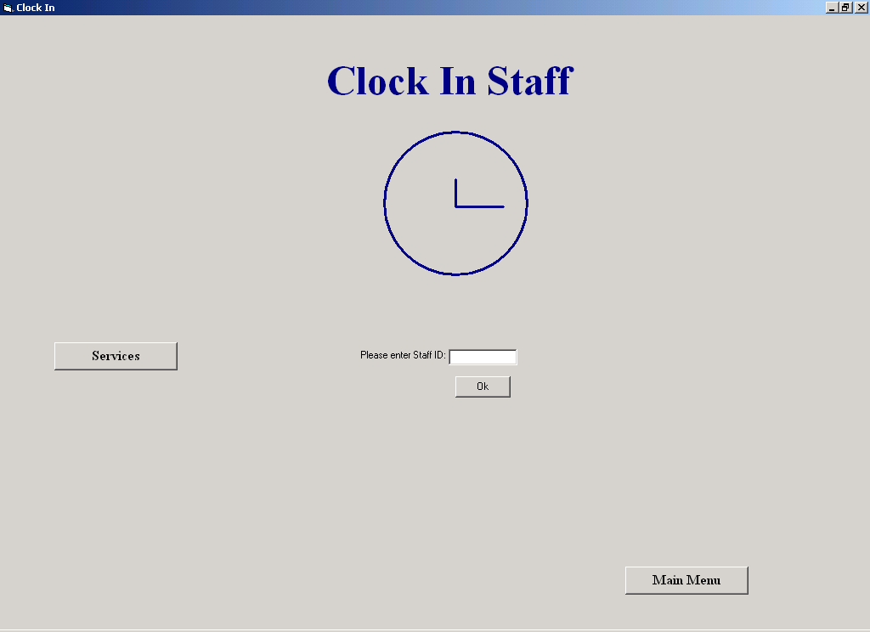

Purpose of the Screen:

This screen allows the user to clock in or out

How to get to the Screen:

Choose the Staff Clock-In option on the Main Menu

How to use the Screen:
- Enter your employee ID and click "OK".
If the ID that was entered is not a valid ID, the following message will appear on the screen:
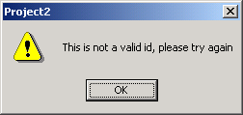
Services

Screen Shot:

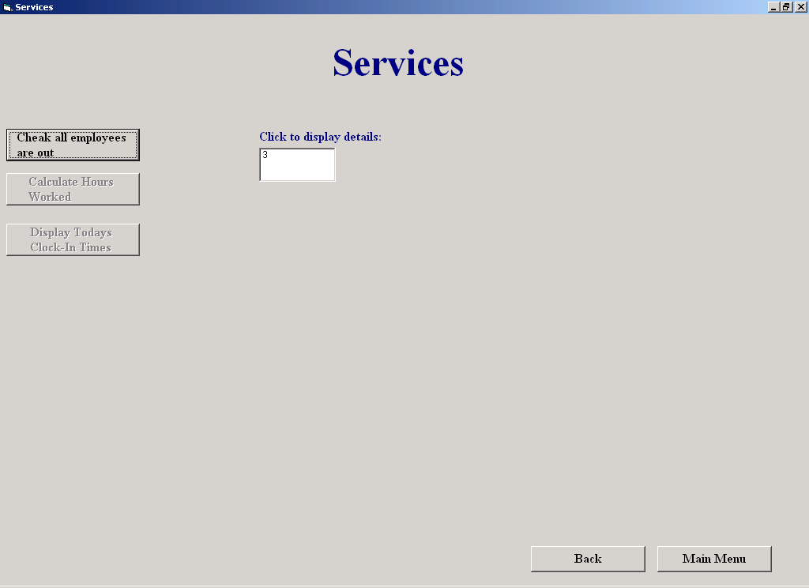

Purpose of the Screen:

This screen allows the user to check that all employees are clocked out. Once all employees are clocked out, the user can then calculate the hours worked for the week of each employee. The user can also get a listing of clock in times for the day, the system automatically marks those employees who arrived late and those who left early.

How to get to the Screen:

Choose the Staff Clock-In option on the Main Menu and then click the Services button on the Staff Clock-In screen

How to use the Screen:

- Click “Check all employees are out”.
If every employee has clocked out, the following message will appear:
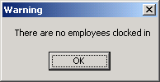

A listing of those who haven't clocked out, is displayed.
- Click on the ID number to view their details
- Click “Supply Clock-Out Time”
- Click the Hours combobox to choose the hours
- Click the Minutes combobox to choose the minutes
- Click "OK":

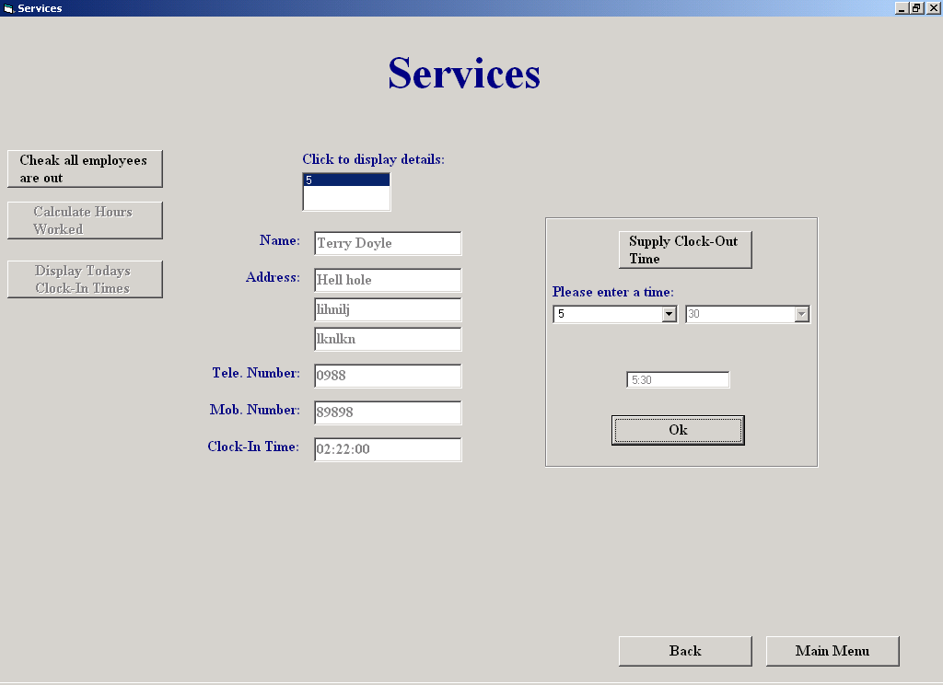
Once all employees are clocked out, the user can calculate the hours worked for the week:
- Click "Calculate Hours Worked"
A list of clock in times for the day can be also be displayed:
- Click "Display Today’s Clock-In Times":
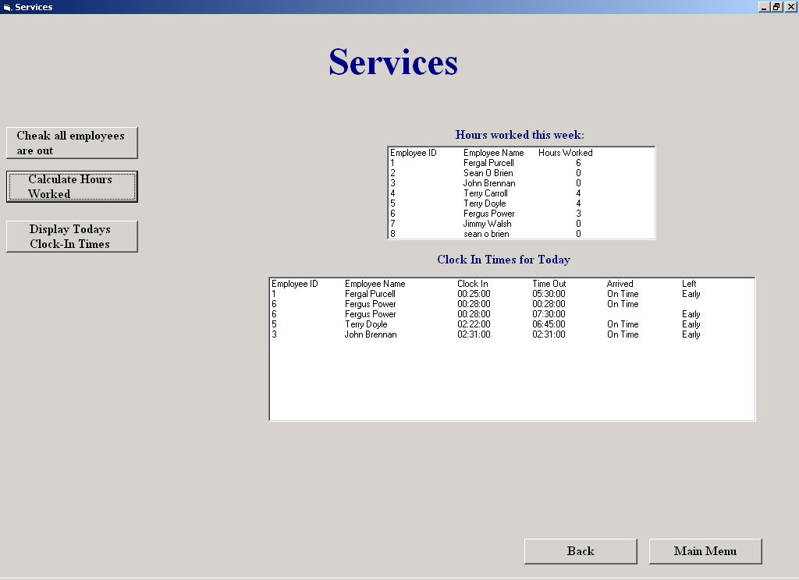

Add Supplier

Screen Shot:
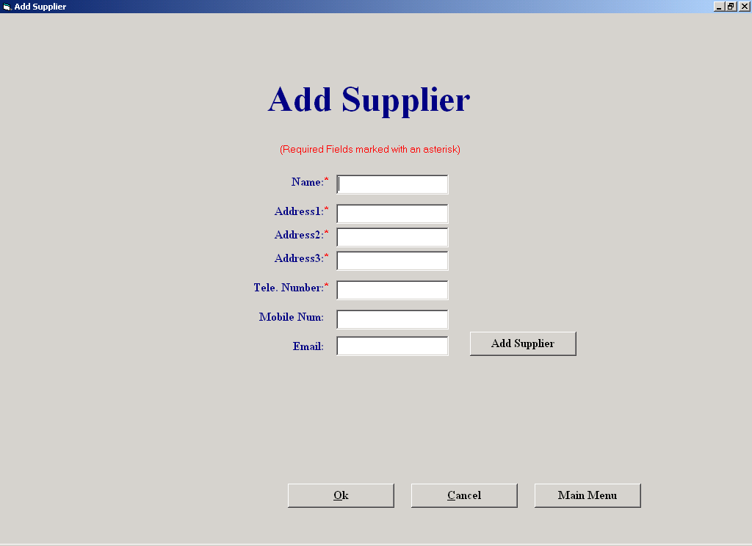

Purpose of the Screen:

The purpose of this screen is to allow the user to enter the details of a new supplier.

How to get to the Screen:

Click File Maintenance on the Main Menu, and then click Supplier File Processing. Then choose the Add Supplier option on the Supplier Maintenance Menu

How to use the Screen:
- Enter the details of the supplier in the relevant textboxes
- Click "Add Supplier".
If the supplier already exists in the system, the following message appears:

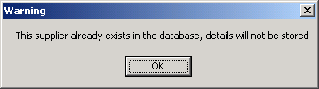
If the you want to cancel any suppliers that were entered since this screen was last invoked, Click "Cancel"
Amend/View Supplier

Screen Shot:

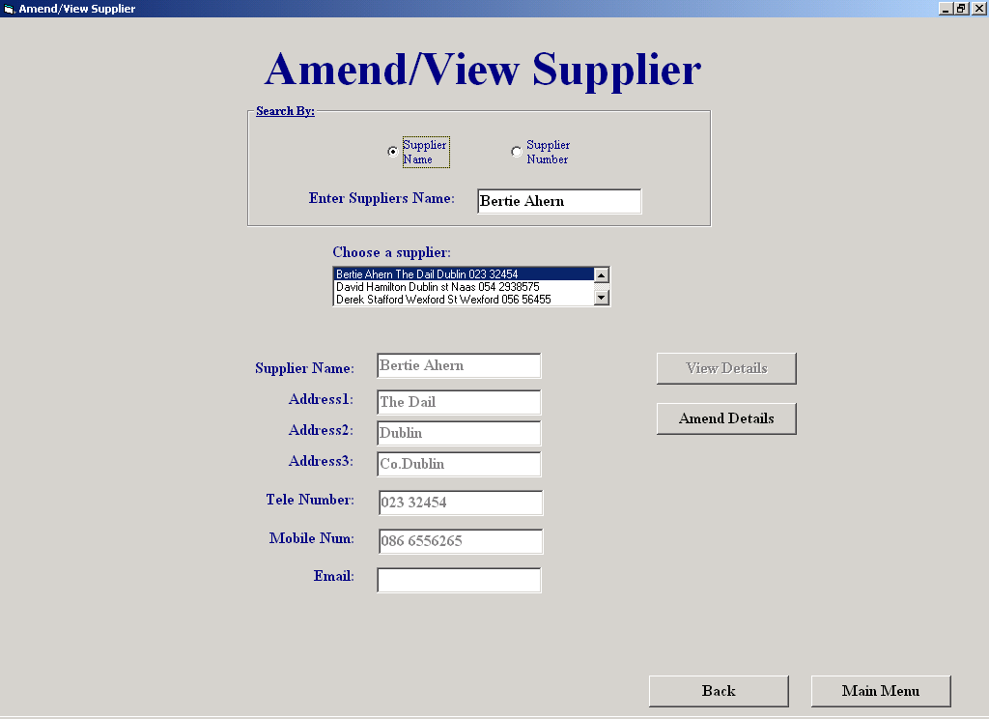

Purpose of the Screen:

This screen will allows the user amend or simply view an existing supplier's details

How to get to the Screen:

Click File Maintenance on the Main Menu, and then click Supplier File Processing. Then choose the Amend/View Supplier option on the Supplier Maintenance Menu

How to use the Screen:

- Enter the supplier's id or name or select a supplier from the list.
If the supplier doesn’t exist, the following message will appear:
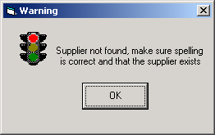
When found, the rest of the supplier's details are displayed in view mode.
If you wish to change the supplier’s details:
- Click the "Amend" button and amend the details.
- To cancel the amendments, click "Cancel"
- To save the changes:
- Click "Save Changes", the following message appears:
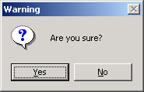
- Click “Yes” to save the changes.

Delete a Staff Member

Screen Shot:

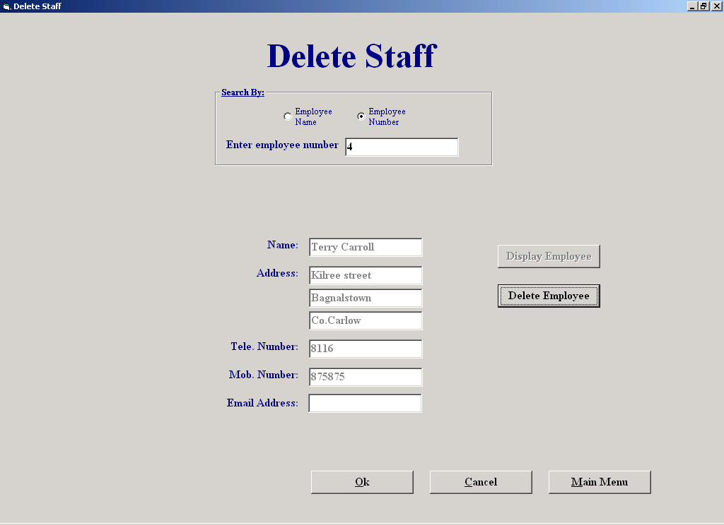

Purpose of the Screen:

This screen allows the user to delete an existing staff member's details from the database

How to get to the Screen:

Click File Maintenance on the Main Menu, and then click Staff File Processing. Then choose the Delete Staff option on the Staff Maintenance Menu

How to use the Screen:

- Enter the staff member's ID or name.
If the employee is not found, the following message appears:
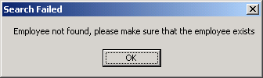
When found, the rest of the staff member's details are displayed.
- To delete the record from the database:
- Click the "Delete Employee" button, the following message appears:

To delete the employee, click “Yes”.

Customer Report

Screen Shot:

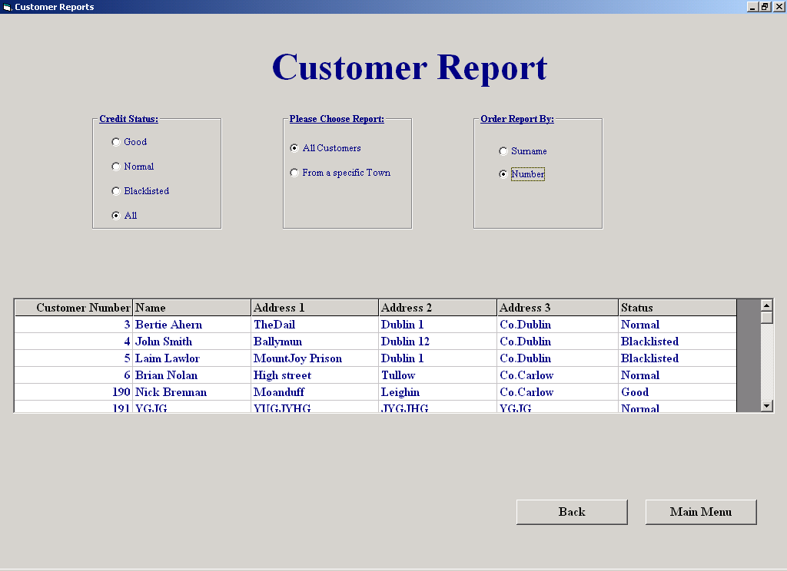

Purpose of the Screen:

This screen allows the user to produce reports on customer details.

How to get to the Screen:

Choose the Reports option on the Main Menu and then click on the Customer Details Report button on the Reports Menu

How to use the Screen:

- Choose a Credit Status
- Choose either a list of all customers matching it by clicking "All customers", or a list of all customers from a particular town matching it by clicking "From a Specific town".
- Sort the report by either Customer Surname, by clicking "SurName" or by Customer Number by clicking "Number".

