Amend/View Staff

Screen Shot:

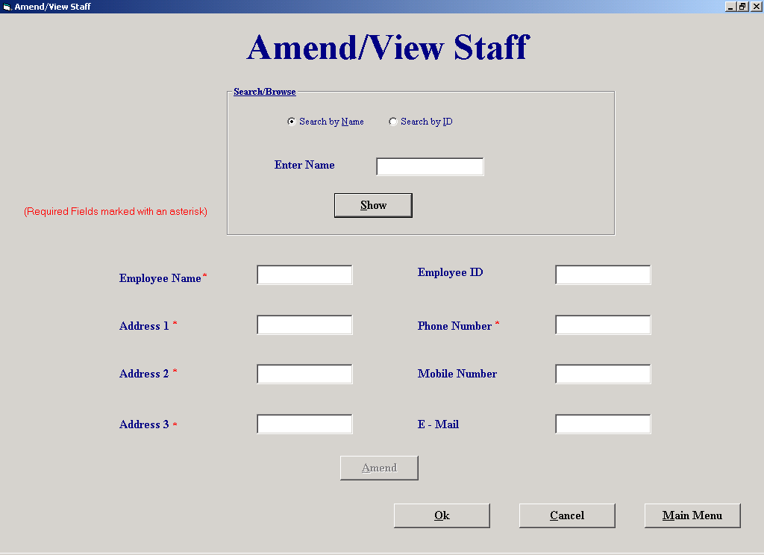

Purpose of Screen: The purpose of this screen is to allow the user to simply view staffs details or to amend staffs details.

How to get to the screen:
- Start up system;
  - Click on “File Maintenance” in the Main Menu screen;
  - Click on “Staff File Processing”;
  - Click “Amend/View Staff”.

How to use the screen:
- Choose whether to “Search by name” or “Search by ID”.
- Click “Show” when you have entered the staff’s name or number.
- If you search by ID, the ID must not contain any characters. If you do enter an ID with characters you will receive the following message:

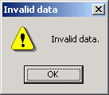

- If there is no matching name or number you will receive this message:

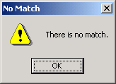

- If you have chosen “Search by Name” and there is more than one match you will see two buttons appear:

Next

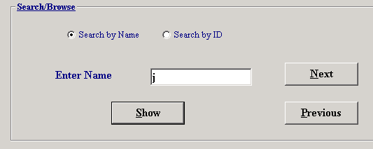

Previous

- Click “Next” to view the next match or click “Previous to view the previous match.
- If you want to amend the staff’s details, click on the field or fields you wish to change (e.g., Address 1 or E-Mail) and make the changes.
- Click “Amend” when you have made the changes.
- The process may be repeated for other staff members.
- If you decide you want to cancel all the amendments you made, click “Cancel” and you will leave the screen without making any changes.
- Click “Ok” if you want to leave the screen and keep the amendments you made.
- Click “Main Menu” if you wish to return to the main menu.

Delete Supplier

Screen Shot:

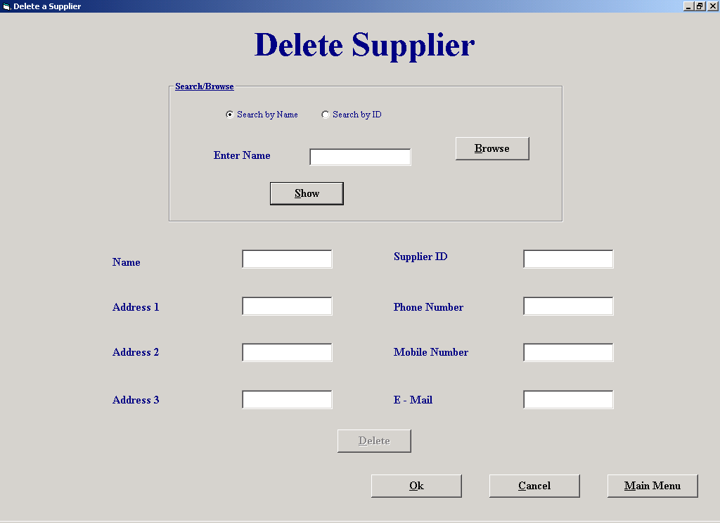

Purpose of Screen: The purpose of this screen is to allow the user to delete a supplier.

How to get to the screen:
- Start up the system;
  - Click on “File Maintenance” in the Main Menu screen;
  - Click on “Supplier File Processing”;
  - Click on “Delete Supplier”.

How to use the screen:
- Choose whether to “Search by Name” or “Search by ID” or “Browse”.
- Enter the supplier name or number if you chose to search by name or ID.
- If you clicked to browse for the supplier the following screen will appear:

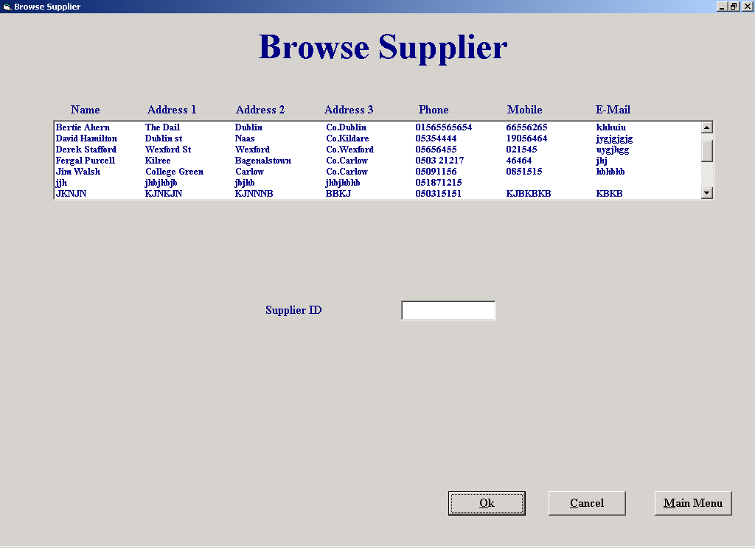

- Choose the supplier from the list that you wish to delete.
- Click “Ok”.

- Click “Show” to display the supplier’s details.
- If you search by ID, the ID must not contain any characters. If you do enter an ID with characters you will receive the following message:

- If there is no matching name or number you will receive this message:

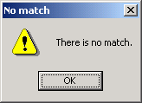

- If you have chosen “Search by Name” and there is more than one match you will see two buttons appear:

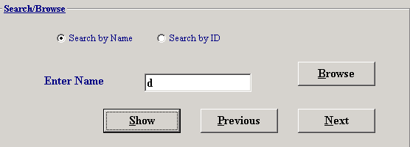

Previous Next

- Click “Next” to view the next match or click “Previous” to view the previous match.
- If you want to delete the supplier click “Delete”.
- If the supplier has an undelivered order you will receive the following message:

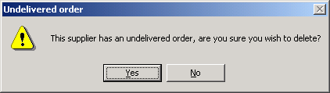

- Click “Yes” if you are sure you want to delete the supplier.
- The process may be repeated for other suppliers.
- If you decide to want to cancel all the deletions that you have just made click “Cancel” and you will leave the screen without making any deletions.
- Click “Main Menu” if you wish to return to the main menu.
- Click “Ok” if you wish to leave the screen and keep any deletions that you have just made.

Make a Payment

Screen Shot:

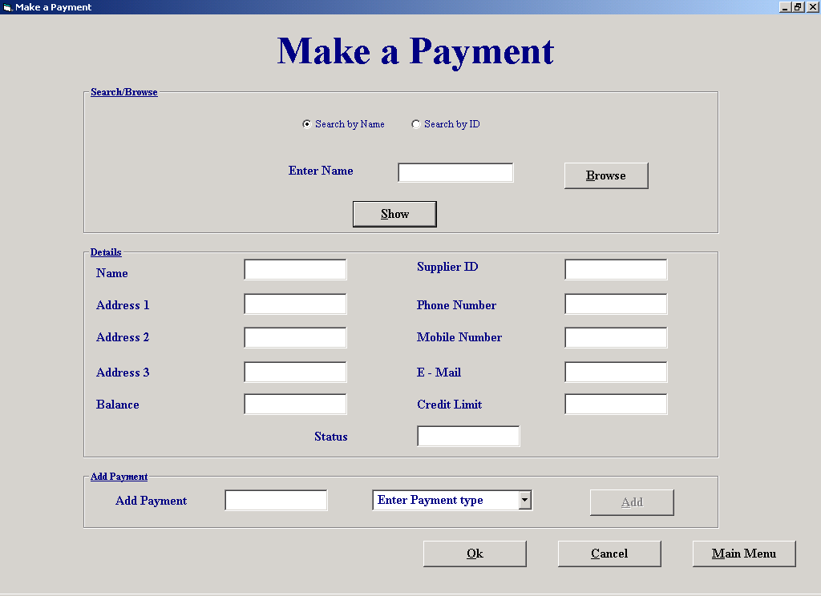

Purpose of Screen: The purpose of this screen is to allow the user to enter a payment that a customer has made.

How to get to the screen:
- Start up the system;
        - Click on “Payment Details” in the Main Menu.
- Start up system;
        - Click on “Hire Equipment” in the Main Menu;
        - Click on “Pay Now”.
- Start up system;
        - Click on “Return Equipment” in the Main Menu;
        - Click on “Make Payment”.

How to use the screen:
- Choose whether to “Search by Name” or “Search by ID” or “Browse”.
- Enter the customer name or number if you chose to search by name or ID.
- If you clicked to browse for the customer the following screen will appear:

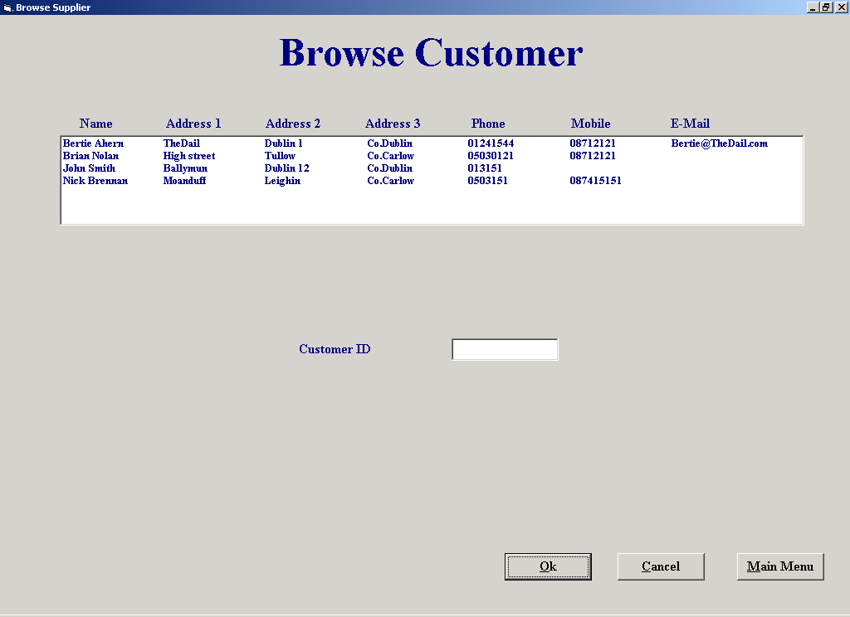

- Choose the customer from the list that you want to enter a payment for;
- Click “Ok”.

- Click “Show” to display the customer’s details.
- If you search by ID, the ID must not contain any characters. If you do enter an ID with characters you will receive the following message:

- If there is no matching name or number you will receive this message:

- If you have chosen “Search by Name” and there is more than one match you will see two buttons appear:

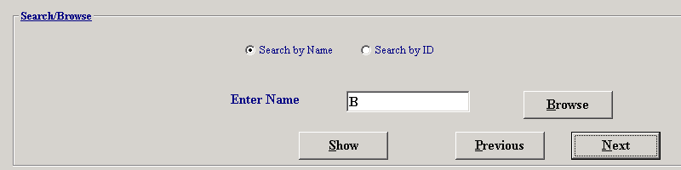

Previous Next

- Click “Next” to view the next match or click “Previous” to view the previous match.
- To add a payment, enter the payment amount in the “Enter Payment” box.
- If you enter a payment that consists of characters, you will receive the following message:

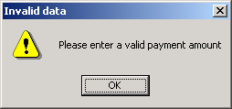

- Select a payment type from the drop down list.
- If you don’t select a payment type you will get this message:

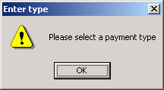

- Click “Add” to enter payment.

Enter payment box Drop down list

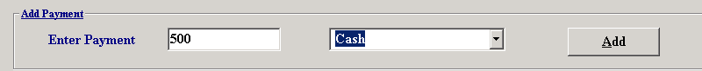

- If you decide you want to cancel all the payments that you have just entered click “Cancel” and you will leave the screen without entering any payments.
- Click “Main Menu” if you wish to return to the main menu.
- Click “Ok” if you wish to leave the screen and keep any payments that you have just entered.

Orders Report

Screen Shot:

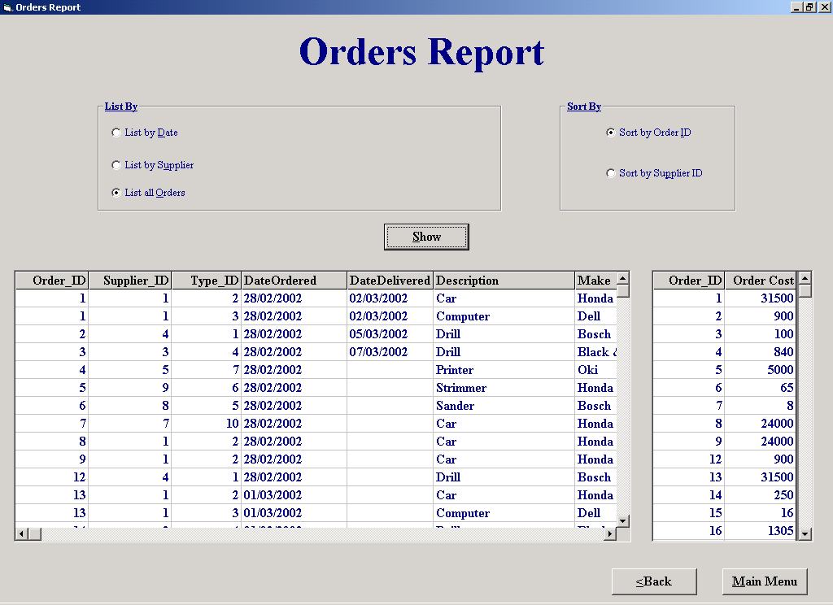

Purpose of Screen: The purpose of this screen is to give the user an orders report.

How to get to the screen:
- Start up the system;
  - Click on “Reports” in the main menu;
  - Click on “Orders Report”.

How to use the screen:
- Choose whether to “List by date” or “List by Supplier” or “List all orders”.
- If you have chosen to list by date enter the date, e.g. 01/03/2002, if you enter an invalid date you will get this message:

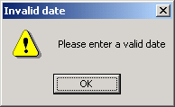

- If you have chosen to list by supplier enter the supplier ID, the supplier ID cannot contain any characters. If you enter an ID with characters you will get this message:

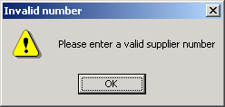

- If you do choose to list by supplier the “Browse” button will appear. Click on it to browse for the supplier that you want:

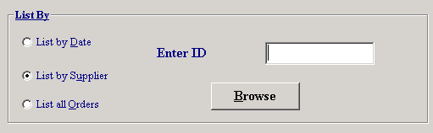

Browse

- Choose the supplier from the list that you wish to delete.
- Click “Ok”.

- If you enter the ID and there was no supplier matching the ID you entered you will get this message:

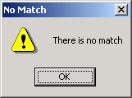

- Choose whether to “Sort by Order ID” or “Sort by Supplier ID.
- Click “Show” to view the report.
- Click “Back” to exit the screen.
- Click “Main Menu” if you wish to return to the main menu.

Place an Order

Screen Shot:

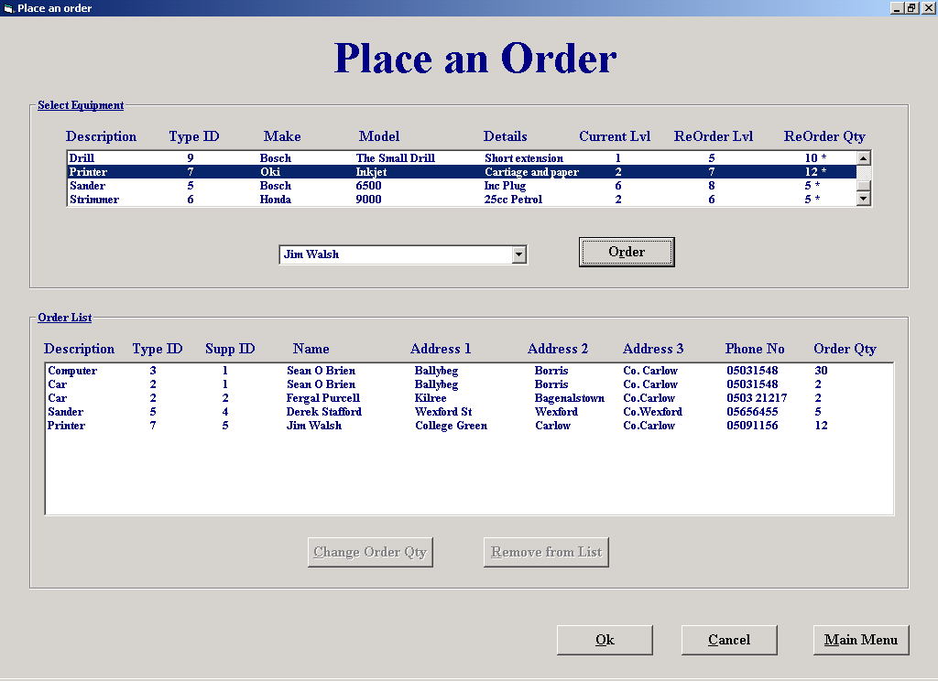

Purpose of Screen: The purpose of this screen is to allow the user to place orders for equipment from suppliers.

How to get to the screen:
- Start up system;
  - Click on “Place an Order” in the Main Menu.

How to use the screen:
- Click on the piece of equipment in the equipment list that you wish to order.
- Those that are marked with a ‘*’ are below their re-order level.
- Select a supplier from the drop down list that you wish to order from.
- Click on “Order” to add the order to the order list.

Equipment list

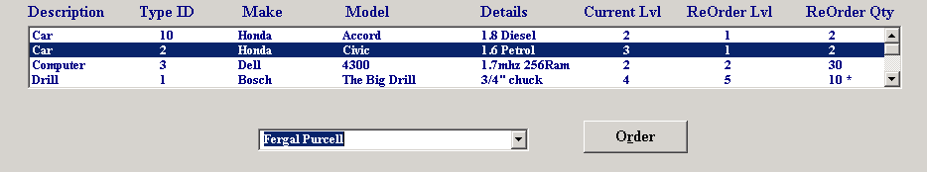

Drop down list

- If the order already exists you will receive the following message:

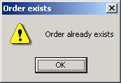

- If you clicked “Order” and didn’t select a supplier, you will receive this message:

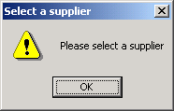

- If you wish to change the amount required for that order then click on “Change order Qty”.
- After clicking “Change order Qty” you will be prompted for a new order quantity:

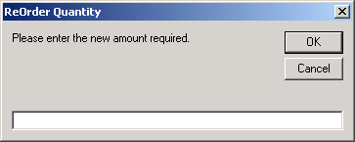

- Enter the new order quantity and click “Ok”.
- If you wish to remove the order from the list click on the order and then click “Remove from list”.
- If you decide you want to cancel the orders that you just made click “Cancel”.
- If you wish to return to the main menu then click “Main Menu”.
- Click “Ok” if you want to leave the screen and print out the order list.

Supplier Maintenance Menu

Screen Shot:

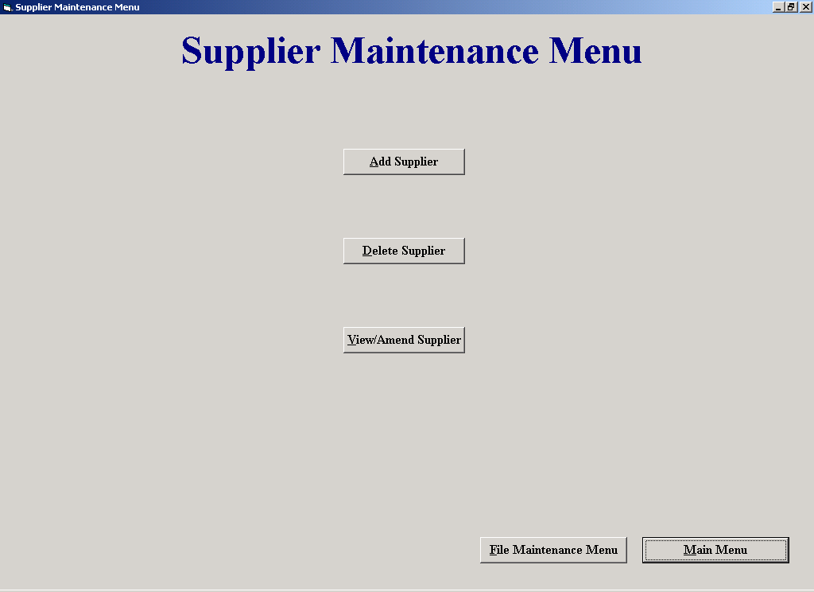

Purpose of Screen: The purpose of this screen is to allow the user to maintain the suppliers records.

How to get to the screen:
- Start up the system;
  - Click on “File Maintenance” in the main menu;
  - Click on “Supplier File Processing”.

How to use the screen:
- Click “Add Supplier” if you wish to add a new supplier.
- Click “Delete Supplier” if you wish to delete a supplier.
- Click “Amend/View supplier” if you want to amend a suppliers details or simply view their details.
- Click “File Maintenance Menu” to return to the File Maintenance Menu.
- Click “Main Menu” to return to the main menu.

