Analog input

v1.0.0

Wednesday, 12 October 2016

# Revision history

|  |  |  |  |
| --- | --- | --- | --- |
| Date | Version | Description | Author |
| 2016-09-03 | 1.0 | Initial specification | Dominik Guz |
|  |  |  |  |

Table of contents

Revision history 2

Architectural Representation 4

purpose 4

scope 4

references 4

definitions 4

Architectural Goals and Constraints 5

Non-functional requirements 5

functional requirements 5

environmental requirements 5

Dependency requirements 5

Use-Case View 6

Logical view 7

Process view 8

Module decomposition view 9

Deployment view 10

Size and performance 11

Issues and concerns 12

# Architectural Representation

## purpose

Circuit specification for analog inputs.

## scope

Specification of circuit parameters along with list of used components.

Proposed circuit model and drawing of specified circuit.

## references

## definitions

# Architectural Goals and Constraints

## Non-functional requirements

1. Low component count, integrated circuit prefered

## functional requirements

1. Input voltage range 2-24V
2. ESD protection
3. EMI Filtering, decoupling
4. Low maximum load current, <5mA
5. Minimum load current 1mA

## environmental requirements

## Dependency requirements

## Operating conditions

1. Temperature ranges : -20°C -> 80°C

# Requirements analysis

## Circuit parameters

### Operating condtions

### Voltage ranges

1. Input voltage range 0-5V
2. Output voltage 0-3V

### Power consumption

### Frequency ranges

1. <1kHz input frequency

### Dimensions

## Components comparision

### Manufacturers list

### Comparison table

## Component selection

### Matching components list

### Optimization goals

## Component specification

1. Precision divider resistors, 402 package
2. ESD protection array 3.3V
3. Reverse polarity protection rectifier diode

# Circuit model

## Block diagram

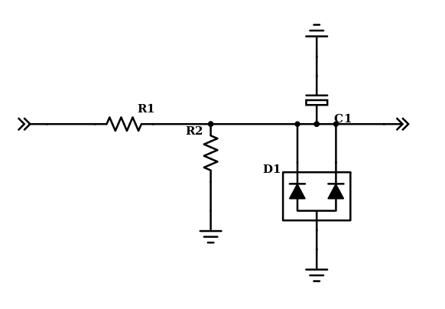

# Circuit drawing

# Circuit simulation results

# Implementation notes

# Issues and concerns