**COMPUTER**

**JOURNAL**

By

Aniruddha Ponnuri

Class – XII_S1

READ A TEXT FILE LINE BY LINE AND DISPLAY EACH WORD SEPARATED BY A “#”

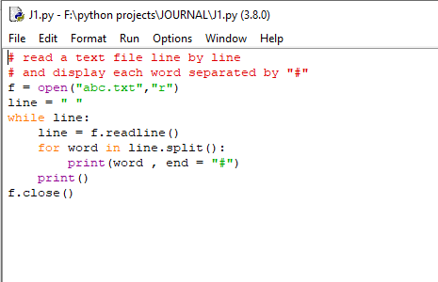

OUTPUT:-

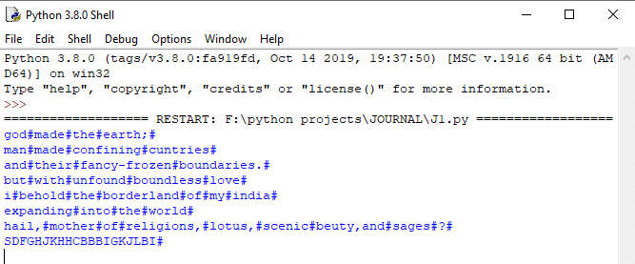

READ A TEXT FILE AND DISPLAY THE NUMBER OF VOWELS, CONSONANTS, UPPERCASE, LOWERCASE CHARACTERS IN THE FILE

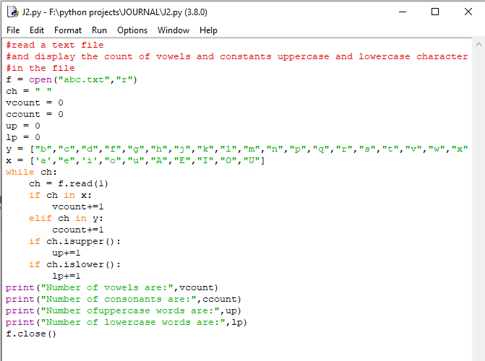

OUTPUT:-

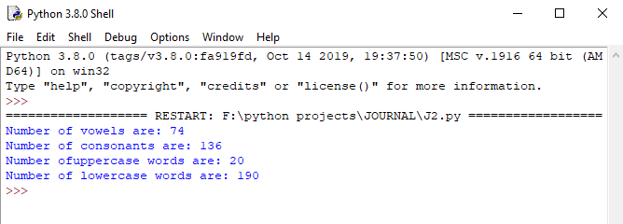

CREATE A BINARY FILE WITH NAME AND ROLL NUMBER, SEARCH FOR A GIVEN NAME ROLL NUMBER AND DISPLAY THE NAME .IF NOT FOUND DISPLAY APPROPRIATE MESSAGE

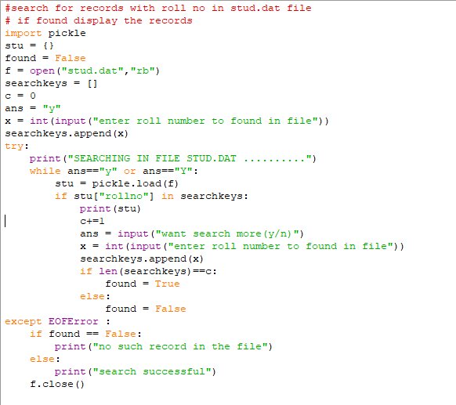

OUTPUT:-

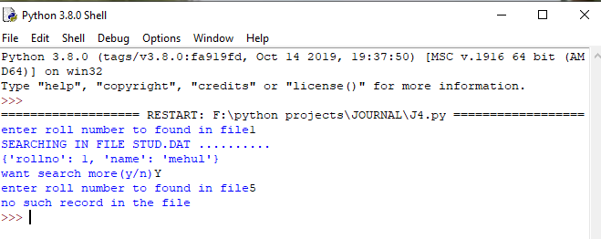

CREATE A BINARY FILE WITH ROLL NUMBER, NAME,MARKS.INPUT A ROLL NUMBER AND UPDATE THE MARKS

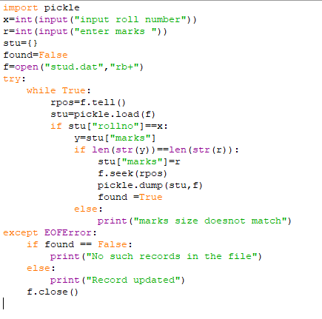

OUTPUT:-

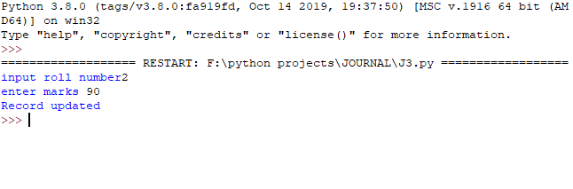

REMOVE ALL THE LINES THAT CONTAIN THE CHARACTER ‘a’ IN A FILE AND WRITE IT TO ANOTHER FILE

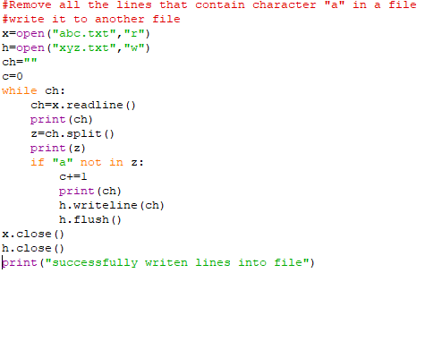

OUTPUT:-

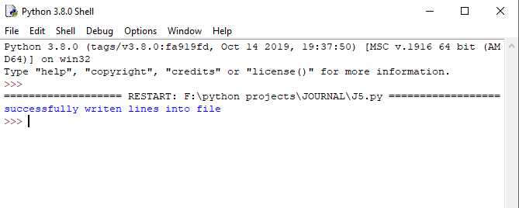

A RAMDOM NUMBER GENERATOR THAT GENERATES RANDOM NUMBERS BETWEEN 1 AND 6.

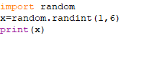

OUTPUT:-

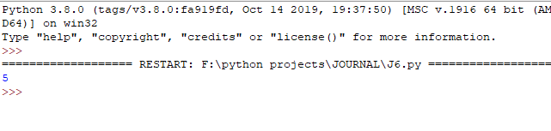

WRITE A PROGRAM TO IMPLEMENT STACK USING A LIST DATA STRUCTURE

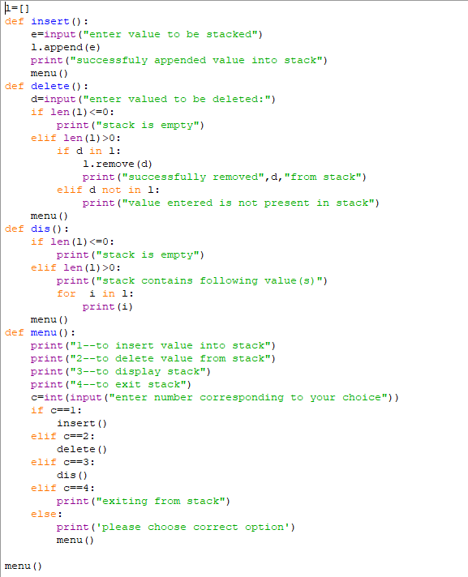

OUTPUT:-

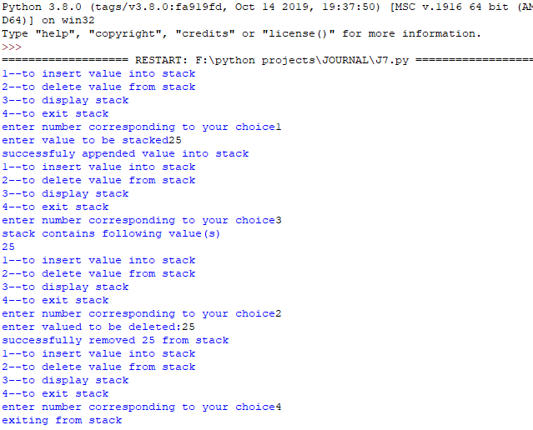

TAKE A SAMPLE OF TEN PHISHING E-MAILS ( OR ANY TEXT FILE ) AND FIND THE MOST COMMONLY OCCURING WORD(S).

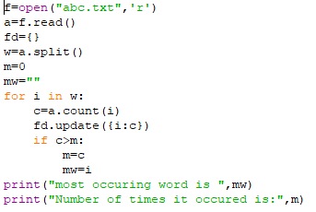

OUTPUT:-

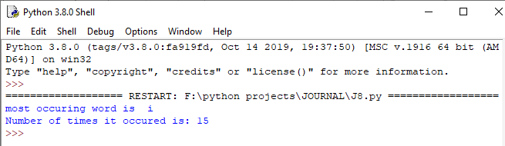

WRITE A FUNCTION THAT RECEIVES TWO STRING ARGUMENTS AND CHECKS WHETHER THEY ARE SAME LENGTH STRINGS.

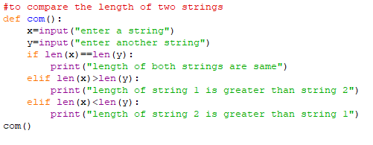

OUTPUT:-

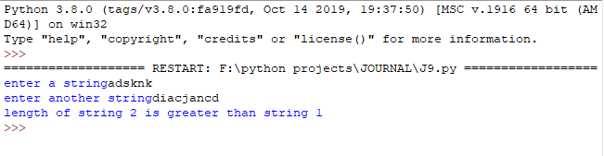

WRITE A PROGRAM THAT GENERATES A SERIES USING A FUNCTION WHICH TAKES FIRST AND LAST VALUES OF SERIES AND THEN GENRATES 4 EQUIDISTANT TERMS

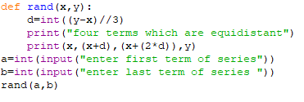

OUTPUT:-

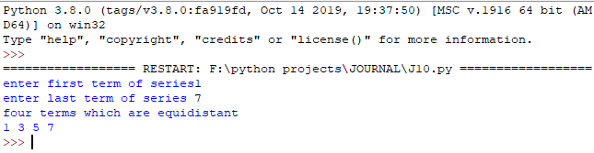

WRITE A FUNCTION THAT TAKES TWO NUMBERS AND RETURNS NUMBER THAT HAS MINIMUM ONE’S DIGIT

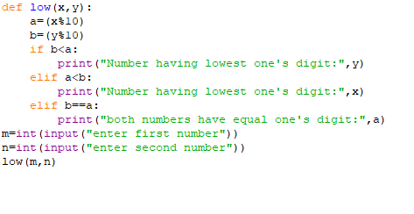

OUTPUT:-

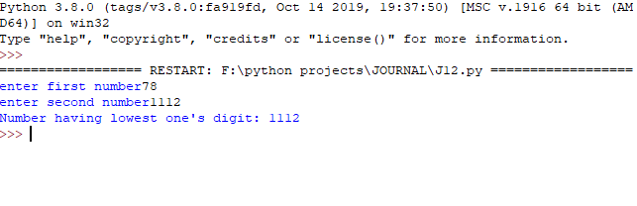

WRITE A PYTHON PROGRAM TO WRITE NESTED LIST TO CSV FILE. AFTER WRITING THE CSV FILE , READ FILE AND DISPLAY THE CONTENT

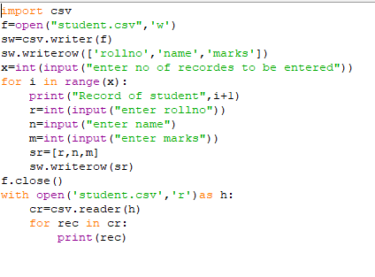

OUTPUT: -

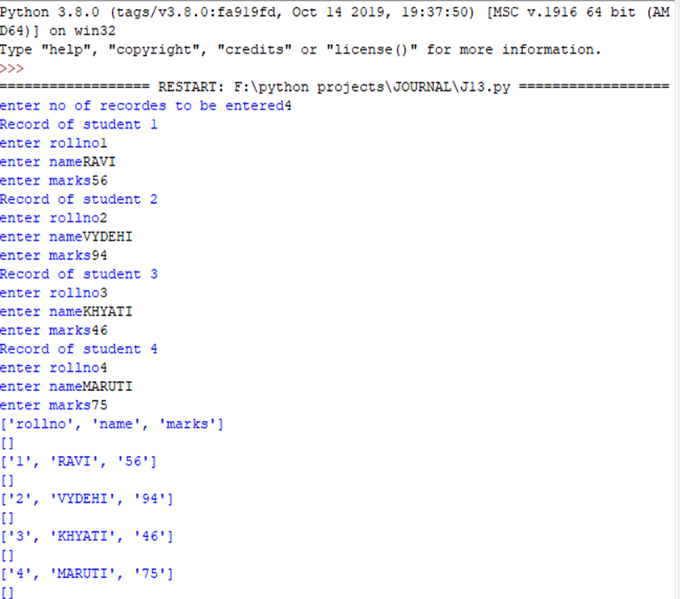

WRITE A FUNCTION THAT READS A CSV FILE AND CREATE ANOTHER CSV FILE WITH SAME CONTENT BUT WITH A DIFFERENT DELIMITER

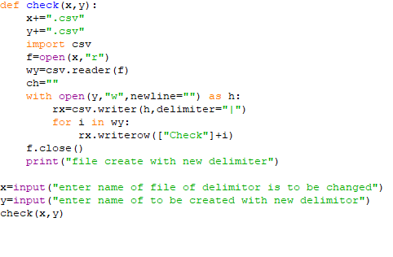

OUTPUT:-

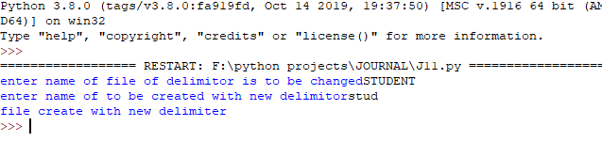

QUESTION BASED ON MY SQL CONNECTIVITY

CREATE A PROGRAM THAT INSERTS ROWS IN TABLE EMPLOYEE OF MY SQL DATABASE EMP.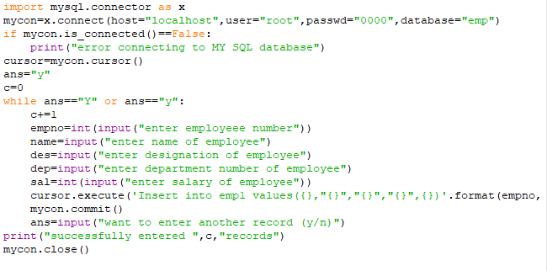

OUTPUT:-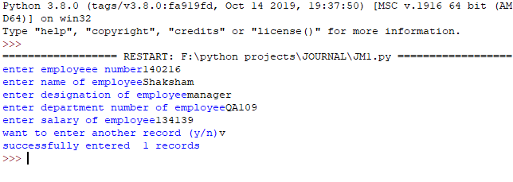

QUESTION BASED ON MYSQL

Q: Create table customer as per following

Table Instance Chart

|  |  |  |  |  |  |  |
| --- | --- | --- | --- | --- | --- | --- |
| Column name | Cust_ID | Cust_Name | Cust_Address1 | Cust_Address2 | Pincode | Cust_phone |
| Data Type | Number | Varchar | Varchar | Varchar | Number | Varchar |
| Length | 7 | 30 | 20 | 30 | 6 | 10 |

Answer:--

“create table customer(Cust_ID int (7), Cust_Name varchar(30), Cust_Address1 varchar(20), Cust_Address2 varchar(30) , Pincode int(6), Cust_phone varchar(10)”

|  |  |  |  |  |  |  |
| --- | --- | --- | --- | --- | --- | --- |
| No. | Name | Stipend | Stream | AvgMark | Grade | Class |
| 1 | KARAN | 400.00 | MEDICAL | 78.5 | B | 12B |
| 2 | DIVAKAR | 450.00 | COMMERCE | 89.5 | A | 11C |
| 3 | DIVYA | 300.00 | COMMERCE | 68.6 | C | 12C |
| 4 | ARUN | 350.00 | HUMANITES | 73.1 | B | 12C |
| 5 | SABINA | 500.00 | NONMEDICAL | 90.6 | A | 11A |
| 6 | JOHN | 400.00 | MEDICAL | 75.4 | B | 12B |
| 7 | ROBERT | 250.00 | HUMANTIES | 64.4 | C | 11A |
| 8 | RUBINA | 450.00 | NONMEDICAL | 88.5 | A | 12A |
| 9 | VIKAS | 500.00 | NONMEDICAL | 92.0 | A | 12A |
| 10 | MOHAN | 300.00 | COMMERCE | 67.5 | C | 12C |

Q:

1. Select all the Non-Medical students from STUDENT1.
2. List the names of those students who are in class 12 sorted by Stipend
3. List all the students sorted by Avgmarks
4. Display a report, listing Name, Stipend, Stream and Amount of stipend received in a year assuming that the stipend is paid every month

Answers: -

1. ” select * from STUDENT1 where ‘Stream’ = ‘Nonmedical’ ;”
2. “select ‘Name’ from STUDENT1 where ‘Class’ like ‘12%’ , order by (‘Stipend’);”
3. “ select * from STUDENT1 order by

d)“ select ‘Name’, ‘Stream’, ‘Stipend’ * 12 as ‘Amount’ from STUDENT1 ;

Q: Give the output of following SQL statements

1. Select TRUNCATE(AvgMark) from STUDENT1 where AvgMark<75;
2. Select ROUND(AvgMark) from STUDENT1 where Grade= ‘b’;
3. Select CONCAT (Name, Stream) from STUDENT1 where Class = ‘12A’;
4. Select RIGHT(Stream,2) from STUDENT1

ANSWER:

Q:

Table: Personal

|  |  |  |  |  |
| --- | --- | --- | --- | --- |
| EmpNo | Name | Dobirth | Native-place | Hobby |
| 123 | Amit | 23-jan-1965 | Delhi | Music |
| 127 | Manoj | 12-dec-1976 | Mumbai | Writing |
| 124 | Abhai | 11-aug-1975 | Allahabad | Music |
| 125 | Vinod | 04-apr-1977 | Delhi | Sports |
| 128 | Abhay | 10-mar-1974 | Mumbai | Gardening |
| 129 | Ramesh | 28-oct-1981 | Pune | Sports |

Table: Job

|  |  |  |  |  |  |
| --- | --- | --- | --- | --- | --- |
| SNO | Area | App-date | Salary | Retd_date | dept |
| 123 | Agra | 25-jan-2006 | 5000 | 25-jan-2026 | Marketing |
| 127 | Mathura | 22-dec-2006 | 6000 | 22-dec | Finance |
| 124 | Agra | 19-aug-2007 | 5500 | 19-aug-2027 | Marketing |
| 125 | Delhi | 14-apr-2004 | 8500 | 14-apr-2018 | Sales |
| 128 | Pune | 13-mar-2008 | 7500 | 13-mar-2028 | Sales |

Create following table such that Empno and Sno are not null and unique, date of birth is after ’12-jan-1960’, name is never blank, Area and Native place is valid, hobby, dept is not empty, salary is between 4000 and 10000.

**Answer:**

Create table Personal ( Empno integer(3) NOT NULL Unique, Name varchar(10) NOT NULL, Dobirth Date, Native-place varchar(10), Hobby varchar(10) NOT NULL, CHECK (Dobirth>'1960-01-12'), check (Native-place in ('Delhi','Mumbai','Allahabad','Pune')));

Create table job(Sno integer(3) NOT NULL UNIQUE, Area varchar(10), App_date Date, Salary integer(4), Retd_date date, Dept varchar(10) Not Null, Check(Area in ('Agra','Mathura','Delhi','Pune')), CHECK(Salary between 4000 and 10000));

**Q:**

a) Show empno, name and salary of those who have Sports as hobby.

b) Show name of the eldest employee.

c) Show youngest employees from each Native place.

d) Show Sno, Name, Hobby and salary in descending order of salary

e) Show the hobbies of those whose name is ‘Abhay’

f) Show the appointment date and native place of those whose name starts with ‘A’ or ends in ‘d’

g) Show the salary of those who shall retire after 20-jan-2006

h) Show additional burden on the company in case salary of employees having hobby as sports, is increased by 10%

i) Show the hobby of which there are 2 or more employees

j) Increase salary of the employees by 5% of their present salary with hobby as music

k) Add a new tuple in the table Personal essentially with hobby as Music

l) Insert a new column email in job table

m) Create a table with values of columns empno, name and hobby

n) Remove the table personal

**Answer:**

a) select empno, name, salary from personal, job where personal.empno=job.sno and hobby='sports';

b) select name, min(dobirth) from personal;

c) select name, max(dobirth), Nativeplace from personal group by Nativeplace;

d) select sno,name,hobby,salary from personal,job where personal.empno=job.sno order by salary desc;

e) select hobby from personal where name='Abhay';

f) select Name,Native-place, App_date from personal,job where personal.empno=job.sno and (name like 'a%' or name like '%d');

g) select name,salary from personal,job where empno=sno and retd_date>'2006-01-20';

h) select name, salary*0.1 as 'additional_burden' from personal, job where empno=sno and hobby='sports';

i) select hobby from personal group by hobby having count(*)>=2;

j) update personal,job set salary=salary*1.05 where empno=sno and hobby='Music';

k) insert into personal values(126, 'Sanjay', '1977-10-12', 'Allahabad', 'Music');

l) insert into personal values(126, 'Sanjay', '1977-10-12', 'Allahabad', 'Music');

m) Create table sample (Select empno, name, hobby from personal);

n) drop table personal;

Q:

a) Select distinct hobby from personal;

b) select avg(salary) from personal, job where personal.empno=job.sno and area in ('Agra','Delhi');

c) Select count(distinct Nativeplace) from personal;

d) Select name, max(salary) from personal, job where Personal.empno=Job.Sno