CHEMISTRY PROJECT REPORT

SURFACE CHEMISTRY

BY:- PONNURI ANIRUDDHA

CLASS: 12_S1(NON-MEDICAL)

BOARD ROLL NUMBER:

CERTIFICATE

THIS IS TO CERTIFY THAT THIS “CHEMISTRY INVESTIGATION PROJECT” ON THE TOPIC “SURFACE CHEMISTRY” HAS BEEN SUCCESSFULLY COMPLETED BY **PONNURI ANIRUDDHA** OF

CLASS **XII-S1** UNDER THE GUIDANCE OF MR. ARNORAJ MISHRA AND MRS. MEENA MAKKAR IN PARTICULAR FULFILMENT OF THE CURRICULAM OF CENTRAL BOARD OF SECONDARY EDUCATION [CBSE] LEADING TO THE AWARD OF ANNUAL EXAMINATION OF THE YEAR 2020-21

TEACHER IN-CHARGE EXTERNAL EXAMIER

ACKNOWLEDGEMENT

I WOULD LIKE TO PROFUSELY THANK MY CHEMISTRY TEACHER MRS. MEENA MAKKER AND

MR.ARNORAJ MISHRA FOR THEIR AND SUPPORT IN COMPLETING MY PROJECT . I WOULD ALSO LIKE TO EXTEND MY GRATITUDE TOWARDS MY PRINCIPAL FOR PROVIDING ME WITH ALL THE FACILITIES THAT WAS REQUIRED .LAST BUT NOT LEAST I WOULD LIKE TO THANK MY PARENTS AND MY FRIENDS WHO SUPPORTED ME TO COMPLETE

THIS PROJECT

INTRODUCTION

Surface chemistry deals with phenomena that occur at the interreferences or surfaces. Due to complete miscibility there is no interreference between the gases

The bulk phases that we come across in surface chemistry finds many applications in industry analytical work and daily life situation.

SURFACE CHEMISTRY

Surface chemistry is the study of physical and chemical phenomenon

that occur at the interface of two phases including solid-liquid interfaces, solid-gas interfaces, solid-vacuum interfaces, and liquid-gas interfaces. It includes the fields of surface chemistry and surface physics. Some related practical applications are classed as surface engineering, The science composes of concepts such as heterogenous catalysis, semiconductor devices, fuel cells, self assembled monolayers, and adhesives. Surface science is closely related to interface and colloid science. Interfacial chemistry and physics are common subjects for both. The methods are different. In additional, interface and colloid science studies macroscopic phenomena that occur in heterogenous systems due to peculiarities of interfaces.

**Adsorption**

There are several examples, which reveal that the surface of a solid has the tendency to attract and retain the molecules of the phase with which it comes into contact. These molecules remain only at the surface and do not go deeper into the bulk. The accumulation of molecular species at the surface rather than in the bulk of a solid or liquid is term as adsorption. The molecular species or substance which concentrates or accumulates at the surface is termed adsorbate and the material on the surface of which the adsorption takes place is called adsorbent. Solids, particularly in finely divided state, have large surface area and therefore charcoal, silica gel, alumina gel, clay, colloids, metals in finely divided state, etc act as good absorbents. Adsorption in action.

**Application of adsorption**

1.If a gas like O2, H2, CO, CL2, NH3, or SO2 is taken in a closed vessel containing powdered charcoal, it is observed that the pressure of the gas in the enclosed vessel decreases. The gas molecules concentrate at the surface of the charcoal, ie , gases are absorbed at the surface.

2.In a solution of an organic dry say methylene blue, when animal charcoal is added and the solution that the filtrate turns colourless. The molecules of the dye thus, accumulate on the surface of charcoal ie, are adsorbed.

3.Aqueous solution of raw sugar when passed over beds of animal charcoal becomes colourless as the colouring substances are adsorbed by the charcoal.

4.The air becomes dry in the presence of silica gel because the water molecules get adsorbed on the surface of the gel. It is clear from the above examples that solid surfaces can hold the gas or liquid molecules by virtue of adsorption. The process of removing an adsorbed substance from a surface on which it is adsorbed is called **DESORPTION.**

**Adsorption Isotherms**

The variation in the amount of gas adsorbed by the adsorbent with pressure at constant temperature can be expressed by means of curve termed as adsorption isotherm. Freundlich adsorption isotherm:

Freundlich, in 1909 gave an empirical relationship between the quantity of gas adsorbed by unit mass of solid adsorbent and pressure at a particular temperature. The relationship can be expressed by the following equation:

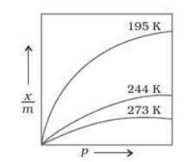

Xm=k.p/n(n>1)…. (5.1) where x is the mass of the gas adsorbed on mass m of the adsorbent at pressure p, k and n are constants which depend on the nature of the adsorbent and gas at particular temperature. The relationship is generally represented in the form of a curve where mass of the gas adsorbed per gram of the adsorbent is plotted against pressure.

These curves indicate that at a fixed pressure, there is a decrease in physical adsorption with increase in temperature. These curves always seem to approach saturation at high pressure. Taking logarithm of eq. (5.1)

Log x m= log k + 1 n log p

**Freundlich Isotherms**

The validity of this can be verified by plotting log x m on y axis (ordinate) and log p on x axis (abscissa) if it comes to be straight line, the Freundlich isotherm is valid otherwise not. The slope of the straight line gives the value of 1 n. the intercept on the y axis gives the value of log k.

Freundlich isotherm explains the behaviour of adsorption in an approximate manner. The factor 1 n can have values between 0 and 1 (probable range 0.1 to 0.5). Thus equation (5.2) holds good over a limit

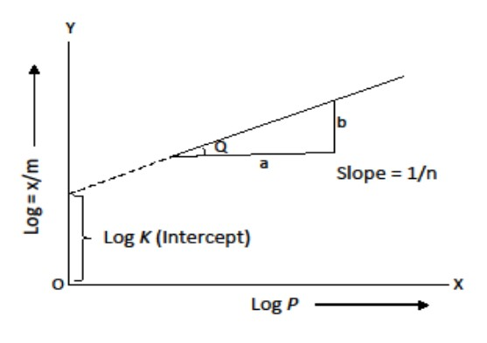

When 1 n=0, x m = constant the adsorption is independent of pressure.

When 1 n = 1, x m = k p i.e. x m directly proportional p the adsorption varies directly with pressure

Both the conditions are supported by

experimental results.

The experimental isotherms always

seem to approach saturation at high

pressure. This cannot be explained by

Freundlich isotherm. Thus, it fails at

high pressure. ed range of pressure.

**Applications of Adsorption**

* Production of high vacuum: The remaining traces of air can be adsorbed by charcoal from a vessel evacuated by a vacuum pimp to give a very high
* Gas masks: Gas mask (a device which consists of activated charcoal or mixture of adsorbents) is usually used for breathing in coal mines to adsorb poisonous gases
* Control of humidity: Silica and aluminium gels are used as adsorbents for removing moisture and controlling humidity
* Removal of colouring matter from solutions: Animal charcoal removes colours of solutions by adsorbing coloured impurities.
* Heterogenous catalysis: Adsorption of reactants on the solid surface of the catalysts increases rate of reaction. There are many gaseous reactions of industrial importance involving solid catalysts manufacture of H2SO4 by contact process and use of finely divided nickel in the hydrogenation of oils are excellent examples of heterogenous catalysis
* Separation of inert gases: Due to the difference in degree of adsorption of gases by charcoal a mixture of noble gases can be separated by adsorption on coconut charcoal at different temperature
* In curing diseases: A number of drugs are used to kill germs by getting adsorbed on them vacuum

**Catalysis**

Catalyst is a chemical substance which can change the rate of reaction without being used up in that reaction and tis process is known as **catalysis.**

A catalyst mat be positive (increase rate of reaction) or negative (decreases rate of reaction). Types of catalysis :-

* **Homogenous catalysis:** in this catalysis and the catalysts reactants are in the same physical state
* **Heterogenous catalysis:** in this catalysis, catalyst is present in a different phase than that of reactants
* **Autocatalysis:** when one of the product of a reaction acts as catalysts the process is called autocatalysis

**Characteristics of catalyst:**

1. The catalyst remains unchanged in mass and chemical composition
2. In case of reversible reactions the catalyst does not influence composition of reaction mixture at equilibrium. It only helps to attain the equilibrium quickly

**Adsorption theory of heterogenous catalysts**

The mechanism involves five steps:

1. Diffusion of reactants to the surface of the catalyst
2. Adsorption of reactant molecules on the surface of the catalysts
3. Occurrence of chemical reaction on the catalysts surface through formation of an intermediate
4. Desorption of reaction products from the catalyst surface.
5. Diffusion of reaction products away from the catalyst's surface important

**Features of Solid Catalysts**

**Activity**

The activity of a catalyst depends upon the strength of

chemisorption to a large extent. The adsorption should

be reasonably strong but not so strong that they become

immobile and no space is available for other reactants to

get adsorbed.

**Selectivity**

The selectivity of a catalyst is its ability to direct a

reaction to yield a particular product, e.g, starting with

Hz and C0 using different catalysts, we get different

products.



**Shape selective catalysis**

The catalytic reaction that depends upon the pore

structure of the catalyst and the size of the reactant and

product molecules is called shape-selective catalysis.

Cracking Isomerization of hydrocarbons in the presence of zeolites is an example of shape selective catalysis.

An important zeolite catalyst used in the petroleum

industry is ZSM-S.It converts alcohols directly into

gasoline.

**Enzyme catalysis**

Enzymes are complex nitrogenous organic compounds which are produced by living plants and animals.

They are actually protein molecules of high molecular mass and form colloidal solutions in water. They are also known as biochemical catalysis.

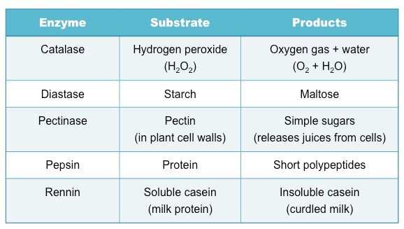

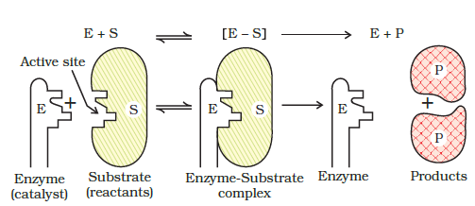

**Characteristics of enzyme catalysis**

* **High efficiency-**  One molecule of an enzyme may transform one million molecule of reactant per minute.
* **Highly specific nature-** each enzyme catalyst cannot catalyse more than one reaction
* **Optimum temperature-** enzyme catalyst gives higher yield at optimum temperature ie at 298-310k. Human body temperature ie at being 310k is suited for enzyme catalysed reactions
* **Optimum pH-** the rate of an enzyme catalysed reaction is maximum at optimum pH range 5 to 7
* **Activators-** like ions such as Na+, Ca, 2+, Mn2+ help in the activation of enzymes which cannot act on their own strength
* **Co enzyme-**  are the substance having nature similar to the enzyme and their presence increases the enzyme activity. Mostly vitamins act as co enzymes
* **Effect of inhibitors-** inhibitors slow down the rate of enzymatic reaction. The use of many drugs is based on enzyme inhibition action of those drugs in the body

**CONCLUSION**

The science encompasses

Concepts such as heterogenous

catalysis, semiconductor device

fabrication, fuel cells, self

assembled monolayers ad

adhesive. Surface science is

closely related to interface

science and colloidal science

studies macroscopic phenomena

that occur in heterogenous

systems due to peculiarities of

interfaces.

**Bibliography**

* + https//:www.wikipedia.com
  + <https://www.encylopedia.com>
  + Google search engine
  + Chemistry NCERT book for class 12 th
  + Chemistry Pradeep