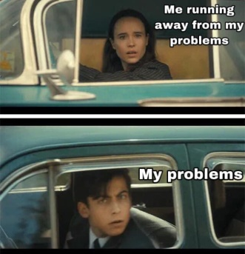

Original Subtitle: "Pilots when they see each other:"

From: The Umbrella Academy

Popularized On: August 6th, 2020

Original Post: Facebook

Meme Author: Erika Quimson

About: In one scene of the episode, character Vanya Hargreeves and character Number Five drive by each other in their cars and are surprised to see each other

Description: This represents an unexpected event that may holds significance in your life.

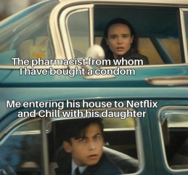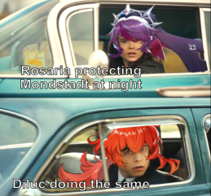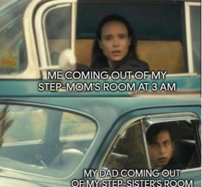Example Pictures:

Cite/Reference: KnowYourMeme 2008, *Vanya and Five Drive By Each Other*, accessed June 11 2022, < <https://knowyourmeme.com/memes/vanya-and-five-drive-by-each-other>>

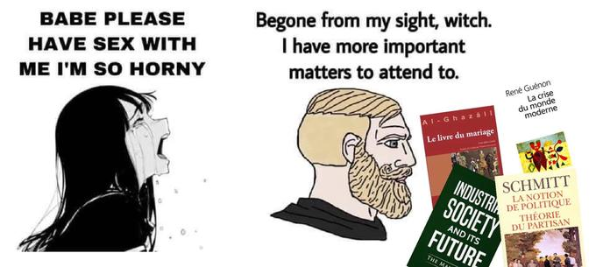

Original Subtitle: "Babe Please Have Sex With Me I'm So Horny"

From: Magical Girl Site

Popularized On: October 19th, 2020

Original Post: Facebook

Meme Author: gokin32

About: A girl begging her boyfriend to stop doing something, and stop ignoring her.

Description: This depicts where a man has a priority over something rather than the other.

Example Pictures:

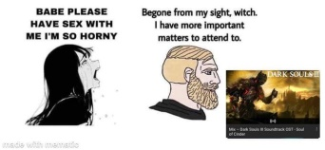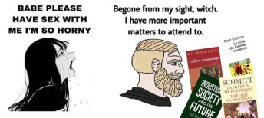

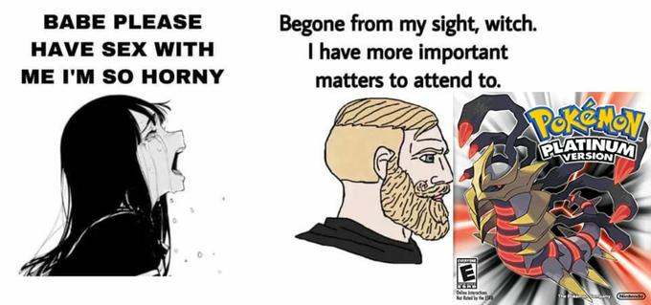

Cite/Reference: KnowYourMeme 2008, *Babe Please Stop*, accessed June 11 2022, < <https://knowyourmeme.com/memes/babe-please-stop>>

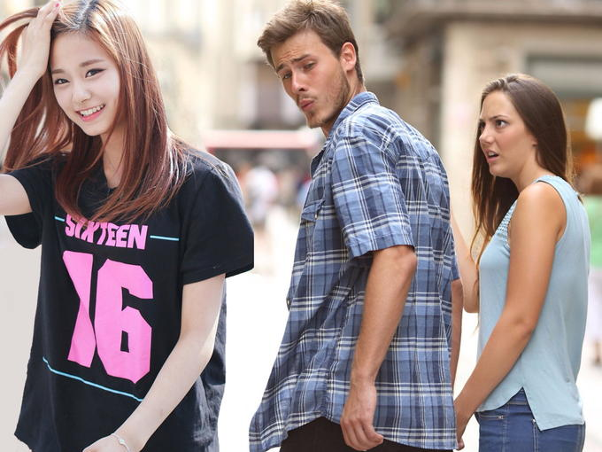

Original Subtitle: “Tag That Friend / Who Falls in Love Every Month”

From: iStock

Popularized On: February 23rd, 2017

Original Post: Instagram

Meme Author: _dekhbai_

About: a man looks at the backside of a woman walking by while another woman, presumably his romantic partner, looks on disapprovingly.

Description: This as the image shows how a man falls in love to another girl depicting their weak relationship with the girl it makes you contemplate on how you view your relationships whether or not they were weak or not.

Example Pictures:

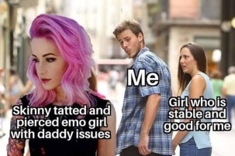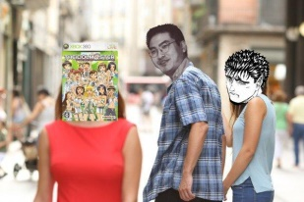

Cite/Reference: KnowYourMeme 2008, *Distracted Boyfriend*, accessed June 11 2022, < <https://knowyourmeme.com/memes/distracted-boyfriend>>

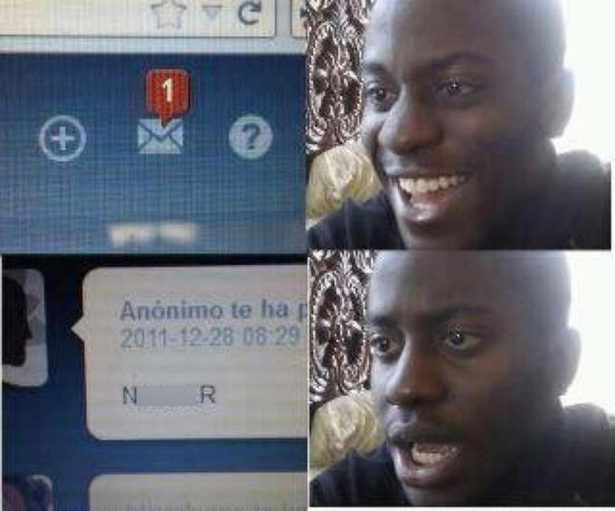

Original Subtitle: "N****r"

From: Tediferous

Popularized On: August 12th, 2018

Original Post: Tumblr

Meme Author: tediferous

About: A happy, excited man. The third panel usually reveals the full picture of the first panel, which is different and unappealing, followed by a picture of the same person, but now with an expression of disappointment or shock.

Description: Never celebrate too early

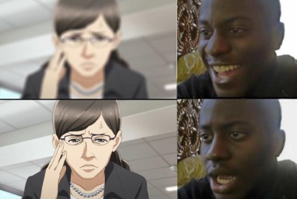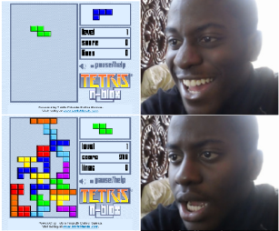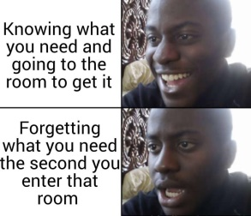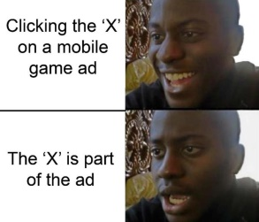Example Pictures:

Cite/Reference: KnowYourMeme 2008, *Disappointed Black Guy*, accessed June 11 2022, < <https://knowyourmeme.com/memes/disappointed-black-guy>>

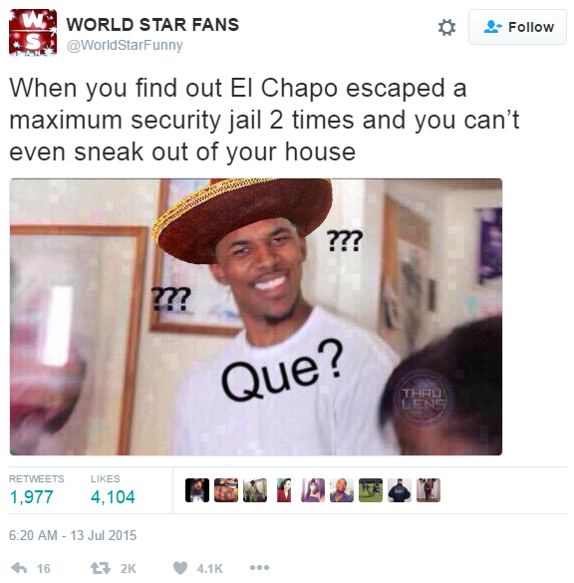

Original Subtitle: "Que?"

From: NBA

Popularized On: July 13th, 2015

Original Post: YouTube

Meme Author: WorldStarFunny

About: Has question marks surrounding his head to express confusion online.

Description: This makes a man contemplate about his knowledge on why he was confused.

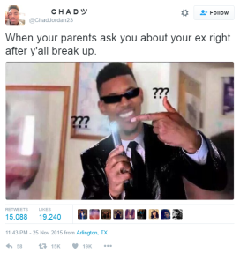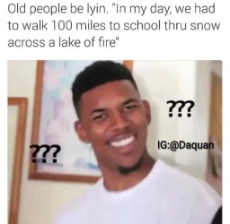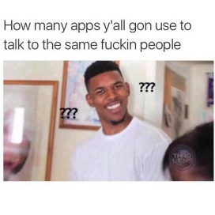Example Pictures:

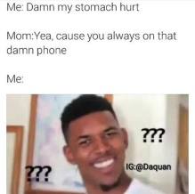

Cite/Reference: KnowYourMeme 2008, *Confused Nick Young*, accessed June 11 2022, < <https://knowyourmeme.com/memes/confused-nick-young>>

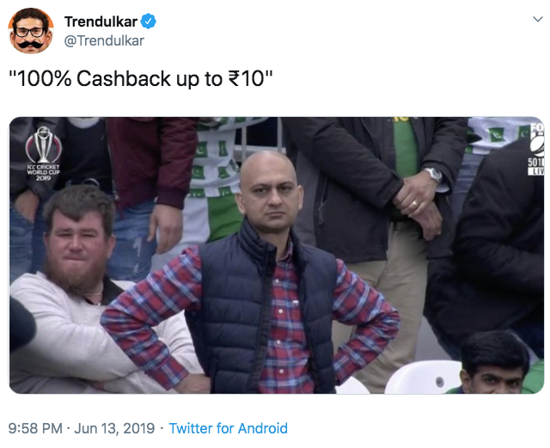

Original Subtitle: " (•_•)<) )>/ \ “

From: Cricket World Cup

Popularized On: June 12th, 2019

Original Post: Facebook

Meme Author: Akhtar

About: Appearing annoyed and dismayed due to disappointing reasons

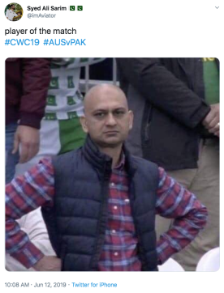Description: This meme acts as an reminder that you should not be doing things what you should not do otherwise this man shall be disappointed in you.

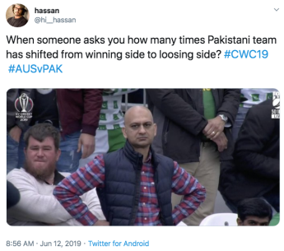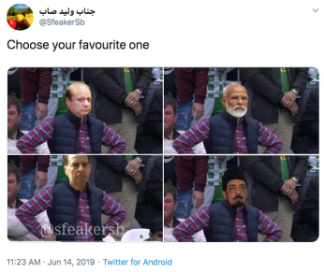Example Pictures:

Cite/Reference: KnowYourMeme 2008, *Disappointed Muhammad Sarim Akhtar*, accessed June 12 2022, < <https://knowyourmeme.com/memes/disappointed-muhammad-sarim-akhtar> >

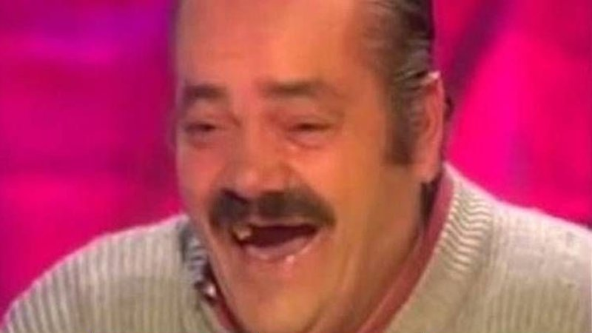

Original Subtitle: "When I got to the beach the tide has risen”

From: Ratones Coloraos

Popularized On: March 28th, 2014

Original Post: YouTube

Meme Author: Thursday Comics

About: He burst into laughter after telling a humorous anecdote about throwing kitchen pans into the sea while working at a beach restaurant as a young man

Description: This just tells you to be responsible for your actions and tend to them when needed.

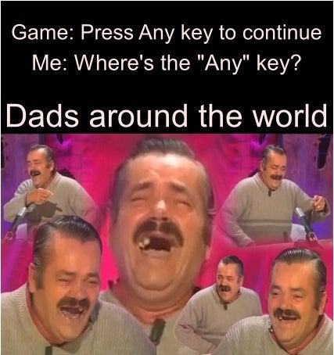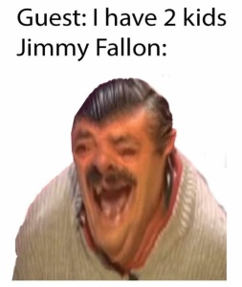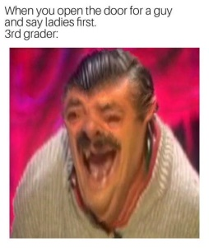Example Pictures:

Cite/Reference: KnowYourMeme 2008, *Spanish Laughing Guy / "El Risitas" Interview Parodies*, accessed June 12 2022, < <https://knowyourmeme.com/memes/people/spanish-laughing-guy-el-risitas-interview-parodies> >