Report
BigMart Products Outlet Sales Analysis and Prediction

Data loading
In that part we load train and test data and we checked types of data and null values and some statistic information like mean, min and max ….

Exploratory Data Analysis
The most important in that section we visualize our data. Every feature we have in our data. In the main goal to check if we have something wrong like the same attribute but written with different forms as we discover with attribute low fat and LF in the Fat content variable.
Secondly, we checked the problem of balanced data and also, we check the distribution of our data, especially the variable that are of types float (non-categorical).
We detect outliers in target variable and also in other variables (type float), but in this model we didn’t remove any outlier in target variable in contract we remove them in other variables (type float).
We replace all missing values in categorical variable we most often appear in categorical variable in the mean time we replace other nan variables with median.
Finally, we encode the categorical variable with ONE HOST ENCODER.

Modeling
We used a variance of algorithm for this regression problem such as linear regression model, random forest regression and XGBoost ..
For linear regression we can see the result as bellow
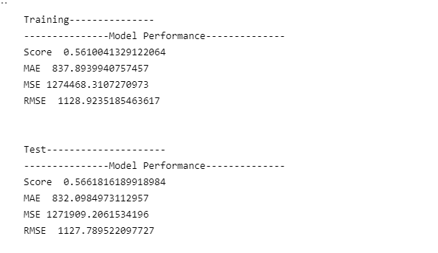

The result of train data and test data is stable as we can see from the R2 score
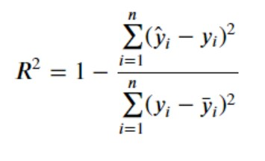

The best result was given by the Random Forest Regressor and XGBoot without any transformation on our data.
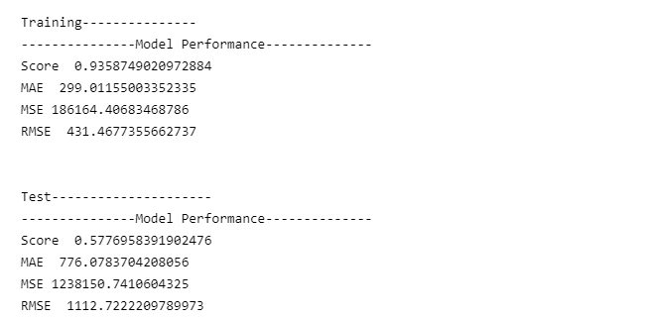
Figure 1: result of Random forest
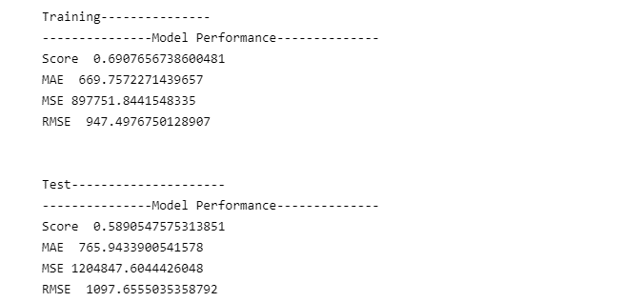
Figure 2 : result of XGboost
The difference between to result that the random forest fit data well but in test part fails in the meantime the xgboost doesn’t fit well but give best result in testing part which is logic because we don’t have a huge difference between score of training and score of the test.
After that we apply power transform on target variable and other variable of type float.
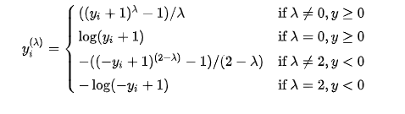
Figure 3: Yeo–Johnson transformation
You could see the graph of transformation in the jupyter notebook in the section of transformation.
The result with random forest with default parameter as bellow
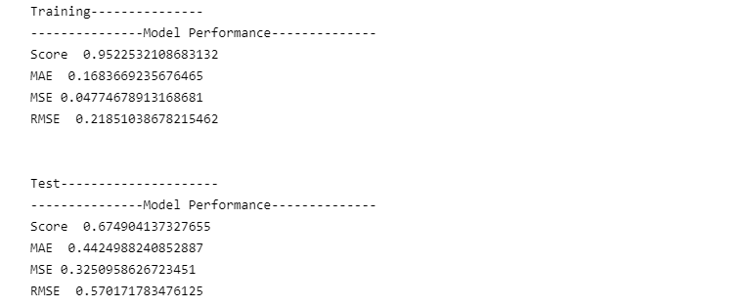
Figure 4:The result with random forest with default parameters
We fit also the XGBoost with the train data that we got from power transform, which gave us the result bellow.
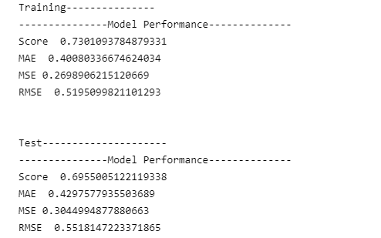
Figure 5: result of xgboost with power transform data

Feature engineering
As the final step we choose the XGBoost algorithm to continue with for feature engineering. For that we started with PCA for now and in the next version of my project I will add more transformation for feature engineering.
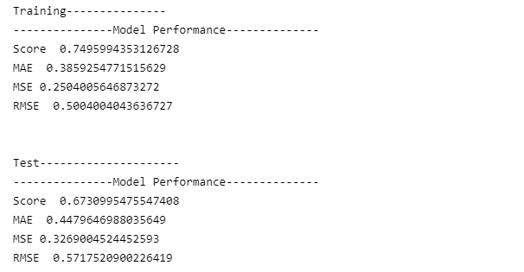
Figure 6 : the result of xgboost after applying PCA

Conclusion
We don’t look for fine tuning the parameter right for the XGBoost, but we will do it for the next version because takes too much time.
For now we are going to test our unlabeled data with XGBoost model without PCA.

