Cuttle Multiplayer Version v1.2
For 2-5 players. Recommended 2-3 players. Ages 8+ Use a standard deck of 52 cards without jokers
Play time: Average 10 minutes. 20 seconds – 20 minutes.

Setup
Dealer shuffles, deals everyone FIVE cards, and dealer gets SIX cards. The remaining cards become a DRAW PILE placed face-down in the center. The DISCARD PILE will start next to the draw pile. Player to the left of dealer starts with the first turn. Play clockwise. If the draw pile is empty, shuffle the discard pile to continue play.

On your turn, pick ONE action: How to win
- Draw a card Score 21 or more points to win.
- Play a point card
- Play an effect card Hand limit
- Play a permanent card SEVEN (discard down at the end of your turn)
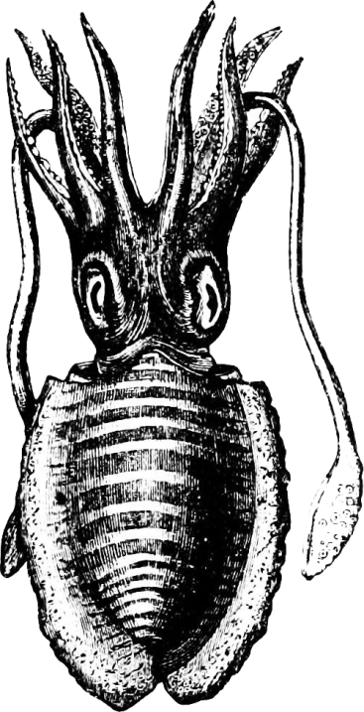
Point Cards (Play vertically in front of you)
Ace (1) through 10

Effect Cards (Play by discarding)
Ace Destroy ALL points.
2 Counter an effect OR destroy a permanent card. Anyone
can counter at any time; place the two in front of you
until your turn, discard the two and your turn is finished.
3 Revive a card from the discard pile, show everyone,
and place it in your hand.
4 Everyone else discards TWO cards.
5 Draw TWO cards.
6 Destroy ALL permanents.
7 Draw a card and immediately play it (even if it is to
your disadvantage). If the card cannot be used, discard.
9 Return a permanent card to owner’s hand.

Permanent Cards (Play sideways)
8 Everyone else places their hand face up on the table.
Jack Place on top of a point card to transfer ownership. Stacked Jacks are possible.
Queen Protect your points and permanents from single attacks (TWO, NINE, and JACK).
A queen is always vulnerable to a TWO and SIX. Your points and permanents are vulnerable to ACE and SIX.
0K | 21+
1K | 14+
2K | 10+
3K | 7+
4K | 5+
King Each King you play lowers the amount of points you need


Cuttle (2 player) created anonymously in the 1970s. Cuttle Multiplayer created by Michael McMahon and the Intel Computer Clubhouse at Blue Hill Boys & Girls Club in 2014.
Cuttle Multiplayer Version v1.2
Suggestions for faster play:
- When introducing the game, play a practice round first with all hands face up.
- Print multiple rule sheets and place them between all players for reference.
- Announce your turn. Examples: “I am drawing a card.” “I am playing an EIGHT for points.”
- Remind players of their turn.
- If playing with 4-8 players, remove an ACE and a SIX after each shuffle or as seen fit.

Suggestions for advanced play or house rules:
- A long term points system could be added like with Rummy 500. Keep a pen and a notepad around your deck of cards, write initials at the top of columns, and add up points at the end of each round. First person to a predefined number wins the game.
- The basic game generally works with low point cards having strong powers and higher point cards having weak powers. The ACE and TWO have powerful effects, the NINE has the weakest effect, and the 10 has no effect. Try changing the rules for cards. If you want to add more rules than the number of cards, card color can double the rules and card suits can quadruple the rules. Jokers can also be added for a rule. Temporary rules can be written directly on the rules page.
  - Effect “Place on top of a permanent card to transfer ownership.”
  - Effect “Destroy a point card.”
  - Effect “Revive a card from the discard pile and immediately play it (even if it is to your disadvantage). If the card cannot be used, discard.
  - Effect “Skip the next player’s turn.”
  - Effect “Skip a player’s turn of your choosing.”
  - Effect “Return a point card to owner’s hand.”
  - Effect “Look at a player’s hand of your choosing.”
  - Effect “Choose a card to discard from a player’s hand of your choosing.”
  - Effect “Choose a card to keep from a player’s hand of your choosing.”
  - Permanent “Prevent group attacks (ACE, FOUR, and SIX).”
  - Permanent “All points are are subtracted if this card is active at the end of the round.” for game while keeping score.
  - Permanent “If you laugh, discard a card of your choosing.”
  - Permanent “Everyone places their hand face up on the table.”

Frequently Asked Questions:
- Can I make my own version of Cuttle? Yes, this version of Cuttle is released under the Creative Commons Attribution-ShareAlike 4.0 International (CC BY-SA 4.0) license. This allows you to share and adapt this work as long as you give appropriate credit, indicate if changes were made, provide a link to the license, and share under the same license. For more information, check out https://creativecommons.org/licenses/by-sa/4.0/
- Why is Cuttle so similar to other card games? Cuttle is thought to be the first modern battle card game. Many popular games are based off its concepts.

Cuttle (2 player) created anonymously in the 1970s. Cuttle Multiplayer was created by Michael McMahon and the Intel Computer Clubhouse at the Blue Hill Boys & Girls Club in 2014.

