Static Traffic Assignment (STA) Tutorial

# Download QGIS

In this tutorial, we will use **QGIS 2.18 (NOT QGIS 3.2 which is an unstable version)**. You may download QGIS 2.18 at: <https://www.qgis.org/en/site/forusers/download.html>

For Windows users, use one of the two links (according to your operating system) for version 2.18 in the “Standalone installers from OSGeo4W packages” section. If you do not know which one to use, try the 64-bit version first.

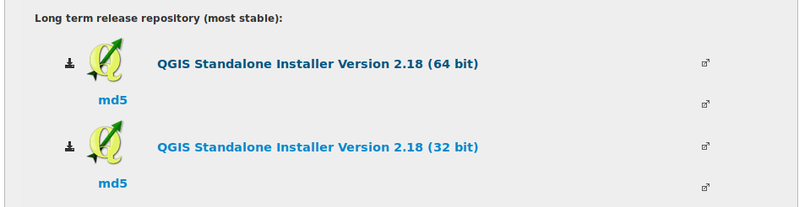

For macOS users, use this link:

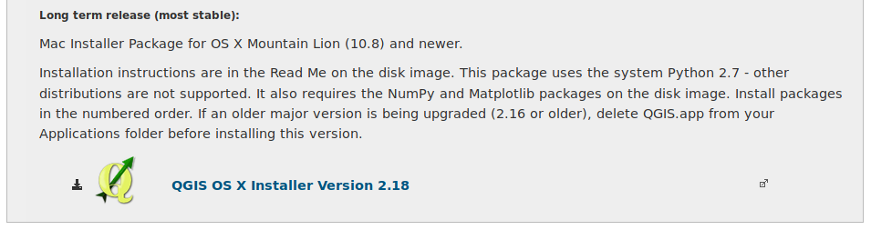

* Note: **do not use the version 3.2**. It is the latest release that does not work for this tutorial.

# Import data files

Unzip the “data.zip” file provided, we will find a “demands.csv” file and four sets of shape files under the spatial folder:

├── demands.csv  
└── spatial  
 ├── links.dbf  
 ├── links.prj  
 ├── links.shp  
 ├── links.shx  
 ├── links_r.dbf  
 ├── links_r.prj  
 ├── links_r.shp  
 ├── links_r.shx

├── pittsburgh.dbf  
 ├── pittsburgh.prj  
 ├── pittsburgh.shp  
 ├── pittsburgh.shx  
 ├── nodes.dbf  
 ├── nodes.prj  
 ├── nodes.shp  
 └── nodes.shx

First, open QGIS 2.18. Go to ‘Layer’ -> ‘Add layer’ -> ‘Add vector layer’ to open the “links.shp” file in QGIS. This is the file that contains all the roads of interest in Pittsburgh. In the ‘Layers Panel’, select the ‘links’ layer, right click and then select ‘Open Attribute Table’. There are in all 12 columns in the attribute table. “id” is the unique link id, “name” is the road name, “from” is the starting junction of a link, and “to” is the ending junction of a link. All other fields are parameters in the Bureau of Public Roads (BPR) function for each link. The BPR function estimates the travel time of a link with respect to the traffic volume.

Here, is the travel time on a road, is the free flow travel time on this link, is the volume of the traffic on this road (the number of cars passing by per hour), is the capacity flow of this road (the maximum number of cars that can pass by per hour), and and are two parameters without much physical meaning (usually and ). Note that in the attribute table, fields with the suffix “_r” are for the reverse direction of a link.

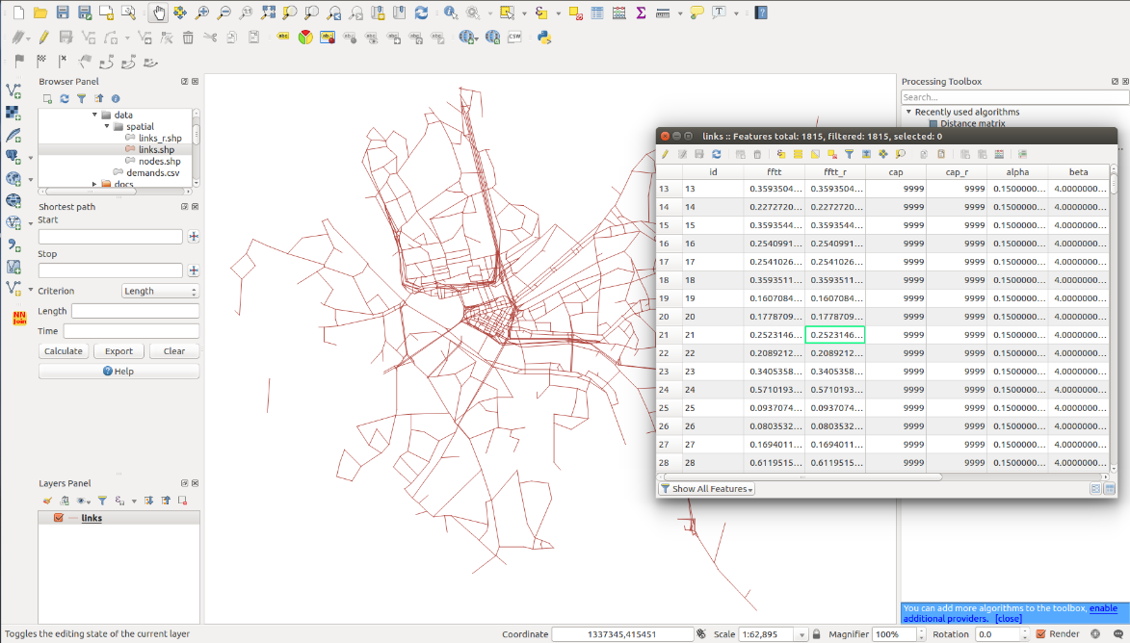

Then, open the “link_r.shp” file, which is a shifted version of “link.shp”. There are only two columns in the attribute table of this layer, namely the link id and road name. This layer is for visualization only.

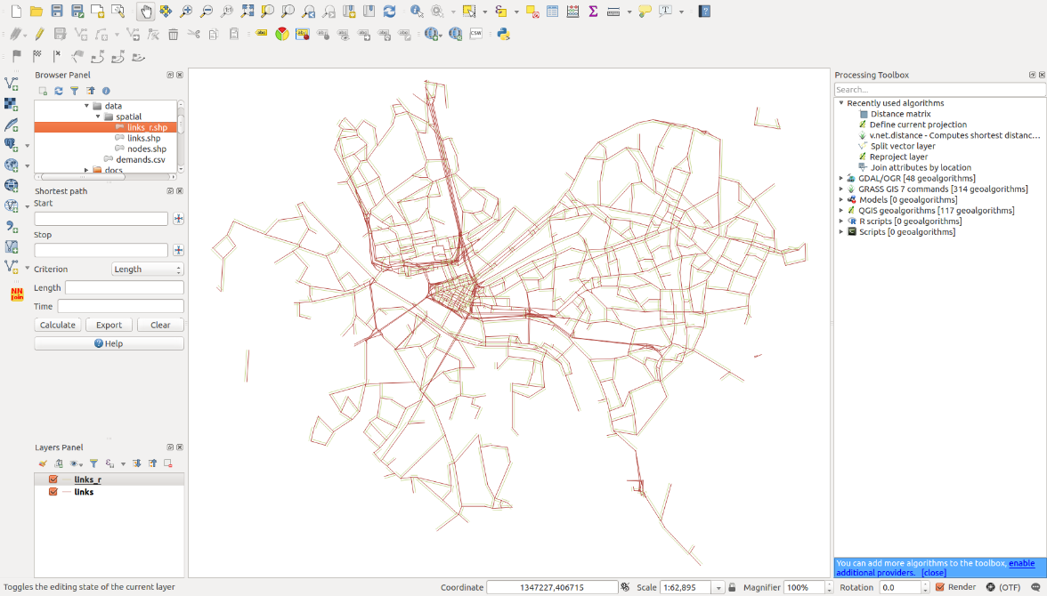

(This step is optional, only if you are interested.) Note that the Coordinate Reference System (CRS) of those shape files has already been transformed to EPSG:2272 (SPCS Pennsylvania South).

There are several artificial links on the map with capacity equal to 9999. They are not physical links and are used for the traffic assignment models. For the visualization purpose, we use the Query Builder to remove those links.

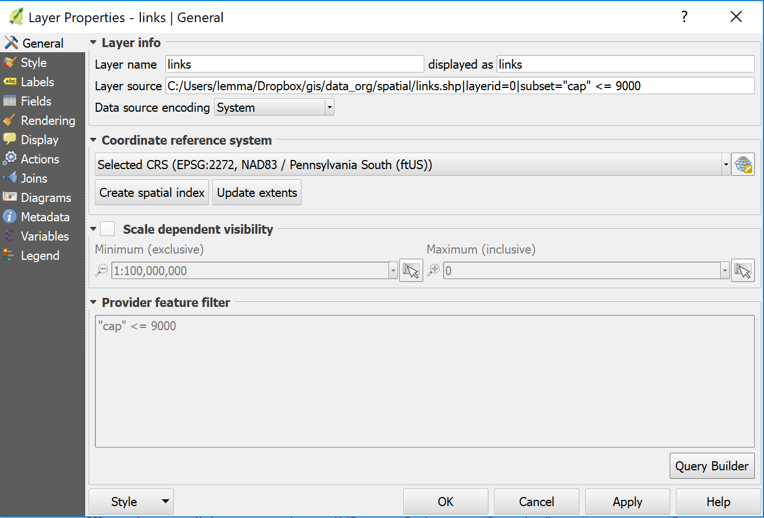

# Run the traffic model

1. Export the attribute table of “links.shp” file as a csv file. Right click on the links layer in QGIS, then click “Save As”. Fill the dialog. Be sure the “Format” field is “CSV”, and the “SEPARATOR” field is “COMMA”. Click OK. (You will need to browse to the subfolder where you placed all shape files, such as ..\data\spatial\)

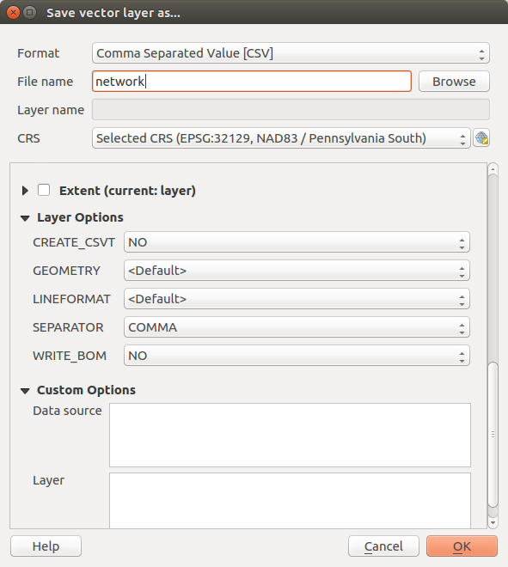

1. Open the csv file in Excel. Find a link or a set of links you would like to ‘physically close’ (namely performing your roadway construction projects). Edit the value with your best estimate. For instance, you may want to increase the fftt and/or reduce the flow capacity as a result of road closure projects. Save your csv file.
2. Go to <http://sta.heinz.local.cmu.edu/models/ue>. Note that this site is only accessible in the CMU network. If working off-campus, connect to the VPN first before go to this webpage.
3. Click “Network” and select the csv file you just exported and edited.
4. Click “Demands” and select the “demands.csv” file provided in “data.zip”.

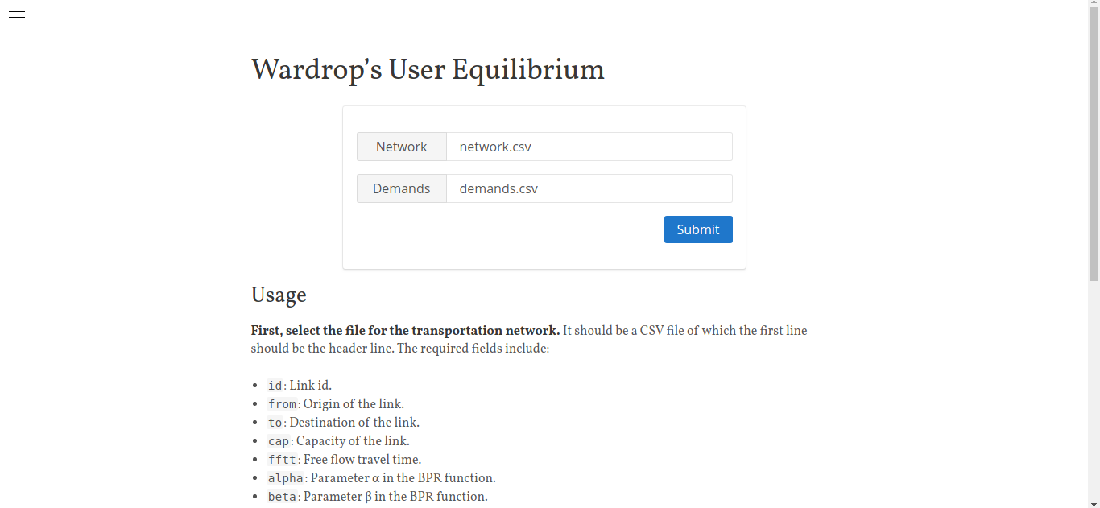

1. Click “Submit” and wait (60–120 seconds).
2. Download the results (ue-2018datetime.csv). The results are kept on our server for **only two minutes**. After two minutes, there is no way to retrieve the results. So please download it soon.

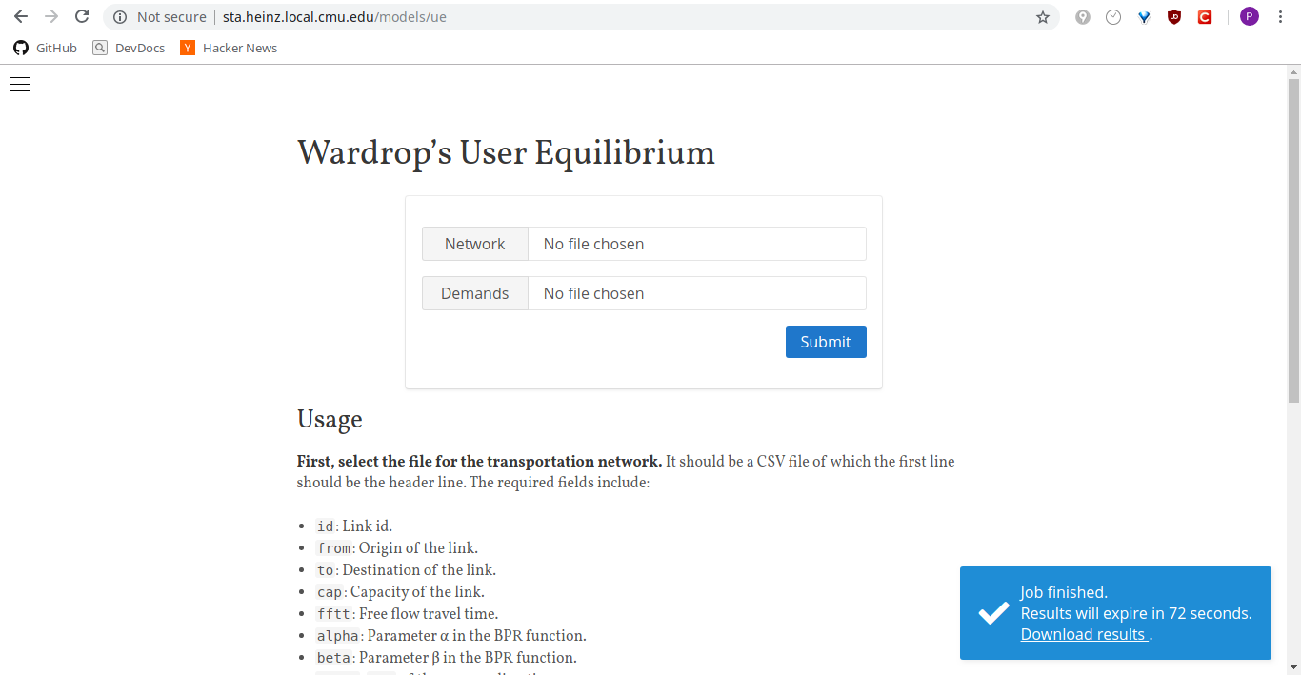

A few things to note:

1. There are only two processors on the server running the algorithm. So you may have to wait for a longer time when there are many requests.
2. If you close the browser tab accidentally when your job is still running, just reopen <http://sta.heinz.local.cmu.edu/models/ue>. In most cases you will get your job back.
3. If you submit multiple requests, only the latest one is kept. All other jobs will be discarded.

# Visualize the results

1. Open the file (ue-2018datetime.csv) with Excel, and save it as an “.xls” file. (NOT a .xlsx file)
2. Open the file (ue-2018datetime.xls) in QGIS by dragging this file directly to the ‘Layers Panel’ in QGIS, and rename the layer to a name that is easy to read/type, for example, “flow”.
3. Then, join the ‘flow’ table to the ‘links’ layer and the ‘links_r’ layer. Right click the ‘links’ layer, click “Properties”, and then click “Joins”. Add a new join with the ‘flow table’ (click the button with a plus sign) by matching the ‘id’ column. Do the same for the ‘links_r’ layer.

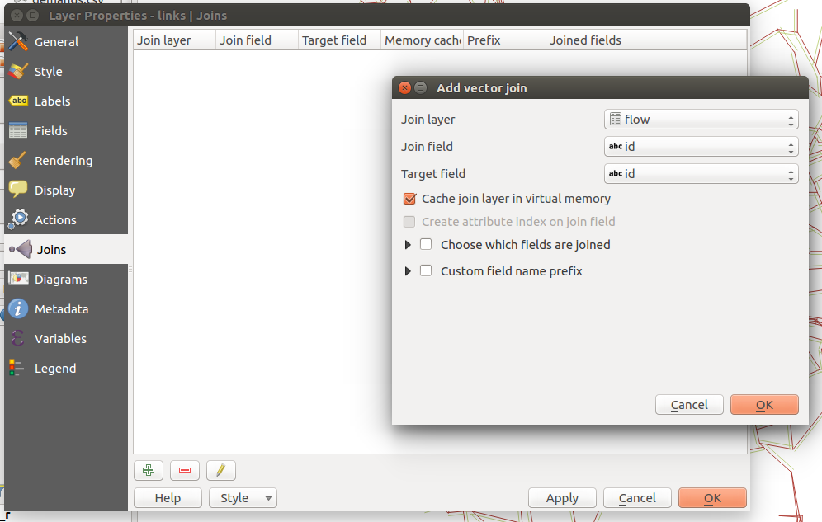

1. In the attribute table of the ‘links’ and ‘links_r’ layer, you will find new columns added to the flow table. They are the estimated traffic volumes for each link.

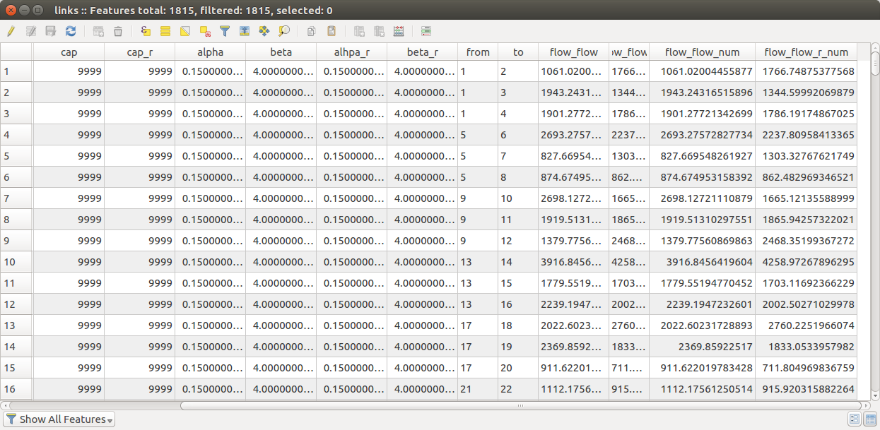

Now you can visualize the results in any way you like.

# Add a base layer

You can also add a base layer to your map to bring a bit context. The base layer we will use is a raster image from OpenStreetMap. First, install the “QuickMapServices” plugin for QGIS. Click “Plugins” in the menu bar, then click “Manage and install plugins…”, search “QuickMapServices” or “OpenLayers plugin”and install it.

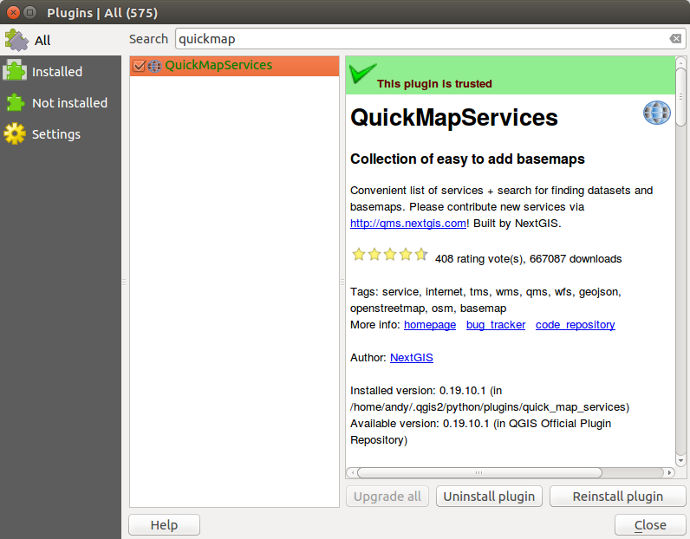

After installing the plugin, click “Web” on the menu bar, then select “QuickMapServices” → “OSM” → “OSM Standard” (or “Openlayers plugin” → “Bing Maps” → “Bing Road”). Note that this layer should be added after other layers, otherwise the world map will be loaded.

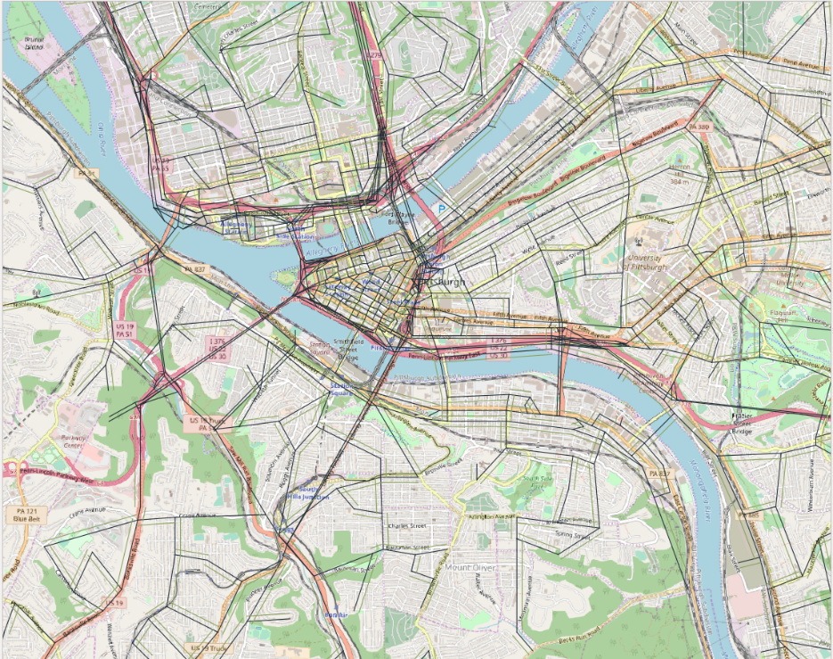

You may notice that the base layer is blurry. That is normal and expected. For those who are curious, that is because we transform the raster image from ESPG:3857 to ESPG:2272 when adding it to our map. This distorts a photo, and there is no easy way to fix this as far as we know.

# Evaluate social costs

You may now export the attribute table of the ‘links’ layer to a csv file. Excel can then read the csv file. You may use Excel to compute the travel time for each link, as well as for the total travel time for all cars of the entire city. Note that the total travel time is the traffic volume multiplied by its travel time on each link, summing over all links. In addition, you may also select several links of your interest to gauge the change in travel time induced by a scenario of your choice.

# Create layout

You can create a layout using “Composer Manager” in “Project” tab.

