## CS 2340 Computer Architecture

## Homework 4: MMIO with MARS

**This homework is worth 200 points**

**Objective:** To gain experience working with memory-mapped I/O.

### Instructions

1. Write and test a function to draw a box on the bitmap display. The box should be roughly in the center of the screen. Draw the box one pixel at a time. Use 4 loops, one for the top, one for the right side, one for the bottom, one for the left side. Each loop writes 7 pixels per side. To make debugging easier, make the box a solid color first, then go on to step 2. Make sure that your code uses these settings:

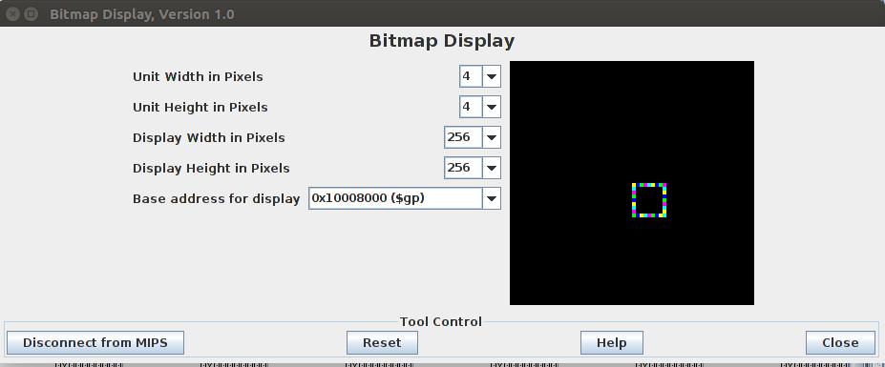

1. Modify the draw box function to have the marquee effect by drawing each pixel in a color from an array of colors. You can use colors similar to the following:

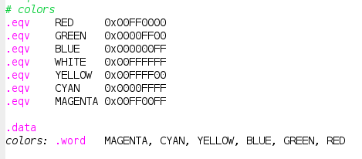

1. Slow the marqee appearance down by adding a pause function between pixel writes, using syscall 32. Make the delay 5 ms.
2. Add keyboard functionality. You can see similar code in the bitmap sample program 2 in the GitHub. The w, a, s, and d keys should move the box up, left, right, or down one pixel. The space key should terminate the program.
   1. Take input
   2. Blackout previous box
   3. Adjust start position
   4. Print new box

Grading Rubric:

200 points

100 points – draw a box near the center of the screen; use a loop for each side

40 points – use rotating colors so that the box has a “marquee” appearance

10 points – use a pause function between pixel writes

30 points – keyboard functionality to move the box with wasd, or space to end

20 points – comments in the code, plus comments on how to run;

and good use of white space

***Upload your .asm file to eLearning***

