## CS/SE 2340 Computer Architecture

## Homework 2: MIPS Control Structures

Objective: Practice MIPS loops, conditionals, functions.

### Instructions

Create a MIPS program that fulfills the following specifications:

1. use the dialog syscall (#54) to input a string from the user
2. call a function which counts the number of characters and number of words in the string and returns these in $v0 and $v1; store these in memory
3. output (console) the string and counts to the user (see example below)
4. repeat from 1 until the user enters a blank string or hits “cancel”
5. additionally, use $s1 somewhere in your function so that you must save it on the stack at the top of your function and restore it before the function exits; Of course this function could be written without using an s register, but this is good practice in using the stack.
6. output a dialog message (syscall #59) to say goodbye before the program ends

Note: space is a character, so it should be counted

What to turn in:

* after you test your program, upload the .asm file to eLearning

Grading Rubric:

|  |  |
| --- | --- |
| **Points** | **Element** |
| 10 | input string from user using a dialog box |
| 15 | write a function, saving/restoring $s1 |
| 20 | count characters correctly |
| 20 | count words correctly |
| 15 | main program ends when user enters cancel or empty string |
| 10 | Display results: string, char count, word count |
| 10 | Program contains meaningful comments as usual |

Sample Run:

Sample input dialog:

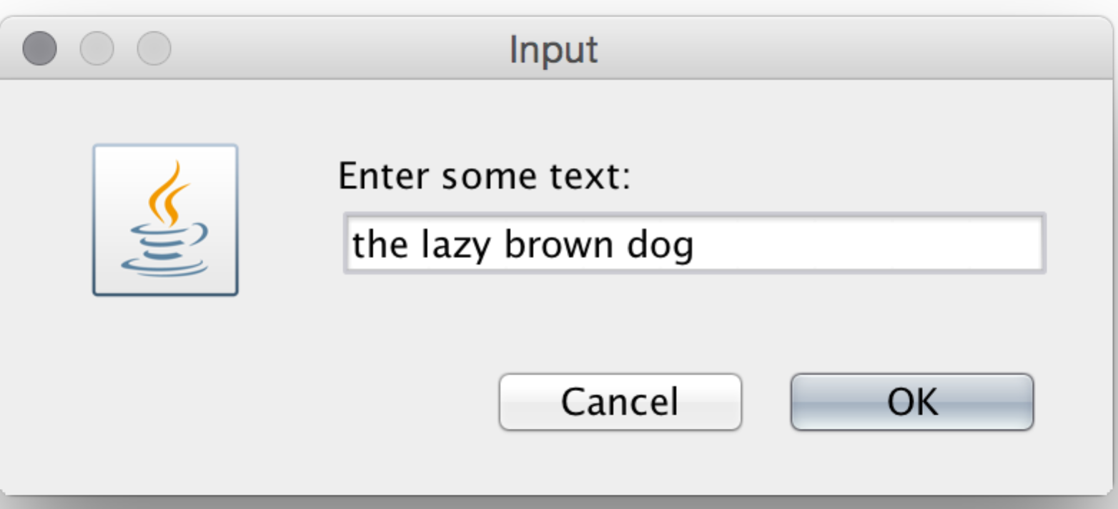

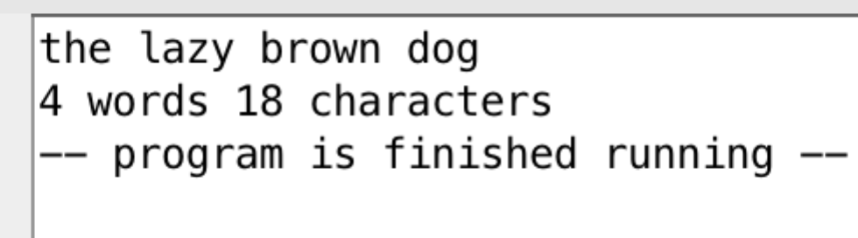Sample output: