Create project in visual studio and copy the ApplicationID

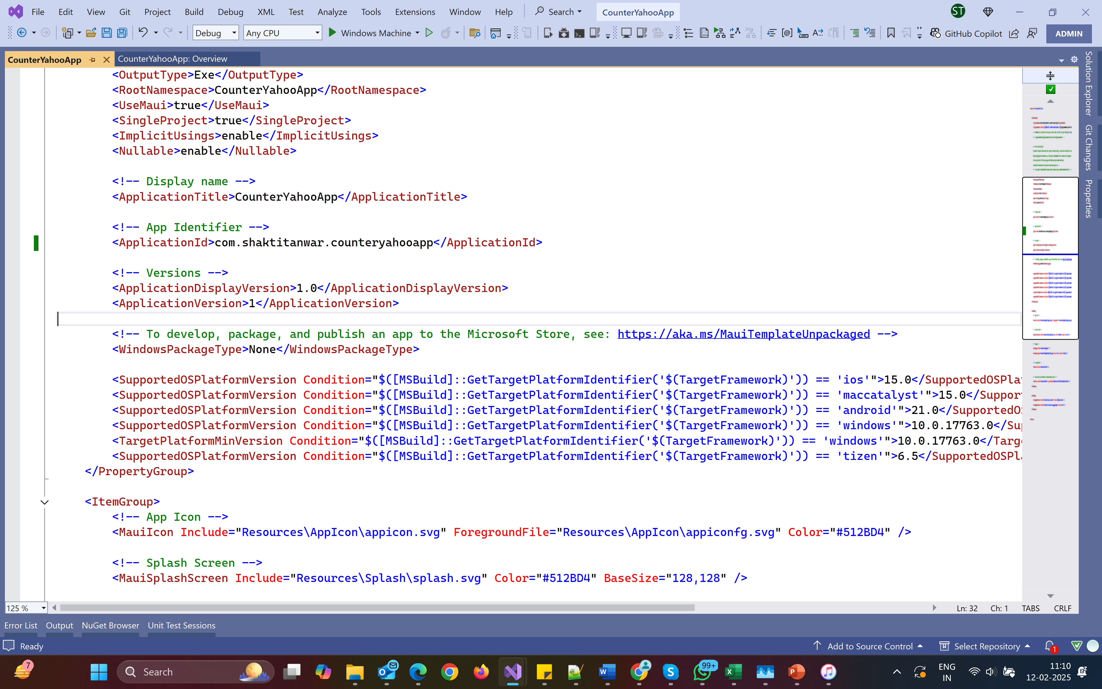

Go to Developer.apple.com and create identifier

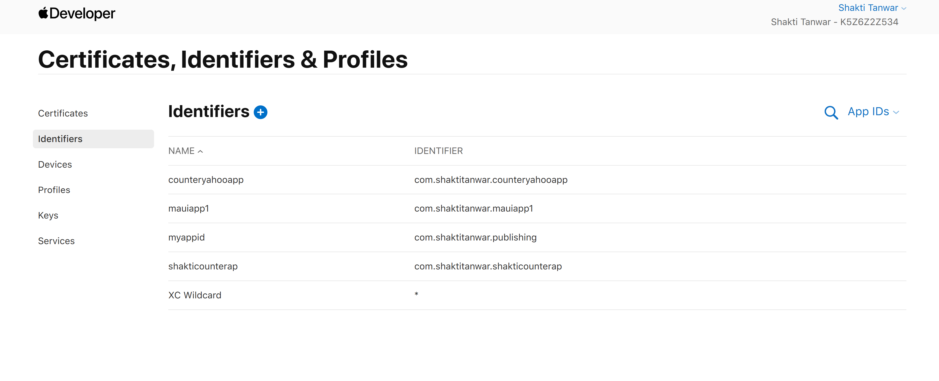

Go to Appconnect and create a new app

