**Articles**

**1.**

“most of our customers tell us they love the taste of our “fettle” water.  Many say they fill containers and take our water with them everywhere they go, and some have even said they cannot wait to get home from a trip just to have a glass of great tasting water. Customers also advise us that they drink way more water and their kids drink less pop and juice and more water too. When water tastes great people tend to drink more, an obviously good thing!

**How Do You Get Great Tasting Water?**

For those of us not lucky enough to have a natural spring in our backyard, we need to look at how we can get great tasting and safe drinking water. First, you need to purify the water by filtering with a combination of filters to allow the removal of all unwanted contaminants. The first filter needed is a sediment filter.  This is required for removing the sediment, rust, and general debris from the water. The second filter required is a carbon block filter, which removes the Chlorine, Organic Material, Lead and other contaminants. Third in line is the RO Membrane.  This is the heart of the system.  This membrane only allows particles smaller that .0001 micron in size to get past it, so this reduces most contaminants drastically.

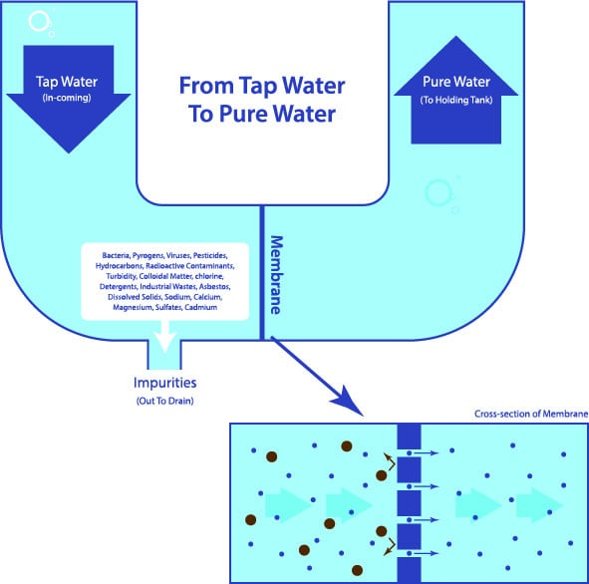

The final approach to great water is the re-mineralising process.  Why is this so important?  Water that has gone through the filtering and RO membrane, while extremely clean, does not have any minerals in it as these minerals are removed in the RO process.  As a result, the water is very acidic, usually between 5 to 6 PH, tastes very flat,  and is basically dead, unhealthy water.  When water tastes dead most people don’t enjoy drinking it so typically drink less. Mineral Pro adds the natural minerals back into the water after filtering and it is these minerals that not only make the water “alive”, but create water that is very healthy, and as importantly,  great tasting!

[SHOP REVERSE OSMOSIS SYSTEM](https://www.mineralpro.com/product/reverse-osmosis-system/)

This addition of minerals back into the water just prior to itcominge out the faucet creates Mineral Alkaline water with a PH of approximately 8.5.  Minerals in a granular state are placed in the last stage of the filtering system so when water flows through this cartridge the minerals are “Absorbed” into the water.  Just like rainwater flowing down a mountain stream, it absorbs these minerals and creates Mineral Alkaline “Spring Water”.  It is truly the minerals that give the water the great taste.  Some companies only use Calcite to make the water “Alkaline” but Mineral Pro uses a combination of 6 natural minerals in this last stage to ensure a balance of the healthiest minerals in the water.

**Alkaline water needs to have minerals in it to be healthy and great tasting.**

**The MineralPro Water Polisher -The Final Process:**

The last stage also has a section of carbon in it made from coconut husks, the purest form of carbon.  This carbon puts a final polish on the water, ensuring a clean, fresh taste every time!  The Mineral Pro system stores the water in the pressure tank in the pure form after the RO Membrane has removed all the contaminants. When the RO faucet is opened, this pure water comes out of the pressure tank and back through the system passing through the last stage, the mineral/carbon stage.  By designing it this way we can guarantee the water will always taste fresh, not stale from sitting in the tank!

**2.**

## 4 Properties To Get Healthy Water

Healthy drinking water has four properties that set it apart from regular tap water and most [bottled waters](https://www.mineralpro.com/blog/get-a-bottle-free-water-cooler/). To be considered healthy drinking water it must be:

### **Cleaned of Harmful Contaminants**

Including [chlorine](http://www.ncbi.nlm.nih.gov/pmc/articles/PMC1518976/), fluoride, pharmaceutical drugs, metals (mercury, [bromide](http://www.ncbi.nlm.nih.gov/pubmed/26489011), lead, arsenic), chemicals, bacteria and more.

### **Replenished with Natural Minerals**

[Water filter systems](https://www.mineralpro.com/product/new-700-series-carbon-filter-ro-and-uf-systems/) remove these minerals from the water; therefore, re-mineralization is required to ensure the naturally occurring minerals are present. Drinking de-mineralized water can actually leach minerals from bones and teeth.

### **Alkaline pH Balanced**–

Ensures optimal health, water filter systems and contaminants typically leave the water acidic.

### **Great Natural Spring Water Taste**

Great tasting water is fundamental to ensure proper hydration – when water does not taste good alternative beverages are typically selected.

[Click here to get your MineralPro system](https://www.mineralpro.com/product-category/drinking-water-systems/)

## Remove Toxic & Harmful Contaminants

Ensure that water is clean. The**1st step for healthy water** is to ensure the water is clean which involves [removing the toxic and harmful contaminants](https://www.mineralpro.com/blog/mineralpro-whole-house-cartridge-filtration-system/)that are present in the water. Multi-stage filtering is required to ensure all the possible contaminants are removed.

* **Sediment filtering** – Removes silt, dirt, sediment
* **Carbon Filtering** – Removes chlorine and chemicals
* **Membrane Filtering** – Removes small contaminants – bacteria, pharmaceuticals, metals

Clean water is absolutely essential for all proper body functions, including skin and organ integrity, immune system balance, cellular respiration and repair, waste elimination, and longevity.

The primary purpose of clean water within the body is to transport nutrients to the cells and then transport waste byproducts to the eliminatory system. It is absolutely essential in maintaining the critical balance needed to support life. Yet this system, with its multiplicity of interrelated dependencies, can be grossly affected by minute traces of chemical toxins like chlorine.

## Replenish The Natural Minerals In The Water

The**2nd step for healthy water** is to replenish the natural minerals in the water.

* Water naturally has beneficial minerals including: calcium, magnesium, sodium & potassium
* The levels of natural minerals are reduced in water due to the the piping and distribution process, from exposure to contamination, and from the water being taken away from natural mineral sources in rivers and streams.
* The key to creating “Healthy water” is by removing the contaminants while retaining the beneficial minerals
* Higher amounts of minerals in drinking water lowers heart disease and cancer mortality rates
* According to Dr. John Sorenson, a leading authority on mineral metabolism, “Minerals in drinking water are more easily and better absorbed than minerals from food.”
* Drinking water with higher amounts of minerals results in lower heart disease and cancer mortality rates.
* The drinking water in the 100 largest cities in the US were found to have 10% to 25% reduction in the amount of cancer deaths if the drinking water had a moderately high level of minerals, and if the water had an alkaline pH

## Alkaline PH Balanced

The**3rd step for healthy water** is to ensure the pH is balanced to a healthy alkaline level.

* Healthy alkaline pH level for drinking water is between 7.5 and 9.5.
* Alkaline water helps to neutralize stored acids and helps eliminate toxins
* Mineral, alkaline water can help the body maintain an ideal pH which some believe helps resist disease and slow the aging process

### Symptoms of a pH imbalance:

* low energy – fatigue
* excess weight
* poor digestion
* aches and pains
* other serious disorders

Several [research studies](http://fluoride-class-action.com/wp-content/uploads/cotruvo-health-aspects-of-calcium-and-magnesium-in-drinking-water.pdf) have demonstrated the presence of[chemical carcinogens](http://www.ncbi.nlm.nih.gov/pmc/articles/PMC1026058/) in surface, ground water, and municipal treated drinking water. However, often overlooked are the [beneficial properties in drinking](http://www.szu.cz/uploads/documents/chzp/voda/pdf/hardness.pdf) water that can help protect us from diseases such as cancers – natural minerals and alkaline pH.

Water that contains[natural minerals and alkaline](https://www.mineralpro.com/blog/mineral-alkaline-water-the-best-water-to-drink/) pH is associated with lower mortality from heart disease and cancer, and overall health. The drinking water in the 100 largest cities in the US were found to have 10% to 25% reduction in the amount of cancer deaths when the drinking water had a moderately high level of minerals and had an alkaline pH (above 7.0).

## Natural Spring Water Taste

The**4th step for healthy water**is to ensure the water has a great natural spring water taste.

* The human body consists of 70% water
* The human brain consists of 85% water
* Proper hydration is required for a healthy body
* Proper hydration is more likely with great tasting water of spring water quality

So if you want to have the peace of mind of knowing the water you drink is the best water possible for your health, give us a call at [**1-855-586-6667**](tel:18555866667)and we will be pleased to help you select the right healthy water system for your health needs.

3.

# Health Benefits of Sparkling Mineral Water

POSTED [1ST AUGUST 2017](https://www.brandedmineralwater.co.uk/blog/health-benefits-sparkling-mineral-water/) [WE ARE DAPA](https://www.brandedmineralwater.co.uk/blog/author/dapa/)

The normal drinking water that we drink possesses some surprising and unexpected health benefits. It may be hard for you to believe that, but mineral water is an essential mix of minerals like magnesium, sodium, calcium and potassium. [Mineral water](https://www.brandedmineralwater.co.uk/) posses differentiating qualities to boiled water and tap water as it improves the overall health and skin condition if consumed regularly. Human body is made up of certain minerals that are considered fundamental for the proper growth and performance of human brain and body. A deficiency of these minerals can cause certain health problems. So, still wondering w[hy you should opt for mineral water?](https://www.brandedmineralwater.co.uk/blog/opt-mineral-water/)

Here are the following amazing health benefits of mineral water which backs its consumption in ample amounts.

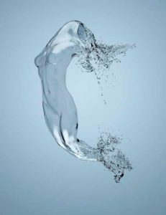

1. Promotes Bone Health: Mineral water is rich in calcium. Calcium is the most important mineral involved in bone formation. Hence, daily consumption of mineral water supplements the calcium requirements in the body. It strengthens human bones, teeth and even nails against damage.

2. Regulates Body Fat: Mineral water is an essential fat-free supplement that offers a good amount of fat metabolising minerals. Mineral water makes you slimmer and leaner, thereby helping you shape your body. It is any day a better choice over aerated drinks and soda. Regular consumption supports weight management.

3. Blood Pressure Management: Fluctuating levels of blood pressure can be kept in control with the regular consumption of water. It comprises of magnesium and calcium. The electrolytic process of the human brain and body is activated by these minerals which is essential for the maintenance of blood pressure in humans.

4. Reduces Cardiac Diseases: Mineral water keeps the body metabolism intact which has the power to reduce fat from the human body. Healthy metabolism ensures that the production of bad cholesterol is in control. Bad cholesterol if deposited in the adipose tissues and in and around the blood capillaries hampers the blood circulation and narrows the openings of capillaries. The narrowing of blood carriers increases the flow of blood and thereby increases the risk of heart attacks in heart patients.

5. Reduces Acids: Mineral water contains sulphates. Sulphates are catalysts that induce production of digestive enzymes like lipase and amylase. These enzymes if secreted in appropriate quantities cure the problems like bloating and constipation. Also, nullifies the problem of acidity.

6. Increases Physical Alertness: Mineral water is a mixture of different minerals like calcium, magnesium and potassium. These minerals are essential and helpful for proper growth and functioning of human muscles. Mineral water consumption increases the response rate of muscles. They become more supportive to contraction and expansion.

7. Increases Mental Alertness: Potassium is essential ingredient of mineral water; it is also called as a memory charging mineral. Potassium is an active constituent of the electrolyte present in brain. Hence, mineral water is a good option to increase mental alertness and reduce mental fatigue and lethargy.

8. Increases Skin’s lustre: Mineral water contains skin friendly silica particles. Silica is considered as a natural secret for beautiful skin. It triggers the creation of collagen in human skin which leads to reduced wrinkles, dark spots and dullness. It makes the skin-blemish free, moist, supple and glow.

9. Eases Arthritis: It also serves as a remedy for inflammation and pain caused due to arthritis. The anti-inflammatory benefits of mineral water help reduce swelling in joints.

10. Makes Hair Stronger: Hair adds to the beauty of a person. Pollution and sun largely ruin the hair quality. Mineral water possesses the detoxifying properties that help in restoration of lost strength and sheen of hair. It does so by restoring the normal PH level of the scalp from within. Mineral water is rich in oxygen and it increases its supply to the brain as well. This enhances the hair texture and grant strength to each hair strand against damage caused.

If not consuming mineral water yet, [contact](https://www.brandedmineralwater.co.uk/) a mineral water supplier and reap the amazing benefits.

4.

# Why should you opt for mineral water?

POSTED [21ST JUNE 2017](https://www.brandedmineralwater.co.uk/blog/opt-mineral-water/) [WE ARE DAPA](https://www.brandedmineralwater.co.uk/blog/author/dapa/)

With the summer kicking in water is essential for this time of year. Mineral water is the sort of quenching drink you need in this heat. It is a fact that today many of you are concerned with the quality of fruits and vegetables being less nutritious. This concern has been on a rise due because the soil is lacking its vital minerals.

There are certain health benefits of drinking mineral water. Our body needs minerals, which you are no doubt getting from the regular drinking water. Usually tap water contains minerals, to give the accurate numbers. By drinking 2 litres of water a day, you will be getting 10 to 15% of your daily calcium requirement. With an addition to a third of your required magnesium, which comes just from the water you drink.

## Essential reason for drinking mineral water

Yes! Bottled [mineral water](https://www.brandedmineralwater.co.uk/) is said to contain up to four times as much calcium and magnesium, when compared to regular tap water. You are right; if you suspect that regular drinking water is low in minerals. Thus, it is required to drink more mineral water; it will be beneficial if added in your diet.

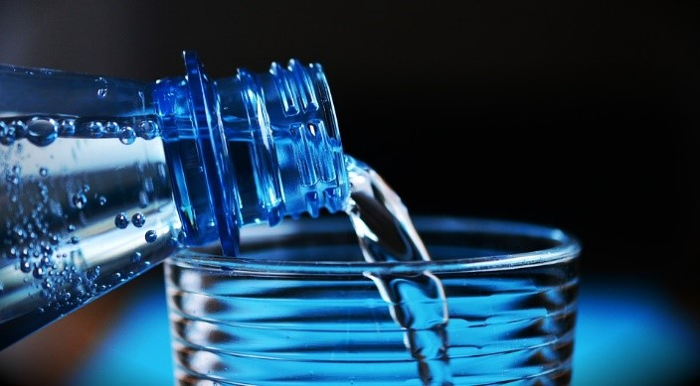

Water being an essential component in human body, will no doubt affect your health. A recent study shows that people who drink water with the required percent of magnesium, are able to lower their blood pressure by drinking a litre of mineral water every day. There are more than one way to get the required magnesium for your body. You can achieve so by adding brown rice, almonds, lima beans, and spinach, in your diet and these all food substances are indeed good sources of magnesium. By drinking mineral water you are ensuring your body, the right intake of calcium, magnesium, and other minerals.

## How Do Minerals in Drinking Water Affect Your Health?

* **Increases bone health** – Calcium is the most important mineral when bone formation is concerned and mineral water is rich in calcium. Hence, you see by daily consumption of mineral water you will be ensuring daily supplement of calcium in the body. It strengthens human bones, teeth and even nails against damage.

* **Regulates Body Fat** – It is also a fat free supplement, which offers a good amount of fat metabolising minerals, which helps in fat breakdown. Therefore, if you choose mineral water over aerated drinks and soda, you now know that you are making a healthier choice.

* **Blood Pressure Management** – Mineral water is in fact a boon for people suffering from the problem of fluctuating levels of blood pressure. Magnesium and calcium being actively involved in electrolytic process of the human brain and body, helps to maintain the essential balance of blood pressure in humans.

* **Reduces Cardiac Diseases** – Bad cholesterol gets deposited in the adipose tissues and around the blood capillaries. This results in no blood circulation, and the openings of the capillaries are narrowed. This increases blood pressure, which increases the risk of heart attacks in heart patients. Mineral water hampers the growth and accumulation of bad cholesterol in capillaries and thus reduces the risk of cardiac diseases as well.

The proper growth and functioning of human muscles, due to the mineral water only increases physical and mental alertness. Mineral water is also a fresh source of skin friendly silica particles, which is a natural secret to a beautiful skin. As you see, there is no reason why you should not drink mineral water. With choosing mineral water you are only opting for a healthier life

**5**

# What Elements Should Be Checked On Label While Buying Mineral Water

POSTED [31ST JULY 2017](https://www.brandedmineralwater.co.uk/blog/elements-checked-label-buying-mineral-water/) [WE ARE DAPA](https://www.brandedmineralwater.co.uk/blog/author/dapa/)

Mineral water contains certain minerals that benefit the human body and are of significant importance because of their healing properties. Our body can more easily absorb minerals from water as opposed to food. Hence, more minerals can be gained by drinking mineral water. Despite of certain [advantages](https://www.brandedmineralwater.co.uk/blog/branded-mineral-water/), there are few reasons as to why people hesitate to drink mineral water.

1. It will give you essential minerals such as calcium, magnesium and potassium. However, some brands may also have minerals which are not so beneficial, like sodium, sulphur and nitrate.
2. Although you need minerals to maintain a healthy body, these can be taken by eating a healthy and balanced diet or by taking supplements. The body needs minerals only in small quantities. Hence, there is no need to drink mineral waters to get them, especially since each production will provide a different composition.
3. Bottled drinks, including bottled mineral water are not healthy. Chemicals in the plastic bottle may be released into the water, especially if it is left in a car on a hot sunny day.
4. [Bottled water](https://www.brandedmineralwater.co.uk/) costs more compared with tap water.

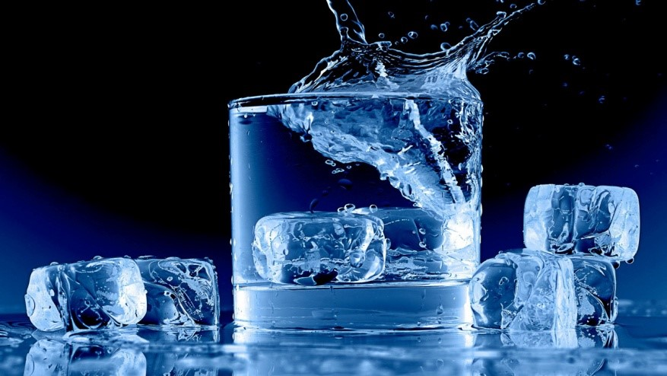

Can we rely on drinking tap water or it is preferable to buy bottled water? Among the several brand on sale, which one should we choose? Before you buy bottled mineral water, read the label. Make a healthier choice by understanding its contents.

**Check for the following constituents on the label:**

* **Sodium**: sodium consumption in diet and water collectively should not exceed the recommended limit. This will be harmful, especially for high blood pressure patients.
* **Nitrates**: Mineral water with high nitrate content may be harmful for pregnant women and babies under six months old. It is, therefore recommended to avoid brands that contains nitrate in it.
* **Aluminium:**Although the effects of aluminium are still uncertain, especially with regard to Alzheimer’s disease, it is best to avoid brands that have traces of it in their water.
* **Sulphates**: Sulphate is present in most ground-waters; you will find almost all brands with traces of this mineral. Sulphates are known to detoxify the liver, assist in digestion, and improve skin health by increasing circulation. It also reduces muscle cramps.

**Additional Information to Check on Label**

Not all bottled mineral water come from the natural sources. It can also be distilled or tap water that has been subsequently processed and added with minerals during the bottling stage. Hence, read the label to know if you are buying a natural mineral water or otherwise.

Also read the label for the following:

* **Acidity (pH):**Mineral water should be neutral and have a pH level of 7 or slightly higher. Below 7 means the water is acidic and above 7, it is alkaline.
* **Total Dissolved Solids (TDS):**It must be at least 250 mg/litter (or 250 parts per million)

Every day we lose body water through sweat and other body wastes. On average, we must replace about 5 pints of water, daily. Drinking appropriate quantities of [good quality water](https://www.brandedmineralwater.co.uk/) will, therefore, keep our body in good working condition.

**6.**

# Bottle Quality Matters!

POSTED [3RD AUGUST 2017](https://www.brandedmineralwater.co.uk/blog/bottle-quality-matters/) [WE ARE DAPA](https://www.brandedmineralwater.co.uk/blog/author/dapa/)

When it comes to a healthy drink, nothing competes the [benefits of water](https://www.brandedmineralwater.co.uk/blog/opt-mineral-water/). This precisely is the reason why everyone carries a water bottle wherever they go. But are our water bottles a health issue? Especially those made from plastic?

Generally they are safe, but it depends on the kind of plastic the bottle is made from. Plastics are made up of long chains of hydrocarbon molecules. Some other chemicals are added to these plastics to give them features such as flexibility or colour.

## Buying bottled water

The ‘single use’ [water bottles](https://www.brandedmineralwater.co.uk/blog/choose-branded-mineral-water-marketing-product-summer/) bought at milk bars, service stations are usually made from polyethylene terephthalate (abbreviated to PET or PETE), an inexpensive and lightweight plastic. Its recycling code is 1.

PET is not one of the plastics that one would think has a propensity to cause a problem. Hence for water, bottles made of PET are appropriate to use for storing water.

## Know Which Plastics Are Safe?

The plastics are rated in three categories on the basis of their use.

## GOOD TO USE

These plastics are known not to leach any chemicals that are suspected of causing cancer or disrupting hormones.

1. **Polyethylene Terephthalate (PET or PETE).**  
   These are used to make bottles that store soft drink, water, sports drink, ketchup, peanut butter, pickle, jelly and jam jars.
2. **High density polyethylene (HDPE).**  
   This plastic is used in making bottles that stores milk, water, and juice. They are also used in making yogurt and margarine tubs, cereal box liners, and grocery, trash, and retail bags.

## OK TO USE

These are of hazardous nature during production. These plastics are known not to leach any chemicals that are suspected of causing cancer or disrupting hormones. They are not as widely recycled as compared to PET or HDPE.

1. **Low-density polyethylene (LDPE).**  
   LDPE is used for bread and frozen food bags and squeezable bottles.
2. **Polypropylene (PP).**  
   It is used for ketchup bottles and yogurt and margarine tubs.

## BAD TO USE

These plastics either contain hormone disruptors or human carcinogens. They are likely less recyclable than better plastics.

1. **Polyvinyl chloride (V or PVC).**  
   Most cling-wrapped meats, cheeses, and other foods sold in delicatessens and groceries are wrapped in PVC.
2. **Polystyrene (PS).**  
   Foam insulation and also for hard applications (e.g. cups, some toys)
3. **Other usually polycarbonate.**  
   These are not fit for baby bottles, microwave ovenware, eating utensils and plastic coating for metal cans.

## Choosing a bottle

If, you want to stay on the side of caution, it is advisable to avoid consumption of drinks from bottles that have the recycling codes of 3 or 7, particularly for children.

The best bottles to use and reuse are those with the recycling codes 2, 4 and 5. 2 and 4 are made from polyethylene and 5 are made from polypropylene.

But these bottles are expensive to produce; hence their use is mainly done in production of reusable bottles.

PET is likely to be the plastic of choice for single-use bottles. These are highly used by certain [mineral water suppliers](https://www.brandedmineralwater.co.uk/) for bottling the water.

Another thumb rule is to use transparent and clear plastic instead of coloured or opaque because they eliminate the potential risks from colouring agents added to the plastic.

**7.**

# How Packaged Drinking Water Brands are Helping Customers?

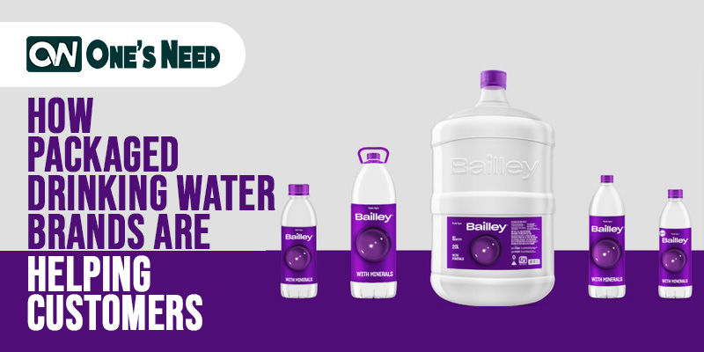

Safe drinking water is one of the fundamental requirements for human health, growth, and wellbeing. The door to safe drinking water and a hygienic way of living is a widespread concern. People are becoming health conscious and have turned to be more careful about drinking water.

[**Packaged drinking water**](https://www.onesneed.in/) has been taken as a prudent source of drinking water provision. It is important in many places, especially while we travel. With the charge of in-home purifiers, they have lost their importance in daily life but hold immense importance while we step out. Imagine drinking water from unsafe tap water while you are travelling! Who does that nowadays? Nobody would prefer to take the risk, especially during a pandemic. Moreover, people prefer packaged drinking water because they believe that it tastes better and comprehend it to be safer and of better quality. People while moving out take bottles of water along or purchase packed waterfront outside. Now that people move out often for jobs or similar tasks, the demand for packaged drinking water has thus, increased to a great extent and seems to be growing more in the coming future.

Packaged drinking water comes from safe sources and is treated and sterilized, a process that could involve filtration, ozone treatment, switch osmosis before it is declared fit for human consumption and is released in the market. Packaged drinking water is absolutely safe and helpful in many respects. These bottles have the safety mark on them which ensures customers to rely on the product without giving it a second thought.

Thus, brands offering packaged drinking water including Bailley, Bisleri Aquafina and many others have turned out to be extremely helpful for customers across the globe.

If you too are looking for reliable packaged water delivery services then your hunt is over because you can now get it delivered at your doorstep without any fuss.

Get good-quality water delivered to the comfort of your home without any hassle. Get purified water in clean bottles that are regularly sanitized and ensured to be hygienic. A variety of sizes are available for you to choose from. Select the one that best suits your requirement. Also, efforts are made to make the delivery in as little time as possible.

Grab extraordinary services that are cost-effective and are not available anywhere else. Make the right choice and select the one that delivers it to you at a reasonable price that fits your budget. Get it at the time of your convenience without being late. So do not waste any more time looking for services because the best is all prepared to provide you with services like no other. Hurry!