Lecture Notes
Year:1 | Semester: II
Subject: Biochemistry | Unit: I | Topic: Diabetes Mellitus
Research Summary
Diabetes Mellitus is a group of chronic metabolic disorders characterized by persistent hyperglycemia resulting from defects in insulin secretion, insulin action, or both. Type 1 diabetes involves autoimmune destruction of pancreatic β-cells leading to absolute insulin deficiency, whereas Type 2 arises from insulin resistance coupled with progressive β-cell dysfunction. Gestational diabetes occurs when pregnancy-induced insulin resistance exceeds β-cell compensatory capacity. Secondary forms result from other diseases, drugs, or genetic syndromes impairing insulin action or secretion. Hyperglycemia drives polyuria, polydipsia, polyphagia, weight loss, and chronic complications—retinopathy, nephropathy, neuropathy, and atherosclerosis—through glucotoxicity, lipotoxicity, and advanced glycation end-product formation. Diagnosis relies on fasting and post-load glucose measurements, HbA₁c, and, where appropriate, ketone analysis. Management encompasses lifestyle modification, pharmacotherapy (insulin, oral agents, injectables), and rigorous monitoring to prevent acute emergencies (DKA, HHS) and long-term vascular sequelae. Understanding the biochemical basis of insulin action and glucose homeostasis underpins effective therapeutic strategies.
Section 1 – Introduction
- Diabetes Mellitus is a chronic disorder marked by elevated blood glucose levels due to inadequate insulin production or impaired insulin sensitivity.
- Type 1 diabetes results from autoimmune destruction of pancreatic β-cells, leading to absolute insulin deficiency and risk of ketoacidosis.
- Type 2 diabetes is characterized by peripheral insulin resistance and relative insulin deficiency often associated with obesity and sedentary lifestyle.
- Gestational diabetes manifests during pregnancy when placental hormones induce insulin resistance that outstrips β-cell compensation.
- Secondary diabetes arises from pancreatic diseases, endocrine disorders, drugs, or genetic syndromes affecting insulin secretion or action.
Section 2 – Why It Matters / Clinical Link
- Chronic hyperglycemia damages small and large blood vessels, leading to retinopathy, nephropathy, neuropathy, and cardiovascular disease.
- Diabetic ketoacidosis (DKA) is a life-threatening complication of absolute insulin deficiency with dehydration and acidosis.
- Hyperosmolar hyperglycemic state (HHS) in Type 2 diabetics causes profound dehydration and altered mental status.
- Gestational diabetes increases perinatal morbidity and predisposes mothers and offspring to future Type 2 diabetes.
- Effective management reduces morbidity and mortality, improving quality of life and reducing healthcare burden.
Section 3 – Learning Outcomes
After studying this topic, students will be able to:
- Define Diabetes Mellitus and classify its major types according to ADA/WHO guidelines.
- Explain the pathophysiological mechanisms underlying insulin deficiency and resistance.
- Describe the clinical presentation and biochemical basis of acute complications DKA and HHS.
- Outline the diagnostic criteria using fasting glucose, OGTT, and HbA₁c values.
- Discuss lifestyle and pharmacological management strategies for each diabetes type.
- Correlate chronic hyperglycemia with macrovascular and microvascular complications.
- Apply knowledge of insulin action to rationalize the use of oral and injectable antidiabetic agents.
Section 4 – Concept Map / Key Diagram
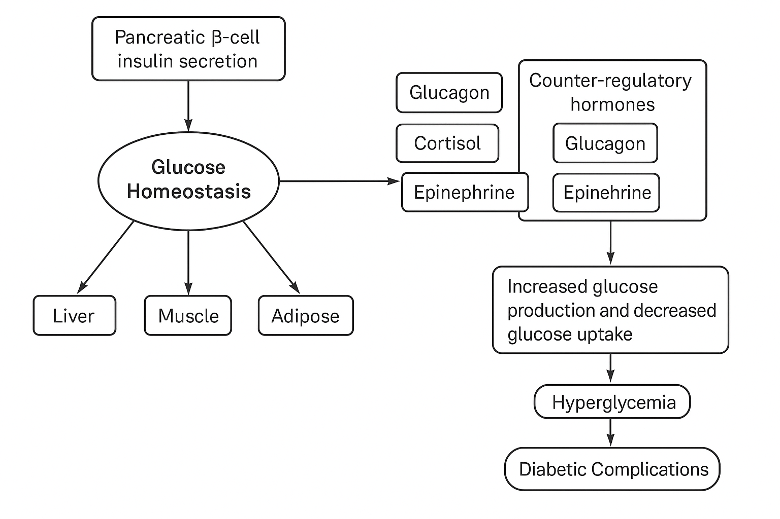

Section 5 – Core Theory & Key Concepts
Diabetes Mellitus (DM) arises from defects in insulin secretion and/or insulin action, leading to chronic hyperglycemia with disturbances in carbohydrate, fat, and protein metabolism.
- Insulin Biosynthesis and Secretion
- Insulin is synthesized in pancreatic β-cells as preproinsulin, processed to proinsulin, then cleaved into insulin and C-peptide.
- Glucose enters β-cells via GLUT2 transporters; metabolism raises the ATP/ADP ratio, closing K⁺ channels, depolarizing the membrane, and opening voltage-gated Ca²⁺ channels.
- Calcium influx triggers exocytosis of insulin-containing granules.
- Insulin Action
- Insulin binds its receptor (a tyrosine kinase) on muscle, adipose, and liver cells, initiating a cascade (IRS-1, PI3K, Akt) that promotes GLUT4 translocation to the plasma membrane for glucose uptake.
- In the liver, insulin stimulates glycogen synthesis (activating glycogen synthase), inhibits gluconeogenesis (suppressing PEPCK), and promotes lipogenesis.
- Type 1 DM Pathophysiology
- Autoimmune destruction of β-cells (Type 1A) leads to absolute insulin deficiency.
- Without insulin, glucose uptake falls, intracellular “starvation” leads to lipolysis and ketogenesis; accumulation of ketone bodies (acetoacetate, β-hydroxybutyrate) induces metabolic acidosis (DKA).
- Type 2 DM Pathophysiology
- Characterized by insulin resistance in peripheral tissues (muscle, adipose) and relative β-cell dysfunction.
- Compensatory hyperinsulinemia initially maintains normoglycemia but eventual β-cell exhaustion leads to overt hyperglycemia.
- Contributing factors include central obesity, ectopic lipid deposition, pro-inflammatory cytokines, and genetic predisposition.
- Acute Metabolic Derangements
- DKA (Type 1): Absolute insulin deficiency → hyperglycemia, osmotic diuresis, dehydration, ketonemia, anion-gap metabolic acidosis.
- HHS (Type 2): Relative insulin deficiency allows some lipogenesis (preventing ketoacidosis) but profound hyperglycemia (>600 mg/dL), hyperosmolarity, and severe dehydration → altered mental status.
- Chronic Complications
- Microvascular: retinopathy, nephropathy, neuropathy (small-vessel damage from prolonged hyperglycemia and AGE formation).
- Macrovascular: accelerated atherosclerosis leading to coronary artery disease, peripheral vascular disease, and stroke.
- Mechanisms include protein kinase C activation, polyol pathway flux, hexosamine pathway activation, and oxidative stress.

Section 6 – Key Definitions & Tables
Definitions
- Hyperglycemia: A condition of elevated plasma glucose (fasting ≥ 126 mg/dL), resulting from impaired insulin action or secretion.
- Glucotoxicity: Cellular dysfunction induced by chronic high glucose, impairing β-cell function and insulin signaling.
- Lipolysis: Breakdown of triglycerides into free fatty acids and glycerol, enhanced in insulin deficiency.
- Ketogenesis: Hepatic production of ketone bodies (acetoacetate, β-hydroxybutyrate) during insulin deficiency or prolonged fasting.
- Glycated Hemoglobin (HbA₁c): Hemoglobin covalently bound to glucose; reflects average blood glucose over 2–3 months.
- Insulin Resistance: Diminished biological response to insulin in target tissues, requiring higher insulin concentrations to achieve normoglycemia.
- Anion-Gap Metabolic Acidosis: Acid–base disorder characterized by elevated anion gap due to unmeasured anions (e.g., ketone bodies).
- Osmotic Diuresis: Increased urine output resulting from high solute load (e.g., glucose) in renal tubules.
- Advanced Glycation End-Products (AGEs): Irreversible cross-linked proteins formed by non-enzymatic glycation, contributing to vascular damage.
- Autoantibodies (against β-cells): Immune markers (e.g., anti-GAD, islet cell antibodies) diagnosing Type 1 DM.
Test | Diagnostic Threshold (ADA 2025)
Fasting Plasma Glucose (FPG) | ≥ 126 mg/dL (7.0 mmol/L)
2-h OGTT (75 g glucose) | ≥ 200 mg/dL (11.1 mmol/L)
Random Plasma Glucose + symptoms | ≥ 200 mg/dL
HbA₁c | ≥ 6.5%
Urine Ketones | Positive in Type 1 DKA

Parameter | Healthy | Type 1 DM | Type 2 DM
Insulin Level | Normal | Absent | Normal/High → decreases with time
Insulin Action | Normal | Absent | Resistant
Glucose Uptake | Efficient | Impaired | Impaired
Ketone Production | Minimal | High (DKA risk) | Low–moderate
Onset | N/A | Acute (childhood/adolescence) | Insidious (adults, obesity)

Section 7 – Mathematical Framework & Derivations
- Conversion of Glucose Units
Glucose_mmol/L = Glucose_mg/dL ÷ 18
Thus, FPG 126 mg/dL corresponds to 7.0 mmol/L.
- Body Mass Index (BMI)
BMI = weight_kg ÷ (height_m)^2
Obesity (BMI ≥ 30 kg/m²) is a major risk factor for Type 2 DM.
- Homeostatic Model Assessment of Insulin Resistance (HOMA-IR)
HOMA_IR = (Fasting_Insulin_µU/mL × Fasting_Glucose_mmol/L) ÷ 22.5
A HOMA-IR > 2.5 indicates significant insulin resistance.
- Anion Gap Calculation (DKA Assessment)
Anion_Gap = [Na⁺] – ([Cl⁻] + [HCO₃⁻])
An elevated gap (> 12 mEq/L) suggests presence of unmeasured anions (ketones) in DKA.
- Total Daily Insulin Requirement (Type 1 DM)
TDI ≈ 0.5 units/kg/day
Basal:Bolus ratio ~ 50:50.

Section 8 – Worked Examples
Solved Example 1
Problem: A patient has FPG 140 mg/dL and fasting insulin 15 µU/mL. Calculate HOMA-IR.
Glucose_mmol/L = 140 ÷ 18 = 7.78 mmol/L
HOMA_IR = (15 × 7.78) ÷ 22.5 ≈ 5.18
Interpretation: HOMA-IR of 5.18 indicates marked insulin resistance.
Solved Example 2
Problem: Convert a random glucose of 250 mg/dL to mmol/L and determine if it meets DM criteria.
250 ÷ 18 = 13.9 mmol/L
Since ≥ 11.1 mmol/L with symptoms, this fulfills diagnostic criteria for DM.
Solved Example 3
Problem: Calculate the anion gap if Na⁺ 140 mEq/L, Cl⁻ 100 mEq/L, HCO₃⁻ 12 mEq/L.
Anion_Gap = 140 – (100 + 12) = 28 mEq/L
Anion gap 28 mEq/L indicates high anion-gap metabolic acidosis consistent with DKA.
Unsolved Problem 1
A 70 kg Type 1 DM patient requires total daily insulin (TDI). Calculate basal and bolus doses if TDI is 0.6 U/kg.
Unsolved Problem 2
Determine the new diagnostic fasting glucose threshold in mmol/L if the ADA lowers the mg/dL cutoff from 126 to 120 mg/dL.

Section 9 – Practical / Industrial Applications
- Insulin Production: Recombinant DNA technology in E. coli or yeast produces human insulin; downstream purification and crystal formulation allow subcutaneous and rapid‐acting analog preparations.
- Glucose Monitoring Devices: Electrochemical glucometers employ glucose oxidase immobilized on electrodes; continuous glucose monitors (CGMs) use subcutaneous sensors transmitting real-time interstitial glucose levels to insulin pumps.
- Biotechnological Research: High-throughput screening assays measure compounds that enhance β-cell proliferation or insulin sensitization, guiding novel antidiabetic drug development.

Section 10 – Clinical & Professional Relevance
- Diabetic Retinopathy: Chronic hyperglycemia damages retinal capillaries → microaneurysms, hemorrhages, neovascularization; leading cause of adult blindness.
- Diabetic Nephropathy: Glomerular basement membrane thickening, mesangial expansion, proteinuria, progressive renal failure.
- Diabetic Neuropathy: Metabolic and vascular factors injure peripheral nerves → sensory loss, pain, foot ulcers, risk of amputation.
- Cardiovascular Disease: Accelerated atherosclerosis in coronary, cerebral, peripheral arteries → myocardial infarction, stroke, claudication.
- Gestational Diabetes Complications: Macrosomia, neonatal hypoglycemia, pre-eclampsia; mothers have ↑ Type 2 DM risk postpartum.

Section 11 – Important for Exam
- Key Points to Remember: Fasting ≥ 126 mg/dL; 2-h OGTT ≥ 200 mg/dL; HbA₁c ≥ 6.5%.
- Common Errors: Confusing mmol/L and mg/dL; forgetting conversion factor (÷ 18).
- Clinical Correlations: Link autoimmune markers (Type 1) with DKA risk, obesity with insulin resistance (Type 2).
- Answer Structuring: For “describe pathophysiology,” separate insulin deficiency vs. resistance; include molecular cascade and clinical sequelae.
- Equation Tips: Always define units when presenting HOMA-IR or anion gap formulas.

Section 12 – Summary & Recap Table
Diabetes Mellitus encompasses disorders of insulin deficiency and resistance, leading to chronic hyperglycemia with multi-system complications. Type 1 DM is autoimmune β-cell destruction requiring lifelong insulin, whereas Type 2 DM combines insulin resistance and progressive β-cell failure often tied to obesity. Diagnosis relies on plasma glucose thresholds and HbA₁c. Acute emergencies (DKA, HHS) differ in presence of ketosis and osmolarity. Chronic complications—retinopathy, nephropathy, neuropathy, and macrovascular disease—stem from prolonged hyperglycemia and oxidative stress. Management integrates lifestyle modification, glucose monitoring, and pharmacotherapy: insulin (basal–bolus regimens) for Type 1 and a spectrum of oral and injectable agents (metformin, sulfonylureas, SGLT2i, GLP-1 agonists) for Type 2. Emerging technologies—recombinant insulin analogs, CGMs, closed-loop insulin pumps—optimize glycemic control. Biochemical understanding of insulin signaling, glucose metabolism, and compensatory mechanisms underpins both current therapies and future research into β-cell preservation and insulin sensitization.
Aspect | Key Features
Etiology | Type 1: Autoimmune β-cell loss; Type 2: Insulin resistance + β-cell dysfunction
Pathogenesis | Hyperglycemia → osmotic diuresis, lipolysis/ketogenesis, AGE formation
Diagnosis | FPG ≥ 126 mg/dL; 2-h OGTT ≥ 200 mg/dL; HbA₁c ≥ 6.5%
Acute Complications | DKA (Type 1: ketones, acidosis); HHS (Type 2: extreme hyperosmolarity)
Chronic Complications | Retinopathy, nephropathy, neuropathy, cardiovascular dise

