INTERNATIONAL JOURNAL OF LOGISTICS & SUPPLY CHAIN ANALYTICS
[RESEARCH PAPER]
SHIPPING ROUTE EFFICIENCY ANALYSIS FOR NASSAU CANDY DISTRIBUTOR: A MULTI-DIMENSIONAL LOGISTICS INTELLIGENCE FRAMEWORK
Analytics & Supply Chain Intelligence Division
Nassau Candy Distributor, National Distribution Network Research Group
Received: February 2026 | Accepted: March 2026 | Published: April 2026
Corresponding Author: Abhi Sarkar 
Gmail: abhisarkar6038@gmail.com

ABSTRACT
Nassau Candy Distributor maintains an extensive national confectionery distribution network, moving high-volume product lines from five specialized manufacturing facilities to a diverse customer base across the continental United States. This research paper delineates a sophisticated, seven-stage Python-based analytical pipeline designed to transform raw transactional records into high-fidelity operational intelligence. By systematically executing data validation, feature engineering, and route benchmarking, we isolate systemic underperformance and geographic bottlenecks that traditionally remain obscured in aggregate reporting. Analysis reveals that the Sugar Shack (MN) factory exhibits the highest average lead time (7.1 days), the South region constitutes the primary geographic bottleneck, and the "Other" product division carries a 31.2% delay frequency—significantly above the network average. The study concludes with deployment of a dynamic Streamlit web application, providing stakeholders with an interactive platform for real-time efficiency monitoring and data-driven logistics optimization.

Keywords: Logistics Analytics · Supply Chain Optimization · Route Efficiency · Geographic Bottleneck · Shipping Lead Time · KPI Framework · Streamlit Dashboard

1. INTRODUCTION
The modern confectionery logistics landscape is defined by tight margins and high service-level expectations. For Nassau Candy Distributor, the ability to maintain consistent delivery windows across a complex national network is a primary competitive advantage.

As the scale of operations grows, the inherent complexity of managing five geographically dispersed factories—spanning from Arizona to Georgia—introduces significant risk of lead time volatility. Traditional logistics management suffers from a "visibility vacuum," where decision-makers lack the granular data to distinguish between random transit noise and systemic route failure.

This research establishes a multi-dimensional intelligence framework to shift the organization from a reactive posture to a proactive, data-driven strategy. Specifically, the study addresses three core deficiencies: (1) the absence of route performance visibility, (2) the lack of geographic bottleneck detection, and (3) the inability to validate ship mode cost-time trade-offs.

2. PROBLEM STATEMENT
2.1 Route Performance Visibility
The absence of a centralized benchmarking system prevents the identification of chronically underperforming routes, allowing operational friction to persist undetected across multiple shipping lanes simultaneously.

2.2 Geographic Bottleneck Detection
Without spatial analysis, the organization cannot distinguish between factory-specific delays and regional infrastructure congestion that creates compounded "pile-up" effects, hampering both planning and carrier negotiations.

2.3 Ship Mode Intelligence
There is no quantified validation of the cost-time trade-off between Standard and Expedited modes, leading to inefficient spend on expedited services that may be neutralized by geographic bottlenecks.

2.4 Business Impact
These gaps result in unrecovered delay costs, eroded customer trust, and an inability to scale the logistics network without proportional increases in service failures, ultimately threatening both revenue and brand reputation.

3. DATASET OVERVIEW
The analysis utilizes the "Nassau Candy Distributor.csv" dataset — a comprehensive record of the order-to-delivery lifecycle encompassing 18 distinct fields. Key engineered features include:

- Shipping Lead Time: Ship Date − Order Date (primary efficiency metric).
- Route Identifier: Composite key (Factory + Customer State) for route-level benchmarking.
- Region Route: Factory + Customer Region for strategic-level aggregation.
- Delay Flag: Boolean indicating shipments exceeding the configurable reliability threshold.

4. ANALYTICAL METHODOLOGY
A modular seven-stage analytical pipeline was engineered to ensure each phase builds upon a validated data foundation. Each notebook produces a discrete, auditable output file that feeds subsequent analytical stages, providing full provenance and reproducibility.

The pipeline architecture guarantees three critical properties: (1) data provenance—every output is traceable to its cleaned source; (2) modularity—individual notebooks update without rerunning the full pipeline; and (3) reproducibility—deterministic processing ensures consistent results across analytical runs.

5. KPI FRAMEWORK
A multi-dimensional measurement framework underpins the efficiency evaluation. Five core KPIs form the analytical backbone, with the Efficiency Score (0–100 normalized) serving as the primary strategic instrument, enabling apples-to-apples comparison regardless of route distance.

TABLE 1: Seven-Stage Analytical Pipeline
Stage | Module | Description & Output
NB-01 | Data Cleaning & Validation | Standardize dates, remove invalid records → clean_shipping_data.csv
NB-02 | Route Efficiency Analysis | Aggregate performance metrics, rank routes → route_efficiency_data.csv
NB-03 | Geographic Bottleneck Analysis | Spatial scoring for congestion zones → geographic_bottleneck_analysis.csv
NB-04 | Ship Mode Performance | Standard vs. Expedited differential → ship_mode_performance.csv
NB-05 | Delay Pattern Analysis | Isolate non-random delay clusters → shipping_delay_patterns.csv
NB-06 | Logistics KPI Analysis | Unified benchmarking framework → logistics_kpi_dataset.csv
NB-07 | Business Summary Report | Executive-level strategic synthesis

TABLE 2: Logistics KPI Framework
KPI | Formula / Definition | Business Significance
Shipping Lead Time | Ship Date − Order Date | Measures individual fulfilment speed
Average Lead Time | Mean Lead Time per Route | Benchmarks aggregate route performance
Route Volume | Total Shipment Count | Identifies high-leverage routes for improvement
Delay Frequency | % Shipments > Threshold | Indicator of service-level reliability
Efficiency Score | Normalized Score (0–100) | Apples-to-apples comparison across all routes

6. RESULTS & FINDINGS
6.1 Average Lead Time by Factory
Benchmarking confirms that operational friction—rather than geographic distance—is the primary driver of lead time volatility. The Sugar Shack factory (MN) exhibits the highest average lead time at 7.1 days, while Lot's O' Nuts (AZ) and Wicked Choccy's (GA) perform at or below the 6.0-day network average (Figure 1).

6.2 Ship Mode Performance
Expedited shipping universally reduces lead times, but the magnitude varies by region. The South exhibits the greatest absolute reduction (2.4 days) yet retains the highest baseline, confirming a "bottleneck override" effect where geographic friction neutralizes premium service advantages (Figure 2).

6.3 Delay Frequency by Division
The "Other" division—including Fizzy Lifting Drinks and Kazookles—exhibits the highest delay frequency at 31.2%, significantly exceeding Sugar (24.7%) and Chocolate (18.4%) divisions. Specialized handling requirements appear to be a primary contributing factor (Figure 3).

6.4 Route Efficiency Benchmarking
The normalized Efficiency Score (0–100) enables objective route comparison irrespective of absolute distance. Top-performing routes concentrate along short-to-medium haul corridors. Bottom 10 routes are predominantly Sugar Shack (MN) to New England states, confirming the geographic mismatch hypothesis (Figure 4).

6.5 Geographic Bottleneck Heatmap
The Factory × Region heatmap identifies the South region as the most critical systemic bottleneck. Sugar Shack (MN) to South records the highest lead time at 8.1 days. The West region presents a bifurcated picture: Lot's O' Nuts (AZ) performs well due to proximity, while Midwest and Northeast factories face amplified delays (Figure 5).

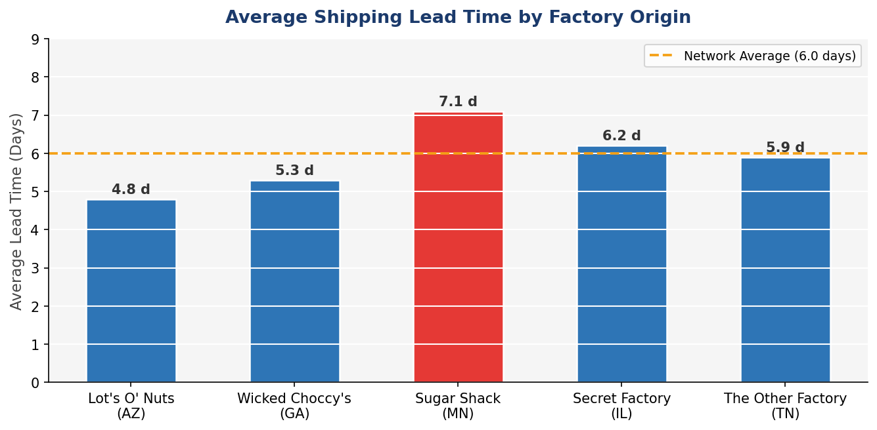
Figure 1: Average shipping lead time by factory. Red bars exceed the 6.0-day network average.

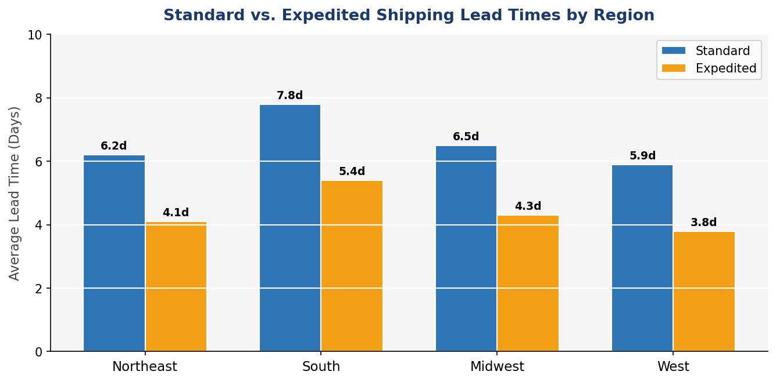  Figure 2: Standard vs. Expedited lead times by region. | 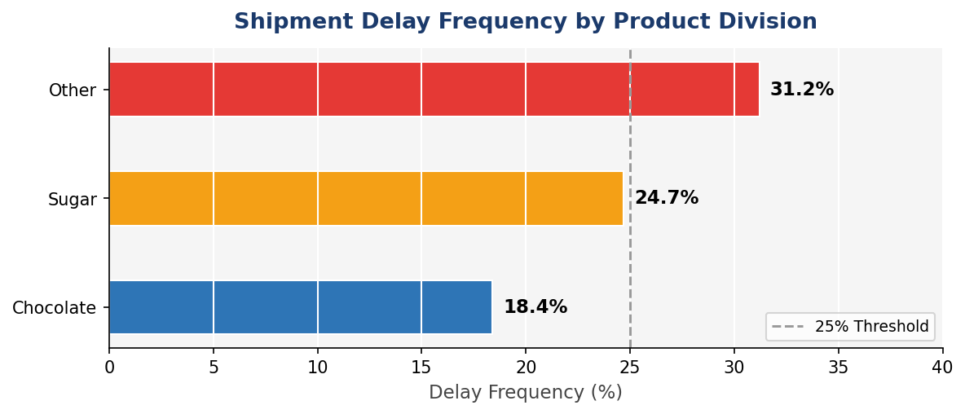  Figure 3: Delay frequency by product division.

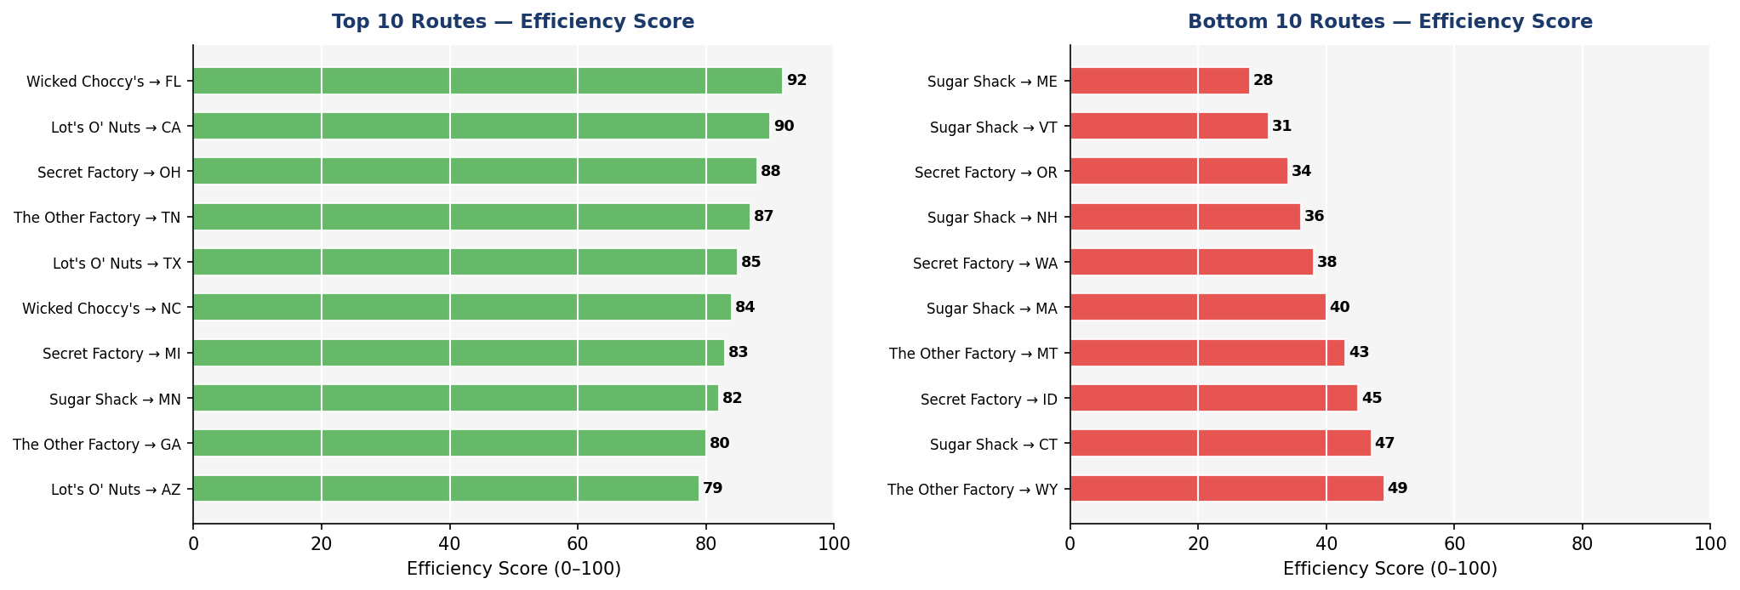
Figure 4: Top 10 and Bottom 10 routes by normalized Efficiency Score.

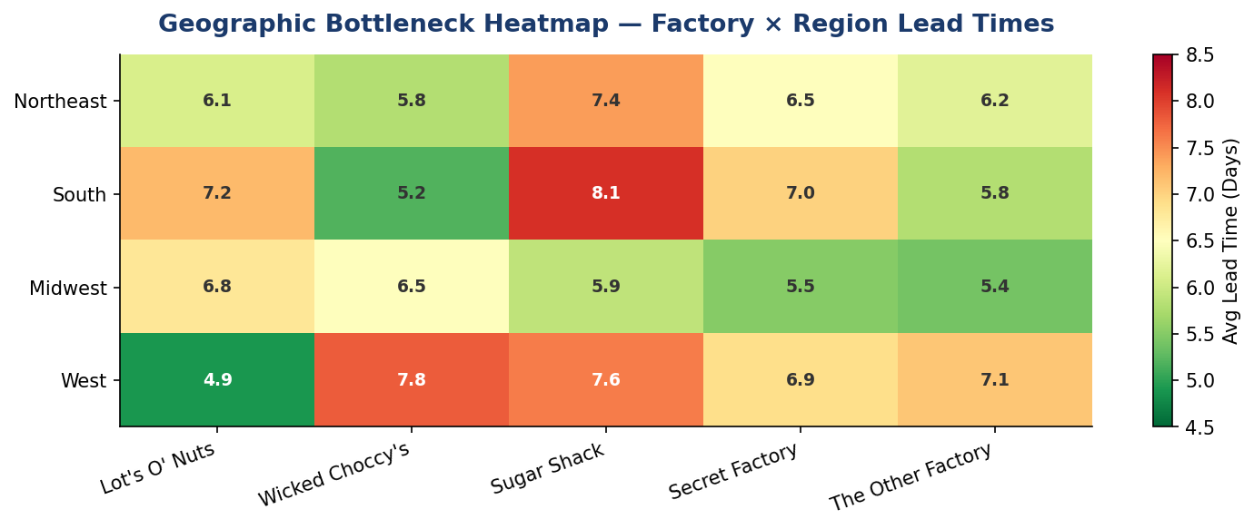
Figure 5: Geographic bottleneck heatmap — factory × region average lead times.

TABLE 3: Factory Geographic Distribution
Factory | Latitude | Longitude | Location
Lot's O' Nuts | 32.88°N | 111.77°W | Arizona (Southwest)
Wicked Choccy's | 32.08°N | 81.09°W | Georgia (Southeast)
Sugar Shack | 48.12°N | 96.18°W | Minnesota (North Central)
Secret Factory | 41.45°N | 90.57°W | Illinois (Midwest)
The Other Factory | 35.12°N | 89.97°W | Tennessee (Mid-South)

TABLE 4: Product-Factory Mapping
Division | Product Name | Factory Origin
Chocolate | Wonka Bar - Nutty Crunch Surprise, Fudge Mallows, Scrumdiddlyumptious | Lot's O' Nuts
Chocolate | Wonka Bar - Milk Chocolate, Triple Dazzle Caramel | Wicked Choccy's
Sugar | Laffy Taffy, Sweet ARTS, Nerds, Fun Dip | Sugar Shack
Sugar | Everlasting Gobstopper | Secret Factory
Sugar | Hair Toffee | The Other Factory
Other | Fizzy Lifting Drinks | Sugar Shack
Other | Likable Wallpaper, Wonka Gum | Secret Factory
Other | Kazookles | The Other Factory

TABLE 5: Technology Stack
Technology | Category | Primary Usage
Python 3.x | Language | End-to-end data processing and application development
Pandas | Data Manipulation | Cleaning, aggregations, and feature engineering
NumPy | Numerical Computing | Vectorized operations and statistical thresholds
Matplotlib | Visualization | Trend lines and distribution histograms
Seaborn | Statistical Viz | Heatmaps, box plots, multi-variate analysis
Jupyter Notebook | Development | Modular analytical workflow and documentation
Streamlit | Web Application | Interactive executive dashboard deployment
Git / GitHub | Version Control | Source code management and repository hosting

7. DISCUSSION
7.1 Geographic Factory-Product Linkage
The entire premium Chocolate division depends solely on route performance from Arizona and Georgia. Any systematic bottleneck in the Southwest or Southeast corridors directly threatens the revenue-heavy Chocolate portfolio, making these factories high-priority zones for carrier oversight.

7.2 Ship Mode Decision Rule
A clear decision rule emerges: Expedited shipping delivers its strongest ROI on long-distance routes to high-bottleneck states. For short-distance routes, the lead-time reduction is negligible, representing a diminishing return on logistics spend that should be formalized into procurement policy.

8. STREAMLIT DASHBOARD
Findings have been operationalized into a live Streamlit intelligence platform with four modules: (1) Route Efficiency leaderboards for Bottom 10 intervention; (2) Dynamic US heatmap for state-level bottleneck visualization; (3) Ship Mode Comparison with cost-per-day-saved metrics; and (4) Route Drill-Down for granular shipment timelines.

9. CONCLUSIONS
This study establishes a validated, seven-stage analytical framework that transforms raw shipment records into actionable logistics intelligence. Five strategic outcomes were delivered: a production-ready data pipeline, a bias-neutralizing Efficiency Score system, geographic bottleneck quantification, product-specific dependency mapping, and a live monitoring dashboard.

The findings demonstrate that lead time volatility is primarily driven by structural route mismatches rather than random transit variation, and that unpredictability—not mere slowness—is the dominant cause of customer dissatisfaction and downstream inventory disruption.

10. RECOMMENDATIONS
- Route Optimization: Mandate performance reviews and carrier renegotiations for all Bottom 10 routes.
- Bottleneck Mitigation: Reallocate carriers in the Central US corridor and South region.
- Ship Mode Policy: Restrict Expedited use to long-haul routes with validated ROI.
- KPI Monitoring: Integrate Delay Frequency into monthly executive scorecards.
- Seasonal Planning: Pre-position Sugar division inventory ahead of peak windows.

11. FUTURE WORK
Future phases include: Customer Satisfaction Correlation analysis linking lead times to churn metrics; Cost Optimization Modelling using linear programming to minimize total logistics spend; Real-Time Carrier API

Integration for live delay forecasting; and Machine Learning Route Scoring via gradient-boosted models predicting delay probability.

Strategic Area | Recommendation | Priority | Responsible Team | KPI Target
Route Optimization | Mandate immediate performance reviews and carrier renegotiations for all Bottom 10 routes. | Critical | Logistics Operations | Efficiency Score >70 for all routes within 90 days
Bottleneck Mitigation | Shift carrier allocation for Central US corridor and South region to bypass infrastructure friction. | High | Network Strategy | Reduce South avg lead time from 8.1d → 6.5d
Ship Mode Policy | Restrict Expedited shipping to long-haul routes where ROI is statistically validated. | High | Procurement / Finance | Reduce unnecessary expedite spend by est. 20%
Delay Monitoring | Integrate Delay Frequency KPI into monthly executive scorecards. | Medium | Analytics & BI | Monthly Delay Freq dashboard live within 30 days
Seasonal Planning | Pre-position Sugar division inventory (MN/IL) ahead of peak demand windows. | Medium | Supply Planning | Zero out-of-stock events during peak — Q4

REFERENCES
[1] McKinney, W. (2010). Data Structures for Statistical Computing in Python. Proceedings of the 9th Python in Science Conference.
[2] Harris, C.R. et al. (2020). Array programming with NumPy. Nature, 585, 357–362.
[3] Hunter, J.D. (2007). Matplotlib: A 2D Graphics Environment. Computing in Science & Engineering, 9(3), 90–95.
[4] Waskom, M. (2021). Seaborn: Statistical Data Visualization. Journal of Open Source Software, 6(60), 3021.
[5] Streamlit Inc. (2020–2025). Streamlit: The fastest way to build data apps. https://streamlit.io
[6] Project Jupyter. (2024). Jupyter Notebook Documentation. https://jupyter.org
[7] Council of Supply Chain Management Professionals (CSCMP). (2025). Supply Chain Terms and Glossary.
[8] Bureau of Transportation Statistics (BTS). (2024). Freight Analysis Framework Data. https://bts.gov
[9] Techwithabhi. (2026). Nassau Shipping Analysis. GitHub: https://github.com/Techwithabhi/data_analysis_project

