Guest Lecture of Prof.Atul Kahate, Author & Ex-IT Professional on 8th September, 2023
Topic: Topic: Career Avenues for MCA

Brief Description:
Guest Lecture for FYMCA & SYMCA students was conducted in the C.K.Pralhad Hall, 4th Floor. The program aimed to provide students with in-depth knowledge and practical experience in various changing IT Jobs landscape and career paths in IT.

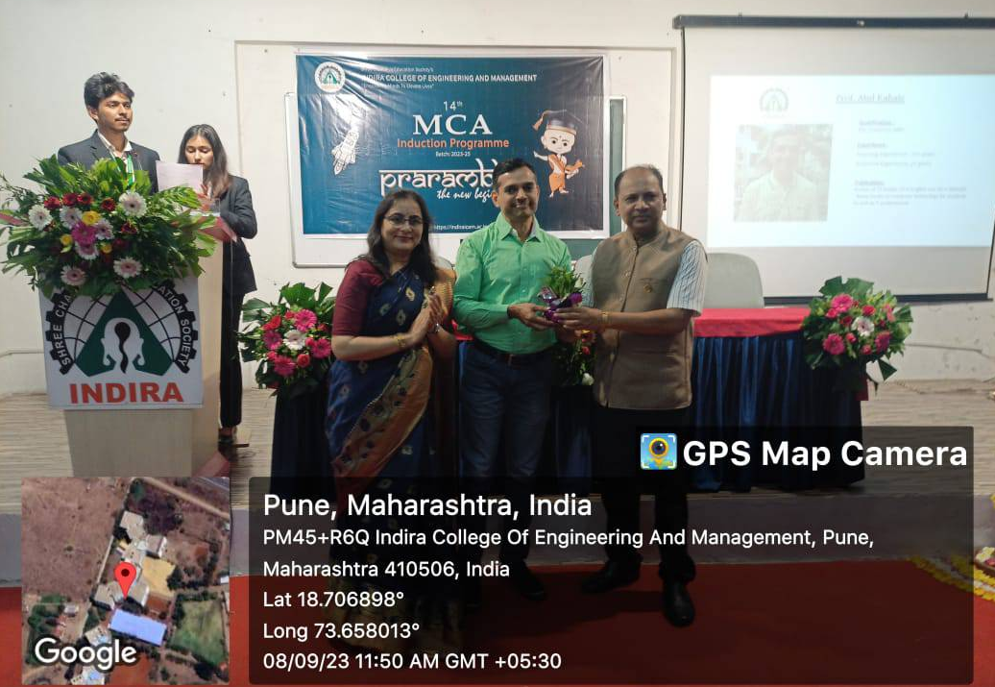

Guest Lecture of Prof.Atul Kahate, Author & Ex-IT Professional on : 7^{h} Feb, 2024

Topic: Successful Project Completion
(Project Management & Development)
Brief Description:
Guest Lecture for FYMCA & SYMCA students was conducted in the Visvesvaraya Hall. The program aimed to provide students with in-depth knowledge and practical experience Successful Project Completion.

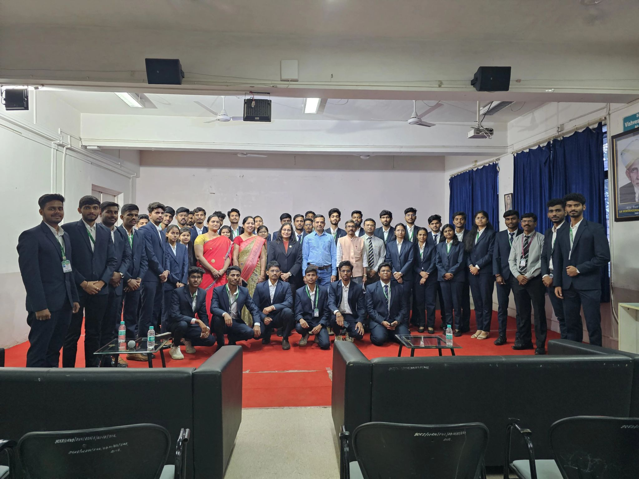

Guest Lecture of Mr. Deepak Shikarpur, Author & Director on : 10th Oct 2023
Topic: Pathway & Skills

Brief Description:
Guest Lecture for FYMCA students was conducted in the Visvesvaraya Hall. The program aimed to provide students with skill based knowledge in IT.

Mr. Deepak Shikarpur covers the following topics in details
- Software and oppournity available for MCA students
- How to increase the different technology skills
- Unveiling the technological pathways to promising career
- He appeals to students to expose their dreams
He advised students that while living life, we should time management with good health care

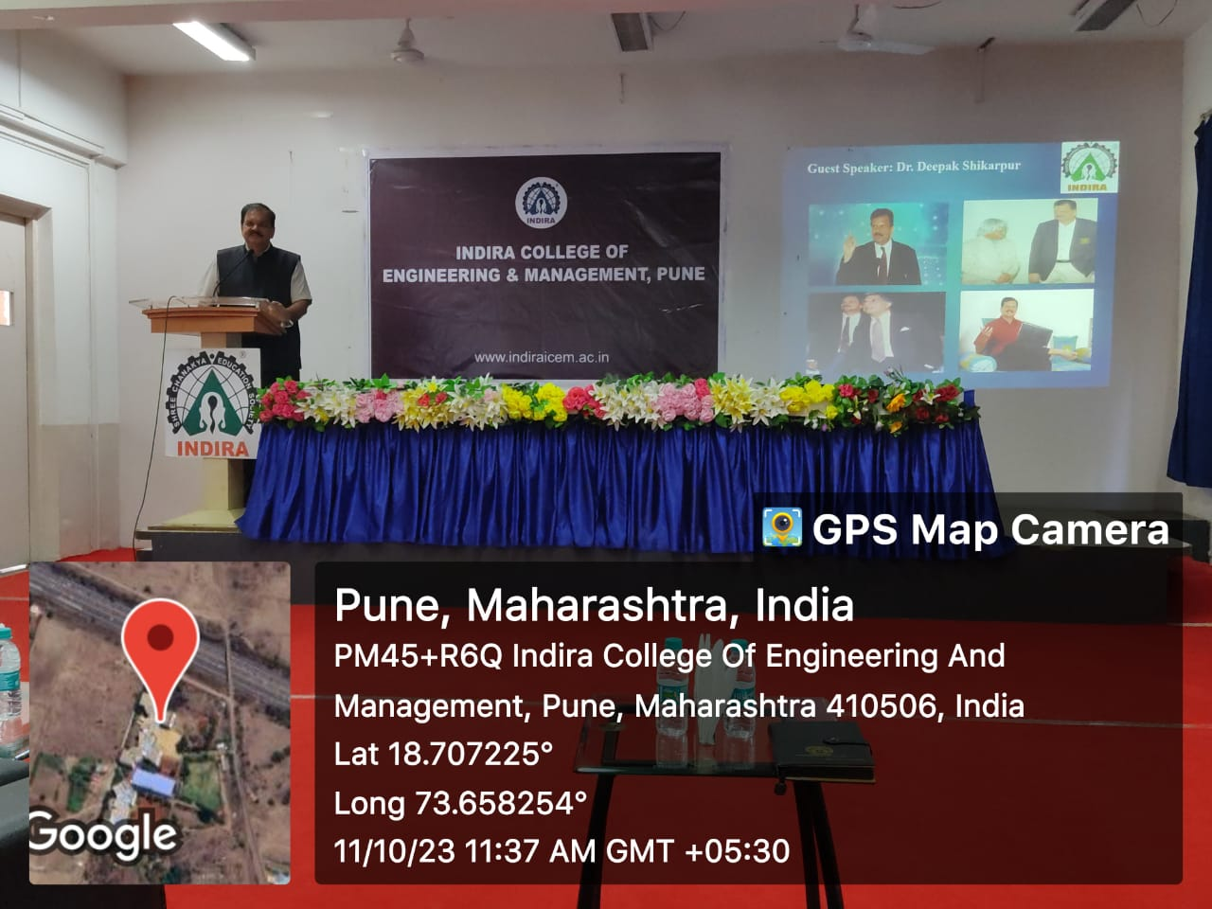

Guest Lecture of Mrs. Kanchana Bangani (Corporate Trainer) on : 10^{h} Feb, 2024
Topic: Linux

Brief Description:
Mrs. Kanchana Bangan covers the following topics in details

- Linux Environment
- Basics of Linux
- Working with files and users
- Shell
- Examples of path
  - Create AAA directory
  - Create some f1,f2,f3 files in directory
  - Create BBB directory
  - Go to BBB directory
  - Long listing of files form AAA directory
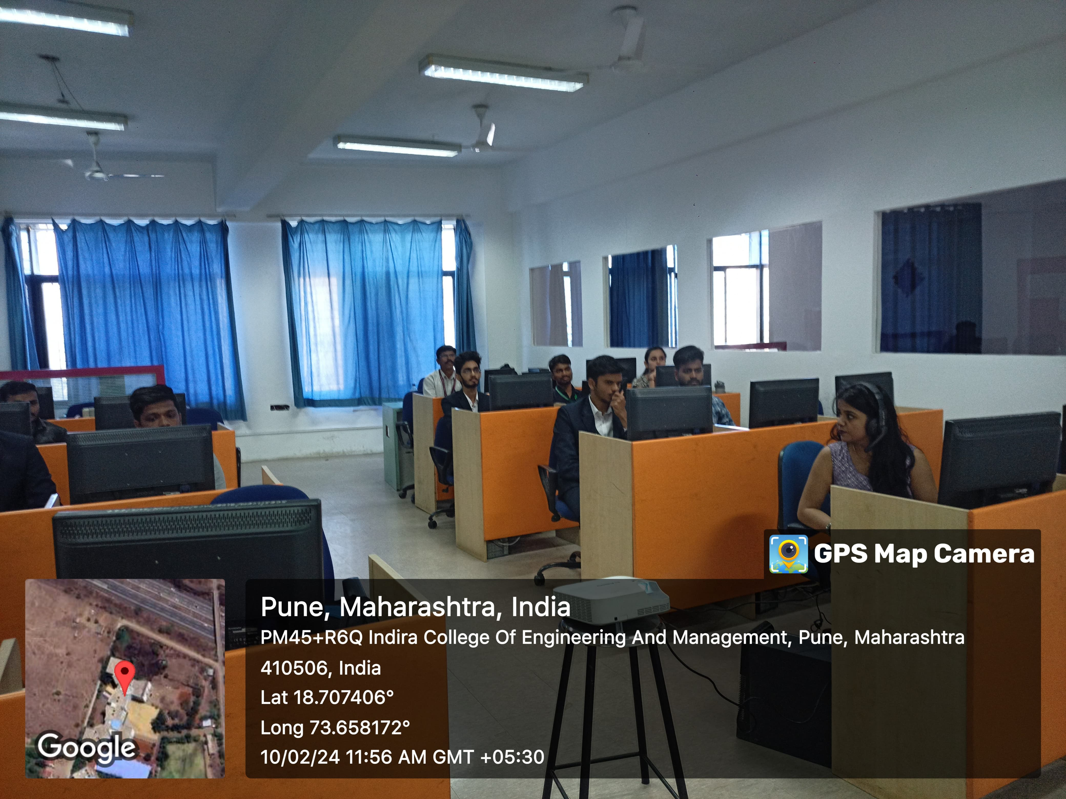

Guest Lecture of Mr.Ajay Dogney (Alumini) on : 28th Oct, 2023
Topic: Career Avenues for MCA in Data Science & Data Analytics

Brief Description:
Guest Lecture for FYMCA & SYMCA students was conducted in the C.K.Pralhad Hall, 4th Floor. The program aimed to provide students with in-depth knowledge and practical experience in various changing IT Jobs landscape and career paths in Data Science & Data Analytics.

Mr. Ajay Dogney covers the following topics in details

- Placement oriented Inputs and technical preparation
- ​Finding placement that is right fit for MCA students
- Tips to ease the transition from campus to corporate
- How to make the most and importance use of LinkedIn Networking
- Explain about Data science is the domain of study that deals with vast volumes of data using modern tools and techniques to find unseen patterns, derive meaningful information, and make business decisions. Data science uses complex machine learning algorithms to build predictive models.
- Data analysis Tools
- R, Apache Spark, Python,
- Tableau

