% 初始化工作区
clc
clear
% 基础变量
Type = 'FCC';
element = 'Ni';
a0 = 3.524;
mass = 58.693;
% 定义晶胞原子
atom1 = [0.0 * a0, 0.0 * a0, 0.0 * a0];
atom2 = [0.5 * a0, 0.5 * a0, 0.0 * a0];
atom3 = [0.5 * a0, 0.0 * a0, 0.5 * a0];
atom4 = [0.0 * a0, 0.5 * a0, 0.5 * a0];
% 定义基矢量
ux = [1.0 * a0, 0.0, 0.0];
uy = [0.0, 1.0 * a0, 0.0];
uz = [0.0, 0.0, 1.0 * a0];
% 循环生成
id = 0;
for i = -10:10
for j = -10:10
for k = -10:10
% 得到位移矢量
vector = ux * i + uy * j + uz * k;
% 由晶胞原子出发沿位移矢量添加原子
id = id + 1;
crystal(id, 1:3) = atom1 + vector;
id = id + 1;
crystal(id, 1:3) = atom2 + vector;
id = id + 1;
crystal(id, 1:3) = atom3 + vector;
id = id + 1;
crystal(id, 1:3) = atom4 + vector;
end
end
end
% 生成序号的随机全排列数列
rand_list = randperm(id);
% 按比例分配随机数号段
Ni_atoms_indices = rand_list(1:id / 2);
Al_atoms_indices = rand_list((id / 2 + 1):id);
% 遍历查找并拾取对应原子
Ni_id = 1;
Al_id = 1;
for i = 1:id
if find(Ni_atoms_indices == i)
% 序号属于Ni号段
Ni_crystal(Ni_id, 1:3) = crystal(i, 1:3);
Ni_id = Ni_id + 1;
else
% 序号属于Al号段
Al_crystal(Al_id, 1:3) = crystal(i, 1:3);
Al_id = Al_id + 1;
end
end
% MATLAB作图
plot3(Ni_crystal(:, 1), Ni_crystal(:, 2), Ni_crystal(:, 3), 'o', 'MarkerFaceColor','g', 'MarkerSize', 10);
axis square;
hold on;
plot3(Al_crystal(:, 1), Al_crystal(:, 2), Al_crystal(:, 3), 'o', 'MarkerFaceColor','b', 'MarkerSize', 10);
axis square;
hold off;
% 输出pdb和txt
pdb_file_ID = fopen('FCC-NiAl lattice.pdb', 'w');
txt_file_ID = fopen('FCC-NiAl lattice.txt', 'w');
rasmol_format_spec = '%-6s%-5d %-4s%-1s%-3s %-4d%-1s %-8.3f%-8.3f%-8.3f\n';
table_format_spec = '%-5s\t%-8.3f\t%-8.3f\t%-8.3f\n';
num = 0;
for id = 1:length(Ni_crystal)
num = num + 1;
fprintf(pdb_file_ID, rasmol_format_spec, 'ATOM', num, element, ' ', ' ', 1, ' ', Ni_crystal(id, 1), Ni_crystal(id, 2), Ni_crystal(id, 3));
fprintf(txt_file_ID, table_format_spec, '1', Ni_crystal(id, 1), Ni_crystal(id, 2), Ni_crystal(id, 3));
end
num = 0;
for id = 1:length(Al_crystal)
num = num + 1;
fprintf(pdb_file_ID, rasmol_format_spec, 'ATOM', num, 'Al', ' ', ' ', 1, ' ', Al_crystal(id, 1), Al_crystal(id, 2), Al_crystal(id, 3));
fprintf(txt_file_ID, table_format_spec, '2', Al_crystal(id, 1), Al_crystal(id, 2), Al_crystal(id, 3));
end
fclose(pdb_file_ID);
fclose(txt_file_ID);
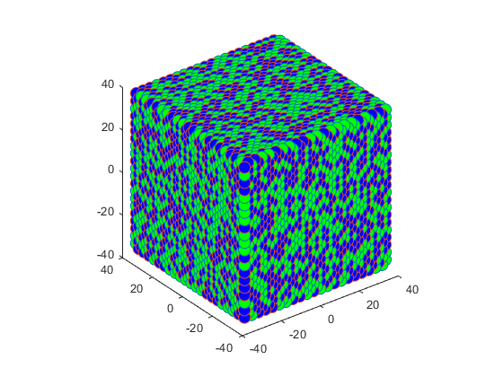
Published with MATLAB® R2023b

