Student Information
Name: |  |  | Farhan ullah
Roll No: |  |  | 42272(M2)
session |  |  | 2022-2026(BSCS)

Instructor Information
Name |  |  | Ahmad Jan
Phone |  |  | nill

Assignment information
Submission date & Name |  | 19/06/2025 ,Visual programming
Assignment Visual programming
Question 1:Marks class program

using System;
class StudentMarks
{
int m1, m2, m3;
public StudentMarks()
{
m1 = 0;
m2 = 0;
m3 = 0;
}
public void InputMarks()
{
Console.WriteLine("Enter three subject marks:");
Console.Write("Mark 1: ");
m1 = int.Parse(Console.ReadLine());
Console.Write("Mark 2: ");
m2 = int.Parse(Console.ReadLine());
Console.Write("Mark 3: ");
m3 = int.Parse(Console.ReadLine());
}
public int CalculateTotal()
{
return m1 + m2 + m3;
}
public double CalculateAverage()
{
return CalculateTotal() / 3.0;
}
}
class MainProgram
{
static void Main()
{
StudentMarks myMarks = new StudentMarks();
myMarks.InputMarks();
Console.WriteLine("\nResults:");
Console.WriteLine("Total Marks: " + myMarks.CalculateTotal());
Console.WriteLine("Average Marks: " + myMarks.CalculateAverage().ToString("0.00"));
Console.ReadKey();
}}
Question 1:Marks class program output screenshot

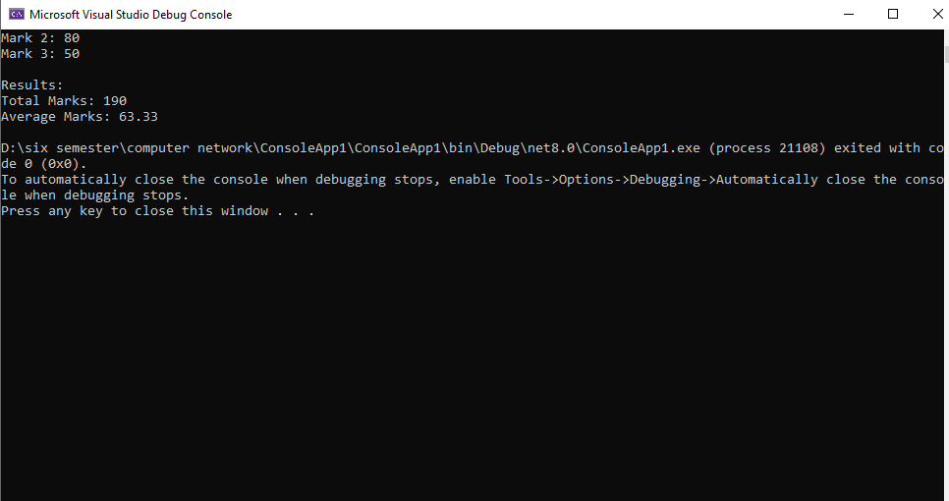

Question 2:Class book

using System;
class Book
{
private int bookid;
private int pages;
private double price;
public void getdata()
{
Console.Write("Enter Book ID: ");
bookid = Convert.ToInt32(Console.ReadLine());
Console.Write("Enter Number of Pages: ");
pages = Convert.ToInt32(Console.ReadLine());
Console.Write("Enter Price: ");
price = Convert.ToDouble(Console.ReadLine());
}
public void show()
{
Console.WriteLine($"Book ID: {bookid}");
Console.WriteLine($"Pages: {pages}");
Console.WriteLine($"Price: {price:C}");
}

public void set(int id, int pg, double pr)
{
bookid = id;
pages = pg;
price = pr;
}
public double getPrice()
{
return price;
}
}
class Program
{
static void Main(string[] args)
{
Book book1 = new Book();
Book book2 = new Book();
Console.WriteLine("Enter details for Book 1:");
book1.getdata()
Console.WriteLine("\nEnter details for Book 2:");
book2.getdata();
Console.WriteLine("\nBook Details:");
Console.WriteLine("Book 1:");
book1.show();
Console.WriteLine("\nBook 2:");
book2.show();
if (book1.getPrice() > book2.getPrice())
{
Console.WriteLine("\nMost costly book is Book 1");
}
else if (book2.getPrice() > book1.getPrice())
{
Console.WriteLine("\nMost costly book is Book 2");
}
else
{
Console.WriteLine("\nBoth books have the same price");
}
}
}
Question 2:Book class program output screenshot



Question 3:Bank Account Class

using System;
class BankAccount
{
private string accountHolder;
private string accountNumber;
private string accountType;
private double balance;

// Constructor to initialize default values
public BankAccount()
{
accountHolder = "Unknown";
accountNumber = "000000";
accountType = "saving";
balance = 0.0;
}
public void CreateAcc(string holder, string number, string type, double initialBalance)
{
accountHolder = holder;
accountNumber = number;

if(type == "current" || type == "saving")
accountType = type;
else
accountType = "saving"; // Default to saving if invalid type
balance = initialBalance;
}
public void Deposit(double amount)
{
if(amount > 0)
{
balance += amount;
Console.WriteLine($"Deposited Rs.{amount}. New balance: Rs.{balance}");
}
else
{
Console.WriteLine("Invalid deposit amount!");
}
}
public void Withdraw(double amount)
{
if(amount > 0)
{
if(amount <= balance)
{
balance -= amount;
Console.WriteLine($"Withdrawn Rs.{amount}. Remaining balance: Rs.{balance}");
}
else
{
Console.WriteLine("Insufficient balance for withdrawal!");
}
}
else
{
Console.WriteLine("Invalid withdrawal amount!");
}
}
public void Display()
{
Console.WriteLine("\nAccount Details:");
Console.WriteLine($"Holder: {accountHolder}");
Console.WriteLine($"Account No: {accountNumber}");
Console.WriteLine($"Type: {accountType}");
Console.WriteLine($"Balance: Rs.{balance}");
}
}
class Program
{
static void Main()
{
BankAccount myAccount = new BankAccount();
myAccount.CreateAcc("Farhanullah", "123456789", "saving", 5000.0);
myAccount.Deposit(1500.0);
myAccount.Withdraw(800.0);
myAccount.Withdraw(6000.0); // Should show insufficient balance
myAccount.Display();

}
}

Question 3 :Bank Class program output screenshot

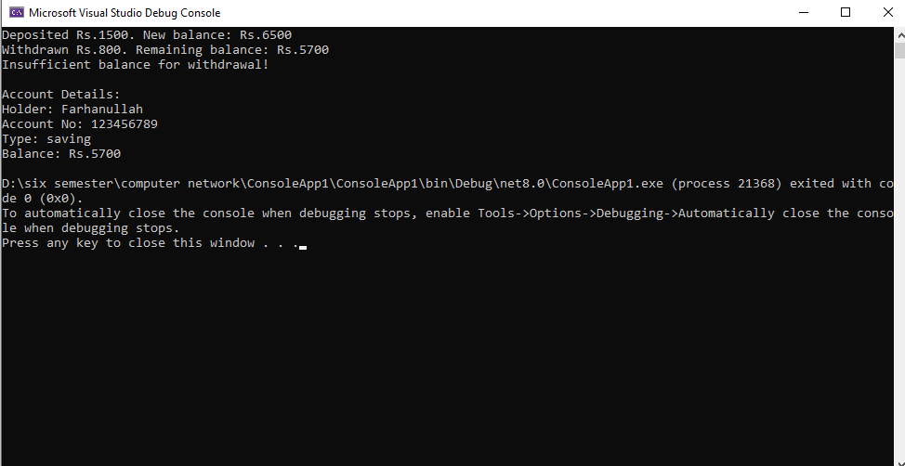

Question 4 :Exception Handling

Exception Handling Defination:
Exception handling is a mechanism to manage runtime errors gracefully, preventing program crashes and allowing for proper error recovery. It separates error-handling code from main logic. Why Use It? Prevents abrupt program termination Provides meaningful error messages Enables cleanup operations Maintains program stability.
Why Use It:
Prevents abrupt program termination
Provides meaningful error messages
Enables cleanup operations Maintains program stability
Key Exception Handling Keywords
Key Exception Handling Keywords
keywods | purpose
try | Marks code block where exceptions may occur
catch | Handles the thrown exception
finally | Executes code regardless of exceptions (cleanup operations)
throw | Explicitly raises an exception
when | Filters exceptions in catch blocks (C# 6+)

Practical Implementation:
using System;
class BankExceptionDemo
{
static void Main()
{
try
{
Console.Write("Enter amount to withdraw: ");
double amount = Convert.ToDouble(Console.ReadLine());
ValidateWithdrawal(amount);
Console.WriteLine($"Successfully withdrew ${amount}");
}
catch (FormatException) when (DateTime.Now.Hour > 17) // Filter
{
Console.WriteLine("Evening error: Please enter numbers only!");
}
catch (FormatException)
{
Console.WriteLine("Error: Invalid number format");
}
catch (InvalidOperationException ex)
{
Console.WriteLine($"Bank error: {ex.Message}");
}
finally
{
Console.WriteLine("Transaction attempt completed");
}
}

static void ValidateWithdrawal(double amount)
{
if (amount <= 0)
throw new ArgumentOutOfRangeException("Amount must be positive");
if (amount > 10000)
throw new InvalidOperationException("Exceeds daily limit");
}
}
Exception Handling program output screenshot
using System;

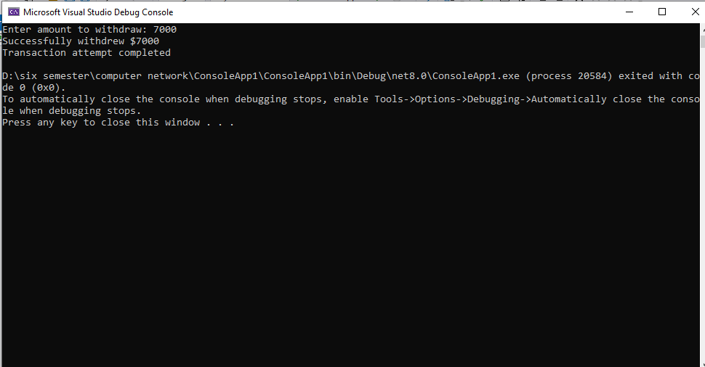
Question 5:Calculator

using System;
using System.Windows.Forms;
namespace CalculatorApp
{
public partial class Form1 : Form
{
double firstNumber = 0;
string operation = "";
bool isSecondNumber = false;

public Form1()
{
InitializeComponent();
textBox1.Text = "0";
}
private void btn_Click(object sender, EventArgs e)
{
Button button = (Button)sender;
if (textBox1.Text == "0" || isSecondNumber)
{
textBox1.Text = "";
isSecondNumber = false;
}
textBox1.Text += button.Text;
}
private void operator_Click(object sender, EventArgs e)
{
Button button = (Button)sender;
firstNumber = double.Parse(textBox1.Text);
operation = button.Text;
textBox1.Text += " " + operation + " ";
isSecondNumber = true; // Next number will start
}
private void btnEquall_Click(object sender, EventArgs e)
{
// Split input based on spaces: "5 + 3" → ["5", "+", "3"]
string[] parts = textBox1.Text.Split(' ');
if (parts.Length < 3)
{
MessageBox.Show("Invalid expression");
return;
}
double secondNumber = double.Parse(parts[2]);
double result = 0;
switch (operation)
{
case "+":
result = firstNumber + secondNumber;
break;
case "-":
result = firstNumber - secondNumber;
break;
case "X":
result = firstNumber * secondNumber;
break;
case "/":
if (secondNumber != 0)
result = firstNumber / secondNumber;
else
{
MessageBox.Show("Cannot divide by zero");
return;
}
break;
}
textBox1.Text = result.ToString();
isSecondNumber = true; // Ready for next input
}
private void btnClear_Click(object sender, EventArgs e) { textBox1.Text = "0"; result = 0; operation = "";
}
}
}

Question 5 :Calculator program output screenshot

