**ADVANCED REAL ESTATE SCRIPT**

**BUG-1**

Module name: Register

Priority: medium

**Status: new**

Link: http://thavasu.com/demo/advance-realestate/index.php

Screenshot:

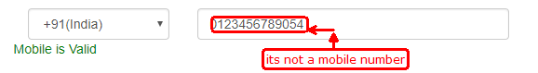

Description: The valid mobile numbers has 10 digits only, and also starts with 6,7,8,9. But it support above 10 digits.

Dated on: 05.09.2018

**BUG-2**

Module name: Register

Priority: medium

**Status: new**

Link: http://thavasu.com/demo/advance-realestate/index.php

Screenshot:

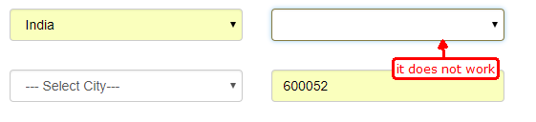

Description: while click dropdown box, it does not show any states in dropdown list.

Dated on: 05.09.2018

**BUG-3**

Module name: Register

Priority: medium

**Status: new**

Link: http://thavasu.com/demo/advance-realestate/index.php

Screenshot:

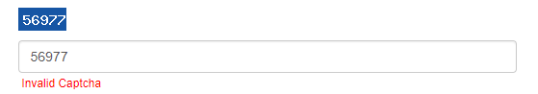

Description: while enter correct captcha code. But it show error notification(invalid captcha)

Dated on: 05.09.2018

**BUG-4**

Module name: Register

Priority: medium

**Status: new**

Link: http://thavasu.com/demo/advance-realestate/dashboard.php

Screenshot:

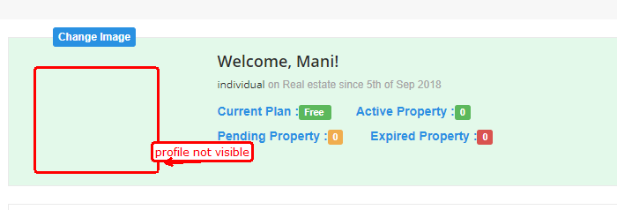

Description: I upload my profile here. But it does not visible

Dated on: 05.09.2018

**BUG-5**

Module name: project-sub category

Priority: medium

**Status: new**

Link: http://thavasu.com/demo/advance-realestate/projectfull.php

Screenshot:

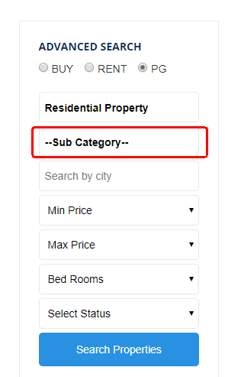

Description: In projects and properties, subcategory dropdown is not worked

Dated on: 06.09.2018

**BUG-6**

Module name: dashboard- my responces-reply

Priority: medium

**Status: new**

Link: http://thavasu.com/demo/advance-realestate/projectfull.php

Screenshot:

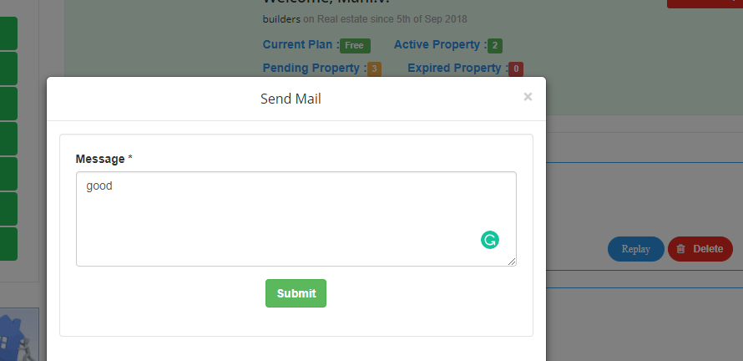

Description: replay mail is not received in the receiver side

Dated on: 06.09.2018