1. **Login Page:**

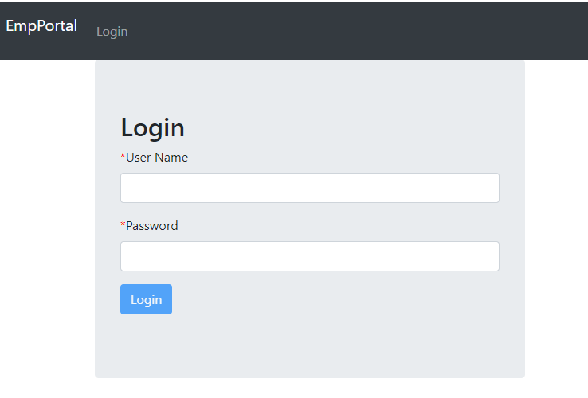

**Login Page Validation:**

**Scenario 1:** Fields should not be blank.

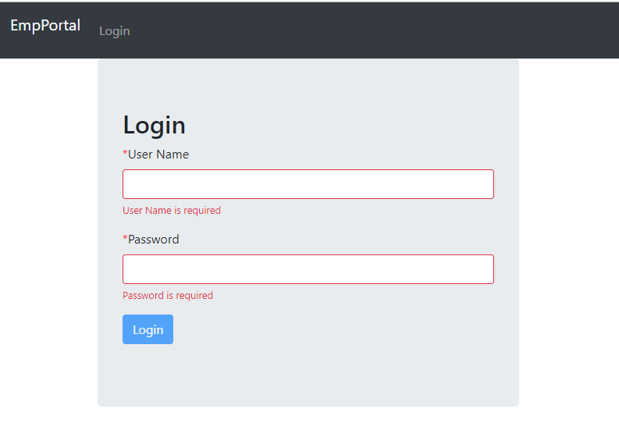

**Scenario 2:** Invalid User Name or Password.

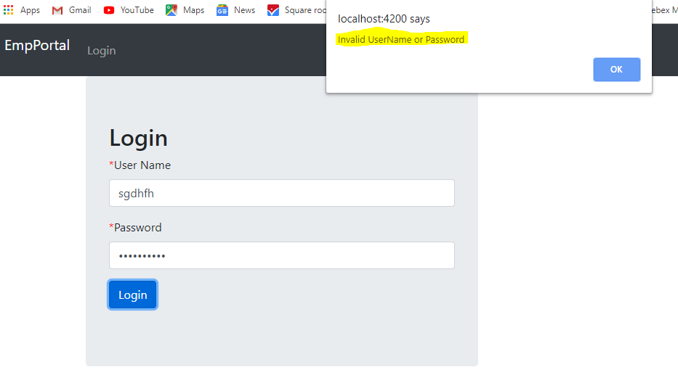

**Scenario 3:** Password length should be at least 6 characters.

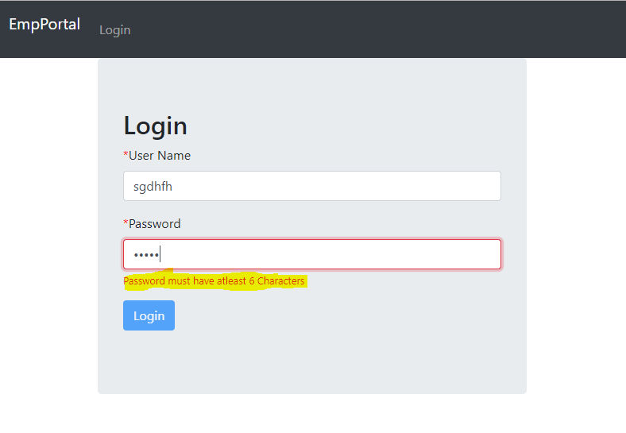

1. **Add Employee Page:**

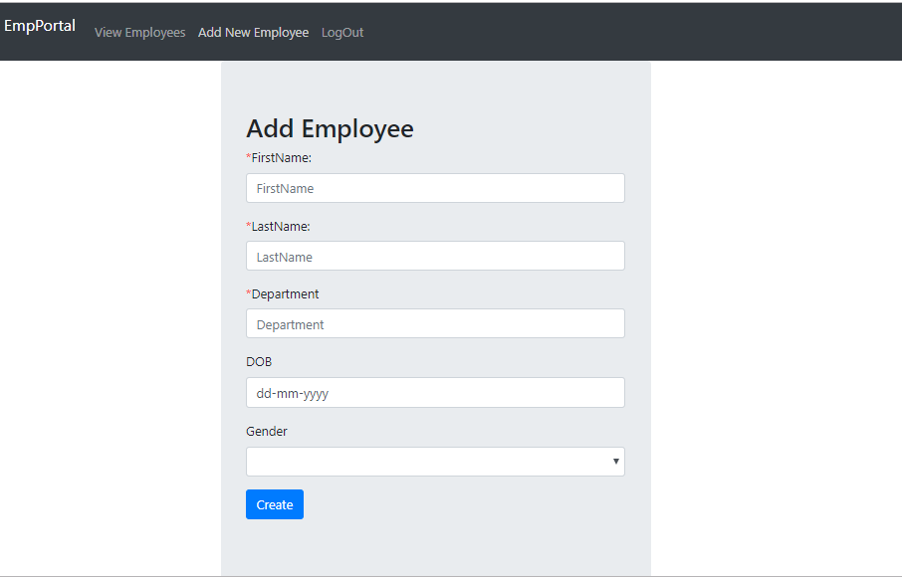

**Add Employee Page Validation:**

**Scenario 1: Fields should not be blank.**

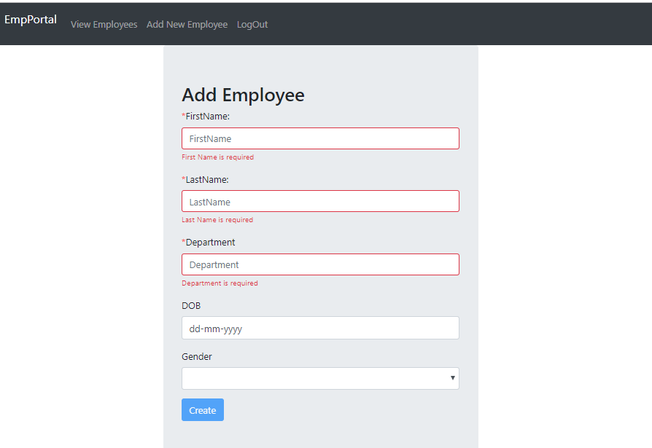

**Scenario 2:** Adding the new employee.

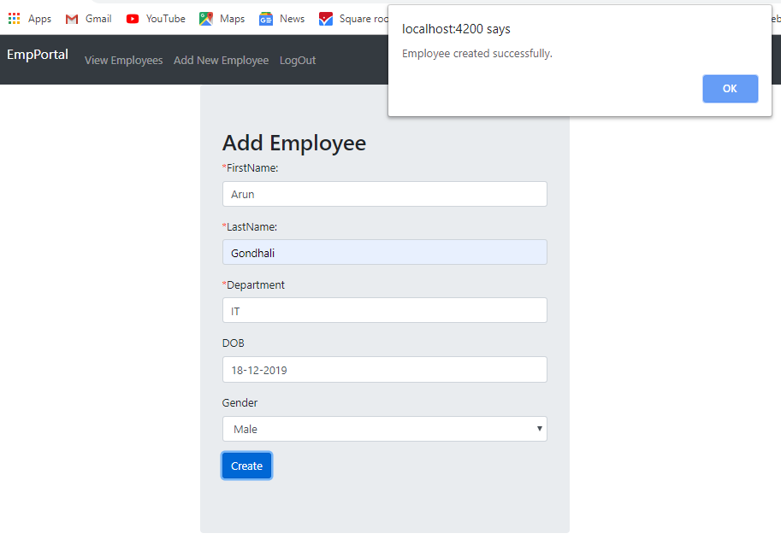

**View Employee Page:**

**Before Add:**

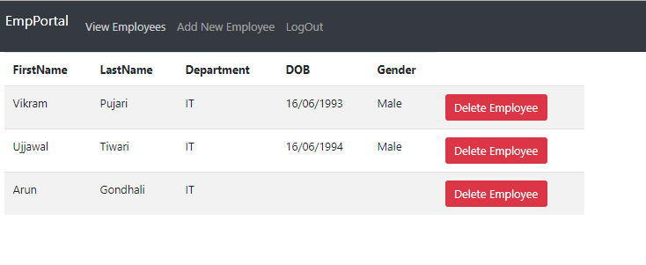

**After Add:**

