STUDENT: |  |  | Qualification
SUBJECT: | COURSE:
DATE: | EVALUATION:

Estimated duration: 50 minutes Learning situation: 3 R2

INSTRUCTIONS
All questions have only one correct answer.
Each correct answer adds half a point, and each incorrect answer subtracts 0.5/4 points.
If a question is not answered, it will not add or subtract points.
To answer the questions, you must mark the table at the end.
The questions often refer to the figures on the last pages.

Test

{% for question in test %}
  - {{ question }}
a. {{ ans1 }}
b. {{ ans2 }}
c. {{ ans3 }}
d. {{ ans4 }}

{% endfor %}

 | Fig 1
 | Fig 2
 | Fig.3
 | Fig.4
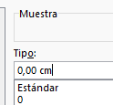 | Fig.5
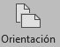 | Fig.6
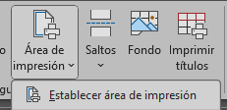 | Fig.7
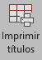 | Fig.8
 | Fig.9
 | Fig.10
 | Fig.11
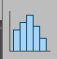 | Fig.12
 | Fig.13
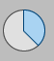 | Fig.14
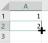 | Fig.15
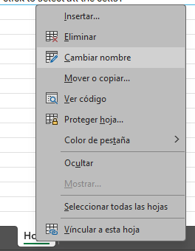 | Fig.16
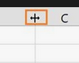 | Fig.17
 | Fig.18
 | Fig.19
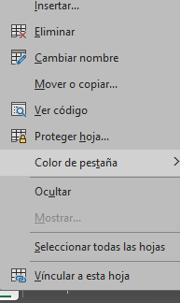 | Fig.20
 | Fig 21

Write an "X" in the answer you selected from each column

Question | A | B | C | D
{%tr for num in numpreg %}
Question {{ num }}
{%tr endfor %}

