1.Backup local

<http://how-to.linuxcareer.com/guide-to-rsnapshot-and-incremental-backups-on-linux>

|  |
| --- |
| apt-get install rsnapshot |

Runt the following command to verify

|  |
| --- |
| rsnapshot configtest  rsnapshot hourly  rsnapshot du  rsnapshot hourly  rsnapshot du  rsnapshot-diff hourly.0/ hourly.1/ |

Test the installations and manually run the back up:

|  |
| --- |
| **rsnapshot -t hourly** |

Use crontab to automatically run rsnapshot

|  |
| --- |
| cat /etc/cron.d/rsnapshot |

2. How to remotely backup using Rsnapshot

<http://www.tecmint.com/rsnapshot-a-file-system-backup-utility-for-linux/>

2.1 Enable SSH login without password in both servers (just for reference, the user account information may vary according to different users and systems)

|  |
| --- |
| Su rtksd8  ssh-keygen -t rsa  ssh ted@172.25.22.10 mkdir -p .ssh  cat id_rsa.pub | ssh ted@172.25.22.10 'cat >> .ssh/authorized_keys' |



|  |
| --- |
| ssh ted@172.25.22.10 "chmod 700 .ssh; chmod 640 .ssh/authorized_keys" |

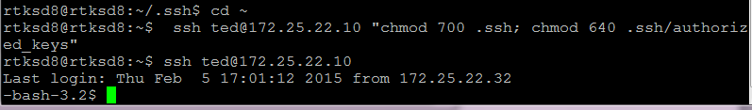

2.2 Change configuration in ‘/etc/rsnapshot.conf’

Also uncomment the “cmd_ssh” line to allow to take remote backups over SSH.

cmd_ssh /usr/bin/ssh

One more thing you need to edit is “ssh_args” variable. If you have changed the default SSH Port (22) to something else, you need to specify that port number of your remote backing up server.

ssh_args -p 7851

Backup Remote Directories

backup root@example.com:/home/ /data/backup/

3. Run the backup process automatically

3.1

|  |
| --- |
| vi /etc/cron.d/rsnapshot |

|  |
| --- |
| # This is a sample cron file for rsnapshot.  # The values used correspond to the examples in /etc/rsnapshot.conf.  # There you can also set the backup points and many other things.  #  # To activate this cron file you have to uncomment the lines below.  # Feel free to adapt it to your needs.  0 */12 * * * root /usr/bin/rsnapshot hourly  30 3 * * * root /usr/bin/rsnapshot daily  0 3 * * 1 root /usr/bin/rsnapshot weekly  #30 2 1 * * root /usr/bin/rsnapshot monthly |

3.2

|  |
| --- |
| vi /etc/rsnapshot.conf |

|  |
| --- |
| # All snapshots will be stored under this root directory.  #  snapshot_root /mnt/sdb1/backup2210/ |

|  |
| --- |
| #########################################  # BACKUP INTERVALS #  # Must be unique and in ascending order #  # i.e. hourly, daily, weekly, etc. #  #########################################  retain hourly 2  retain daily 7  retain weekly 2  #retain monthly 3 |

|  |
| --- |
| # ssh has no args passed by default, but you can specify some here.  #  ssh_args -p 22 |

|  |
| --- |
| ###############################  ### BACKUP POINTS / SCRIPTS ###  ###############################  # LOCALHOST  #backup /home/backup/ localhost/  backup root@172.25.22.10:/home/RTCN1912/ remote/  #backup /etc/ localhost/  #backup /usr/local/ localhost/ |