1. Singtel mesh topology and Singtel lab testing instruction

Singtel layout include: Optical Network Router (ONR) as modem and DHCP server. Mesh nodes are our Askey device. IPTV Set-Top Box or DVR box will connect to either ONR or mesh node.

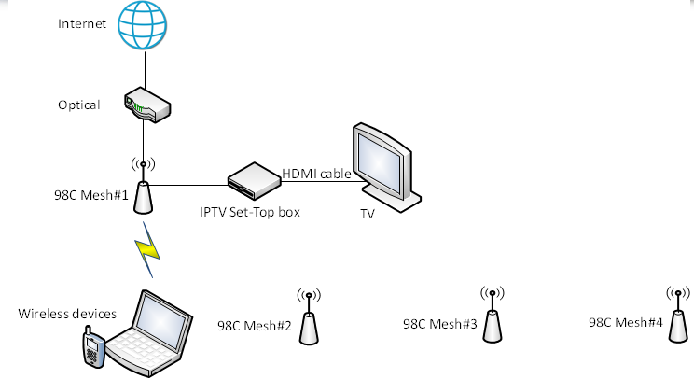

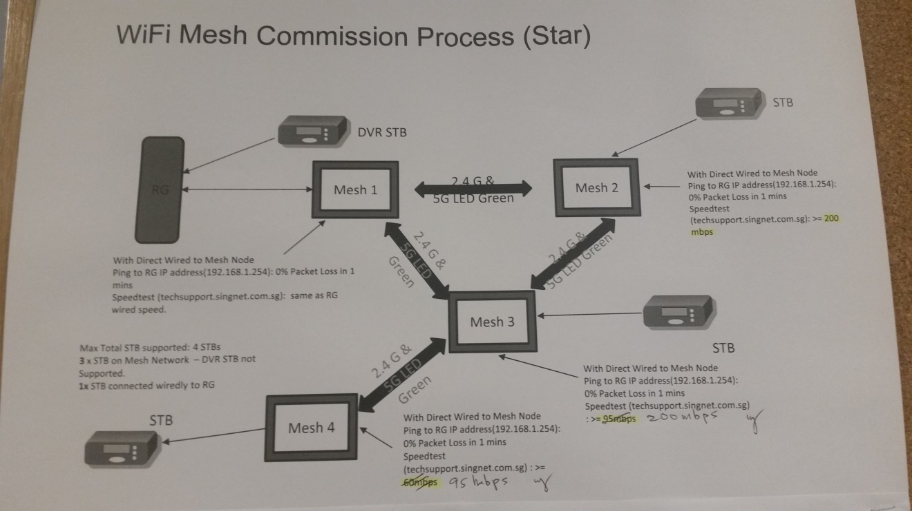

1. Prepare Testing Tools for On-site

Hardware: Sniffer RTL8814 (ASUS USB-AC68), Ethernet cable, Phone, Laptop

Software: Omnipeek, Wireshark,

SpeedTest URL: http://www.speedtest.net/

APP: Net Analyzer, Wifi Analyzer, Speedtest, SIngtel HeatMap

1. Debugging procedures
   1. Understand customers’ network layout and environment

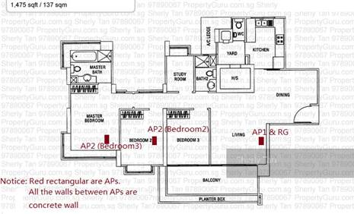

* 1. Roaming test result example

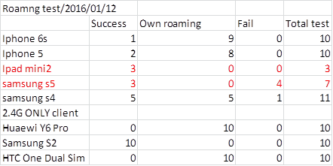

Figure 1: Success: our mechanism; Own roaming: Phone roam by itself; Fail: didn't roam to better AP

* 1. Speed test result example

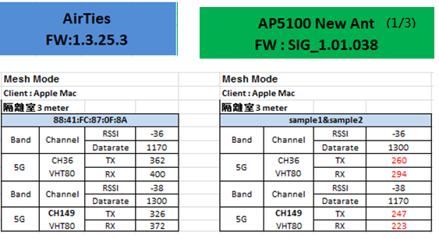

1. Passed Cases Examples

The followings are some cases happened in Singtel office, SIngtel Lab and customers’ residences.

|  |  |  |  |
| --- | --- | --- | --- |
| Cases | Major Steps in debugging | Root Cause | Solution |
| Mesh node can’t get IP addresses. | Use Wireshark to monitor packet in distributing IP | Spanning tree is not enabled and loop will happen | Enable spanning tree |
| Internet intermittence and video/gaming lagging | Test wifi coverage and signal strength. monitor packet loss.  Check hardware conditions like LAN port bandwidth and connectivity  Test using different devices and different testing tools or website | Weak coverage and broken LAN cable or 100mbs port only.  WiFi mesh blocked if multiple Ethernet backhauled.  Some video server or gaming server is slow by nature. | Change AP location to expand coverage.  Fix the hardware to prove.  Unblock WiFi mesh if it’s the better path. |
| Can’t connect WiFi, showing “incorrect password” | Tried in different location and monitor the devices’ whereabout status. | There’s another AP with same SSID but different password nearby, customer forgot to off the old AP. | Turn off the previous leftover AP. |
| Only particular iPhone can’t connect WiFi | Replace our device with other device to test, also log sniffer data to find the failing stage. | Blacklisted by the Optical Network Terminal. | Remove the blacklist. |
| Philip 50pft6200 smart TV can’t connect our mesh | Compare with other AP and sniffer data | Due to 11k, if ft_enable=1, this device doesn’t support encryption mode of WPA2/WPA mix will. | Change default encryption mode to be WPA2 |
| iPhone shows “incorrect password” when try to connect and unable to connect 1 of the mesh | Ensure environment and signal are ok to connect for the device, and compare the encryption mode in sniffer packet | Askey device need to be reset before upgrade firmware, otherwise the encryption mode will be set different as shown on UI | Factory reset on UI before upgrade firmware |
| Can’s use WPS to pair | Sniffer packet, use WiFi analyser to locate the devices sending WPS probe. | Another vendor’s AP WPS button was stuck and kept on sending WPS | Turn off the interfering AP. |
| Keep roaming between APs, iPhone and Android will lose connection forever after around 3 times roaming | Use sniffer to log data and found the roaming is caused by our disassociation | Phone will decide not connect to the AP who disassoc it too often | 3 minutes waiting time before triggering our roaming mechanism |

1. Scenario
   1. Simple RTK Singapore office layout

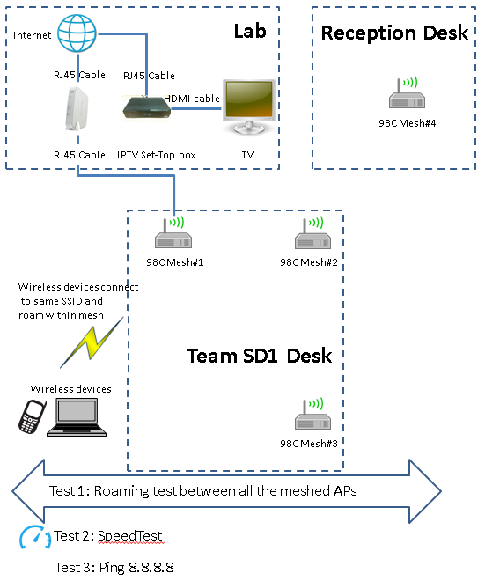

* 1. Case we tested for mesh with IPTV (set-top boxed) 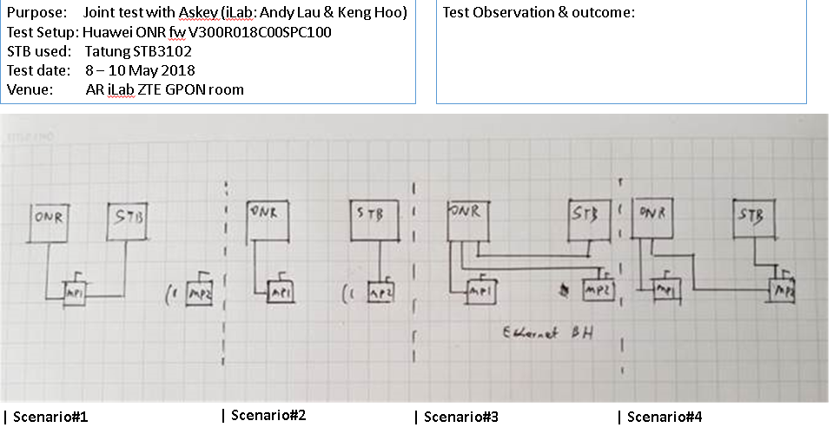
  2. Singtel Testing tools

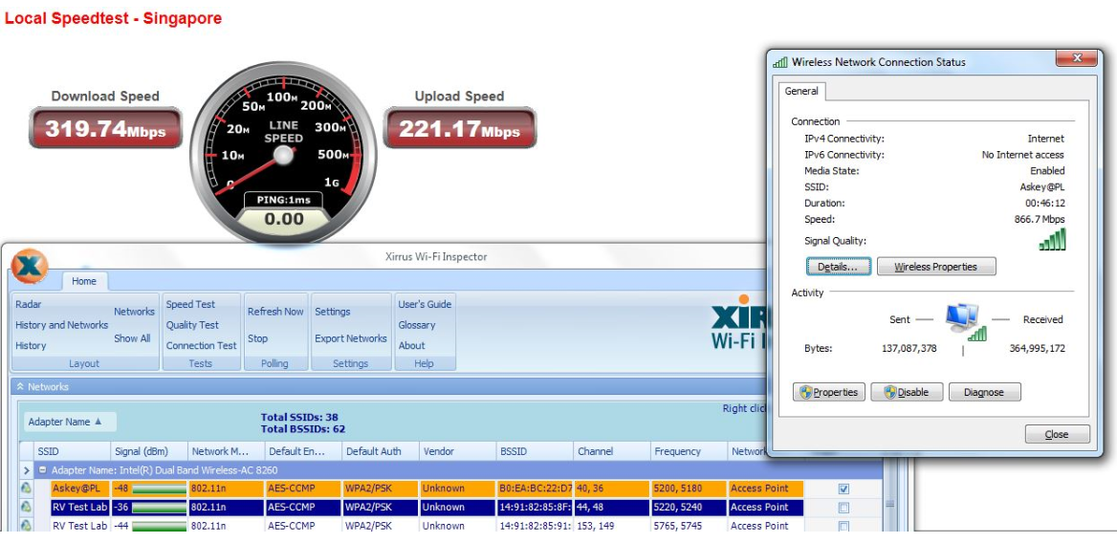

* 1. Singtel QoS, Wireless and WPS test cases

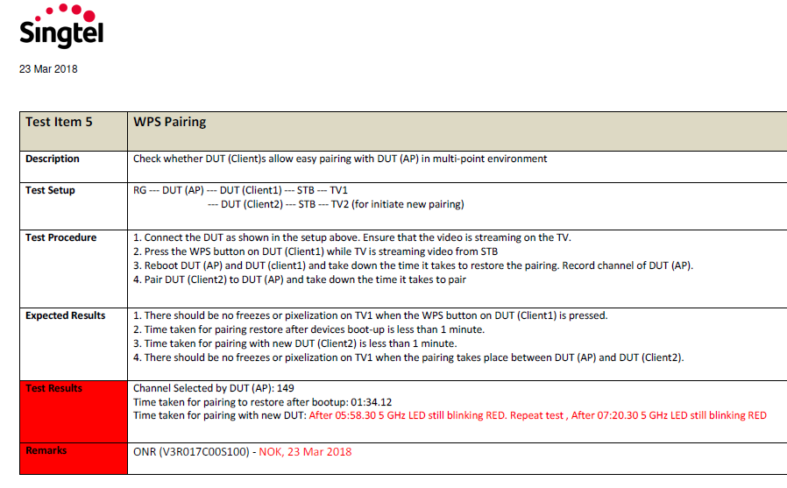

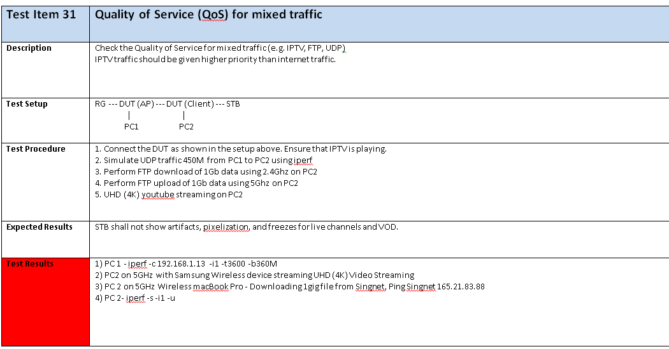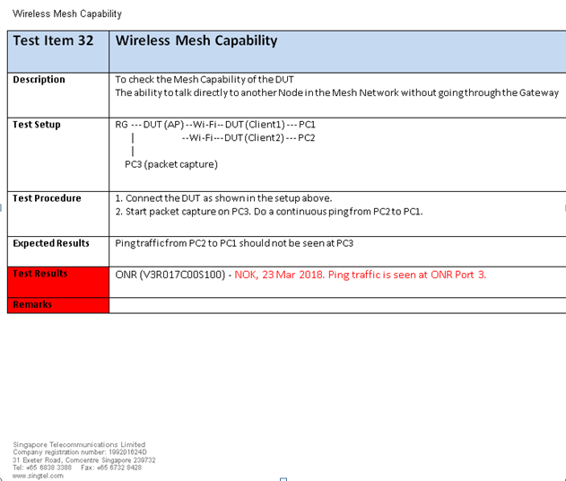

* 1. Singtel Paya Lebar office 6 mesh nodes layout test scenario

Below is PL office Askey Mesh placed position map (Provided by Singtel):

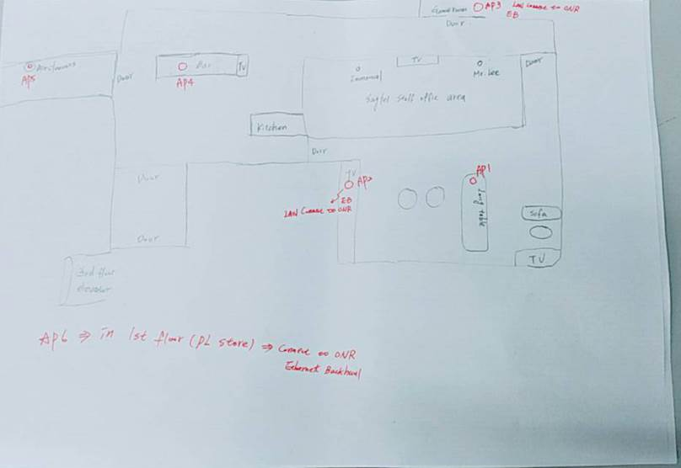

|  |  |  |
| --- | --- | --- |
| **Setup** |  | |
| 1.       ONR ------Askey Port 1 (Askey AP2 , AP3, AP6) --- Ethernet Backhaul | | |
| 2.       WiFi Mesh (Akey AP1, AP4, AP5) | |

* 1. Singtel customer’s home coverage increase with more mesh nodes case

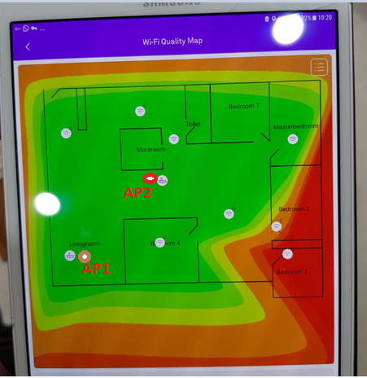 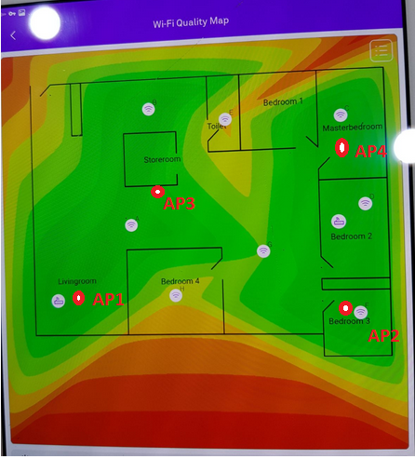

* 1. Good mesh coverage and signal strength case

