***1) Before starting***

First of all, if you decided to work with me then I insist on paying attention to my words, each of those are not said for fun, but said according to my experience. I made almost 40 raids on ATM, more than ten times escaped cops’ chasings and made several escapings from interception measures. I scrupulously researched ways of delivering malware, banks’ security and counteraction measures. For example, if I say that you have to have clean and new flash card, so it definitely has to be as I said, not just because I want it to be like that, but for your safety. There is no need in amateur performances, follow my instructions and then together we will earn a lot of cash.

Now I’m going to deliver my experience. I will describe basic moments of job, give you directions for thoughts and developments. It’s important to know that everything written below wasn’t found in schoolbooks, it’s all about asking Google correct questions and analysis of received information. This manual is not an ABC-book, look for new opportunities by yourself. Look for new methods of realization of given tasks, modernize algorithms of job, find new vulnerabilities. Be creative, improvise.

***You will need :***

1. Usb hub that has minimum two sockets, with light-emitting diode that will flash while working.
2. New flash card of 1 or 4 GBs (less is better, we will need less than 4 Mb).
3. Wireless keyboard with embedded touchpad (that’s for your comfort, you can use usual wired keyboard and mouse).
4. Pocket flashlight.
5. Small but tough knife.
6. Second-hand phone that should be bought in place without cameras, that must not be turned on near your own phone and has to be disassembled almost all time. In between turnings on/off of this and your own phones always take 40 minutes timing, EVEN if you made braking by place – i.e. if you went to another place without your phone still make braking by place and time.
7. Two sets of clothing for each companion (first set for job, second set has to be placed in hiding spot without cameras, so you can change your clothes after job). Among these sets there shouldn’t be any clothes that you used in this season; old, inconspiscious.
8. Dodgy sim card with money on account and stable internet, buying and refreshing your sim card in place without cameras, with reserve.
9. Insulating tape and double-sided tape.
10. Medical masks for each companion, otherwise theatrical stuff (fake beards, mustaches, balaclavas, etc).
11. Two welding electrodes (will serve as a pin – usb hub plug will be adjusted, by this pin we will insert our usb hub into usb ports). Instead of electrodes you can use any pin or stick< it has to be steady and light-weighted to preserve it’s shape. One of my teams made device from selfie-stick, it became folding, compact, pocket sized. Inserted in ATM, then folded, brought back ATM in first position. Let’s make our main tool. It should look like this:

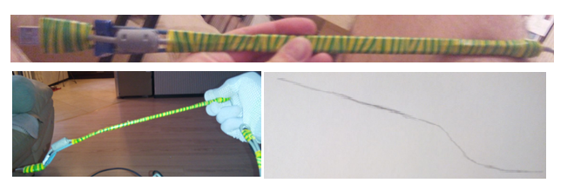

1. Cable of usb hub needs to be adjusted with two electrodes. Usb plug by itself has to be heavily adjusted at the beginning of our pin. Required length of electrodes is about 20-25 cm, not more. Flexure has to be at the beginning of our pin so we can eaqsiliy insert it in ATM. Perhaps you will need to change flexure of pin, so don’t use insulating tape at the place of flexing to avoid bothering. Pin has to go into usb port easily, without effort, don’t push it hardly, if its not going – correct your flexure. Usb plug goes into usb port only in one way, we should call it “ right “ way. Look inside usb plug (in front view) that makes contact with computer – you will see plastic rectangle. Plug is in right position when this rectangle is below.

Photo in the right lower corner is painting of flexures. It can be said that pin consists of two parallel lines and drop between them, it’s length is 4 cm and height – 2,5 cm. You can copy drop’s angle of incline from photo in the right lower corner.

1. Gloves for companion that will work directly with ATM.
2. Minimum two walkie-talkies with headsets (or another way of connection- for example mobile phones, don’t forget about precautions!). My advice is to analyze programmers/phreakers forums before buying high quality walkie-talkies. Otherwise car related forums – we look for information about police radio channels’ frequencies, it’s usually in free access, also you can introduce yourself as a rookie bankworker in targeted internet community asking for help by creating certain topic or talk to private taxi drivers. Usually there are 2-4 frequencies for one million population city.
3. Anonymous credit card in case if access to atm is controlled by card-reader.
4. Small pocket pliers (in extreme case when changing of flexure of pin is needed).
5. Turbo lighter with reserving gas tank
6. Money bag which you will past atop of atm’s dispencer. Place one line of double-sided tape along each handle of bag, along the contour of edges.

Think about purpose of each described item, find out tasks that these tools will solve and desired features. Imagine how and what you’re going to do with tools, how it will be more convenient. Create your own variants of equipment. Each item of your equipment should be elaborated, because every second will be very important. Before job, wipe all fingerprints.

***2) Software and instructions***

***Stimulator – for checking quantity and nominals of banknotes in ATM’s cassettes.***

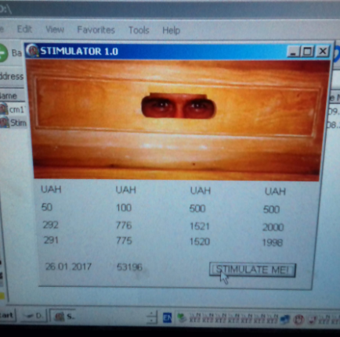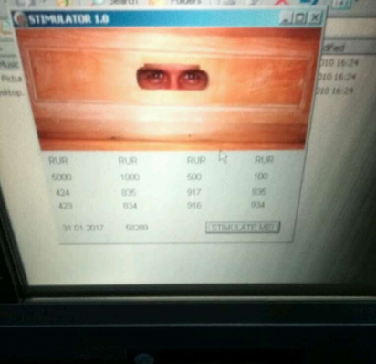

**•**Launch software, press “stimulate me” button.

**•**Sometimes ATM needs to think a little bit, after 6-7 seconds if nothing happened press “stimulate me” button again.

**•**Each column corresponds to each cassette.

**•**Upper row – loaded in cassette currency.

**•**Second row – nominal of banknotes loaded in cassette.

**•**Don’t mind third row.

**•**Fourth row – quantity of banknotes.

***Finale. Initiating output of banknotes***

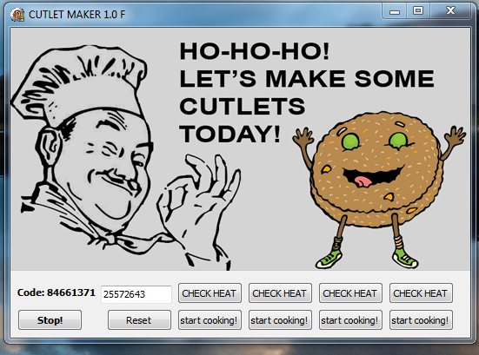

**•**Launch cm17f, see code and empty field on right also two rows of buttons which corresponds to two modes of cash output.

**•**After input of activation code unloading can be started by pressing one of the control buttons.

**•**CHECK HEAT outputs one banknote, to see nominal.

**•**START COOKING activates full output.

**•**Each column corresponds to each cassette, 4 columns – 4 cassettes.

**•**After second starting of .exe input of new activation code is required.

**•**Program doesn’t work on PC, for launching system DLL is needed, which is in set. In regular mode software works only on ATM.

**•**After input of wrong activation code, message of error code 50 appears. After that no visual changes.

**•**After input of correct activation code, software starts countdown of cycle’s timing of outputting packs of banknotes.

***Keygen or miracle, come true !***

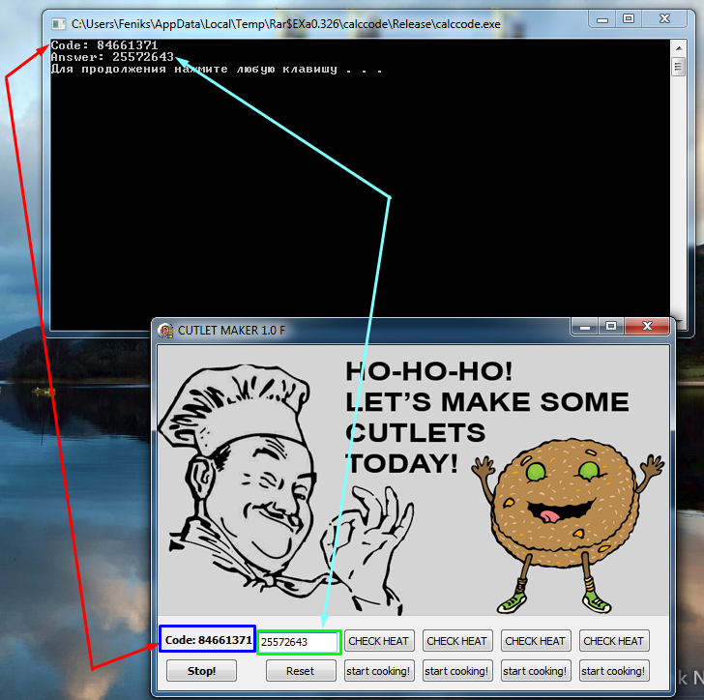

**•**Launch calccode.

**•**Input code that was given by soft on atm.

**•**Press enter.

**•**Receive activation code for current session.

In set with keygen I will give source code on C. For my job it was assembled in form of APK so it was very convenient to use it via phone. A lot of people on forums provide service of source code compilation, it usually takes about 10 minutes. We used to calculate codes on atm quiet frequently.

***3) ATM. What is it and how to work with it***

***Wincor2000xe***

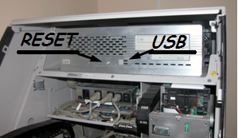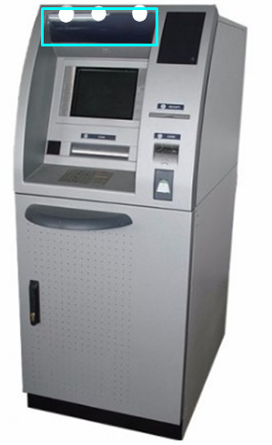 I’m going to mark few features of our ATM model, so you can easily recognize it among variety of “fridges”.

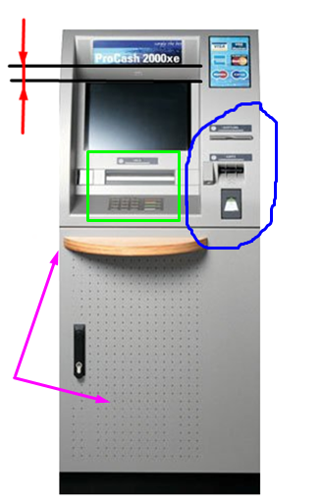**•**Main distinctive features of this model are office oriented, without cash input module, not embedded in wall and size.

**•**Look at the green rectangle, on the left photo. Placing of cash dispenser, screen, pin pad and mirror with camera is always same.

**•**Look at the panel on right of screen, remember placing of card receiver and check printer. Make mark in memory – there is no cash input module.

**•**Pointed by pink arrow door and stand are not always can be founded. Sometimes there is absence of perforation and stand.

**•**Wincor has model 2100xe, a lot of people are confused by these two models. Look at the left photo, red colour is pointing at distance that distinguishes our model from it’s twin. Our atm’s distance between screen and working panel is 4-7 cm, while in 2100xe it is 25-30 cm.

**•**Colouring of atms can be different. If you are not sure – send me photo.

**•**On the right photo, at the outer edge of a cyan rectangle goes edge of plastic plate. We need to take it away for beginning.

**•**Three white points on the right photo point at places where plastic plate is fastened to body of atm, you need to use your knife at this points to pick up plastic plate, it goes very easy while picking. Do it smoothly, don’t break it, when job is done place plastic plate back.

**•**Beyond plastic plate you will see 4 holes. Usb ports will be seen on right second window. Beam your flashlight at the very right hole, insert pin with adjusted usb hub in next hole. Nearby on left there is a reset button. Remember it, can be useful

***Wincor 1500xe***

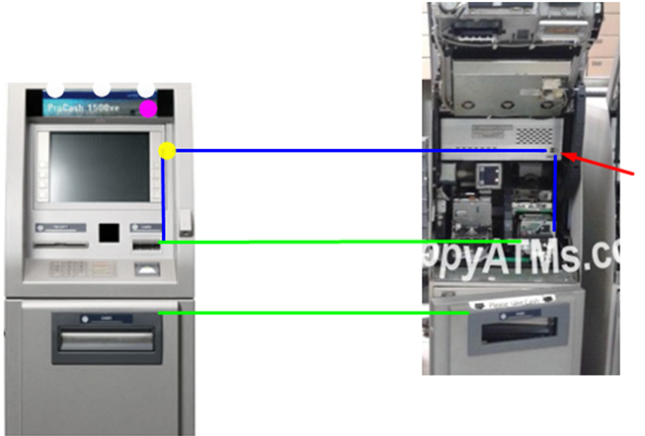This model looks like previous but smaller

**•**Cash output module is located in lower door.

**•**Check printer and receiver are located below screen.

**•**There is no function of cash receiving.

**•**Red arrow points at usb ports.

**•**Using green lines make accordance of scale (basing on cash output module). Using blue lines locate usb ports on the left pic (taking card receiver as starting point).

**•**White markers – places of plate fastening. Accurately pick it up by knife and see solid plastic plate ( like on previous model).

**•**Using lighter make circle at pink marker with diameter of 14-16 cm.

**•**Yellow marker points at usb ports location. Take your usb hub cable and accurately without sharp moves plug it. Visualize view of system block, move your hand alog it to the right. Find it by your hand at the lower right corner of system block.

IMPORTANT. I want you to memorize it. We will deal with windows xp/nt/2000/embedded installed on old hardware, including less than 2 GB of RAM. It’s not necessary to hurry up and press buttons multiple times, while inserting any command. Wait for 4-6 seconds and press it again. Be patient, if ATM will lag then reboot will take away your time and create a lot of problems.

**•**After connection, periodically pressing caps lock button, waiting for keyboard indicator reaction (atm is searching drivers for new equipment) it can take about minute.

**•**Ctrl+esc; alt+ctrl+delete; alt+tab; ctrl+shift+enter. Be familiar with these combinations and provided by them opportunities. Our goal is to open flash card no matter what and run software. We can right down new task via command console or activate software via explorer.

**•**Check atm’s load. Run Stimulator, make photo of balance.

**•**If you can not run .exe then alt+ctrl+del, task manager, analyzing running aps, close everything unnecessary.

**•**Initiating cash output. Launch exe, input activation code, check by one banknote. If nominal is ok to you then start cash output.

**•**When cash will end cash supply belts will make certain sound. Go to next cassette.

**•**Press “stop”, “reset”. Wait for a few seconds. If it doesn’t help – repeat. Otherwise you can close program by pressing cross button and run software again.

**•**If atm lagged – remember “reset” button. Access to “reset” button is not restricted, it’s in open place, it’s diameter 3-4 mm. Any long thin and sharp stick will make it.

**•**When job is done, close software, put all parts back, wipe off fingerprints.

***4) Thinking out loud***

I didn’t mention the most important point. Main part of success in this action is searching ATMs and making choice of working place. Only to this I wasted 2 weeks, giving all my free time. You need to find out at least four working places, it is desirable to pick up ATMs from different banks. It is necessary to have as much variants as it possible in case of unexpected situations such as: cops are already there, somebody died and ambulance arrived, Martians descended from space – you name it.

Searching for working places is not easy job. Before going and checking ATMs make routes.

**•**Ask google for location of banks.

**•**Starting from first list check all official websites of them.

**•**Checking atms by required criterions – all-day, without cash input module, located in building, not embedded into wall.

**•**Take all positive addresses.

**•**Check addresses in google panorama or anywhere, take all comfortable variants for you.

Leave your phone at your place, if you’re going to make pics – do it without noticing. Don’t use your own car. Check out maximum quantity of addresses, don’t be lazy. More places you have – more space for maneuvers.

So, you have list of ATMs, it’s time for preparations. On stage of preparations everyone has to understand working scheme, conventional signs. You have to know actions of each other in case of any situation. Your freedom depends on your companions. It’s in your interest to make them prepared at max. Think about ways of leaving. Think about situation when your companions will leave place separately and on their own. For your understanding – leaving is not running away cowardly.

Work in three, one inside, two are “eyes”. To working place companions go separately, nobody is getting close to each other. Connection among you is walkie-talkies with headsets. “eyes” can hang around with faces covered by scarfs, or take janitors clothings and become invisible for cops.”Eyes” can stay on their places even if it’s going “hot”. The only thing they have to do in critical situation – drop off walkie-talkies (without finger prints). “Worker” at the ATM has to know shortcut to stash, safe spot or hideout, so he can drop gloves, mask and walkie-talkie, and then walk out with bottle of beer and cigarette ‘looking for a taxi’. Or he can rent a taxi and tell to wait until job is done, then leave on it. Or rent apartment in the nearest house/ get access to nearest entrance. Bag with equipment can be left in working place, it has no of your fingerprints. When cops will get to ATM they will search for a criminal. Make everything to be not associated with criminals!

Let’s get back to ways of delivering software, I’ll give you few vectors of thinking. What is ATM? Right, it’s a computer with default OS which is connected to different hardwares. It’s not necessary to have access to usb ports. For example we can make connection to cable that goes to check printer. Cable usb-female to usb-female is needed. This is actual way for 2100xe and few other ATM models. For creating your own methods of delivery you must have certain amount of information about ATM. What are we going to do?

***As opportunity?!*** Seek for forums where ATM or bank workers hang out, read all news columns. There is a lot of information about ATMs, construction and technical characteristics. Besides, by analyzing users’ messages you can assume what kind of security policy is used. You just need to create a beautiful legend about yourself. Or at least introduce yourself as a rookie bank worker, who doesn’t have any support docs or wasn’t trained enough etc.

***Possible alternative.*** Look for ATM related websites that have technical support files, schematics, photos, you need to find out any information about ATM’s guts. CPU location, location of usb-hubs, ways of access. It makes sense to pay attention for types and conjunctions among units of ATM and their type of information-right connections. It is possible to connect to certain cables directly, thanks to functions for which this cable is purposed for from start, we can activate our software and system will eat our commands. I know two models of ncr, that can run software only after bending side plank and connecting to certain cable.

Taking remote access to ATM is a priori creative process. Delivery is possible via casual fishing on mail addresses of bank workers for example. Using good bonding, take remote access and then do best of your abilities. In another side, you can find ATM worker and make him to upload troy for access which will self delete after installation. Think about every opportunity, use certain tools for each case, any required software can be found in free access or for reasonable price, you just need to use it correctly.

***4.1) post scriptum***

If you decided to work in this field< if you are already going – every second give yourself a report, ask yourself why are you here and what do you want. That’s right – money. So don’t come back without them. Don’t hang around ATM making stupid excuses for each other. If you came to do job – do it. If something went wrong, go to second address. Even if security system has alarmed – go to another address. Alarm doesn’t mean that all cops in the city will come after you. It’s common mistake – you came, started doing your job, some standard issue happened and everyone begin to panic and look for reasons to escape. If you don’t have balls don’t fuck around and stop wasting your time. Thousands of cops roll all day around, but in this very night you will think they are coming for you. It’s called paranoia.

***4.4 post post scriptum***

I give you a way for earning real money for 15 minutes. Question is, do you have courage to take them?