**INTERIAR: A MOBILE AUGMENTED REALITY APPLICATION FOR PREVIEWING FURNITURE PRODUCTS ONLINE**

A Capstone Project

Presented to the Faculty of the

Department of Computer and Information Sciences

University of San Carlos

Cebu City, Philippines

In Partial Fulfillment

of the Requirements for the Degree

BACHELOR OF SCIENCE IN INFORMATION TECHNOLOGY

By:

ROALD L. GALANO

LEONILLE CHRISTIE A. LAVADOR

JON MIGUEL R. LINDO

CHRISTIAN TED R. OCHOA

MARY JANE G. SABELLANO, MSIT

Faculty Adviser

#### **ABSTRACT**

There are a lot of people who love to design their rooms. Many of them buy their furnitures from ecommerce websites. A lot of times, the ordered product either doesn’t fit in with the room or does not look like the preview posted on the website. It is important to meet the customers’ expectations of the product bought.

The goal of this study is to improve the customer experience of buying furnitures online and to eliminate scams. This study proposes a mobile app to render the furniture the customer wishes to buy from an ecommerce website onto the physical world using augmented reality. The user can browse through furnitures online and may preview it. A 3D model of the furniture is projected to the camera and it can be moved, rotated, and changed in appearance if other designs are available. The study expects an increase of smarter consumer purchases in furnitures and a reduction of scams online.

**TABLE OF CONTENTS**

**ABSTRACT** ………………………… **ii**

**TABLE OF CONTENTS** ………………………… **iii**

**LIST OF FIGURES** ………………………… **iv**

**LIST OF TABLES** ………………………… **v**

**CHAPTER 1 INTRODUCTION** ………………………… **1**

**1.1 Rationale of the Study** ………………………… **1**

**1.2 Statement of the Problem** ………………………… **2**

**1.2.1 General Objective** ………………………… **2**

**1.2.2 Specific Objectives** ………………………… **2**

**1.3 Significance of the Study** ………………………… **3**

**1.4 Scope and Limitations** ………………………… **3**

**CHAPTER 2 REVIEW OF RELATED LITERATURE** ………………………… **4**

**CHAPTER 3 TECHNICAL BACKGROUND** ………………………… **9**

**CHAPTER 4 DESIGN AND METHODOLOGY** ………………………… **12**

|  |  |  |  |  |  |  |  |  |
| --- | --- | --- | --- | --- | --- | --- | --- | --- |
| **4.1 Concept**  **4.2 Analysis and Design**  **4.3 Development Model**  **4.4 Development Approaches**  **4.5 Software Development Tools**  **4.6.Schedule and Timeline**  **4.7 Responsibilities**  **4.8 Budget and Cost Management**  **4.9 Verification, Validating and Testing**   |  |  |  | | --- | --- | --- | | **BIBLIOGRAPHY** | ………………………… | **20** | |  |  |  |   **CURRICULUM VITAE** | ………………………… …………………………  …………………………  …………………………  …………………………  …………………………  …………………………  …………………………  …………………………  …………………………  ………………………… | **12**  **13**  **14**  **15**  **15**  **17**  **18**  **19**  **20**  **22**  **25** |

#### **LIST OF FIGURES**

**FIGURE 1: Conceptual Framework** ………………………… **12**

**FIGURE 2: Analysis and Design** ………………………… **13**

**FIGURE 3: User Process** ………………………… **13**

**FIGURE 4: Entity Relationship Diagram** ………………………… **14**

**FIGURE 5: Agile Development Cycle** ………………………… **14**

**FIGURE 6: Bottom-up Model** ………………………… **15**

**FIGURE 7: Project Schedule for Milestone 1** ………………………… **17**

**FIGURE 8: Project Schedule for Milestone 2** ………………………… **17**

**FIGURE 9: Project Schedule for Milestone 3** ………………………… **18**

**FIGURE 10: Project Schedule for Milestone 4** ………………………… **18**

#### **LIST OF TABLES**

**TABLE 1: Software Development Tools** ………………………… **15**

**TABLE 2: Tasking Table** ………………………… **18**

**TABLE 3: Budget Cost Table** ………………………… **19**

#### 

#### **CHAPTER 1 INTRODUCTION**

#### **Rationale of the Study**

Interactive interface has long replaced line periphery to deputize for a more affable and convenient machine to user approach for mobile and smart devices. This aims to necessitate people to invest their time into more productive processes for managing their everyday lives whether for professional or personal use in the name of ease of use and convenience.

In the Philippines alone, according to a study conducted by Statista in 2017, the number of smartphone users in the country is estimated at 30.4 million which is a whopping 32% of the entire population. This proportion is forecasted to rise to 40% by year 2021. As technology has continued to progress and develop, new capabilities have become attainable in in the process and a realization of the full potential of this new medium has become a budding platform for local markets, service providers, device and software manufacturers.

Alongside, a need to address existing challenges on availability, practicality, comfort and lifestyle improvement has surged with consumer levels of awareness on smartphone benefits and mobile data.

Advancement in technology has paved way for new possibilities that could essentially change our current reality. An example of which is Augmented Reality technology which had been developed in the 1990’s and made easily sourced for use today. The technology’s concept is simply to augment or overlay what is in the physical world through sensors, like a camera or GPS, which is done real-time on a smart device’s display.

Augmented Reality has become a stepping stone for realizing the applications of technology in our current world. It has aided in multiple fields but has not yet been fully optimized in the entirety. E-commerce, another growing trend that is also resulted from the grand advancement of technology today could be a good platform for further development. Purchasing products online, although very convenient – also has its backlashes and mishaps that could be bettered. This study aims to cross e-commerce and AR Technology to bridge the gap of limited product purchase visualization in the category of furniture and fixtures. By presenting potential customers with the privilege to view the product in real-time as well as to visually manipulate to embed in different environments, this shows for promising and attainable development of user experience in e-commerce.

#### **1.2 Statement of the Problem**

#### **1.2.1 General Objective**

This research aims to develop a mobile application that will project a virtual object into a real-time or actual environment through a mobile device’s camera using Augmented Reality Tools and data gathered from businesses spotlighted on selling furniture.

#### **1.2.2 Specific Objectives**

This research intends to:

1. Create a web application to host data and store the dataset for mobile application retrieval.
2. Train the AR Tool using the gathered data and actual objects as a training set to determine markers or location points.
3. Develop a mobile application that could communicate with a coupled web application to retrieve object information and project it in real-time.
4. Test and evaluate the tool.

#### **1.3 Significance of the Study**

With the Philippines morphing into a speedily growing digital nation along with the field of e-commerce, a digital gap has become conceived. The goal of this research is to create an Augmented Reality application to bridge the newfangled cavity between the newly birthed field and consumers. This study will benefit the following people, sectors, and organizations.

**Furniture Businesses.** The tool will provide exposure and an edge for better user experience in online shopping for interior items.

**Consumers.** The chance of uncertainty, wild guessing and the hassle of returning unfit or unexpected items will be greatly reduced for consumers.

**E-Commerce**. With this tool, potential online shoppers will be more convinced to explore the field of e-commerce increasing the opportunities for more online businesses to flourish and become recognized.

#### **1.4 Scope and Limitation**

This application is for the benefit of clients who would want to display products online as well as for the customers to design the layout of the interior space of a room how they want it to be designed.

The application is only applicable from small to medium scaled environments such as narrow corridors, and enclosed spaces. The application testing of its functionalities will involve only the environments that the developers can reach. The application’s minimum functionality is manipulating furniture in a virtual plane. The application is only operational for small mobile devices such as phones and tablets with an android OS.

**CHAPTER 2**

#### **REVIEW OF RELATED LITERATURE**

This section will focus mainly on previous papers related to Augmented Reality and the boom of E-commerce. The researchers will showcase the ones they deemed appropriate for this study.

With the growth of the Internet and the proliferation of digital information and services, the need for access to information has become more adamant than ever. Feldman et. al (2005) advocated that since our interaction with information always occurred behind a desktop or mobile device, the need for a viable interface that interlaces convenience and practicality in our interaction with everyday objects is cultivated.

Augmented Reality is defined as an electronic image that appears as an overlay over another image that a consumer is viewing (Gale Encyclopedia of E-Commerce, 2012). Augmented Reality in general is something virtual that is seen through a device that emulates an object from the real world. Usually used by Augmented Reality are hand-held devices especially mobile devices like phones. Mobile devices are a good market for AR because majority of people today are almost non detachable from their smartphones.

It is classified into two main categories namely marker-based and markerless AR. Markerless applications usually use positional data like a phone’s GPS, compass or image recognition and where inputs to the camera are compared to certain images in order to find a match (Johnson, Levine, & Smith, 2010).

A marker is used to properly position an object to a position the user wants it to be located at. A solution to a problem is a technique in which virtual and real objects mimics the design process through the use of Augmented Foam (Purdy & Choi, 2014 ). AR provides possible solutions and creates realistic representations much more convenient compared to those existing before it. When a person manipulates a real object, it also manipulates the virtual object since a marker is attached to it making the AR adapt and learn from the interaction.

The uniqueness of a new technology and the benefits that can be obtained of using such technology has piqued the curiosity of millions. A number of people discuss and try to define AR and it’s power yet only a few witness the capabilities it possesses first hand, and let alone designing an application in AR themselves (Djajadiningrat & Lui, 2016).

Despite being the current trending technology, every technology has its benefits and limitations. The problems that are found in developing an application in AR is the plague navigation of 3D scenes, scaling, panning and rotating. In GUIs it turned out to be not needed when a 3D AR marker is held. Also, the representational size of a virtual object is clear as they are shown. AR are mostly based on computer vision, it relies on the visibility of the markers, poor lighting, reflections or weird angles will cause the virtual scene to not work as intended.

(Djajadiningrat & Lui 2016), A lot more problems might be encountered when it comes to AR like perspective distortions, some markers are not implemented to view large fields and not enough points that are provided to enable 3D pose calculation, when it comes to Marker-based systems is more difficult compared to Markerless systems (Sungkur, Panchoo, & Bhoyroo, 2016).

In the past, Augmented Reality traditionally used markers for camera tracking. However, Handy AR by Lee et al. in 2007 presented markerless inspection of Augmented Reality objects using fingertip tracking that used a real-time algorithm that recognizes the user’s fingertips which allowed the user to inspect virtual objects conveniently from different viewing angles in their mobile phones. This proved promised and paved way for the usefulness of selecting and inspecting world-stabilized virtual objects for future applications.

AR-View – presented in an IEEE Conference in 2009 by Liu et al. showcased the power and expediency of Augmented Reality by having presented a digital reconstruction of Yuangmingyuan, a significant piece in Chinese history which had been burnt down. With AR-view, the original exquisite architectures were superimposed upon the current ruins for all to admire. AR-View opened the door to the practical use of Augmented Reality in digital reconstruction and the extensive inspection of demonstrable objects.

Similarly, a study by Dähne et al. (2011) featured the utilization of a mobile outdoor augmented reality system deployed on a mobile platform that presented reconstructed historical sites and artifacts in an attempt to conserve the historical models as well as reduce discrepancies of rebuilding the sites. With the use of their system, visitors may view and experience them in its utmost glory while keeping the original sites and artifacts untouched. Their system paved way for the common people to explore and have an interactive involvement by having a visual model that the users could explore and assess virtually.

Presently, there is a demand for easy-to-use interior design tools as evidenced by Oksman’s study in 2012. The study gathered perceptions of respondents on the acceptance of interior design tools. The study’s results stated, “A clear majority of the respondents felt that this kind of service could be useful, with 80% saying they could use this kind of service in the future and 9% saying they would not. 11% responded they could not say.” (Oksman, Siltanen, & Ainasoja, 2012).

Rooms are an extension of ourselves. For that reason, people want to design them as they wish. Designing rooms is a daunting task. Finding an easy way to evaluate if something fits well into your room was the main motivation behind Nobrega’s study in 2011. Nobrega’s system requires the user to take a picture of a room then augment 3d models of furniture onto the image. Depending on the image’s orientation, the system determines vanishing points then reorients and rescales the augmented models. Nobrega’s study shows that it is possible to design your room through a computer application. Our study aims to take the system to greater heights by augmenting models in real time.

Moving 3D objects in space can be a frustrating task especially if it is performed on mobile devices. A more convenient experience for the users must be devised. A proposed framework by Nobrega in 2012 addresses this issue through the use of “magnetic” objects. With magnetic objects, augmented 3D models can be pushed around an image of a room while being constrained by the local orientation of the floor, ceiling, or wall. In simpler terms, an object snaps itself to some other object. This study improves the feel for designing rooms as it makes augmented models blend seamlessly with the background without having to worry about the model’s perspective as it gets moved around.

Hernandez’ study builds upon Nobrega’s study of augmenting objects onto an image by allowing the user to customize lamps over the background of a room. In addition to a still frame setting, the system supports a live customization feature.

Merrill and Maes in 2007 presented a framework for ascribing information to corporeal objects in a way that can be interactively explored in a multi-modal, and personalized method that leverages users’ natural looking, pointing and reaching behaviors on visual models.

Parks’ system called “Dream House” in 2016 takes user experience of interior design tools to another level. The system lets the user use his / her hands to interact with augmented 3D objects for the purpose of making detailed adjustments. Furthermore, the 3D objects are rendered photorealistically based on the environmental and lighting conditions of the physical world. These features add up nicely to create the perfect view for your beloved room without having to spend money.

#### **CHAPTER 3**

#### **TECHNICAL BACKGROUND**

**Mobile Device**

A mobile device is a small computer system that a user can easily carry around which is capable of transmitting voice and data and does other information services integrated into the system. (Traxler, 2009).With new components added to the mobile device such as the camera it allows for the emergence of augmented reality (Duce, Flood, Harrison, 2013). This research focuses on the accessibility, mobility and functionality a mobile device offers.

**Augmented reality**

A technology that is possible of the existence of cameras integrated into systems (Duce, Flood, Harrison, 2013). Is a technology which combines both virtual information with the real environment in near real-time performance.(Liang, 2015). This research utilizes augmented reality as the core function of the application.

**Android Operating System**

An operating system commonly found in Android mobile devices that is open and innovative. Based on a Linux operating system however it is now mainly used as an OS (operating system) for tablets and smartphones (Begun, 2017). This mobile application uses the Android OS because of its adaptability and utility.

**Relational Database Management System (RDBMS)**

RDBMS is a database management system that specifically involves storing data or value in the relational model using tables. (Beal, 2017). This application will involve using a RDBMS for easy storing of important information and easily accessible data.

**Domain-Specific Language**

A small programming language, that only focuses on a particular part of a software system. A DSL (Domain-Specific Language) consists of two forms which is external and internal. In external, the language is parsed separately from the core language used, an example would be CSS, In internal, the language is somewhat of an API which utilizes the core language (Fowler, 2010). This application would require the use of a DSL to further simplify the processes of the system.

**Web-Application**

A web application is a software application that uses web browsers and a connection a server to do tasks over the Internet. It is a system stored in a server delivered for the use of clients accessed through a browser. (Ndegwa, 2016). This application would require the use of a client-server software application for the portability of storage of valuable information in mobile devices.

**Object-Oriented Language**

A programming language where the data type of a data structure is defined as well as the functions that could be applied to the data structure. It uses the concepts of “objects” that contains value or data (Beal, 2017). Using Object-Oriented Language will, help make easing the creation, modifying and maintenance of the code.

**Markup Language**

A system for glossing a document using tags to define the text in it. Popular Mark-up language such as HTML are used for creating webpages and XML used for storing structured information instead of designing the information on a webpage. (Christensson, 2011). With the use of, Mark-up Languages it will help create a better user experience when providing a cleaner and sleek design of the application.

**Application Program Interface (API)**

APIs are defined as a set of protocols, routines and also tools used for software application making. APIs defines how the components in a software should interact with one another. Popular Existing APIs such, as Google Maps, YouTube APIs, Twitter APIs and etc. are adapted by most software applications (Beal, 2017). Using a specific API, the implementation of augmented reality will be time-efficient as well as be productive.

**Plugins**

Plugins are defined as software that adds on more functionality to existing software programs. Example of Plug-ins commonly used, Adobe Flash Player to view video formats a plug-in found in web-browsers to view videos online. Usually free for use and adds convenience and increase the usability of the system. (Christensson, 2006). Plug-ins are accessible and convenient applications to further improve this software application.

#### **CHAPTER 4**

#### **DESIGN AND METHODOLOGY**

#### **4.1 Concept**

Certainty in online shopping is a must. Furniture from online stores don’t always look like they did in photos. The proponents aim to integrate augmented reality technology into a mobile ecommerce application to resolve this issue. Every item uploaded by the sellers will always come with a 3D model resembling the item. The 3D model will be projected to the user’s surroundings via his camera. While in that application state, the user may move and rotate the 3D model as he wishes. Moreover, he can also change the product color if its manufacturer provides for it. Presented below is an activity diagram of a user’s journey through the proponent’s system.

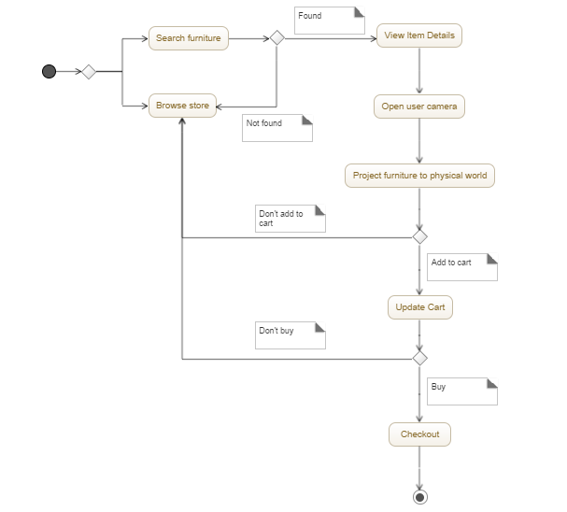

*Figure 1: Conceptual Framework*

**4.2 Analysis and Design**

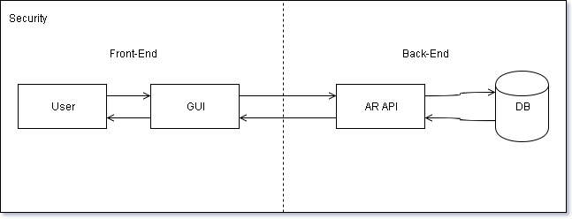

*Figure 2: Analysis and Design*

The User would be able to interact with the application through the GUI (Graphic User Interface) where the GUI would communicate with the back-end modules which starts at AR API (Augmented Reality Application Programming Interface) to be able to use augmented reality processes which then takes necessary data from DB (Database).

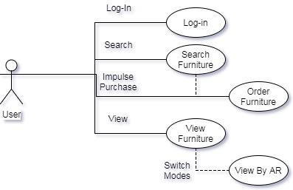

*Figure 3: User Process (Flow Chart)*

The User would be able to Log-in into the personal account to perform Search, View, and Purchase furniture and fixtures desired.

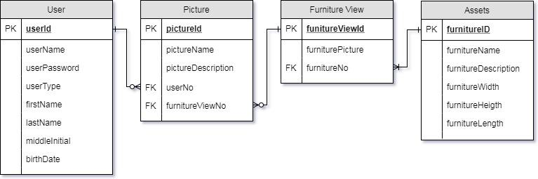

*Figure 4: Entity Relationship Diagram*

This ERD focuses on the minimum viable product of the system.

**4.3 Development Model**

Agile Development uses incremental process models with different iterations of the build until final build has been decided.

Testing

Review

Deployment

Sprint Planning

Development

*Figure 5: Agile Development Cycle*

**4.4 Development Approaches**

Agile Software Development

Modules are divided among the members of the team which regularly perform daily scrum in a given period of time.

Goal

Quality Assurance/Testing

Application Modules/Functionality

Deployment and updates for the application

Achieve the desired quality of the application

Develop necessary modules for the working application

*Figure 6: Bottom-up Model*

**4.5 Software Development Tools**

#### **Table 1: Software Development Tools**

|  |  |  |
| --- | --- | --- |
| Software | Usage | Version |
| Android Studio | This software is the official IDE for Android. It provides the fastest tools for building apps on every type of Android device. It will be used for code editing, debugging, performance tooling, building and deploying the mobile app. | 2.3.3 |
| PAW Server | This software is a web server for Android devices. It will be used to test database connections and perform queries from the mobile app. | 0.97.2 |
| MySQL | This is the relational database management system that will be used by the mobile app. | 5.7 |
| SQL | This is the domain-specific programming language that will be used to create queries that would allow the mobile app to connect to the database and perform transactions. | 2016 |
| Java | This is the object-oriented programming language that will be used in creating the mobile app. | 8 |
| Vuforia | This software is an augmented reality software development kit that will be used to implement the augmented reality features of the mobile app. | 6 |
| Autodesk 3ds Max | This software is a 3D graphics program for making 3D models. It will be used for the 3D modelling of furniture assets that will be utilized in the mobile app. | 2018 |
| 3D-Coat | This software is a 3D graphics program that will be used to paint textures on the furniture assets. | 4.7 |
| Adobe Photoshop | This software is a raster graphics editor. It will be used for creating user interface elements of the mobile app. | CC 2017 |

**4.6 Schedule and Timeline**

Figures 4.6.1 to 4.6.4 presents a Gantt chart of the proponent’s project schedule. The project started on June 13, 2017 and is estimated to end on February 12, 2018. The light blue bars represent the total estimated milestone duration. The dark blue bars represent the duration of each individual sprint that comprises a milestone.

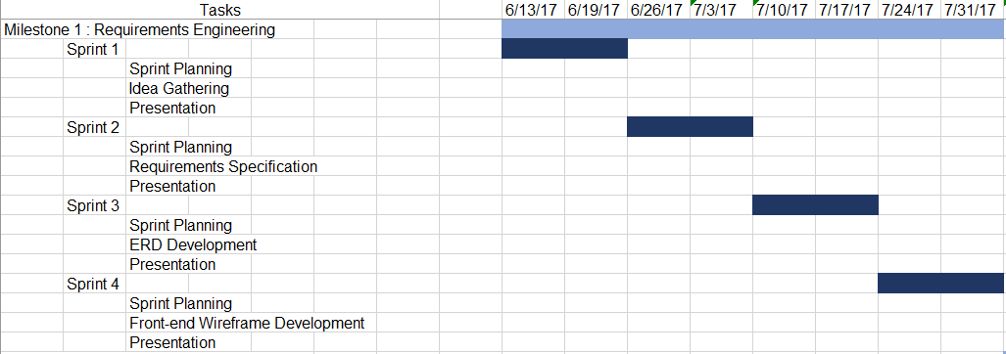

*Figure 7: Project Schedule for Milestone 1*

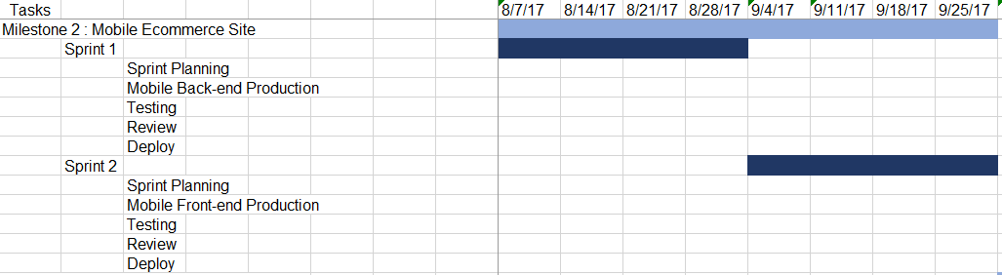

*Figure 8: Project Schedule for Milestone 2*

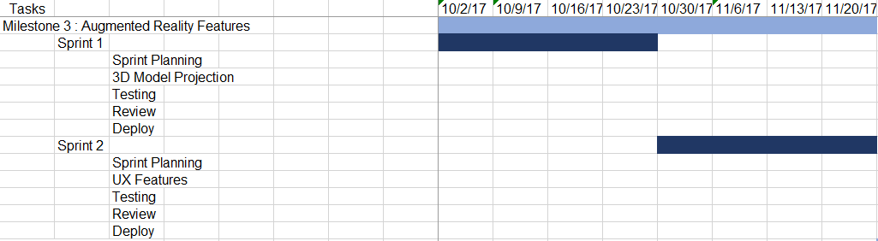

*Figure 9: Project Schedule for Milestone 3*

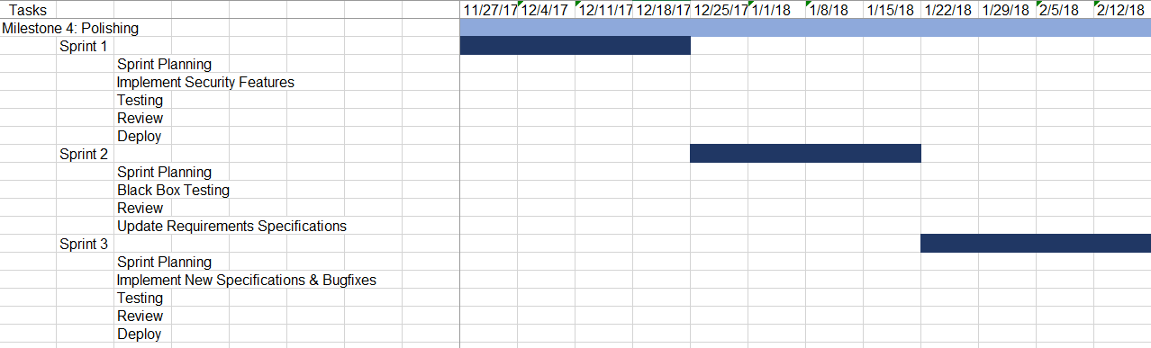

*Figure 10: Project Schedule for Milestone 4*

#### **4.7 Responsibilities**

#### **Table 2: Tasking Table**

|  |  |  |
| --- | --- | --- |
| **Assignee** | **Roles** | **Tasks/Modules** |
| Roald Galano | Back-end and Front-end developer | User module and Augmented Reality module |
| Leonille Christie Lavador | Front-end developer | Graphical User Interface module |
| Jon Miguel Lindo | Back-end developer | Database module and Security module |
| Christian Ted Ochoa | API developer and Back-end developer | Augmented Reality module and Security module |

#### **4.8 Budget and Cost Management**

#### **Table 3: Budget Table**

|  |  |
| --- | --- |
| **Item** | **Cost** |
| Asus x556u Laptop | P 45,000.00 |
| HP Pavilion 14-al106tx Laptop | P 45,000.00 |
| Dell Inspiron 15 7000 Gaming Laptop | P 74,000.00 |
| Dell Inspiron 3437 Laptop | P 20,000.00 |
| Play Store Developer Fee | P 1,250.00 |
| Samsung J7 Prime Mobile Phone | P 13,000.00 |
| Ream of Bond Papers (A4 500 pcs) | P 191.00 |
| Printers for Pre-draft Documentations, Reports and Final Capstone Documents | P 4,000.00 |
|  | **TOTAL: P 202, 441.00** |

#### **4.9 Verification, Validation and Testing**

The proponents of this study aim to utilize validation the techniques and tests commonly used in model verification and validation. A combination of these techniques is generally used. These techniques will be used for verifying and validating the overall model of the system.

Animation: The object’s model’s behavior is displayed visually as the model moves through time. The movements of parts through a live camera during are examined for physical soundness and rationality. The object must be able to move and detect ground for the validation to be successful.

Comparison to Other Models: Various results of the simulation model being validated are compared to results of other accepted models. The object’s movement will be compared to other or real life model animations to compare and contrast the acceptability of its behavior in the system.

Event Validity: The “activity” or occurrences of the simulation model are compared to those of the real events to determine if they are similar. For example, compare the placement of the visual object model to a real object model.

Extreme Condition Tests: The model structure and outputs should be plausible for any extreme and unlikely combination of levels of factors in the system. For example, if there is no visual simulation or camera feed, there should be no visual model placement possible.

The natural flow of the system begins at the home screen where the system’s general look and feel is first introduced. At the bottom of the screen is a button that leads to the log in screen for the user to input their valid credentials in order to utilize the system. In the event of a new or guest user, they will be given the option to select the Sign Up medley which will redirect them to a registration screen. Once the form to be filled up for account information is validated and accepted in the system, the user is then brought to the application’s dashboard. Here, the user may begin using the system’s core functions.

The dashboard screen will contain a search bar as well as a category selection tab for the user to browse for items or products that exist within the system. When a user has selected an item, the application will show the product information screen which contains all relevant information about the item. This includes the product name, product description, price, photos, purchase option and preview option. When a user selects the preview option, the system will connect with the device’s camera and will show the model of the product on the screen. They user will then be able to move around and change the product placement as to view the product in real-time and real-life scenarios for convenience.

Once the user has finished with the preview, they may exit the preview mode by tapping on the “close” button at the upper right which will bring them back to the product information screen.

#### **REFERENCES**

Billinghurst, M. (2002). Augmented reality in education. New horizons for learning, 12.

Bulearca, M., & Tamarjan, D. (2010). Augmented reality: A sustainable marketing tool. Global business and management research: An international journal, 2(2), 237- 252.

Dahne P, Karigiannis JN (2002) Archeoguide: system architecture of a mobile outdoor augmented reality system. Mixed and Augmented Reality, 2002. ISMAR 2002. Proceedings. International Symposium on, vol., no., pp. 263–264, 2002

Djajadiningrat, T., & Lui, P. (2016). Merging Realities: Exploring Meaningful Placement of AR Content . DIS '16 Companion Proceedings of the 2016 ACM Conference Companion Publication on Designing Interactive Systems, 69-72.

Elliott, J. B., Gardner, M., & Alrashidi, M. (2012). Towards a framework for the design of mixed reality immersive education spaces. Proceedings of the 2nd European Immersive Education Summit (EiED’12), 63-76.

Feldman A, Tapia EM, Sadi S, Maes P, Schmandt C (2005) ReachMedia: On-the-move interaction with everyday objects. iswc, pp.52–59, Ninth IEEE International Symposium on Wearable Computers (ISWC‘05), 2005

Fundukian, L. J., editor (2012). Gale Encyclopedia of E-Commerce (2nd ed., Vol. 2). Detroit: Gale, a Cengage Company, 40-41.

Handy AR: Markerless Inspection of Augmented Reality Objects Using Fingertip Tracking. (2007). doi:10.1109/ISWC.2007.4373785

Huang Y, Liu Y, Wang Y (2009) AR-View: and Augmented Reality Device for Digital Reconstruction of Yuangmingyuan”, IEEE International Symposium on Mixed and Augmented Reality

Johnson, L., Levine, A., Smith, R., & Stone, S. (2010). The 2010 Horizon Report. Austin, Texas: The New Media Consortium.

Merrill D, Maes P (2007) Augmenting looking, pointing and reaching gestures to enhance the searching and browsing of physical objects. Proceedings of the 5th International Conference on Pervasive Computing (Pervasive ‘07), Toronto, Canada, May 13–16

Nóbrega, R., & Correia, N. (2011). Design Your Room: Adding Virtual Objects to a Real Indoor Scenario.

Nóbrega, R., & Correia, N. (2012). Magnetic Augmented Reality: Virtual Objects in Your Space.

Oksman, V., Siltanen, S., & Ainasoja, M. (2012). User participation in co-creative services: developing virtual and augmented reality tools for do-it-yourself home design.

Park, J., Kim, S., Park, H., & Woo, W. (2016). "Dreamhouse": NUI-based Photo-realistic AR Authoring System for Interior Design.

Perusquia-Hernandez, M., Kriening, H., Palumbo, C., & Wajda, B. (2014). User- Centered Design of a Lamp Customization Tool.

Peters, R. R., & Karmarkar, A. (2010). U.S. Patent Application No. 12/753,829.

Purdy, T. G., MS, MSM, MTS, & Choi, Y., Ph.D. (2014 ). Enhancing augmented reality for use in product design. CHI EA '14 CHI '14 Extended Abstracts on Human Factors in Computing Systems, 1303-1308 . doi:10.1145/2559206.2581251

Sungkur, R., Panchoo, A., & Bhoyroo, N. (2016) "Augmented reality, the future of contextual mobile learning", Interactive Technology and Smart Education, Vol. 13 Issue: 2, pp.123-146, https://doi.org/10.1108/ITSE-07-2015-0017

Zhang, X., Navab, N., & Liou, S. P. (2000). E-commerce direct marketing using augmented reality. In Multimedia and Expo, 2000. ICME 2000. 2000 IEEE International Conference on (Vol. 1, pp. 88-91). IEEE.

**CURRICULUM VITAE**

**CONTACT INFORMATION** 

Name: Roald C. Galano

Address: USC Dormitories, Nasipit, Talamban, Cebu City, Cebu

Telephone:

Cell Phone: 0925 777 6422

Email: galanoroald@gmail.com

**PERSONAL INFORMATION**

Birthday: September 26, 1997

Religion: Roman Catholic

Civil Status: Single

**EDUCATION**

University of San Carlos

Bachelor of Science in Information Technology

Tertiary Level (2014 – Present)

Bohol Wisdom School

Secondary Level (2010 – 2014)

Bohol Wisdom School

Primary Level (2004 – 2010)  
  
**TECHNICAL SKILLS**

* Programming
  + C, Java – Console Applications, Window Applications
  + HTML/CSS/PHP/Javascript – Website Front-end, Website Back-end, Database
* Media
  + Adobe Photoshop
  + Adobe Premiere Pro
* Office Applications
  + Microsoft Word
  + Microsoft Excel
  + Microsoft Powerpoint

**WORK EXPERIENCE**

**TRAININGS**

**CONTACT INFORMATION** 

Name: Leonille Christie A. Lavador

Address: G1-09A Tabay, Tayud, Lilo-an, Cebu

Telephone: 424 - 5714

Cell Phone: +63 943 550 1586

Email: leonillechristie@gmail.com

**PERSONAL INFORMATION**

Birthday: December 27, 1997

Religion: Roman Catholic

Civil Status: Single

**EDUCATION**

University of San Carlos

*Bachelor of Science in Information Technology*

Nasipit, Talamban,Cebu City

2014 – Present

Mandaue City Science High School

Ibabao Estancia, Mandaue City, Cebu

2010 - 2014

Sotero B. Cabahug FORUM for Literacy

Pulpogan, Tolotolo, Consolacion, Cebu  
2005 - 2010

**TECHNICAL SKILLS**

* Programming
  + C, Java – Window Applications, Mobile Applications
  + HTML5, CSS3, PHP, Javascript, JQuery, Ruby on Rails, WordPress – Web Applications
  + C# - Game Development
  + SQL - Database
* Multimedia
  + Adobe Photoshop
  + Adobe Premiere
  + Adobe Lightroom
  + Adobe Illustrator
  + Adobe After Effects
  + Sony Vegas

**WORK EXPERIENCE**

Digital Artist (Video and Photo Editor)  
 Freelance  
 March 2017 – July 2017

High School Student Tutor  
 Math Academy  
 August 2015 – September 2015

Elementary School Tutor  
 Maranatha Christian School  
 March 2015 – June 2015

**TRAININGS**

On the Job Trainee  
 Rococo Global Technologies Corporation  
 April 2017 – Present

**CONTACT INFORMATION** 

Name: Jon Miguel J. Lindo

Address: 35 M. Velez St., Capitol, Cebu City

Telephone: 263-0693

Cell Phone: 0925 546 9151

Email: [jon2xlindo@gmail.com](mailto:jon2xlindo@gmail.com)

**PERSONAL INFORMATION**

Birthday: December 3, 1997

Religion: Roman Catholic

Civil Status: Single

**EDUCATION**

University of San Carlos

*Bachelor of Science in Information Technology*

Nasipit, Talamban,Cebu City

2014 – Present

Colegio de la Inmaculada Concepcion

45 Gorordo Ave. Cebu City

2004 – 2014

Immanuel Bible College

R. Duterte St., Banawa Hills, Cebu City

2002 – 2004

**TECHNICAL SKILLS**

* Programming/Markup Language
  + C, Java – Console Applications, Window Applications
  + HTML/CSS/PHP, Javascript – Website Front-end, Website Back-end, Database
* Media
  + Adobe Photoshop
* Office Applications
  + Microsoft Word
  + Microsoft Excel
  + Microsoft Powerpoint

**WORK EXPERIENCE**

**TRAININGS**

**CONTACT INFORMATION** 

Name: Christian Ted R. Ochoa

Address: Green Valley Subdivision, Casili, Consolacion, Cebu

Telephone: 423-9347

Cell Phone: 09172064946

Email: christianted.ochoa@gmail.com

**PERSONAL INFORMATION**

Birthday: November 18, 1997

Religion: Roman Catholic

Civil Status: Single

**EDUCATION**

University of San Carlos

*Bachelor of Science in Information Technology*

Nasipit, Talamban,Cebu City

2014 – Present

Saint Louis College - Cebu

Sudlon, Maguikay, Mandaue City, Cebu

2010 - 2014

Saint Louis College - Cebu

Sudlon, Maguikay, Mandaue City, Cebu

2005 - 2010

**TECHNICAL SKILLS**

* Programming
  + C, Java – Console Applications, Window Applications, Mobile Applications
  + HTML, CSS, PHP, Javascript, JQuery, Ruby – Website Front-end, Website Back-end
  + SQL - Database
  + C# - Game Development
* Media
  + Adobe Photoshop
  + Adobe Premiere Pro
  + Adobe After Effects
  + Adobe InDesign
  + 3ds Max
  + 3D Coat
  + Unity3D
  + Zbrush
  + Keyshot
  + Realflow

**WORK EXPERIENCE**

**TRAININGS**

**Appendix A TRANSMITTAL LETTER**

August 03, 2017

Giovanni Boschi

Branch Manager, Giardini del Sole Mandaue

GIARDINI DEL SOLE MANUFACTURING & TRADING CORP.

Dear Mr. Boschi,

Greetings!

May we request from you the permission to gather information from you and the rest of the staff of Giardini del Sole for our research study entitled “InteriAR: An Augmented Reality Application for Online Furniture Purveyors".

The above research study is a requirement for the completion of the degree in Bachelor in Science in Information Technology in the University of San Carlos. I am confident that the result of the study would be useful and helpful in the betterment of the community.

Thank you very much. I am looking for your positive response.

Respectfully yours,

Roald C. Galano

Leonille Christie A. Lavador

Jon Miguel J. Lindo

Christian Ted R. Ochoa

BSIT Students, University of San Carlos

Endorsed by:

Mary Jane G. Sabellano

Thesis Adviser

**APPENDIX B INTERVIEW GUIDE**

**APPENDIX C QUESTIONNAIRE**

1. What is the platform of choice for posting your products online?
2. What are the kinds of product you sell online?
3. What are the some of the challenges you have encountered upon trying to sell your products online?
4. What are the common suggestions for improvement with respect for your current online venture?
5. Do you prefer to improve your current online venture?