# 

# Negated Sound Analysis-Synthesis

Ted Apel

Boise State University, Boise, Idaho, USA

tedapel@boisestate.edu

**Abstract.** This paper investigates the role of erasure and negation in a novel speculative synthesis method termed "negated sound." Beginning with an overview of artistic works incorporating negation and erasure, the paper emphasizes themes influencing the development of the negated sound method presented here. The study presents the technical procedures of the negated sound method and discuss examples of its creative output.

**Keywords:** negated sound, sound analysis, sound synthesis.

## 1 Introduction

In his presentation on the history of digital synthesis, Julius Smith III says that “the promise of computer music was that the computer is capable of generating any sound that could ever come from a loudspeaker” (Smith 1991). Fulfilling this promise appears to have been limited by sound synthesis methods that are modelled on preexisting musical parameterizations. That is, producing sound that is subject to the musical parameterization of traditional musical practices. Dispite musique concrète's aim of liberating practitioners from “preconceived sound abstractions”, computer music largely remains content with expanding the range of existing musical values. One way of countering this tendency can be found inLejaren Hiller’s discussion of the very first piece of computer music, *Illiac Suite:* “These pieces are truly experimental because they are concerned with revealing processes as well as being final product. They are embodiments of objective research results” (Moore. 1996). By making computational processes perceptible, Hiller is combating the inscription of preexisting musical structures. Sound synthesis in *Illiac Suite* is a form of experiment that has musical and research results.

In this context, the speculative sound synthesis system presented here is conceived of as an algorithm that produces conceptual musical works, much as a score is an algorithm for a realization of a work, the algorithm itself is used to transform sounds into a specific work. Central to this system is the concept of erasure and negation of sound as a conceptual musical process. The specific artistic technique involving the phase vocoder spectral representation of sound is used to create conceptually negated sounds that are heard as individual works. We will first review works of art, both sonic and visual, involving erasure and negation with the emphasis on themes and ideas that have influences the conception of this analysis-synthesis system. Then the technical procedures of the algorithm itself will be presented followed by illustrative examples showing the creative potential.

### 2 Background

In 1953 Robert Rauschenberg persuaded Willem de Kooning to give him one of his drawings. Rauschenberg spent one month, and forty erasers erasing the drawing and claimed the finished erasure as his own original artwork. This work appears as a paper which is covered with smudges created by an eraser. Art critic Calvin Tomkins discusses this work as a symbolic destruction of a leading artist father figure by a younger artist (Galpin 1998). However, Rauschenberg maintained that the work simply was intended to determine “whether a drawing could be made out of erasing” (Breslin 1993). Yet Rauschenberg found his prior attempts at erasing his own works of art to be unsatisfactory compared to the completed *Erased de Kooning Drawing*. Rauschenberg's drawing points out that the marks left after an erasure tend to paradoxically highlight the original missing object. This heightened attention to the un-erased original makes the object of erasure significant to the success of works of art involving erasure. The choice of object of erasure is of paramount importance to the success of erasure-based works of art. As we will see, this heightened attention to the object of negation is a common theme of negation-based artworks**.**

The artistic use of erasure has been a subject of interest with the increase in digital photographic editing capability. Lev Manovich argues that the advent of digital manipulation of photographs has not caused a fundamental shift in the way we perceive photographic reality (Manovich 2003). He instead suggests that digital photographic manipulation is part of a tradition of artistic and cultural manipulations of images that has existed long before digital techniques. As an example of this image making tradition Manovich cites Soviet era political photographs in which people have been removed as examples of this image making tradition. The relative ease of digital manipulation techniques has nevertheless allowed photographic artists to create works whose artistic content is based primarily on the removal of parts of a photographic image or objects within the image.

### 2.1 Erasure Based Music and Sound Art

John Cage's well known silent piece *4' 33"* was preceded three years earlier by an unrealized electronic work he proposed in 1948. He proposed the concept of a piece called *Silent Prayer* in his article “A Composer's Confessions” as

...to compose a piece of uninterrupted silence and sell it to the Muzak Co. It will be 4 1/2 minutes long - these being the standard lengths of "canned" music, and its title will be "Silent Prayer." It will open with a single idea which I will attempt to make as seductive as the color and shape or fragrance of a flower. The ending will approach imperceptibility. (Pritchett 1993)

Although this piece is usually understood in the context of Cage's developing ideas about musical silence (Pritchett 1993)(Kahn 1999), we can also think of *Silent Prayer* as an erasure of the Muzak that would otherwise have been played in retail and public spaces. Looking at this piece in relation to the idea that erasure and negation-based works of art are significant in relation to the objects of erasure, the silence of *Silent Prayer* can be understood as a simple condemnation of the ubiquitous presence of particular types of recorded music in retail and public spaces. It appears that Cage's notion that silencing creates an aural space for listening to sounds that would otherwise be obscured is not yet present in *Silent Prayer*.

In 1996, the artist Jeremy Millar, while attempting to copy an audio tape of an interview he had conducted with the novelist J. G. Ballard, instead accidentally erased the master tape (Dillon 2006). Millar now plays this erased tape as an artwork. With close listening one can perceive that something had been recorded on the tape but is now inaccessible. The meaning of the erased silence of the Millar tape is different from that in Cage's *Silent Prayer*. Whereas Cage intended an erasure of the unwanted Muzak, Millar intends an attentive and regretful listening to the static byproduct of the unintended erasure. We are left concentrating on the Ballard interview despite its absence.

Matt Rogalsky's composition *S*, (2002) is a 24 CD set of “silences” created by editing out the words of 24 consecutive hours of a BBC 4 radio broadcast (LaBelle 2006). Each CD contains the electronically compiled “harvest” of the sounds of the gaps between the words from a single hour of radio broadcast. Unlike the Millar interview, which draws attention to the audio material that is missing, Rogalsky's erasure brings out the meaningful qualities of the sonic detritus that is left un-erased. Referring to a later work of Rogalsky that uses the same technique, Jan Allen suggests that “the silences might signal hesitation; more often they stage emphasis. [the silences are] the zone in which what is suppressed or unsaid may be apprehended” (Allen 2005). Rogalsky's silences are understood here as linguistically rich sources of unspoken semantic content made prominent through their juxtaposition.

## 3 Towards a Negated Sound

The previous sections have shown that erasure can be a significant artistic technique in contemporary visual and aural arts. The impulse toward negation in arts does not always take the form of erasure. Sonic musical negation has evolved from a metaphorical or emotional negation, as in Cage's *Silent Prayer*, to the electronically mediated acoustic negations of Millar, Rogalsky, and the negation-based sound works presented here.

Surprisingly, musical theorists have speculated on what the nature of a negated sound might be. For over a hundred years. J. A. Fuller Maitland in his 1893 article *The Music of Negation*, points out that one of music's expressive shortcoming's is its inability to ``bring before us the absence of certain features; it can tell us what the heroine of an opera is feeling, but it is powerless to suggest what she is not going through''(Maitland 1893). Here Maitland does not propose a sound that could negate its effect on a listener but points out this shortcoming of the musical language.

In 1922, Alexander Brent-Smith explained this shortcoming as a lack of a sound that signals the negative in its presence (Brent-Smith 1922). He presents the example of setting to music a poem by Elroy Flecker: “Mute is battle's brazen horn, that rang for Priest and King.” Brent-Smith states that ``if [the composer] does not somehow suggest the horn the thought is incomplete, and if he as much as suggests a horn the thought is incorrect.” He concludes that “not until music has discovered one single sound that shall negative [sic] its assertions” will this type of musical dilemma be solved. Presumably when it is found, this single negative sound would be played before, concurrently, or after the sounds that suggest horns in the composition. I believe Brent-Smith’s suggestion of a sound which can negate its own evocative qualities or those of another sound is the first such speculation on the potential existence of an actual negated sound.

In 1974, Frederick Taylor posited a system of musical logic that could make more apparent what “can be meaningfully examined and criticized” in a musical composition (Taylor 1974). Peter Gibbins argues against Taylor's system of musical logic as a method of increasing our understanding of musical structure, pointing out that one of the shortcomings of Taylor's system is its lack of a concept of negation, and that mathematical negation is a key element in any system of logic (Gibbins 1976). Gibbins, like Brent-Smith above, acknowledges the difficulty of conceiving of a negated sound that would exist in a system of musical logic:

It is difficult to see what the negation of a sound segment could be, for it would have to be some other sound segment. If we argue that consistency is the primitive notion and that a negation of a sound-segment is a second sound-segment inconsistent with the first, we are led to the result that y may be a negation of x while x may not be a negation of y. A “negation” with this property is at best a peculiar sort of negation. For a sound-segment may have two “negations” which are also “negations” of one another.

Gibbins clearly gives serious consideration to the idea that a negated sound could exist as a sonic phenomenon and not just as a byproduct of musical notation manipulations. While it may be unclear what sonic “consistency” might be to Gibbins, his idea that a sound may have multiple negations is relevant to our understanding of the erasure-based sound works of Cage, Millar, and Rogalsky, as well as to the negated music concept presented below.

Stan Link discusses many possible meanings and functions of musical silence in his essay *Much Ado about Nothing* (Link 1995). One of these meanings is that musical silence signifies absence or nothingness. Link states “quietness evokes nothingness as pointedly as human perception might allow.” Later, Link wonders if silence is the “only token of negation in musical contexts.” He also asks, “can negation involve sound as well as silence?” Link, like Brent-Smith and Gibbins, does not provide a recipe for producing a negated sound, but does suggest that the function of such a sound would be to “make us notice nothing,” that is, a sound “which is blank regarding cognitive content -- mute at its core.” Unlike Brent-Smith's negated sound which would evoke the opposite of the meaning of the sound, or Gibbin's negated sound which would complete a system of musical logic, Link's negated sound would, like musical silence, evoke the idea of absence or nothingness.

Sound perception researchers have generally approached acoustic silence as a cognitively blank space between objects of perceptual interest. However, there is interesting evidence that amplitude drops and silences are heard as perceptually salient objects of perception. Kabovy performed experiments with a pitch segregation phenomenon in which differing tones were removed from a chordal complex in a sequence (Kabovy 1976). “On listening to this chord, subjects perceived a melody that corresponded to the order in which the amplitude drops occurred. (Deutsch 1999). Although the qualities of this (negated) melody have not been studied, its presence indicates that a method of negating sounds based on removing spectral components of a sound is not perceptually unfounded.

Recent research by Goh et al. suggest that silences are literally perceived not as a failure to perceive sound but as a successful perception of silence (Goh et al. 2023). They perform seven studies in which established auditory illusions are modified to use silences instead of sounds. In all cases they found that these illusions existed with silences in the place of sounds, suggesting an auditory processing of these silences similar to that of sounds. This study further motivates my speculative synthesis method in that it suggests that any sound produced by removing spectral components, including silence, will not be taken as a cognitively blank space between sounds, but perceived with the same auditory mechanisms that we employ for sound.

My intention with the following sound works is to create a sonic realization of these ideas about how a negated sound might have meaning by creating my own speculative synthesis technique for producing negated sounds. While the negated sounds in each work may not achieve these specific goals of the authors discussed above, they provide a material instantiation of a negated sound which can be used for further speculation on the nature of negated sound.

## 4 Negation Algorithm

The sound negation algorithm presented here is based on analyzing the spectral components of an audio recording, manipulating the spectral representation, and synthesizing a new sound that represents the negation of that sound. Time-varying spectral components of sound are removed from a droning wash of spectral components. This wash of sound which represents the “ground” of sound is composed of all the spectral components that exist during the entire duration of the recorded sound. The algorithm can be performed on any length of recorded sound, however, typically this algorithm is applied to recorded sounds that vary in length from 30 seconds to 2 minutes.

### 4.1 The Sonic Ground

The first step of the negated sound algorithm is to create a sonic “ground” with which the negated sonic “figures” can be heard. This sonic ground consists of a droning sound whose frequency component amplitudes are in direct proportion to the presence of those frequencies during the entire recorded sound. This sound is created using the LTDFT method of Øyvind Hammer and Henrik Sundt in which a single Fourier Transform is performed over long durations of a time-varying sound (Hammer and Sundt 1999). Unlike the phase vocoder representation of sound as amplitude and frequency spectra which localize sonic events in time, the LTDFT does not encode time in a perceptually relevant manner.

The LTDFT is performed on the entire sound and the resulting single (long) phase spectrum is randomized. By combining this new phase spectrum with the original magnitude spectrum and calculating the inverse LTDFT, a new time-domain sound is created that has none of the time-evolution of the original sound but exhibits an undulating sonic texture whose frequencies mirror the total frequency content of the original recording. This undulation comes from the beating of spectral components whose phases were made incoherent. The undulating quality of this texture created from this process is why this technique is employed rather than a similar yet sonically more static process of averaging the amplitude spectra and randomizing the phase of a phase vocoder analysis of the recording.

### 4.2 The Negated Sound

The next step in calculating the negated sound involves subtracting the time-evolving sonic “figure” from this droning ground. This is performed in the spectral domain using a traditional phase vocoder representation of sound. Both the original sound recording and the droning ground sound are both separately analyzed with a phase vocoder. The amplitude spectrum of each Short-Time Fourier Transform (STFT) frame of the original is then subtracted from the STFT amplitude spectrum of the averaged sound to generate a new set of STFT amplitude spectra. This subtraction is the essence of the algorithm in that it is aims to remove the spectral content of each sound as it occurs in time. This absence is perceptible only in a sonic ground that included these frequencies. Finally, the new amplitude spectra are combined with the original phase spectra and transformed via the ISTFT back to the time domain. The result is typically a droning sound punctuated by removals of sound events that occurred in the original recordings. Fig. 1 shows the entire negated sound analysis synthesis method. Where x(n) is the source sound, LTDFT is the Long-Term Discrete Fourier Transform, PV analysis denotes the Phase Vocoder analysis, and y(n) is the resultant negated sound.

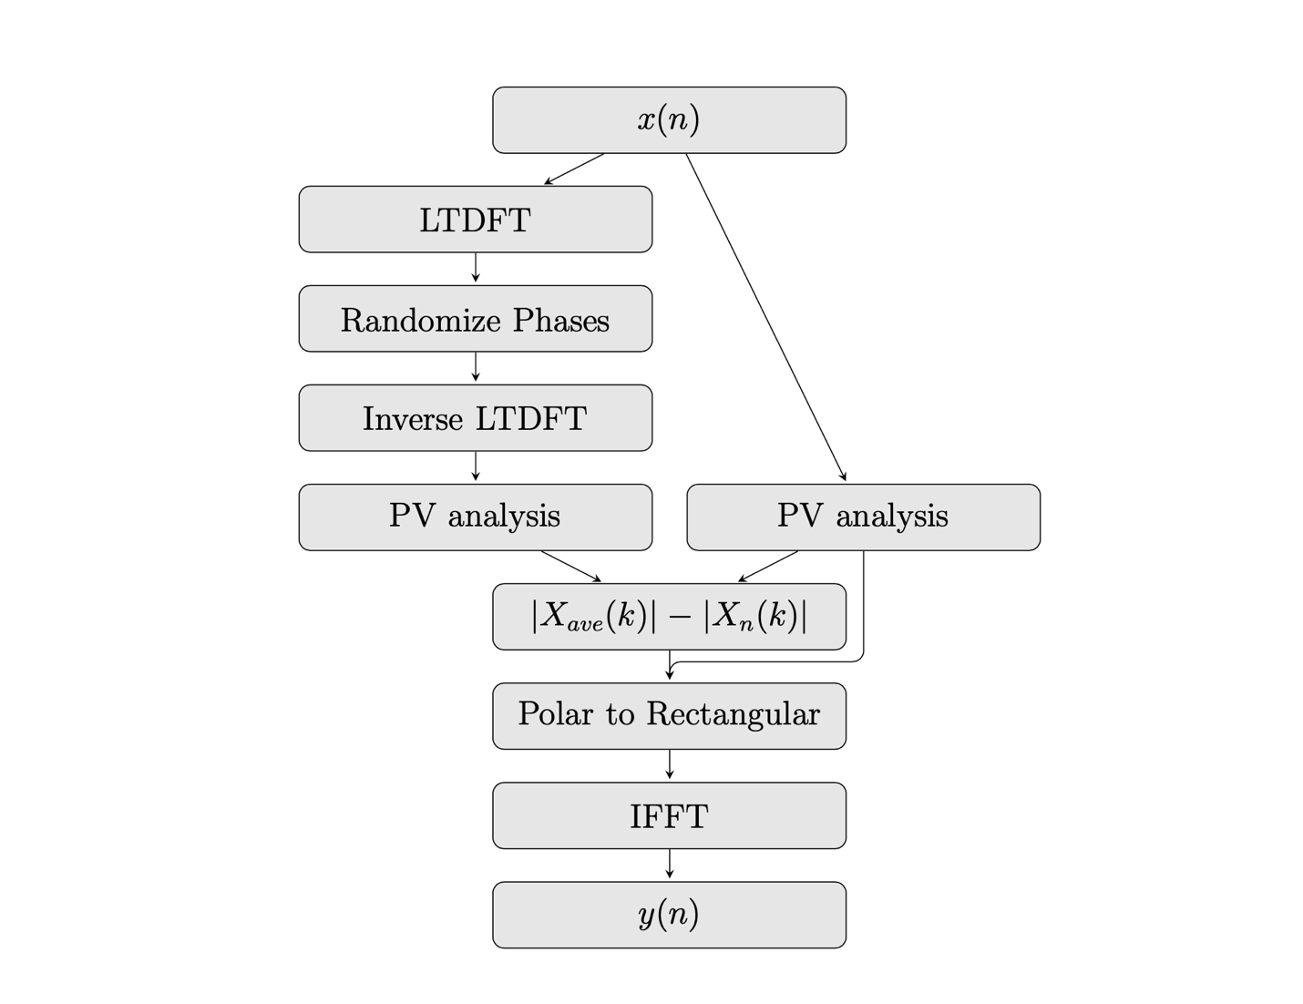

#### **Fig. 1.** Negated Sound Analysis-Synthesis method

## 5 Negation Based Sound Works

I consider the use of this algorithm not as an audio effect that can be used to create novel sound textures in an electroacoustic music context, but rather as a conceptual sound art piece in which the algorithm is the score. Each use of the algorithm creates a new piece that explores this specific notion of negated sound with the analyzed sound. The meaning of the sound produced is contingent on understanding the specific conception of negated sound presented here.

One way of using the algorithm involves presenting the negated sound with a video of the sound producing event. This juxtaposition of image and negated sound allows the viewer/listener to understand the source of the sound in a sonic context that may not clearly support causal listening with sound alone. I will discuss here three of these that illustrate aspects of negated sound. Each video is between 40 seconds and 1 minute 20 seconds in duration, and each consists of a single continuous shot in which a sonic event is accompanied by a soundtrack created using the negated music process.

The *Breaking Glass* video (Fig. 2) is a good introduction to the sonic nature of the negated music process. This video depicts a floor for 22 seconds followed by a wine glass breaking on it. This is the only perceptible sonic event that happens in the original video. The negated music process produces a sound that is continuous throughout the entire video and contains all the spectral components of the glass break sound. When the glass breaks, this sound is subtracted from the averaged sound to quiet the sound during the break. This video and soundtrack clearly show the inverse nature of the negating process.

#### **Fig. 2.** shows one frame of the Glass Break video.

The *Clarinet* video (Fig 3) exhibits other aspects of the process. In this video a single E flat tone is held for an entire breath, there is a brief pause, followed by another E flat held tone. During these tones, the player was purposely tuning the note sharp and flat at different times. After processing, the tone can be heard as a quiet high frequency sound during the original note's times, and as a tone much like the original clarinet E Flat during the breath rest in the middle. This again shows the inverse relationship to traditional sound production that exists with this technique.

#### **Fig. 3.** shows one frame of the Clarinet video.

The *Toy Piano* video (Fig. 4) shows the inside mechanism of a toy piano music box that is playing. Here we can hear the individual negated notes as we see them struck in the piano mechanism. This process results in a ghostly impression of the original melody with the original rhythm largely intact.

#### **Fig. 4.** shows one frame of the Toy Piano video.

## 5 Conclusion

​The negated sound process presented here produces pieces of musical conceptual art, as opposed to a musical composition. As such, it is also intended to reference the ideas of negation in twentieth century art and music more broadly than our discussions of musical negation presented here. Many twentieth century art movements can be seen as negations: abstract art's negation of the figure, conceptual art's negation of the art object, minimalism's negation of self-expression, and musical minimalism's negation of musical development. I hope sounds produced by the negation algorithm presented here can be used as both an example of speculative synthesis and as an example of how negated sound could function in music and other sonic arts.

## References

**Allen, J.** 2005. “Speaking through silence: thoughts on the limits of articulation and the nature of curatorial authority.” In *Unspoken Assumptions: Visual Art Curators in Context*, 1–6. Ontario Association of Art Galleries.

**Brent-Smith, Alexander.** 1922. “The negative in music.” In *The Musical Times*, 63(958), 839–840.

**Breslin, James.** 1993. *Mark Rothko: A Biography.* Chicago: University of Chicago Press.

**Deutsch, Diana.** 1999. “Grouping mechanisms in music.” In *The psychology of music*, pp. 299-348. Academic Press.

**Dillon, Brian.** 2006. “The revelation of erasure.” In *Tate Etc*., 8.

**Galpin, Richard.** 1998. Erasure in Art: Destruction, Deconstruction, and Palimpsest. *website*.

**Gibbins, Peter.** 1976. “Logics as models of music.” In *The British Journal of Aesthetics*, 16(2).

**Goh, Rui Zhe, Ian B. Phillips, and Chaz Firestone.** 2023. “The perception of silence.” In *Proceedings of the National Academy of Sciences* 120, no. 29.

**Hammer, Øyvind, and Henrik Sundt.** 1999. "Musical applications of decomposition with global support." In *Proceedings of the 2nd COST-G6 Workshop on Digital Audio Effects (DAFx99), Trondheim, Norway, December 9*, vol. 11.

**Kahn, Douglas.** 1999. *Noise, Water, Meat: A History of Sound in the Arts*. Cambridge MA: MIT Press.

**Kubovy, Michael.** 1976. “The sound of silence: A new pitch segregation phenomenon.” In *The 17th Annual Meeting of the Psychonomic Society*, St. Louis.

**LaBelle, Brandon.** 2006. *Background noise: perspectives on sound art*. Continuum International.

**Link, Stan.** 1995. "Much ado about nothing." *Perspectives of New Music*.

**Maitland, J. A. F.** 1893. “The music of negation.” in *The Musical Times and Singing Class Circular*, 34(602).

**Manovich, Lev.** 2003. “The paradoxes of digital photography.” In *The Photography Reader*, editor L. Wells. Routledge.

**Moore, F. Richard.** 1996. “Dreams of Computer Music: Then and Now”. In *Computer Music Journal*, Vol. 20, No. 1.

**Pritchett, James.** 1993. *The Music of John Cage.* Cambridge: Cambridge University Press.

**Smith III, Julius O.** 1991. “Viewpoints on the history of digital synthesis.” In *Proceedings of the International Computer Music Conference*.

**Taylor, Frederick.** 1974. “Music and its logic.” In “*The British Journal of Aesthetics*, 14.