DATA7202 : Assessment 3

Name : Peng Yu

Student ID : 46635884

Question 1

Answer:

Decision tree leads to different results according to different $x_{i}$ and $y_{i}$, so the decision tree model is easy to overfit. Assume that when the first node is $x_{1}$, the result is $y_{1}$; if not, the depth of the tree is increased, and determine whether to $x_{2}$, if it is, the result is $y_{2}$, if not, to increase the depth of the tree again, and so on., when the depth of the decision tree is equal to the sample size of the training set, any training set can be fitted via a tree with zero training loss.

Question 2

Answer:

Suppose there is a c that minimizes the squared-error loss.

Then $\sum_{i=1}^{k}{{(y_{i}-c)}^{2} = \sum_{i=1}^{k}{(y_{i}^{2}-2cy_{i}+c^{2})}}$

$=nc^{2}-2c\sum_{i=1}^{k}{y_{i}+\sum_{i=1}^{k}{y_{i}^{2}}}$

The transformed expression can be equivalent to a quadratic equation of c of one variable, which is the minimum value for $c=-\frac{-2\sum_{i=1}^{k}{y_{i}}}{2n}=n^{-1}\sum_{i=1}^{,n}{y_{i}=h^{w}(x)}$.

Therefore $h^{w}(x)$ is minimizes the squared-error loss.

Question 3

Answer:

First there are 3 blue and 2 red data points in a certain tree region.

Then $P_{b} = \frac{3}{5}$, $P_{r} = \frac{2}{5}$.

Misclassification impurity:

$$Misclassification\left(t\right)= 1 - maxP\left(i | t\right)= 1- \frac{3}{5} = \frac{2}{5}$$

Gini impurity:

$$Gini\left(z\right)= \frac{1}{2}\left(1-\sum_{z=0}^{c-1}{P_{z}^{2}}\right)= \frac{1}{2}*(1-(({\frac{3}{5})}^{2}+{(\frac{2}{5})}^{2})) = \frac{6}{25}$$

Entropy impurity:

$$Entropy\left(z\right)= -\sum_{z=0}^{c-1}{P_{z}\log_{2}\left(P_{z}\right)= -\left(\frac{3}{5}{*log}_{2}\left(\frac{3}{5}\right)+\frac{2}{5}*\log_{2}\left(\frac{2}{5}\right)\right)=0.97095}$$

Second for 2 blue and 3 red data points.

$$P_{b}=\frac{2}{5} , P_{r}=\frac{3}{5}$$

Misclassification impurity:

$$Misclassification\left(t\right)= 1 - maxP\left(i | t\right)= 1- \frac{3}{5} = \frac{2}{5}$$

Gini impurity:

$$Gini\left(z\right)= \frac{1}{2}\left(1-\sum_{z=0}^{c-1}{P_{z}^{2}}\right)= \frac{1}{2}*(1-(({\frac{2}{5})}^{2}+{(\frac{3}{5})}^{2})) = \frac{6}{25}$$

Entropy impurity:

$$Entropy\left(z\right)= -\sum_{z=0}^{c-1}{P_{z}\log_{2}\left(P_{z}\right)= -\left(\frac{2}{5}{*log}_{2}\left(\frac{2}{5}\right)+\frac{3}{5}*\log_{2}\left(\frac{3}{5}\right)\right)=0.97095}$$

In summary, the results of “3 blue and 2 red” and “2 blue and 3 red” are the same.

Question 4

Answer:

Suppose p is that $τ^{*}$ contains a fraction of the points from $τ.$

When n = 2, $p=\frac{1}{2}+\frac{2-1}{2}*\frac{1}{2}$

When n = 3, $p=\frac{1}{3}+\frac{3-1}{3}*\frac{1}{3}+{\left(\frac{3-1}{3}\right)}^{2}*\frac{1}{3}$

When n = 4, $p=\frac{1}{4}+\frac{4-1}{4}*\frac{1}{4}+{\left(\frac{4-1}{4}\right)}^{2}*\frac{1}{4}+{\left(\frac{4-1}{4}\right)}^{3}*\frac{1}{4}$

When n = 5, $p=\frac{1}{5}+\frac{5-1}{5}*\frac{1}{5}+{\left(\frac{5-1}{5}\right)}^{2}*\frac{1}{5}+{\left(\frac{5-1}{5}\right)}^{3}*\frac{1}{5}+{\left(\frac{5-1}{5}\right)}^{4}*\frac{1}{5}$

$…$

Therefore when n = n

$$p =\frac{1}{n}+{\frac{1}{n}\left(\frac{n-1}{n}\right)}^{1}+{\frac{1}{n}\left(\frac{n-1}{n}\right)}^{2}+\frac{1}{n}{\left(\frac{n-1}{n}\right)}^{3}+…+\frac{1}{n}{\left(\frac{n-1}{n}\right)}^{n-1}$$

$=\frac{1}{n}\left({\left(\frac{n-1}{n}\right)}^{0}+{\left(\frac{n-1}{n}\right)}^{1}+{\left(\frac{n-1}{n}\right)}^{2}+{\left(\frac{n-1}{n}\right)}^{3}+…+{\left(\frac{n-1}{n}\right)}^{n-1}\right)$

$=\frac{1}{n}*\frac{{\left(\frac{n-1}{n}\right)}^{0}*\left(1-{\left(\frac{n-1}{n}\right)}^{n}\right)}{1-\frac{n-1}{n}}$

$=1-{\left(1-\frac{1}{n}\right)}^{n}$

Therefore, (1 - p) is that $τ^{*}$ does not contain a fraction of the points from $τ.$

When n is large

$$\lim_{n→∞}{1-p}=\lim_{n→∞}{1-\left({1-\left(1-\frac{1}{n}\right)}^{n}\right)}$$

$=\lim_{n→∞}{{\left(1-\frac{1}{n}\right)}^{n}}$

$=\lim_{n→∞}{{\left(\frac{1}{1+\frac{1}{n-1}}\right)}^{n}}$

$=\lim_{n→∞}{\frac{1}{{\left(1+\frac{1}{n-1}\right)}^{n-1}}\left(\frac{1}{1+\frac{1}{n-1}}\right)}=\frac{1}{e}*1=e^{-1}≈0.37$

From what has been discussed above that for large n, $τ^{*}$ does not contain a fraction of about $e^{-1}≈0.37$ of the points from $τ.$

Question 5

Answer:

The optimal parameter m is 9. R^2 score = 0.8113597391961835.

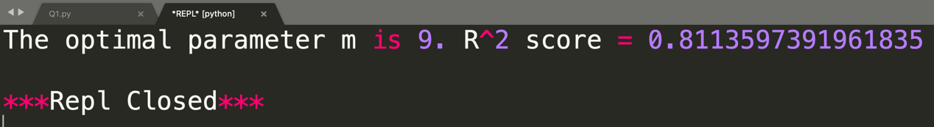

Question 6

Answer:

As can be seen from the figure below, the smaller a is, the faster the slope of decreases with the increase of B. When the range of B is 0 to 20, the curve drops the fastest. When B is greater than 100, all the curves approach 0.

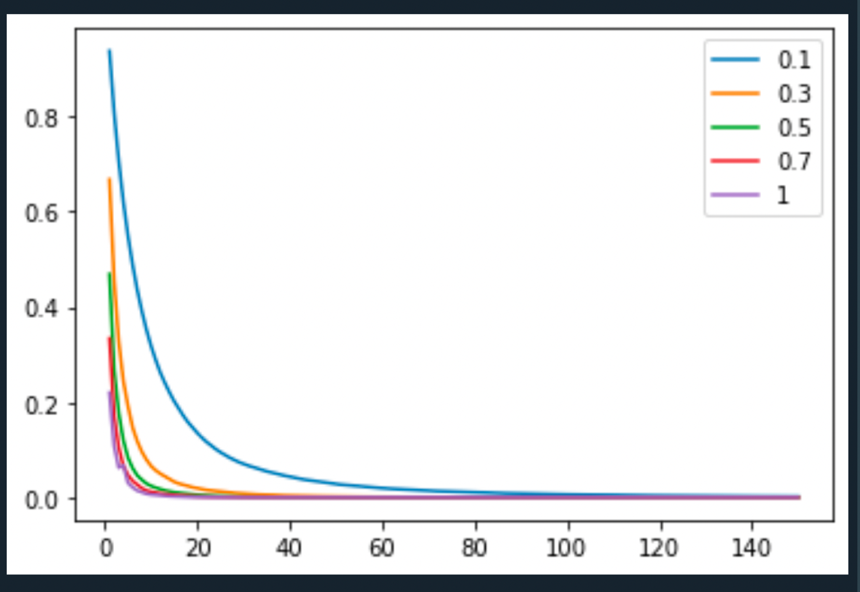

**Code Appendix**

**Question 5**

import numpy as np

from sklearn.datasets import make_friedman1

from sklearn.ensemble import RandomForestRegressor

from sklearn.model_selection import train_test_split

from sklearn.metrics import r2_score

# create regression problem

n_points = 1000 # points

scores=[]

x, y = make_friedman1(n_samples=n_points, n_features=15,

noise=1.0, random_state=100)

# split to train/test set

x_train, x_test, y_train, y_test = \

train_test_split(x, y, test_size=0.33, random_state=100)

#Answer:

for i in np.arange(1,15):

rf = RandomForestRegressor(n_estimators=1000, oob_score = True, max_features=i, random_state=100)

rf.fit(x_train,y_train)

yhatrf = rf.predict(x_test)

scores.append(r2_score(y_test, yhatrf))

print('m='+str(i)+'. r2='+str(scores[i-1]))

print('The optimal parameter m is '+ str(scores.index(max(scores))+1) + ". R^2 score = "+ str(max(scores)))

**Question 6**

from sklearn.datasets import make_blobs

from sklearn.metrics import zero_one_loss

from sklearn.model_selection import train_test_split

import numpy as np

import matplotlib.pyplot as plt

from sklearn.ensemble import GradientBoostingClassifier

X_train, y_train = make_blobs(n_samples=1000, n_features=10, centers=3, random_state=10, cluster_std=5)

#Answer:

gammas = [0.1, 0.3, 0.5, 0.7, 1]

for gamma in gammas:

GBC = GradientBoostingClassifier(learning_rate=gamma, n_estimators = 150)

GBC.fit(X_train, y_train)

plt.plot(np.arange(1,151,1), GBC.train_score_, label = gamma)

plt.legend()

plt.show()