INFS 3200: Practice One

Name: Peng Yu

Student ID: 46635884

Task 1

1. Answer:

Code:

SELECT COUNT(*)

FROM ATHLETE2

WHERE CCODE = 'AUS';

Result:

|  |
| --- |
| COUNT(*) |
| 243 |

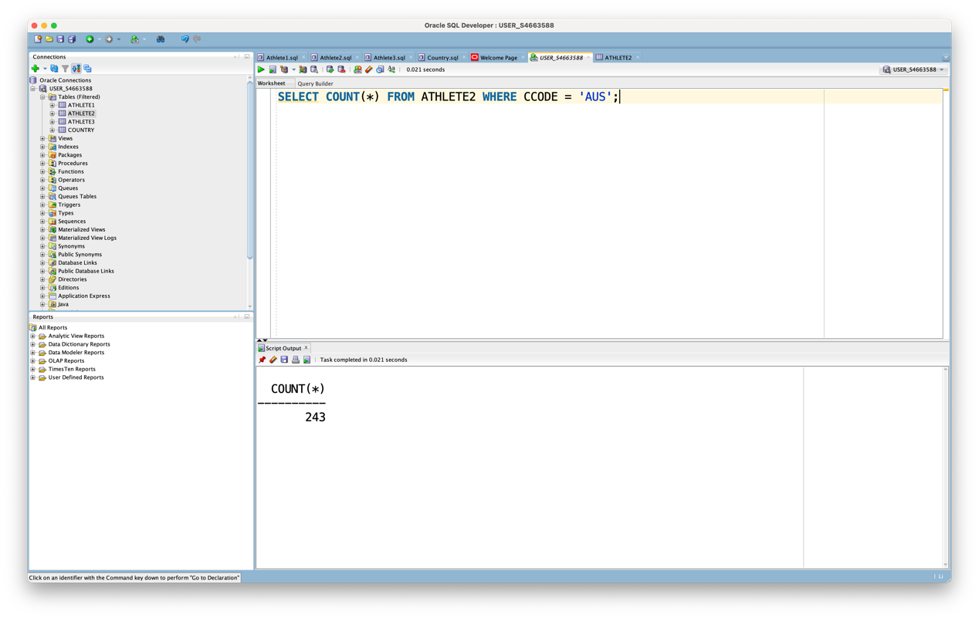

1. Answer:

Code:

SELECT SPORTID AS Sport_ID, COUNT(*) AS Count

FROM ATHLETE3

WHERE CCODE = 'RUS'

GROUP BY SPORTID;

Result:

|  |  |  |
| --- | --- | --- |
|  | Sport_ID | COUNT |
| 1 | 30 | 5 |
| 2 | 51 | 1 |
| 3 | 44 | 2 |
| 4 | 29 | 6 |
| 5 | 47 | 4 |
| 6 | 46 | 23 |
| 7 | 53 | 11 |
| 8 | 52 | 17 |
| 9 | 50 | 39 |
| 10 | 45 | 4 |
| 11 | 49 | 25 |

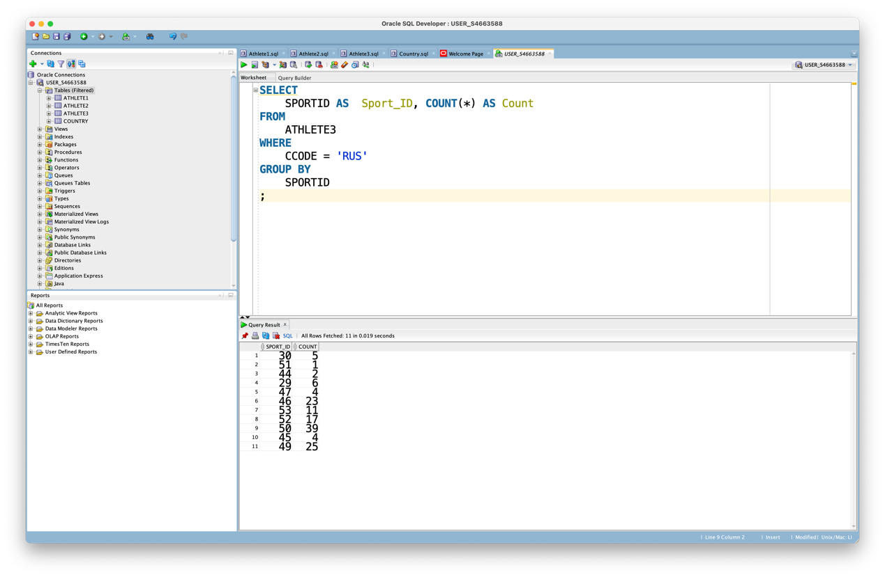

1. Answer:

First, we combine all the tables into a single table.

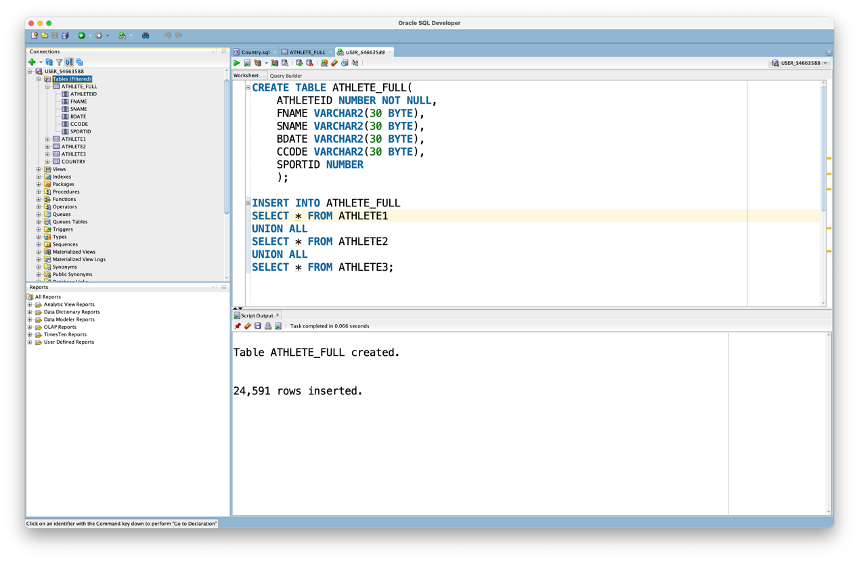

And then follow the instructions and get the results

Code:

CREATE TABLE ATHLETE_FULL(

ATHLETEID NUMBER NOT NULL,

FNAME VARCHAR2(30 BYTE),

SNAME VARCHAR2(30 BYTE),

BDATE VARCHAR2(30 BYTE),

CCODE VARCHAR2(30 BYTE),

SPORTID NUMBER

);

INSERT INTO ATHLETE_FULL

SELECT * FROM ATHLETE1

UNION ALL

SELECT * FROM ATHLETE2

UNION ALL

SELECT * FROM ATHLETE3;

SELECT COUNT(ATHLETE_FULL.ATHLETEID)

FROM ATHLETE_FULL, COUNTRY

WHERE ATHLETE_FULL.CCODE = COUNTRY.CCODE

AND COUNTRY.CONTINENT = 'EU';

Result:

|  |
| --- |
| COUNT(ATHLETE_FULL.ATHLETEID) |
| 16077 |

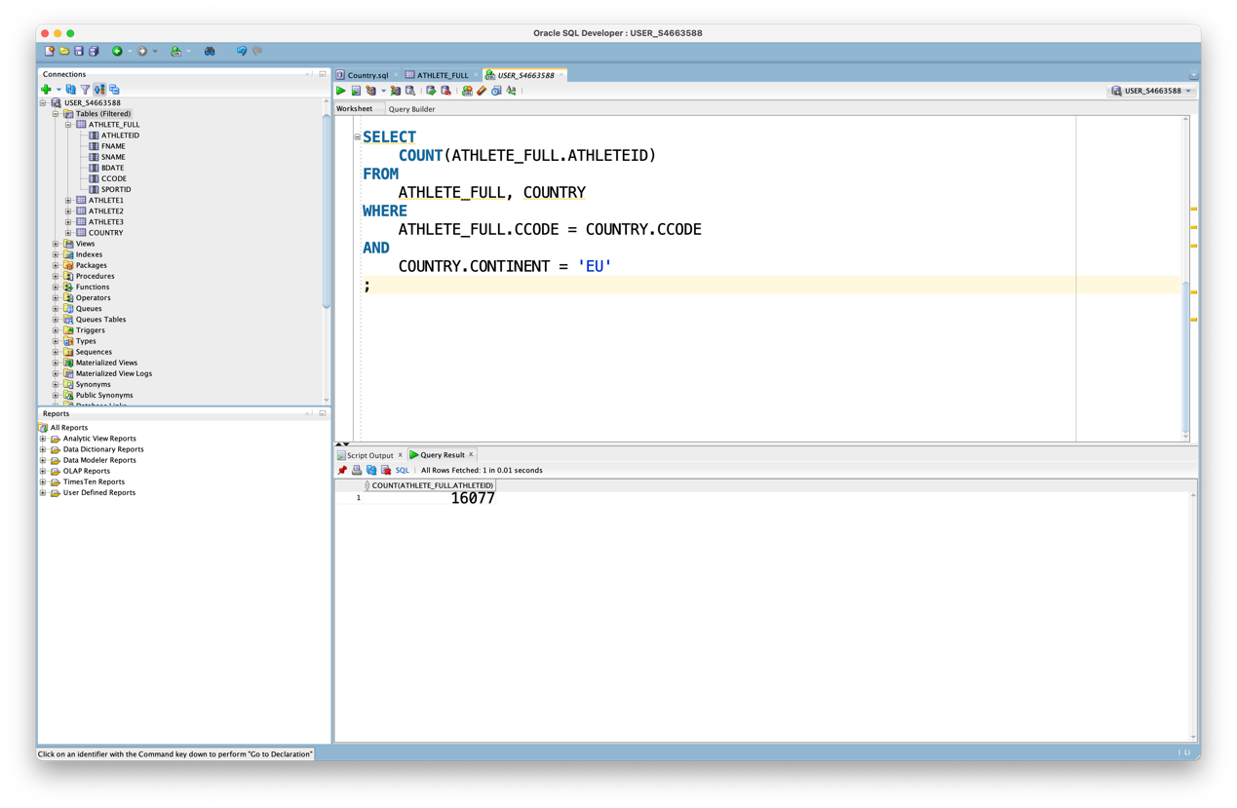

TASK 2

Answer:

The change of ID is 305. We know that the table is Horizontal fragmentation. The condition of fragmentation is Athlete1: 1<= AthleteID < 7656 , Athlete2: 7657<= AthleteID < 17318 and Athlete3: 17319 <= AthleteID <= 24591. So we only need to change the information in table Athlete1.

Due to Full Replication, each site has a full copy of each fragment, so each site needs to be modified.

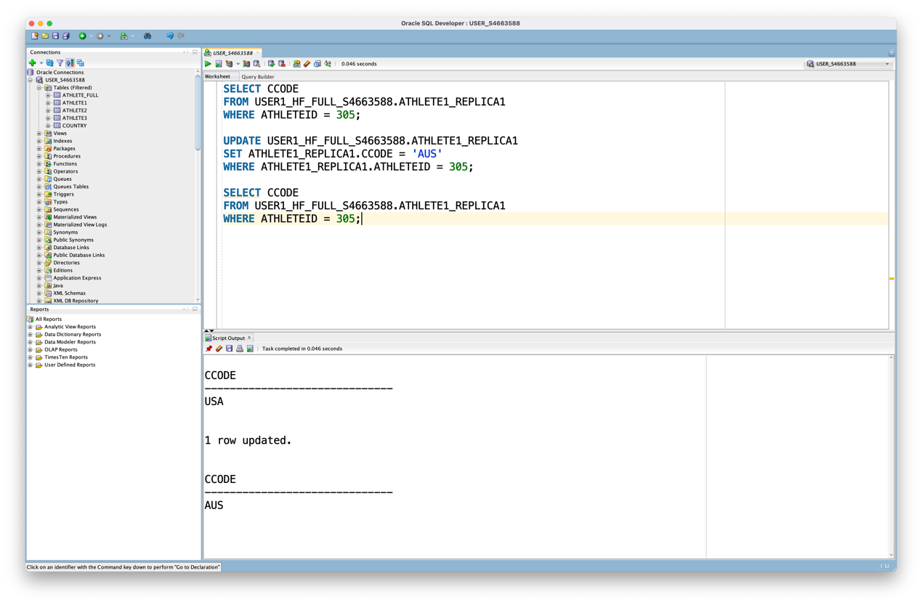

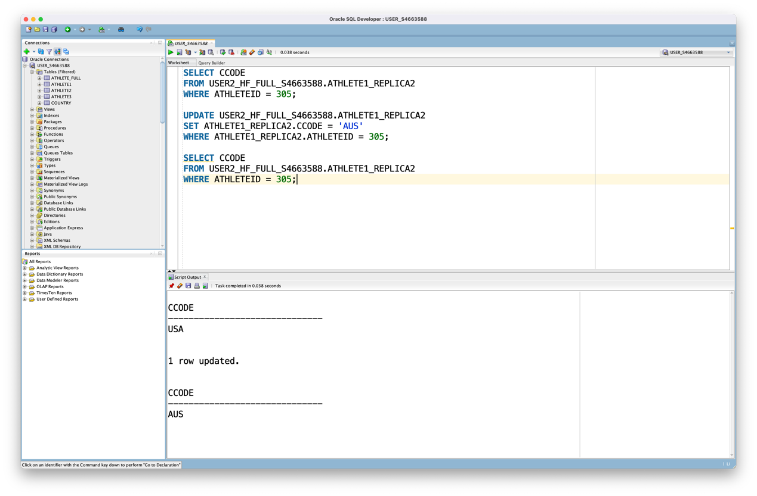

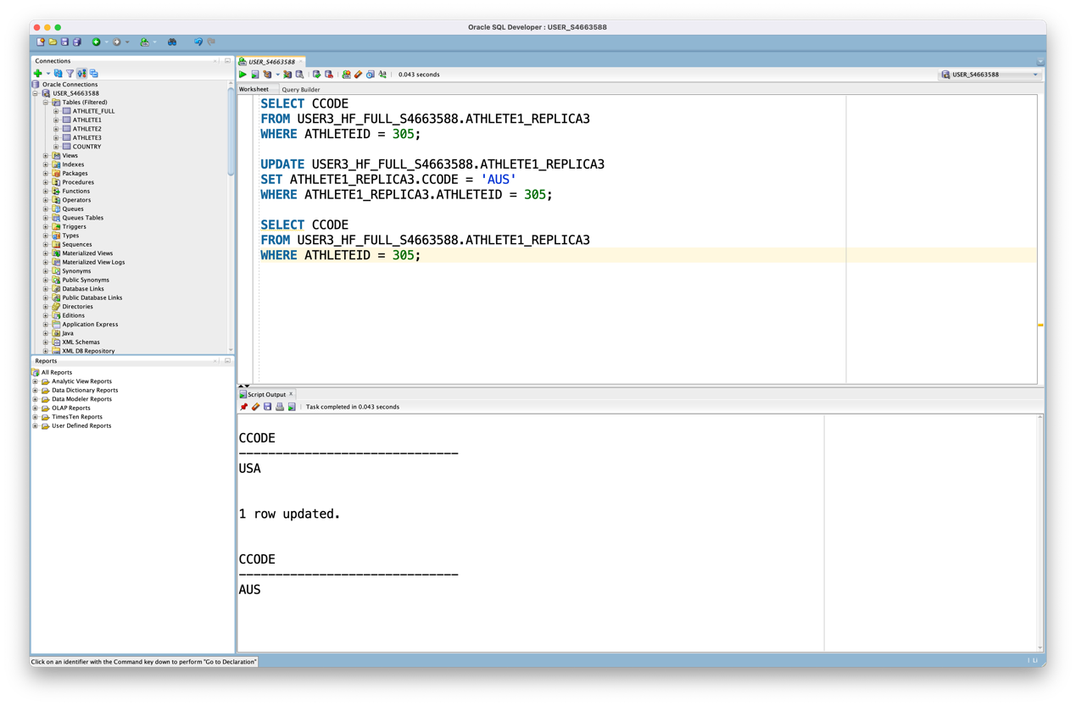

Due to Partial Replication, more than one site may have a copy of this fragment, but not all of them. Therefore, only part of site (USER1_HF_PA_S4663588 and USER2_HF_PA_S4663588) needs to be modified.

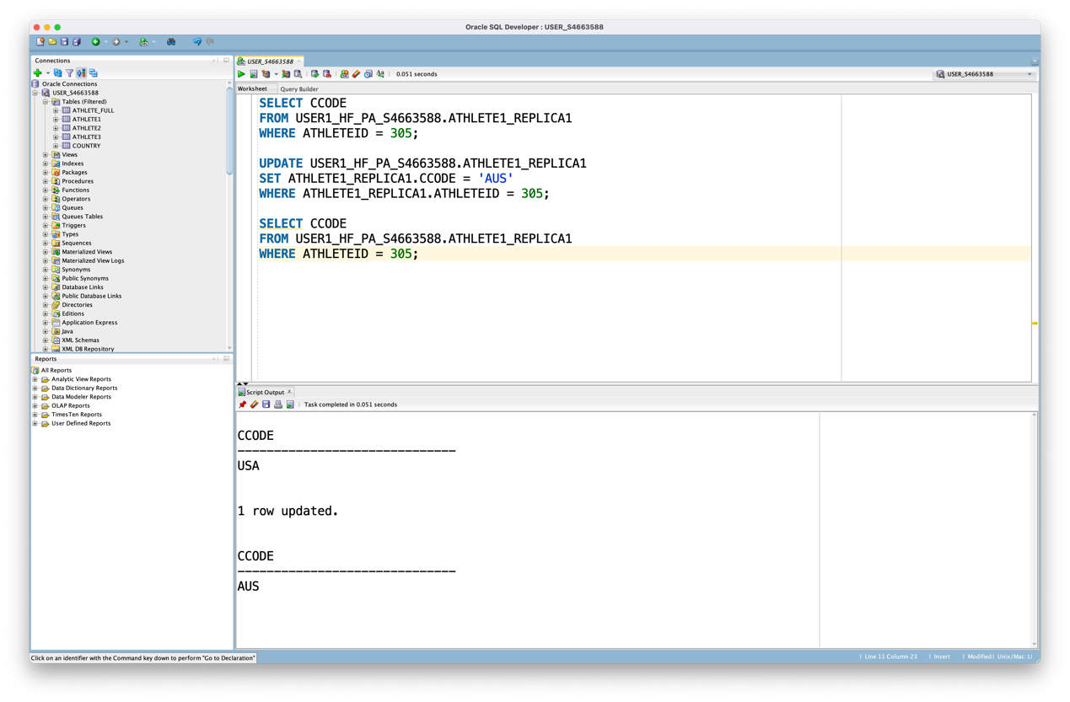

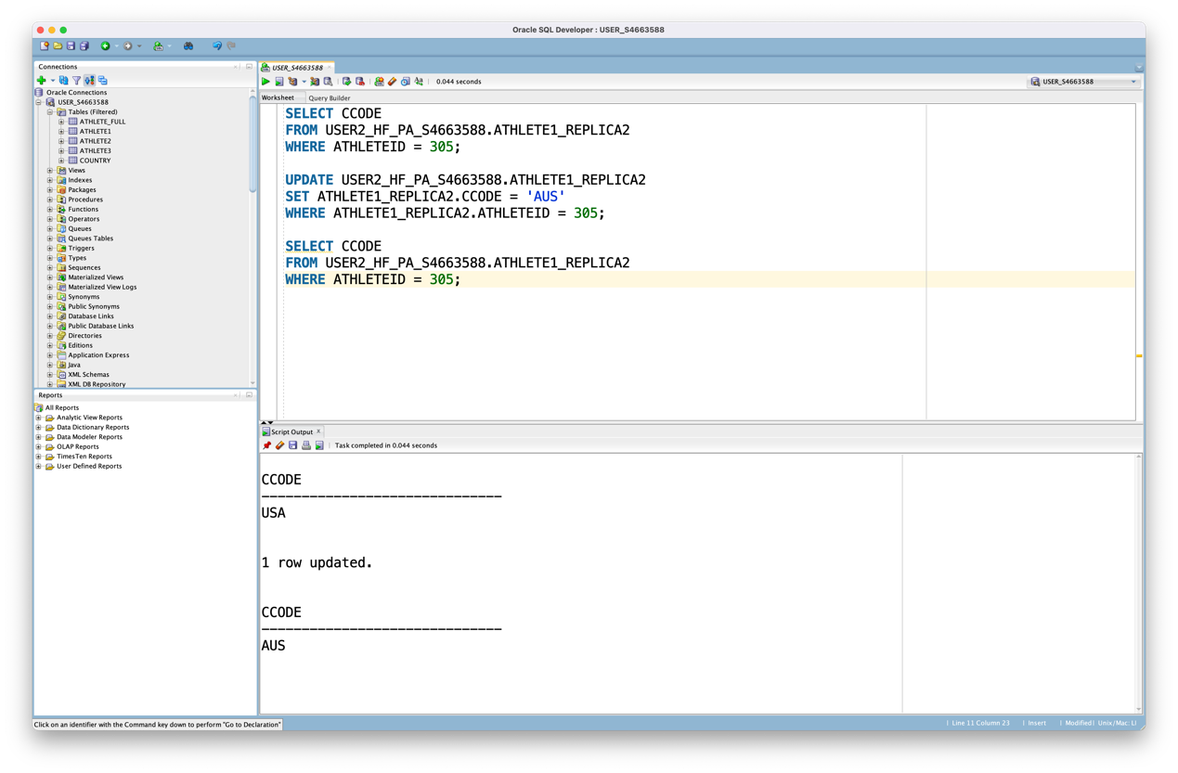

Due to No Replication, Each fragment will be a relation located on only one site. Therefore, only one site (USER1_HF_NO_S4663588) needs to be modified.

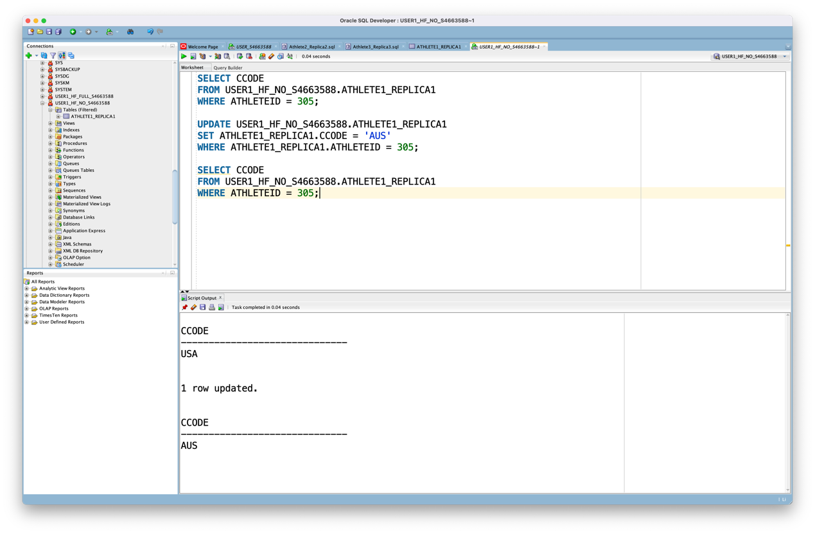

TASK 3

Answer:

Code:

SELECT V1.FNAME, V1.SNAME, V2.BDATE

FROM USER1_VF_S4663588.ATHLETE_V1 V1, USER2_VF_S4663588.ATHLETE_V2 V2

WHERE V1.ATHLETEID = V2.ATHLETEID

AND ( V1.ATHLETEID >= 305 AND V1.ATHLETEID <= 310 );

Result:

|  |  |  |  |
| --- | --- | --- | --- |
|  | FNAME | SNAME | BDATE |
| 1 | “Jason” | “Kidd” | (null) |
| 2 | “Chris” | “Paul” | (null) |
| 3 | “Tayshaun” | “Prince” | (null) |
| 4 | “Michael” | “Redd” | (null) |
| 5 | “Dwyane” | “Wade” | (null) |
| 6 | “Deron” | “Williams” | (null) |

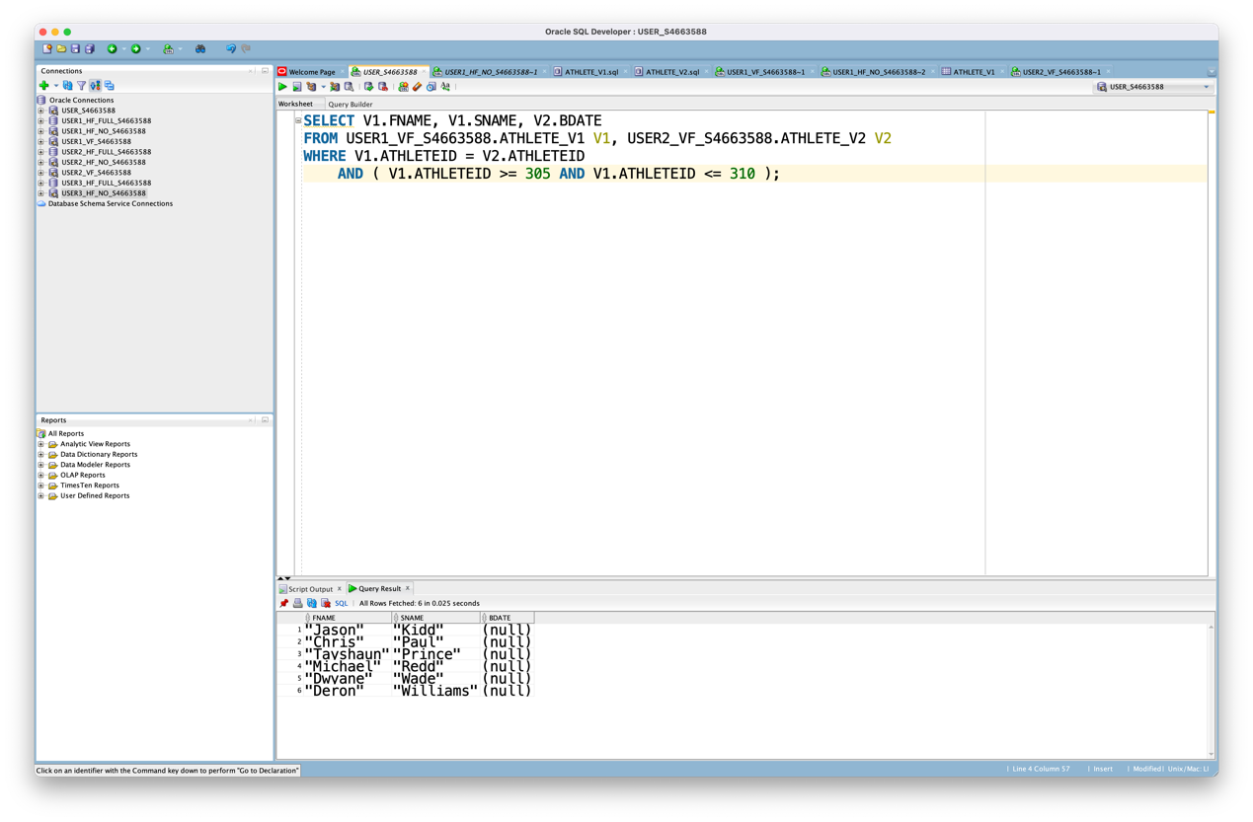

Task 4

Step one

SELECT DISTINCT(AthleteID)

FROM "USER1_VF_S4663588"."ATHLETE_V1";

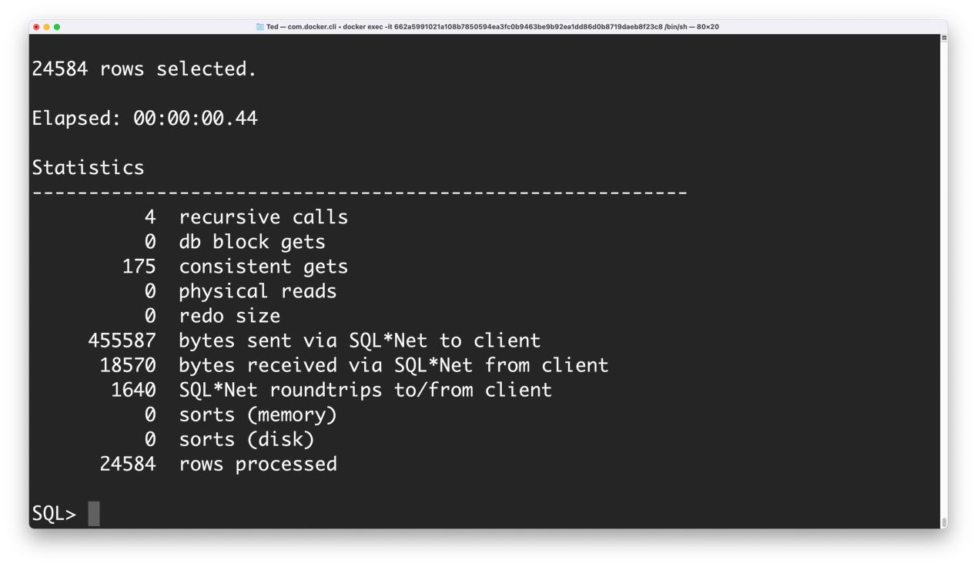

Step two

SELECT c.BDate, c.CCode, c.SportID

FROM "USER2_VF_S4663588"."ATHLETE_V2" c

WHERE c.CCODE = 'AUS' AND c.AthleteID IN

(SELECT DISTINCT(AthleteID)

FROM "USER1_VF_S4663588"."ATHLETE_V1");

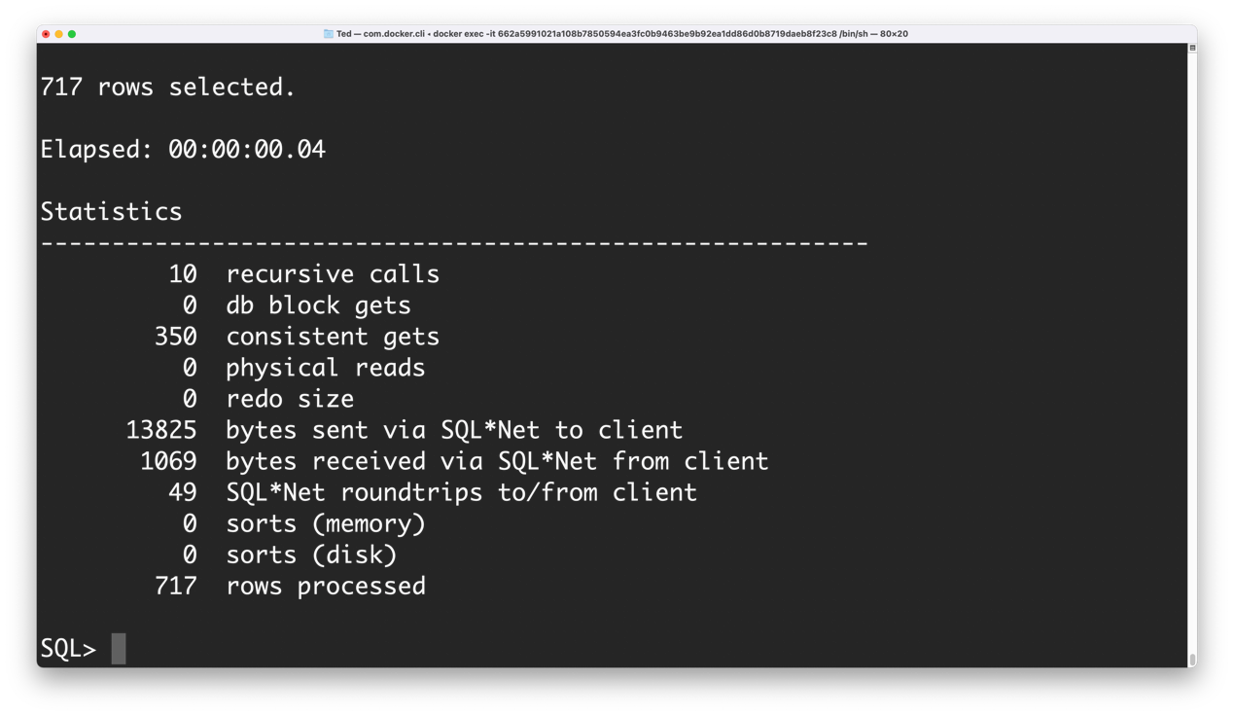

Step three

SELECT b.AthleteID, b.FName, b.SName, c.BDate, c.CCode, c.SportID

FROM "USER1_VF_S4663588"."ATHLETE_V1" b, (

SELECT c.AthleteID, c.BDate, c.CCode, c.SportID

FROM "USER2_VF_S4663588"."ATHLETE_V2" c

WHERE c.CCODE = 'AUS' AND c.AthleteID IN (

SELECT DISTINCT(AthleteID)

FROM "USER1_VF_S4663588"."ATHLETE_V1"

)

) c

WHERE b.AthleteID = c.AthleteID;

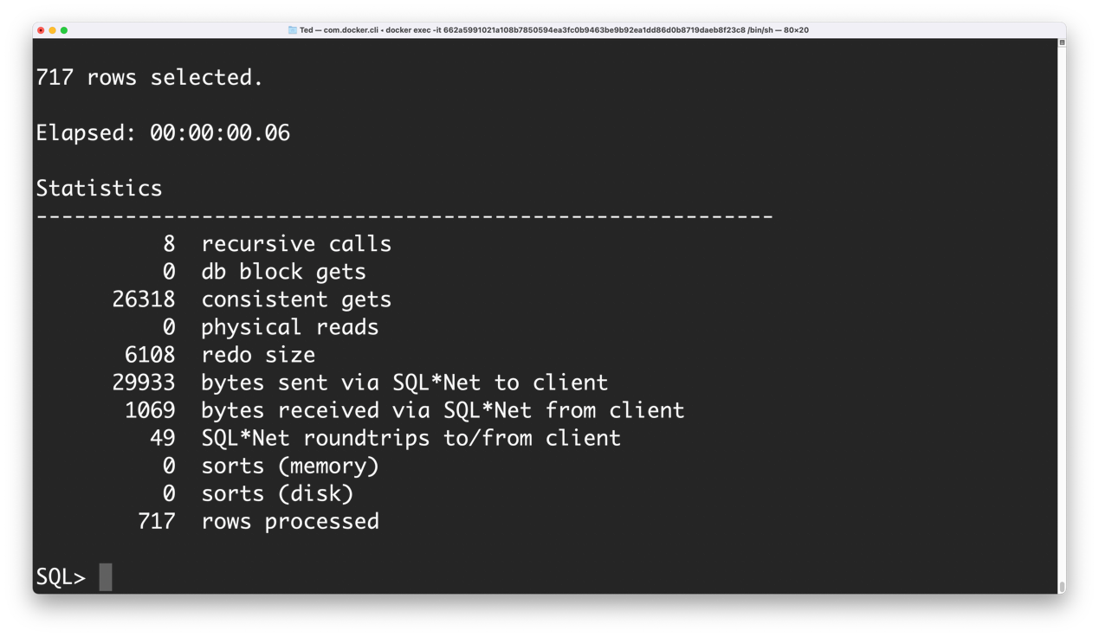

Inner-join:

SELECT

b.AthleteID, b.FName, b.SName, c.BDate, c.CCode, c.SportID

FROM

"USER1_VF_S4663588"."ATHLETE_V1" b, "USER2_VF_S4663588"."ATHLETE_V2" c

WHERE

b.AthleteID= c.AthleteID AND c.CCODE='AUS';

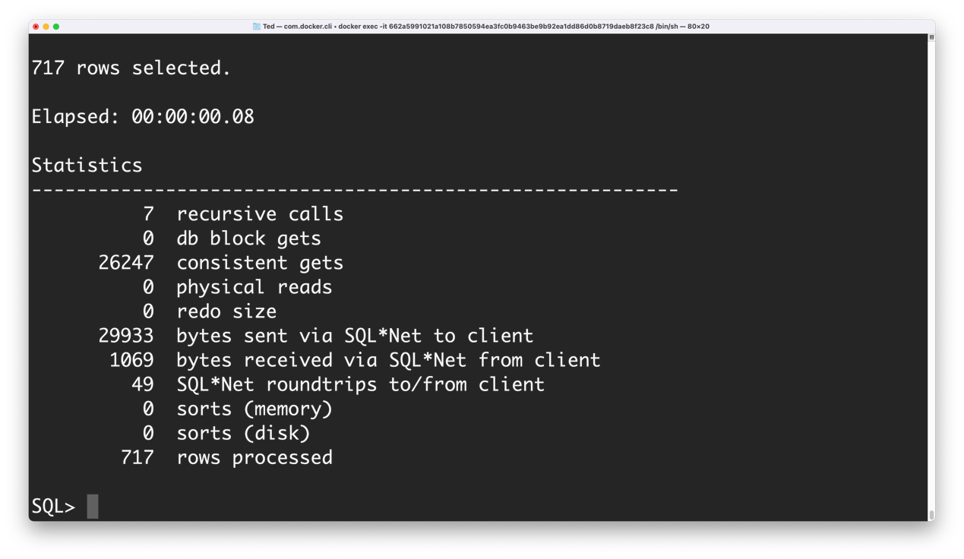

Therefore, the transmission cost of the semi-join plan is 455587(step 1) + 13825(step 2) = 469412. By decomposing the query into a step-by-step plan, we calculate that the final cost is 469412, but the inner-join cost is 29933. Therefore, we conclude that the cost of the semi-join is higher than that of the inner-join in this example.

Code Appendix

Task 1:

(1)

SELECT COUNT(*)

FROM ATHLETE2

WHERE CCODE = 'AUS';

(2)

SELECT SPORTID AS Sport_ID, COUNT(*) AS Count

FROM ATHLETE3

WHERE CCODE = 'RUS'

GROUP BY SPORTID;

(3)

CREATE TABLE ATHLETE_FULL(

ATHLETEID NUMBER NOT NULL,

FNAME VARCHAR2(30 BYTE),

SNAME VARCHAR2(30 BYTE),

BDATE VARCHAR2(30 BYTE),

CCODE VARCHAR2(30 BYTE),

SPORTID NUMBER

);

INSERT INTO ATHLETE_FULL

SELECT * FROM ATHLETE1

UNION ALL

SELECT * FROM ATHLETE2

UNION ALL

SELECT * FROM ATHLETE3;

SELECT COUNT(ATHLETE_FULL.ATHLETEID)

FROM ATHLETE_FULL, COUNTRY

WHERE ATHLETE_FULL.CCODE = COUNTRY.CCODE

AND COUNTRY.CONTINENT = 'EU';

Task 2:

/*Change Full Replication code*/

UPDATE USER1_HF_FULL_S4663588.ATHLETE1_REPLICA1

SET ATHLETE1_REPLICA1.CCODE = 'AUS'

WHERE ATHLETE1_REPLICA1.ATHLETEID = 305;

UPDATE USER2_HF_FULL_S4663588.ATHLETE1_REPLICA2

SET ATHLETE1_REPLICA2.CCODE = 'AUS'

WHERE ATHLETE1_REPLICA2.ATHLETEID = 305;

UPDATE USER3_HF_FULL_S4663588.ATHLETE1_REPLICA3

SET ATHLETE1_REPLICA3.CCODE = 'AUS'

WHERE ATHLETE1_REPLICA3.ATHLETEID = 305;

/*Change Partial Replication code*/

UPDATE USER1_HF_PA_S4663588.ATHLETE1_REPLICA1

SET ATHLETE1_REPLICA1.CCODE = 'AUS'

WHERE ATHLETE1_REPLICA1.ATHLETEID = 305;

UPDATE USER2_HF_PA_S4663588.ATHLETE1_REPLICA2

SET ATHLETE1_REPLICA2.CCODE = 'AUS'

WHERE ATHLETE1_REPLICA2.ATHLETEID = 305;

/*Change No Replication code*/

UPDATE USER1_HF_NO_S4663588.ATHLETE1_REPLICA1

SET ATHLETE1_REPLICA1.CCODE = 'AUS'

WHERE ATHLETE1_REPLICA1.ATHLETEID = 305;

Task 3:

SELECT V1.FNAME, V1.SNAME, V2.BDATE

FROM USER1_VF_S4663588.ATHLETE_V1 V1, USER2_VF_S4663588.ATHLETE_V2 V2

WHERE V1.ATHLETEID = V2.ATHLETEID

AND ( V1.ATHLETEID >= 305 AND V1.ATHLETEID <= 310 );

Task 4:

/*Step one*/

Select distinct(AthleteID) from "USER1_VF_S4663588"."ATHLETE_V1";

/*Step two*/

Select c.BDate, c.CCode, c.SportID from "USER2_VF_S4663588"."ATHLETE_V2" c where c.CCODE = 'AUS' and c.AthleteID in (Select distinct(AthleteID) from "USER1_VF_S4663588"."ATHLETE_V1");

/*Step three*/

Select b.AthleteID, b.FName, b.SName, c.BDate, c.CCode, c.SportID from "USER1_VF_S4663588"."ATHLETE_V1" b, (Select c.AthleteID, c.BDate, c.CCode, c.SportID from "USER2_VF_S4663588"."ATHLETE_V2" c where c.CCODE = 'AUS' and c.AthleteID in (Select distinct(AthleteID) from "USER1_VF_S4663588"."ATHLETE_V1")) c where b.AthleteID = c.AthleteID;

/*inner-join*/

select b.AthleteID, b.FName, b.SName, c.BDate, c.CCode, c.SportID from "USER1_VF_S4663588"."ATHLETE_V1" b, "USER2_VF_S4663588"."ATHLETE_V2" c where b.AthleteID= c.AthleteID and c.CCODE='AUS';