Article: Augmented reality near-eye display using Pancharatnam-Berry phase lenses
Journal: Nature
Authors: Seokil Moon, Chang-Kun Lee, Seung-Woo Nam, Changwon Jang, Gun-Yeal Lee, Wontaek Seo, Geeyoung Sung, Hong-Seok Lee & Byoungho Lee

This article investigates using Pancharatnam-Berry phase (actually it is just a specific position of lens) lens. And I believe it is quiet similar to my research project. But I did not think that complicated, I just think to use the reflection to project a 2D graph on glasses, but the result in this research means to be like holograms. I think this article can be one direction of my later developing reference. This article mainly focus on how do they combine holographic optical elements and diffractive optical elements together to be able to show the real world and the photo together, which is the same project I am currently focusing on, it verifies my final goal is achievable and provides me one way to approach to it.
In this article, the researchers first build a first prototype with just a lens, (the Pancharatnam-Berry phase mentioned in the title) they found a problem called chromatic aberration. (AKA color fringing, is a color distortion that creates an outline of unwanted color along the edges of objects in a photograph) Then they continue to fix the color issue due to different light wave length. They used some extra lens to fixed the angles. I think this idea would help me when I meet the same color issue.
The results of the research are clearly presented and explained. The main method in this research is to calculate the diffuser holographic optical elements of lens (where and which side should the lens face to) with physic formula, but actually they made some mistakes on the formula. And they calculate the expected value with the wrong formula. But what’s interesting is that, the data experiment is pretty close to the expected value. And following the methodology, the outcome is just as expected. As the image shows, this result is just what I am hoping to make.
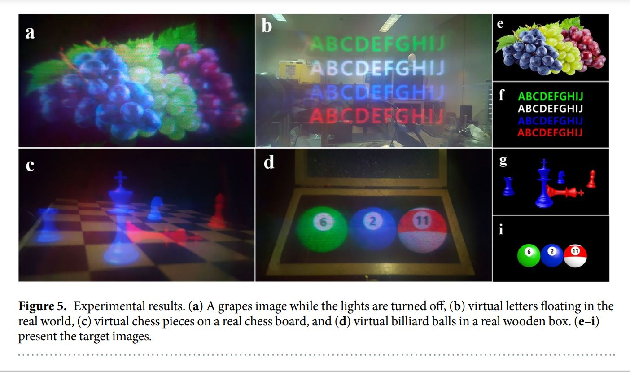
The article takes an original approach to the problem, the model of the lens are successfully built. The original insight is to build a model of near-eye augmented reality display with lens. The model provides a new way for AR display with Pancharatnam-Berry phase lenses, but with a wrong formula. The paper acknowledges its limitations, which if the virtual image is provided with an excessively wide field of view, the edges of the image can be out of focus while the center of the image is well focused. The researchers think holograms could fix that problem. I will mark that point when I meet the same issue in my research.
To use this article, I will try to understand how its formula are supposed to work, and use them in my own development. Also for the model in this article, I can reference it as further development when I finish my prototype. And its multi-lens structure could help me to develop my own model. If others read this article looking for information on augmented reality glasses, I suggest them do not be afraid of the advanced concept name, because this article is just using the advanced name, but actually, the article made some mistake on some formula. For example, in the formula of the relationship of field of view angle and eye relief, the article messed up with some data. They calculate field of view with a wrong length of lens. (θ₂ = tan⁻¹(r₁ / e)) Also, it doesn’t make sense to use an unrelated angle to express a ratio between two lines. (r₂ / f_{p}) As a result, I advise others should just focus on how the process is done, but not on its concepts and formula. It is better to get formula ourselves when it is not hard to understand basic laws.
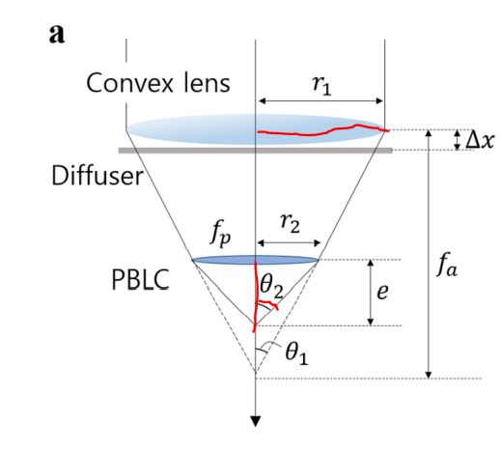
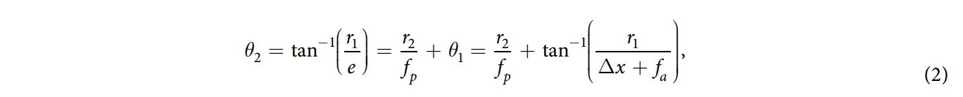

References
1. Seokil Moon, Chang-Kun Lee, Seung-Woo Nam, Changwon Jang, Gun-Yeal Lee , Wontaek Seo, Geeyoung Sung, Hong-Seok Lee & Byoungho Lee. (2019). Augmented reality near-eye display using Pancharatnam-Berry phase lenses. Nature, 9:6616. https://doi.org/10.1038/s41598-019-42979-0
2. Wikipedia. Geometric phase. https://en.wikipedia.org/wiki/Geometric_phase
3. Adobe. Chromatic aberration. https://www.adobe.com/creativecloud/photography/discover/chromatic-aberration.html

