Developing mobile ECommittee application for Alberta Government. Application is facilitating multiple meetings/agenda management, collaboration of related agenda’s documents. Meetings organizing, managing participants and attendees.

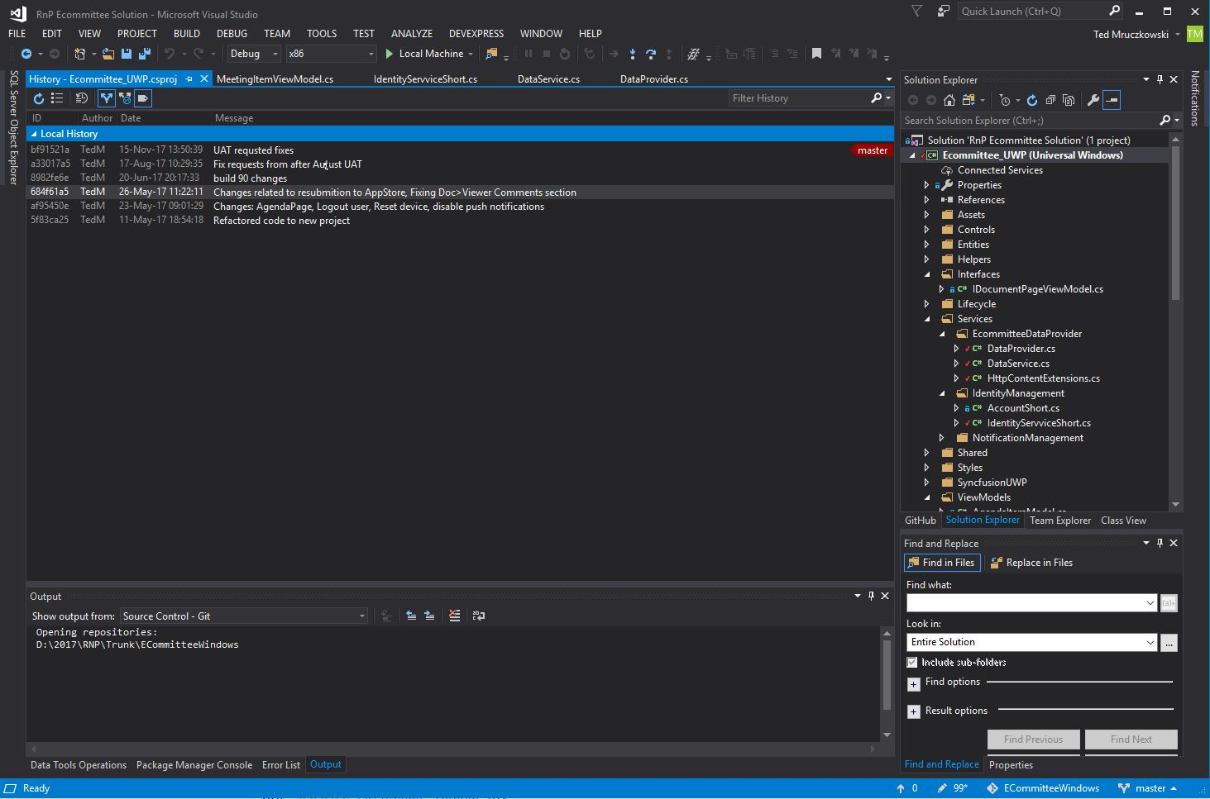

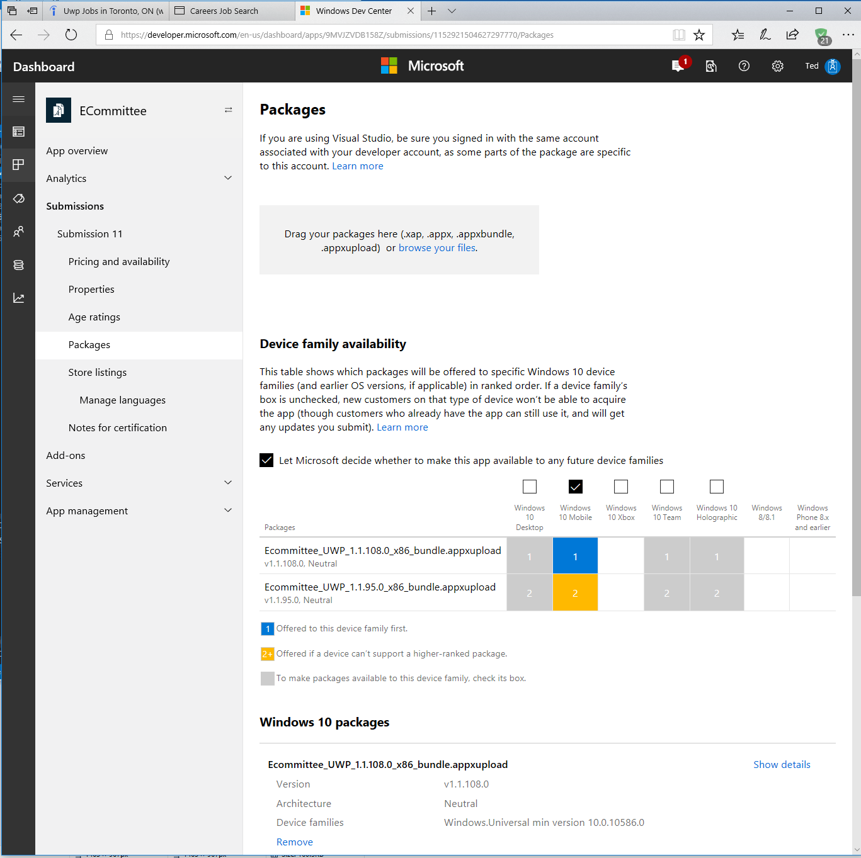

Contributions to Open Source – samples for WPF/UWP/.Net Framework Core

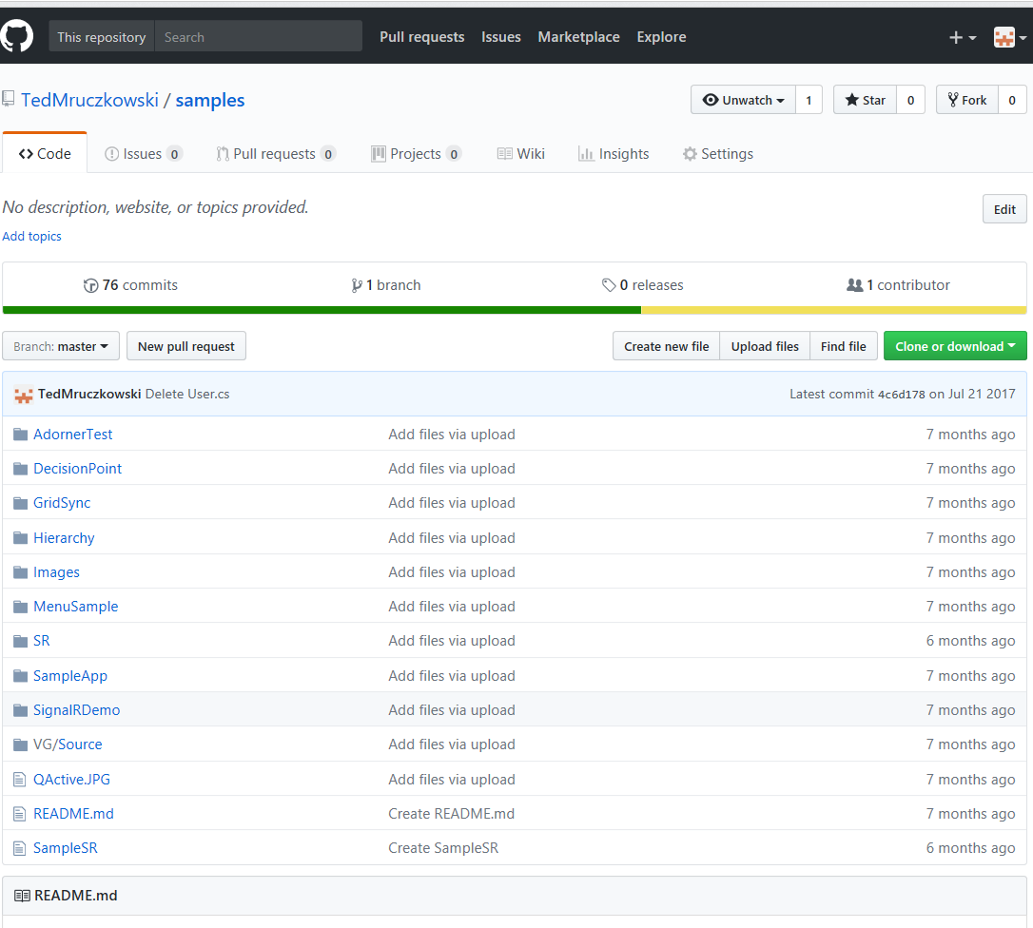

Mobile applications published for Microsoft sponsored contest. Some of them might not be working since they were published about 3-4 years ago and those are relayed on third party data services which were changed. Wininsider is my incorporated company name.

