# Power BI Dev Camp Setup Guide for .NET Core

**Setup Time**: 45-60 minutes

**Setup Overview**: These setup instructions walk through the steps required to configure a Windows PC or a virtual machine (VM) that will be used by students when working on the lab exercises for the **Power BI Developer Bootcamp**.

### Install and Configure Windows 10 or Windows 8.1

In this step you will install the Windows operating system.

* 1. Start with a computer Windows 10 or Windows 8.1 to complete lab exercises.

1. Install the .NET Core SDK
   1. Go to <https://dotnet.microsoft.com/download>.
   2. Download and run the installation program

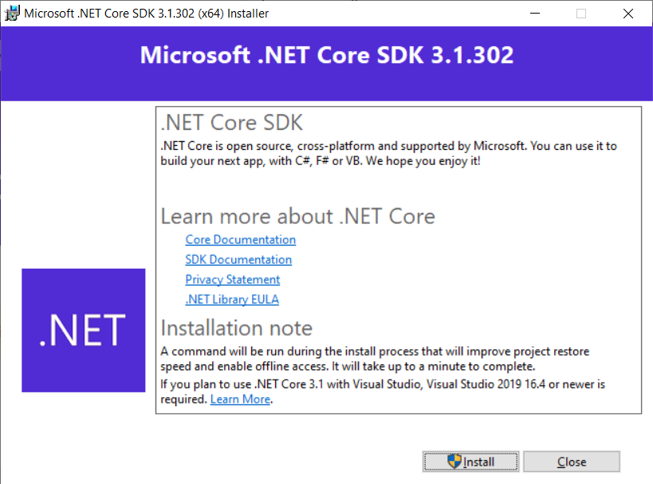

* 1. Z

1. Install Visual Studio Code
   1. <https://code.visualstudio.com/download>
   2. xxx
2. install Node.js
   1. <https://nodejs.org>

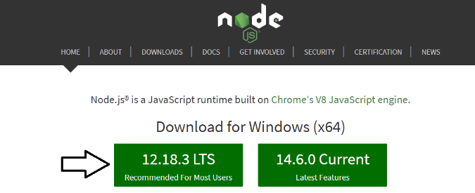

1. Install the Azure PowerShell modules by executing the following PowerShell commands one at a time in the PowerShell console.
   1. In the PowerShell console, execute the following command

Install-PackageProvider -Name NuGet -MinimumVersion 2.8.5.201 -Force

* 1. Next, execute the following command to trust the PowerShell gallery.

Set-PSRepository -Name PSGallery -InstallationPolicy Trusted

* 1. Next, execute the following command to install the Azure Active Directory PowerShell cmdlets library.

Install-Module AzureAD -AllowClobber -Force

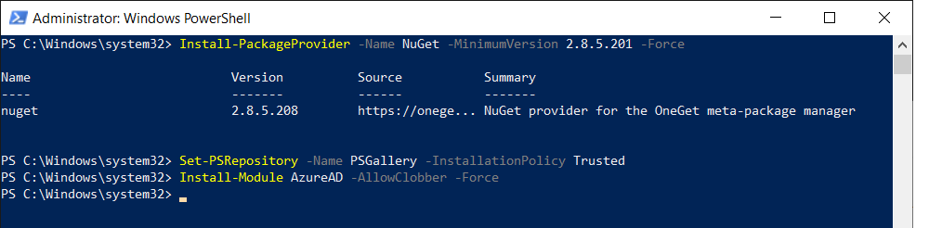

1. Make sure you have an Power BI environment with a app workspace with a report for embedding.