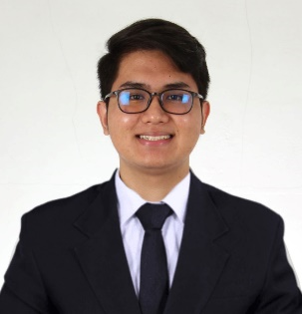Name: Rosalio L. Encabo III

Course: Bachelor of Science in Information Technology

Address: 7th East Tubod Rosario Heights. Iligan City

Contact No. 0927-987-6791

Email Add: rosaliolumacad.encaboiii@my.smciligan.edu.ph

Age: 22 Civil Status: Single Citizenship: Filipino

Place of Birth: Iligan City

Height: 167cm Weight: 66 kg Religion : Roman Catholic

Father’s Name: Rosalio A. Encabo Jr Occupation: Retired

Mother’s Name : Evelyn L. Encabo Occupation: Nurse

Tertiary School: Saint Michaels College of Iligan City S.Y. 2021-Present

Address: Quezon Ave. Iligan City

Secondary School: La Salle Academy S.Y. 2016 - 2021

Address: Bro. Raymund Jeffrey St. Pala-o Iligan CIty

Elementary School: La Salle Academy S.Y. 2010-2016

Address: Bro. Raymund Jeffrey St. Pala-o Iligan CIty

TRAININGS & SEMINAR *(3 Recent Trainings & Seminars Attended)*

|  |  |
| --- | --- |
| *Date* | *Title: DevFest (Google Developer Groups)* |
| *Nov 16, 2024* | *Venue: Liceo de Cagayan University, Rodelsa Hall* |
|  | *Address: Cagayan De Oro City* |

|  |  |
| --- | --- |
| *Date* | *Title: Educational Tour* |
| *Oct 16, 2024* | *Venue: RISE and Synacy Cebu* |
|  | *Address: Cebu Business Park, Cebu City,*  *Philippines* |

|  |  |
| --- | --- |
| *Date* | *Title: Optimization Technique Prediction Model Through Modified Crossover Operator (Webinar)* |
| *Oct 27, 2023* | *Venue: St Michael’s College* |
|  | *Address: Iligan City* |

*Please include Character References (Dean of the College & (1) Faculty with contact Numbers)*

|  |  |
| --- | --- |
| **Edsel Baba-Monterola, Ph.D.**  Dean, College of Computer Studies  St. Michael’s College  Quezon Ave., Iligan City  Contact No.: | **Leonie A. Cajes**  Faculty, College of Computer Studies  St. Michael’s College  Quezon Ave., Iligan City  Contact No.: |