Multiparadigm shiiiit

## Functionality

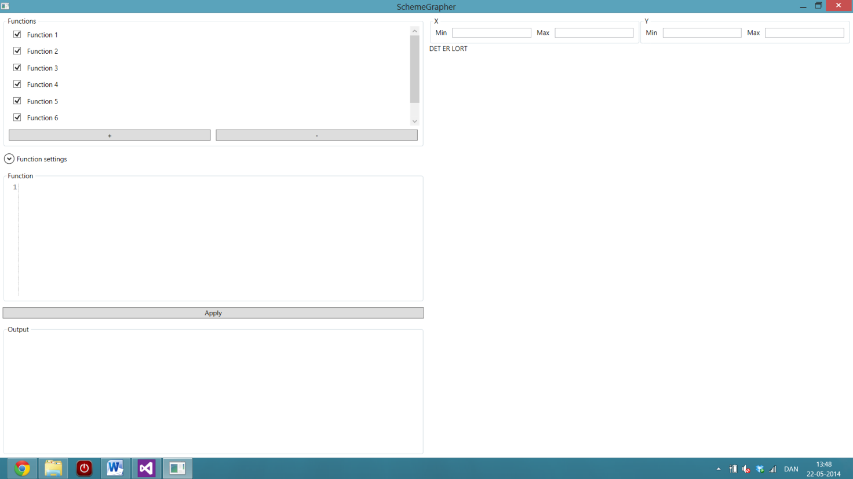

### Graphical User Interface

The GUI is made up by a single modeless window. This window is split up in grids, whereas different options are customizable on how and which functions are to be shown as graphs in the Graph Section on the right side. First of all, a function is to be selected in the upper left corner. These functions are bound to their individual settings, which are shown below the function list in the ‘Function settings’ dropdown box. In the Function list, each function has a checkbox attached which indicates if the selected function is drawn in the Graph Section. The background color of the Function list items matches the respective graphs in the Graph Section to give a better overview of which functions matches which graphs. In addition to this, it is possible to add and remove functions from the list.

The settings of the functions are to be changed and set in the Function settings box. The step size and number of samples can be set to change the resolution of the graph. In addition to this, the derivative and integral can be shown, with additional settings on the integral on the resolution and the minimum and maximum values of the integral calculation. All these settings are only set for the current function selected in the Function list.

Below the settings box, the Function code box is shown. This box is an editable textbox where the code for the corresponding chosen list item in the Function list is shown. This code can be corrected and applied to the Graph Section by clicking the ‘Apply’ button below the box.

The last box in the left side is the Output box. In this box all the output from the applied code is written. This box is also for error messages for syntactical errors and other exceptions.

The right side of the GUI is the Graph section. At the top, some settings are shown, specific to the Graph layout, that is, these functions are valid for all the functions where the left side options are specific for each of the functions. Here the minimum and maximum values of the X and Y axes can be changed, and also if the axes are to linear or logarithmic. Additional logarithmic settings are available for either $\log_{2}$, $\log_{10}$ or $ln$.

The rest of the GUI is the Graph, where the checked functions in the Function list are shown as well as their derivatives and integrals, if checked. The legend shows the functions names and colors. In addition, for the integrals shown, the result of the integral is shown in the legend of the integral.