You are approached by the **New Century University, NCU**, to design a database to manage the data for its newly created **Vehicle Management Centre, VMC**.

A brief description of how they intend to operate the VMC is as follows:

Faculty members may use the vehicles owned by the NCU for officially sanctioned travel. For example, the vehicles may be used by faculty members to travel to off-campus learning centers, to travel to locations, at which research papers are presented, to transport students to officially sanctioned locations, and to travel for public service purposes. The vehicles used for such purposes are managed by VMC.

Using reservation forms, each department can reserve vehicles for its faculty, who are responsible for filling out the appropriate trip completion form at the end of a trip. A vehicle must be booked before it can be used. The reservation form includes the expected departure date, vehicle type required, destination and name of the authorized faculty member. When the faculty member arrives to pick up the vehicle, (s)he must sign a checkout form to log out the vehicle and pick up a trip completion form. (The VMC employee who releases the vehicle for use also signs the checkout form). The vehicle’s identification, the odometer readings at the start and end of the trip, maintenance complaints (if any), liters of fuel purchased (if any), and the NCU credit card number used to pay for the fuel. If fuel is purchased, the credit card receipt must be stapled to the trip completion form. Upon receipt of the faculty trip completion form, the faculty member’s department is billed at a mileage rate based on the vehicle type used.

All vehicles at NCU must have annual maintenance by VMC, during which a number things need to be done (e.g., safety checking). Each time a vehicle requires maintenance, a maintenance log entry is completed on a pre-numbered maintenance log form. The maintenance log form includes the vehicle identification, a brief description of the type of maintenance required, the initial log entry date, the date on which the vehicle back into service. (Only mechanics who have an inspection authorization may release the vehicle back into service).

As soon as the log form has been initialized, the log form’s number is transferred to a maintenance detail form; the log form’s number is also forwarded to the parts department manager, who fills out a parts usage form on which the maintenance log number is recorded. The maintenance detail form contains separate lines for each maintenance item performed, for the parts used, and for identification of the mechanic who performed the maintenance item. When all maintenance items have been completed, the maintenance detail form is stapled to the maintenance log form, the maintenance log form’s completion date is filled out, and the mechanic who releases the vehicle back into service signs the form. The stapled forms are then filled, to be used later as the source for various maintenance reports.

VMC maintains a parts inventory, including oil, oil filters, air filters and belts of various types. The parts inventory is checked daily to monitor parts usage and to reorder parts that reach the ‘minimum quantity on hand’ level. To track parts usage, the parts manager requires each mechanic to sign out the parts that are used to perform each vehicle’s maintenance; the parts manager records the maintenance log number under which the part is used.

Each month, VMC issues a set of reports. The reports include the mileage driven by vehicle, by department, and by faculty members with a department. In addition, various revenue reports are generated by vehicle and department. A detailed parts usage report is also filed each month. Finally, a vehicle maintenance summary is created each month.

**Monthly Report**

CREATE VIEW report AS

SELECT faculty_member.m_id,faculty_member.m_name,faculty_member.dept_id,expenses.v_id,expenses.card_no,expenses.cost_of_fuel,expenses.reciept_no,reservation.depature_date,reservation.destination_date

FROM faculty_member

INNER JOIN expenses

ON faculty_member.m_id = expenses.m_id JOIN reservation

ON faculty_member.m_id = reservation.m_id;

**2. Student activities**

Current practice for vehicle management at NCU is very inefficient (e.g., too many forms to be filled manually, there is no effective way for tracking and reporting for decision making). You are expected to read above scenario thoroughly to understand the business, to work out all requirements, and to carefully design a relational database for NCU to manage its vehicle operations. You can make relevant assumptions, but ONLY when there is no information provided in the given scenario. The following is a list of activities you are expected to do:

a) **You are required to design the database using Entity Relationship Modelling technique. A VERY CLEAR ERD (exported from MySQL workbench as a PNG file) needs to be included in the assignment report. Detailed explanation of the ERD is expected – immediately following the ERD diagram, you need to justify your choices of entities, relationships, etc. The database should be normalized, to at least 2NF.**



**b) You are expected to implement your design into fully working relational database, that can meet all business requirements. Create Tables, views, stored procedures, triggers, etc when necessary.**

**Database Creation:**

Create database vmc;

**Create table Faculty_member:**

CREATE TABLE faculty_member(

`m_id` int,

`m_name` varchar(255),

`dept_id` int(255),

`phone` int(255)

);

**Create table department:**

CREATE TABLE departement(

`dept_id` int,

`dept_name` varchar(255)

);

**Create table expenses:**

CREATE TABLE expenses(

`e_id` int,

`v_id` int(255),

`m_id` int(255),

`card_no` int(255),

`cost_of_fuel`int(255),

`reciept_no`int(255)

);

**Create table inventory:**

CREATE TABLE inventory(

`v_id` int,

`part_id` int(255),

`price` int(255)

);

**Create table check_out:**

CREATE TABLE check_out(

`m_id` int,

`user_name` varchar(255),

`date` date(255)

);

**Create table journey:**

CREATE TABLE journey(

`start_date` date(255),

`end_date` date(255),

`complain` varchar(255)

);

**Create table journey:**

CREATE TABLE journey(

`start_date` date(255),

`end_date` date(255),

`complain` varchar(255)

);

**Create table maintenance:**

CREATE TABLE maintenance(

`mantain_id` varchar(255),

`m_id` varchar(255),

`v_id` varchar(255),

`service_date` date(255)

);

**Create table parts:**

CREATE TABLE parts(

`mantain_id` int(255),

`part_id` int(255),

`description` varchar(255)

);

**Create table reservation:**

CREATE TABLE reservation(

`r_id` int(255),

`depature_date` date(255),

`destination_date` date(255),

`v_id` int(255),

`m_id` int(255)

);

**Create table vehicle:**

TABLE vehicle(

`v_id` int(255),

`v_name` int(255),

`model` varchar(255)

);

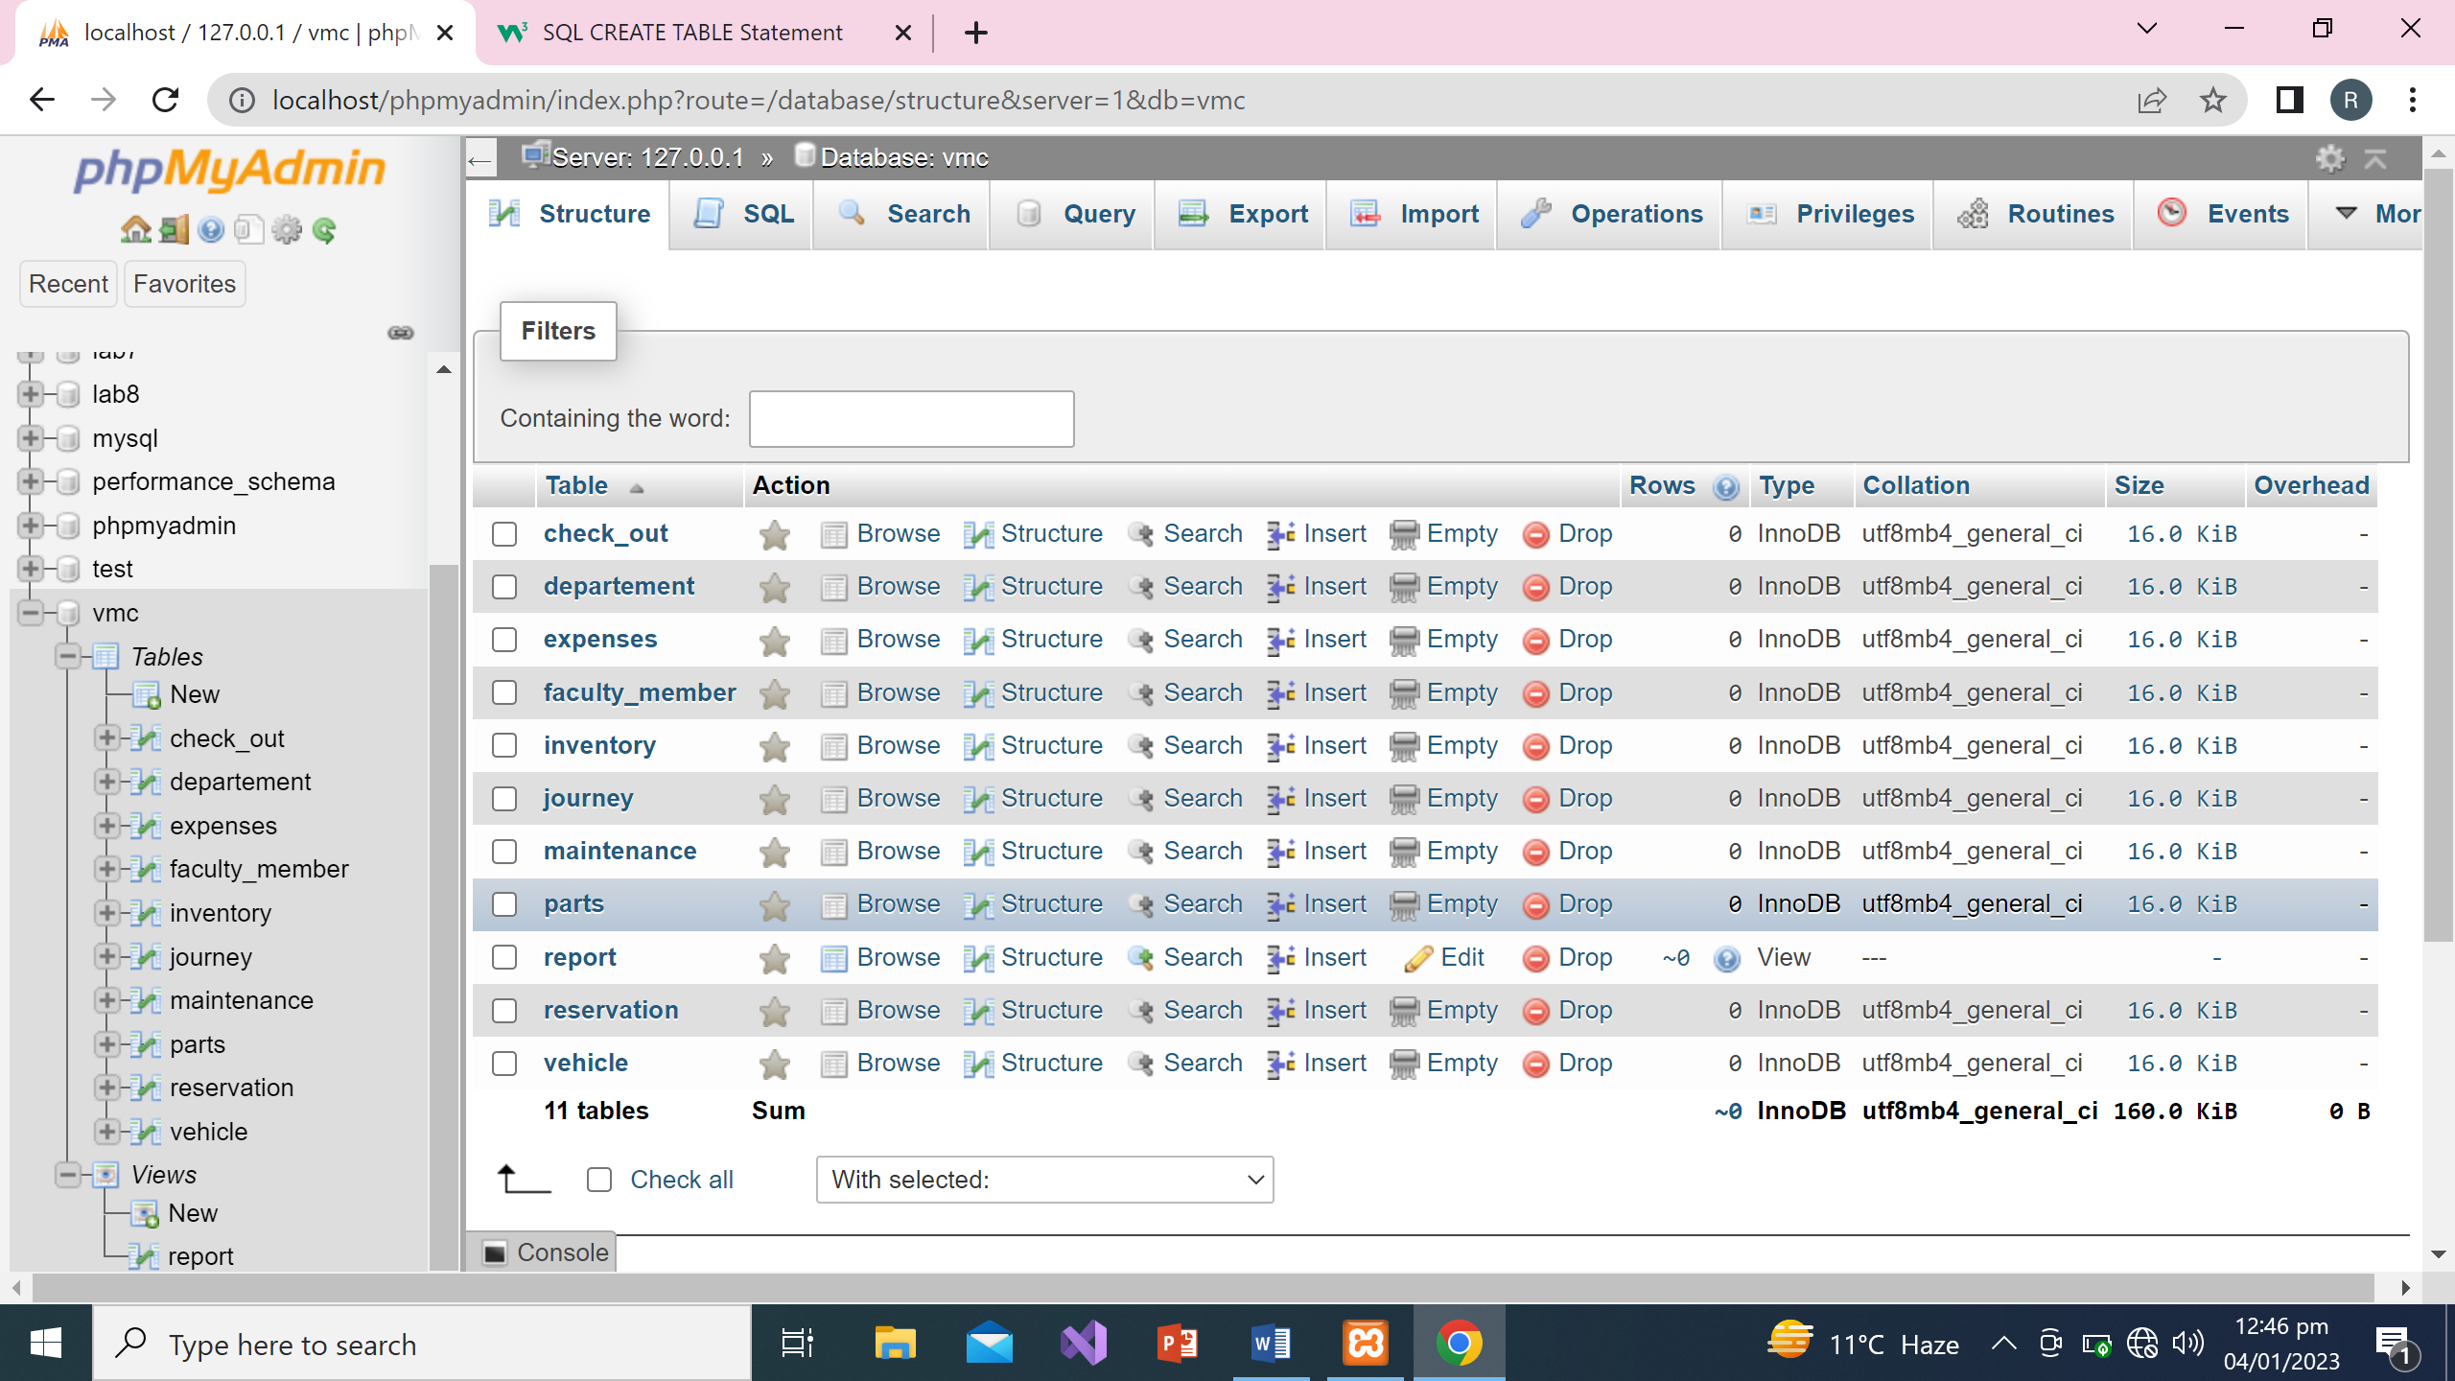

**View Creation (Report)**

CREATE VIEW report AS

SELECT faculty_member.m_id,faculty_member.m_name,faculty_member.dept_id,expenses.v_id,expenses.card_no,expenses.cost_of_fuel,expenses.reciept_no,reservation.depature_date,reservation.destination_date

FROM faculty_member

INNER JOIN expenses

ON faculty_member.m_id = expenses.m_id JOIN reservation

ON faculty_member.m_id = reservation.m_id;

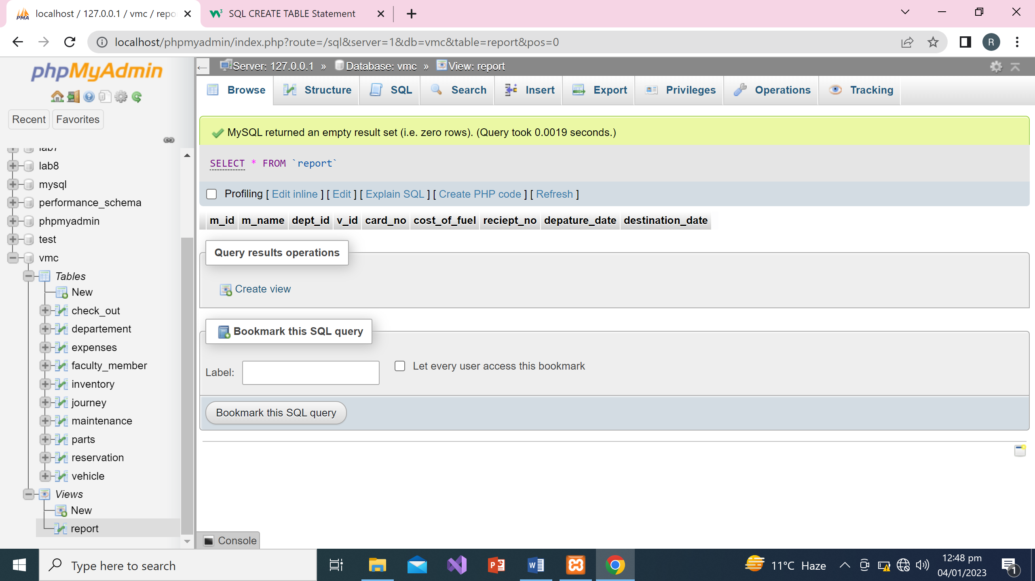

**c) Once the database is created, you need to populate some arbitrary data into the tables to test the business transactions.**

INSERT INTO `faculty_member` (`m_id`, `m_name`, `dept_id`, `phone`) VALUES ('1', 'elis', '1', '+94847647'), ('2', 'Etta', '2', '+345678');

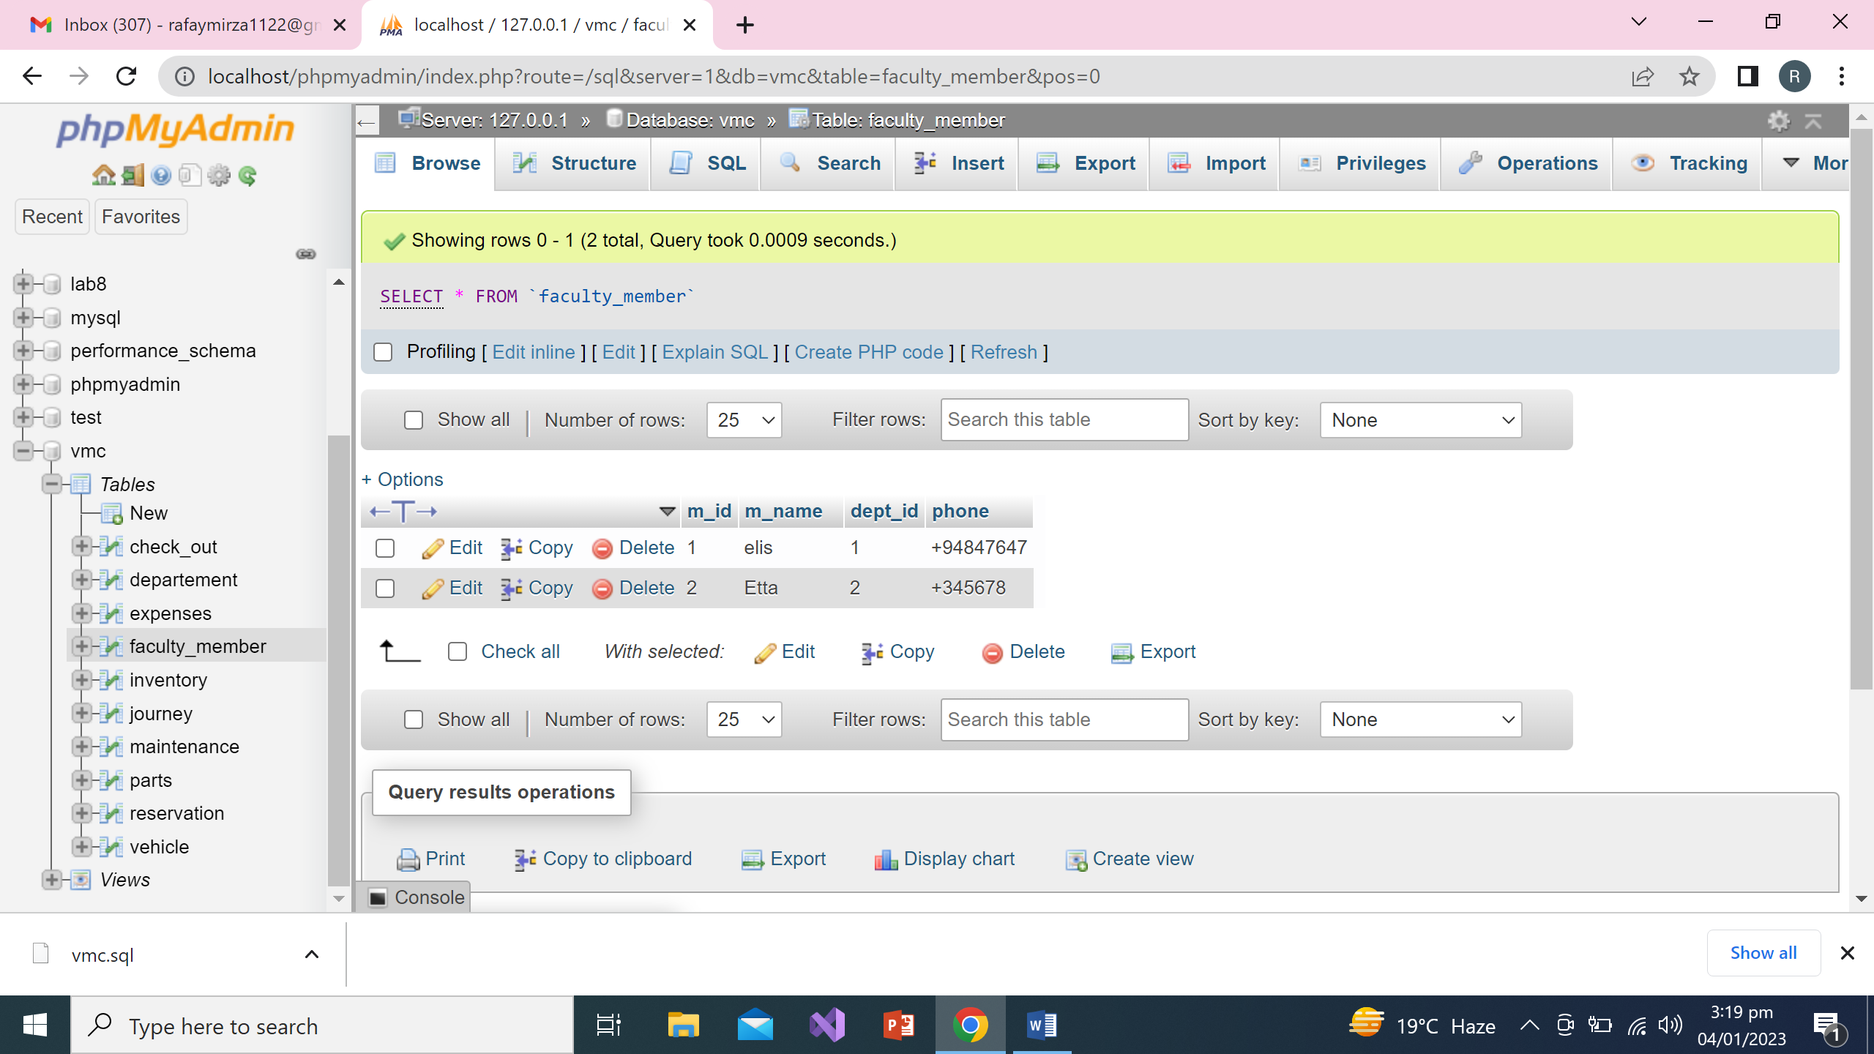

INSERT INTO `departement` (`dept_id`, `dept_name`) VALUES ('1', 'Finance'), ('2', 'Human Resource'), ('3', 'Management'), ('4', 'Accounting'), ('5', 'IT');

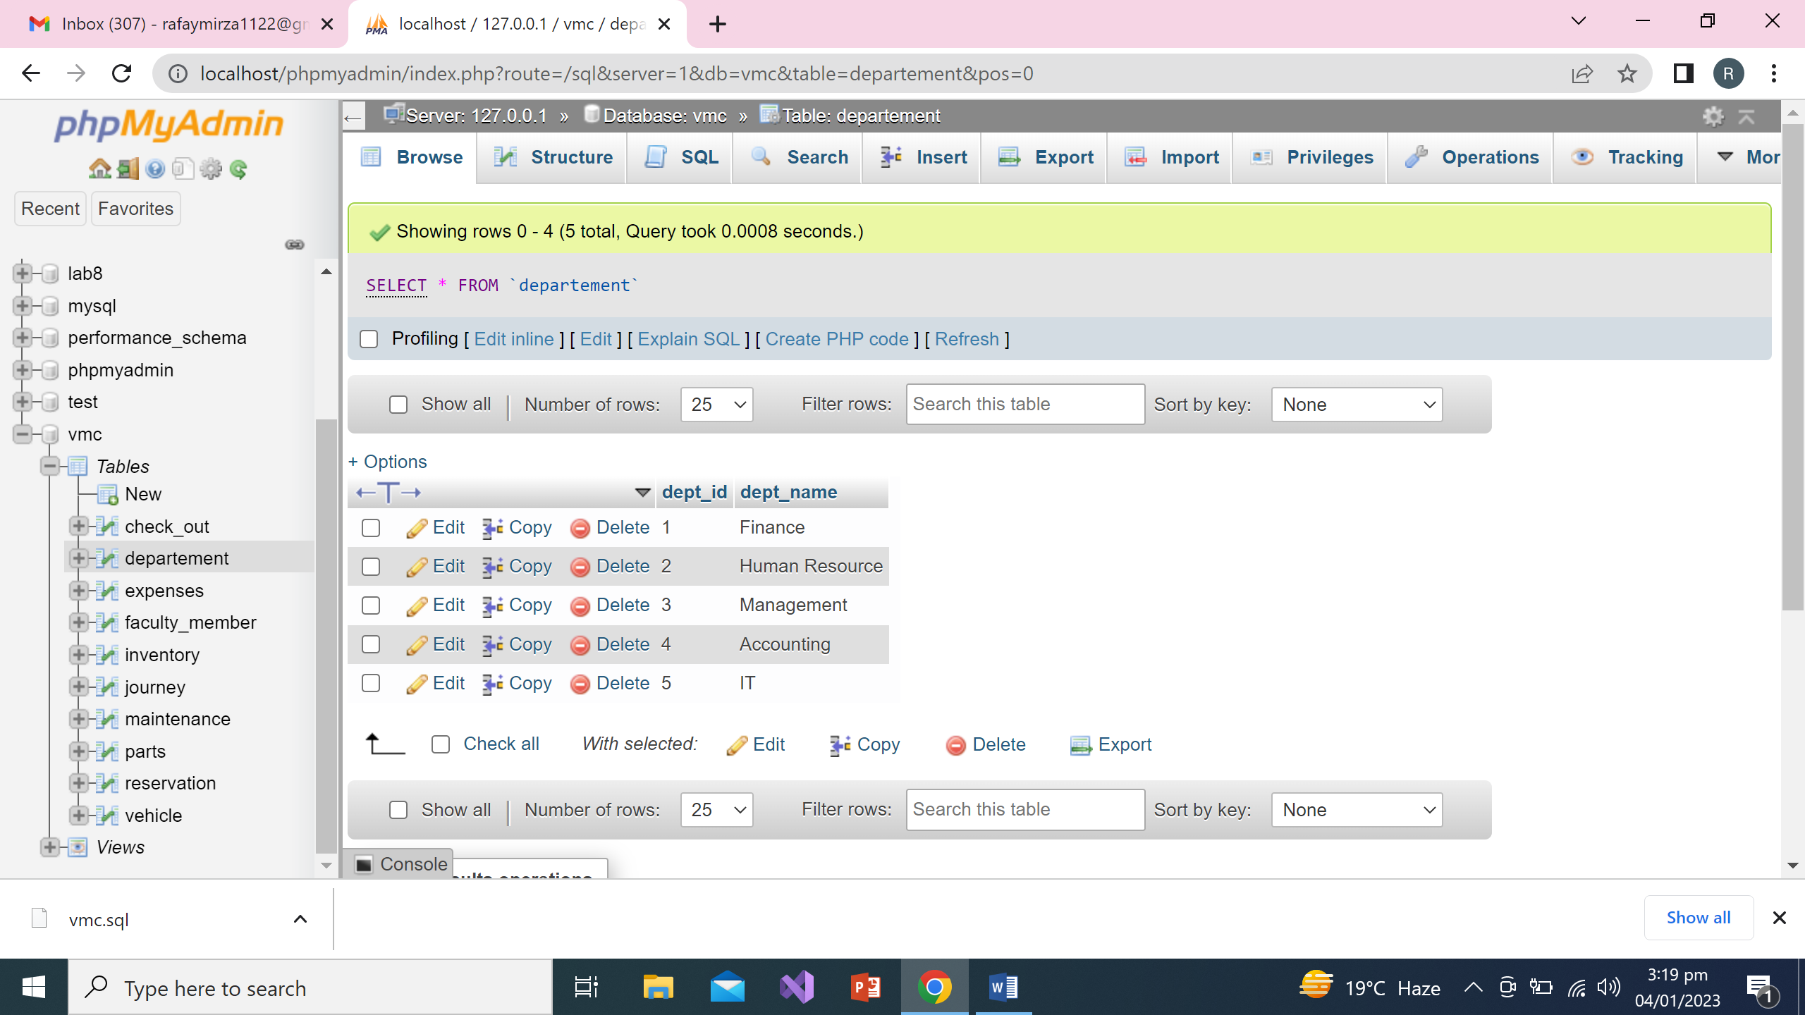

INSERT INTO `vehicle` (`v_id`, `v_name`, `model`) VALUES ('1', 'Classic', '2020'), ('2', 'Gear', '2021'), ('3', 'Fire_class', '2021'), ('4', 'sports', '2022');

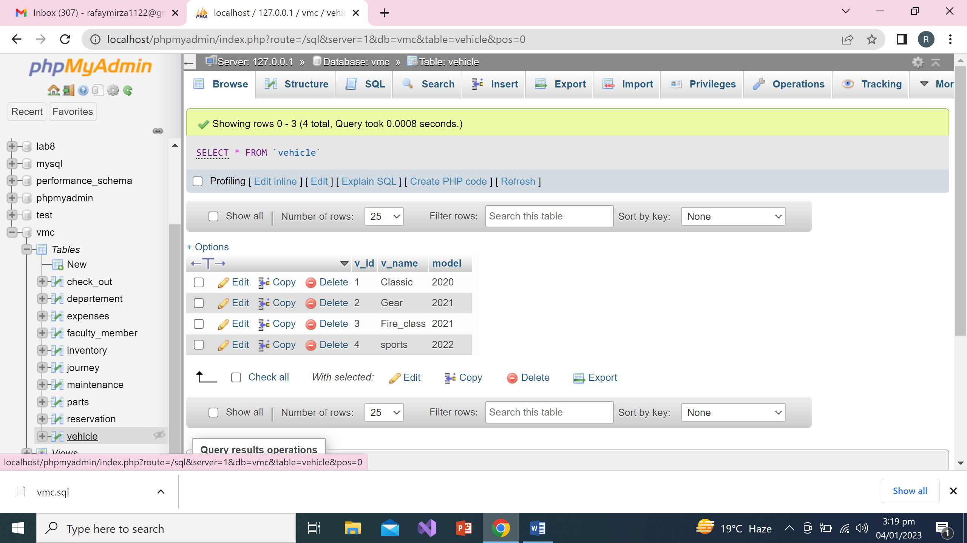

**d) Practically test your database through the use of appropriately designed SQL statements for the provided transactions (refer to section 1); you need to clearly explain the idea of each of your solutions in the report.**

**Typical transactions**

NCU has provided some examples of typical queries that the database system must support:

* Display all available vehicles on a given date.

SELECT

vehicle.v_id,

vehicle.v_name

FROM vehicle

JOIN reservation

ON vehicle.v_id != reservation.v_id;

* Display how many vehicles each department has used so far.

SELECT COUNT(v_id),m_id

FROM reservation GROUP BY `m_id`;

* Show details of a particular bill.

SELECT `m_id`,`v_id`,`card_no`,`cost_of_fuel`,`reciept_no` FROM expenses;

* Display those who booked vehicles but not actually used them.

SELECT reservation.m_id,check_out.user_name

FROM check_out

RIGHT JOIN reservation

ON check_out.m_id = reservation.m_id;