**What changes I have to make to my scanner**

1. 將掃到的Token return 給 Yacc

Before:

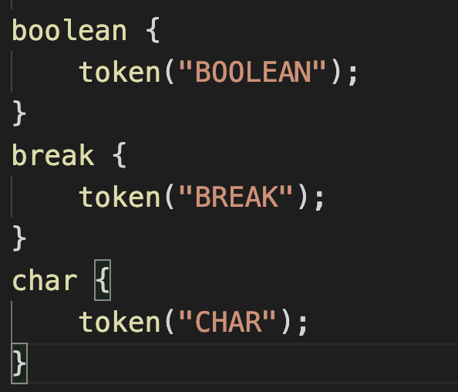

After:

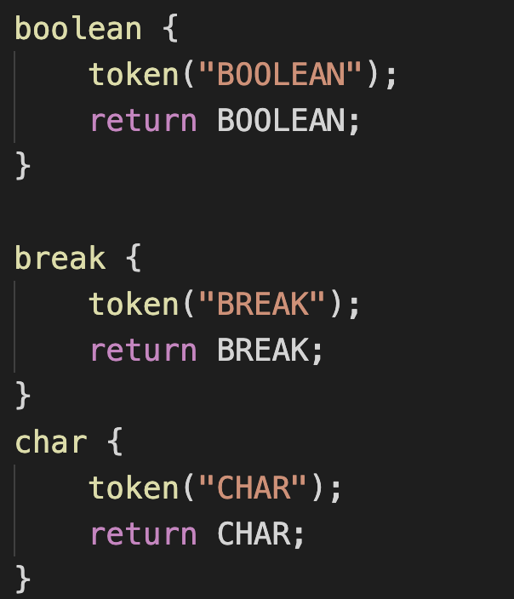

1. 將一些特殊的Token assign到yylval

(true,false,string,char,int,realnum,char,id)

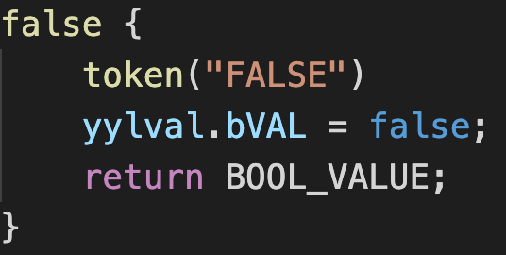

1. 原本的邏輯判斷改成獨立出來，並且也是return給Yacc

Before:

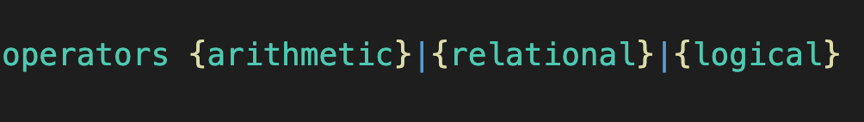

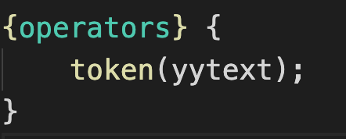

After:

