**Dic 4a**

* A.1
  + **State of affairs** är det nuvarande statet i förhållande till alla andra agenter runt omkring.
  + **Desires** är vad en agent vill göra av sin egen vilja precis som människans desire att önska sig till något. Detta kan exempelvis vara så simpelt som att agenten önskar att bli klar med dess designerade uppgifter då denna är programerad till detta.

Alternativa mål.

* + **Intentions** är agentens ursprunliga avsikt vilket är varför agenten gör något. En agent kan ha en önskan att utföra en uppgift och då är dess intention med vad agentn gör att slutföra sin uppgift och uppnå sitt desire då genom att utföra saker på sådant sett att dess mål uppnås. Intentions är som avsikten bakom varför man gör något och dess anledning.
  + **Commitment** bestämmer hur en agent i stora drag kommer att agera. I språket AGENT0 programeras agenter med initiala belifs, initial commitments och comittment rules, commitment reglerna innehåller en message condition, mental condition och en action. Dessa olika karaktäristikerna matchas tillsamans med ursprungliga belifsen och den mentala conditionen för att avgöra vad agenten skall comitta till och alltså prioritera utförande av.
  + **Belifs** är vad en agent tror om sig själv, andra och sin omgivning. Människor har fördommar medans agenter har antagande om omgivningen. Belifs tolkar omgivningen och skapar en bild av omgivningen som används för att ta sina nästa beslut med mera.
  + **Deliberation** är hur en agent resonerar om vilka actions den skall ta baserat på dess mål och hur man skall gå tillväga baserat på beliefs intentions och desires.
  + Ur mitt liv kan man ta plugg som ett exempel. Det state of affairs jag vill uppnå är att jag skall ha en stadig utbildning och bred grund att bygga på för framtiden. Mina desires är att ta mig igenom utbildningen och få min examen. Min aintentions är att skapa en bra grund för arbetslivet. Min comittment är att jag prioriterar plugg över mycket annat som idag med denna uppgift sitter jag och jobbar med den trots att jag är enligt schema ledig. Mina beliefs är att utbildningen kommer underlätta jobbletande för mig och att det kommer öppna många dörrar i arbetslivet. Deliberations är sammanställningen av allt jag precis nämnt och hur jag kommer kombinera dessa olika saker för att på bästa och smidigaste sätt nå mitt mål, jag har inte direkt något som krockar utav dessa punkter vilket gör att det blir gnaska rakt på sak i mitt fall men för agenter som sammarbetar ed varandra kan där ske konflikter vilket ger andra resultat. Det man kan tänka sig krockar i mitt fall är isåfall sociala aspekter då mina sociala desires krockar med plugg desires.
* A.2
  + Diagram

    Description automatically generated
  + Figuren visar hur alla olika begrepp kombinderas in i planner och blir en plan/recipie på hur man skall uppnå sin task. Min task i detta fallet är examen. Means-end algoritmen som AI använder går ut på att man tolkar sitt mål och sitt enviroment och analyserar olika actions man kan utföra. Resultatet av denna operationen blir som en guide på hur man skall nå sitt mån och tillfredsställa sin task. I mitt fall blir detta att jag analyserar vad mina mål med utbildningen är, examen.

Mean-ends reasoning hade sett ut på ett ungefär:

* + - * Mitt mål: examen
      * Mitt enviroment / beliefs: Mängden föreläsningar samt inlämningar och tentor jag har en given vecka
      * Mina actions: Plugga tenta, skriva inlämning, gå på föreläsning eller vila/ha fritid
      * Min plan blir att om jag har kommande inlämningar pluggar jag ex antal timmar till dessa samt kommande tentor, om jag är klar med mina uppgifter eller har pluggat länge i sträck tar jag en paus och gör något annat och sedan pluggar igen nästa dag tills att alla uppgifter och tentor är klara samt examen uppnås.
* B Questions regarding other material
  + A picture containing text, handwriting, font, letter

    Description automatically generated
  + Målet är att nå en specifik vattennivå Z=0, Z=1 eller Z=2
  + Planen blir våra rules i bilden ovan och består av if-satser

If goal = ”z = 0” and state = “z = 0” then u = 0

--||-- and state = "z = 1” --||--

--||-- and state = "z = 2” --||--

If goal = ”z = 2” and (state = “z = 0”) or (state = “z = 1”) then u = 1

--||-- and state = "z = 2” then u = 0

If goal = ”z = 1” and state = “z = 0” then u = 1

--||-- and state = "z = 1” then u = 0

--||-- and state = "z = 2” --||--

* + Actions som agenten kan utföra är

u = 0 utflöde 🡪 inflöde

u = 1 inflöde 🡪 inflöde

* C Questions regarding the implementation in the project

Arbetsvillkor

Kämpa för demokrati

Skilja sig med fair rättssystem

fackförening

* + C1
    - Frukost kan vara ett av de första målen för en citizen och intentionerna bakom är att få en bra start p åmorgonen. Målen kan variera på morgon dag och kväll så detta var ett morgon mål och när detta är avslutat kan målet ändras til att ta sig genom arbetsdagen och bli klar med sina tasks på jobb vilket sedan leder till att man tar hand om barnen och kanske hämtar de från skola eller liknande. Dessa målen förblir relativt samma under de olika förhållandena vi blev presenterade.
  + C2
    - I en demokrati kan intentions vara att hålla sig sysselsatt och se till att man har mat på bordet och kan erbjuda ett bra liv för familjen. Även en människas intentions förblir rätt samma under olika demokratiska och diktaturistiska förhållanden då man strävar efter och gör mycket samma saker under dagarna, de flesta vuxna har ett jobb för att försörja sig själva och eventuell familj oavsett om denna ger betalt i form av pengar eller annan form.
  + C3
    - Däremor beliefs är något som kan ändra ganska drastiskt. Diktaturer och demokratier ger olika möjligheter för fritiden då man kanske inte får jobba med vad man vill eller tycka och tänka vad man vill, staten kan därmed påberka citizens beliefs båda direkt i en diktatur samt indirekt i en demokrati då samhället påverkar en väldigt mycket. Men beliesfs i en diktatur är ofta mer strikta då man ej får tycka och tänka som man vill vilket man får i en demokrati därmed kan man tro som man vill i en demokrati och utrycka detta medans i en diktatur är det mer staten som formar medborjarnas olika beiefs till något strikt och gemensamt för alla ofta i form av manipulation för att man ej skall ifrågasätta styret i landet.
  + C4
    - Actions är något man väljer att göra, i detta fallet, att göra frukost och att köra till jobbet och de vanliga vardagsaktiviteterna blir någon form av actions i detta fallet och kombinationen av människans dagsvanor blir någon form av plan för hur man skall nå målet med dagen vilket i mångas fall är ta sig igenom arbetsdagen, va med familjen samt att ta det lite lugnt på kvällen. Actions som skiljes åt är yttrandefriheten då du i en demokrati kan prata om vad du vill och därav utföra en action till detta samt att gå och rösta är en form av action som enbart går att göra i en demokrati.

**Dic 4b**

**A.  Questions regarding the theory in the textbook**

Referring to Chapter 4.3 in the textbook, see course activities week 14.

A.1 Study carefully the pseudo programming code in figure 4.3, line by line. Identify the code which corresponds to the four parts of the decision-making process loop as mentioned on pg. 75.

* Uppdatera beliefs
  + Rad 4-5 beliefs, 13-14
* Deliberate
  + Rad 6-7, 16-17
* Mean-ends reasoning
  + Rad 8, 19-21
* Execute plan
  + Rad -12

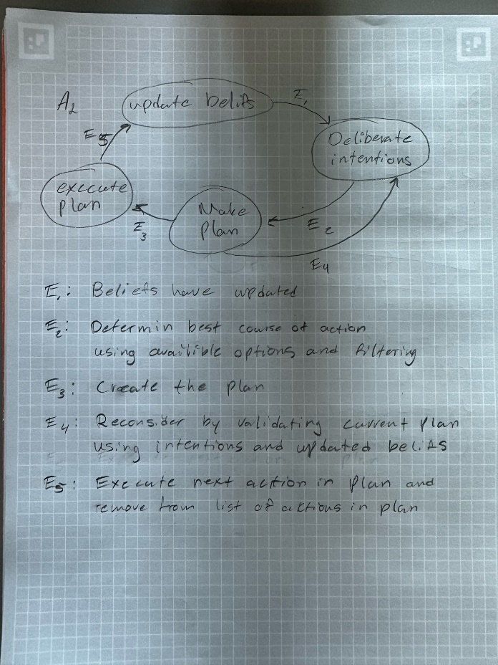A.2 Once you understand the code and the mentioned decision-making process loop, try to draw the decision-making process loop as a finite state machine (by hand on paper, using circles as states and arrows as conditions for state-transitions).

**B.  Questions regarding research articles/the other research material**

If you have problems to understand A.2 above, you might want to repeat once more the content from the lecture slides on state machines from week 13. (No question here to be answered).

**C. Questions regarding the implementation in the project**

C.1 Apply the structure of the final state machine from A.2 above on the citizen agents in a democratic state with the identified beliefs, goals, intentions and actions from DiC_chpt4a. Draw the finite state machine by hand on paper.

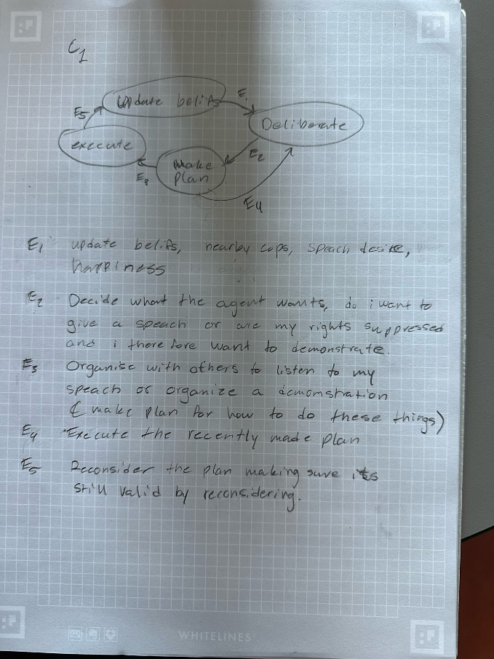

**Dic 8**

**Referring to Chapter 8 in the textbook according to the reading instructions, see course activities week 17.**

**A.1 Task Sharing or Result Sharing:**

1. **discuss the pros and cons of selecting task- versus result sharing for citizen agents organizing and carrying out demonstrations**

Task sharing:

Pros

* Task sharing is the more efficient way to go since we can evenly distribute tasks among our agents, the less busy agents can complete more tasks in a day resulting in being assigned more tasks based on availability and ability, this can lead to more efficiently managed demonstrations.
* Agents can have speciality’s meaning they can have sort of professions so that they complete certain tasks faster than others.
* All agents work on their own trying to complete their own goals independently based on their own beliefs and desires and this can in some cases increase their individual adaptability.

Cons

* Lack of communication could reduce the efficiency of our agents due to a lack of coordination
* Agents with specialities are a double edged sword since it can also lead to less effective groups of agents if they are given tasks they are slower at doing meaning some are done and some are still working hard.

Result sharing

Pros

* Result sharing allows more flexibility when the environment changes around them
* All agents work on independent strategies for optimal demonstrations leading in more diverse and potentially better solotuibs
* Easier to make a combined solution based on all the agents work due to them all working towards the same goal and sharing the results of their actions

Cons

* Agents can complete the sae task resulting in wasted opportunity and reduced efficiency
* Not helping each other could lead to reduced overall problem-solving capabilities due to the agents not helping each other.
* All different solutions might be hard to incorporate into one so some sort of extra step desciding what is the best solution might be needed.

1. **discuss the pros and cons of selecting task- versus result sharing for police agents fighting or turning down demonstrations**

Task sharing:

Pros

* Agents can be allocated to handle different parts of demonstration and manage the citizens and their demonstrations more efficiently.
* You could allocate districts for different cops to handle making sure resources are evenly divided among the city trying to reduce the risk for potential build-ups of angry citizens by scaring them away.

Cons

* Task sharing can strain resources when there is a need for bigger coordination and communication efforts due to them needing to inform other agents about their actions to keep up efficiency. Also dividing everything evenly might not be optimal due to some areas being less populated resulting in having to coordinate mobilisation of the cops to more areas in need.
* Different specialities can reduce the efficiency of some parts of the force and raise the efficiency of others resulting in bottlenecks and agents walking around doing nothing.

Result sharing

Pros

* Easier adaptation to changes in the environment and reduced need for big coordination efforts
* Independent work can lead to more efficient ways of handling demonstrations and allow the cops to be more efficient in their work

Cons

* Different agents can complete the same task resulting in wasted labour
* Working more independently means that less experienced cops cannot take advantage of their more efficient counterparts resulting in a potentially lowered efficiency

**A.2 Agents that work together or help each other need to be coordinated:**

1. **how could the theory of 'partial global planning' be used to coordinate the citizen agents wanting to demonstrate and the police officers trying to stop them?**

The stages of partial global planning are determining goals, exchanging informayion, altering local plans.

The goals for cops and citizens are to achieve safety and a working city, or for the citizens it is to organise a peaceful demonstration and voice their concerns and exercise their freedom of speech. This can be done by applying the theory of partial global planning by simply following the steps.

1. **how could the theory of 'joint intentions' be used to coordinate the citizen agents wanting to demonstrate and the police officers trying to stop them?**

Joint intentions wants to promote the idea of shared goals and this can be used to coordinate demonstrations in a peaceful manner between cops and citizens by finding common ground and making boundraries for what they are allowed to do and what they get in turn and such. Creating a sort of give and take scenario between our agent types. By doing this our different agents can come to a peaceful solution that satisfies both parts.

1. **Which one of the coordination theories 'partial global planning' or 'joint intentions' is best suited for the case of citizens demonstrating? Which one for police officers stopping demonstrations? Explain your reasoning.**

For demonstrations I believe joint intentions to be best since it is sort of how it is done in real life when peaceful organized demonstrations and such are made. By collaborating and making sure all laws are followed bith citizens can be pleased by getting to voice their concerns and police can be satisfied by the demonstration staying within legal boundaries.

For stopping a demonstration we could also use joint intentions by negotiating with the demonstrators however I feel like this is not always the best rout to take and finding a solution in the midst of chaos can be hard and result in the cops having to eventually go to a more patial global planning strategy by making a efficient and adaptable plan for how to resolve the issue and maintaining order and safety.

**A.3 Committment of demonstrating citizen agents:**

* **How committed shall citizen agents be towards demonstrating? Study the code in figure 8.5 on pg 169 to get some ideas of possible requirements that a citizen agent could use when trying to decide if it should continue to demonstrate or not. Be specific about how the citizen agent shall reassess its joint commitment and select actions to repair failed teamwork.**

Agents should be very committed to what they believe in however they should not let their own safety be questioned. They need to be able to adapt and be able to respond to changes in environments and their goals.

Possible requirements as followed by figure 8.5

Match rules

R1: if a task has been finished and this task has produced a desired outcome then the joint goal is satisfied

R2: if a bit of received information is related to a condition for the joint goal and the received information invalidates current beliefs for current joint goal then this motivation disappears.

R3: if a task is delayed and this task is a step towards something else and this task needs to be synchronised with another task then the end goal of these tasks is violated

R4: if a big task built up by smaller tasks in finished and the expected results were not produced and an alternate solution exists then the big task is invalid

Select rules

R1: If joint goal is satisfied then abandon all other activity correlated with this goal and inform cooperation module of success

R2: if motivation for joint goal no longer exists then abandon all associated local activities towards goal and inform cooperation module

R3: if common big task is violated and it can be rescheduled then suspend local activities associated with the task and redet all timings and desctiptiond accciated with the task and inform cooperation module

R4: if a big task is invalid and alternare solution for task exists then abandon all local activities twords old solution and inform cooperation module that the old solution is invalid and propose the new solution to cooperation module.

**B.  Questions regarding research articles/the other research material**

**No additional material to the text book is being provided, hence there are no such questions.**

**C. Questions regarding the implementation in the project**

**Referring to the citizens agents and the police (cops) agents.**

**Surrounding the figure 8.5 on pages 168 and 170 a 'teamwork-based model of CDPS' is being explained. It describes the process of a team of agents working together in four stages. Elaborate each one of the four stages first for the citizens-agents organizing and running demonstrations and then for cops agents trying to stop them. Make use of the studied theory in this chapter to be as specific as possible in how to program each one of the stages for each type of agents.**

**C.1 How could the implementation of the stages 'recognition', 'team formation', 'plan formation' and 'team action' look like for citizen agents that want to demonstrate? (Describe each stage with words and with pseudo code).**

Recognition is when a citizen realises they need to demonstrate

To citizen-anger

If anger > 50 and demonstration? Is false

Set demonstration true

End

Team formation is when agents come together with a joint intention forming a group that works together to better achieve this common goal

To join-demonstration

Broadcast-to-nearby-citizens

Request “recruit a team”

If demonstration? is true and member-of-team? Is false

Create-links other citizens with [demonstration?]

Set member-of-team? True

End

Plan formation is the team working together to make a plan by discussing how to best achive their goal and what ways it can be done.

To make-plan

If member-of-team? And not plan?

Ask citizens with [demonstration][

Set goal work-towords-goal

Set strategy make-a-strategy

Set role random-part-of-plan

]

Set plan? True

End

Team action is the execution of the created plan and coordination of the plan

To execute-plan

If plan?

Ask citizens with [demonstration][

Execute-part-of-plan

Adapt-to-enviroment

]

end

**C.2 How could the implementation of the stages 'recognition', 'team formation', 'plan formation' and 'team action' look like for cops agents that want to stop citizen agents from demonstrating? (Describe each stage with words and with pseudo code).**

Recogniton for cops would be to identify nearby demonstrations

If demonstration-nearby

Set stop-demonstration? true

End

Team formation is the cops gathering around to combine forces to be able to stop the demonstration

To stop-demonstration

If stop demonstration? And member-of-team? Is false

Broadcast-to-nearby-cops

Request “stop demonstration”

If stop-demonstration? and member-of-team? Is false

Create-links other cops with [stop-demonstration?]

Set member-of-team? True

End

Plan formation is the team working together to make a plan of how to stop the demonstration

To make-plan

If member-of-team? And not plan?

Ask cops with [stop-demonstration][

Set goal work-towards-goal

Set strategy make-a-strategy

Set role random-part-of-plan

]

Set plan? True

End

Team action is the cops executing the current plan and working together to do so.

To execute-plan

If plan?

Ask cops with [demonstration][

Execute-part-of-plan

Adapt-to-environment

]

End