Uppgift 1

Uppgift 2

Uppgift 3a

Uppgift 3b

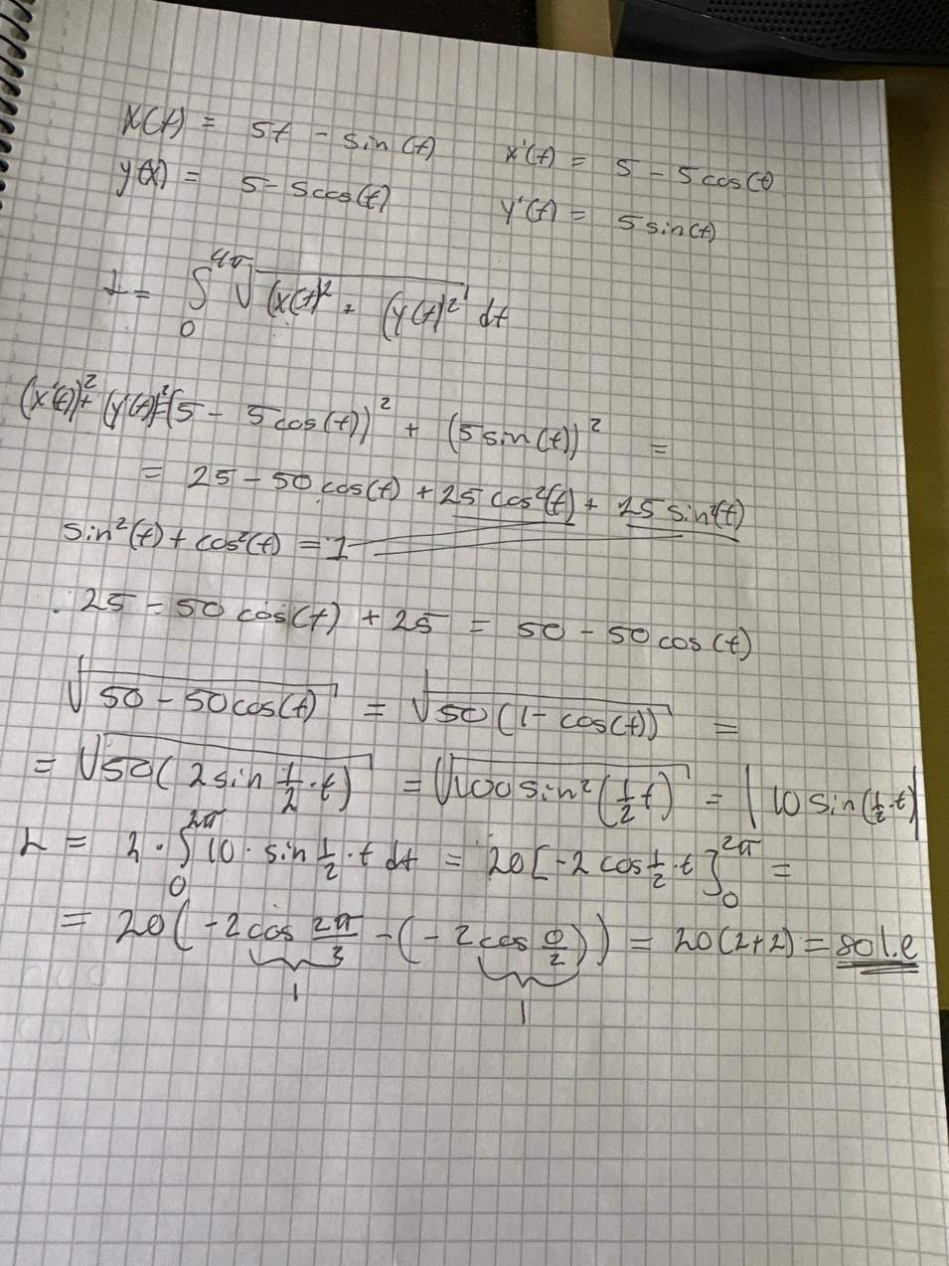Uppgift 3c

Uppgift 4a

ax^2 + b, b = 2, a = 0.1

0.1x^2 + 2

Uppgift 4b

