1. Introduction
Referring to Flasky documentation, we have:

Acceptance Criteria / EPICs
As a UI user I can:
1: Register through web portal
2: Review my own user information from the main view
As an API Consumer I can:
1: Review users registered in system
2: If authenticated I can get personal information of users
3: If authenticated I can update personal information of users

In this document, we will break down UI EPIC #1 and API Epic #3 into user stories/requirements.
While doing so, we will also provide flowcharts on
- how registration form works for UI EPIC #1
- How API works for API Epic #3

2. EPIC: As a UI user, I can register through web portal
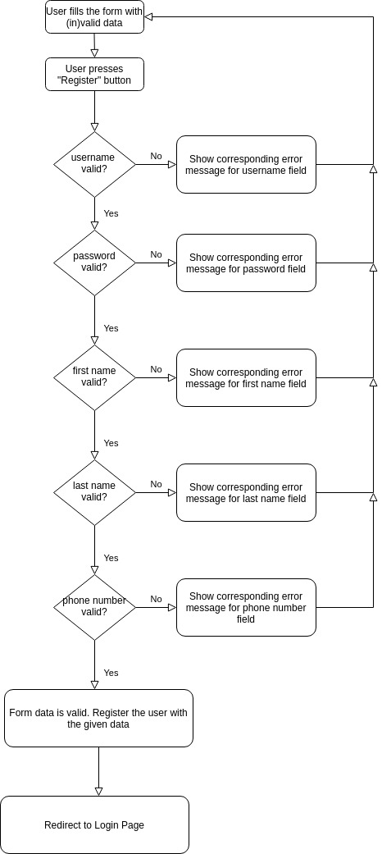

Figure 1 – In case of errors, registration form gives 1 error at a time from top to bottom

As shown in Figure 1, the design of the registration form has chosen a lean approach; Instead of showing all the errors at once, it shows the errors 1 error at a time from top to bottom. So, each time user corrects the error and presses “Register” button, then the form shows the next error and so on until there are no more errors in the form data. Then registration must succeed and user must be redirected to login page.

1) All 5 fields are mandatory; If any of the fields is missing, then "Please fill out this field." error message is shown. Note that Figure 1 still applies; if many fields are missing, then only the topmost one’s error message is shown.

3) All 5 fields are verified against their respective requirements:
a) Username field’s rules:

Requirement ID / Tag | Description | Status
REQ-REG-FORM-USERNAME-1 | Referring to Fig-1, among other fields, username field has the first priority when it comes to showing error | FAIL
REQ-REG-FORM-USERNAME-2 | Minimum 8 characters | FAIL
REQ-REG-FORM-USERNAME-3 | Alpha numeric characters and non-alpha numeric characters and their mix are allowed | PASS
REQ-REG-FORM-USERNAME-4 | Space character is not allowed | FAIL
REQ-REG-FORM-  USERNAME-5 | If username is missing, then "Please fill out this field." error message is shown. Note that Figure 1 still applies; if many fields are missing or incorrect, then username’s error message is shown. | PASS

b) Password field’s rules

Requirement ID / Tag | Description | Status
REQ-REG-FORM-PASSWORD-1 | Referring to Fig-1, among other fields, password field has the second priority when it comes to showing error | FAIL
REQ-REG-FORM-PASSWORD-2 | Minimum 8 characters | FAIL
REQ-REG-FORM-PASSWORD-3 | Must include at least one character from the sets [a-z],  [A-Z], [0-9] and [!?.] | FAIL
REQ-REG-FORM-  PASSWORD-4 | If password is missing, then "Please fill out this field." error message is shown. Note that Figure 1 still applies; if many fields are missing or incorrect, then only the topmost one’s error message is shown | FAIL

c) First Name field’s rules:

Imagine there is a person with full name: Helena Margaretha Holm Cuzdan.
Note that Margaretha is the 2.nd first name and Cuzdan is the 2.nd last name.

Imagine there is a person with full name: Ha Xi (a valid Vietnamese full name)

Requirement ID / Tag | Description | Status
REQ-REG-FORM-FIRST-NAME-1 | Referring to Fig-1, among other fields, first name field has the third priority when it comes to showing error | FAIL
REQ-REG-FORM-FIRST-NAME-2 | Minimum 2 characters for each word (e.g. Ha Xi but not H X, or Ha but not H) | FAIL
REQ-REG-FORM-FIRST-NAME-3 | Must contain letters from the set [a-zA-Z] for each word | PASS
REQ-REG-FORM-FIRST-NAME-5 | Cannot contain numbers | FAIL
REQ-REG-FORM-FIRST-NAME-6 | Cannot contain non-alphanumeric characters | FAIL
REQ-REG-FORM-FIRST-NAME-7 | Can contain two first names, which must be separated with a single space (e.g. 'Holm Cuzdan' but not 'Holm Cuzdan') | FAIL
REQ-REG-FORM-FIRST-NAME-8 | If first name is missing, then "Please fill out this field." error message is shown. Note that Figure 1 still applies; if many fields are missing or incorrect, then only the topmost one’s error message is shown | FAIL

d) Last Name

Requirement ID | Description | Status
REQ-REG-FORM-LAST-NAME-1 | Referring to Fig-1, among other fields, last name field has the fourth priority when it comes to showing error | FAIL
REQ-REG-FORM-LAST-NAME-2 | Each word must be at least 2 letters (e.g. Ha Xi but not H X, or Ha but not H) | FAIL
REQ-REG-FORM-LAST-NAME-3 | Must contain letters from the set [a-zA-Z] for each word | PASS
REQ-REG-FORM-LAST-NAME-5 | Cannot contain numbers | FAIL
REQ-REG-FORM-LAST-NAME-6 | Cannot contain non-alphanumeric characters | FAIL
REQ-REG-FORM-LAST-NAME-7 | A single space must separate the last names, if there are 2 last names (e.g. 'Holm Cuzdan' but not 'Holm Cuzdan') | FAIL
REQ-REG-FORM-LAST-NAME-8 | If last name is missing, then "Please fill out this field." error message is shown. Note that Figure 1 still applies; if many fields are missing or incorrect, then only the topmost one’s error message is shown | FAIL

e) Phone number

This is a mobile phone number from any country, not a fixed line. Referring to https://en.wikipedia.org/wiki/List_of_mobile_telephone_prefixes_by_country

Requirement ID/Tag | Description | Status
REQ-REG-FORM-PHONE-NUMBER-1 | May contain a single '+' character as the first character and the rest must be numbers | FAIL
REQ-REG-FORM-PHONE-NUMBER-2 | If REQ-REG-FORM-PHONE-NUMBER-1 is not met, then it must contain only numbers | PASS
REQ-REG-FORM-PHONE-NUMBER-3 | Must not contain alphabetic characters [a-zA-Z] | FAIL
REQ-REG-FORM-PHONE-NUMBER-4 | Must not contain non-alphanumeric characters | FAIL
REQ-REG-FORM-PHONE-NUMBER-5 | Must not contain space(s) | FAIL
REQ-REG-FORM-PHONE-NUMBER-6 | Referring to Fig-1, among other fields, phone number field has the least priority when it comes to showing error for a typed phone number | FAIL
REQ-REG-FORM-PHONE-NUMBER-7 | If phone number is missing, then "Please fill out this field." error message is shown. Referring to Fig-1, among other fields, phone number field has the least priority when it comes to showing error | FAIL

IMPORTANT! Each requirement may have multiple test cases. Requirement Ids are used as tags in automated test cases.

3. EPIC: As an API User, If authenticated I can update personal information of users
In the next page, we give how api is supposed to work when it comes to the epic in question.
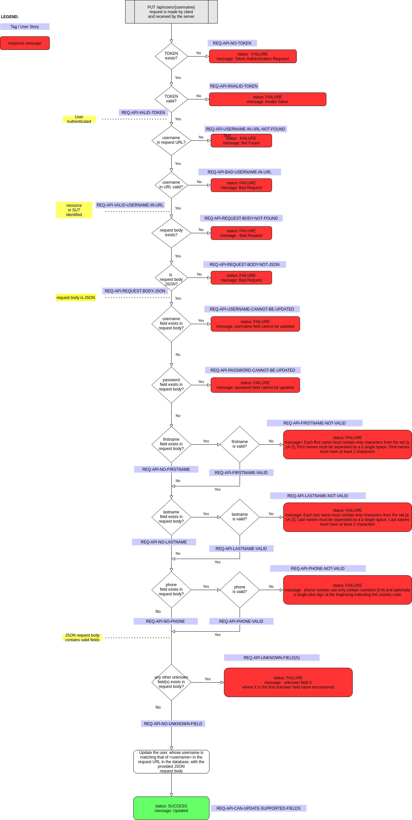
Figure 2 – How API works when it comes to the epic “Updating personal information of users”
Referring to Fig. 2, we have the following user stories & their status:
(*) Exploratory tested with POSTMAN only
(**) Automated & tagged
Definitions:
(1) System User: The user, who is registered to the system under test with a valid token
(2) API User: The user, who calls the API to update personal information of the system user
Tag / User Story | Description | Status | Explanation
REQ-API-NO-TOKEN | When no token is provided with otherwise valid update request | PASSED (*)
REQ-API-INVALID-TOKEN | When the given token is invalid with otherwise valid update request | PASSED (*)
REQ-API-VALID-TOKEN | When the given token is valid with a (in)valid update request. This is an epic containing the sub user stories in the subsequent rows. | FAILED (*) | Some of the subsequent sub stories failed
REQ-API-USERNAME-IN-URL-NOT-FOUND | When the token is valid, we make a PUT request to /api/users with otherwise valid update request | FAILED (*) | API returns HTML, when JSON is expected
REQ-API-BAD-USERNAME-IN-URL | We make a PUT request to /api/users/non-existing-user with otherwise valid update request | FAILED (*) | 500 Internal server error
REQ-API-VALID-USERNAME-IN-URL | When the given username is valid with a (in)valid update request. This is an epic containing the sub user stories in the subsequent rows. | FAILED (*) | Some of the subsequent sub stories failed
REQ-API-REQUEST-BODY-NOT-FOUND | For otherwise a valid request, we provide no body in request | FAILED (*) | API returns HTML, when JSON is expected
REQ-API-REQUEST-BODY-NOT-JSON | For otherwise a valid request, we provide XML/HTML body in request | FAILED (*) | API returns HTML, when JSON is expected
REQ-API-REQUEST-BODY-JSON | When the given request body is JSON with a (in)valid update request. This is an epic containing the sub user stories in the subsequent rows. | FAILED (*) | Some of the subsequent sub stories failed
REQ-API-USERNAME-CANNOT-BE-UPDATED | Using all valid tokens, each time we attempt to update username of all users with valid <username> in request URL and a JSON request body | FAILED (**) | Refer to the robot’s test report. API returns HTML response, but JSON is expected
REQ-API-PASSWORD-CANNOT-BE-UPDATED | Using all valid tokens, each time we attempt to update password of all users with valid <username> in request URL and a JSON request body | FAILED (**) | Refer to the robot’s test report. API returns HTML response, but JSON is expected
REQ-API-FIRSTNAME-NOT-VALID | Using all valid tokens, each time we attempt to update firstname of all users with valid <username> in request URL and a JSON request body but with invalid firstname data | FAILED (**) | Refer to the robot’s test report. API returns HTML response, but JSON is expected
REQ-API-FIRSTNAME-VALID | Using all valid tokens, each time we attempt to update firstname of all users with valid <username> in request URL and a JSON request body and with valid firstname data | FAILED (**) | Refer to the robot’s test report. API returns HTML response, but JSON is expected
REQ-API-NO-FIRSTNAME | Using all valid tokens, each time we attempt to update lastname/phone of all users with valid <username> in request URL and a JSON request body and with (in)valid lastname/phone data. This is an epic containing the sub user stories in the subsequent rows. | FAILED (**) | Refer to the robot’s test report. API returns HTML response, but JSON is expected
REQ-API-LASTNAME-NOT-VALID | Using all valid tokens, each time we attempt to update lastname of all users with valid <username> in request URL and a JSON request body but with invalid lastname data | FAILED (**) | Refer to the robot’s test report. API returns HTML response, but JSON is expected
REQ-API-LASTNAME-VALID | Using all valid tokens, each time we attempt to update lastname of all users with valid <username> in request URL and a JSON request body and with valid lastname data | FAILED (**) | Refer to the robot’s test report. API returns HTML response, but JSON is expected
REQ-API-NO-LASTNAME | Using all valid tokens, each time we attempt to update phone of all users with valid <username> in request URL and a JSON request body and with (in)valid phone data. This is an epic containing the sub user stories in the subsequent rows. | FAILED (**) | Refer to the robot’s test report. API returns HTML response, but JSON is expected
REQ-API-PHONE-NOT-VALID | Using all valid tokens, each time we attempt to update phone of all users with valid <username> in request URL and a JSON request body but with invalid phone data | FAILED (**) | Refer to the robot’s test report. API returns HTML response, but JSON is expected
REQ-API-PHONE-VALID | Using all valid tokens, each time we attempt to update phone of all users with valid <username> in request URL and a JSON request body and with valid phone data | FAILED (**) | Refer to the robot’s test report. API returns HTML response, but JSON is expected
REQ-API-NO-PHONE | We have a mix of valid firstname & lastname in request body. Using all valid tokens, each time we attempt to update those field(s) of all users with valid <username> in request URL and a JSON request body. | FAILED | Refer to the robot’s test report. API returns HTML response, but JSON is expected
REQ-API-UNKNOWN-FIELD(S) | In request body, we have field(s) that are unknown to system under test (SUT). Otherwise, we have all the requirements for the request satisfied, such as token, request URL, JSON request body and known fields in JSON like firstname, lastname and phone. | FAILED | Refer to the robot’s test report. API returns HTML response, but JSON is expected

IMPORTANT: You can refer to the Robot’s test report, where test cases are properly tagged with the tags referred in the above table. Also, you can refer to TestProject/Postman/CRF Demo App & API.postman_collection.json file having the POSTMAN call collection for exploratory testing.

