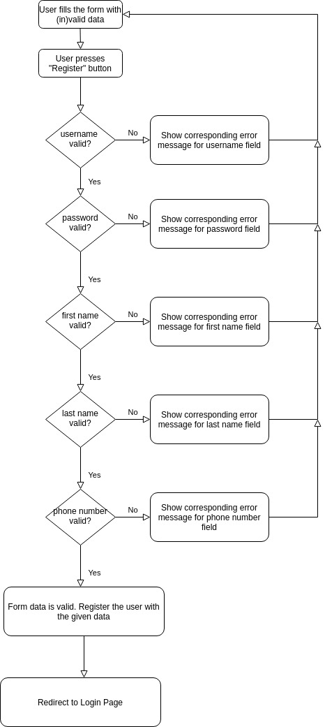
Requirements For Register Form Functionality

Figure 1 – In case of errors, registration form gives 1 error at a time from top to bottom
As shown in Figure 1, the design of the registration form has chosen a lean approach; Instead of showing all the errors at once, it shows the errors 1 error at a time from top to bottom. So, each time user corrects the error and presses “Register” button, then the form shows the next error and so on until there are no more errors in the form data. Then registration must succeed and user must be redirected to login page.

1) All 5 fields are mandatory.
2) If any of the fields are missing, then "Please fill out this field." error message is shown. Note that Figure 1 still applies (i.e. if many fields have errors, then only the topmost one’s error is shown)

3) All 5 fields are verified against their respective rules:
a) Username field’s rules:
- Minimum 8 characters
- Alpha numeric characters and non-alpha numeric characters are allowed
- Space character is not allowed
b) Password
- Minimum 8 characters
- Must include at least one character from the set [a-z]
- Must include at least one character from the set [A-Z]
- Must include at least one character from the set [0-9]
- Must include at least one character from the set [!?.]

Imagine there is a person with full name: Helena Margaretha Holm Cuzdan.
Note that Margaretha is the 2.nd first name and Cuzdan is the 2.nd last name.

Imagine there is a person with full name: Ha Xi (a valid Vietnamiese full name)

c) First Name
- Must take into account 2.nd first name if exists
- Must contain letters from the set [a-zA-Z] for each word
- Each word must be at least 2 letters (e.g. Ha)
- Cannot contain numbers
- Cannot contain non-alphanumeric characters
- A single space must seperate the first names, if there are 2 first names (e.g. 'Helena Margaretha'
but not 'Helena Margaretha')
d) Last Name
- Must take into account 2.nd last name if exists
- Must contain letters from the set [a-zA-Z] for each word
- Each word must be at least 2 letters (e.g. Xi)
- Cannot contain numbers
- Cannot contain non-alphanumeric characters
- A single space must seperate the last names, if there are 2 first names (e.g. 'Holm Cuzdan'
but not 'Holm Cuzdan')

e) Phone number
- I assume this is a mobile phone number from any country, not a fixed line.
- Referring to https://en.wikipedia.org/wiki/List_of_mobile_telephone_prefixes_by_country
- May contain a single '+' character as the first character
- May only contain numbers but not alphabetic characters [a-zA-Z] nor non-alphanumeric characters
- cannot contain spaces
4) If any of the fields does fail against its respective verification, an error message is shown

