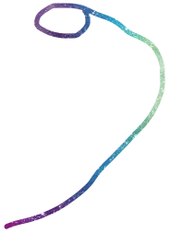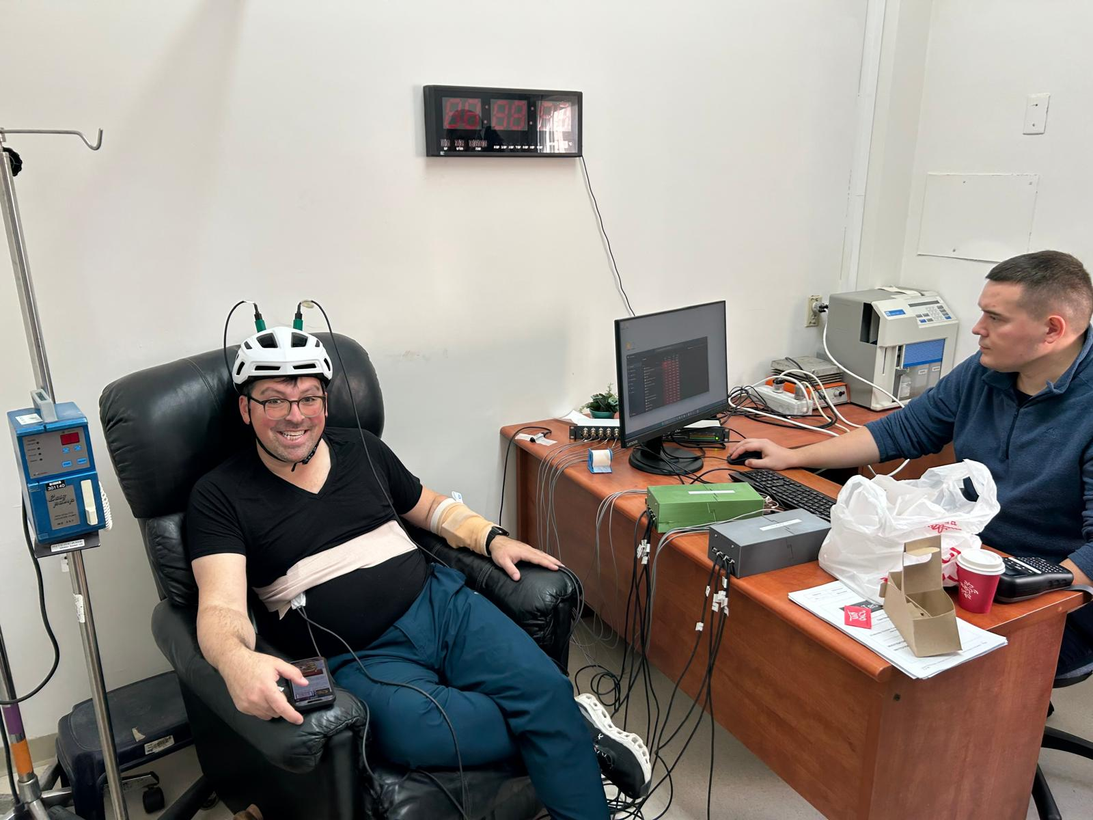

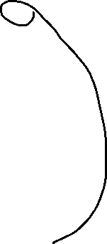

We have 8 sensors/Channels measuring simultaneously.

1. 2 sensors L Forearm
2. 2 Sensors RUQ (over liver area)
3. 2 sensors in helmet
4. 2 sensors on table facing subject (bkgd EMF)

For the T1DM there will be IV’s in each arm, one of them will be connected to an IVAC system for insulin administration. The experiment starts with a stable glucose level, administer insulin to create a close to low of 70 (MOH didn’t allow going totally low to 60) and then a sugar laden drink to create a hyperglycemic event, additional insulin to normoglycemia and then release.

We will be getting a CSV for the CGM data, and will have an Excel for blood samples for glucose every 10 minutes for the period of excursions (ie from initiation of insulin till stabilization).