

Name: Ganji Madhan Kumar Reg.no:192472328

Course: Artificial Intelligence Code: CSA1709

Faculty Name: Rajaram p

Experiment No: 1
Title: Write a Python Program to Solve the 8-Puzzle Problem Aim
To develop a Python program to solve the 8-Puzzle Problem using the Breadth First Search (BFS) algorithm and obtain the sequence of moves from the initial state to the goal state.

Objective
To implement the Breadth First Search (BFS) algorithm for solving the 8-Puzzle Problem by exploring all possible states until the goal state is reached.

Algorithm
- Step 1: Define the goal state of the puzzle.
- Step 2: Read the initial state from the user.
- Step 3: Insert the initial state into the queue.
- Step 4: Remove the first state from the queue.
- Step 5: Generate all possible valid moves of the blank tile.
- Step 6: Compare each new state with the goal state.
- Step 7: If the goal state is found, display the solution.
- Step 8: Otherwise, add unvisited states to the queue and repeat the process until the goal state is reached.

Program
from collections import deque

# Goal State goal = [1, 2, 3,
4, 5, 6,
7, 8, 0]

# Print the puzzle as a 3x3 matrix def print_board(state):
for i in range(0, 9, 3):
print(state[i], state[i+1], state[i+2])

print()

# Generate all possible moves def get_moves(state):
moves = []
pos = state.index(0)

# Up
if pos >= 3: new = state[:]
new[pos], new[pos-3] = new[pos-3], new[pos] moves.append(new)

# Down
if pos <= 5: new = state[:]
new[pos], new[pos+3] = new[pos+3], new[pos] moves.append(new)

# Left
if pos % 3 != 0: new = state[:]
new[pos], new[pos-1] = new[pos-1], new[pos] moves.append(new)

# Right
if pos % 3 != 2: new = state[:]
new[pos], new[pos+1] = new[pos+1], new[pos]

moves.append(new)

return moves

# BFS Algorithm def bfs(start):
queue = deque([start]) visited = []

while queue:
state = queue.popleft()

if state == goal:
print("Goal State Reached!\n") print_board(state)
return

if state not in visited: visited.append(state)

print("Current State:") print_board(state)

for move in get_moves(state): if move not in visited:
queue.append(move)

print("No Solution Found")

# User Input
print("Enter the Initial State (Use 0 for Blank):") start = list(map(int, input().split()))

bfs(start)

Sample Input
Enter the Initial State (Use 0 for Blank): 1 2 3 4 0 6 7 5 8

Sample Output
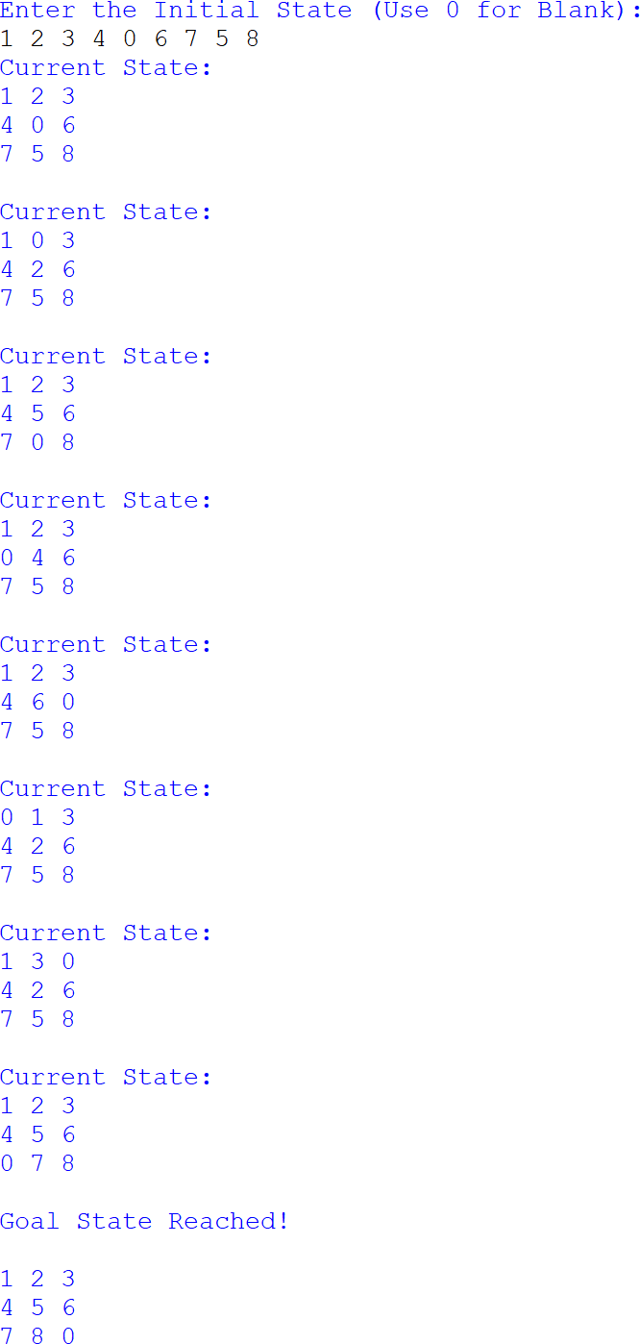

Result
Thus, the Python program to solve the 8-Puzzle Problem using the Breadth First Search (BFS) algorithm was executed successfully and the goal state was reached.

Experiment No: 2
Title: Write a Python Program to Solve the 8-Queen Problem Aim
To develop a Python program to solve the 8-Queen Problem using the Backtracking algorithm by placing eight queens on a chessboard such that no two queens attack each other.

Objective
To implement the Backtracking algorithm for finding a valid arrangement of eight queens on an 8 × 8 chessboard while satisfying all the constraints.

Algorithm
- Step 1: Define the size of the chessboard as 8 × 8.
- Step 2: Start placing queens from the first row.
- Step 3: Check whether the current position is safe.
- Step 4: If the position is safe, place the queen.
- Step 5: Move to the next row and repeat the process.
- Step 6: If no safe position is found, backtrack to the previous row.
- Step 7: Continue until all eight queens are placed.
- Step 8: Display the final arrangement of queens.

Program
N = 8

board = [[0 for _ in range(N)] for _ in range(N)]

def is_safe(row, col): # Check left side for i in range(col):
if board[row][i] == 1: return False

# Check upper diagonal i, j = row, col

while i >= 0 and j >= 0: if board[i][j] == 1:
return False
i -= 1
j -= 1

# Check lower diagonal i, j = row, col
while i < N and j >= 0: if board[i][j] == 1: return False
i += 1
j -= 1

return True

def solve(col): if col >= N:
return True

for row in range(N): if is_safe(row, col):
board[row][col] = 1

if solve(col + 1): return True

board[row][col] = 0

return False

if solve(0):
print("Solution Found:\n") for row in board:
print(*row)
else:
print("No Solution Exists")

Sample Input
No user input required.

Sample Output

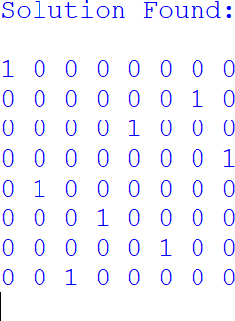

Result
Thus, the Python program to solve the 8-Queen Problem using the Backtracking algorithm was executed successfully, and a valid arrangement of eight queens was obtained.

Experiment No: 3
Title: Write a Python Program for the Water Jug Problem Aim
To develop a Python program to solve the Water Jug Problem by determining the sequence of operations required to measure the desired quantity of water using two jugs of different capacities.

Objective
To implement the Water Jug Problem in Python using the operations of filling, emptying, and transferring water between the two jugs until the required quantity of water is obtained.

Algorithm
- Step 1: Start the program.
- Step 2: Read the capacities of Jug 1, Jug 2, and the target quantity from the user.
- Step 3: Check whether the target quantity can be achieved.
- Step 4: If the target is not possible, display an appropriate message and stop.
- Step 5: Fill Jug 1 with water.
- Step 6: Pour water from Jug 1 to Jug 2 and empty Jug 2 whenever it becomes full.
- Step 7: Repeat the process until the target quantity is obtained.
- Step 8: Display the steps and print the success message.

Program
from math import gcd

def water_jug(jug1, jug2, target): if target > max(jug1, jug2):
print("Target cannot be achieved.") return

if target % gcd(jug1, jug2) != 0: print("Target cannot be achieved.") return

x = 0
y = 0

print("\nSteps:")

while x != target and y != target:

if x == 0: x = jug1
print(f"Fill Jug1 -> ({x}, {y})")

elif y == jug2: y = 0
print(f"Empty Jug2 -> ({x}, {y})")

else:
transfer = min(x, jug2 - y) x -= transfer
y += transfer
print(f"Pour Jug1 -> Jug2 -> ({x}, {y})")

print("\nTarget achieved!")

jug1 = int(input("Enter capacity of Jug1: ")) jug2 = int(input("Enter capacity of Jug2: ")) target = int(input("Enter target quantity: "))

water_jug(jug1, jug2, target)

Sample Input
Enter capacity of Jug1: 4 Enter capacity of Jug2: 3 Enter target quantity: 2

Sample Output

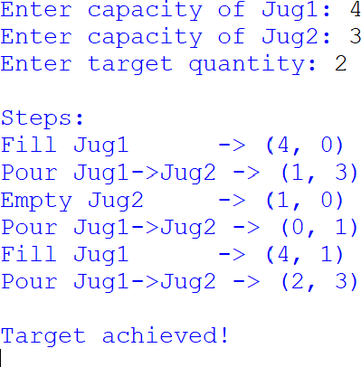

Result
Thus, the Python program for the Water Jug Problem was executed successfully, and the required target quantity of water was obtained.

Experiment No: 4
Title: Write a Python Program for the Crypt-Arithmetic Problem Aim
To develop a Python program to solve the Crypt-Arithmetic Problem by assigning unique digits to letters such that the given arithmetic expression is satisfied.

Objective
To implement the Crypt-Arithmetic problem in Python by assigning unique digits to alphabets and verifying the correctness of the given arithmetic expression.

Algorithm
- Step 1: Start the program.
- Step 2: Read the words from the user.
- Step 3: Identify all unique letters in the words.
- Step 4: Generate possible digit assignments for the letters.
- Step 5: Assign a unique digit to each letter.
- Step 6: Check whether the arithmetic equation is satisfied.
- Step 7: If a valid assignment is found, display the solution.
- Step 8: Stop the program.

Program
from itertools import permutations # Read input
word1 = input("Enter First Word: ").upper() word2 = input("Enter Second Word: ").upper() result = input("Enter Result Word: ").upper()

letters = list(set(word1 + word2 + result))

if len(letters) > 10:
print("Too many unique letters.") exit()

digits = '0123456789'

found = False

for perm in permutations(digits, len(letters)): table = dict(zip(letters, perm))

# Leading letter cannot be zero
if table[word1[0]] == '0' or table[word2[0]] == '0' or table[result[0]] == '0': continue

n1 = int(''.join(table[ch] for ch in word1)) n2 = int(''.join(table[ch] for ch in word2)) n3 = int(''.join(table[ch] for ch in result))

if n1 + n2 == n3: print("\nSolution Found\n") for k in sorted(table):
print(k, "=", table[k])

print("\n", n1)
print("+", n2) print(" ")
print(n3) found = True break

if not found:
print("No Solution Found.")

Sample Input
Enter First Word: SEND Enter Second Word: MORE Enter Result Word: MONEY

Sample Output

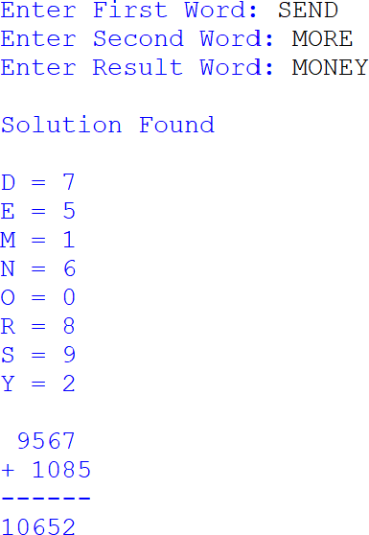

Result
Thus, the Python program for the Crypt-Arithmetic Problem was executed successfully, and a valid digit assignment satisfying the given arithmetic expression was obtained.

Experiment No: 5
Title: Write a Python Program for the Missionaries and Cannibals Problem Aim
To develop a Python program to solve the Missionaries and Cannibals Problem by safely transporting all missionaries and cannibals across the river without violating the problem constraints.

Objective
To implement the Missionaries and Cannibals problem in Python by generating valid boat movements and ensuring that the number of cannibals never exceeds the number of missionaries on either riverbank.

Algorithm
- Step 1: Start the program.
- Step 2: Define the initial state and the goal state.
- Step 3: Generate all possible valid boat moves.
- Step 4: Check whether each new state is valid.
- Step 5: If the state is valid and not visited, add it to the queue.
- Step 6: Repeat the process until the goal state is reached.
- Step 7: Display the sequence of valid states.
- Step 8: Stop the program.

Program
from collections import deque

# Check whether the state is valid def is_valid(m_left, c_left):
m_right = 3 - m_left c_right = 3 - c_left

if m_left < 0 or c_left < 0 or m_left > 3 or c_left > 3: return False
if (m_left > 0 and c_left > m_left):

return False

if (m_right > 0 and c_right > m_right): return False

return True

# BFS Algorithm
def missionaries_cannibals(): start = (3, 3, 'L')
goal = (0, 0, 'R')

moves = [(1,0), (2,0), (0,1), (0,2), (1,1)]

queue = deque([[start]]) visited = set()

while queue:
path = queue.popleft() state = path[-1]

if state == goal: print("Solution Path:\n") for s in path:
print(s) return

if state in visited: continue

visited.add(state)

m, c, boat = state

for dm, dc in moves:

if boat == 'L':
new_state = (m-dm, c-dc, 'R') else:
new_state = (m+dm, c+dc, 'L')

if is_valid(new_state[0], new_state[1]): queue.append(path + [new_state])

print("No Solution Found") missionaries_cannibals()

Sample Input
No user input required.

Sample Output
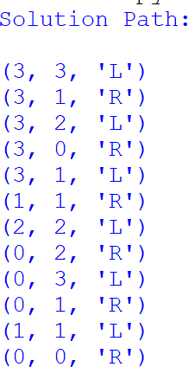

Result
Thus, the Python program for the Missionaries and Cannibals Problem was executed successfully, and all missionaries and cannibals were safely transported across the river without violating the given constraints.

Experiment No: 6
Title: Write a Python Program for the Vacuum Cleaner Problem Aim
To develop a Python program to simulate the Vacuum Cleaner Problem using a simple reflex agent that cleans all dirty rooms and displays the final room status.

Objective
To implement a Vacuum Cleaner agent in Python that senses the condition of each room and performs the cleaning operation until all rooms become clean.

Algorithm
- Step 1: Start the program.
- Step 2: Define the rooms and their initial status (Dirty/Clean).
- Step 3: Read the status of each room.
- Step 4: Check whether the current room is dirty.
- Step 5: If the room is dirty, clean the room.
- Step 6: Move to the next room and repeat the process.
- Step 7: Display the final status of all rooms.
- Step 8: Stop the program.

Program
# Vacuum Cleaner Problem using DFS

rooms = {}

n = int(input("Enter the number of rooms: "))

for i in range(n):
room = input(f"Enter Room Name {i+1}: ")
status = input(f"Enter Status of {room} (Dirty/Clean): ").capitalize()

rooms[room] = status

print("\nInitial Room Status") print(rooms)

visited = set()

def dfs(room):
if room in visited: return

visited.add(room)

if rooms[room] == "Dirty": print(f"{room} is Dirty -> Cleaning...") rooms[room] = "Clean"
else:
print(f"{room} is already Clean.")

print("\nCleaning Process")

for room in rooms:
if room not in visited: dfs(room)

print("\nFinal Room Status") print(rooms)

Sample Input
Enter the number of rooms: 2 Enter Room Name 1: A
Enter Status of A (Dirty/Clean): Dirty Enter Room Name 2: B
Enter Status of B (Dirty/Clean): Dirty

Sample Output
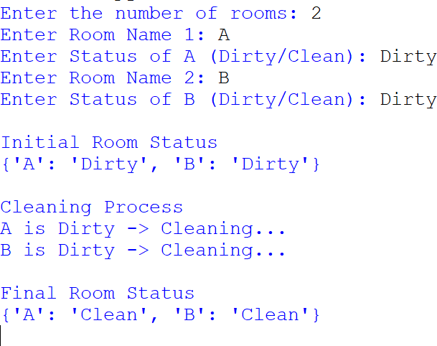

Result
Thus, the Python program for the Vacuum Cleaner Problem was executed successfully, and all dirty rooms were cleaned by the Vacuum Cleaner agent.

Experiment No: 7 Title
Write a Python Program to Implement Breadth First Search (BFS) Aim
To develop a Python program to implement the Breadth First Search (BFS) algorithm for finding the shortest path between a source node and a destination node in a graph.

Objective
To implement the Breadth First Search (BFS) algorithm using a queue to traverse the graph level by level and determine the shortest path between two given nodes.

Algorithm
Step 1: Start the program.
Step 2: Define the graph using an adjacency list.
Step 3: Read the source node and destination node.
Step 4: Initialize a queue with the source node and its path.
Step 5: Create an empty set to store visited nodes.
Step 6: Remove the front node from the queue.
Step 7: If the current node is the destination node, display the shortest path and stop.
Step 8: Otherwise, visit all unvisited neighbouring nodes and insert them into the queue.
Step 9: Repeat Steps 6–8 until the queue becomes empty. Step 10: If no path exists, display an appropriate message. Step 11: Stop the program.

Program
from collections import deque

# Breadth First Search Function def bfs(graph, start, goal):

queue = deque([(start, [start])]) visited = set()

while queue:

node, path = queue.popleft()

if node == goal: return path

if node in visited: continue

visited.add(node)

for neighbour in graph[node]: if neighbour not in visited:
queue.append((neighbour, path + [neighbour]))

return None

# Main Program

graph = { 0: [1, 2],
1: [0, 2, 3],
2: [0, 1, 3],
3: [1, 2, 4],

4: [3]
}

print("Graph Representation") print(" ")

for node in graph:
print(node, "->", graph[node])

print()

start = int(input("Enter Source Node : ")) goal = int(input("Enter Destination Node : "))

path = bfs(graph, start, goal)

print()

if path:

print("Breadth First Search Successful") print(" ")
print("Source Node :", start) print("Destination Node :", goal)
print("Shortest Path :", " -> ".join(map(str, path))) print("Number of Nodes Visited :", len(path))

else:
print("No Path Found")

Sample Input
Enter Source Node 0
Enter Destination Node : 4

Sample Output

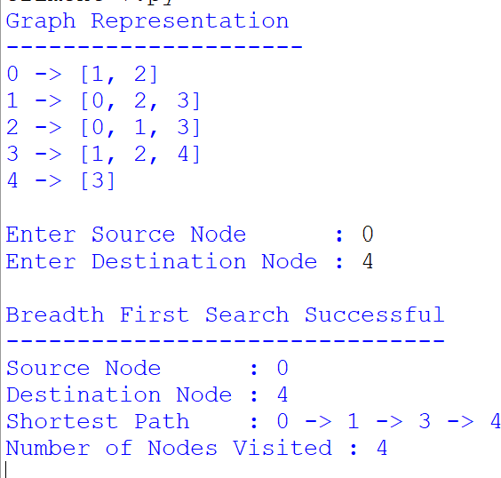

Result
Thus, the Python program to implement the Breadth First Search (BFS) algorithm was executed successfully, and the shortest path between the source node and destination node was obtained correctly.

Experiment No: 8 Title
Write a Python Program to Implement Depth First Search (DFS)

Aim
To develop a Python program to implement the Depth First Search (DFS) algorithm for traversing a graph by visiting each vertex recursively.

Objective
To implement the Depth First Search (DFS) algorithm using recursion to traverse all reachable vertices in a graph from a given starting node.

Algorithm
Step 1: Start the program.
Step 2: Represent the graph using an adjacency list. Step 3: Create an empty set to store the visited nodes. Step 4: Select the starting node.
Step 5: Mark the current node as visited and display it.
Step 6: Visit each adjacent unvisited node recursively.
Step 7: Continue the process until all reachable nodes are visited.
Step 8: Stop the program.

Program
# Depth First Search (DFS)

graph = {
'A': ['B', 'C'],
'B': ['D', 'E'],
'C': ['F'],
'D': [],

'E': ['F'], 'F': []
}

visited = set()

def dfs(node):

if node not in visited:

print(node, end=" ")

visited.add(node)

for neighbour in graph[node]: dfs(neighbour)

print("Graph:") for node in graph:
print(node, "->", graph[node])

print("\n\nDFS Traversal:")

dfs('A')

Sample Input
Starting Node : A
(The graph is predefined in the program.)

Sample Output
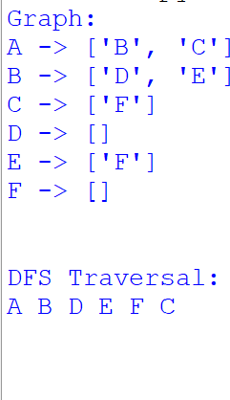

Result
Thus, the Python program to implement the Depth First Search (DFS) algorithm was executed successfully, and all reachable vertices were traversed recursively.

Experiment No: 9 Title
Write a Python Program to Implement the Travelling Salesman Problem (TSP)

Aim
To develop a Python program to solve the Travelling Salesman Problem (TSP) using the Nearest Neighbour approach and determine the shortest tour that visits all cities exactly once and returns to the starting city.

Objective
To implement the Travelling Salesman Problem by calculating the distances between cities and selecting the nearest unvisited city until all cities are visited.

Algorithm
Step 1: Start the program.
Step 2: Read the coordinates of all cities.
Step 3: Construct the distance matrix using Euclidean distance.
Step 4: Select the first city as the starting city.
Step 5: Find the nearest unvisited city.
Step 6: Add the nearest city to the tour and update the total distance.
Step 7: Repeat Steps 5 and 6 until all cities are visited.
Step 8: Return to the starting city.
Step 9: Display the tour and total distance.
Step 10: Stop the program.

Program
import numpy as np

def tsp(cities):

n = len(cities)

# Create Distance Matrix distance = np.zeros((n, n))

for i in range(n): for j in range(n):
if i != j:
distance[i][j] = np.linalg.norm(cities[i] - cities[j])

visited = [False] * n visited[0] = True

tour = [0]
total_distance = 0
current = 0

while len(tour) < n:

nearest = -1
minimum = float('inf')

for city in range(n):

if not visited[city] and distance[current][city] < minimum: minimum = distance[current][city]
nearest = city

tour.append(nearest)

visited[nearest] = True total_distance += minimum current = nearest

total_distance += distance[current][0] tour.append(0)

return tour, total_distance

# Main Program

n = int(input("Enter Number of Cities: "))

cities = []

for i in range(n):
x = float(input(f"Enter x-coordinate of City {i}: ")) y = float(input(f"Enter y-coordinate of City {i}: ")) cities.append(np.array([x, y]))

tour, distance = tsp(cities)

print("\nOptimal Tour")
print(" -> ".join(map(str, tour)))

print("Total Distance =", round(distance,2))

Sample Input
Enter Number of Cities: 4

City 0 : (0,0)

City 1 : (2,3)

City 2 : (5,2)

City 3 : (6,6)

Sample Output

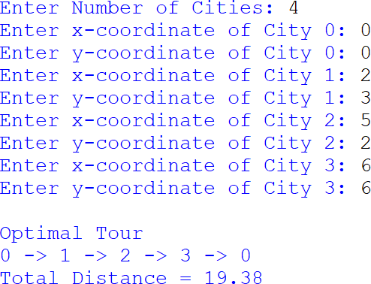

Result: Thus the Program was executed and the output was found to be Correct.

Experiment No: 10 Title
Write a Python Program to Implement A* Algorithm

Aim
To develop a Python program to implement the A* search algorithm for finding the shortest path between a start node and a goal node.

Objective
To implement the A* search algorithm using a priority queue and heuristic function to determine the optimal path from the source node to the destination node.

Algorithm
Step 1: Start the program.
Step 2: Define the graph and heuristic values.
Step 3: Initialize the open list with the start node.
Step 4: Select the node with the lowest f(n) = g(n) + h(n).
Step 5: Expand the current node and calculate the cost of its neighbours.
Step 6: Update the cost and parent of each neighbour if a shorter path is found. Step 7: Repeat until the goal node is reached or the open list becomes empty. Step 8: Display the shortest path and total cost.
Step 9: Stop the program.

Program
import heapq

graph = {
'A': [('B', 2), ('C', 4)],
'B': [('D', 3), ('E', 5)],
'C': [('F', 2)],

'D': [('G', 4)],
'E': [('G', 2)],
'F': [('G', 3)], 'G': []
}

heuristic = { 'A': 8,
'B': 6,
'C': 5,
'D': 3,
'E': 2,
'F': 2,
'G': 0
}

def astar(start, goal):

priority_queue = [] heapq.heappush(priority_queue, (0, start))

parent = {} cost = {}

parent[start] = None cost[start] = 0

while priority_queue:

current = heapq.heappop(priority_queue)[1]

if current == goal: break

for neighbour, weight in graph[current]:

new_cost = cost[current] + weight

if neighbour not in cost or new_cost < cost[neighbour]:

cost[neighbour] = new_cost

priority = new_cost + heuristic[neighbour]

heapq.heappush(priority_queue, (priority, neighbour))

parent[neighbour] = current

path = []

node = goal

while node is not None: path.append(node) node = parent[node]

path.reverse()

return path, cost[goal]

start = input("Enter Start Node : ").upper() goal = input("Enter Goal Node : ").upper()

path, total_cost = astar(start, goal)

print("\nShortest Path :", " -> ".join(path)) print("Total Cost :", total_cost)

Sample Input
Enter Start Node : A Enter Goal Node : G

Sample Output

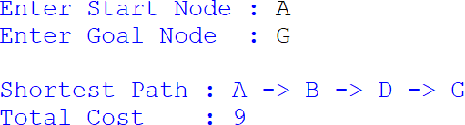

Result
Thus, the Python program to implement the A* algorithm was executed successfully, and the shortest path along with the minimum cost was obtained correctly.

Experiment No: 11 Title
Write a Python Program for Map Coloring using Constraint Satisfaction Problem (CSP)

Aim
To develop a Python program to solve the Map Coloring Problem using the Constraint Satisfaction Problem (CSP) approach by assigning different colors to adjacent regions.

Objective
To implement the Map Coloring problem using the backtracking technique of CSP so that no two neighbouring regions are assigned the same color.

Algorithm
Step 1: Start the program.
Step 2: Define the map regions and available colors. Step 3: Specify the neighbouring regions as constraints. Step 4: Assign a color to each region one by one.
Step 5: Check whether the assigned color satisfies all constraints.
Step 6: If valid, continue assigning colors to the next region.
Step 7: If no valid color is available, backtrack and try another color.
Step 8: Repeat until all regions are colored. Step 9: Display the final color assignment. Step 10: Stop the program.

Program
# Map Coloring using CSP (Backtracking)

regions = ['WA', 'NT', 'SA', 'Q', 'NSW', 'V', 'T']

colors = ['Red', 'Green', 'Blue']

neighbours = { 'WA': ['NT', 'SA'],
'NT': ['WA', 'SA', 'Q'],
'SA': ['WA', 'NT', 'Q', 'NSW', 'V'], 'Q': ['NT', 'SA', 'NSW'],
'NSW': ['SA', 'Q', 'V'],
'V': ['SA', 'NSW'], 'T': []
}

assignment = {}

def is_safe(region, color):

for neighbour in neighbours[region]:
if neighbour in assignment and assignment[neighbour] == color: return False

return True

def solve(index):

if index == len(regions): return True

region = regions[index]

for color in colors:

if is_safe(region, color):

assignment[region] = color

if solve(index + 1): return True

del assignment[region]

return False

if solve(0):

print("\nColor Assignment\n")

for region in regions:
print(region, ":", assignment[region])

else:

print("No Solution Found")

Sample Input
No user input.

Sample Output
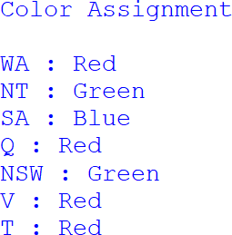

Result
Thus, the Python program for Map Coloring using Constraint Satisfaction Problem (CSP) was executed successfully, and the map was colored without assigning the same color to any adjacent regions.

Experiment No: 12 Title
Write a Python Program for Tic Tac Toe Game

Aim
To develop a Python program to implement the Tic Tac Toe game for two players and determine the winner or draw based on the game rules.

Objective
To implement a two-player Tic Tac Toe game using Python and verify the winning conditions after each move.

Algorithm
Step 1: Start the program.
Step 2: Initialize a 3 × 3 game board with empty spaces.
Step 3: Display the board.
Step 4: Allow Player X and Player O to enter their moves alternately.
Step 5: Check whether the entered position is empty. Step 6: After every move, check for a winning condition. Step 7: If a player wins, display the winner.
Step 8: If all positions are filled without a winner, declare a draw.
Step 9: Stop the program.

Program
# Tic Tac Toe Game

board = [' ' for _ in range(9)]

def display_board(): print()

print(board[0], "|", board[1], "|", board[2]) print("--+---+--")
print(board[3], "|", board[4], "|", board[5]) print("--+---+--")
print(board[6], "|", board[7], "|", board[8]) print()

def check_win(player):

win = [
(0,1,2), (3,4,5), (6,7,8),
(0,3,6), (1,4,7), (2,5,8),
(0,4,8), (2,4,6)
]

for x, y, z in win:
if board[x] == board[y] == board[z] == player: return True

return False

def board_full():
return ' ' not in board

player = 'X'

while True:

display_board()

position = int(input(f"Player {player}, Enter Position (1-9): ")) - 1

if position < 0 or position > 8: print("Invalid Position") continue

if board[position] != ' ': print("Position Already Filled") continue

board[position] = player

if check_win(player): display_board()
print("Player", player, "Wins!") break

if board_full(): display_board() print("Match Draw") break

if player == 'X': player = 'O'
else:
player = 'X'

Sample Input
Player X, Enter Position (1-9): 1
Player O, Enter Position (1-9): 5
Player X, Enter Position (1-9): 2
Player O, Enter Position (1-9): 8
Player X, Enter Position (1-9): 3

Sample Output
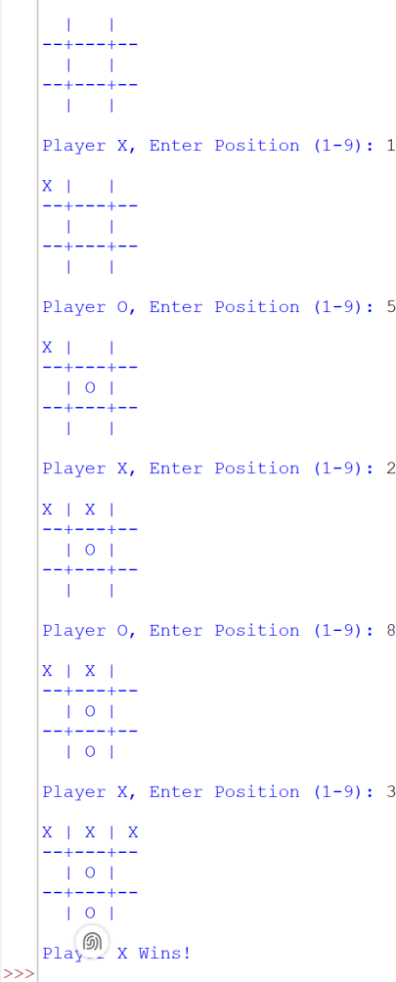

Result
Thus, the Python program for the Tic Tac Toe Game was executed successfully, and the winner was determined based on the game rules.

Experiment No: 13 Title
Write a Python Program to Implement Minimax Algorithm for Gaming

Aim
To develop a Python program to implement the Minimax Algorithm for selecting the optimal move in a two-player game.

Objective
To implement the Minimax algorithm to evaluate game states and determine the best possible move for a player.

Algorithm
Step 1: Start the program.
Step 2: Define the game tree values.
Step 3: Check whether the current node is a leaf node.
Step 4: If it is the maximizing player's turn, select the maximum value. Step 5: If it is the minimizing player's turn, select the minimum value. Step 6: Repeat recursively until the root node is evaluated.
Step 7: Display the optimal value.
Step 8: Stop the program.

Program
# Minimax Algorithm

scores = [3, 5, 2, 9, 12, 5, 23, 23]

def minimax(depth, node, maximizing):

if depth == 3:

return scores[node]

if maximizing:

left = minimax(depth + 1, node * 2, False)
right = minimax(depth + 1, node * 2 + 1, False)

return max(left, right)

else:

left = minimax(depth + 1, node * 2, True) right = minimax(depth + 1, node * 2 + 1, True)

return min(left, right)

result = minimax(0, 0, True)

print("Optimal Value :", result)

Sample Input
No user input.

Sample Output
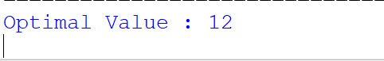

Result
Thus, the Python program to implement the Minimax Algorithm was executed successfully, and the optimal game value was obtained correctly.

Experiment No: 14 Title
Write a Python Program to Implement Alpha-Beta Pruning Algorithm for Gaming

Aim
To develop a Python program to implement the Alpha-Beta Pruning algorithm for finding the optimal move in a game.

Objective
To implement the Alpha-Beta Pruning algorithm for reducing unnecessary node evaluation while determining the optimal game value.

Algorithm
Step 1: Start the program.
Step 2: Define the leaf node values.
Step 3: Initialize alpha as −∞ and beta as +∞. Step 4: Traverse the game tree recursively.
Step 5: If it is the maximizing player's turn, choose the maximum value and update alpha. Step 6: If it is the minimizing player's turn, choose the minimum value and update beta. Step 7: If alpha ≥ beta, prune the remaining branches.
Step 8: Display the optimal value.
Step 9: Stop the program.

Program
# Alpha-Beta Pruning Algorithm

scores = [3, 5, 2, 9, 12, 5, 23, 23]

def alphabeta(depth, node, alpha, beta, maximizing):

if depth == 3:
return scores[node]

if maximizing:

value = float('-inf')

for i in range(2):

value = max(value,
alphabeta(depth + 1,
node * 2 + i, alpha,
beta, False))

alpha = max(alpha, value)

if alpha >= beta: break

return value

else:

value = float('inf')

for i in range(2):

value = min(value,
alphabeta(depth + 1,
node * 2 + i, alpha,
beta, True))

beta = min(beta, value)

if alpha >= beta: break

return value

result = alphabeta(0, 0, float('-inf'), float('inf'), True)

print("Optimal Value :", result)

Sample Input
No user input.

Sample Output


Result
Thus, the Python program to implement the Alpha-Beta Pruning Algorithm was executed successfully, and the optimal game value was obtained by pruning unnecessary branches.

Experiment No: 15 Title
Write a Python Program to Implement Decision Tree

Aim
To develop a Python program to implement a Decision Tree Classifier for classifying data and predicting the output.

Objective
To build and test a Decision Tree model using the Iris dataset and evaluate its prediction accuracy.

Algorithm
Step 1: Import the required libraries.
Step 2: Load the Iris dataset.
Step 3: Split the dataset into training and testing sets.
Step 4: Create a Decision Tree classifier.
Step 5: Train the classifier using the training data.
Step 6: Predict the output for the testing data.
Step 7: Calculate and display the accuracy.
Step 8: Stop the program.

Program
from sklearn.datasets import load_iris
from sklearn.model_selection import train_test_split from sklearn.tree import DecisionTreeClassifier from sklearn.metrics import accuracy_score

# Load Dataset iris = load_iris()

X = iris.data y = iris.target

# Split Dataset
X_train, X_test, y_train, y_test = train_test_split( X, y, test_size=0.30, random_state=42
)

# Create Decision Tree Model
model = DecisionTreeClassifier(random_state=42)

# Train Model model.fit(X_train, y_train)

# Predict
y_pred = model.predict(X_test)

# Accuracy
accuracy = accuracy_score(y_test, y_pred)

print("Predicted Classes:") print(y_pred)

print("\nAccuracy:", round(accuracy * 100, 2), "%")

Sample Input
No user input.
(Iris dataset is loaded automatically.)

Sample Output

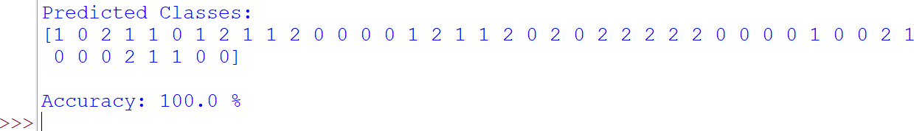

Result
Thus, the Python program to implement the Decision Tree Classifier was executed successfully, and the classification accuracy was obtained correctly.

Experiment 16 Title
Write the python program to implement Feed forward neural Network

Aim
To develop a Python program to implement a Feed Forward Neural Network for classifying the Iris dataset.

Objective
To train a neural network using the Iris dataset and evaluate its classification accuracy.

Algorithm
Step 1: Import the required libraries.
Step 2: Load the Iris dataset.
Step 3: Split the dataset into training and testing sets.
Step 4: Create a Feed Forward Neural Network with one hidden layer and one output layer.
Step 5: Compile the model using the Adam optimizer and categorical crossentropy loss function.
Step 6: Train the model using the training dataset.
Step 7: Test the model using the testing dataset.
Step 8: Display the classification accuracy.

Program
from tensorflow.keras.models import Sequential from tensorflow.keras.layers import Dense
from tensorflow.keras.utils import to_categorical from sklearn.datasets import load_iris
from sklearn.model_selection import train_test_split

# Load Iris Dataset

iris = load_iris()

X = iris.data y = iris.target

# Convert target values into one-hot encoding y = to_categorical(y)

# Split the dataset
X_train, X_test, y_train, y_test = train_test_split( X, y, test_size=0.3, random_state=42
)

# Create Feed Forward Neural Network model = Sequential()

# Hidden Layer
model.add(Dense(10, input_shape=(4,), activation='relu'))

# Output Layer
model.add(Dense(3, activation='softmax'))

# Compile Model model.compile(
optimizer='adam', loss='categorical_crossentropy', metrics=['accuracy']
)

# Train Model model.fit(
X_train, y_train, epochs=50, batch_size=10, verbose=1
)

# Evaluate Model
loss, accuracy = model.evaluate(X_test, y_test, verbose=0)

print("\nModel Evaluation") print(" ")
print("Testing Accuracy : {:.2f}%".format(accuracy * 100)) print("Testing Loss : {:.4f}".format(loss))

Sample Input
No manual input is required.
The Iris dataset is loaded automatically by the program.

Sample Output
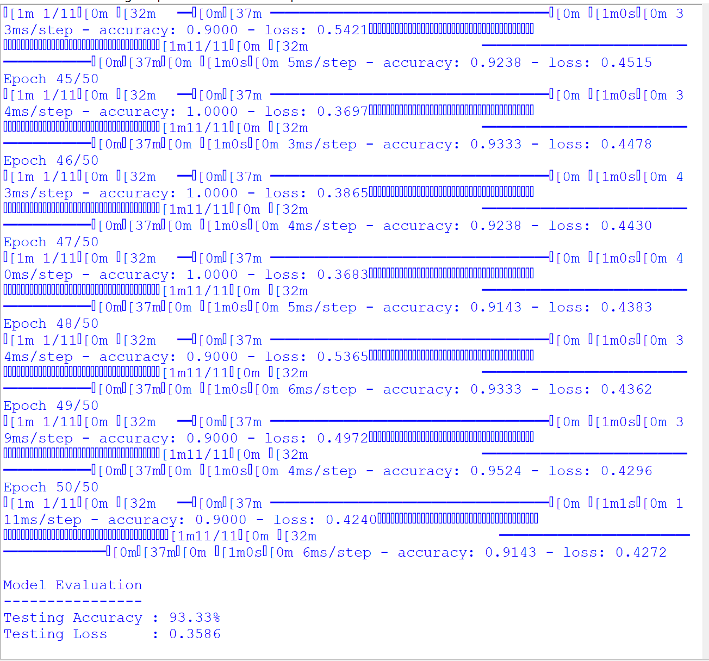

Result
Thus, the Python program to implement a Feed Forward Neural Network was executed successfully, and the classification accuracy of the Iris dataset was obtained.

Experiment 17 Title
Write a Prolog Program to Sum the Integers from 1 to n. Aim
To develop a Prolog program to find the sum of integers from 1 to n using recursion.

Objective
To understand the concept of recursion in Prolog by computing the sum of natural numbers from 1 to n, using a base case and a recursive rule.

Algorithm
Step 1: Define the base case where the sum of 0 is 0.
Step 2: Accept a positive integer N. Step 3: Decrease N by 1.
Step 4: Recursively calculate the sum from 1 to N−1. Step 5: Add N to the previous sum.
Step 6: Display the final sum.

Program
% Base Case sum(0,0).

% Recursive Case sum(N,Sum) :-
N > 0,
N1 is N - 1,
sum(N1,Sum1), Sum is Sum1 + N.

Sample Input
?- sum(5,Sum).

Sample Output
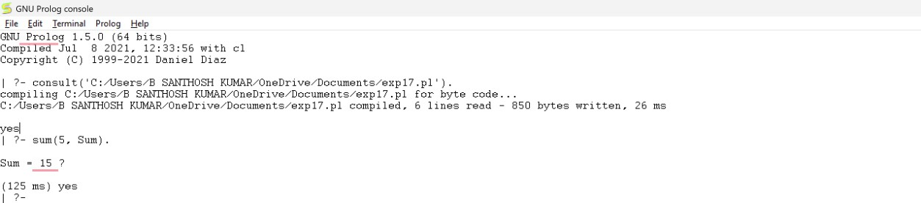

Result
Thus, the Prolog program to find the sum of integers from 1 to n using recursion was executed successfully, and the correct sum was obtained.

Experiment 18 Title
Prolog Program for a Database with Name and Date of Birth (DOB)

Aim
To develop a Prolog program to create a simple database containing a person's name and date of birth and perform database queries.

Objective
To understand how facts and predicates are used in Prolog to store and retrieve information from a simple database.

Algorithm
Step 1: Define facts containing the person's name and date of birth. Step 2: Create a predicate to retrieve the DOB using the person's name. Step 3: Enter the query with the required name.
Step 4: Search the database for the matching record.
Step 5: Display the corresponding date of birth.

Program
% Database of Names and Date of Birth

person(john, date(1990, 5, 1)).
person(jane, date(1985, 12, 10)).
person(bob, date(1978, 2, 28)).
person(sue, date(1995, 8, 15)).
person(tom, date(2000, 4, 22)).

% Predicate to retrieve DOB find_dob(Name, DOB) :-

person(Name, DOB).

Sample Input
?- find_dob(john, DOB).

Sample Output
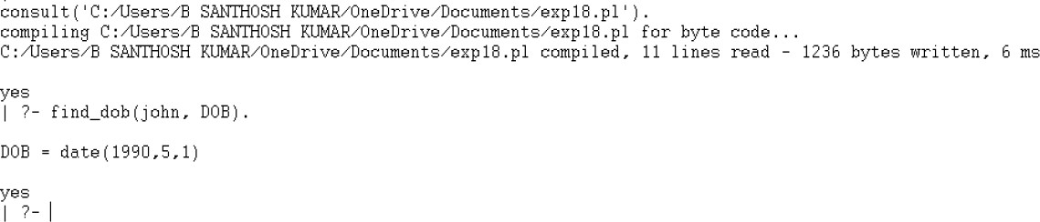

Result
Thus, the Prolog program to create a simple Name and Date of Birth database was executed successfully, and the required records were retrieved correctly.

Experiment 19 Title
Write a Prolog Program for Student–Teacher–Subject Database Aim
To implement a Student–Teacher–Subject database using Prolog facts and retrieve teacher and student information through queries.

Objective
To understand how Prolog stores facts and uses rules to search and retrieve information from a simple database.

Algorithm
Step 1: Define facts for teachers and the subjects they teach. Step 2: Define facts for students and the subjects they study. Step 3: Create a rule to retrieve the subject handled by a teacher.
Step 4: Create another rule to retrieve the students studying a particular subject.
Step 5: Execute the required query and display the matching result.

Program
% Teacher and Subject Database

teacher(john, math). teacher(jane, english). teacher(bob, science). teacher(sue, history). teacher(tom, art).

% Student and Subject Database

student(alice, math). student(alice, science).

student(bob, english). student(bob, science).

student(carol, history). student(carol, art).

student(dave, math). student(dave, english). student(dave, art).

% Retrieve teacher subject

teacher_subject(Teacher, Subject) :-teacher(Teacher, Subject).

% Retrieve students studying a subject

subject_student(Subject, Student) :-student(Student, Subject).

Sample Input
?- teacher_subject(john, Subject).

Sample Output
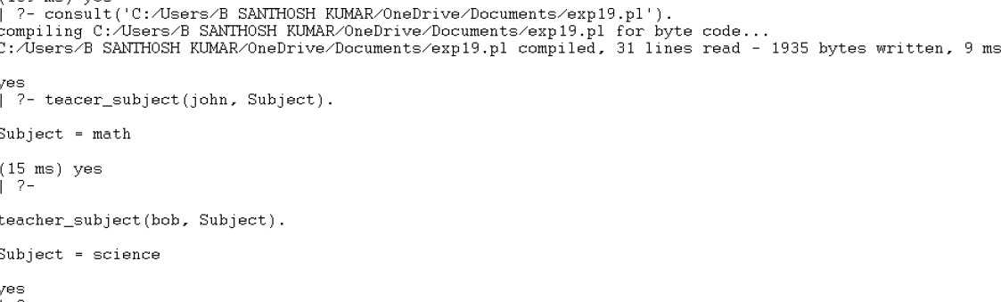

Result
Hence, the Prolog program for the Student–Teacher–Subject database was executed successfully and the correct output was obtained.

Experiment 20 Title
Write a Prolog Program for Planets Database Aim
To implement a Planets database using Prolog facts and retrieve the properties of a planet using queries.

Objective
To understand how Prolog stores planetary information and displays the required details based on the given planet name.

Algorithm
Step 1: Define facts for each planet with its type, size, temperature, and position.
Step 2: Create a rule to retrieve the details of a selected planet.
Step 3: Accept the planet name through a query.
Step 4: Search the database for the matching planet.
Step 5: Display the planet's properties such as type, size, temperature, and position.

Program
% Planet Database

planet(mercury, rocky, small, hot, first). planet(venus, rocky, small, hot, second). planet(earth, rocky, medium, moderate, third). planet(mars, rocky, small, cold, fourth). planet(jupiter, gas_giant, large, cold, fifth). planet(saturn, gas_giant, large, cold, sixth). planet(uranus, ice_giant, large, cold, seventh). planet(neptune, ice_giant, large, cold, eighth).

% Display Planet Information

show_planet(Name) :-
planet(Name, Type, Size, Temperature, Position), write('Planet Name : '), write(Name), nl, write('Type : '), write(Type), nl,
write('Size : '), write(Size), nl, write('Temperature : '), write(Temperature), nl, write('Position : '), write(Position), nl.

Sample Input
?- show_planet(earth).

Sample Output
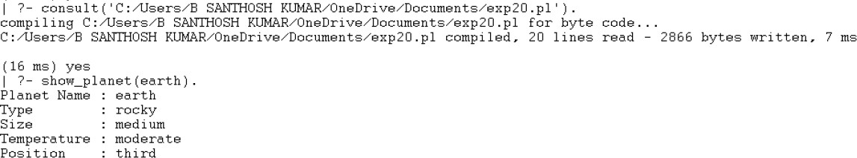

Result
Hence, the Prolog program for the Planets Database was executed successfully and the correct output was obtained.

Experiment 21 Title
Write a Prolog Program to implement Towers of Hanoi Aim
To implement the Towers of Hanoi problem using Prolog and display the sequence of moves
required to transfer all the disks from the source peg to the destination peg.
Objective
To understand the concept of recursion in Prolog by solving the Towers of Hanoi problem and generating the correct sequence of disk movements.
Algorithm
Step 1: Define a base case to move one disk from the source peg to the destination peg.
Step 2: If the number of disks is greater than one, move N−1 disks from the source peg to the auxiliary peg.
Step 3: Move the largest disk from the source peg to the destination peg. Step 4: Move the N−1 disks from the auxiliary peg to the destination peg. Step 5: Display each move until all the disks are transferred successfully. Program
% Towers of Hanoi

hanoi(1, Source, _, Destination) :-write('Move disk 1 from '), write(Source),
write(' to '), write(Destination), nl.

hanoi(N, Source, Auxiliary, Destination) :-N > 1,
M is N - 1,
hanoi(M, Source, Destination, Auxiliary), write('Move disk '),

write(N), write(' from '), write(Source), write(' to '),
write(Destination), nl,
hanoi(M, Auxiliary, Source, Destination).
Sample Input
?- hanoi(3, 'A', 'B', 'C').
Sample Output
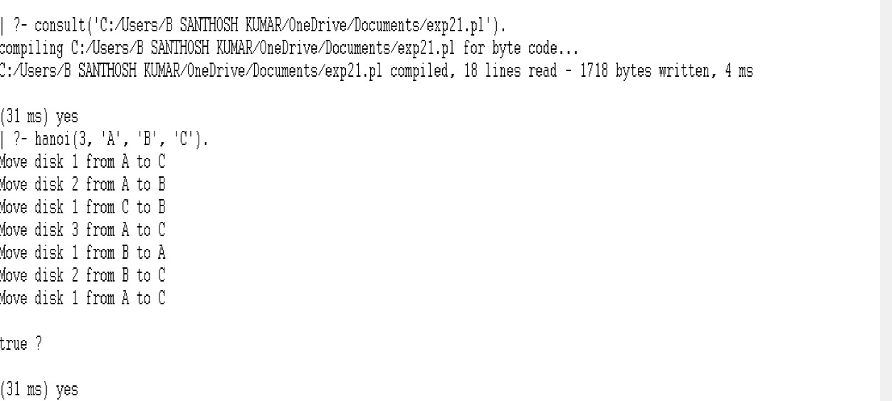

Result
Hence, the Prolog program to implement the Towers of Hanoi was executed successfully and the correct sequence of moves was obtained.

Experiment 22 Title
Write a Prolog Program to print whether a particular bird can fly or not. Aim
To implement a Prolog program to determine whether a particular bird can fly using facts and queries.

Objective
To understand the use of facts and rules in Prolog by identifying whether a given bird can fly or not.

Algorithm
Step 1: Define facts for different birds and their flying ability.
Step 2: Create a rule to check whether a bird can fly.
Step 3: Enter the bird name through a query.
Step 4: Prolog searches the database for the given bird.
Step 5: Display whether the bird can fly or not.

Program
% Bird Database

bird(ostrich, cannot_fly). bird(penguin, cannot_fly). bird(kiwi, cannot_fly).
bird(eagle, can_fly). bird(pigeon, can_fly).
bird(sparrow, can_fly).

% Rule to check flying ability

can_fly(Bird) :-
bird(Bird, can_fly).

cannot_fly(Bird) :-
bird(Bird, cannot_fly).

Sample Input
?- can_fly(eagle).
?- can_fly(ostrich).
?- bird(Bird, cannot_fly).

Sample Output
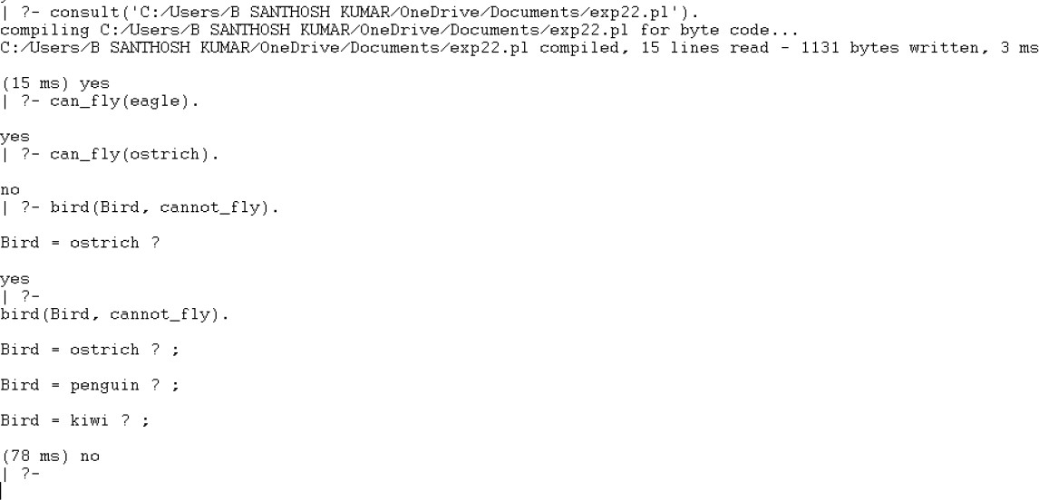

Result
Hence, the Prolog program to determine whether a particular bird can fly or not was executed successfully and the correct output was obtained.

Experiment 23 Title
Write a Prolog Program to implement a Family Tree. Aim
To implement a Family Tree in Prolog using facts and rules to identify different family relationships.

Objective
To understand how Prolog uses facts and rules to represent and retrieve family relationships such as mother, father, grandfather, grandmother, sister, and brother.

Algorithm
Step 1: Define facts for male and female family members.
Step 2: Define parent relationships between the family members.
Step 3: Create rules for mother and father using gender and parent facts. Step 4: Create rules for grandfather, grandmother, sister, and brother. Step 5: Execute queries to retrieve the required family relationships.

Program
% Family Members

female(pam). female(liz). female(ann). female(pat).

male(tom). male(bob). male(jim).

% Parent Relations

parent(tom, liz).

parent(tom, bob). parent(pam, liz). parent(pam, bob). parent(bob, ann). parent(bob, pat). parent(liz, jim).

% Mother

mother(X, Y) :-female(X), parent(X, Y).

% Father

father(X, Y) :-male(X),
parent(X, Y).

% Grandmother

grandmother(X, Y) :-female(X), parent(X, Z),
parent(Z, Y).

% Grandfather

grandfather(X, Y) :-

male(X),
parent(X, Z),
parent(Z, Y).

% Sister

sister(X, Y) :-female(X), parent(Z, X),
parent(Z, Y), X \= Y.

% Brother

brother(X, Y) :-male(X),
parent(Z, X),
parent(Z, Y), X \= Y.

Sample Input
?- father(X, bob).
?- mother(X, bob).
?- grandfather(X, ann).
?- grandmother(X, ann).
?- sister(X, pat).
?- brother(X, liz).

Sample Output
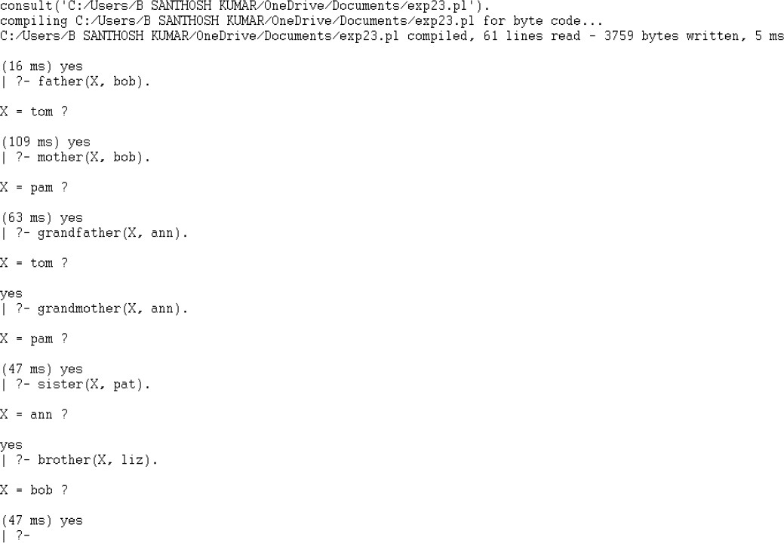

Result
Hence, the Prolog program to implement a Family Tree was executed successfully and the correct family relationships were obtained.

Experiment 24 Title
Write a Prolog Program to suggest a Dieting System based on Disease. Aim
To implement a Prolog program that suggests a suitable diet based on a given disease.

Objective
To understand how Prolog uses facts and rules to recommend an appropriate diet for different diseases.

Algorithm
Step 1: Define facts for different diseases and their recommended diets.
Step 2: Create a rule to retrieve the diet for a given disease.
Step 3: Enter the disease name through a query.
Step 4: Prolog searches the database for the matching disease.
Step 5: Display the recommended diet.

Program
% Diet Database

diet(heart_disease, [apple, carrot, chicken, fish, almonds]). diet(diabetes, [apple, carrot, fish, spinach, almonds]). diet(anemia, [spinach, chicken, fish, almonds]). diet(obesity, [apple, carrot, fish, spinach]).

% Rule to Suggest Diet

suggest_diet(Disease, Diet) :-diet(Disease, Diet).

Sample Input
?- suggest_diet(diabetes, Diet).
?- suggest_diet(obesity, Diet).

Sample Output
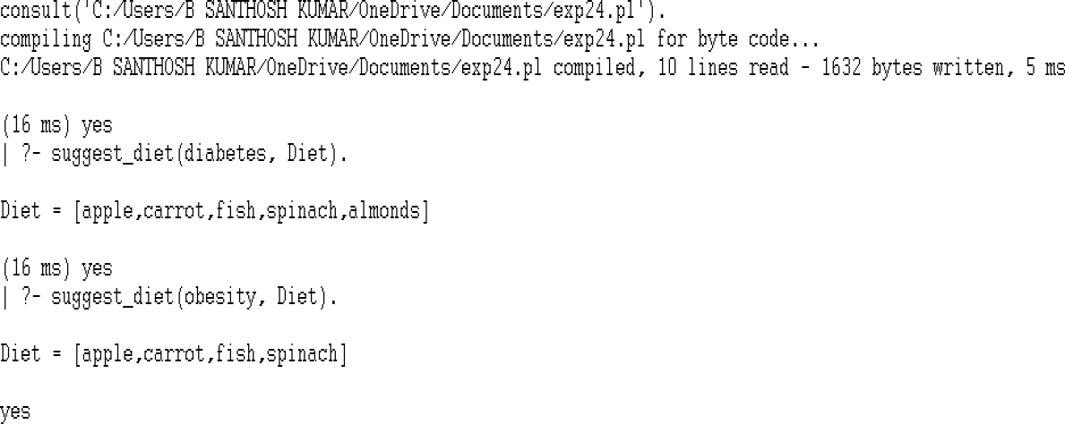

Result
Hence, the Prolog program to suggest a Dieting System based on Disease was executed successfully and the correct diet recommendations were obtained.

Experiment 25 Title
Write a Prolog Program to implement the Monkey Banana Problem. Aim
To implement the Monkey Banana Problem using Prolog and determine the sequence of actions required for the monkey to obtain the banana.

Objective
To understand how Prolog uses facts and rules to solve a state-space problem by finding the required sequence of actions.

Algorithm
Step 1: Define the initial state of the monkey, box, and banana.
Step 2: Define the final state where the monkey has obtained the banana. Step 3: Define the possible actions and their effects on the current state. Step 4: Execute the actions recursively until the goal state is reached.
Step 5: Display the sequence of actions required to solve the problem.

Program
% Initial and Final States

initial_state(state(at_door, on_floor, at_window, has_not_eaten)). final_state(state(_, _, _, has_eaten)).

% Actions

action(state(at_door, on_floor, at_window, has_not_eaten), climb,
state(at_window, on_window, at_window, has_not_eaten)).

action(state(at_window, on_window, at_window, has_not_eaten), grasp,

state(at_window, on_window, at_window, has_eaten)).

% Execute Actions

execute([], State, State).

execute([Action|Rest], CurrentState, FinalState) :-action(CurrentState, Action, NextState),
execute(Rest, NextState, FinalState).

% Solve Problem

solve(Actions) :-
initial_state(State),
execute(Actions, State, FinalState), final_state(FinalState).

Sample Input
?- solve(Actions)

Sample Output
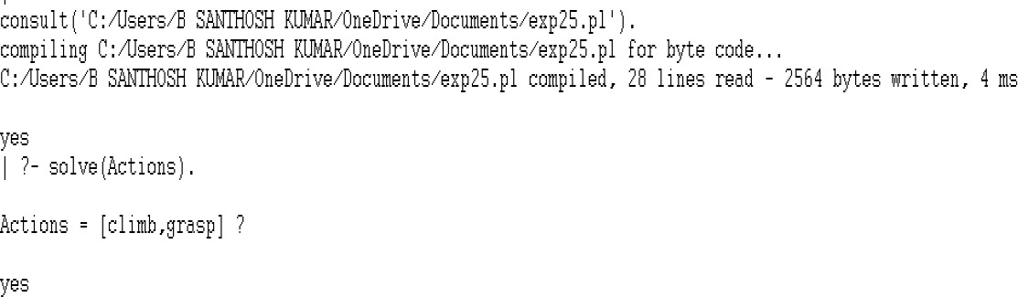

Result
Hence, the Prolog program to implement the Monkey Banana Problem was executed successfully and the correct sequence of actions was obtained.

Experiment 26 Title
Write a Prolog Program for Fruit and its Color using Backtracking. Aim
To implement a Prolog program that identifies the color of a fruit using backtracking.

Objective
To understand how Prolog uses facts and backtracking to retrieve fruits and their corresponding colors.

Algorithm
Step 1: Define facts representing fruits and their colors.
Step 2: Create a rule to match a fruit with its color. Step 3: Enter the fruit name or color through a query. Step 4: Prolog searches the database for matching facts.
Step 5: Using backtracking, Prolog displays all possible matching fruits and colors.

Program
% Fruit Database

fruit(apple, red). fruit(banana, yellow). fruit(grape, purple). fruit(orange, orange). fruit(watermelon, green).

% Rule to Match Fruit and Color

fruit_color(Fruit, Color) :-fruit(Fruit, Color).

Sample Input
?- fruit_color(Fruit, Color).

Sample Output
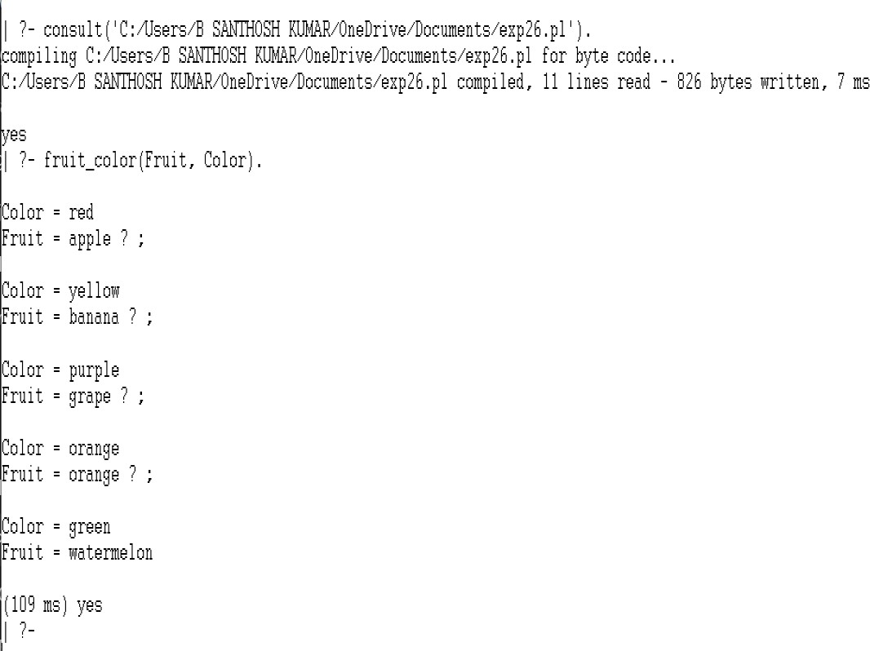

Result
Hence, the Prolog program for Fruit and its Color using Backtracking was executed successfully and the correct fruit-color combinations were obtained.

Experiment 27 Title
Write a Prolog Program to implement Best First Search Algorithm. Aim
To implement the Best First Search algorithm in Prolog to find the best path from the source node to the goal node.

Objective
To understand how Best First Search selects the most promising node based on the minimum edge cost and finds a path to the goal.

Algorithm
Step 1: Define the graph using facts with edge costs. Step 2: Specify the source node and the goal node. Step 3: Select the adjacent node having the lowest cost.
Step 4: Continue the search while avoiding already visited nodes.
Step 5: Display the best path from the source node to the goal node.

Program
% Graph with Edge Costs

edge(a,b,2).
edge(a,c,5).
edge(b,d,3).
edge(b,e,6).
edge(c,f,7).
edge(d,g,2).
edge(e,g,4).
edge(f,g,1).

% Best First Search

best_first(Start, Goal, Path) :-bfs(Start, Goal, [Start], RevPath), reverse(RevPath, Path).

bfs(Goal, Goal, Visited, Visited).

bfs(Current, Goal, Visited, Path) :-findall(Cost-Next,
(edge(Current, Next, Cost),
\+ member(Next, Visited)), Neighbours),
sort(Neighbours, [_-Best|_]), bfs(Best, Goal, [Best|Visited], Path).

Sample Input
?- best_first(a,g,Path).

Sample Output
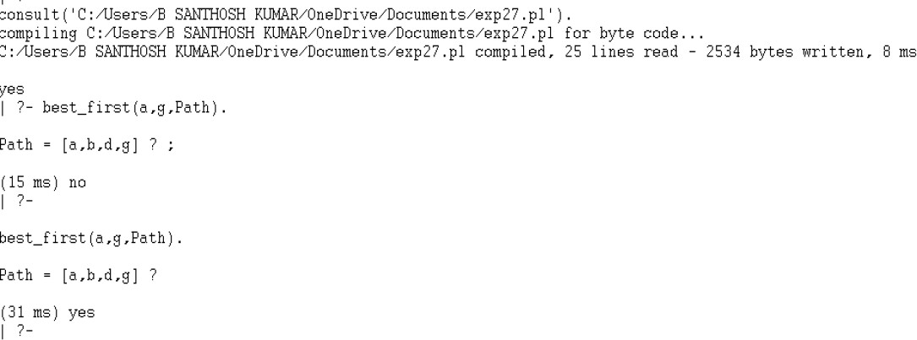

Result
Hence, the Prolog program to implement the Best First Search Algorithm was executed successfully and the best path was obtained.

Experiment 28 Title
Write a Prolog Program for Medical Diagnosis. Aim
To implement a Prolog program for medical diagnosis based on the symptoms of a patient.

Objective
To understand how Prolog uses facts and rules to diagnose diseases based on the symptoms provided.

Algorithm
Step 1: Define the symptoms of different patients as facts.
Step 2: Define rules that relate symptoms to diseases.
Step 3: Enter the patient name through a query.
Step 4: Prolog searches for the patient's symptoms.
Step 5: Display the diagnosed disease if the symptoms match a disease rule.

Program
% Symptoms of Patients

symptom(john, fever). symptom(john, cough). symptom(john, headache).

symptom(anu, fever). symptom(anu, rash).

symptom(rahul, fever). symptom(rahul, body_ache). symptom(rahul, cough).

% Disease Rules

disease(Patient, flu) :-symptom(Patient, fever),
symptom(Patient, cough), symptom(Patient, headache).

disease(Patient, measles) :-symptom(Patient, fever), symptom(Patient, rash).

disease(Patient, viral_fever) :-symptom(Patient, fever), symptom(Patient, body_ache), symptom(Patient, cough).

% Diagnosis

diagnose(Patient) :-
disease(Patient, Disease), write('Disease : '), write(Disease), nl.

Sample Input
?- diagnose(john).

?- diagnose(anu).

?- diagnose(rahul).

Sample Output
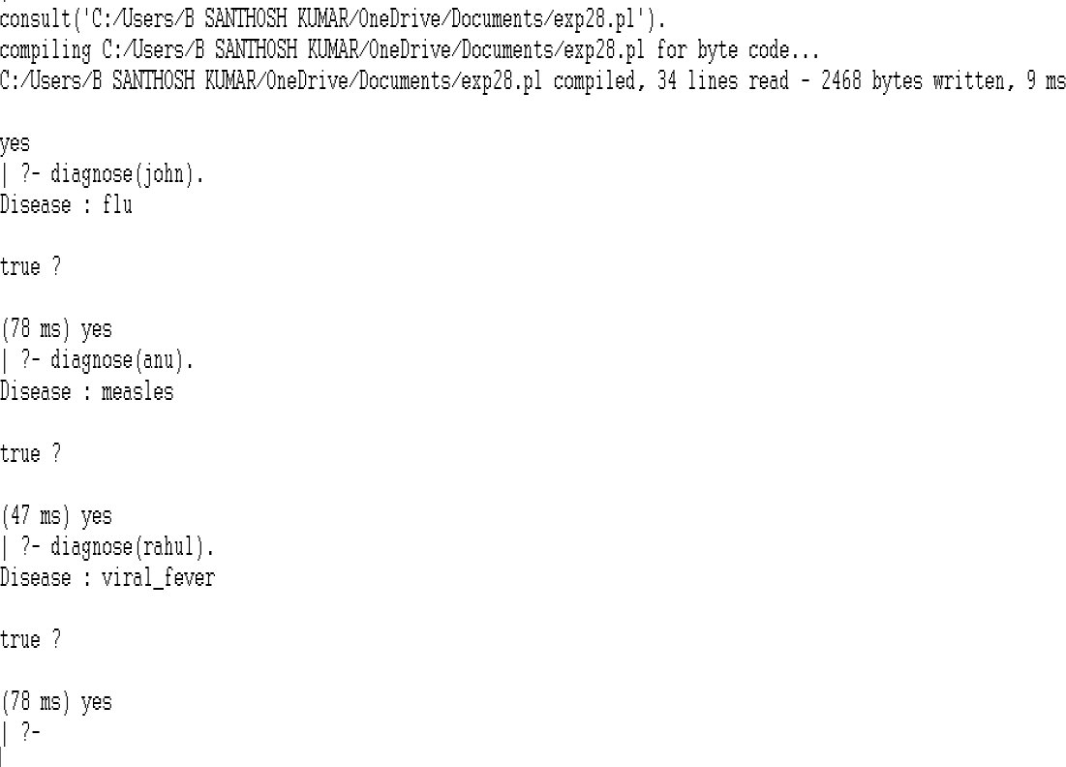

Result
Hence, the Prolog program for Medical Diagnosis was executed successfully and the correct disease was diagnosed.

Experiment 29 Title
Write a Prolog Program for Forward Chaining. Incorporate Required Queries. Aim
To implement Forward Chaining in Prolog to infer new facts from the given knowledge base.

Objective
To understand how Prolog derives new facts by applying rules to the available facts in the knowledge base.

Algorithm
Step 1: Define the initial facts in the knowledge base.
Step 2: Define inference rules to derive new facts.
Step 3: Execute the forward chaining rule.
Step 4: Prolog applies the rules to the available facts.
Step 5: Display the inferred result.

Program
% Facts

bird(eagle).
bird(penguin).

has_wings(eagle). has_wings(penguin).

can_fly(eagle).

cannot_fly(penguin).

% Forward Chaining Rules

animal(X) :-
bird(X).

flying_bird(X) :-bird(X), has_wings(X), can_fly(X).

non_flying_bird(X) :-bird(X), cannot_fly(X).

% Inference Rule

infer(X) :-flying_bird(X).

infer(X) :-non_flying_bird(X).

Sample Input
?- infer(X).

Sample Output

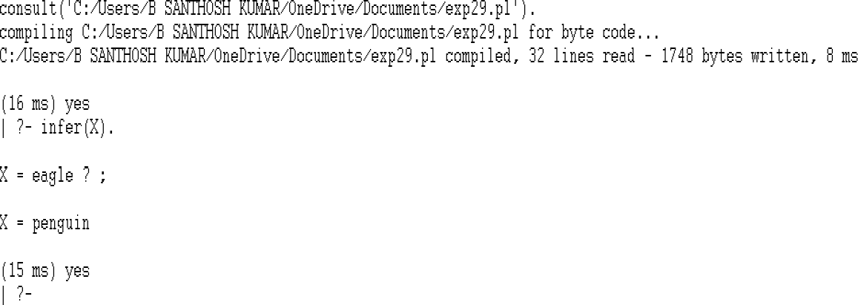

Result
Hence, the Prolog program for Forward Chaining was executed successfully and the required facts were inferred.

Experiment 30 Title
Write a Prolog Program for Backward Chaining. Incorporate Required Queries.

Aim
To implement Backward Chaining in Prolog to determine whether a goal can be satisfied using the available facts and rules.

Objective
To understand how Prolog uses backward chaining to prove a goal by matching it with rules and facts in the knowledge base.

Algorithm
Step 1: Define the facts in the knowledge base.
Step 2: Define rules that relate the facts.
Step 3: Enter the goal through a query.
Step 4: Prolog searches the rules to satisfy the goal.
Step 5: Display the inferred result if the goal is proved.

Program
% Facts

bird(eagle).
bird(penguin).

has_wings(eagle). has_wings(penguin).

can_fly(eagle). cannot_fly(penguin).

% Backward Chaining Rules

flying_bird(X) :-bird(X), has_wings(X), can_fly(X).

non_flying_bird(X) :-bird(X), cannot_fly(X).

% Goal

goal(X) :-flying_bird(X).

goal(X) :-non_flying_bird(X).

Sample Input
?- goal(eagle).

?- goal(penguin).

?- goal(crow).

Sample Output

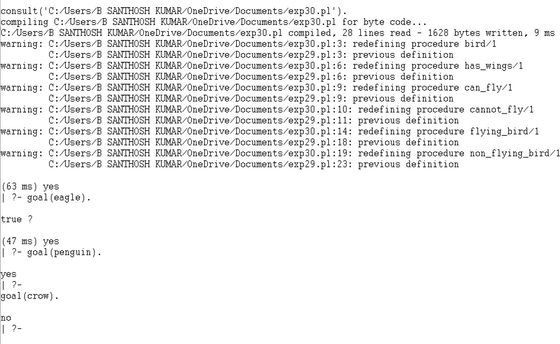

Result
Hence, the Prolog program for Backward Chaining was executed successfully and the required goal was proved.

EXPERIMENT NO. 31
Title
Create a Web Blog using WordPress to demonstrate Anchor Tag, Title Tag, etc.
Aim
To create a web blog using WordPress on the topic “Artificial Intelligence in Everyday Life” and demonstrate basic web elements such as Title, Headings, Paragraphs, Anchor Tag, Image and List.
Objective
To understand how WordPress can be used to create and publish a web blog and to demonstrate the use of hyperlinks and other basic web-page elements.
Software Required
- WordPress
- Web Browser
- Internet Connection

Procedure / Steps
- Open the WordPress website and create or open a WordPress site.
- Open the WordPress Dashboard.
- Select Posts → Add New Post.
- Enter the title “Artificial Intelligence in Everyday Life.”
- Add paragraphs explaining Artificial Intelligence and its uses.
- Insert suitable headings using the Heading block.
- Select the required text and use the Link option to add an Anchor Tag/Hyperlink.
- Insert an appropriate AI-related image using the Image block.
- Add a list of common applications of Artificial Intelligence.
- Add a conclusion to the blog.
- Click Publish to publish the blog.
- Click View Post to verify the final webpage.
- Click the hyperlink and verify that it opens the correct webpage.

Blog Content
Artificial Intelligence in Everyday Life
Introduction
Artificial Intelligence (AI) is one of the important technologies used in modern life. It enables computers and machines to perform tasks that normally require human intelligence. AI is used in smartphones, websites, online shopping, education, transportation and many other areas.
What is Artificial Intelligence?
Artificial Intelligence is a technology that allows machines to learn from data, recognize patterns and make decisions. Machine Learning, Natural Language Processing and Computer Vision are some important areas of AI.
Applications of Artificial Intelligence
AI is used in many everyday applications. Voice assistants can understand spoken commands, recommendation systems suggest movies or products, and navigation applications help users find suitable routes. AI is also used in healthcare, banking, education and cybersecurity.
Anchor Tag
Learn more about Artificial Intelligence
The text Artificial Intelligence is provided as a hyperlink to another webpage.
HTML code:
<a href="https://www.ibm.com/think/topics/artificial-intelligence">
Artificial Intelligence
</a>
When the user clicks Artificial Intelligence, the browser opens the linked webpage.
Common Applications of AI
- Voice Assistants
- Recommendation Systems
- Online Chatbots
- Image Recognition
- Navigation Applications
- Smart Home Devices
- AI-Based Education Tools
Image
Insert a suitable Artificial Intelligence-related image using the WordPress Image block.
Caption: Artificial Intelligence in Everyday Life
Benefits of Artificial Intelligence
- Saves time and effort.
- Automates repetitive tasks.
- Provides personalized recommendations.
- Helps in faster data analysis.
- Supports better decision-making.
Conclusion
Artificial Intelligence has become a useful part of everyday life. It helps people perform tasks more quickly, provides intelligent services and improves many areas such as education, healthcare, transportation and communication. As AI technology continues to develop, its role in our daily lives is expected to increase.

Demonstration of Web Elements
S.No. | Web Element | Demonstration
1 | Title / Post Title | Artificial Intelligence in Everyday Life
2 | Heading | What is Artificial Intelligence?
3 | Paragraph | Description of AI and its applications
4 | Anchor Tag | Artificial Intelligence hyperlink
5 | Image | Artificial Intelligence-related image
6 | List | Common Applications of AI
7 | Conclusion | Summary of Artificial Intelligence

Sample Input
The following content is entered into the WordPress editor:
Title:
Artificial Intelligence in Everyday Life
Heading:
What is Artificial Intelligence?
Text:
Artificial Intelligence is a technology that allows machines to learn from data, recognize patterns and make decisions.
Hyperlink:
Artificial Intelligence
List:
- Voice Assistants
- Recommendation Systems
- Online Chatbots
- Image Recognition
- Navigation Applications
- Smart Home Devices
- AI-Based Education Tools
Image:
Artificial Intelligence-related image


Output
Result
Thus, the web blog “Artificial Intelligence in Everyday Life” was successfully created and published using WordPress. The Title, Headings, Paragraphs, Anchor Tag, Image, List and Conclusion were demonstrated successfully, and the hyperlink was verified in the browser.

