  - “Comparing translation quality gaps between low and high resource languages across English translation directions in neural machine translation”
  - Assignment 4
Results and Discussion
Fariza Ismagambetova
Aizada Sembayeva
Zhanibek Yskak
Group SE-2418

1 Research question and hypotheses
Research question: How does the reported translation-quality gap between low- and high-resource language groups differ between translation into English and translation from English in multilingual NMT evaluations?
The aim is to compare this gap using published results measured under comparable conditions. The objectives are to define resource groups, extract translation scores, calculate the gaps in both directions, compare model configurations, and assess the limits of the comparison.
H1 states that the gap differs between the two directions.
H0 states that it does not differ.

2 Deviations from the frozen protocol
The analysis followed the planned models, data, metric, tests and sample selection. Assignment 3 provided preliminary results; this study extends the analysis to released model scores for individual languages. The literature comparison uses the sources discussed in Assignment 2.

3 Final experimental setup
We used Meta’s published NLLB scores on the original FLORES-200 devtest set, containing 1,012 sentences per translation direction (NLLB Team et al., 2022; Meta AI, n.d.-a). The data contain 1,206 matched scores from three models, 201 non-English language-script combinations and two English directions. Distilled 600M is the smaller existing-system baseline, Dense 3.3B is the strong baseline, and MoE 54.5B is the main model examined. We analysed existing evaluations without training models or generating new translations.
Resource groups follow Meta’s public training-data counts (Meta AI, n.d.-b). High-resource languages have at least one million examples; low-resource languages have fewer. The very-low-resource subgroup has at most 100,000 examples. Six languages appear in two scripts. We averaged these script scores within each language before calculating group means. This produced 195 language units: 52 high-resource and 143 low-resource languages, each with equal weight. Checks confirmed complete direction pairs, valid scores and consistent group labels. All eligible observations were retained.
The metric is chrF++, which compares character and word sequences in translations and reference texts (Popović, 2017). It was selected because the three releases report compatible scores and it captures overlap beyond exact whole-word matches. It is a score, not percentage accuracy. In each direction, the resource gap equals the high-resource mean minus the low-resource mean. The primary outcome, DeltaGap, equals the from-English gap minus the into-English gap. Positive values indicate a larger gap when English is the source language.
All models were compared using the same language coverage, metric and averaging procedure. Their original training and inference conditions were not controlled in this secondary comparison. The analysis used an ARM64 Mac and Python 3.12.14. The recorded main calculation took 3.52 seconds; this measures secondary analysis, not translation inference. Table 1 gives the remaining settings.
Table 1 Analysis settings
Item | Setting
Design | Quantitative secondary analysis of released benchmark results
Models | Distilled 600M; Dense 3.3B; MoE 54.5B
Evaluation coverage | 402 directions per model; 1,206 scores; 195 base languages
Primary and derived outcomes | chrF++ DeltaGap; group means; directional gaps
Uncertainty and tests | 20,000 stratified bootstrap samples; 100,000 label permutations; Holm across 3 tests
Seed | 20261108; separate recorded RNG streams

4 Main results
Table 2 shows the group means and gaps for every planned model. For MoE 54.5B, high-resource and low-resource languages score 63.63 and 54.85 into English. This gives a gap of 8.79 points. From English, the means are 55.56 and 42.49, giving a gap of 13.07 points. The difference between these gaps is 4.28 points. Its 95% confidence interval is [2.14, 6.23], so the estimated difference remains positive across the interval. Values are rounded for presentation; calculations use unrounded intermediate results.
Table 2 Mean chrF++ scores and resource gaps
Model | High  into EN | Low  into EN | Gap  into EN | High  from EN | Low  from EN | Gap  from EN
Distilled 600M | 59.84 | 50.17 | 9.67 | 51.58 | 39.12 | 12.47
Dense 3.3B | 63.14 | 53.61 | 9.53 | 54.91 | 41.68 | 13.23
MoE 54.5B | 63.63 | 54.85 | 8.79 | 55.56 | 42.49 | 13.07
Means weight each language equally. High-resource n = 52; low-resource n = 143. EN = English. All values are chrF++ scores or score differences.
The same direction pattern appears in both baselines. Distilled 600M has gaps of 9.67 into English and 12.47 from English, giving a difference of 2.80 points. Dense 3.3B has gaps of 9.53 and 13.23, giving 3.70 points. Figure 1 compares the two gaps within each model. The larger models have higher absolute scores in both resource groups, while the difference between direction gaps also increases.
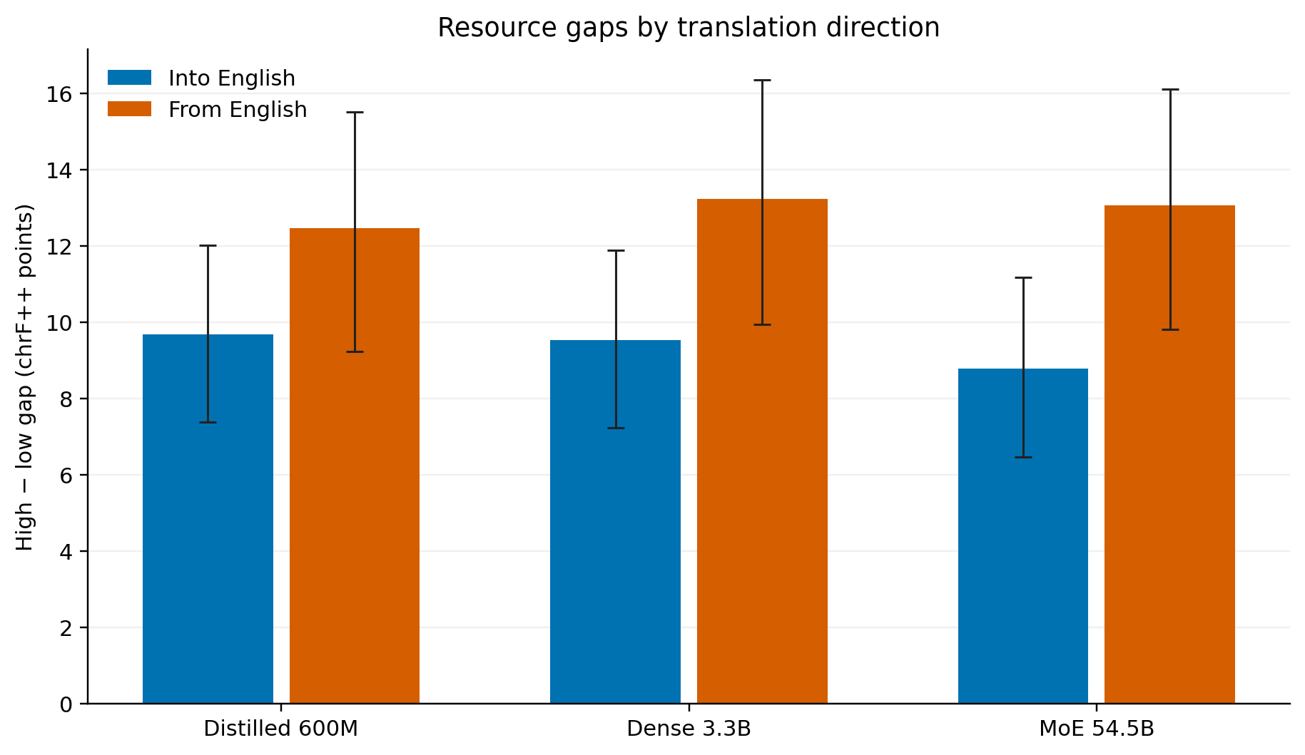
Figure 1 Resource gaps by translation direction. Error bars show 95% bootstrap confidence intervals across languages.
Language-level diagnostics show variation within both groups. For MoE, the median direction difference is 7.20 points in the high-resource group and 11.20 in the low-resource group. The interquartile ranges are 4.65 and 7.85 points. Two high-resource and three low-resource languages score higher from English, unlike the overall pattern.
We estimated uncertainty with 20,000 bootstrap samples. Languages were sampled separately within each resource group, keeping their two directions and three model scores together. This preserves the paired comparisons. The lower and upper interval limits are the 2.5th and 97.5th percentiles. These samples measure sensitivity to language composition; they are not repeated model-training runs.
The statistical test used each language’s into-English score minus its from-English score. The low-resource mean of this difference minus the high-resource mean equals DeltaGap. We shuffled the resource labels 100,000 times, keeping group sizes fixed, and calculated a two-sided permutation p-value. This test compares the observed difference with differences obtained under exchangeable group labels. A plus-one correction prevents zero Monte Carlo p-values (Phipson & Smyth, 2010). Holm correction accounts for the three model-specific tests.
Table 3 Directional contrasts and statistical comparisons
Model | DeltaGap | 95% interval | Raw p | Holm p
Distilled 600M | 2.80 | [0.75, 4.68] | 0.00714 | 0.00714
Dense 3.3B | 3.70 | [1.55, 5.68] | 0.00077 | 0.00154
MoE 54.5B | 4.28 | [2.14, 6.23] | 0.00016 | 0.00048
DeltaGap and confidence intervals are in chrF++ points. The tests are two-sided; Holm correction covers all three models.
For MoE 54.5B, the raw p-value is 0.00016 and the adjusted value is 0.00048. All three adjusted values are below 0.05, and all three intervals exclude zero. The results therefore meet the stated criterion for supporting H1 under the test assumptions. Figure 2 shows the estimates and intervals. The 4.28-point main difference gives its absolute magnitude. Its usefulness depends on the translation setting; statistical significance alone does not establish a benefit for users.
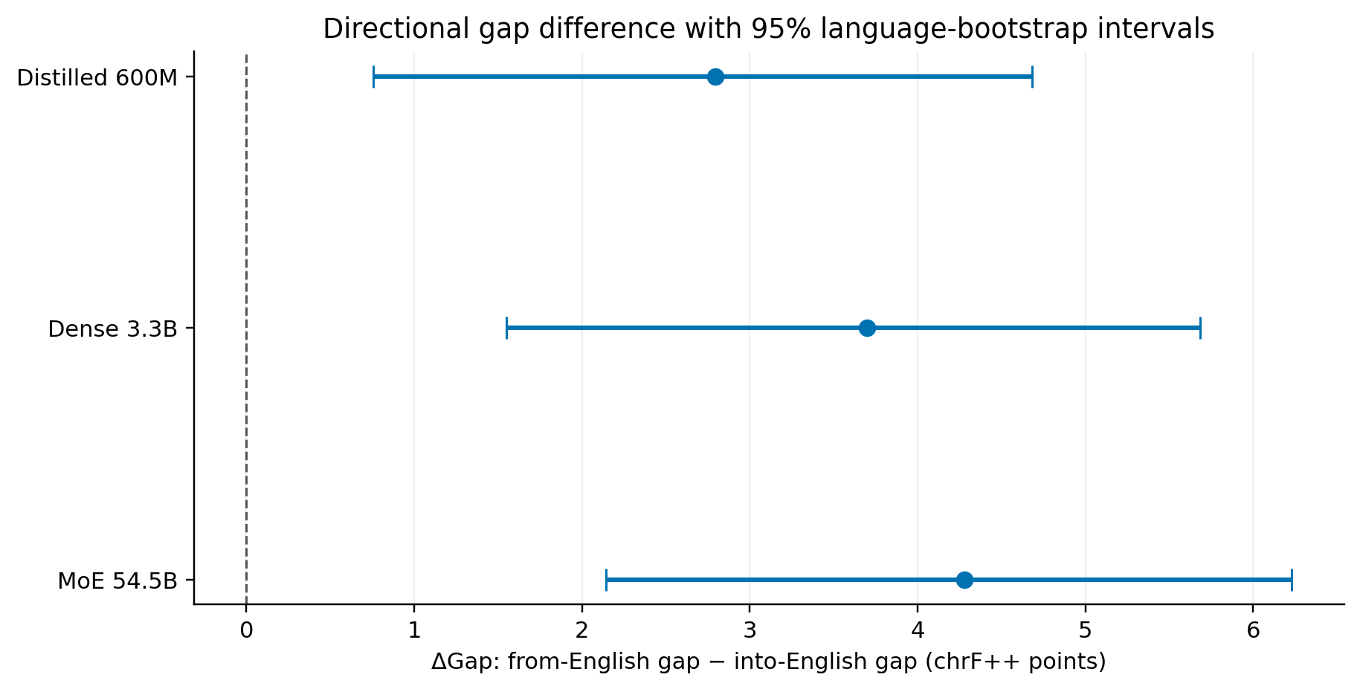
Figure 2 Difference between direction gaps with 95% bootstrap confidence intervals. Positive values indicate a larger gap from English.

5 Additional analysis
The result was stable under the planned sensitivity checks. Giving equal weight to all 201 script combinations produced a MoE difference of 3.89 points, compared with 4.28 in the main language-based analysis. Replacing group means of the direction difference with medians gave 4.00 points. Removing one language at a time produced values from 4.09 to 4.85. All 195 exclusions retained a positive difference. The two baselines also remained positive in every check (Table 4).
Table 4 Sensitivity checks
Model | Main result | Equal script weights | Median contrast | One language removed
Distilled 600M | 2.80 | 2.41 | 2.80 | 2.58 to 3.32
Dense 3.3B | 3.70 | 3.24 | 3.20 | 3.50 to 4.25
MoE 54.5B | 4.28 | 3.89 | 4.00 | 4.09 to 4.85
All values are chrF++ differences. The final column gives the range across single-language exclusions, not a confidence interval.
The resource subgroups provide further detail. For MoE, the average into-English score minus the from-English score is 8.07 points for high-resource languages. It is 9.40 for the 64 low-resource languages outside the very-low-resource subgroup and 14.74 for the 79 very-low-resource languages. The strongest direction difference is therefore concentrated in the group with the fewest published training examples. This is an association; the grouping does not separate data quantity from language structure or reference quality.
The error analysis examined 60 outputs from six fixed low-resource directions into English. Ten outputs with the lowest sentence chrF++ scores were selected per direction, with sentence ID used to break ties. The review retained 37 errors, eight acceptable paraphrases and 15 uncertain cases. The dominant categories were meaning substitution (25), omission (10), named-entity error (one) and repetition (one). Appendix B gives definitions, examples and possible causes.
Possible differences between the source and reference were flagged in 23 cases. Ten still contained a separate clear defect, such as a whole omitted sentence; the other 13 remained uncertain. For example, a Khmer output uses BC where the English reference uses AD, but BC also appears in the source. This case was excluded from the error count. The findings show why low overlap cannot automatically be treated as a model failure. This selected sample describes error types, not the error rate of the full benchmark.

6 Answer to the research question
Table 5 Hypotheses and objectives
Hypothesis or objective | Evidence and numerical finding | Assessment
H1 The direction gaps differ | DeltaGap = 4.28; 95% CI [2.14, 6.23]; adjusted p = 0.00048 for MoE. | Supported under the test assumptions
H0 There is no direction difference | All three adjusted p-values are below 0.05. | Rejected under the test assumptions
Define groups and compare scores | 52 high-resource and 143 low-resource languages; 1,206 source scores; Tables 2 and 3. | Addressed
Compare configurations and assess limits | Three models; sensitivity checks in Table 4; validity limits in Section 7. | Addressed within the selected data

The resource-related translation-quality gap is larger from English than into English in all three examined NLLB models. For MoE 54.5B, it rises from 8.79 to 13.07 chrF++ points, a difference of 4.28. The confidence interval and corrected test support this difference, and the sensitivity checks preserve its direction. The subgroup results show a larger direction difference among very-low-resource languages. These findings answer the research question for the selected published evaluations. They do not imply that every low-resource language follows the average pattern or that resource scarcity alone causes the difference. The conclusions concern the original FLORES-200 benchmark and the selected NLLB models.

7 Discussion
The main finding is that the resource gap is larger when translating from English. Low-resource languages lose more chrF++ score when they are targets rather than sources. The Very Low subgroup shows a mean directional decrease of 14.74 points for the primary model. Producing less-supported target languages may present different difficulties from producing English. However, this study does not manipulate training resources or language properties. This explanation remains a hypothesis, not an established mechanism.
Larger models improve absolute scores without necessarily reducing directional disparity. Compared with Distilled 600M, MoE increases the Low mean from 50.17 to 54.85 into English and from 39.12 to 42.49 from English. Its DeltaGap is nevertheless larger. High and Low scores change by different amounts in each direction. Therefore, gap measures should be read together with their component scores. These checkpoints also differ in architecture, distillation history and training costs, so this is not an equal-compute comparison.
The findings agree in direction with NLLB Team (2024). Assignment 3 reported positive contrasts of 2.30, 3.50 and 5.00 chrF++ points from that study's ablation table. However, those results used FLORES-200 dev and different configurations. The present analysis uses final-checkpoint devtest scores and explicit language weighting. Their magnitudes are not directly interchangeable. Both analyses also belong to the NLLB research family, so their agreement is not independent replication across unrelated systems. The earlier spBLEU findings from Cui et al. (2025) remain separate because the metric and language coverage differ.
Haddow et al. (2022) describe resources through data quantity, quality, domain coverage and available tools. Separating Very Low languages from the remaining Low group supports a more detailed description than a single binary division. However, our labels follow published training counts and cannot capture every resource dimension. Their discussion of evaluation also supports examining metric limitations and test-set quality alongside numerical results.
Morim da Silva et al. (2024) evaluated four systems across four datasets and 26 languages, translating only into English. Results varied by language, system and dataset, with some lower-resource languages performing comparatively well. This supports inspecting individual languages instead of treating group averages as universal rules. Their experiment cannot directly test our bidirectional contrast. Differences in coverage and evaluation conditions also prevent pooling their results with our chrF++ gaps.
In practice, evaluations should report both English directions and separate resource groups. A single multilingual average can hide weaker performance when low-resource languages become targets. System selection should consider absolute quality, domain suitability and concrete errors alongside gap measures. Reducing a gap by lowering High performance would not improve translation for Low users. Social or educational benefits require separate evidence.
Internal validity is limited by the observational design. Resource status is associated with language family, script, training coverage and reference characteristics. The results therefore do not establish causal effects. External validity is limited to the selected NLLB checkpoints and FLORES sentences. Performance in conversation or specialised domains may differ. The diagnostic audit covers selected difficult cases into English, so it cannot establish error patterns in the opposite direction.
Construct validity is limited by chrF++ surface overlap, rounded published scores and source-defined resource categories. Valid paraphrases can receive low scores. Suspected source–reference mismatches also make some discrepancies difficult to attribute to the model. Statistical conclusion validity depends on permutation exchangeability and the bootstrap resampling assumptions. Averaging script variants avoids repeated counting, but related languages may remain dependent. Confidence intervals may therefore understate uncertainty. The benchmark languages are not a random sample of all languages.
Future work should include other model families and independent domains, with paired source texts, references and outputs in both directions. Bilingual review could separate model errors from reference problems. Family-aware uncertainty estimates and alternative resource measures could test the stability of the association. Exact scoring signatures and generation settings should accompany new evaluations to improve comparability and reproducibility. This follows Post’s (2018) emphasis on clear reporting of evaluation settings.

8 Reproducibility
The repository contains the source scores, fixed protocol, analysis code, environment requirements, result files and figures. The README gives the commands needed to reproduce the main tables. The executed notebook presents the saved results, and each language score can be traced to its source file. A fresh public-repository copy reproduced all ten numerical files, five saved arrays and eight figure files in a new environment. Appendix C records this check.
Repository: https://github.com/Tedra-ez/rmt-assignment4-nmt-direction-gap
Submission release: assignment-4

References
Cui, M., Gao, P., Liu, W., Luan, J., & Wang, B. (2025). Multilingual machine translation with open large language models at practical scale: An empirical study (Version 2) [Preprint]. arXiv. https://arxiv.org/abs/2502.02481v2
Haddow, B., Bawden, R., Miceli Barone, A. V., Helcl, J., & Birch, A. (2022). Survey of low-resource machine translation. Computational Linguistics, 48(3), 673–732. https://doi.org/10.1162/coli_a_00446
Meta AI. (n.d.-a). The FLORES-200 evaluation benchmark for low-resource and multilingual machine translation [Data set and documentation]. GitHub. Retrieved November 7, 2026, from https://github.com/facebookresearch/flores/tree/main/flores200
Meta AI. (n.d.-b). No language left behind (Commit ec0ae71a24fbc2f42252f37735f59dd6547eba38) [Source code and published evaluation results]. GitHub. https://github.com/facebookresearch/fairseq/tree/ec0ae71a24fbc2f42252f37735f59dd6547eba38
Morim da Silva, A. A., Srivastava, N., Moteu Ngoli, T., Röder, M., Moussallem, D., & Ngonga Ngomo, A.-C. (2024). Benchmarking low-resource machine translation systems. In A. K. Ojha, C.-H. Liu, E. Vylomova, F. Pirinen, J. Abbott, J. Washington, N. Oco, V. Malykh, V. Logacheva, & X. Zhao (Eds.), Proceedings of the Seventh Workshop on Technologies for Machine Translation of Low-Resource Languages (LoResMT 2024) (pp. 175–185). Association for Computational Linguistics. https://doi.org/10.18653/v1/2024.loresmt-1.18
NLLB Team. (2024). Scaling neural machine translation to 200 languages. Nature, 630(8018), 841–846. https://doi.org/10.1038/s41586-024-07335-x
NLLB Team, Costa-jussà, M. R., Cross, J., Çelebi, O., Elbayad, M., Heafield, K., Heffernan, K., Kalbassi, E., Lam, J., Licht, D., Maillard, J., Sun, A., Wang, S., Wenzek, G., Youngblood, A., Akula, B., Barrault, L., Mejia Gonzalez, G., Hansanti, P., … Wang, J. (2022). No language left behind: Scaling human-centered machine translation [Preprint]. arXiv. https://doi.org/10.48550/arXiv.2207.04672
Phipson, B., & Smyth, G. K. (2010). Permutation p-values should never be zero: Calculating exact p-values when permutations are randomly drawn. Statistical Applications in Genetics and Molecular Biology, 9(1), Article 39. https://doi.org/10.2202/1544-6115.1585
Popović, M. (2017). chrF++: Words helping character n-grams. In O. Bojar, C. Buck, R. Chatterjee, C. Federmann, Y. Graham, B. Haddow, M. Huck, A. Jimeno Yepes, P. Koehn, & J. Kreutzer (Eds.), Proceedings of the Second Conference on Machine Translation (pp. 612–618). Association for Computational Linguistics. https://doi.org/10.18653/v1/W17-4770
Post, M. (2018). A call for clarity in reporting BLEU scores. In O. Bojar, R. Chatterjee, C. Federmann, M. Fishel, Y. Graham, B. Haddow, M. Huck, A. Jimeno Yepes, P. Koehn, C. Monz, M. Negri, A. Névéol, M. Neves, M. Post, L. Specia, M. Turchi, & K. Verspoor (Eds.), Proceedings of the Third Conference on Machine Translation: Research Papers (pp. 186–191). Association for Computational Linguistics. https://doi.org/10.18653/v1/W18-6319

Appendix A Protocol summary
Table A1 Fixed analysis decisions
Item | Decision
RQ and hypotheses | Unchanged English-direction resource-gap question; two-sided H1 and H0
Primary condition and metric | MoE 54.5B; DeltaGap in chrF++ points
Baselines | Smaller Distilled 600M and stronger Dense 3.3B
Data and unit | 1,206 source scores; 201 language-script units; 195 base languages (52 High, 143 Low)
Dataset | Original FLORES-200 devtest; 1,012 sentences per direction; published NLLB releases
Runs and resampling | One secondary analysis; 20,000 bootstrap draws; 100,000 shared label permutations; seed 20261108
Secondary outcomes | High and Low means; resource gap in each translation direction
Statistical criteria | Support H1 if Holm-adjusted p < .05 and the 95% interval excludes zero; otherwise H1 is not supported.
Robustness | Script weighting; median contrast; all single-language exclusions; nested resource subgroups
Error audit | Six fixed Low languages into English; 10 lowest-scoring candidates each; retain every decision

Appendix B Error analysis
All 60 selected cases are recorded in results/error_audit/reviewed_round_01.csv. The table summarises the 37 retained errors; eight acceptable paraphrases and 15 uncertain cases are excluded from the denominator. Each error has one dominant category. Possible causes are explanations to investigate, not established mechanisms.
Table B1 Error categories
Type | Definition | n | % | Example | Possible cause
Meaning substitution | The output changes the main meaning. | 25 | 67.6 | ace:895 — cultural adjustment becomes an unrelated statement about a deceitful tongue. | Incorrect lexical or sentence interpretation.
Omission or truncation | Required content is missing. | 10 | 27.0 | khm:372 — the sentence about hunting prey is omitted. | Loss of content in a longer sentence pair.
Named entity or number | A name or number is changed. | 1 | 2.7 | khm:460 — Muhammad becomes “Mt.”. | Incorrect recognition of a name.
Addition or repetition | The output adds or repeats unsupported content. | 1 | 2.7 | mya:574 — the Cretaceous claim is repeated, followed by a Jurassic version. | Unstable or repetitive generation.
Grammar or word order | Grammar or ordering obscures meaning. | 0 | 0.0 | No case assigned. | Not applicable.

Examples

Omission khm_Khmr 372
Reference: They can see very well in the dark with night vision, and move very stealthily, too. Ocelots hunt their prey by blending in with their surroundings then pouncing on their prey.
Output: At night, they can see clearly and navigate smoothly.
The output omits the second sentence about hunting. It is present in both source and reference.

Acceptable paraphrase mya_Mymr 137
Reference: Fire rescue crews eventually doused the fire by 11:35 pm.
Output: Firefighters finally extinguished the blaze at 11:35 p.m.
The wording changes, but the firefighters, action and time are preserved.

Uncertain case khm_Khmr 490
Reference: Its renown for being an epicenter of luxury began in about 400 A.D. and lasted up until about 1100 A.D.
Output: Renowned for its elegance, it began around 400 BC and continued until 1100 BC.
The reference uses AD and the output uses BC. The source also contains BC markers, so the difference cannot confidently be assigned to the model.

Appendix C Reproduction test record
The main analysis was reproduced from a fresh public-repository copy in a new Python environment. The record below documents the completed reproduction check.
Table C1 Reproduction record
Item | Record
Release | assignment-4-v1
Commands executed | git clone; python -m venv; pip install -r requirements.txt; unit tests; input validation; python scripts/analyze.py --local-protocol-record protocol/local_freeze_record.json
Main results reproduced | Yes. All 10 numerical files, 5 saved arrays and 8 figure files matched.
Differences | Timestamps, local paths, runtime and environment records differed.
Evidence | docs/technical_reproduction_public_release.json; docs/reproduction_evidence/

