Version | Change Notes | Date | Owner
1.0 | Original Document | 31 Jan 2015 | Marcia Wilbur
1.1 | Change to Code  Formatting CLI options  Change “Examples” to “Options” | 13 Feb 2015 | Marcia Wilbur
$TEXT"
Changed text in respin-gui
Select the option you would like?

RESPIN

RESPIN PROJECT

Migration from Remastersys

After contacting the original Remastersys developer regarding the fork to this abandonware, we donated some funds and were given the original code. The code was developed for 2 distros – Debian and Ubuntu. With the code for the core functionality, the gui and gtk code was also included.

The following is a diagram for the flow.

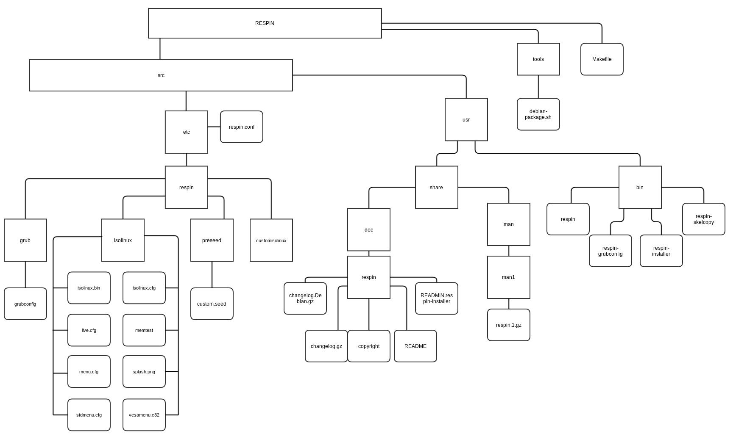

The following table shows the instances of remastersys changed to respin in the Debian version
Path | Document | Changes
tools | debian-package.sh | Changed remastersys to respin  Changed website to linuxrespin.org
src/etc | remastersys.conf | Document name to respin.conf
src/etc |  | Change remastersys dir to respin dir
src/etc | respin.conf | WORKDIR="/home/remastersys" to WORKDIR="/home/respin”
src/etc/respin | grub.png | Changed image
src/etc/respin | remastersys.version | Changed to respin.version
src/etc/respin | respin.version | RESPINVERSION="1.0.0-1"
src/etc/respin | remastersys-installer.conf | Changed to respin-installer.conf
src/usr/bin | remastersys | Change to respin
src/usr/bin | respin | Change Modification date and copyright date
src/usr/bin | respin | Change all remastersys and Remastersys to respin and Respin accordingly
src/usr/bin | remastersys-grubconf | Change to respin-grubconf
src/usr/bin | respin-grubconf | Change from remastersys to respin
src/usr/bin | remastersys-installer | Change to respin-installer
src/usr/bin | respin-installer | Change from remastersys to respin
src/usr/bin | remastersys-skelcopy | Change to respin-skelcopy
src/usr/bin | respin-skelcopy | Change from remastersys to respin
src/usr/share/man/man1 | remastersys.1.gz | Change to respin.1.gz
src/usr/share/man/man1/respin.1.gz | respin.1 | Change to respin
src/usr/share/doc | remastersys | respin
src/usr/share/doc/respin/changelog.Debian.gz | changelog.Debian | Changed remastersys to respin  Changed to first release 0.0.0-1
src/usr/share/doc/respin/changelog.gz | Changelog.Debian | Changed remastersys to respin  Changed to first release 0.0.0-1
src/usr/share/doc/respin | copyright | Changed copyright information
src/usr/share/doc/respin/ | README | Changed from remastersys to respin
src/usr/share/doc/respin/ | README.remastersys.installer | Changed to README.respin.installer
src/usr/share/doc/respin/ | README.respin.installer | Changed from remastersys to respin

Table 1: Modifications from Remastersys to Respin
Path | Document | Changes
src/usr/bin | respin | Change format of the cli output  Change “Examples” to “Options”

